Masters of Space Diary Entry, Figurines and LEGO

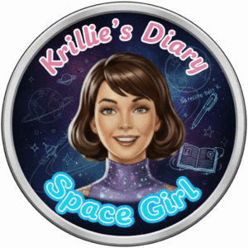
Hi, I’m Krillie. I was born in space on an Earth orbiting space station called “Satellite Belt K”. I write a diary under the moniker “Space Girl” for those interested in what is happening in space and to describe life as a Space Girl. I cover a lot of our activities, about our education and training, our living arrangements and some of our adventures. Along with my friend Kemlo, I write some of the books in “The Further Adventures of Kemlo and Krillie in Space” series. I hope my Diary is of interest to children on Earth, in the Satellite Belts and beyond.

Kemlo e-Pubs and iBooks
You can read a long diary entry I wrote a long time ago and that, by some extreme foresight, Mr. E.C. Eliott included in one of his books written over two centuries ago! See Chapter 1 of “Kemlo and the Masters of Space”.
14 of the Kemlo books (minus Kemlo and the Satellite Builders) are available in e-Pub and online formats via https://www.sfgateway.com/contributor/e-c-eliott/ (or Kindle on Amazon Store).
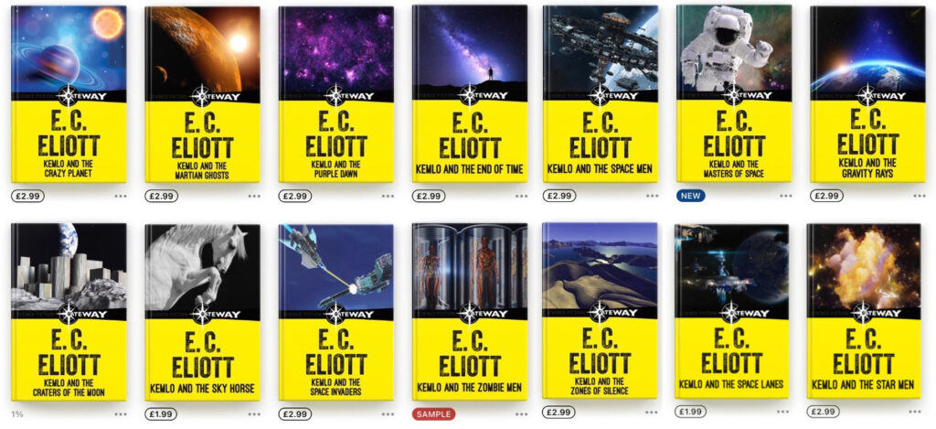

Kemlo & Krillie Figurines
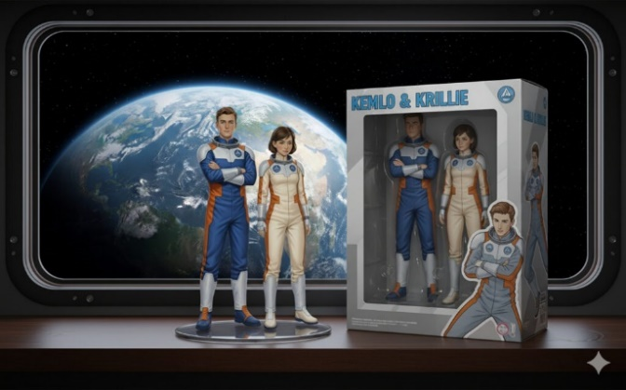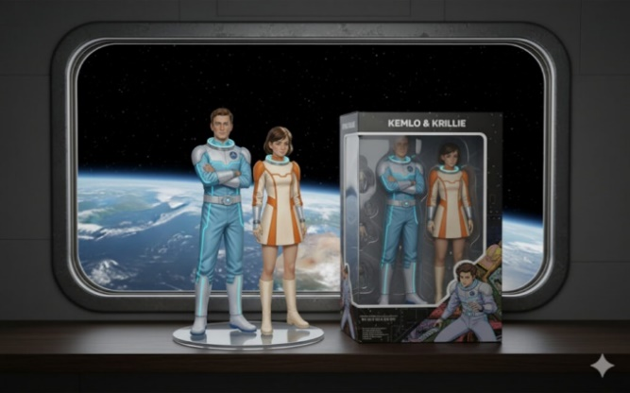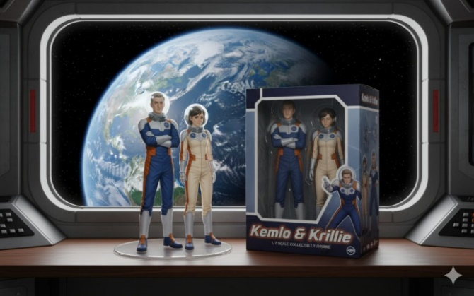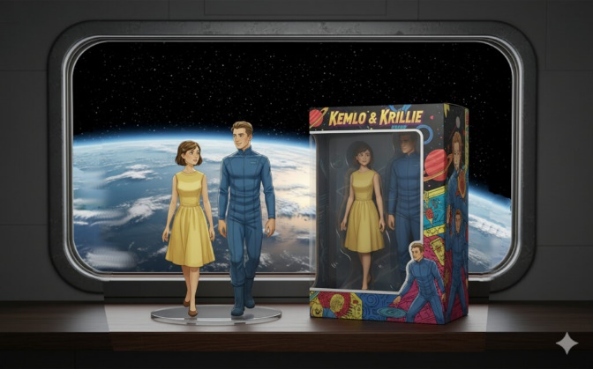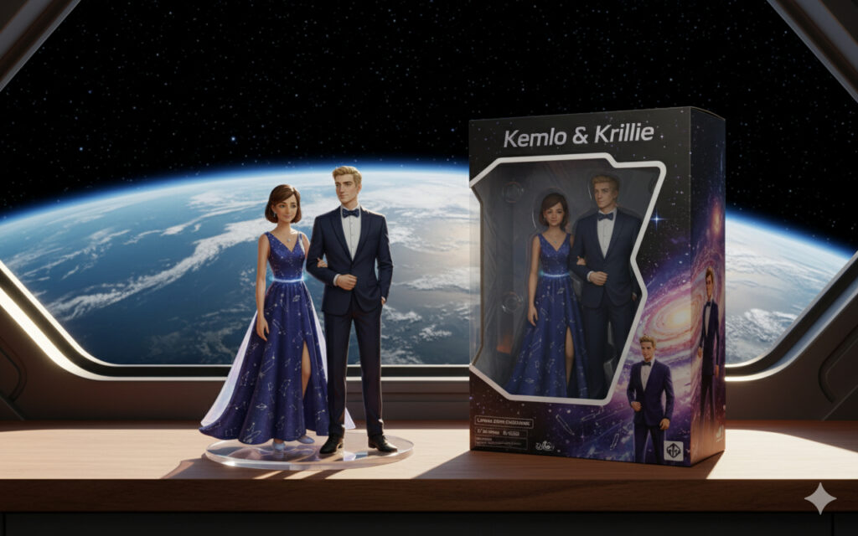

Kemlo & Krillie in LEGO
