Century 22 Sports
Posted on September 23, 2025 by bat

Hi, I’m Krillie. I was born in space on an Earth orbiting space station called “Satellite Belt K”. I write a diary under the moniker “Space Girl” for those interested in what is happening in space and to describe life as a Space Girl. I cover a lot of our activities, about our education and training, our living arrangements and some of our adventures. Along with my friend Kemlo, I write some of the books in “The Further Adventures of Kemlo and Krillie in Space” series. I hope my Diary is of interest to children on Earth, in the Satellite Belts and beyond.

Kemlo and myself are keen on sports and there are many fun things to do in the Sports Domes on Belt K. Yoga and Ballet are popular for both men and women, as well as children, as they provide useful exercises for stretch and balance... both are important when living in space. But on the Belts they are performed with a twist… “Gravity Ray Yoga” and “Situated Ballet”. But there is much more… “Zero-G Air Wave Surfing” and “Resonance-Hexad” – a challenging Six-a-Side Team Game. But if swimming is your thing, try the wild “Infinity Pool”. These entries had some help from Google Gemini.
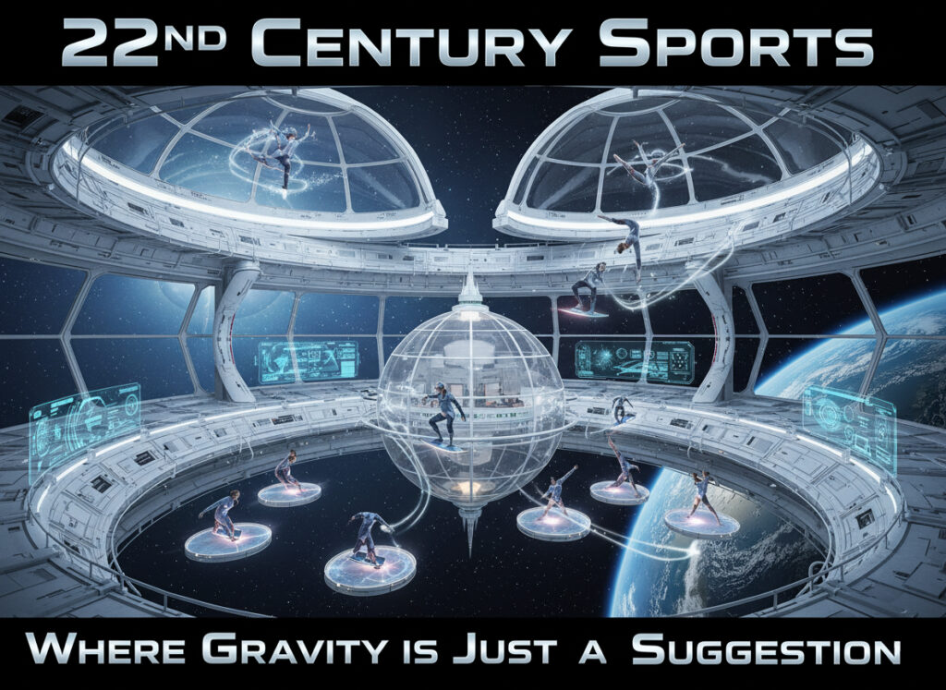

Gravity Ray Yoga
Yoga can be practised by people of all ages and abilities. It provides very good stretch and balance exercises. Gravity Ray Yoga uses the Gravity Rays we use on the space stations and on our spaceships to give a protective envelope and gravity. But in the yoga setting they can be adjusted to lighten or add to the physical resistance of movement. Settings allow for lower gravity to 60% of normal Satellite Belt gravity or to be increased to 1.4 times normal Satellite Belt gravity to push against your yoga poses.
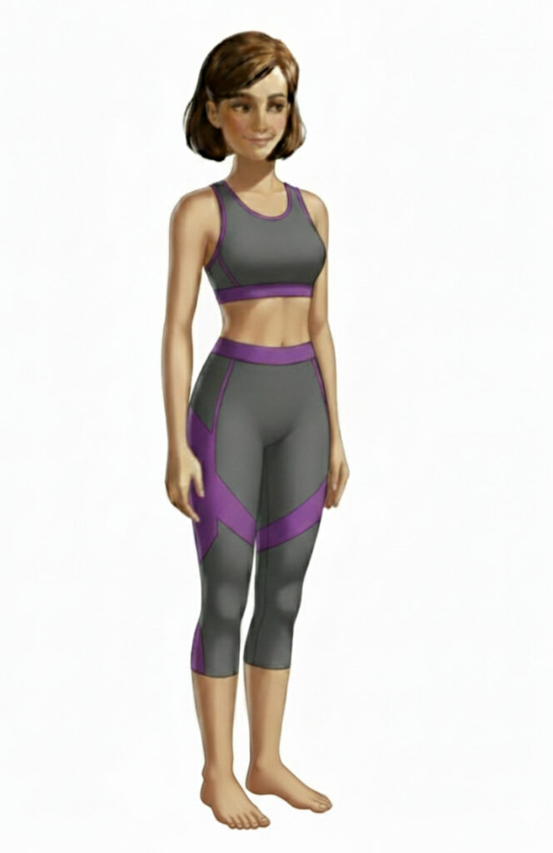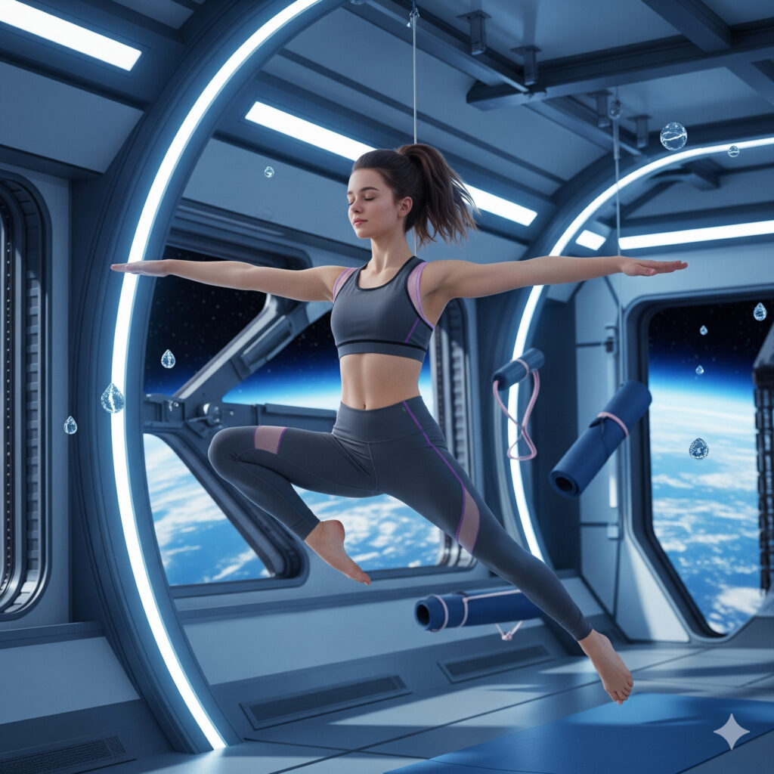

Situated Ballet
Ballet exercises, both done individually and as part of a dance troop, can be set in any environment the participants can recall or imagine. Holographic projection into the dance studio, or use of VR, sets the dancers in an immersive environment. Voice control lets the dancers or choreographers set up and modify the environment. Haptics in the dance costumes and ballet shoes or ballet boots allow for feedback on the environment. Imagine the ballerina performing on the stage at the famous Covent garden Opera House in London back on Earth. Or you can dance en pointe along the ice crystals in Saturn’s rings. Outside of the Satellite Belt’s Gravity Ray protective envelope though you must have on a costume which acts as a complete spacesuit.
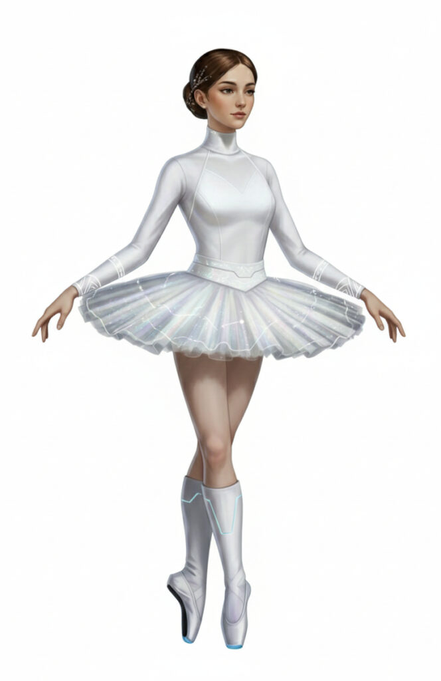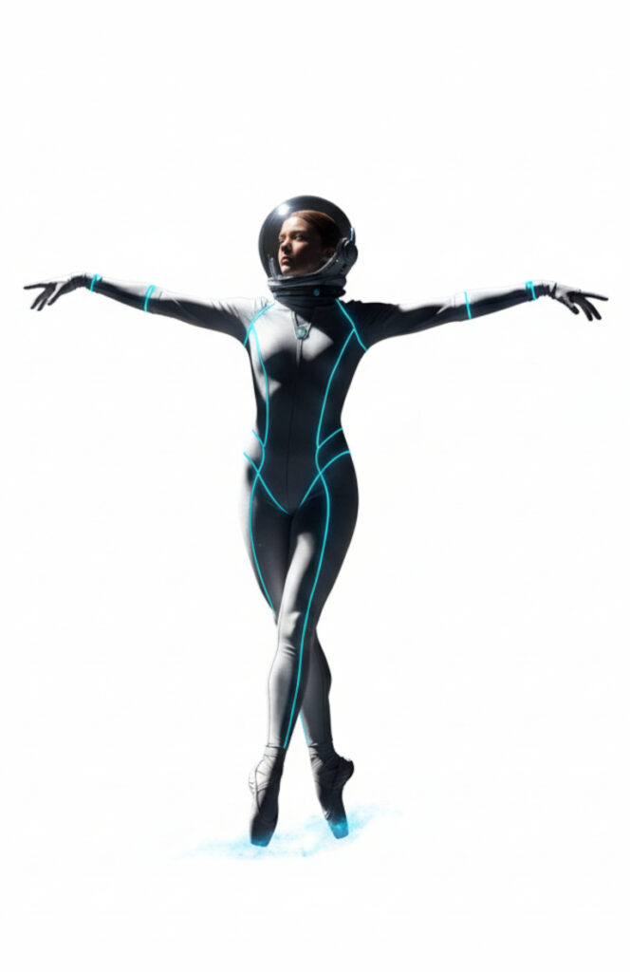

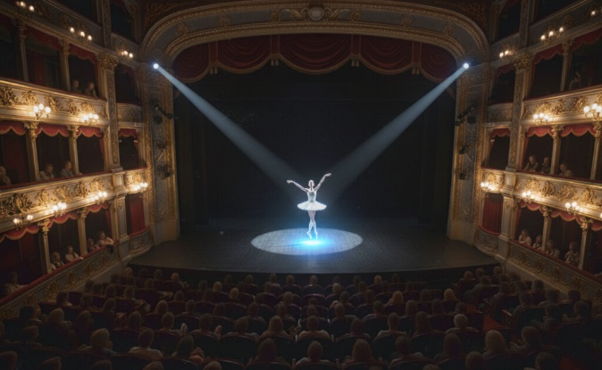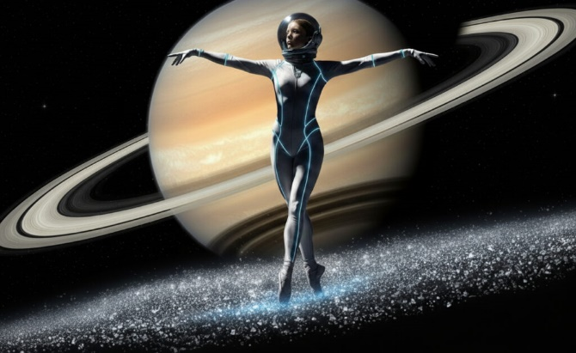

Zero-G Air Wave Surfing
Zero-G sports are always popular in space… especially with visitors from Earth who find it a novel and exciting thing to do on their visits. Currents of air flow are generated in the Surfing Dome by enormous fans at the periphery of the arena and the surfers ride the air waves while in the Zero-G environment. The movements can be gentle or strong and can be made relatively stable or vary a lot. Surfers must “feel” the air waves, much like a glider pilot flying in Earth’s atmosphere can. The air waves can be made to flow out in one direction or made to circle round. Haptics in the Air Flow Surfing costumes allow for audio-sensory feedback on the air flow strength and direction and from the environment. Experienced Air Flow Surfers who “catch a wave” when its circulating in the dome can ride round and round performing flip tricks on the air wave “front”. A pool of water at the base of the arena can be excited by the air wave patterns and even form actual water standing waves which the surfers can interact with. Good surfers get enthusiastic applause form the crowds that can gather for some events.
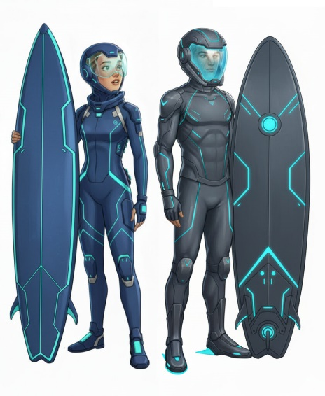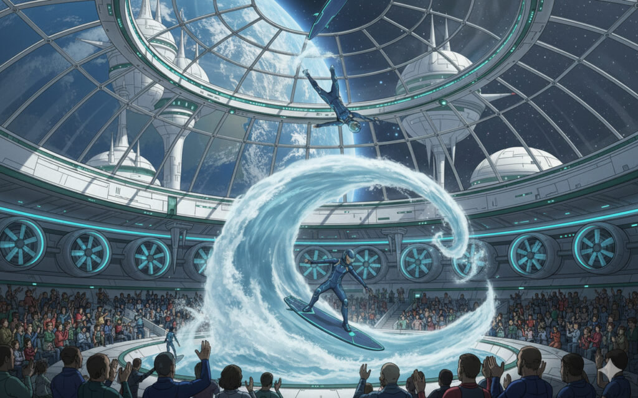

Resonance-Hexad – a Six-a-Side Team Game
The Resonance-Hexad Arena is a popular venue and large crowds gather for tournaments. The game is often referred to just as “Resonance”. The rules at first may seem quite complicated, but actually so long as you understand that coordinated activity and patterns in the arena and between participants is the key, and ways to disrupt the opponents’ similar actions, it begins to make sense. The rules appeal to the engineering types that inhabit the Belts, so it’s become very popular. For full rules of the game see below. Some games between top teams are even videocast to other Belts and to Earth.
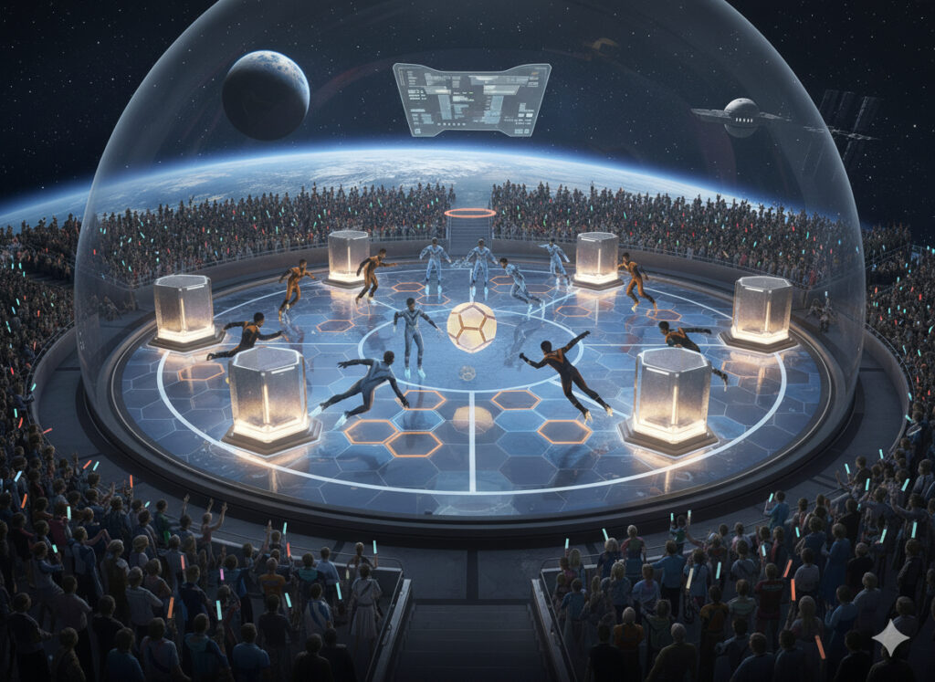

Infinity Pool
The Satellite Belts all have a special kind of swimming pool. The ring shaped pool is around 5 metres wide and 25 metres in diameter. The water is on the inner rim and is about 3 metres deep. Gravity Rays project around the rim of the pool to provide an even gravity outwards so swimmers can continue to swim forwards all the way round the pool and come back to where they started. The orientation of the Infinity Pool can be horizontal with wide views down to Earth, or the truly wild vertical orientation where the Earth view oculus narrows, and where you can swim up the ring, over the top and down again, but it feels the same due to the adjustable Gravity rays.
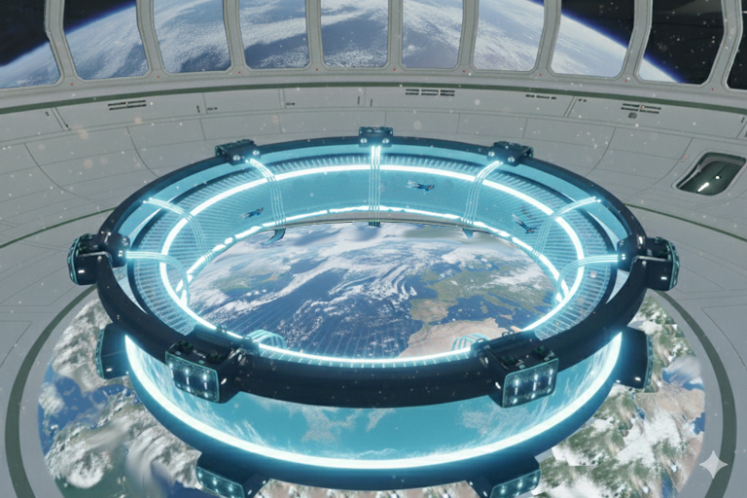
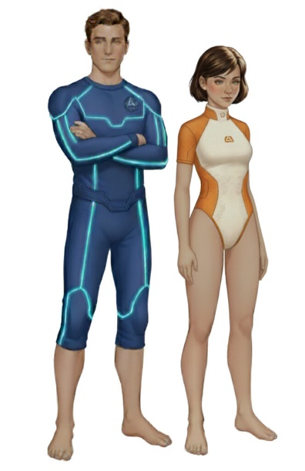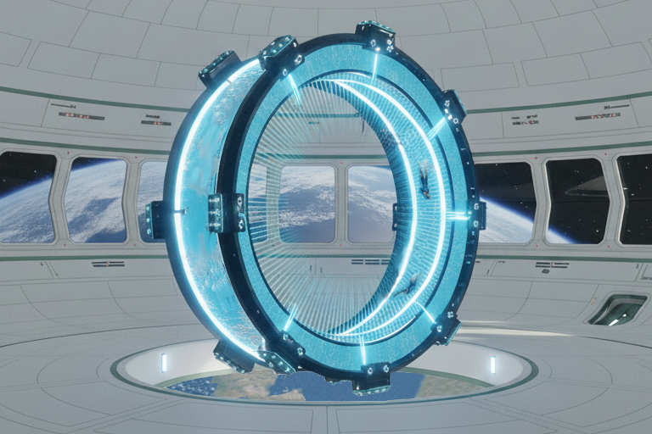

Game: Resonance-Hexad (often referred to just as “Resonance”)
Premise and Rules (assisted by Google Gemini)
Premise:
Resonance-Hexad is a Six-a-Side team-based sport played within a dynamic, virtual-physical arena. It blends strategic puzzle-solving, real-time cooperative decision-making, and synchronized physical movement. The game is popular because it requires a combination of cognitive agility, team cohesion, and fluid adaptability, appealing to a society that values intellectual and collaborative skills as much as physical prowess. It is designed to be accessible to people of various physical abilities, with the core challenge being mental and social rather than purely athletic.
Equipment & Arena:
• The Dome: A large, multi-level geodesic dome, approximately 25 meters in diameter, with a floor, walls, and ceiling that are fully interactive and responsive to player input.
• Holographic Projections: The arena’s surfaces display real-time holographic puzzles, pathways, and obstacles. These are not just visual; they can be “solidified” by the players’ actions, becoming traversable platforms, walls, or even objects.
• Player Suits: Teams wear lightweight, form-fitting suits integrated with hactics and a neuro-interface. The suits track the players’ movements and neural activity, allowing them to interact with the holographic environment.
• The Sphere: At the centre of the Dome is a floating, crystalline object that is the target of the game.
The Rules of Play:
• Teams: Two teams of six players compete.
• Objective: The goal is for a team to “attune” the Sphere to their unique “frequency” before the opposing team can. This is achieved by solving a series of complex, multi-layered puzzles and performing synchronized physical manoeuvrers.
• The Puzzles (The “Attunement Sequence”): Each puzzle in the sequence is a dynamic, holographic challenge that appears on the surfaces of the Sphere. They are not simple riddles; they require the combined effort of the entire team. For example:
• Logic Gates: Players must physically align themselves in a specific pattern on the floor to complete a circuit, which then unlocks the next puzzle segment.
• Geometric Flux: One player may need to hold a specific pose (e.g., a “V” shape with their body) while another player navigates a maze that is projected onto their teammate’s body, all while a third player “stabilizes” the holographic projection with their hands.
• Synaptic Relay: Players must “pass” a beam of light from one to another by touching their suits at precise moments and locations, a task that relies on perfect timing and nonverbal communication.
• The “De-tuning” Mechanic: The opposing team’s primary role is to disrupt the attunement sequence. They do this by projecting “static” or “feedback loops” into the arena, which can scramble a puzzle, change a holographic platform, or temporarily block a player’s suit from interacting with the environment. This is a non-contact defensive strategy, relying on foresight and timing rather than physical interception.
• Synchronicity & Flow: The game rewards “flow states.” When a team operates in perfect harmony—moving, thinking, and acting in a coordinated manner—their suits boost their abilities, allowing them to solve puzzles faster and project stronger attunement signals. This is the core skill of the game: achieving a state of collective cognitive and physical synergy.
Why It’s Different from Today’s Games:
• Focus on Collective Intelligence: Unlike team sports in earlier centuries that often rely on individual star players, Resonance-Hexad is designed to fail if even one player is not fully integrated. The game’s challenges are unsolvable by a single person and require a deep, intuitive understanding of each teammate’s role and capabilities.
• Non-Physical Conflict: The “conflict” is not about scoring a goal or tackling an opponent. It’s about mental and strategic disruption. It’s a game of wits, communication, and environmental manipulation.
• Accessibility: The game’s primary skill is cognitive and collaborative, making it accessible to a wider range of people regardless of their age, size, or physical strength. The physical movements are more akin to synchronized dance or martial arts forms than they are to running and jumping.
• Integration of Tech and Humanism: It is a game that is impossible without advanced technology, but the technology is not the player; it is an extension of the players’ collective will. The suits and the Sphere are simply tools to facilitate human connection and cooperation in a novel way.

