Krillie Tries it On

Posted on September 20, 2025 by bat
Hi, I’m Krillie. I was born in space on an Earth orbiting space station called “Satellite Belt K”. I write a diary under the moniker “Space Girl” for those interested in what is happening in space and to describe life as a Space Girl. I cover a lot of our activities, about our education and training, our living arrangements and some of our adventures. Along with my friend Kemlo, I write some of the books in “The Further Adventures of Kemlo and Krillie in Space” series. I hope my Diary is of interest to children on Earth, in the Satellite Belts and beyond.
Our Belt K uniforms and some other clothing is described at https://blog.inf.ed.ac.uk/atate/2025/09/09/kemlo-krillie-fashion/
My Belt K Fashion Diary Entry is available at: https://g.co/gemini/share/aed957af671c [ PDF Format ] [ Separate Images ] .

But once I got started with trying on outfits, especially as it’s so easy to use VR to “virtually wear” them, it’s tempting to “try it on” more.

Here are some gowns and a black and gold dance night dress…
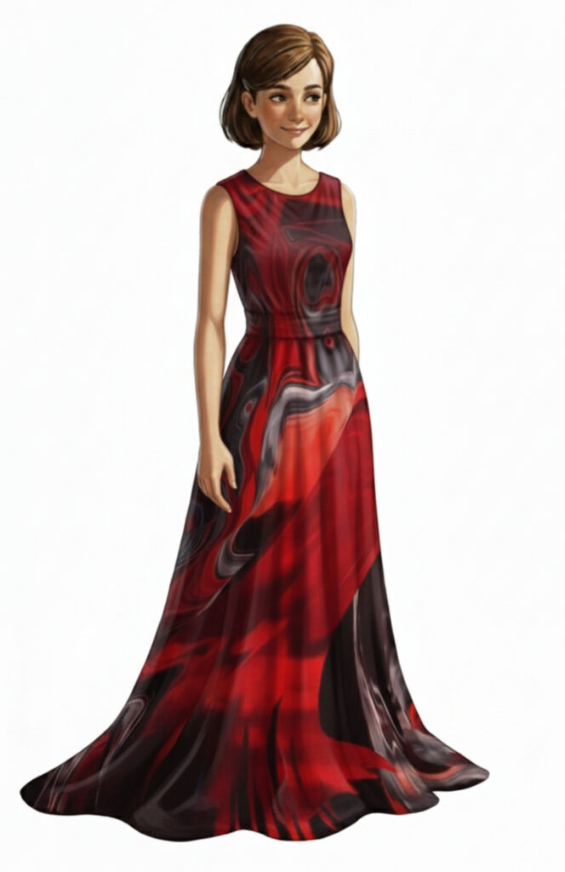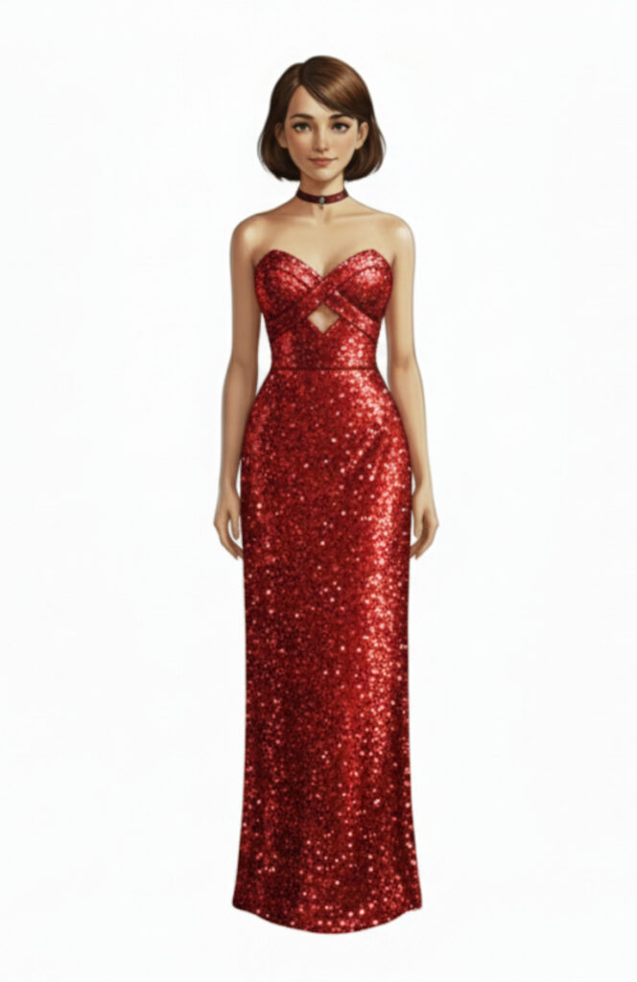
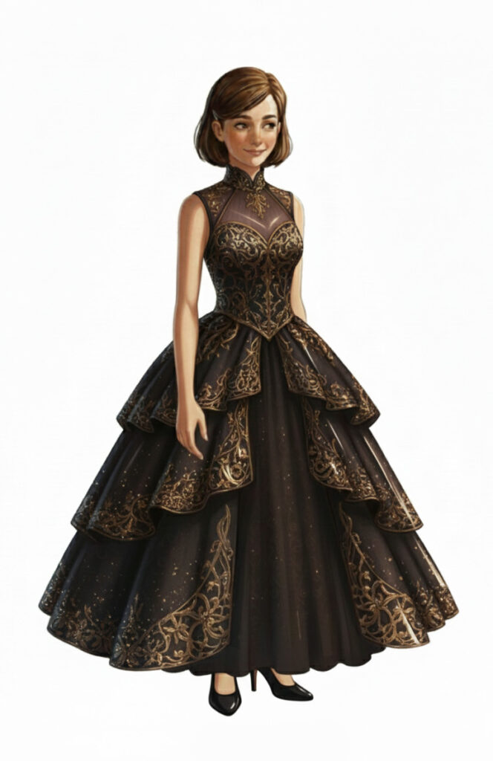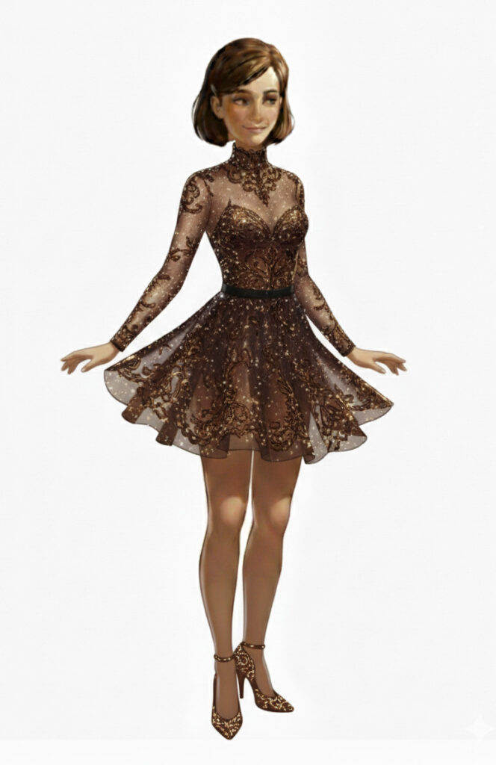

Trying some designer fashion dresses from a couple of centuries ago, and they still look as good today… Little Black Dress designs originally in the 1920s by Coco Chanel. And the Yves Saint Laurent Mondrian Collection of dresses using artwork by Piet Mondrian as inspiration and designed in 1965.
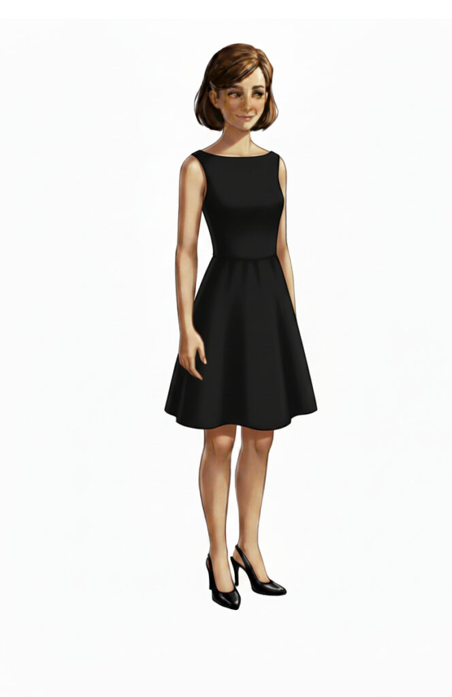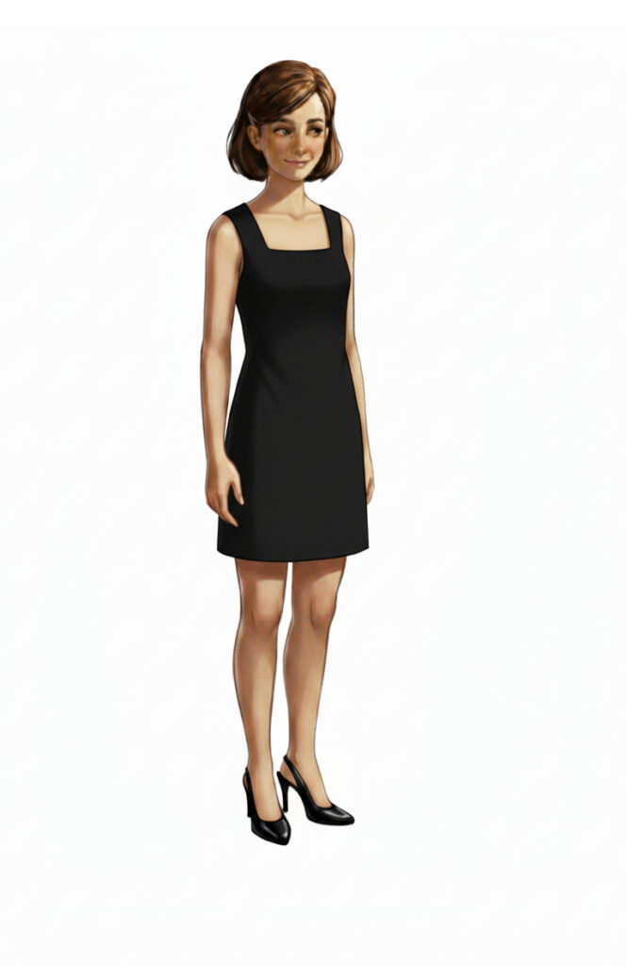
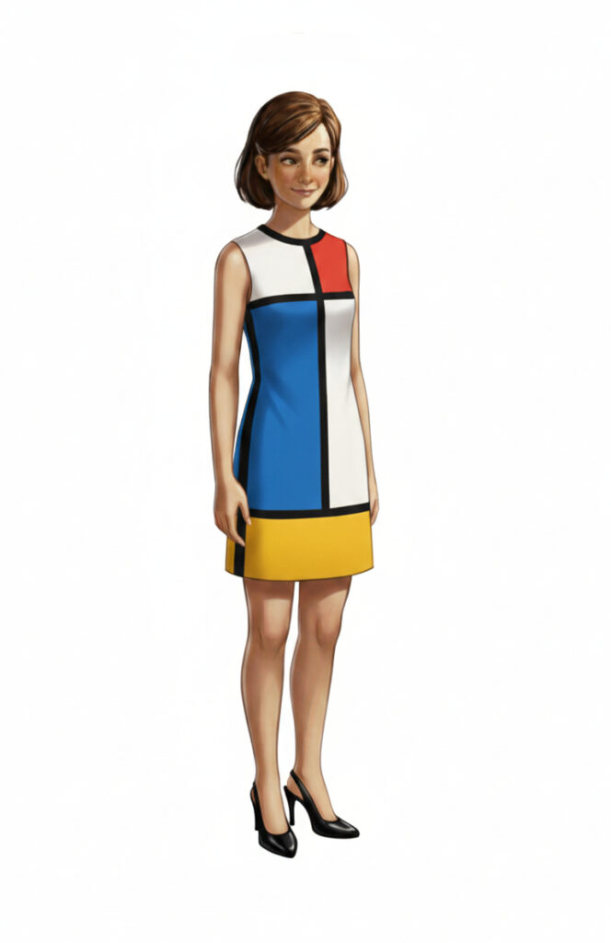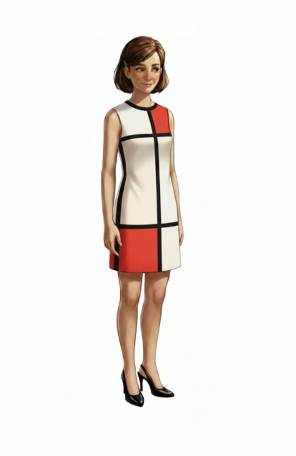
More designer dresses now from Mary Quant in the 1960s and from a design sketch by X/@rjchicago
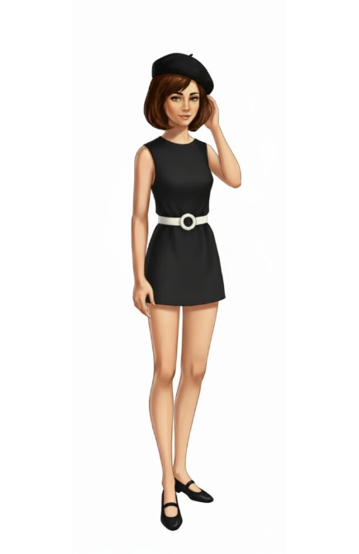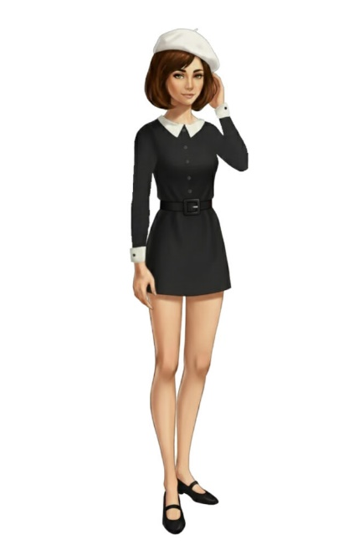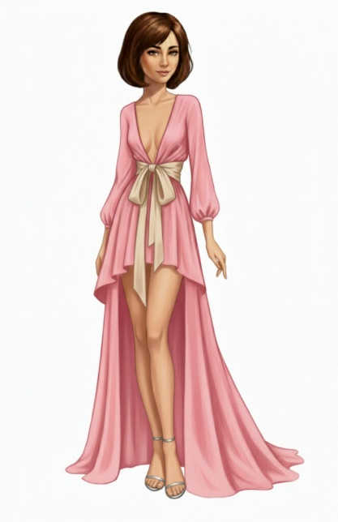

An iconic model from two centuries ago also wore timeless simple “1960s” fashion…Twiggy. Got to put on the short bob haircut cosplay wig…
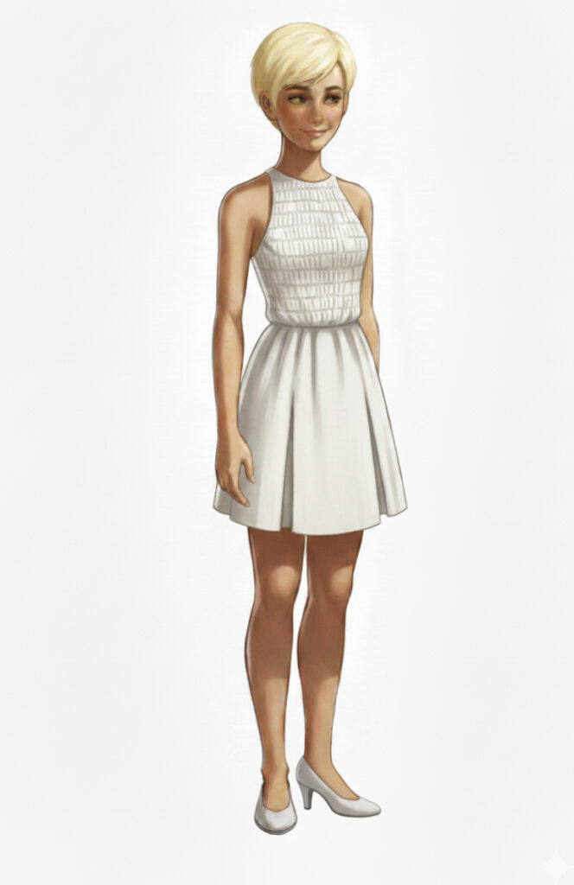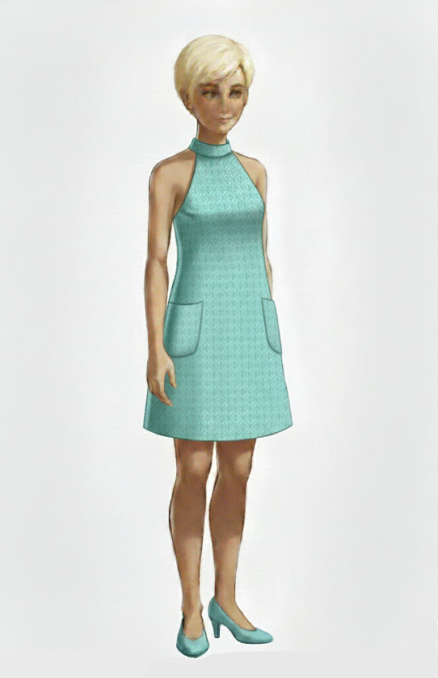

Diana Rigg, who played Mrs. Emma Peel in the Avengers TV programme in the mid 20th century, popularised 1960s Black and White Geometric Style Go-Go Dresses…
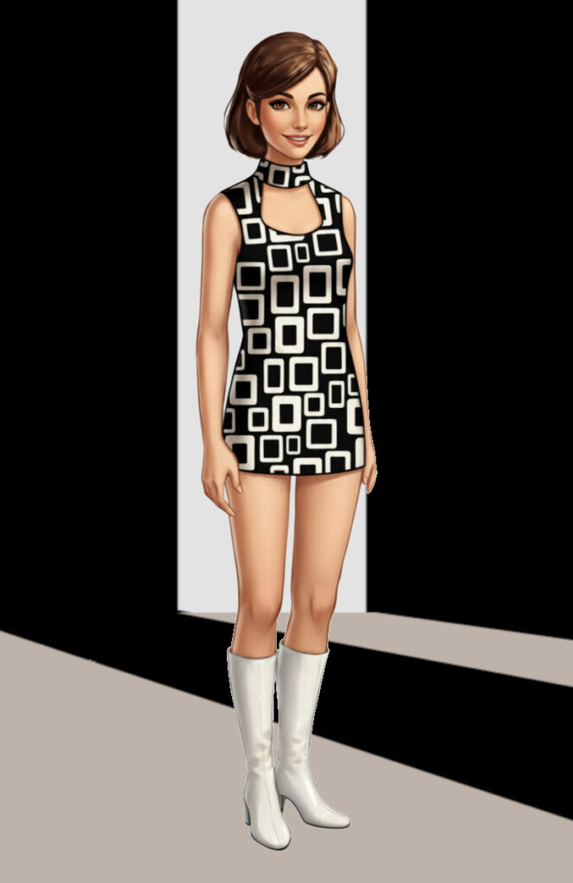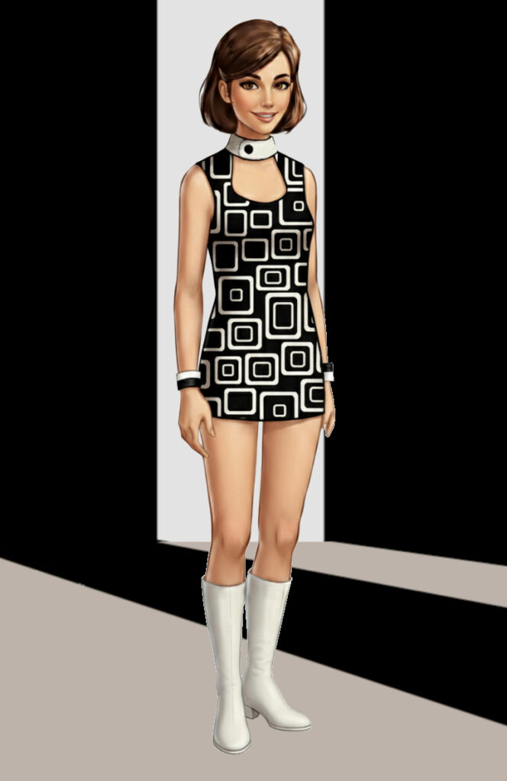
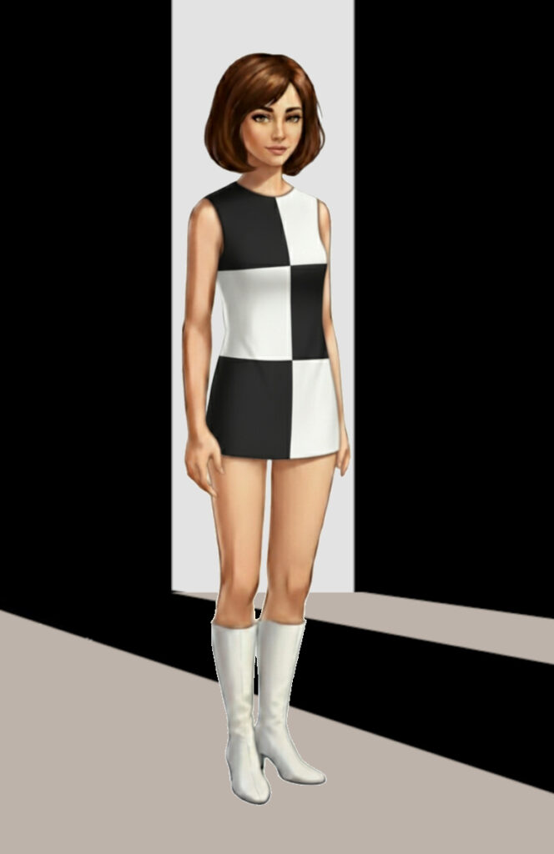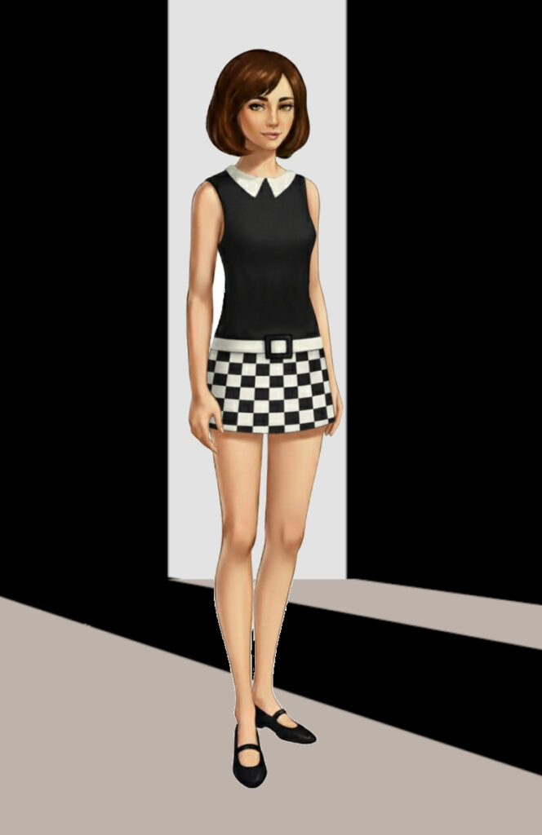

In the “Fancy Dress” theme, I tried on an “Elsa” dress from the “Frozen” films, which now are at their 18th iteration. I also took inspiration from the Art3mis character in the “Ready Player One” movie for a shiny red dress. A couple of “Star Fleet” style outfits too… which is funny when we actually live on a space station. And characters from Fireball XL5 and Stingray which are set more in our own time. I had to don a (virtual) wig (and lotus flower) for those to cosplay the characters of Fireball XL5’s Venus and Stingray’s Marina.
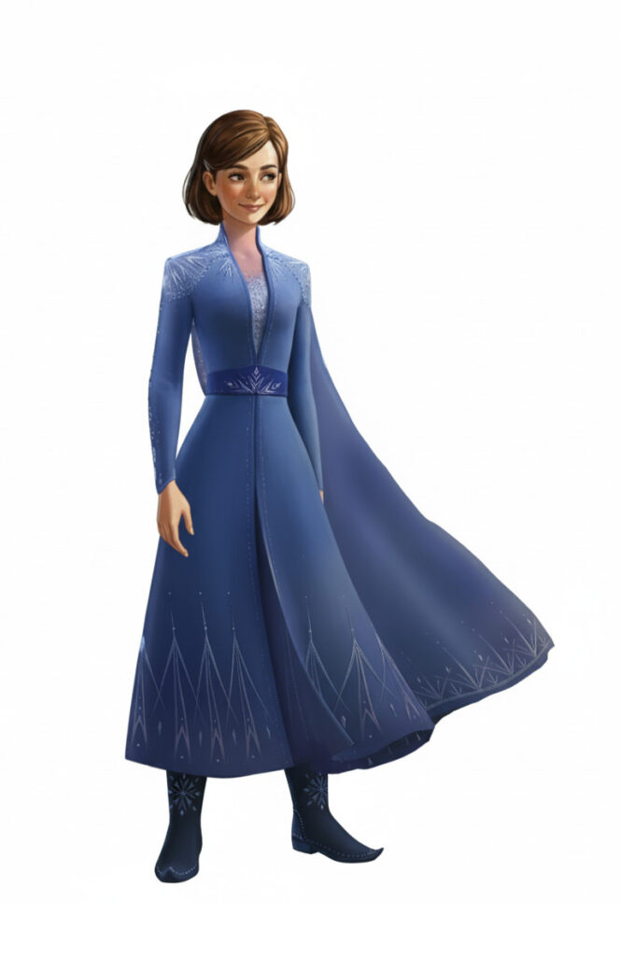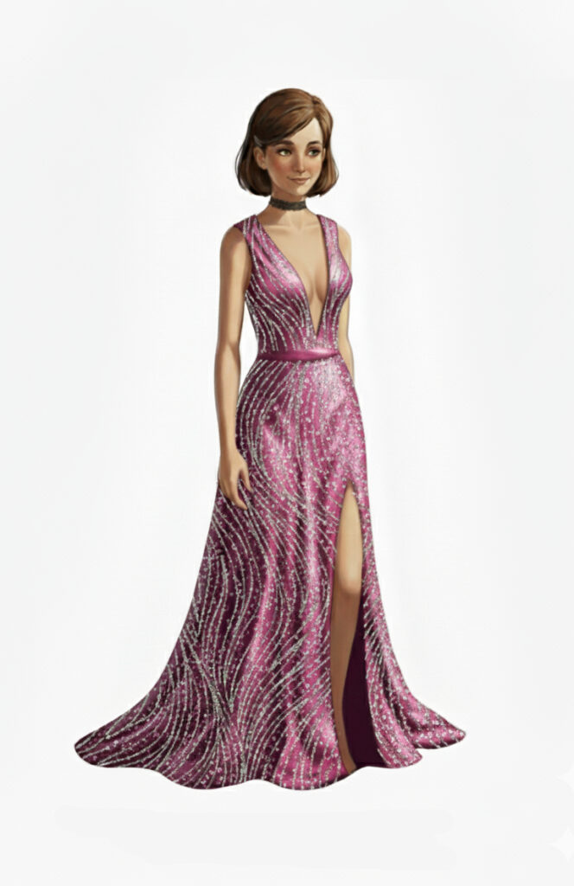
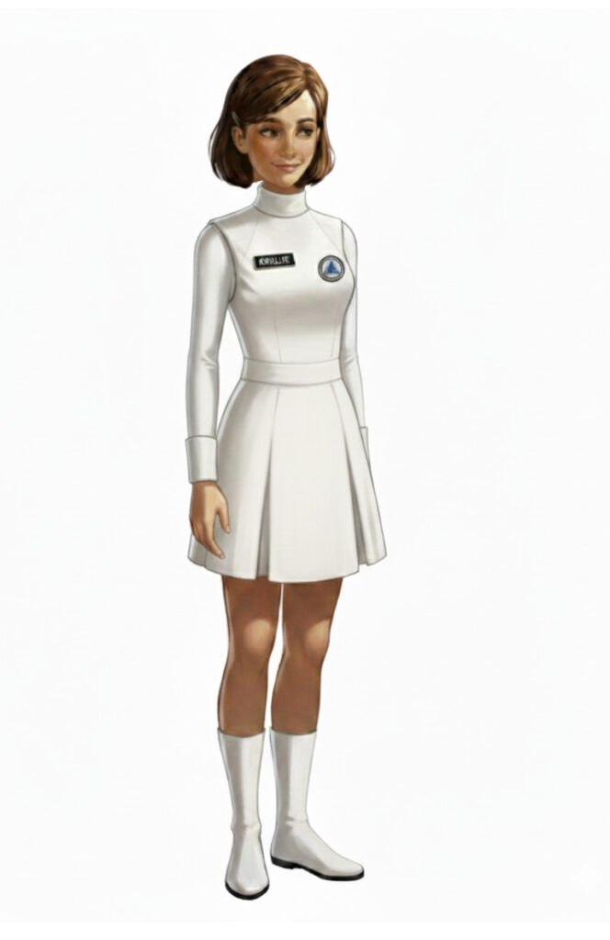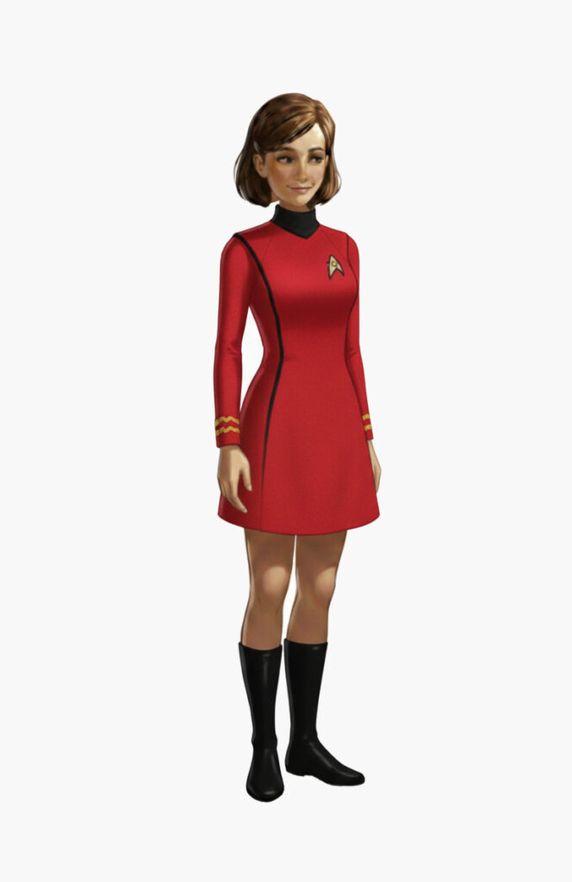

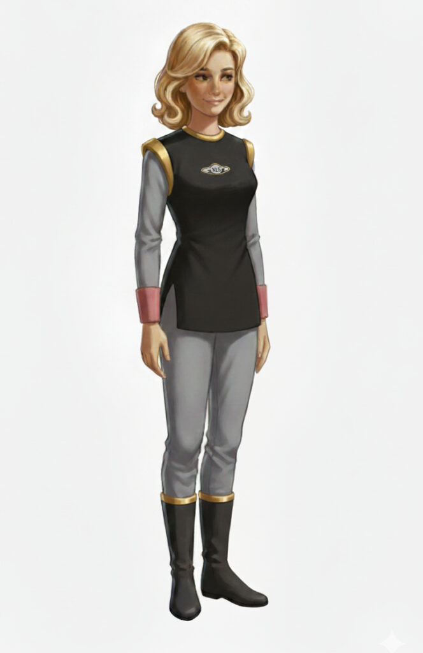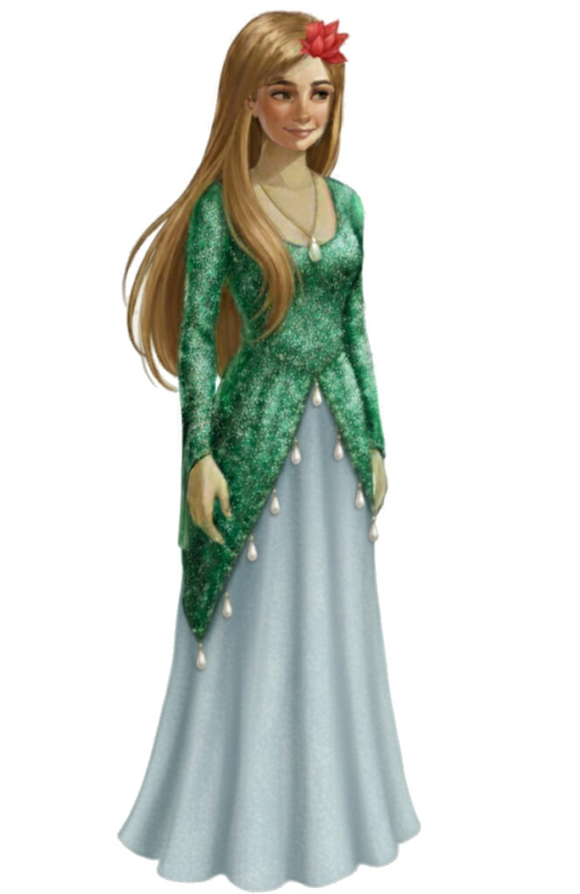

I tried the mode where you could put yourself in costume in front of a themed scenic background… how is this for a gothic dress and a Dune Desert Dweller outfit.
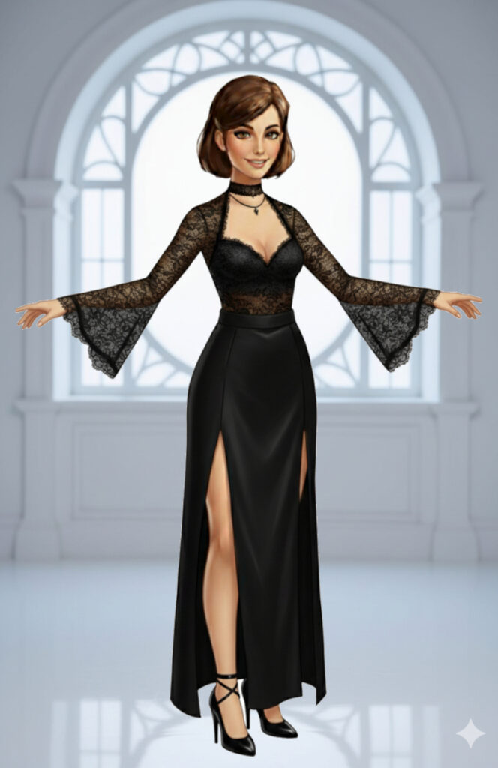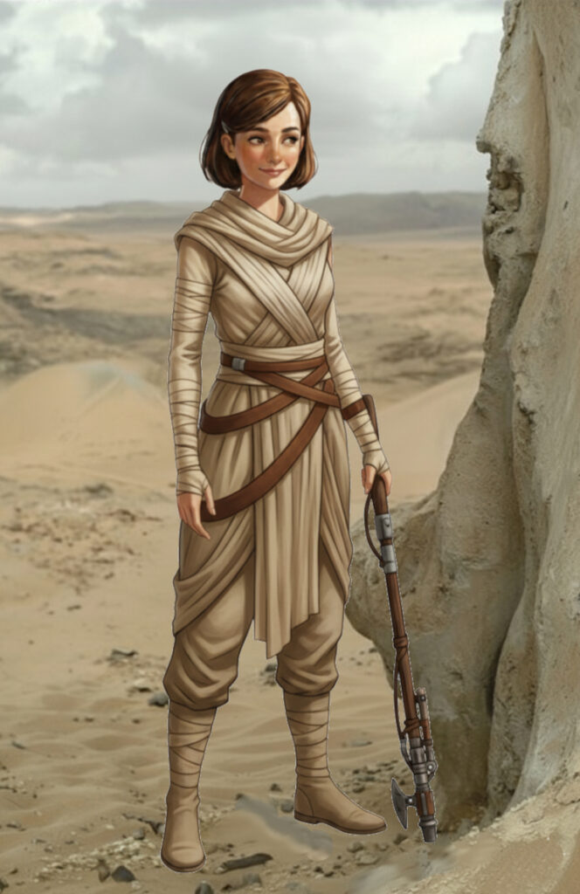

Using VR I was able to create some fashion on avatars in Ready Player Me, and then virtually try the outfits on myself…
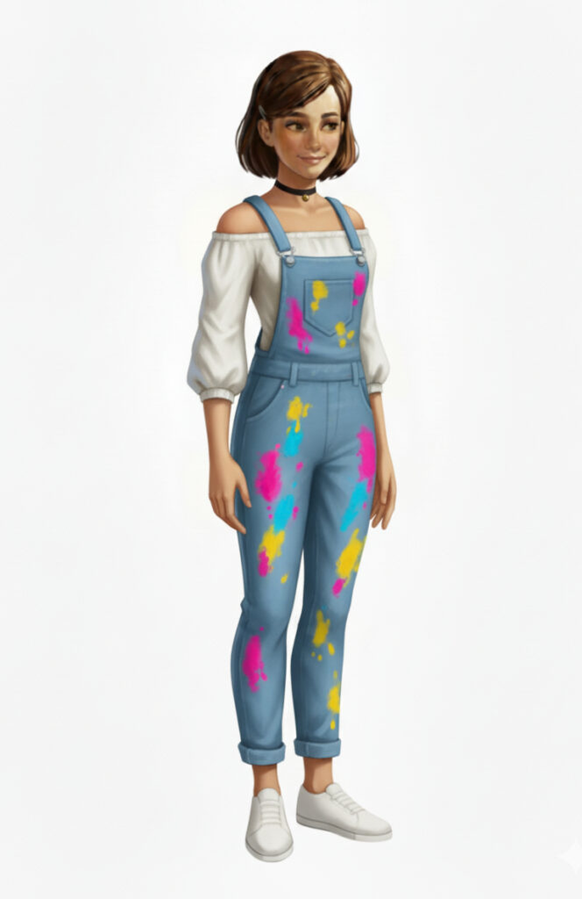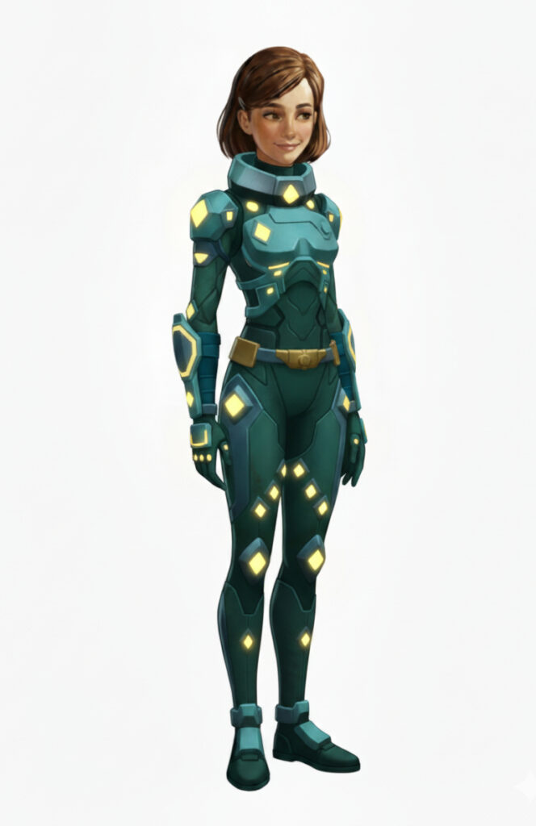

Now a couple of outfits with Kemlo. For the second outfit I asked Google Gemini to “Generate outfits for the two teenage characters that you think will best represent fashion as it could appear in the mid 22nd Century”.
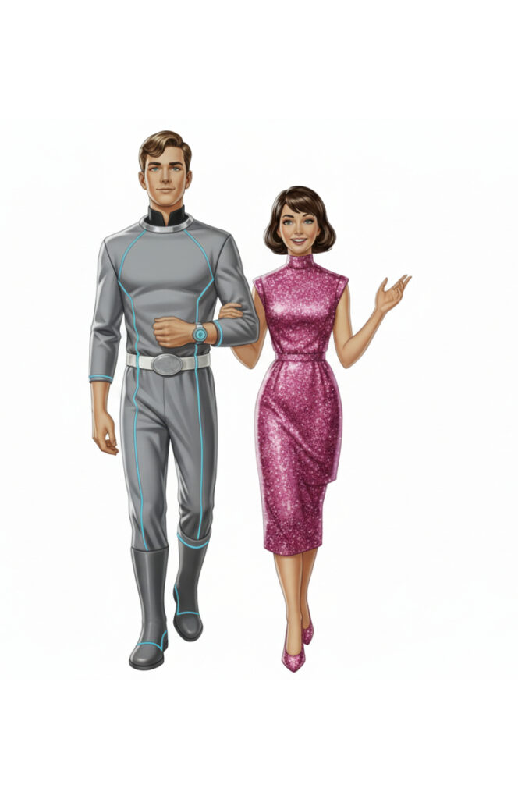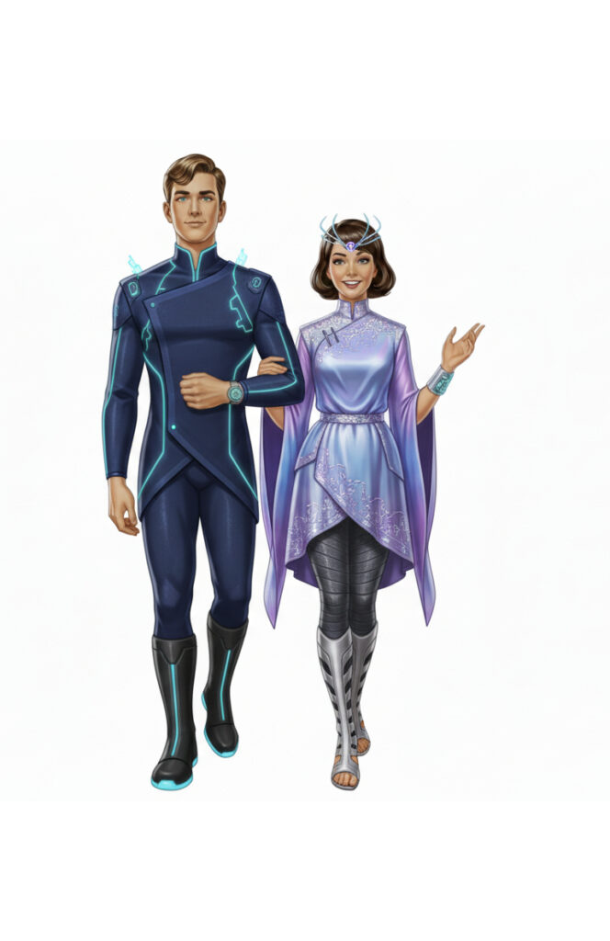

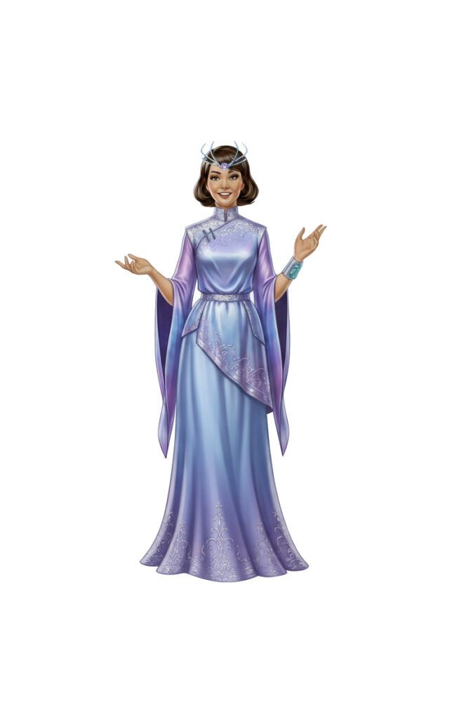
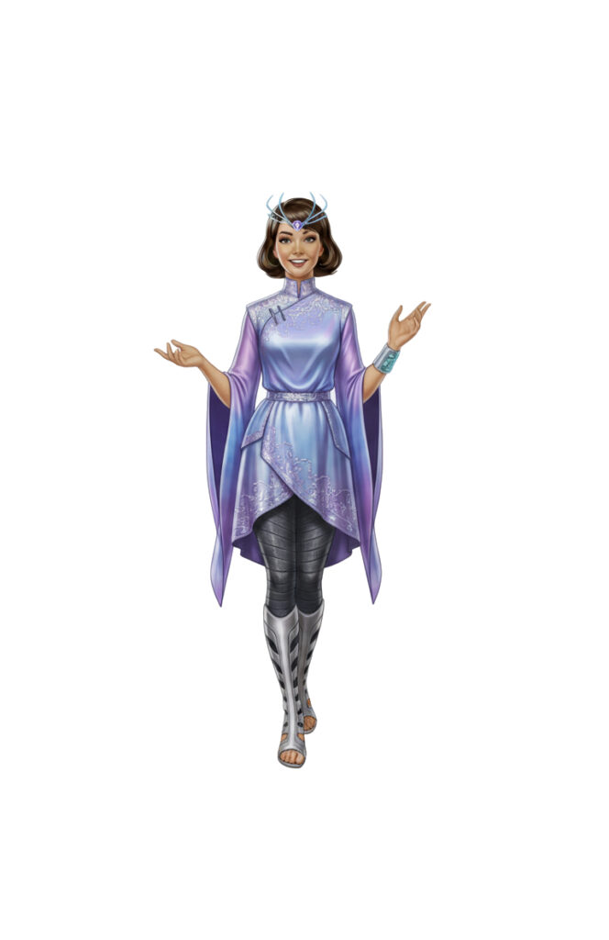

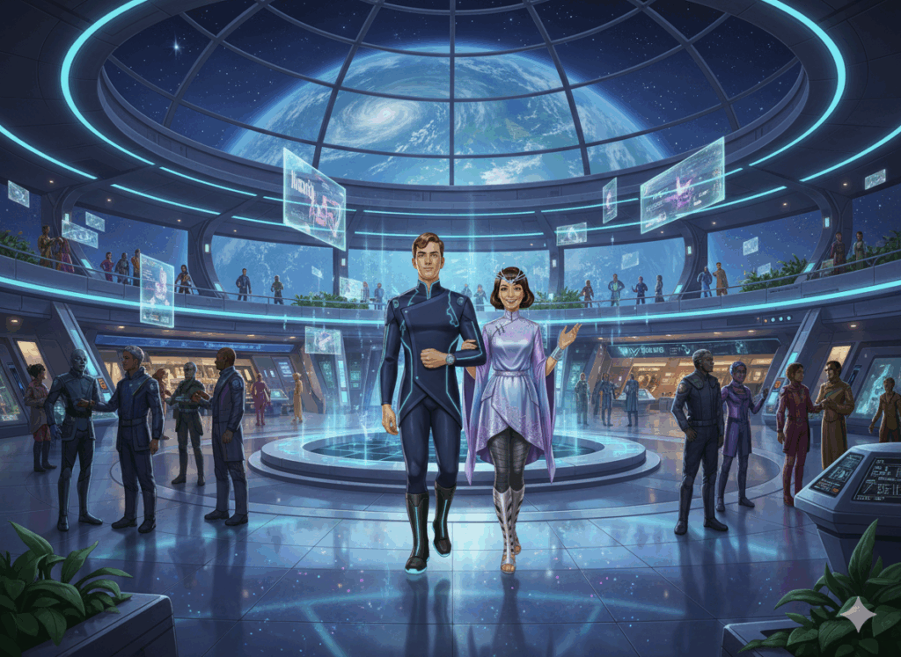Image animated by Grok (M4V) – or via https://x.com/aiaiaustin/status/1969446719222890889 or https://pic.x.com/SOT7fYALC3

