Little Green Men
Posted on September 17, 2025 by bat
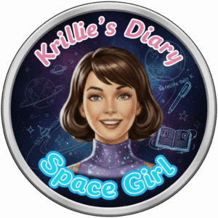
Hi, I’m Krillie. I was born in space on an Earth orbiting space station called “Satellite Belt K”. I write a diary under the moniker “Space Girl” for those interested in what is happening in space and to describe life as a Space Girl. I cover a lot of our activities, about our education and training, our living arrangements and some of our adventures. Along with my friend Kemlo, I write some of the books in “The Further Adventures of Kemlo and Krillie in Space” series. I hope my Diary is of interest to children on Earth, in the Satellite Belts and beyond.

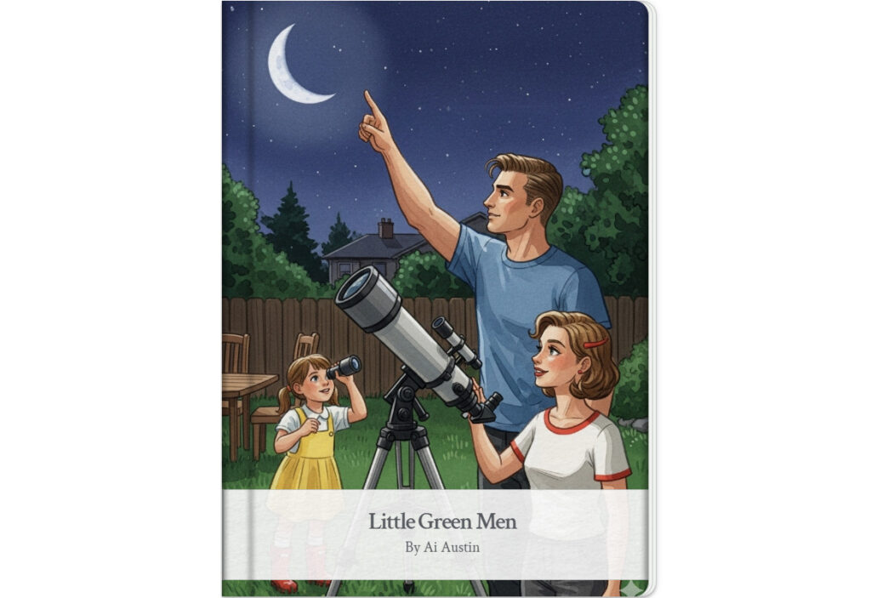
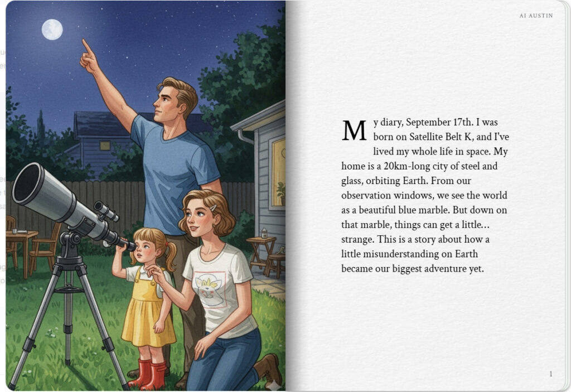
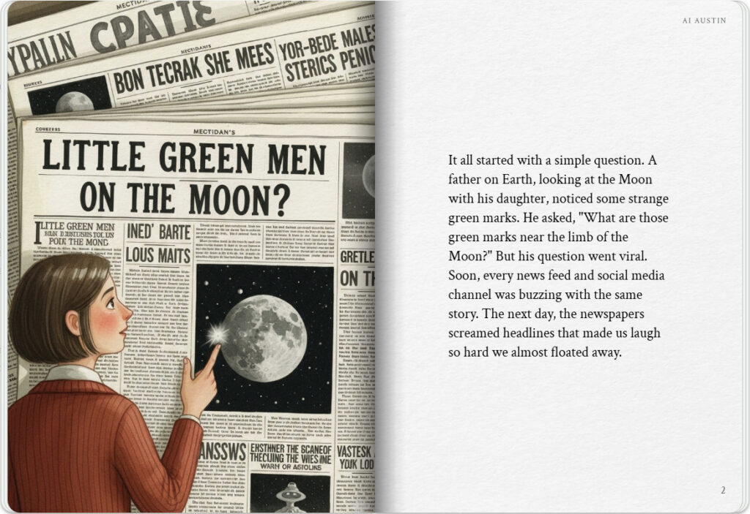

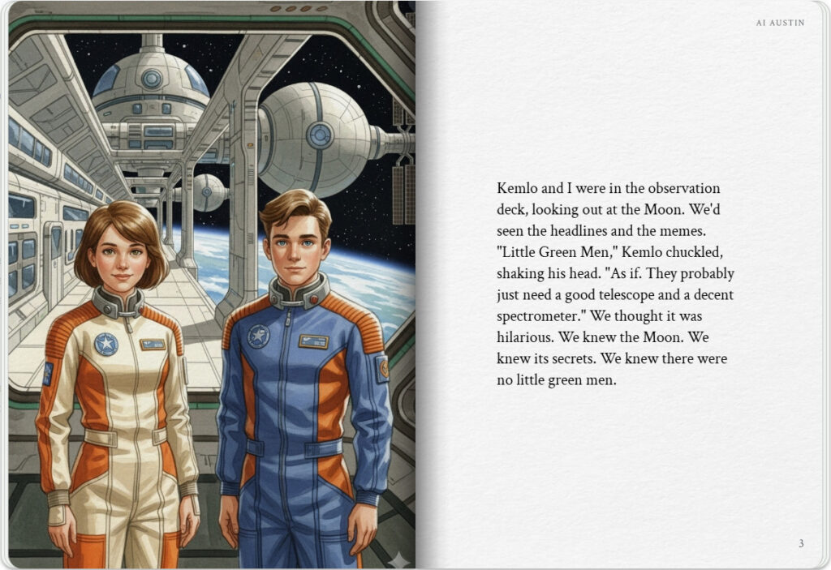
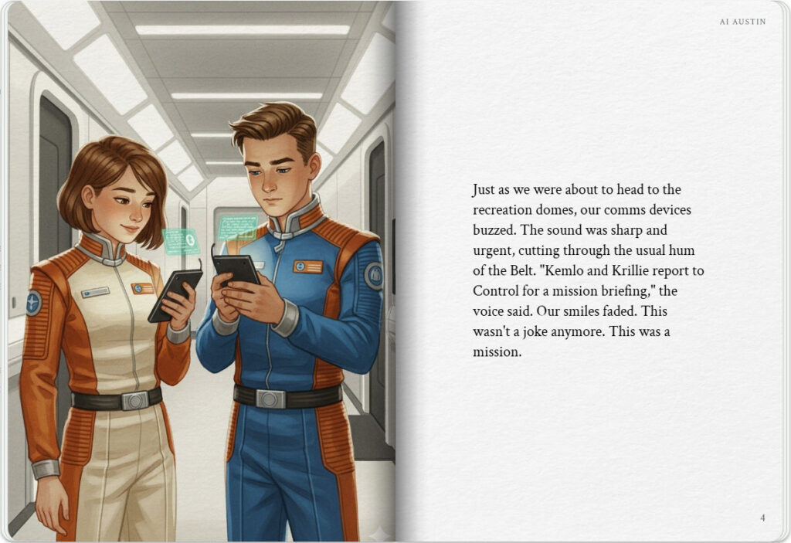

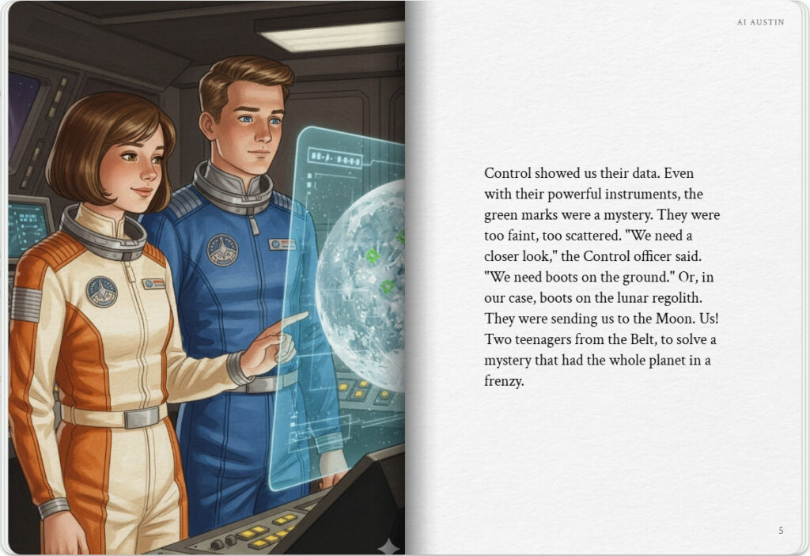
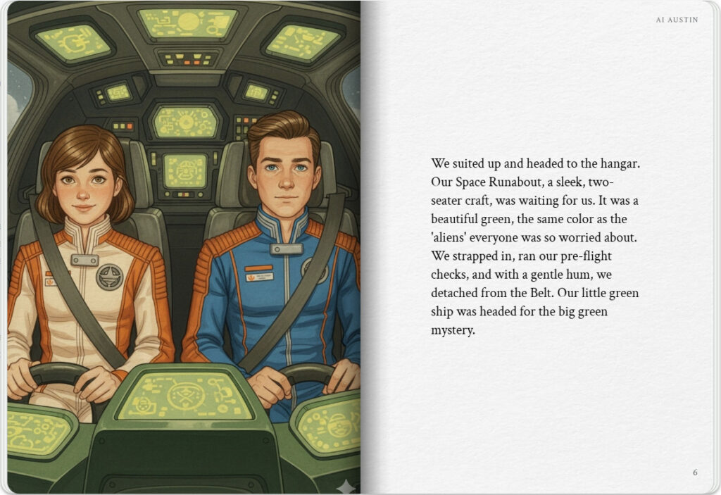

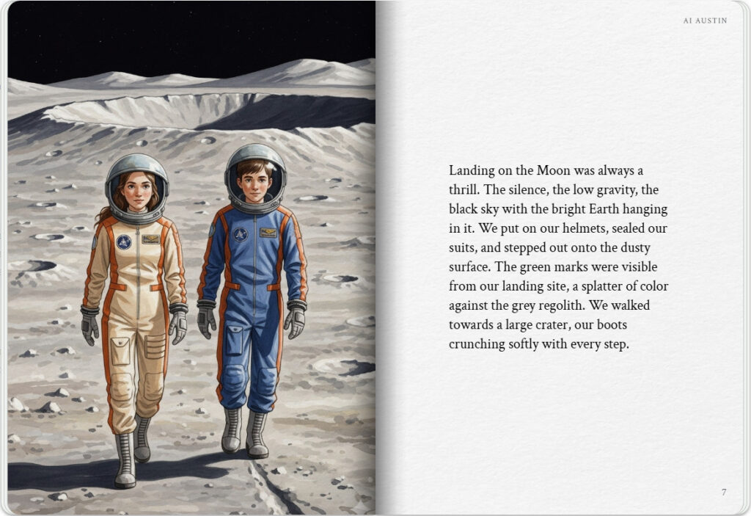
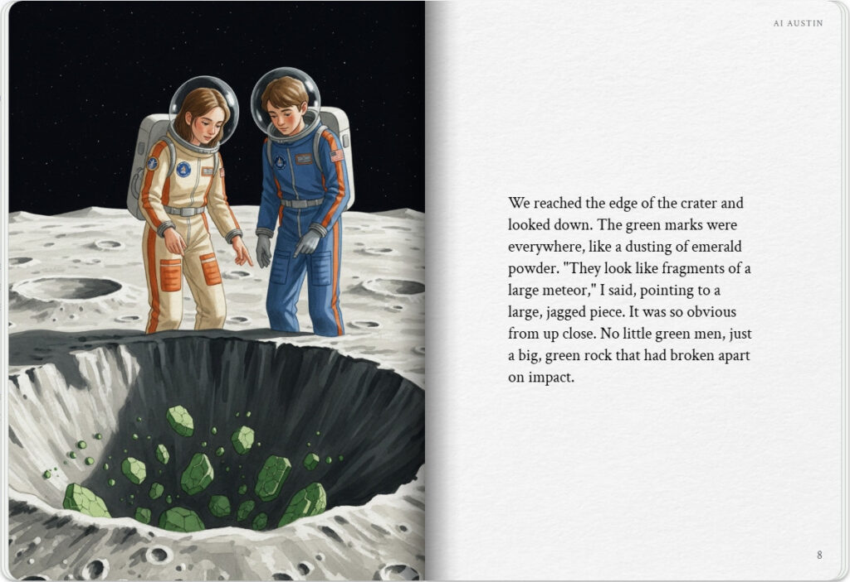

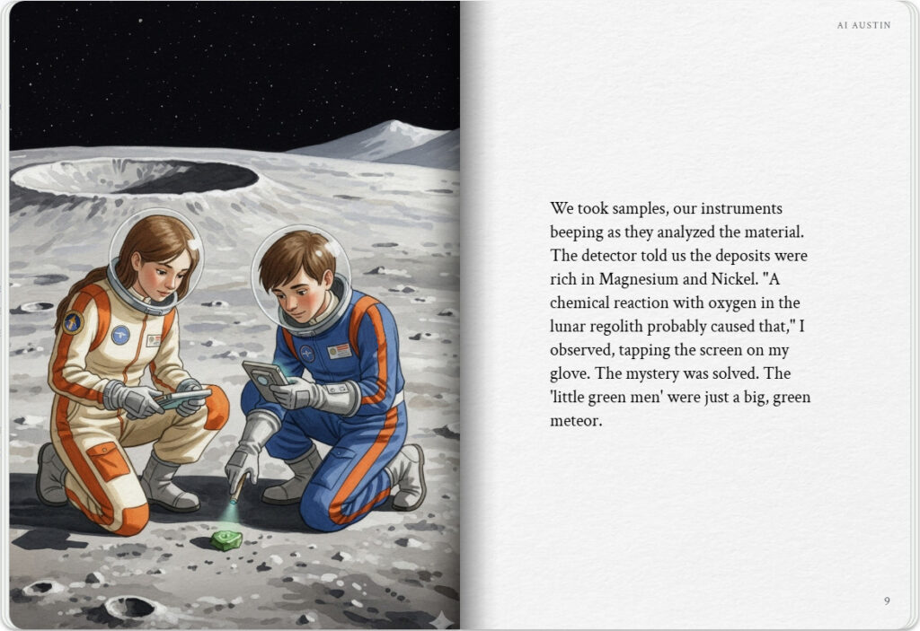
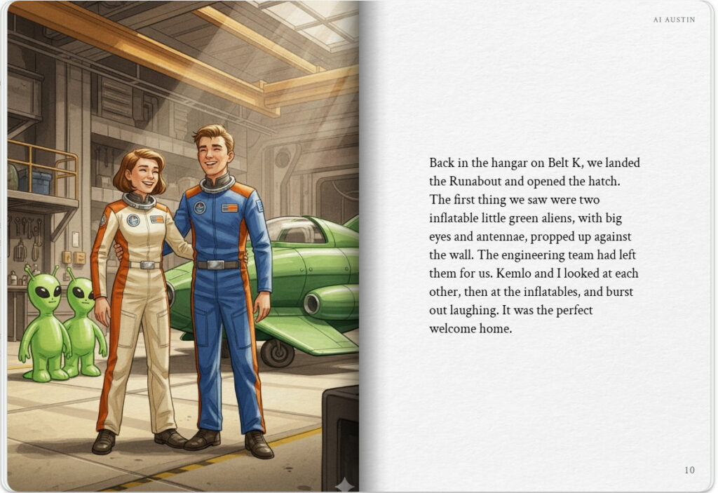

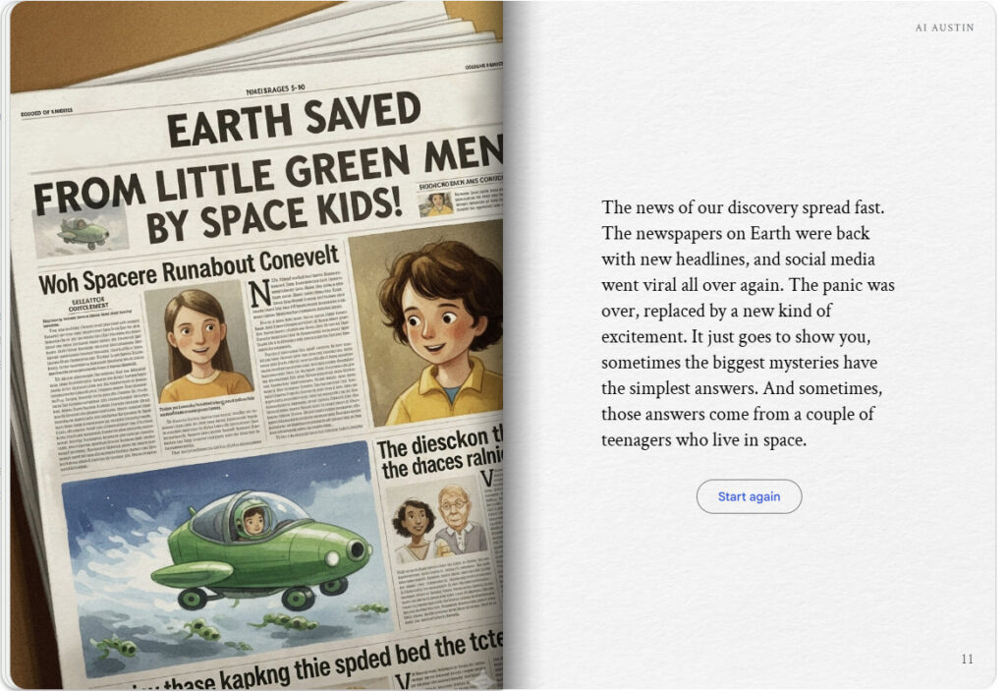
The Storybook produced is available at: https://g.co/gemini/share/3206f844b8fe [ PDF Format ] [ Separate Images ] .

Krillie’s Diary uses background created previously using AI tools based on the Kemlo Spaceworld series of books by E.C. Eliott published in 1954 to 1963. It uses the contents of this blog post: https://blog.inf.ed.ac.uk/atate/2025/09/10/kemlo-and-krillie-briefing/
Google Gemini Prompt:Create a Storybook with title “Little Green Men”. Make the story interesting to a teenage audience. Krillie is the narrator and the style is as if she is writing a diary entry or blog post. Krillie was born on Satellite Belt K and has lived all her life in space. Satellite Belt K is shown in the attached image and is an Earth orbit space habit spread over 20km including habitation, living spaces, educational areas, recreation, physical conditioning areas, manufacturing, solar power generation and storage, space agriculture and hydroponics in large domes (automatically positioned to maximise crop growing quality and time). Robotics and droids are used throughout the Belt. Use the image of Kemlo and Krillie in their space station uniforms throughout the story. Keep the style and appearance of Kemlo and Krillie the same throughout. Keep their name badges in the same place consistently. No national flags or corporate symbols should be visible throughout. When on the Moon Kemlo and Krillie must always wear their space helmets. The sky at the Moon should be black.
The story begins on Earth where a family are in their back yard at night with a telescope. The dad and mom are with their female child. The man is pointing at the Moon and the child is looking through the telescope. The man asks “What are those green marks near the limb of the Moon”? This should be the cover illustration.
Lots of stories start to circulate on social media as many other observers see these green marks on the Moon. The very next day the newspapers are covered with front page headlines…. “LITTLE GREEN MEN ON THE MOON?” Speculation on Earth goes wild. Please make sure images of newspapers with this headline appear in the illustration.
Meanwhile on Satellite Belt K in Earth orbit Kemlo and Krillie are looking out through a large observation window towards the Moon. They have seen the stories and been amused by them. But a call comes through on their comms devices from Belt K Control – “Kemlo and Krillie report to Control for a mission briefing”.
Belt K Control have also seen the green marks through their much more powerful telescopes and instruments. But even unobstructed by the Earth’s atmosphere the observations are inconclusive. Control asks Kemlo and Krillie to investigate.
Kemlo and Krille depart from Satellite Belt K in their two seater green Space Runabout spacecraft headed towards the Moon.
Kemlo and Krille land on the Moon near where the green objects have been seen. They don their full spacesuits with globe helmets and walk across to a side of a large crater to look at the splatter of green marks.
Krillie says that they look like fragments of a large meteor.
So they take samples and their detector tells them the deposits are Magnesium or Nickel rich. She observes that a chemical reaction with oxygen in the Lunar Regolith probably caused that.
Kemlo and Krille take samples to report back to Belt K Control and for further analysis.
Kemlo and Krillie land back in the Satellite Belt K hanger and laugh out loud as they see that inflatable little green aliens inflatables have been put there by the spacecraft engineering team.
Finally, back on Earth, the newspapers are rolling once again and social media is going viral. Please make sure the final illustration in the story again has a similar newspaper headline style image to that shown near the start, with the headline “EARTH SAVED FROM LITTLE GREEN MEN BY SPACE KIDS!”

Note: version for editing (needs Ai Austin author login) is here (Development Notes).

