Fancy Dress
Posted on September 16, 2025 by bat
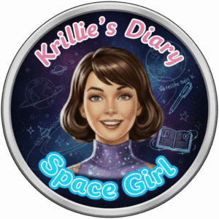
Hi, I’m Krillie. I was born in space on an Earth orbiting space station called “Satellite Belt K”. I write a diary under the moniker “Space Girl” for those interested in what is happening in space and to describe life as a Space Girl. I cover a lot of our activities, about our education and training, our living arrangements and some of our adventures. Along with my friend Kemlo, I write some of the books in “The Further Adventures of Kemlo and Krillie in Space” series. I hope my Diary is of interest to children on Earth, in the Satellite Belts and beyond.

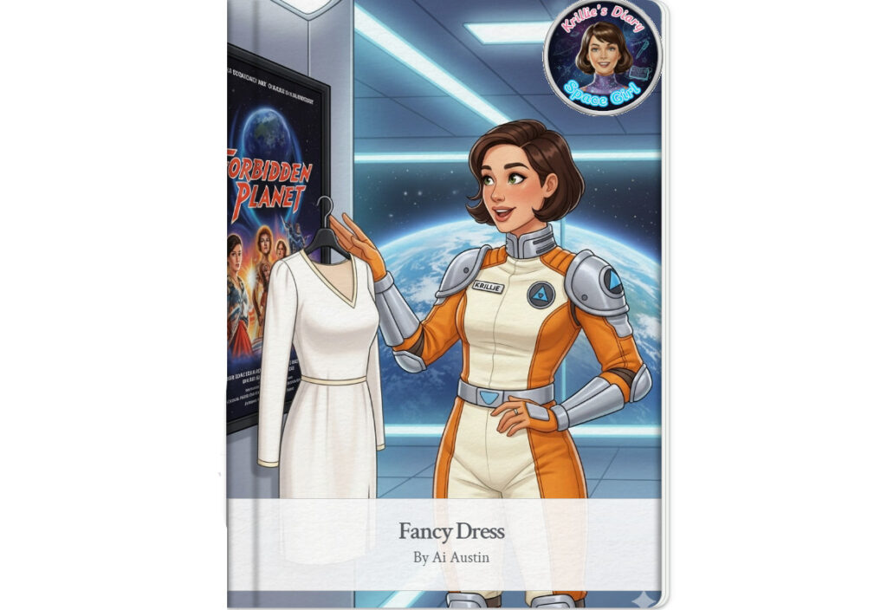
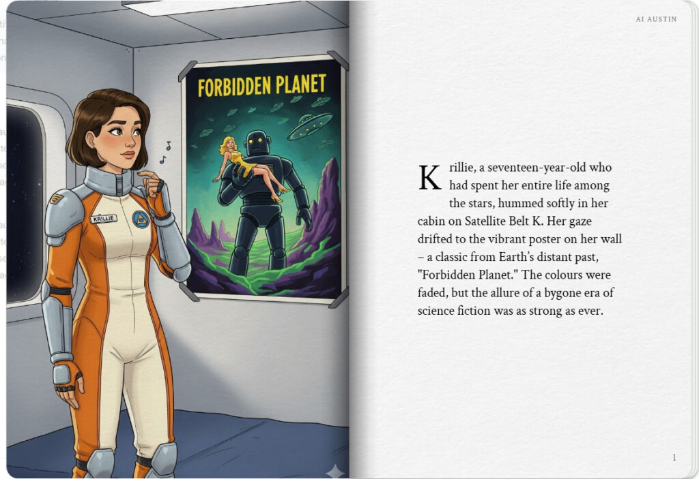
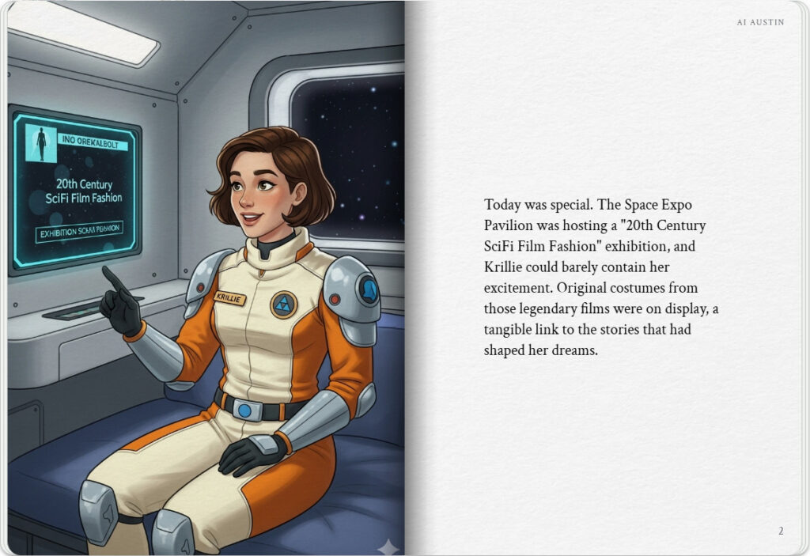

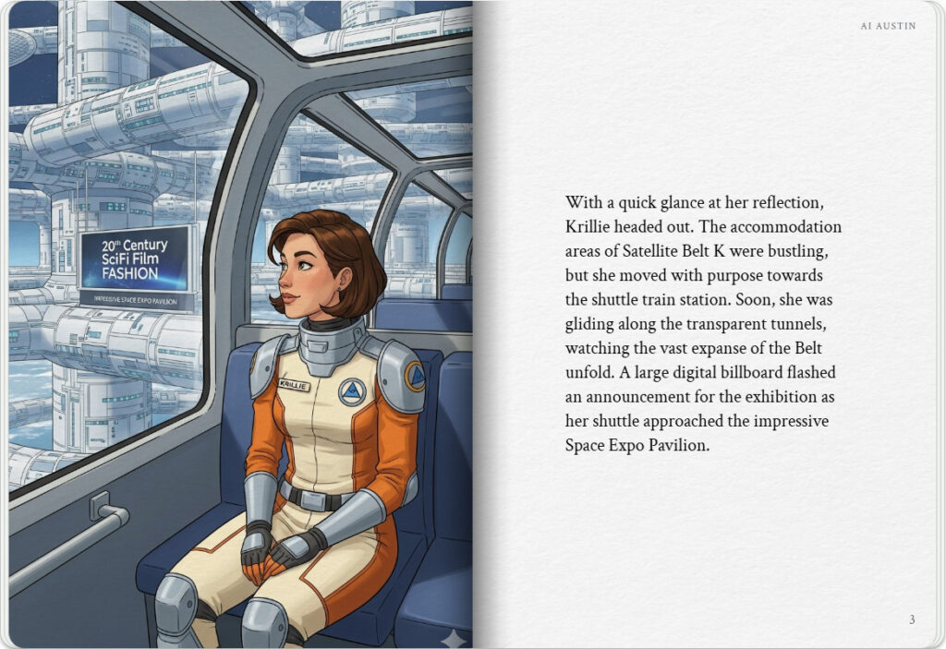
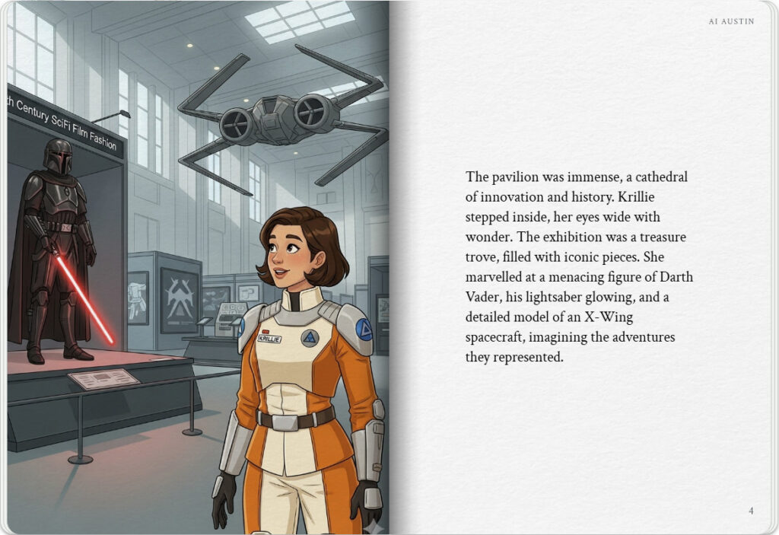

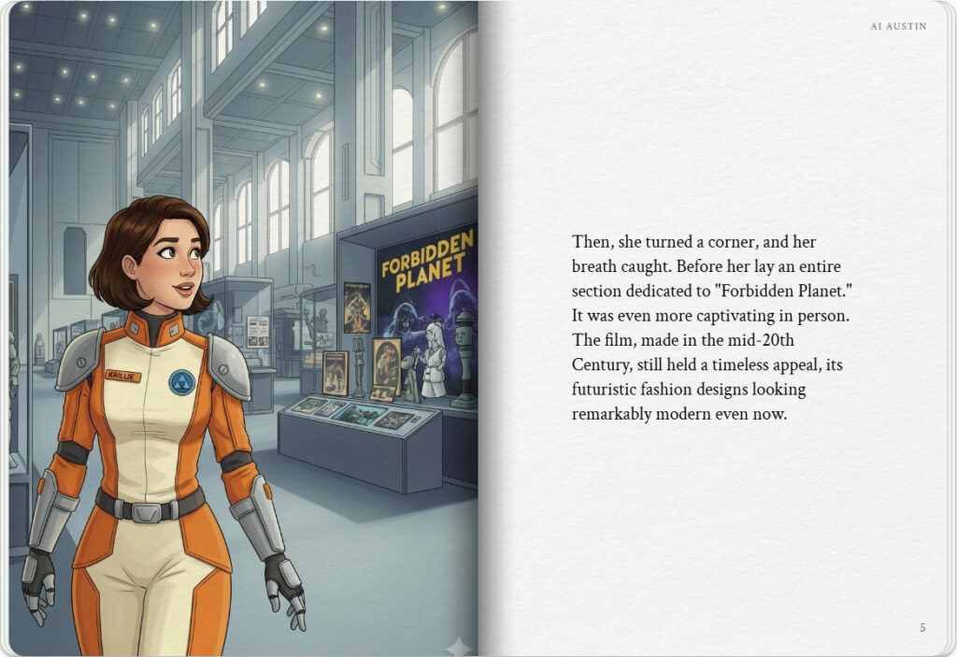
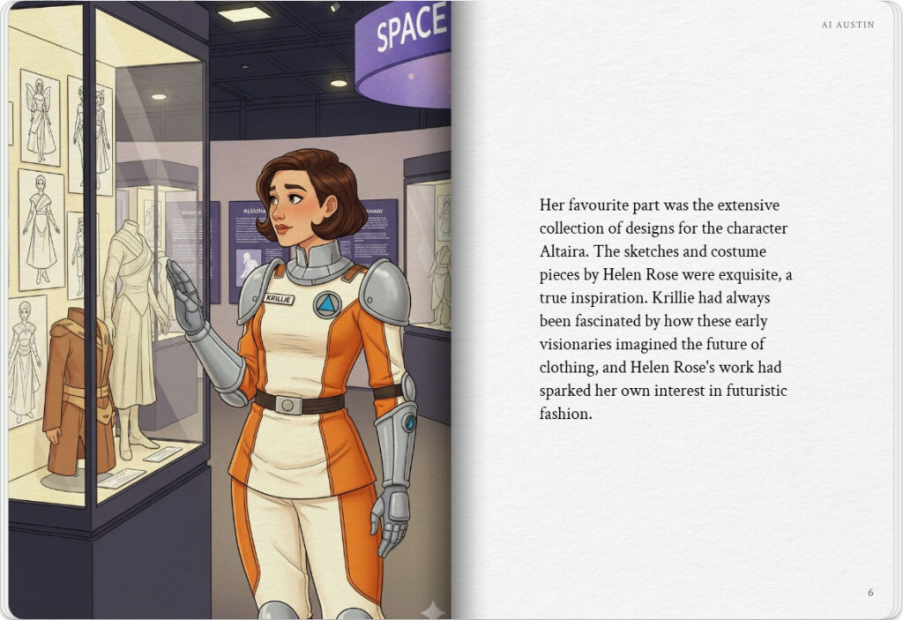

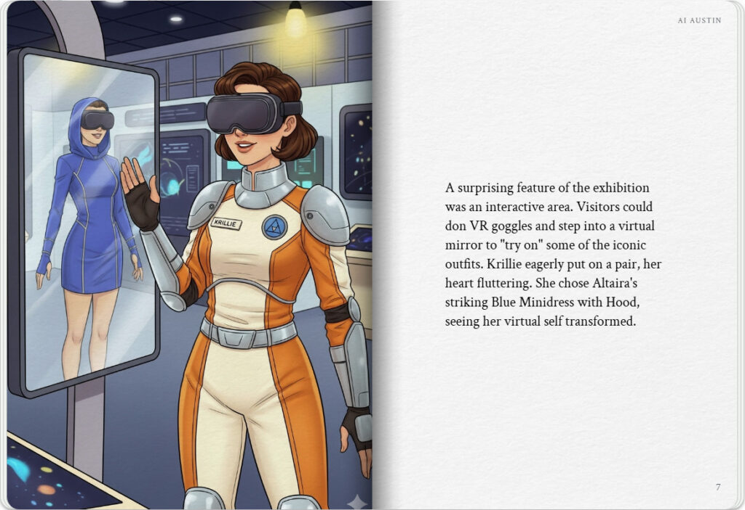
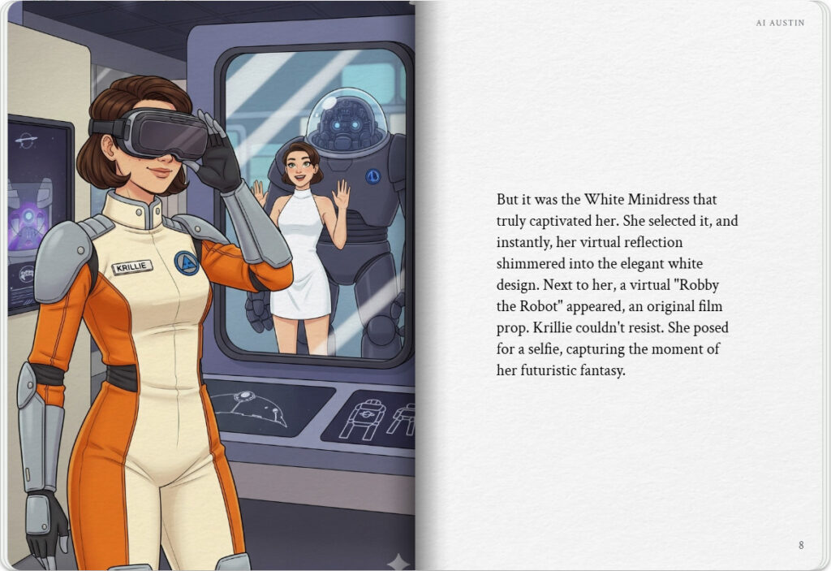

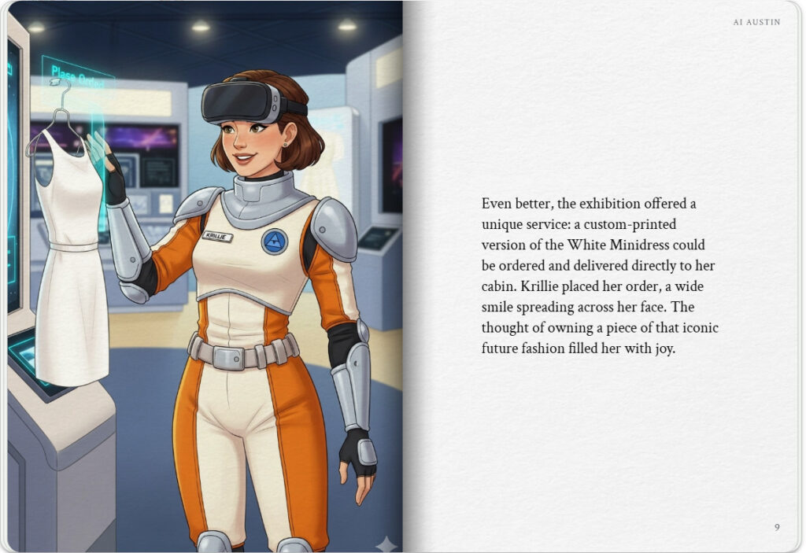
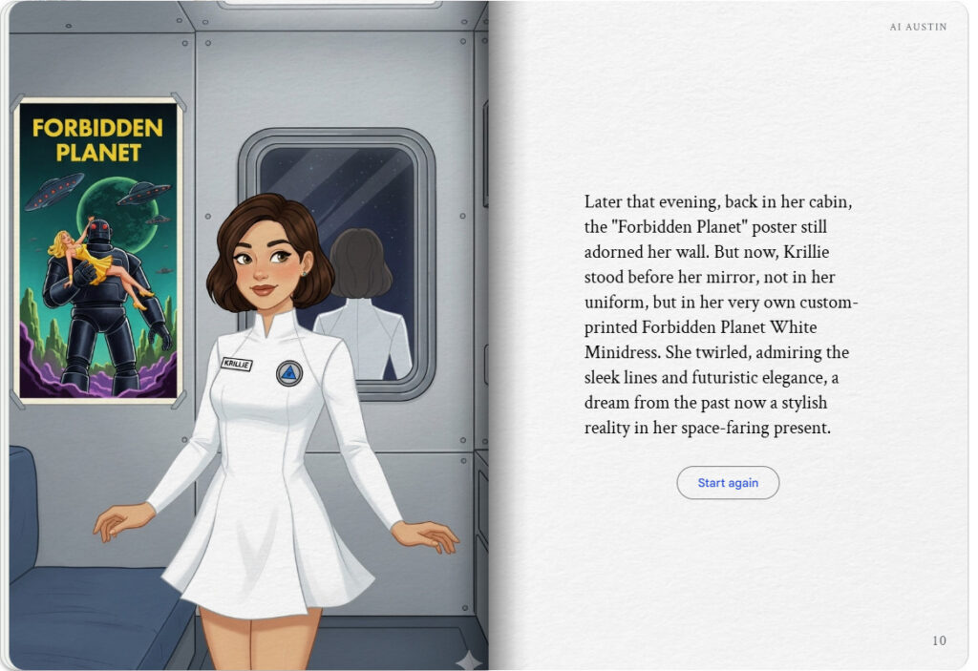

The Storybook produced is available at: https://g.co/gemini/share/249c26806457 [ PDF Format ] [ Separate Images ] .

I just love the style of the costumes in the old SciFi films, so after I got back from the 20th Century SciFi Film at the Expo Pavilion, I used my VR Headset to see how I would look in a range of the old costume designs, many still look very modern…
Star Wars (as Princess Leia and as Rey)
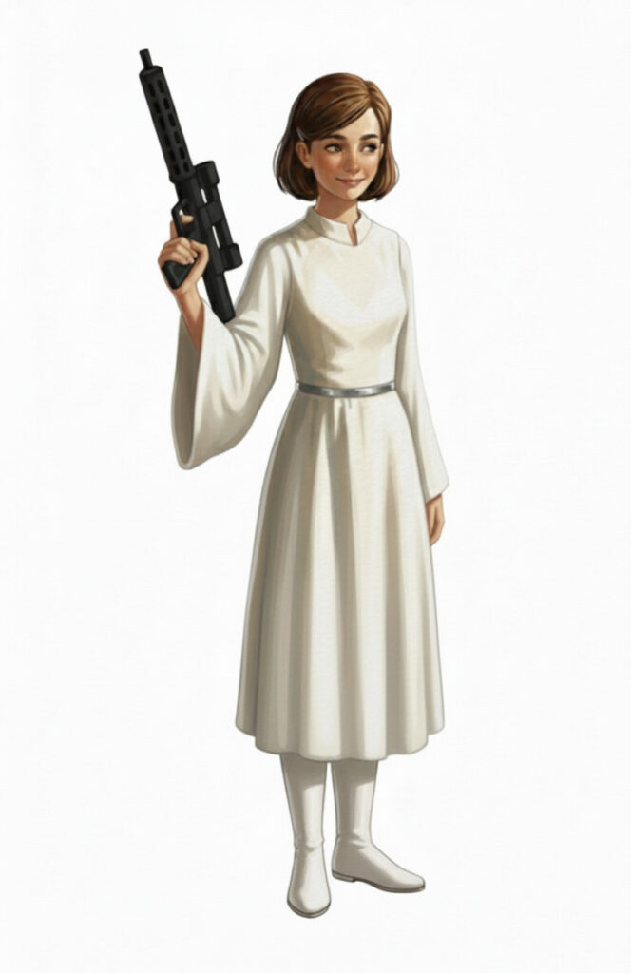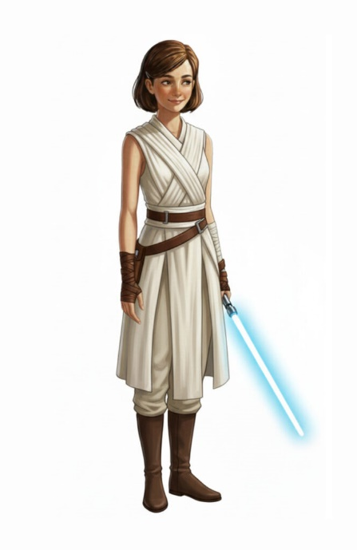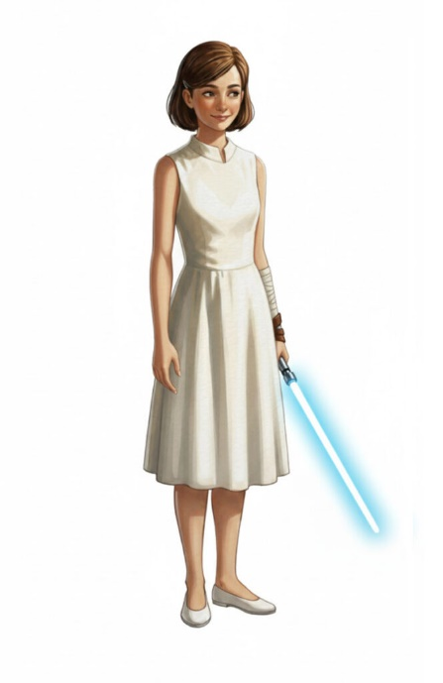

Forbidden Planet (as Altaira with Robby the Robot)
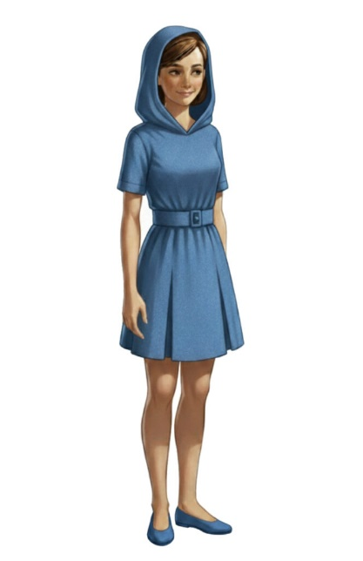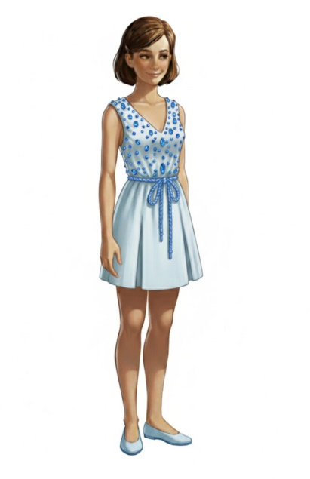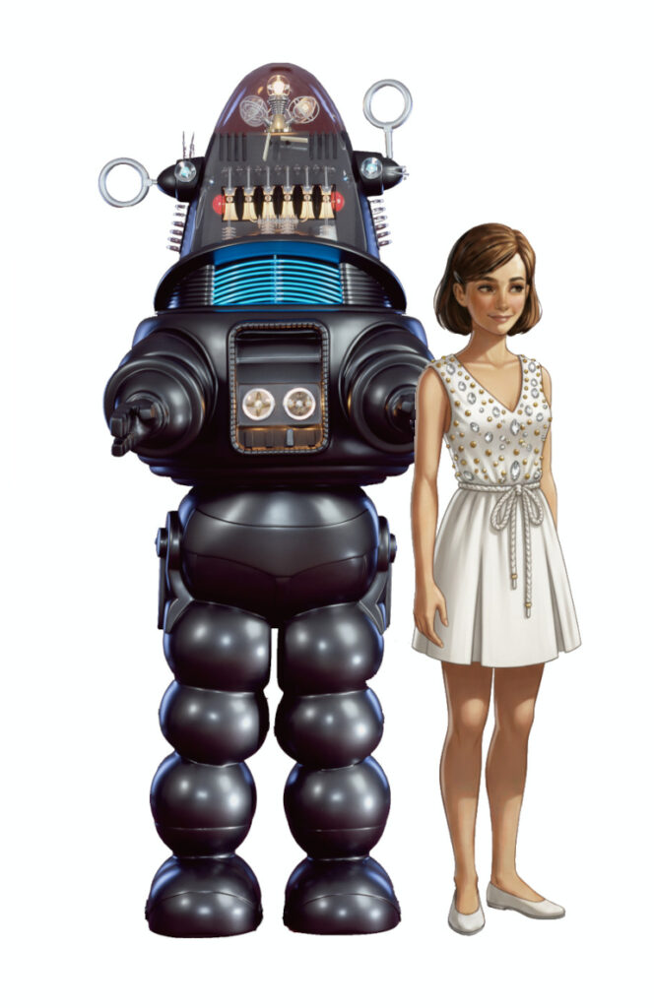

Miniature Figurine
As a follow up to the “20th Century SciFi Film Fashion” exposition you could also order a figurine dressed in one of the outfits and standing alongside “Robby the Robot”…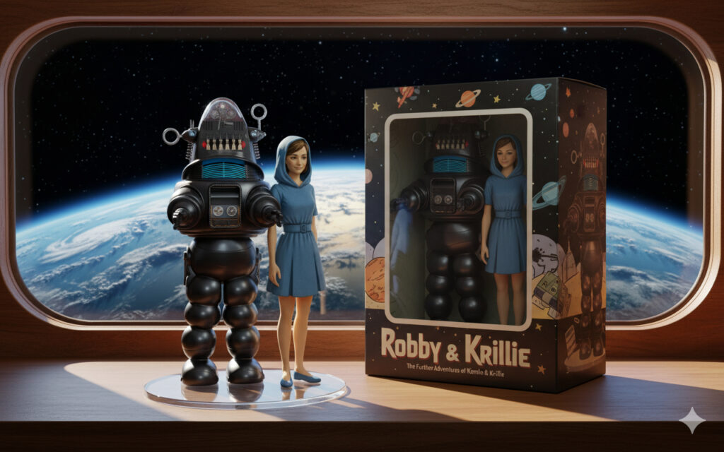

Krillie’s Diary uses background created previously using AI tools based on the Kemlo Spaceworld series of books by E.C. Eliott published in 1954 to 1963. It uses the contents of this blog post: https://blog.inf.ed.ac.uk/atate/2025/09/10/kemlo-and-krillie-briefing/
Google Gemini Prompt:Create a Storybook with title “Fancy Dress”. Make the story interesting to a teenage audience. Krillie is 17 years old and was born on Satellite Belt K. She has lived all her life in space. Satellite Belt K is shown in the attached image and is an Earth orbit space habit spread over 20km including habitation, living spaces, educational areas, recreation, physical conditioning areas, manufacturing, solar power generation and storage, space agriculture and hydroponics in large domes (automatically positioned to maximise crop growing quality and time). Robotics and droids are used throughout the Belt. Use the image of Krillie in her cream and orange space station uniform to start the story. Keep the style and appearance of Krillie the same throughout. Use KRILLIE on her name badge in the same place consistently. No national flags or corporate symbols should be visible throughout.
Krillie is in her cabin on Satellite Belt K in Earth orbit. Krillie is looking at a poster for the movie “Forbidden Plant” on her cabin wall.
There is an exhibition of “20th Century SciFi Film Fashion” at the Belt K Space Expo Pavilion” and Krillie is excited that some of the original costumes from early SciFi films is part of the current exhibition.
Krillie takes a shuttle train from the Belt K Accommodation Area to the large and impressive “Space Expo Pavilion” seeing the announcement of the “20th Century SciFi Film Fashion” as she approaches.
Krillie looks round the exhibition seeing many wonderful and original exhibits from films such as Star Wars (with Darth Vader figure with light sabre and X-Wing spacecraft),
Krillie turns a corner and is thrilled to see the large area of “Forbidden Planet” film memorabilia. The film was made in the middle of the 20th Century and the fashion still looks so modern.
There is an entire area showing designs for the “Forbidden Planet” movie character “Altaira”. Krille particularly loves the designs for the film by “Helen Rose” as they inspired her interest in futuristic fashion.
But a big surprise is that there is an area where exhibition visitors can use VR Goggles and look into a virtual mirror to “try on” some of the outfits. So Krille takes the opportunity to do that. She wears Altaira’s Blue Minidress with Hood.
But she is particularly impressed with trying on Altair’s White Minidress and stands virtually next to the “Robby the Robot” original film prop to pose for a selfie.
She is even more happy that it is possible to order a custom printed version of the White Minidress to be delivered back to her cabin.
Finally, Krillie is back in her cabin. The Forbidden Planet poster is still on the cabin wall, but now Krillie wears her Forbidden Planet White Minidress and admires how it looks on herself in the mirror.

Note: version for editing (needs Be Austin author login) is here (Development Notes).

