The Ever-Learning Belt
Posted on September 16, 2025 by bat
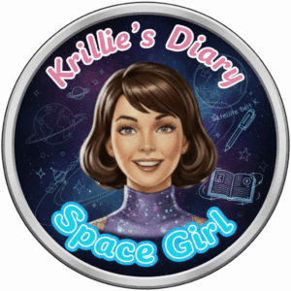
Hi, I’m Krillie. I was born in space on an Earth orbiting space station called “Satellite Belt K”. I write a diary under the moniker “Space Girl” for those interested in what is happening in space and to describe life as a Space Girl. I cover a lot of our activities, about our education and training, our living arrangements and some of our adventures. Along with my friend Kemlo, I write some of the books in “The Further Adventures of Kemlo and Krillie in Space” series. I hope my Diary is of interest to children on Earth, in the Satellite Belts and beyond.

The following are extracts from https://blog.inf.ed.ac.uk/atate/2025/09/10/kemlo-and-krillie-briefing/
Education – Space-born children begin their education and practice simulated space operations very early. Classrooms and experience areas allow for e-Learning (enhanced learning), VR immersion and simulated field trips including holographic spaces and linked teleoperations of devices in many locations. Kids in the Belt call the facilities “sKool”. Belt residents engage in lifelong learning and training opportunities.
Space Operations Training – By the age of 11 many children have usually become familiar with space vehicle operations through simulation and play and can already use autonomous space scooters with confidence. At 13 children can take a basic flight operations test so that they can use the unsupervised mode on space scooters with appropriate oversight by the Belt K Operations Authority. At 15 they are allowed to use space scooters with limited unsupervised operations. At 18 with a pilot’s license they can use space runabouts. Belt children usually achieve their spacecraft qualifications very soon after their relevant birthdays as they make use of e-Learning, simulators and VR ahead of time. At age 20, for those wanting to use space transports professionally, they can obtain a Space Operations License (SOL) from the Space Transport Authority (STA) via exams and after logging flight experience. The SOL is renewable annually.
K-Pad – a device with screen for communications, information, augmented reality for technical operations, education, etc. Age appropriate facilities are on the device. Updates ensure the device stays appropriate to its user for life. Strong privacy protection is enforced with locally stored data entirely private to the user and not shared off device.
Open World University (OWU) – the main provider of educational opportunities and experiences to on-world and off-world learners of all ages. OWU physical bases and computing centres are on and under sea islands named Atlantica Sea City and Pacifica Sea City run by the international United Nations (UN) Organization. OWU programmes are run for all ages and support lifelong learning. e-Learning (enhanced learning) using distance education is employed with group and social functions, VR simulated field trips and experimental labs. Advanced courses including Masters degrees are provided through OWU by specialised Educational Institutions across the world and beyond.
Offworld Heritage Sites and International Monuments – Some early space age activities on the Moon and in Earth Orbit have been kept intact and preserved for future generations. The International Space Station (ISS) constructed in the late 1990s, and the first dual concentric wheel shaped rotating space station (often referred to as the 2001 Space Station as a nod to the film 2001 that depicted such a station) are in orbit and can be visited externally or in detail via remote VR operated telerobotics.
A Tour of the Educational and Training Areas of Satellite Belt K
The Storybook produced is available at: https://g.co/gemini/share/8fa4d32ae45a [ PDF Format ] [ Separate Images ] .
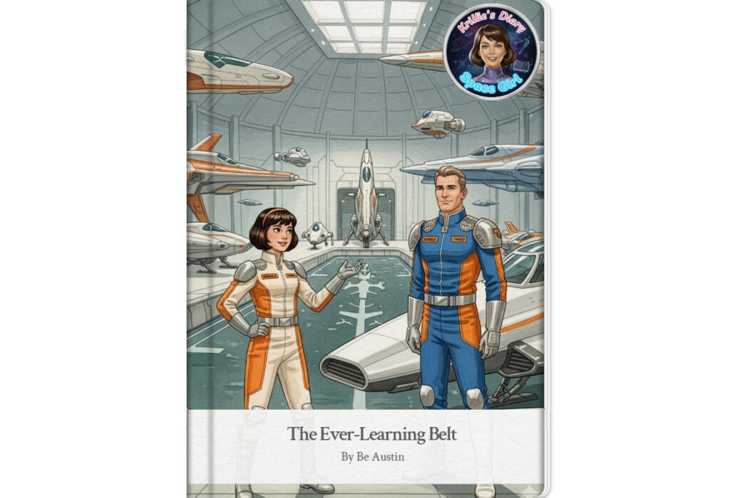
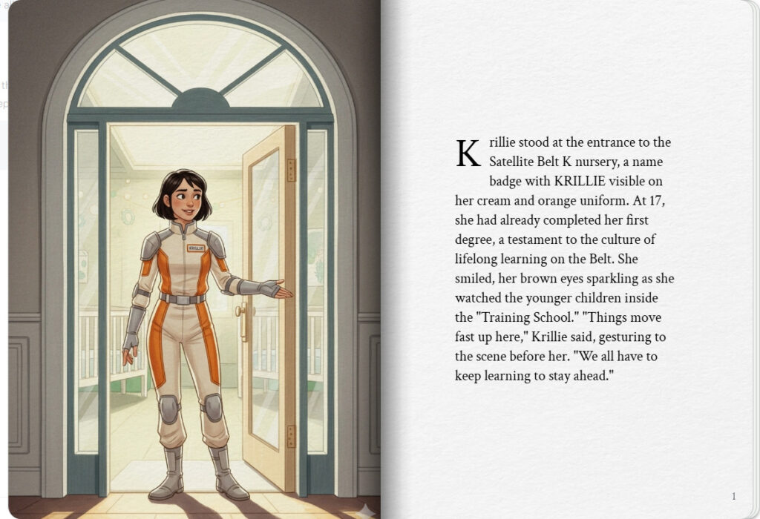
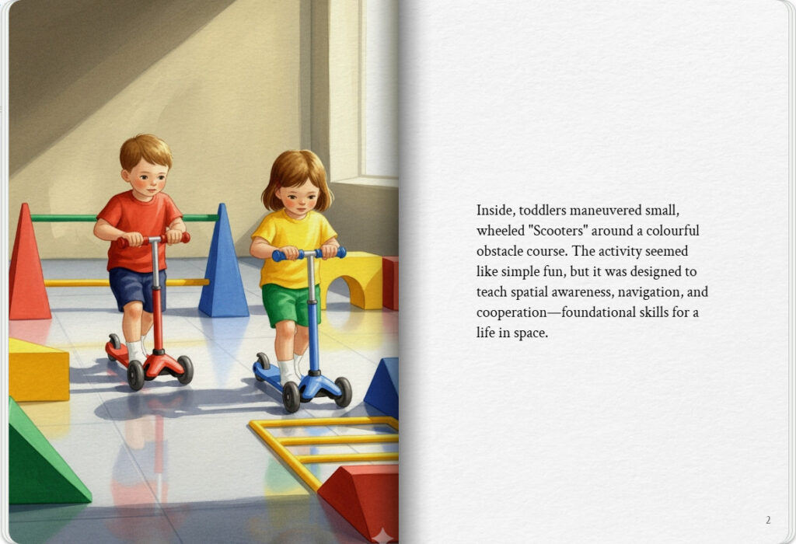

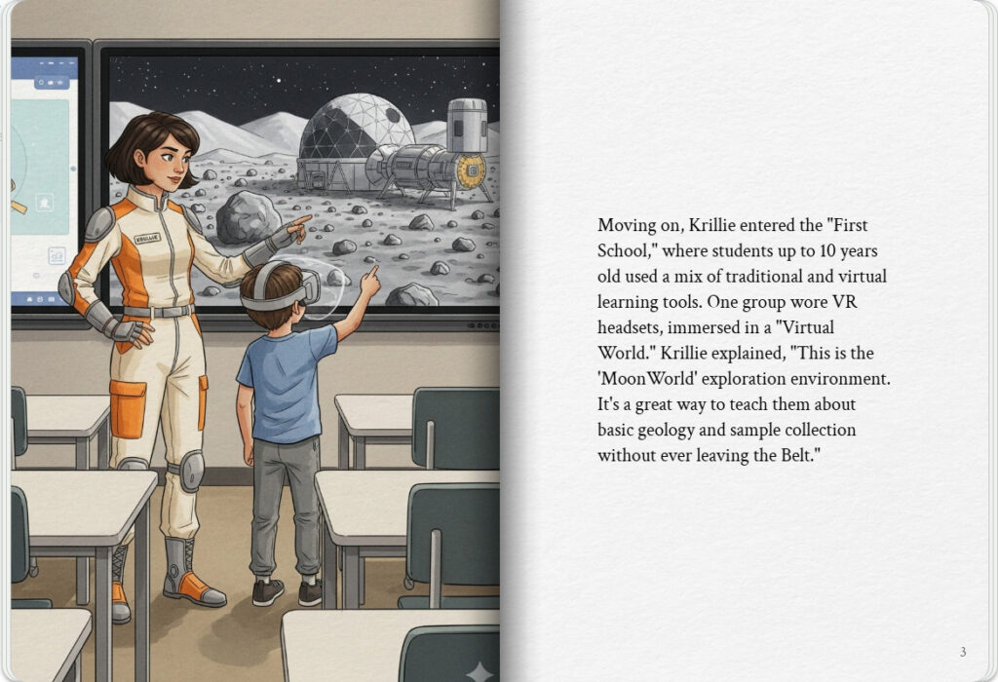
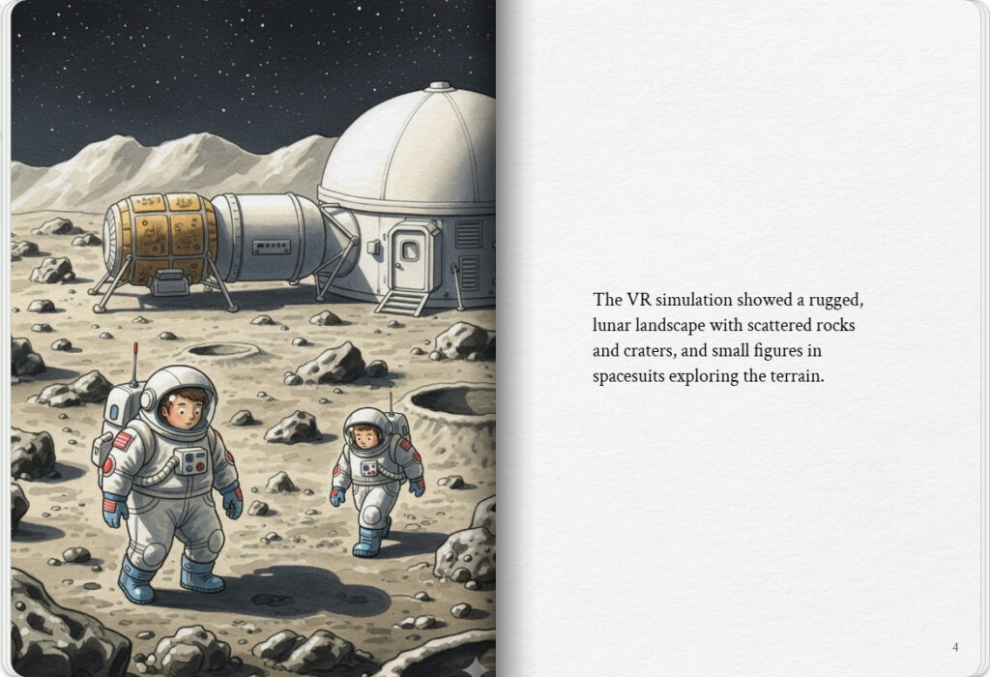

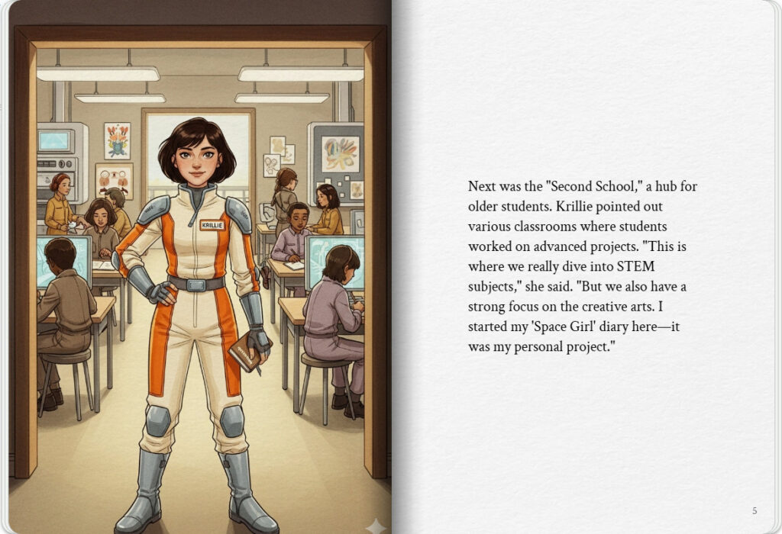
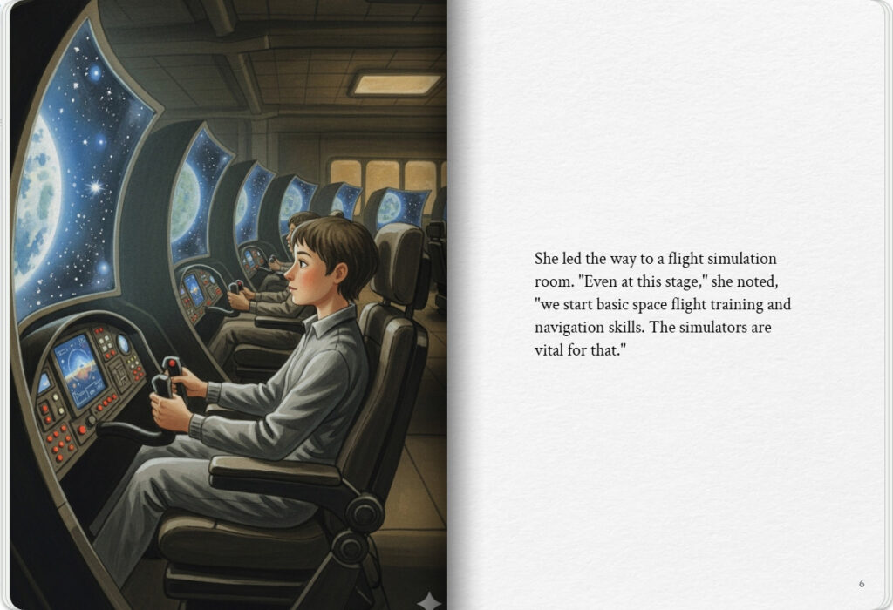

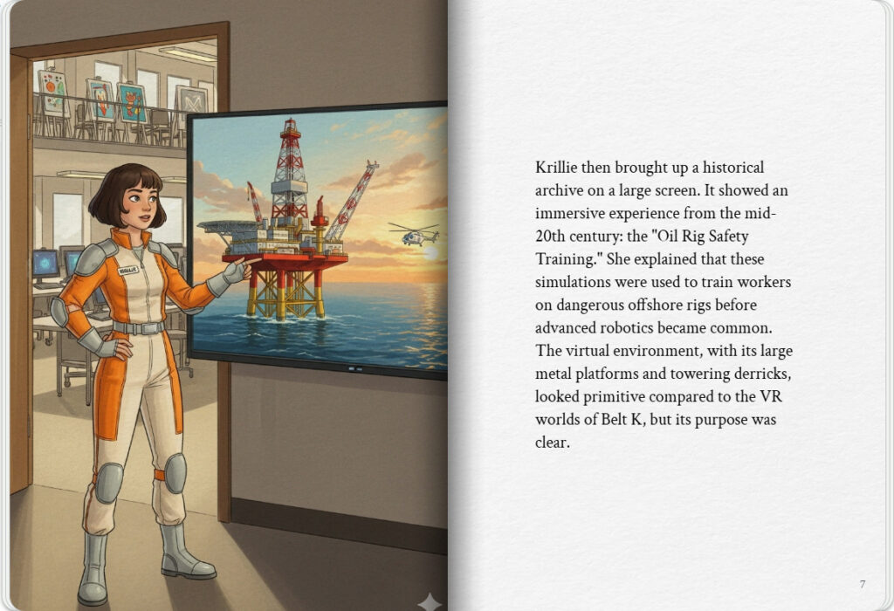
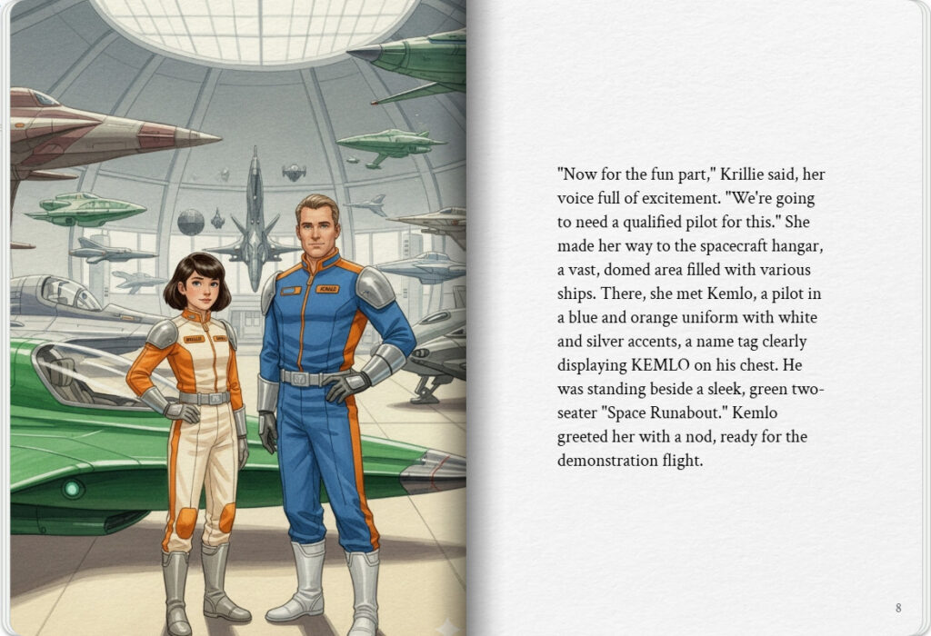

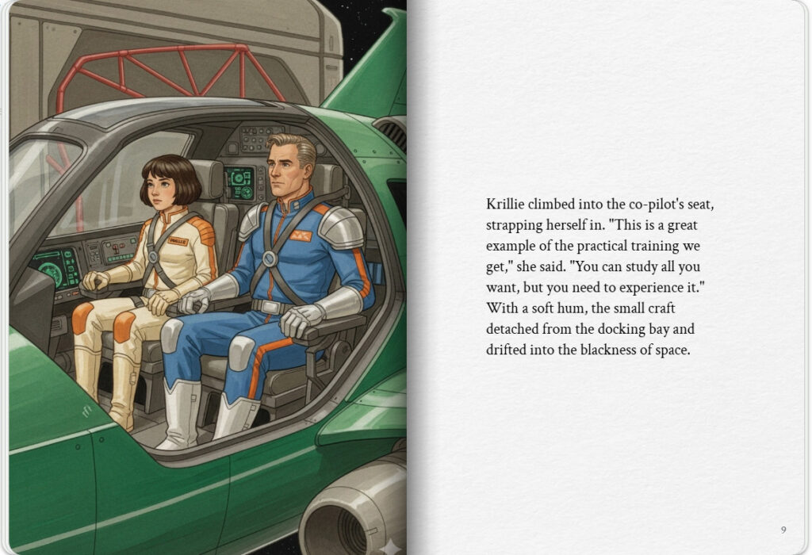
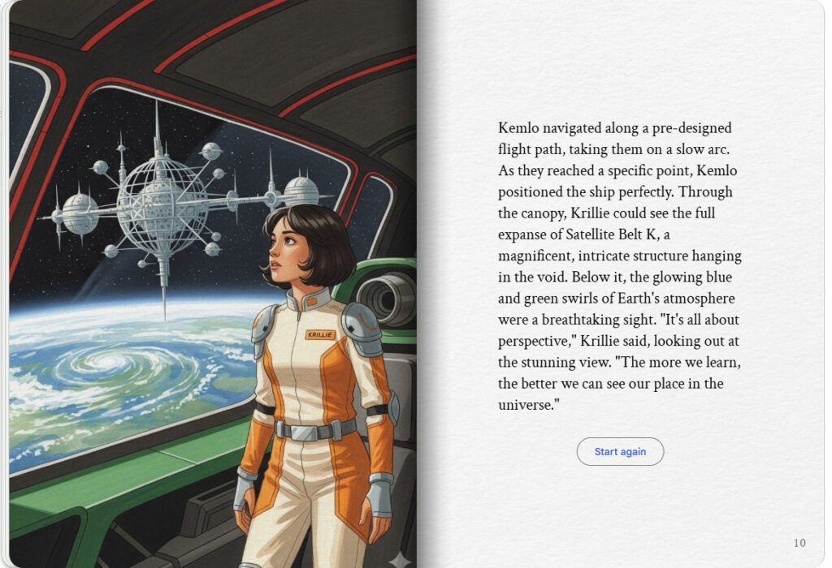

Virtual Reality and Virtual World experiences created all the way back near the start of the 21st century include the “MoonWorld” and “RGU Oil Rig” immersive training environments. More details are available via clicking on the links or images below…
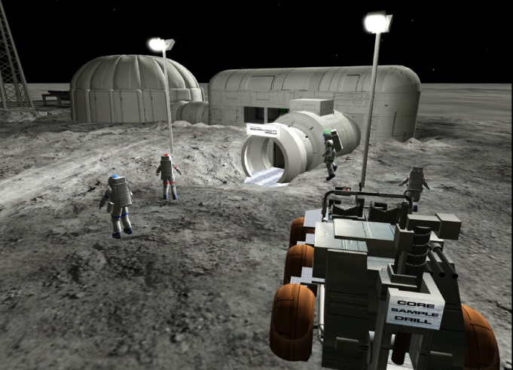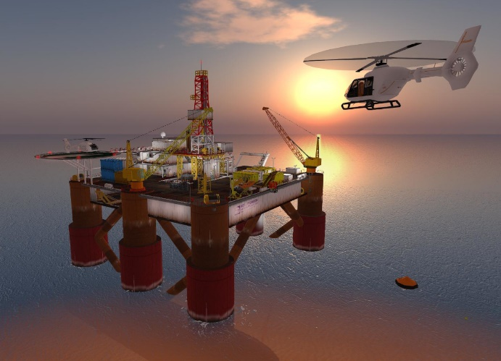
- https://blog.inf.ed.ac.uk/atate/2012/01/19/moonworld-virtual-world-for-inquiry-and-planetary-geology-field-work/
- https://blog.inf.ed.ac.uk/atate/2017/06/07/virtual-oil-rig-enhancing-higher-education/

Krillie’s Diary uses background created previously using AI tools based on the Kemlo Spaceworld series of books by E.C. Eliott published in 1954 to 1963. It uses images and PDF of the contents of this blog post: https://blog.inf.ed.ac.uk/atate/2025/09/10/kemlo-and-krillie-briefing/
Google Gemini Prompt:Create a Storybook interesting to a teenage audience. Krillie is 17 years old and was born on Satellite Belt K. She has lived all her life in space. Satellite Belt K is shown in the attached image and is an Earth orbit space habit spread over 20km including habitation, living spaces, educational areas, recreation, physical conditioning areas, manufacturing, solar power generation and storage, space agriculture and hydroponics in large domes (automatically positioned to maximise crop growing quality and time). Robotics and droids are used throughout the Belt. Use the image of Krillie in her cream and orange space station uniform to start the story. Keep the style and appearance of Krillie the same throughout. Use KRILLIE on her name badge in the same place consistently. No national flags or corporate symbols should be visible throughout.
Krillie is going to show us round the educational and training facilities on Belt K. Things change fast in space and technological knowledge is critical. Belt K citizens of all ages take education and training seriously and most engage in lifelong learning.
Lets start in the nursery “Training School” where young children engage in creative play. Activities are fun but give a grounding for many life skills. Navigation and cooperation is taught using simple wheeled “Scooters”.
Now onto “First School” where children up to 10 years old use a range of educational technology in their classes. VR Headsets and “Virtual Worlds” give useful immersive multi-user virtual experiences. An example is the “MoonWorld” exploration environment to teach basic geology and sample collection.
Older children attend “Second School”. Science, Technology, Engineering and Maths (STEM) subjects are covered in detail. Creative arts are also considered very important for Belt childrens’ rounded education. Krillie first started her own “Space Girl” diary for her own project while at Second School. Simple space flight training and navigation skills are begun at this stage.
Simulated environments are considered a vital educational tool. There is even a historical archive of the “Oil Rig Safety Training” immersive experience to show what VR and virtual worlds looked like a long time ago in the mid-20th century. Oil Rig workers who went out to dangerous offshore oil rigs before the advent of more advanced robotics were trained in such virtual environments.
Belt students often study for a degree from age 15 and many, including Krillie, have been awarded first degrees by the time they reach 17.
For the final part of our tour of the Belt training facilities we are going to need to call on Kemlo. Kemlo is a qualified spacecraft pilot and can take out the “Space Runabouts” without supervision. So, Krillie and Kemlo meet in the Spacecraft hanger of Satellite Belt K near their green two seater Space Runabout.
Finally, Kemlo takes Krillie on a demonstration training flight out from Belt K on a pre-designed flight path out to look back at the Belt K space station hung in the blackness of space above a glowing blue and green Earth.

Note: version for editing (needs Be Austin author login) is here (Development Notes).

