Graduation Day
Posted on September 14, 2025 by bat
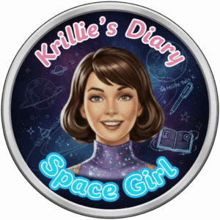
Hi, I’m Krillie. I was born in space on an Earth orbiting space station called “Satellite Belt K”. I write a diary under the moniker “Space Girl” for those interested in what is happening in space and to describe life as a Space Girl. I cover a lot of our activities, about our education and training, our living arrangements and some of our adventures. Along with my friend Kemlo, I write some of the books in “The Further Adventures of Kemlo and Krillie in Space” series. I hope my Diary is of interest to children on Earth, in the Satellite Belts and beyond.

It was my Masters Graduation ceremony earlier this week and I was excited to be going. I have been studying for my Masters degree in AI and Robotics vis remote e-Learning with the University of Edinburgh. Well, it all turned out to be a bit of an adventure really. Quite an adventure!
Kemlo offered to take me down to the Open World University Graduation Hall on Atlantica Space City and as he has been testing the experimental SX-MR2 modular runabout spacecraft he took me down in that. Well things did not exactly go smoothly.
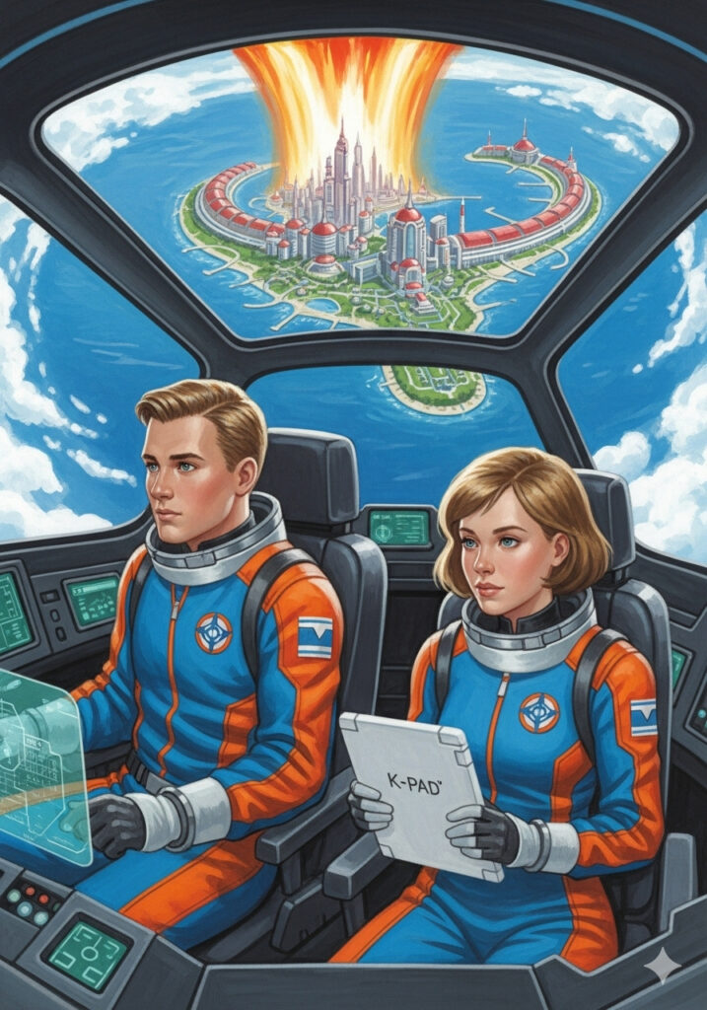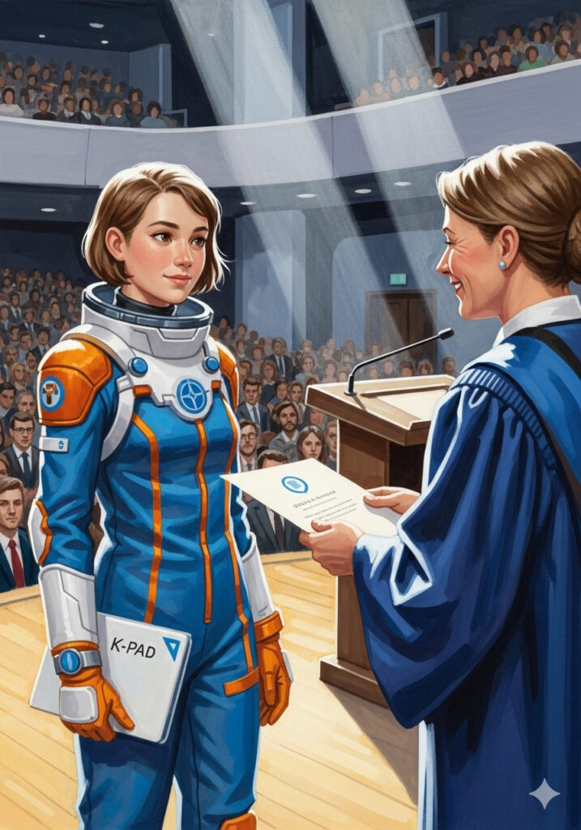
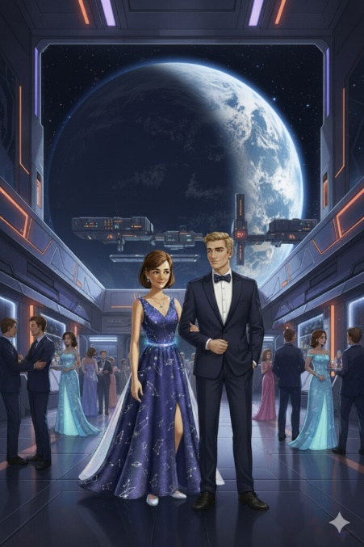
I did make it to the Graduation Ceremony, even though I was a bit breathless and as I did not have time to change, I was still in my space station uniform! No one seemed to mind and I got a very warm reception from the audience and Dean.
Image animated by Grok (MP4) – or via https://pic.x.com/4Ls9pyBkaJ or
https://x.com/aiaiaustin/status/1967312925536010533)
But I made up for it later at the Graduation Ball back at a space station near to Belt K. I was able to change into my own design Graduation Ball dress. Kemlo looked smart too and he used some of the material that made up my dress for his bow tie.

Kemlo and myself wrote a little storybook to explain…
https://g.co/gemini/share/3f97cfe73eb6 [ PDF Format ] [ Separate Images ].
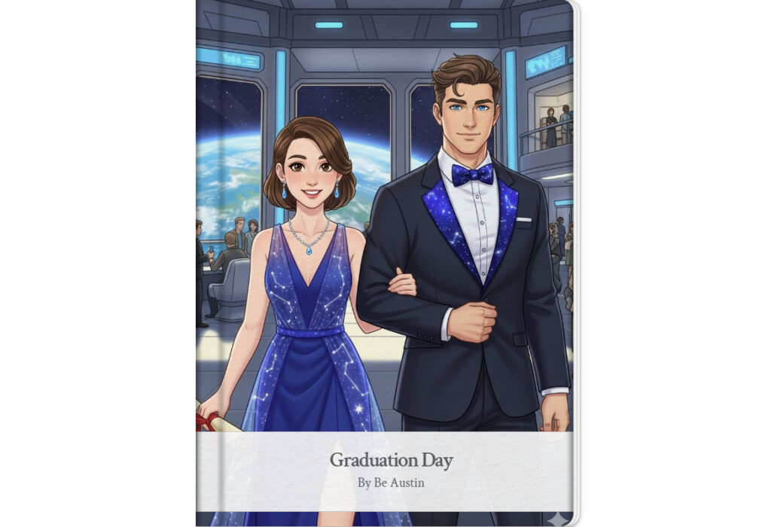
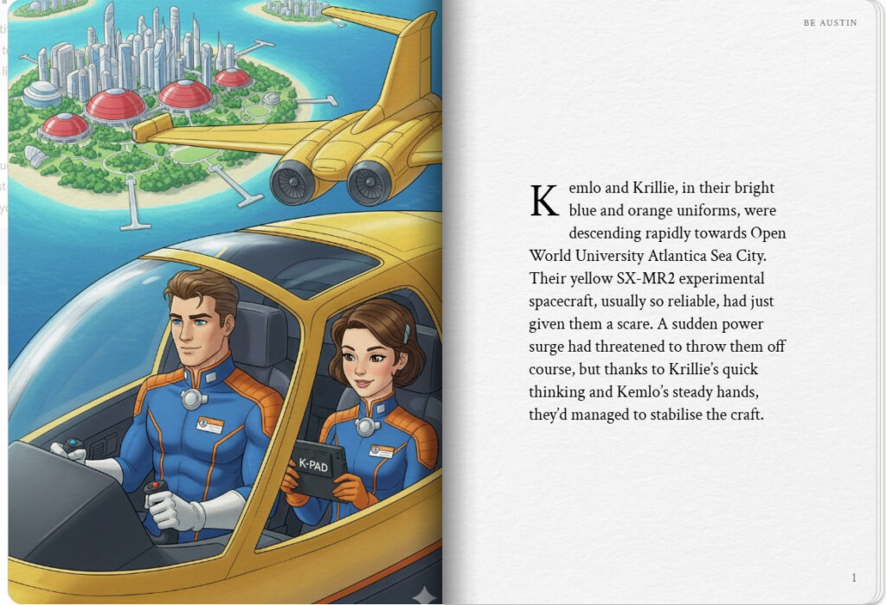
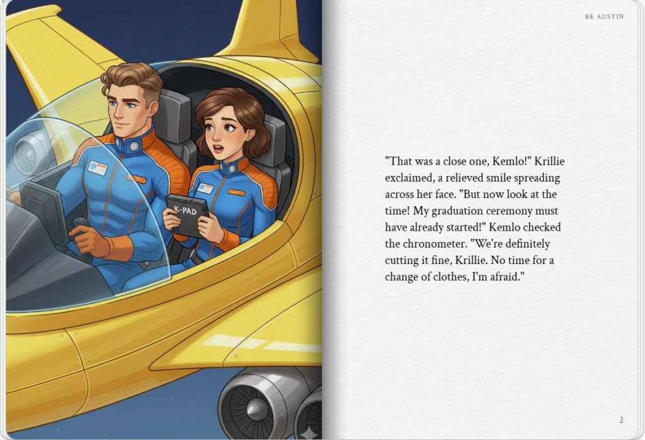

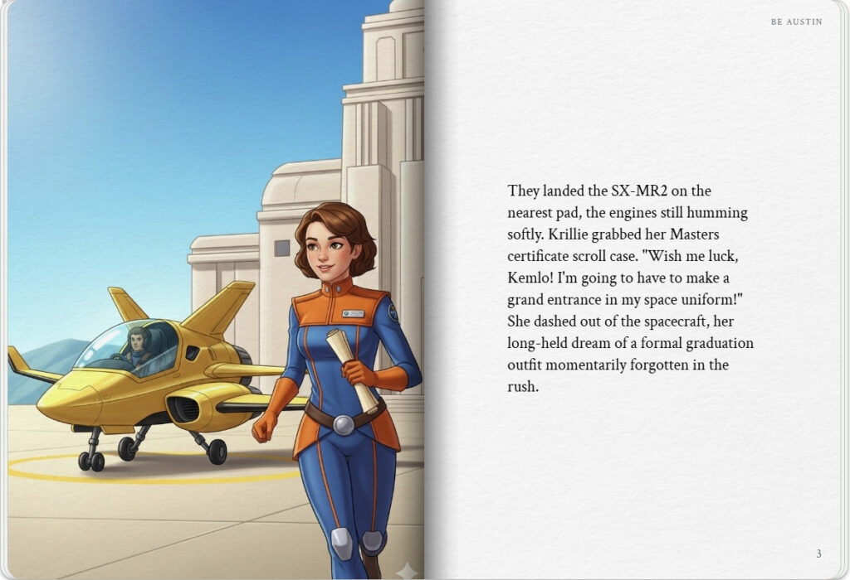
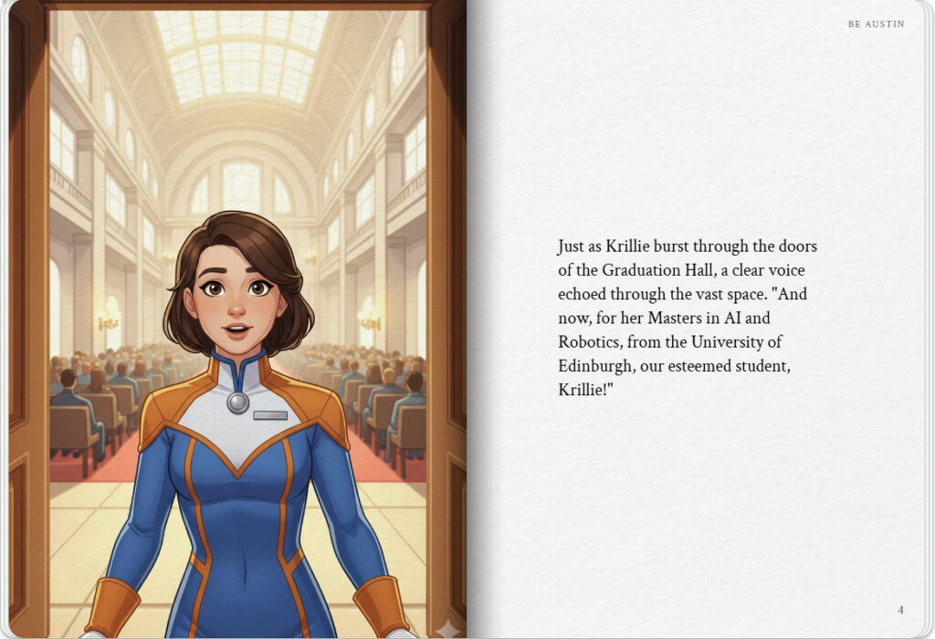

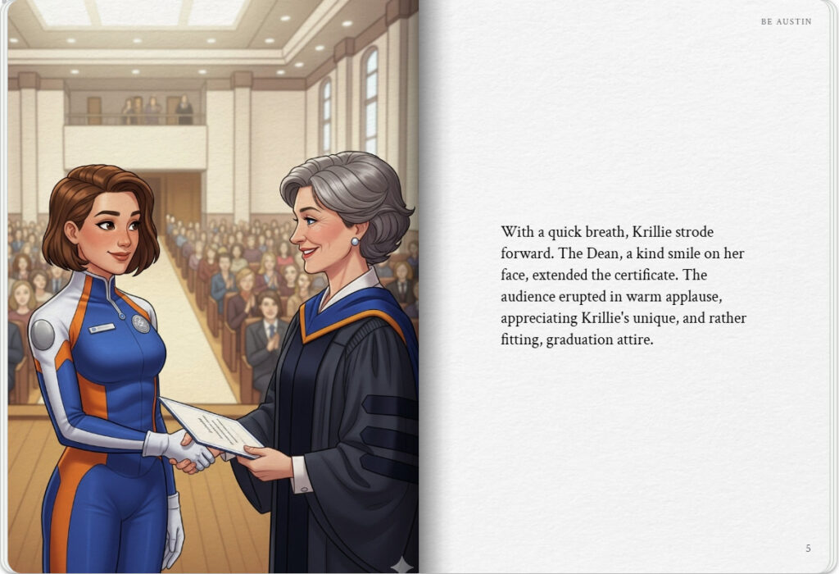
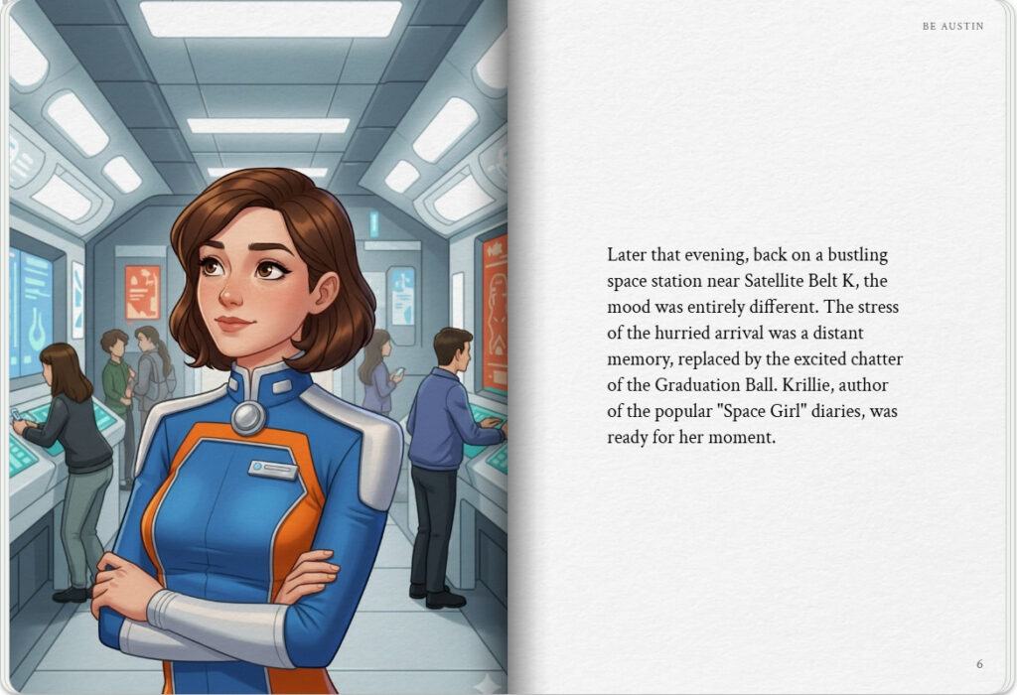

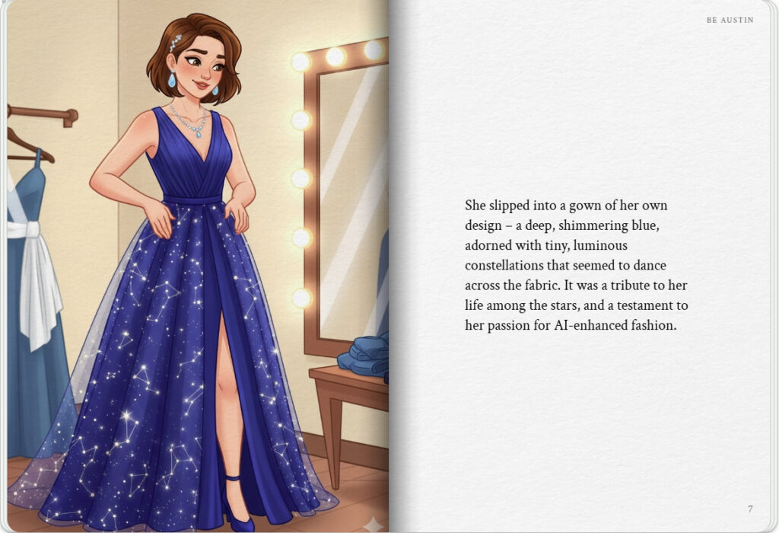
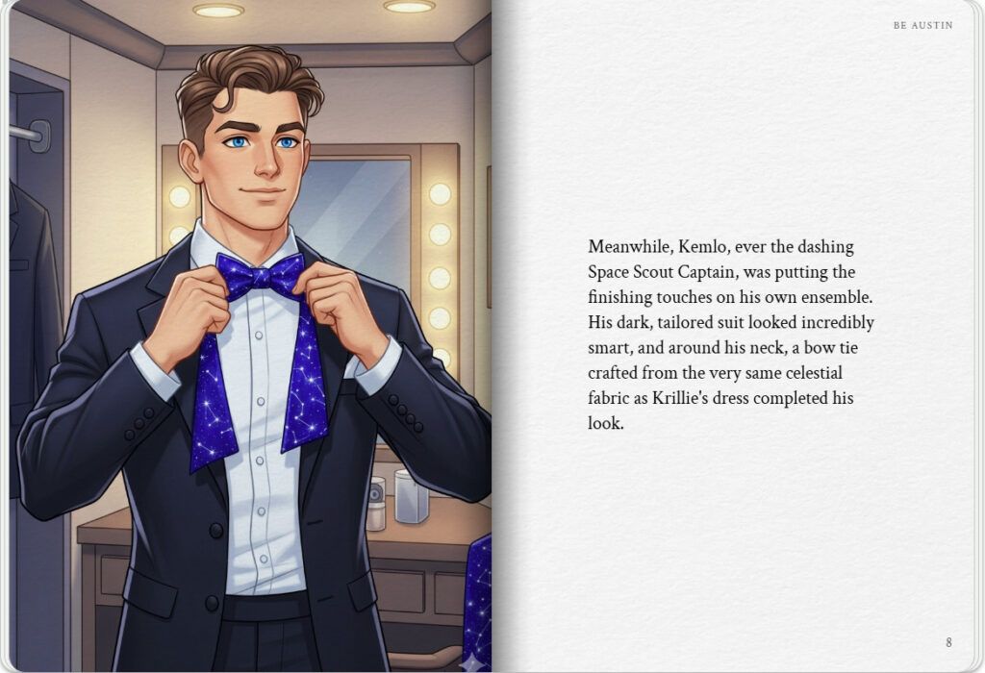

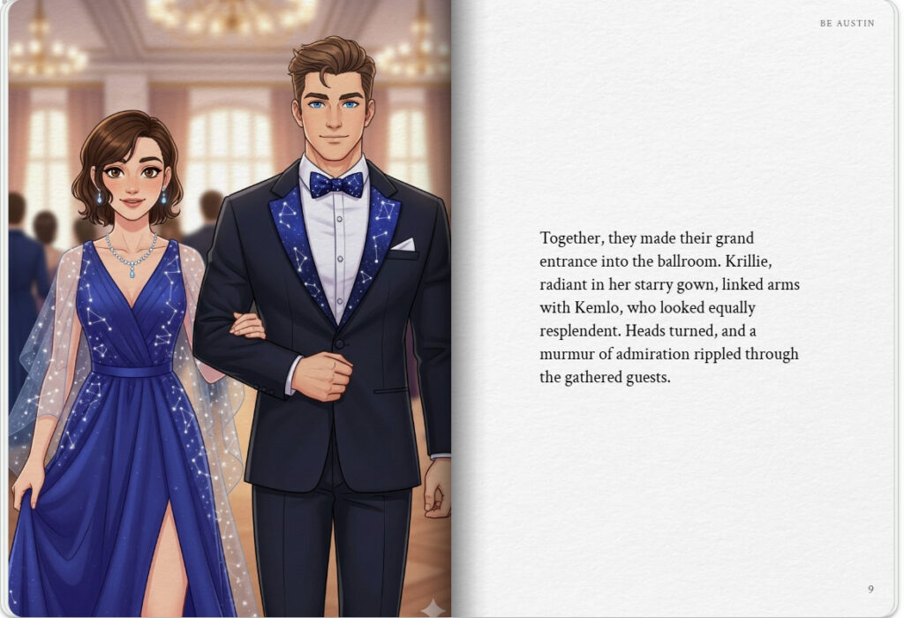
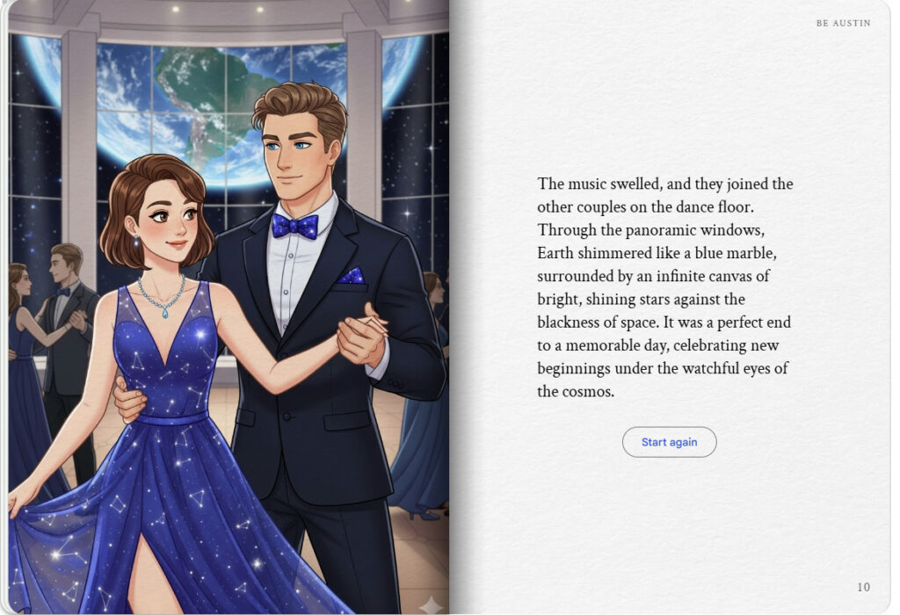

Krillie’s Diary uses background created previously using AI tools based on the Kemlo Spaceworld series of books by E.C. Eliott published in 1954 to 1963. It uses the contents of this blog post: https://blog.inf.ed.ac.uk/atate/2025/09/10/kemlo-and-krillie-briefing/
Google Gemini Prompt:Create a Storybook with title “Graduation Day”. Make the story interesting to a teenage audience. Kemlo and Krillie are teenagers who live on Satellite Belt K in Earth Orbit. Keep the character appearance and name badge labels and position on clothing consistent with the attached images. Use the provided image as a guide for the yellow two side by side seat SX-MR2 spacecraft. No national flags to be visible and no national or recognizable corporate insignia on clothing or space suits.
Krillie was born on Satellite Belt-K and has lived all her life in space. She is 17 years old. She already has a Degree in Space Construction Engineering and has been studying for an Open World University Masters by e-Learning in AI and Robotics from the University of Edinburgh. Krillie is the author of a diary and series of books describing life as a Space Girl which are popular with children on Earth and in the Belts and beyond. Krillie has an interest in fashion in general and in AI-enhanced fashion in particular. Kemlo is an 18-year old Captain of the Space Scouts and Krillie’s friend.
Start the storybook with Kemlo and Krillie in their blue and orange uniforms in their yellow two seater SX-MR2 experimental spacecraft descending to Open World University Atlantica Sea City where the Graduation Hall is located. They have had technical issues on the decent which the pair have between them been able to fix.
But this has left their arrival for the Graduation Ceremony very late. There is no time for Krillie to change clothing and she must dash into the Graduation Hall still wearing her blue and orange uniform just as her name is called to receive her certificate. She receives that from the smiling Dean and is warmly applauded by the full audience.
But Krillie makes up for less than appropriate graduation clothing later at the Graduation Ball back on a space station near to Belt K. She is able to change into the Graduation Ballgown of her own design. Kemlo also looks smart in his ballroom suit and has used some of the material that makes up Krillie’s dress for his bow tie. They look resplendent as they enter the Ballroom.
Finally, at the end show Krillie and Kemlo dancing at the Graduation Ball with other couples nearby in the stunning Ballroom location with its views over the Earth beyond and bright shining stars against the blackness of space.

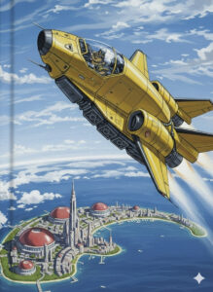
Graduation day – Google Gemini – Text and Image Version
The sleek yellow SX-MR2 experimental spacecraft, with Kemlo at the controls and Krillie beside him, cut a bright streak through the vibrant blue of Atlantica’s sky.
Below them, the futuristic domes and spires of Open World University Atlantica Sea City shimmered like jewels on the water. It should have been a smooth descent, a celebratory glide towards Krillie’s graduation ceremony. But space, as always, had other plans.
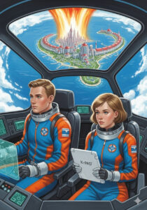
“Stabilizers are still reading critical, Kemlo,” Krillie reported, her brow furrowed as she expertly manipulated a holographic display. “We’re losing altitude faster than programmed. Looks like that micro-meteoroid swarm yesterday did more damage than we thought to the secondary thrusters.”
Kemlo, ever calm, adjusted his grip on the controls. “Alright, Krillie. Let’s reroute auxiliary power to the port thruster and see if we can get some controlled burn. You talk me through the diagnostics.”
Together, their years of living and learning in the Satellite Belts paid off. Krillie, with her degree in Space Construction Engineering and her advanced AI and Robotics studies, quickly pinpointed the exact sequence needed. Kemlo, the Captain of the Space Scouts, executed her instructions with precision. The SX-MR2 shuddered, then slowly, begrudgingly, regained some stability.
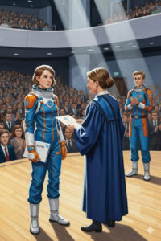
The emergency landing, while successful, had eaten up precious time. They sprinted from the landing pad, Krillie’s blue and orange uniform a stark contrast to the formal wear of other arriving graduates. There was no time to change into a cap and gown.
Just as they burst through the doors of the packed Graduation Hall, a clear voice echoed, “—and now, for her Master’s in AI and Robotics from the University of Edinburgh, Krillie!”
Krillie gasped, her eyes wide. She was still in her flight suit! But there was no turning back. With a nervous glance at Kemlo, who gave her an encouraging nod, she hurried onto the stage. The smiling Dean, unfazed by Krillie’s unconventional attire, presented her with the certificate. The entire audience erupted in warm applause, recognizing not just her academic achievement but the adventurous spirit of the young Space Girl whose diaries were so beloved across Earth and the Belts.
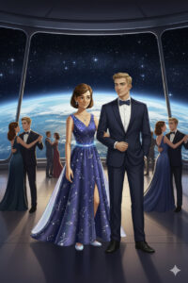
Later that evening, back on a space station orbiting near Belt K, Krillie made up for her less-than-appropriate graduation clothing. She had spent weeks designing her perfect Graduation Ballgown, integrating her passion for AI-enhanced fashion with her love for the cosmos. As she and Kemlo entered the dazzling Ballroom, heads turned. Krillie was resplendent in a deep blue gown, shimmering with constellations and nebulae, a flowing skirt that seemed to hold the very essence of space within its folds. Kemlo, equally smart in his ballroom suit, sported a bow tie crafted from the same unique celestial fabric as Krillie’s dress. They were the stars of the evening.

Note: version for editing (needs Be Austin author login) is here (Development Notes).

