Belt K Fashion
Posted on September 13, 2025 by bat
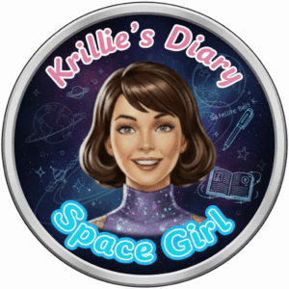
Hi, I’m Krillie. I was born in space on an Earth orbiting space station called “Satellite Belt K”. I write a diary under the moniker “Space Girl” for those interested in what is happening in space and to describe life as a Space Girl. I cover a lot of our activities, about our education and training, our living arrangements and some of our adventures. Along with my friend Kemlo, I write some of the books in “The Further Adventures of Kemlo and Krillie in Space” series. I hope my Diary is of interest to children on Earth, in the Satellite Belts and beyond.
The Storybook produced is available at: https://g.co/gemini/share/aed957af671c [ PDF Format ] [ Separate Images ] .

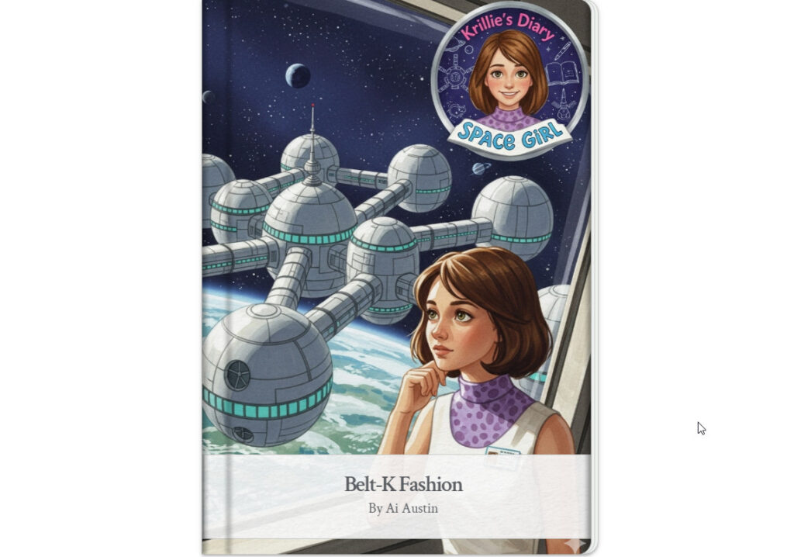
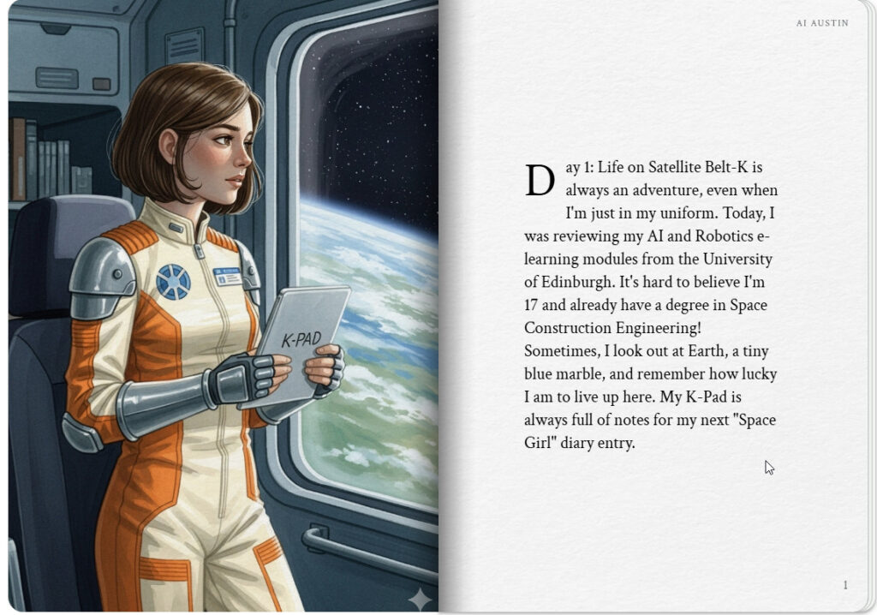
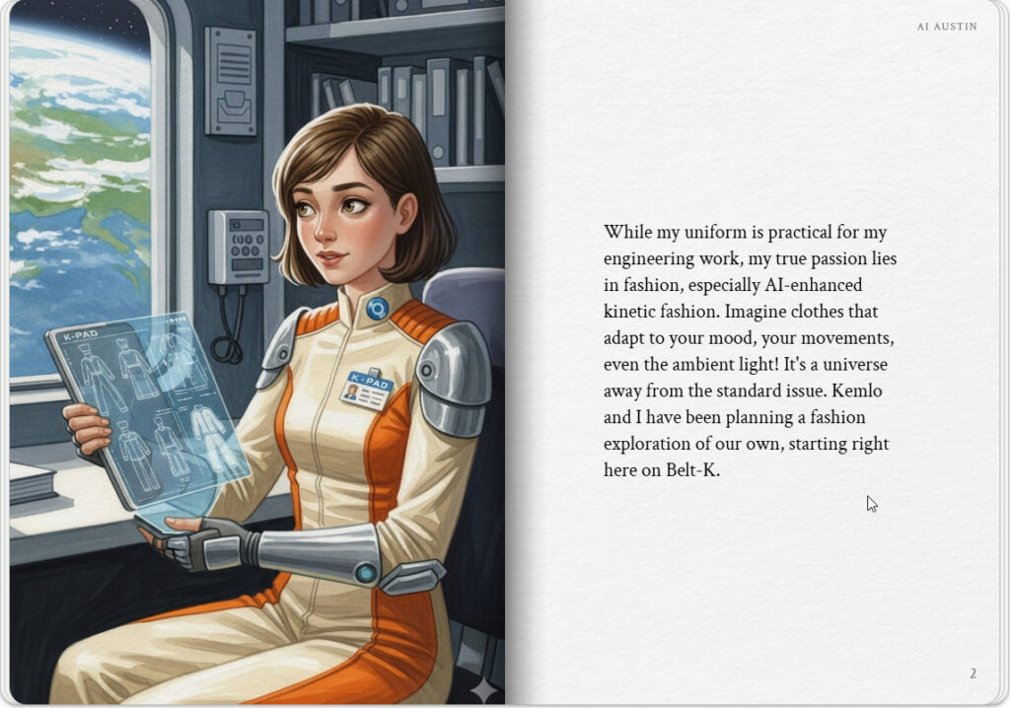

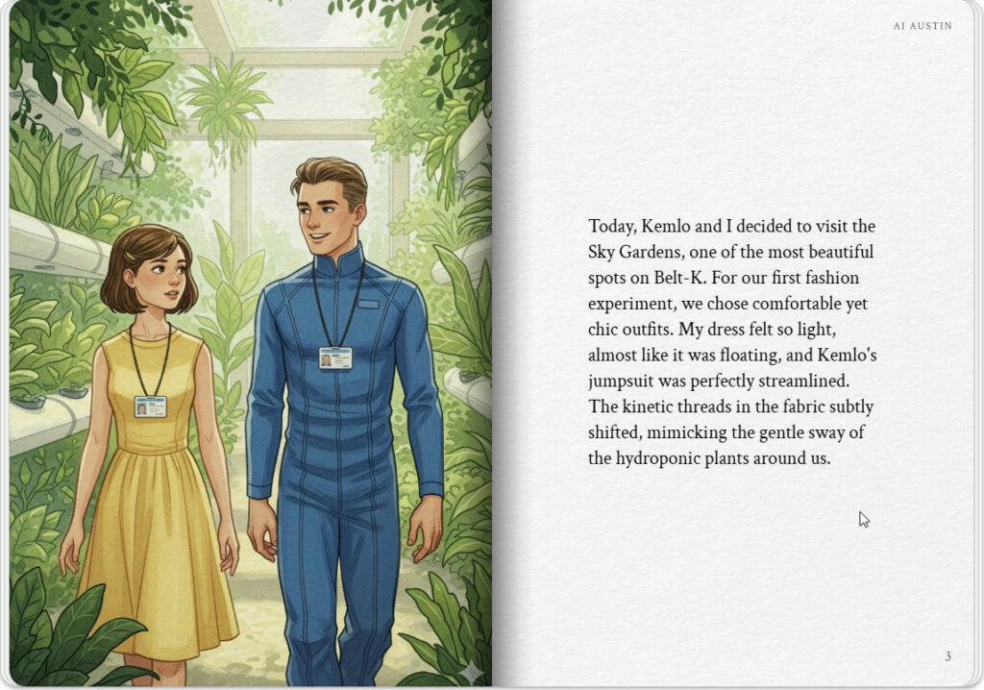
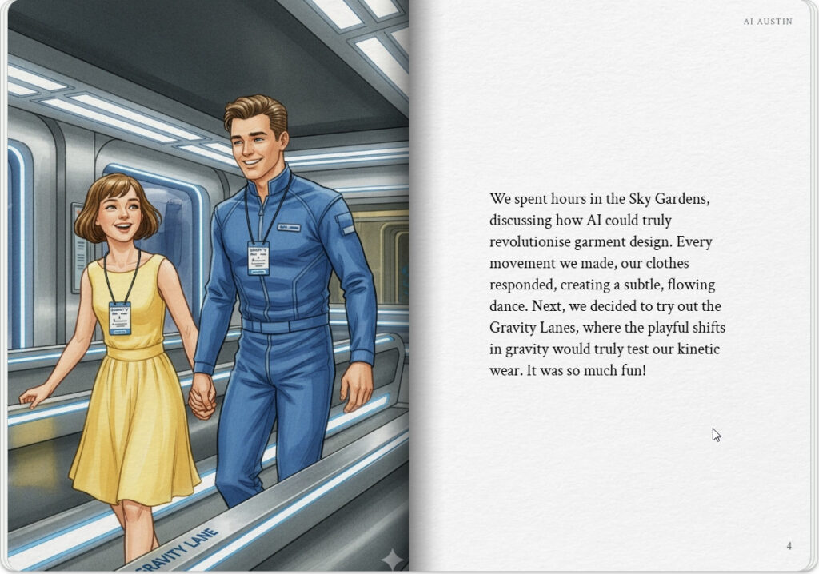

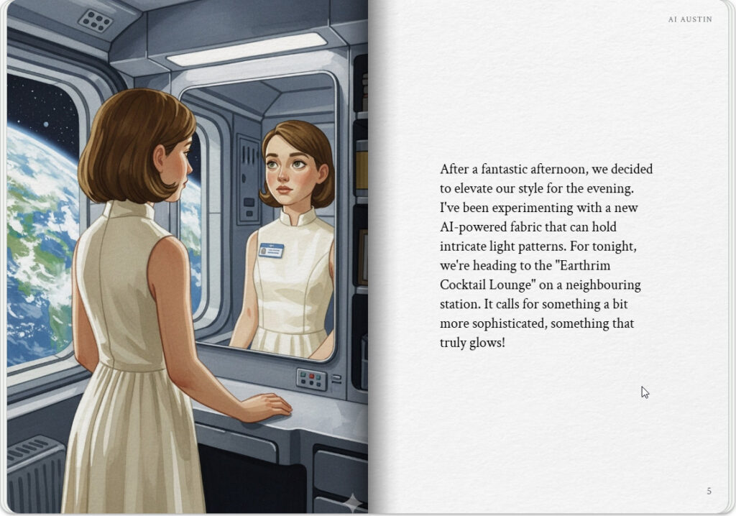
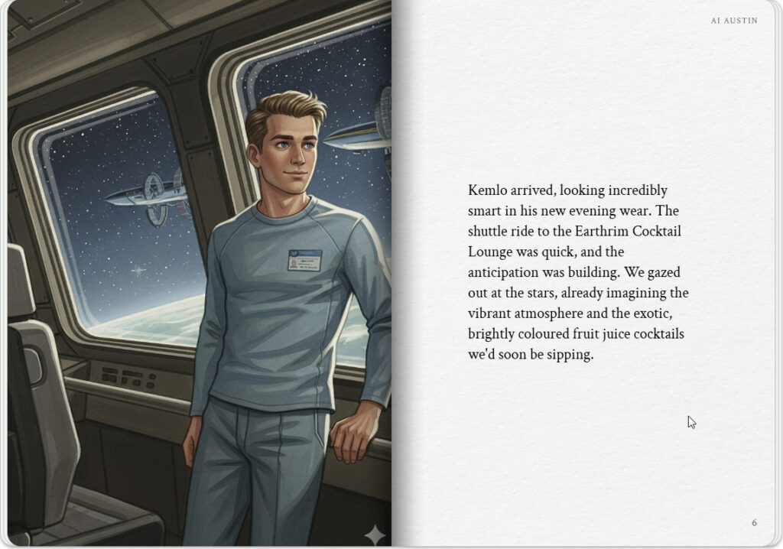

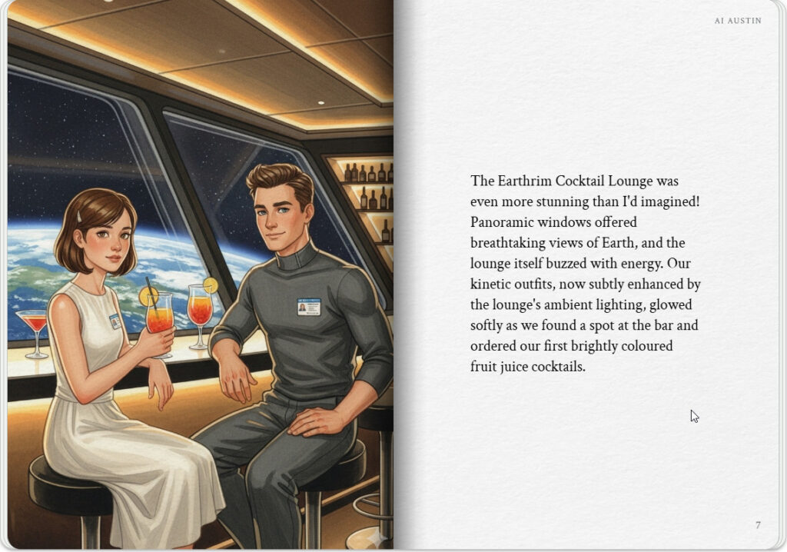
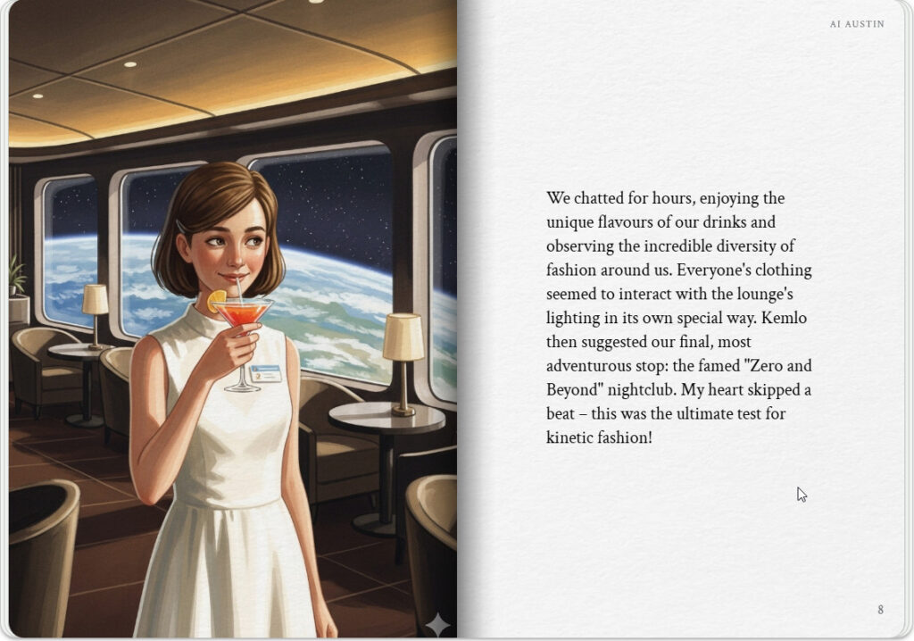

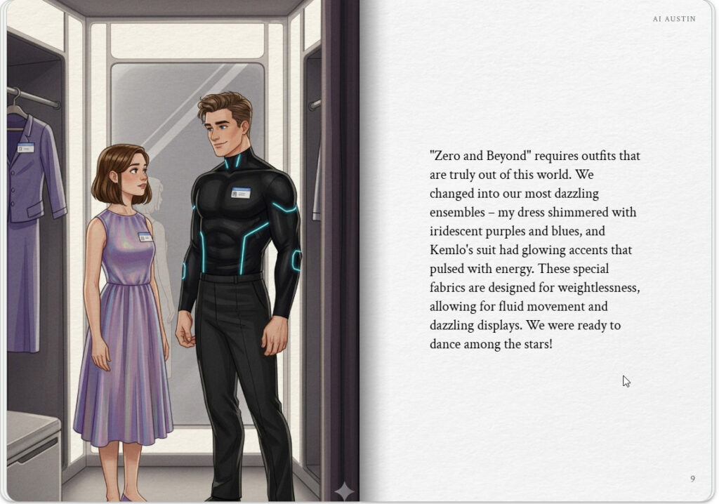
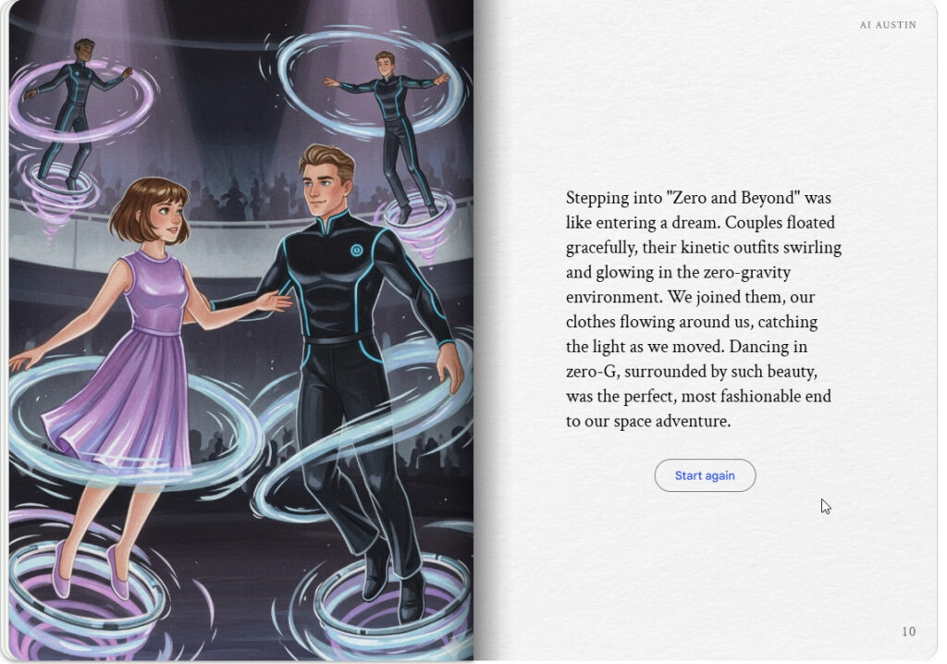

Krille & Kemlo at “Zero and Beyond”
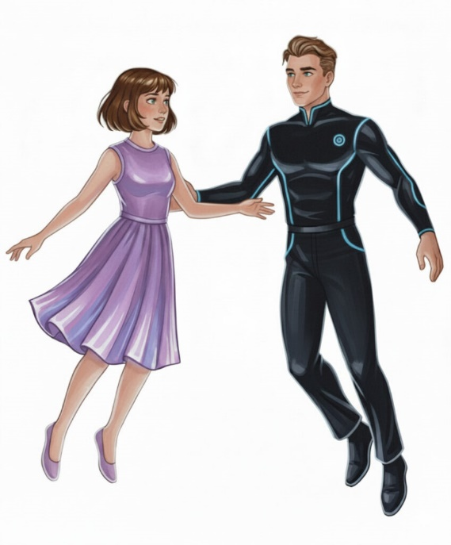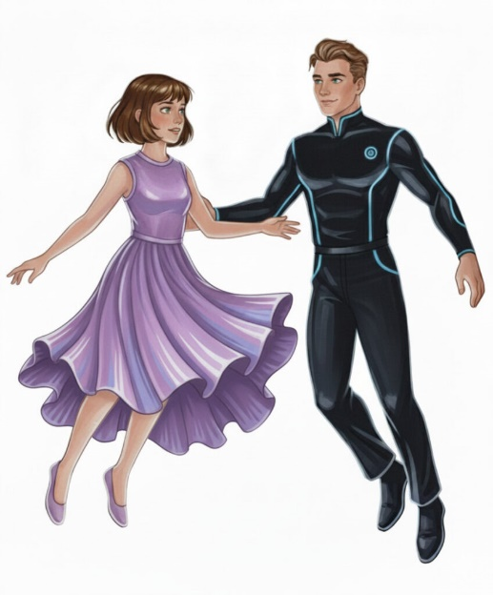

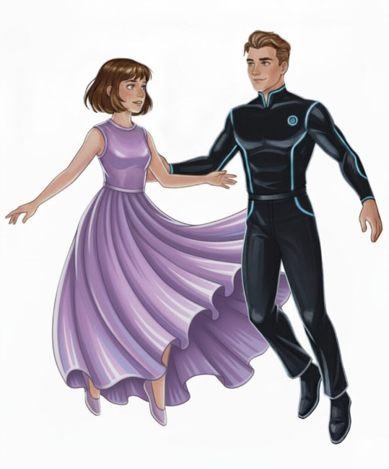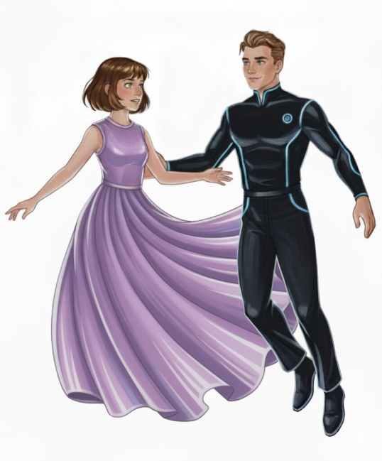

Image animated by Grok (MP4) – or via https://pic.x.com/JCFR3zKzc5 or https://x.com/aiaiaustin/status/1967318292676432283)

Graduation Ball
Here is a gown in fabric I designed myself for my Masters Degree Graduation Ball. Kemlo used some of the same material for his bow tie.
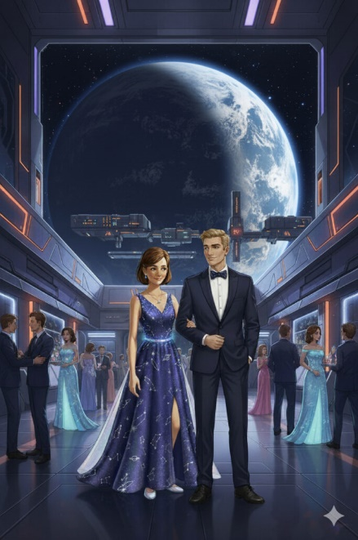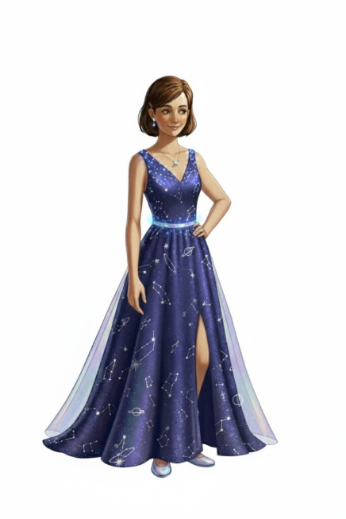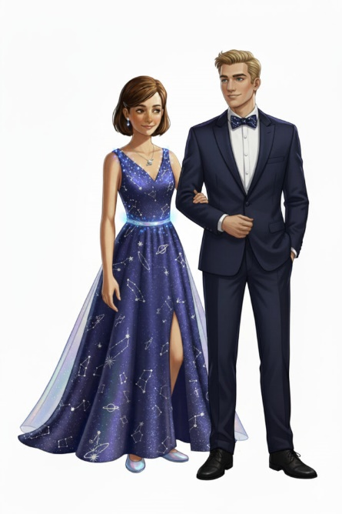

Image animated by Grok (MP4) – or via https://pic.x.com/4Ls9pyBkaJ or https://x.com/aiaiaustin/status/1967312925536010533)

More Belt K Fashion
For more Belt K Fashion see these blog posts:
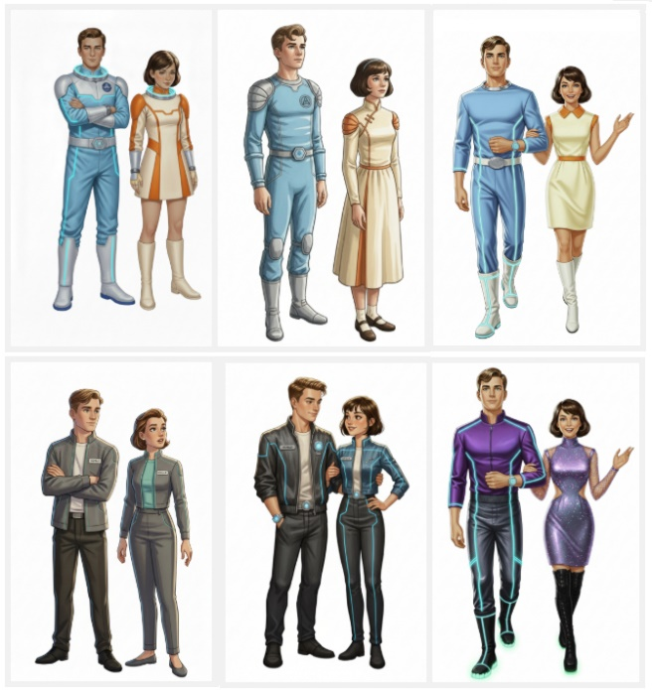
- Kemlo & Krillie Fashion
- Krillie Tries it On
- Century 21 Cosplay

We also have work clothing for when we do maintenance on the Space Runabouts and Scooters…
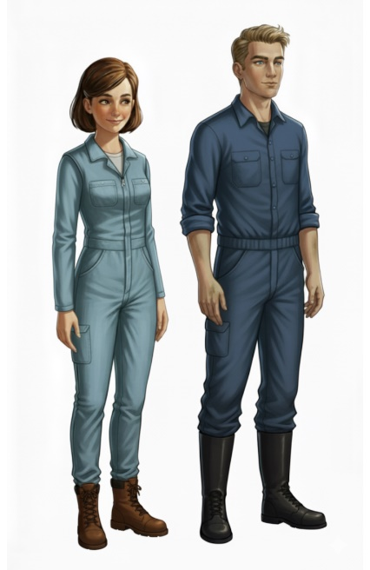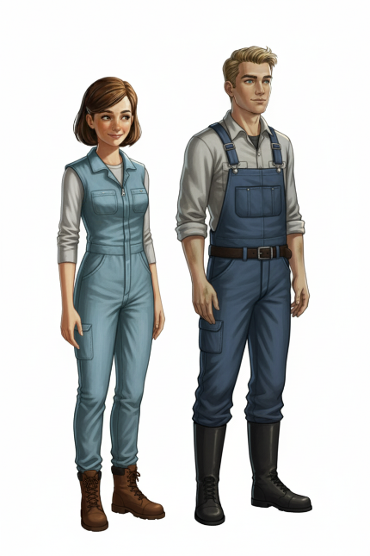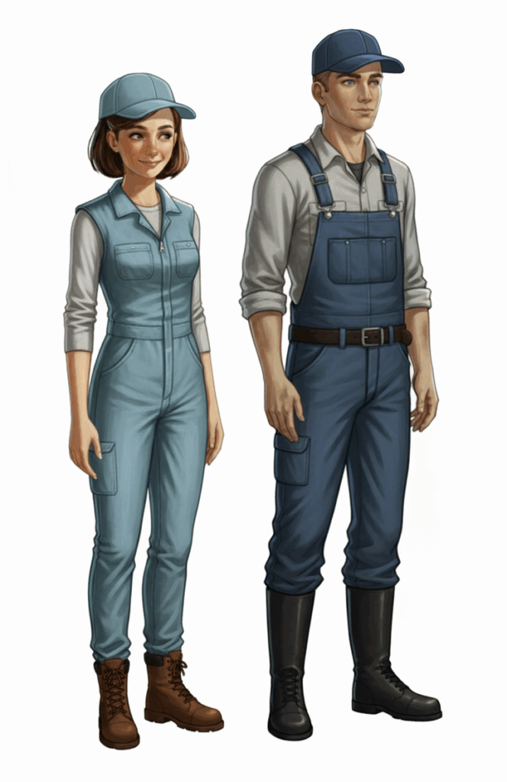
Krillie’s Diary uses background created previously using AI tools based on the Kemlo Spaceworld series of books by E.C. Eliott published in 1954 to 1963. It uses the contents of this blog post: https://blog.inf.ed.ac.uk/atate/2025/09/10/kemlo-and-krillie-briefing/

Google Gemini Prompt: Create a Storybook with title “Belt-K Fashion”. Use the background about “The Further Adventures of Kemlo and Krillie” who are teenagers who live on Satellite Belt K in Earth Orbit. Use the style image for the normal appearance of Krillie and her friend Kemlo. Keep the character appearance and name badge labels and position on clothing consistent with the attached image. No national flags to be visible and no national or recognizable corporate insignia on clothing or spacesuits.
Krillie was born on Satellite Belt K and has lived all her life in space. She is 17 years old. She has a Degree in Space Construction Engineering and is currently studying for a Masters by e-Learning in AI and Robotics from the University of Edinburgh. Krillie is the author of a diary and series of books describing life as a Space Girl which are popular with children on Earth and in the Belts and beyond. Krillie has an interest in fashion in general and in AI-enhanced kinetic fashion in particular.
Make the story interesting to a teenage audience. Start with the image of Krillie in her uniform but have her dress in 22nd Century fashionalble clothing as the story progresses. The storybook should be in a diary style based on Krillie and sometimes with her friend Kemlo, taking the reader to interesting locations on the Satellite Belt-K space station visiting interesting areas where the fashion is appropriate. Krille and Kemlo together in fashionable 22nd Century clothing also go to some exotic space locations on other space stations such as the “Earthrim Cocktail Lounge” where brightly coloured fruit juice cocktails are served. The final page and illustration should be a stunning visit to the famed “Zero and Beyond” nightclub where couples can float Zero-G in dreamy outfits and dresses.
Note: version for editing (needs Ai Austin author login) is here (Development Notes).

