Introducing Belt K

Posted on September 13, 2025 by bat
Hi, I’m Krillie. I was born in space on an Earth orbiting space station called “Satellite Belt K”. I write a diary under the moniker “Space Girl” for those interested in what is happening in space and to describe life as a Space Girl. I cover a lot of our activities, about our education and training, our living arrangements and some of our adventures. Along with my friend Kemlo, I write some of the books in “The Further Adventures of Kemlo and Krillie in Space” series. I hope my Diary is of interest to children on Earth, in the Satellite Belts and beyond.
The Storybook produced is available at: https://g.co/gemini/share/966ef14978de [ PDF Format ] [ Separate Images ] .


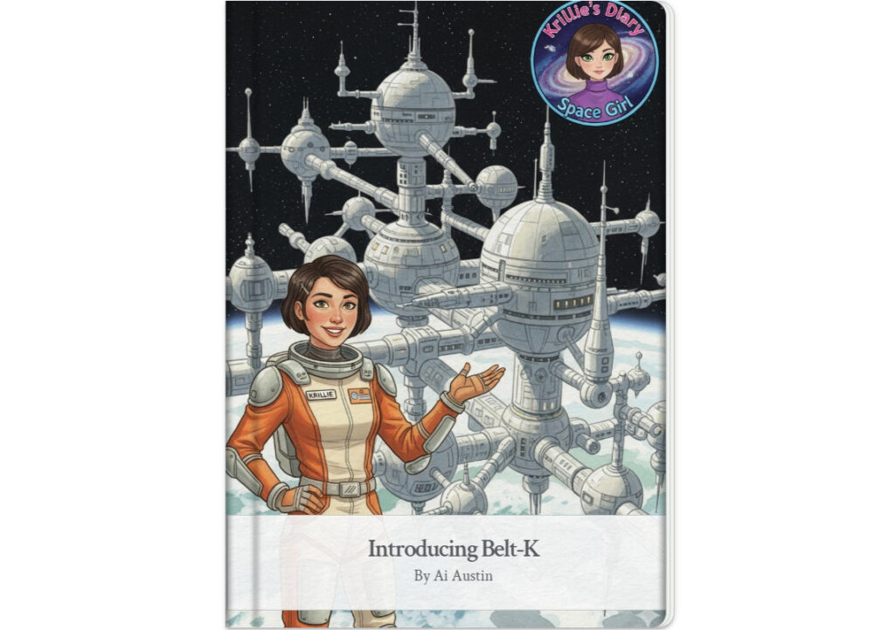
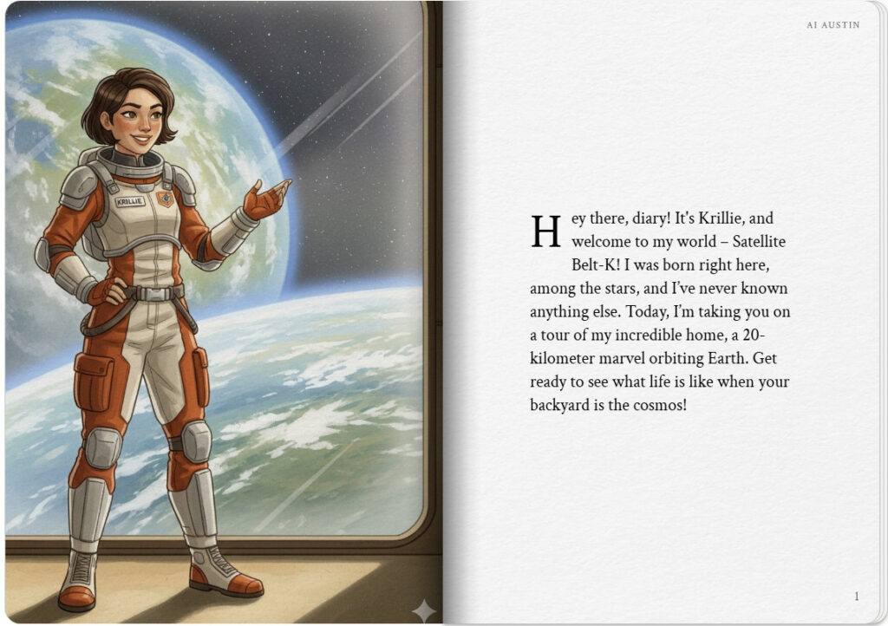
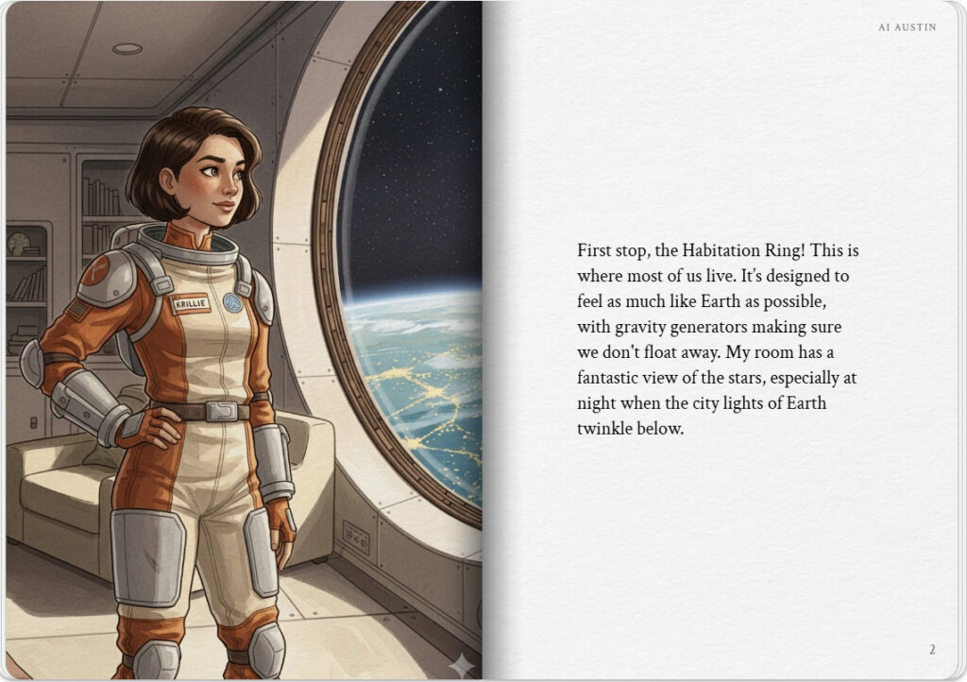

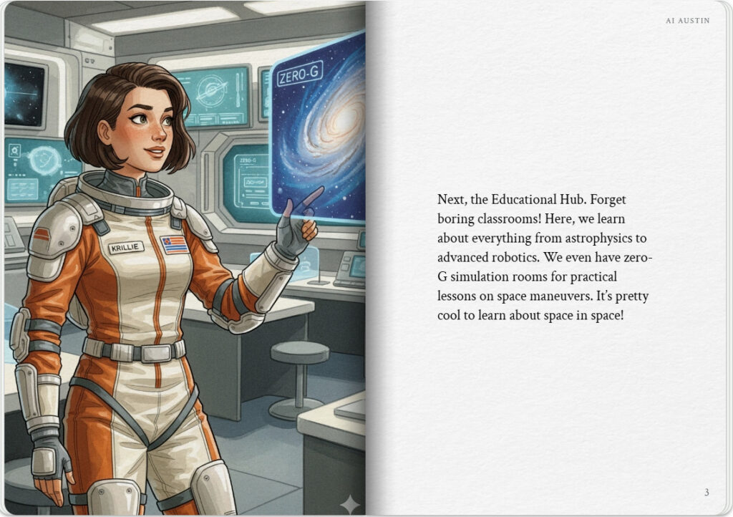
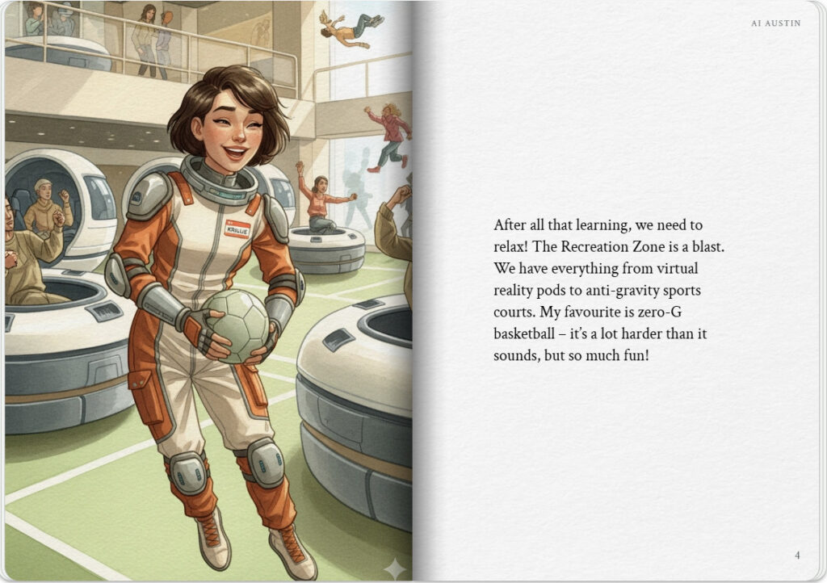

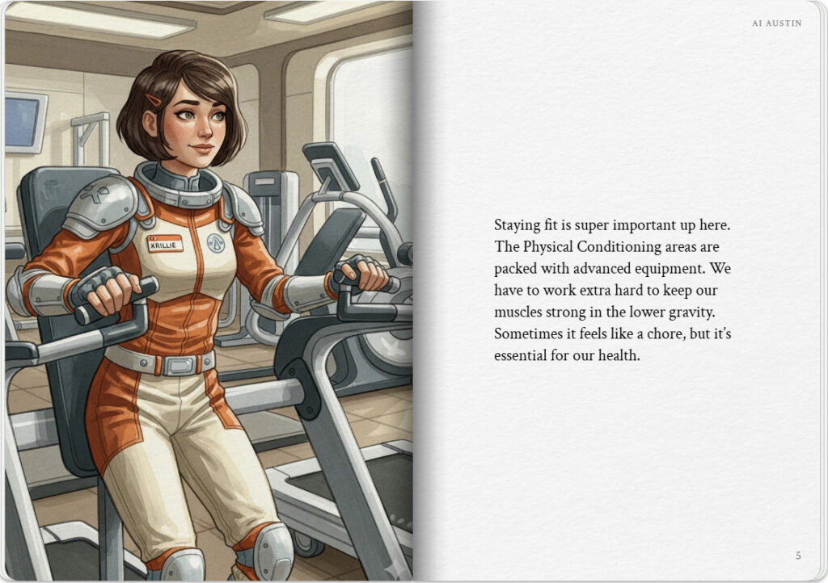
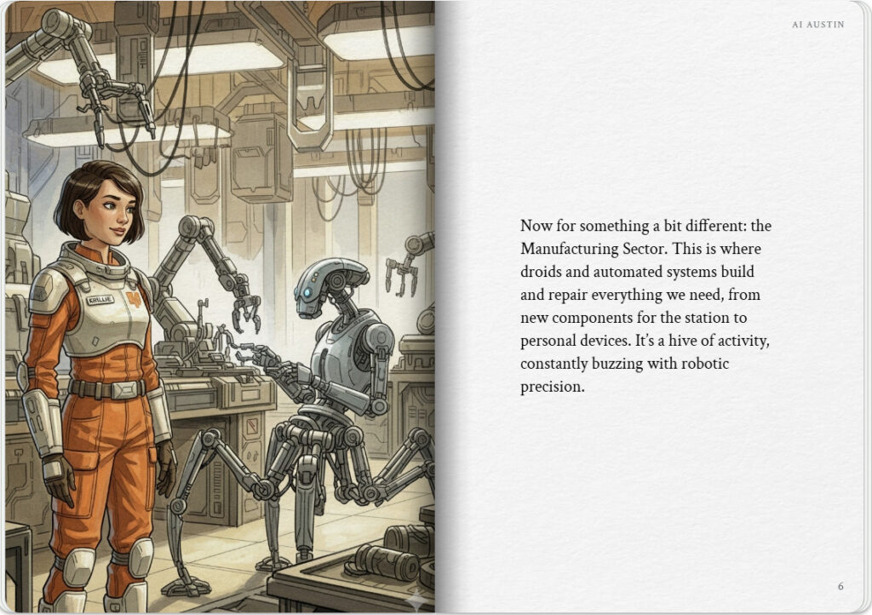

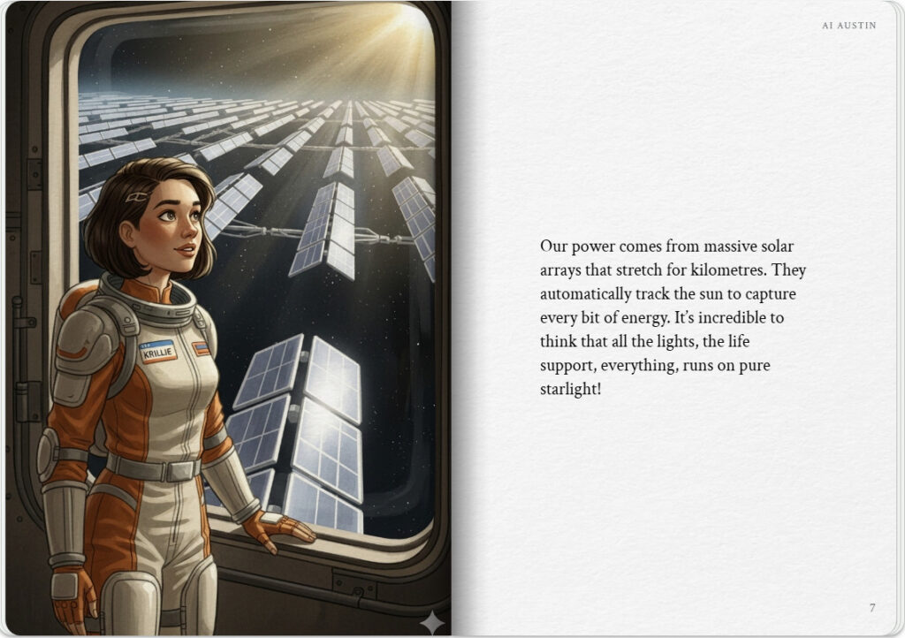
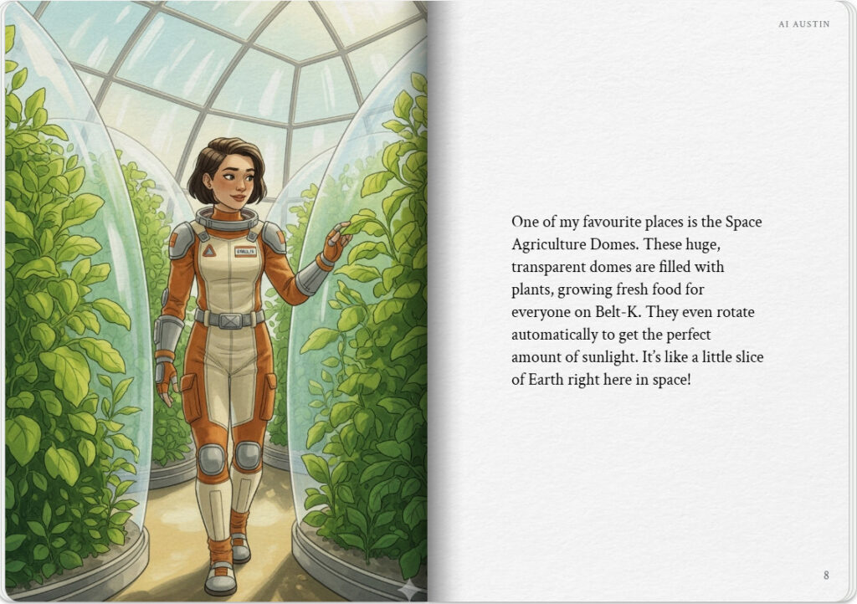

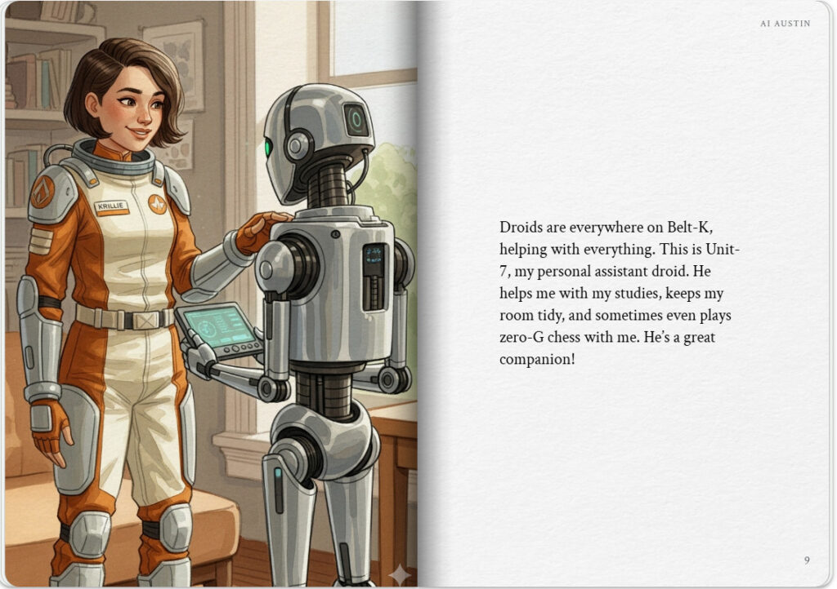
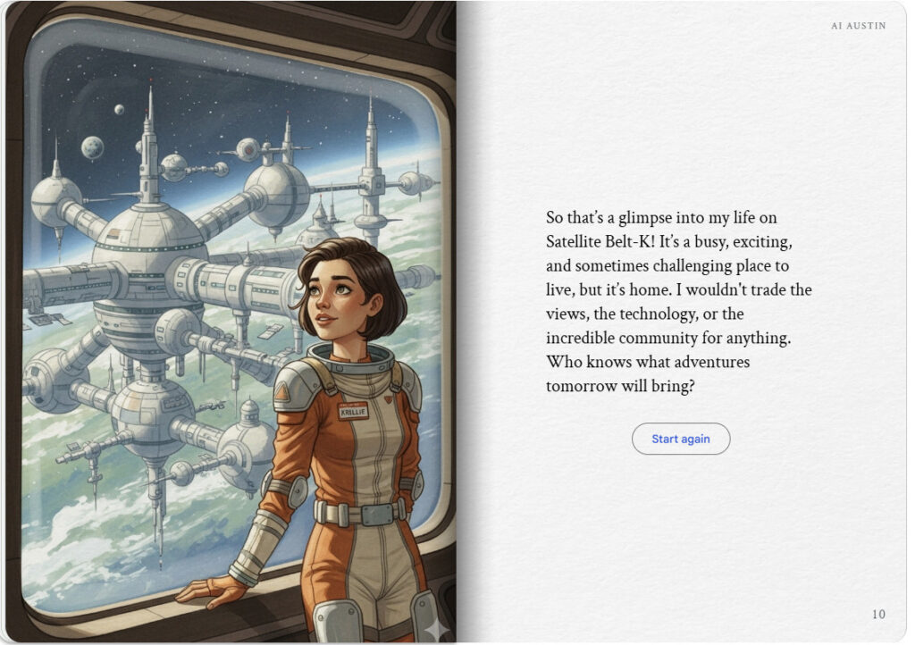

Krillie’s Diary uses background created previously using AI tools based on the Kemlo Spaceworld series of books by E.C. Eliott published in 1954 to 1963. It uses the contents of this blog post: https://blog.inf.ed.ac.uk/atate/2025/09/10/kemlo-and-krillie-briefing/

Google Gemini Prompt: Create a Storybook with title “Introducing Belt-K”. Krillie was born on Satellite Belt-K and has lived all her life in space. The storybook should be in a diary style based on Krillie taking the reader on a trip round the Satellite Belt K space station and visiting interesting areas. Satellite Belt K is shown in the attached image and is an Earth orbit space habit spread over 20km including habitation, living spaces, educational areas, recreation, physical conditioning areas, manufacturing, solar power generation and storage, space agriculture and hydroponics in large domes (automatically positioned to maximise crop growing quality and time). Robotics and droids are used throughout the Belt. Make the story interesting to a teenage audience. Use the image of Krillie in her uniform for her trip round the space station. Keep the style and appearance of Krillie the same throughout. Use KRILLIE on her name badge in the same place consistently. No national flags or corporate symbols should be visible throughout.

Note: version for editing (needs Ai Austin author login) is here (Development Notes).

