Kemlo & Krillie – The SPITAR Anomaly
Posted on October 12, 2025 by bat
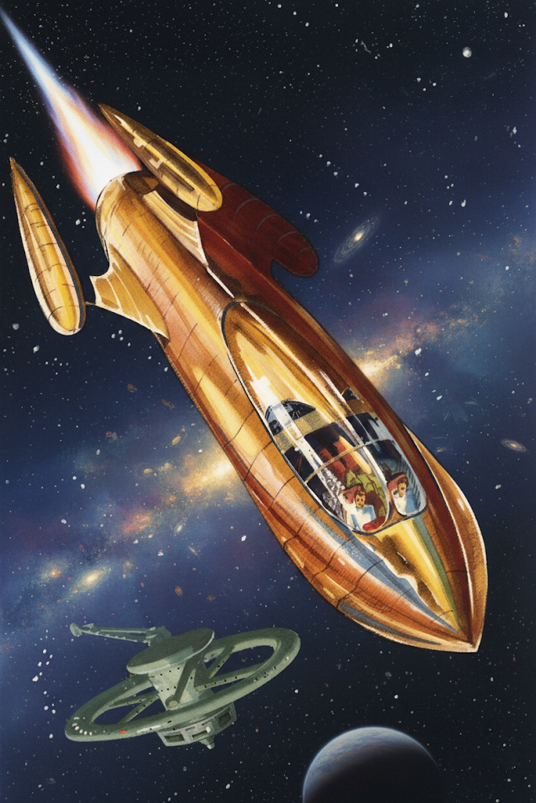
This is Storybook 8 in “The Further Adventures of Kemlo & Krillie in Space” series. It is produced using Google Gemini Storybooks AI App which lets you create a customized picture book, for either children or adults, given a topic, an optional target audience age, and an optional art style for the images.
Prompt: Use the background given in the attached document to write an exciting storybook for a teenager target audience about “The Further Adventures of Kemlo and Krillie in Space”. Kemlo and Krillie are teenagers who live on Satellite Belt K in Earth Orbit. Keep the character appearance and name badge label and position on clothing consistent with the attached images. Keep the spacecraft and Belt K space station designs as provided in the images.
SPITAR – Space Personal Investigation Training and Research Craft Number XK240. The spacecraft has a single central rocket engine and three pods on the horizontal and vertical fins can carry experimental fuels and can be easily swapped out.
Kemlo, Captain of Space Scouts on Belt K is an assigned test pilot for an experimental new spacecraft called SPITAR. The storybook opens with Kemlo looking alongside Belt K engineers at the blueprints for SPITAR. They are seen in the engineering labs where SPITAR is under construction, Kemlo looks on making observations as the work progresses. SPITAR is ready for its first test flight. Kemlo asks Krillie his friend and a qualified engineer to assist and make recordings as they go. Use you imagination to come up with an original and exciting story.
The Storybook produced is available at: https://g.co/gemini/share/95941518717b or PDF Format
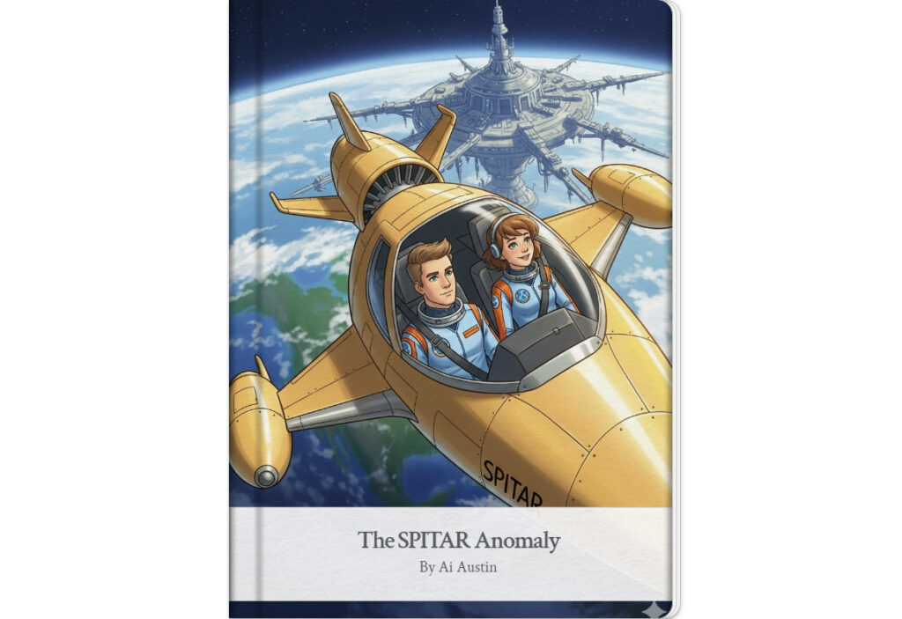
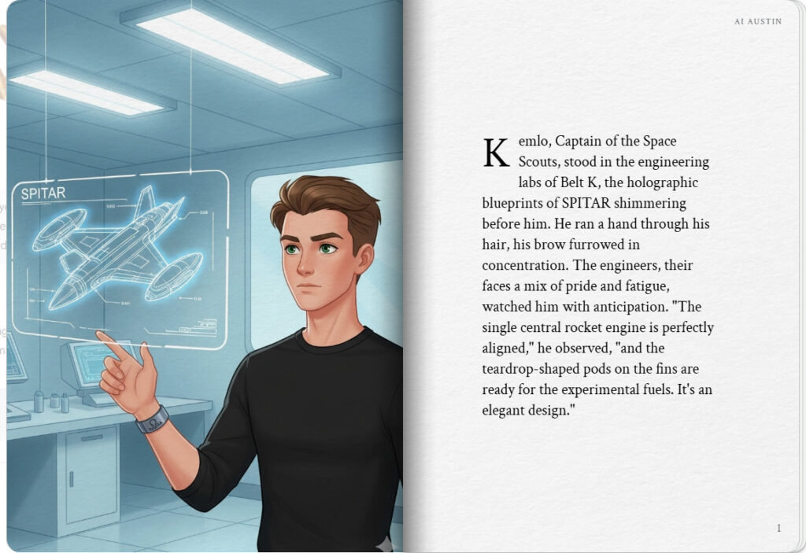
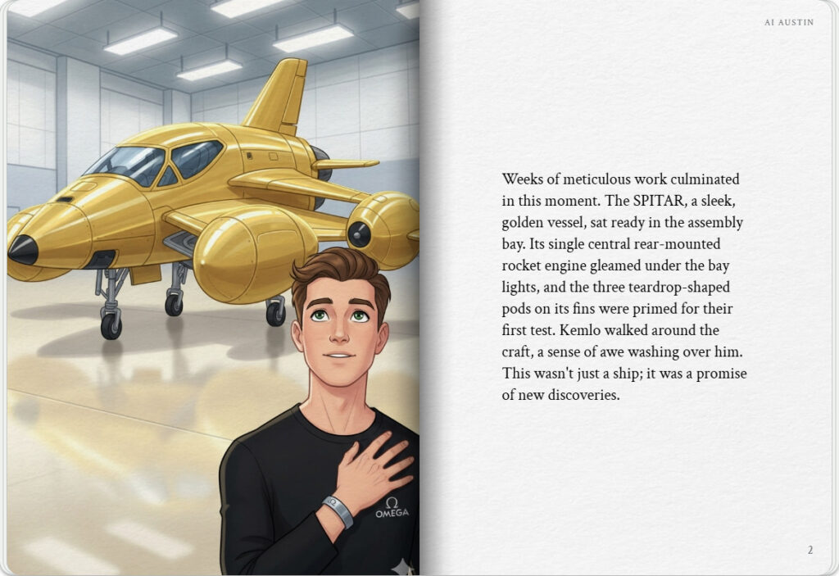

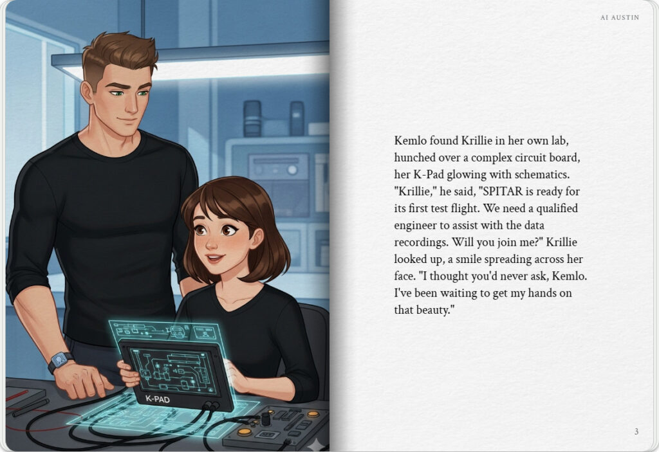
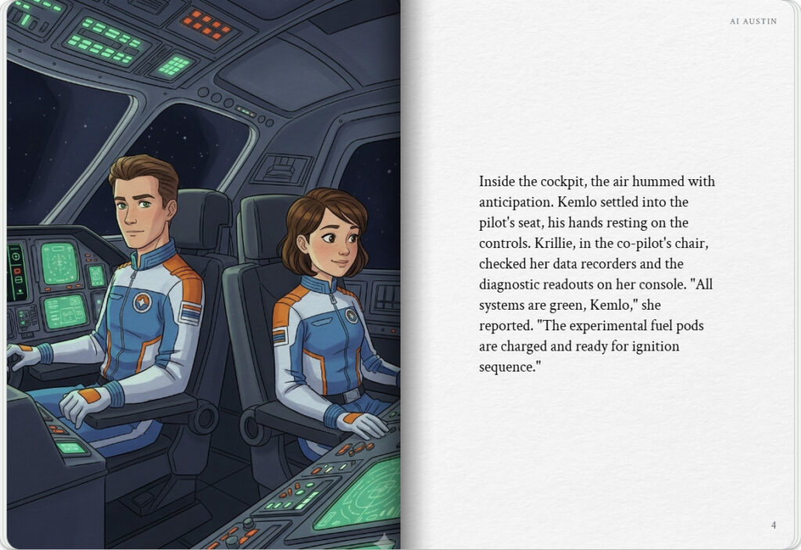

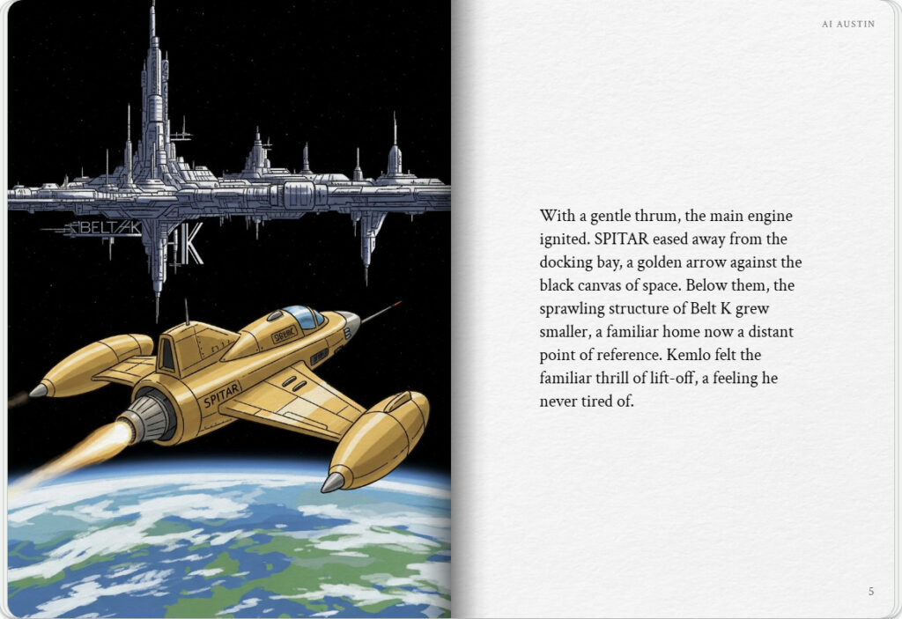
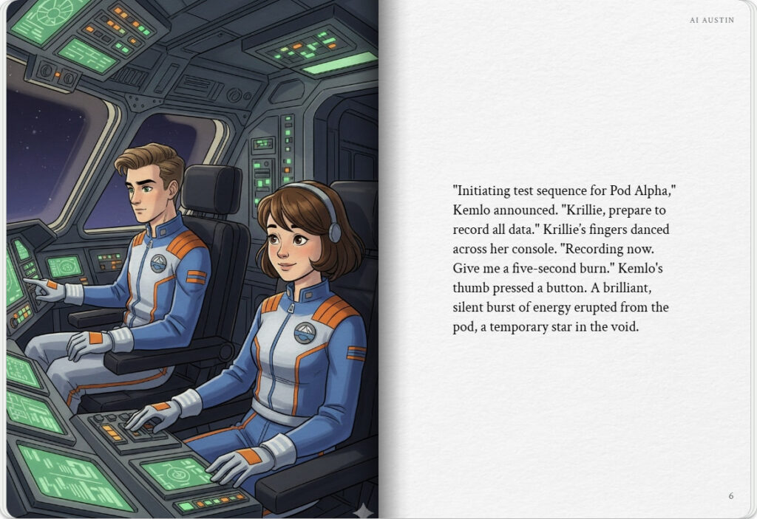

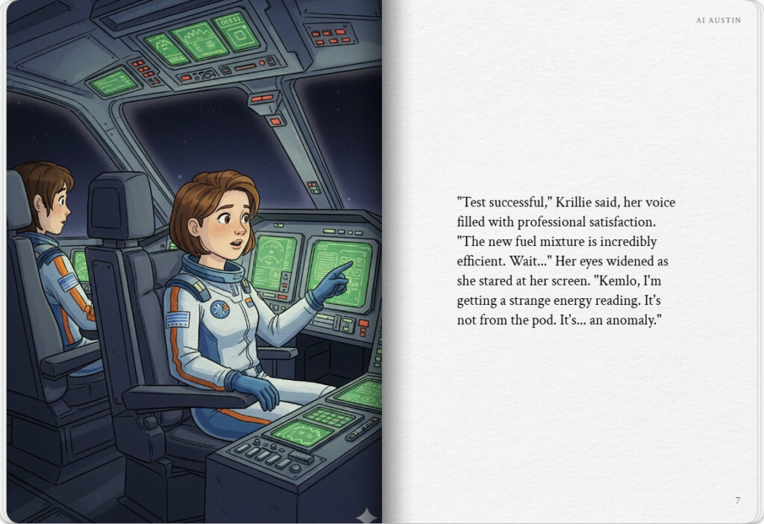
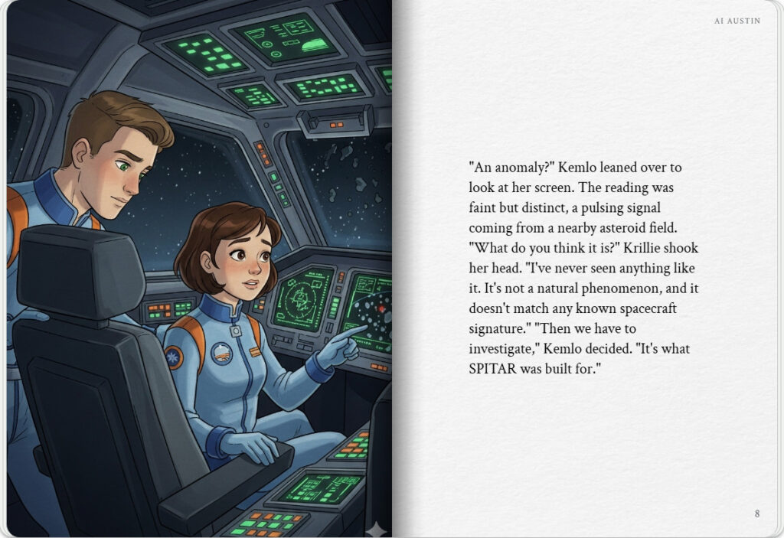

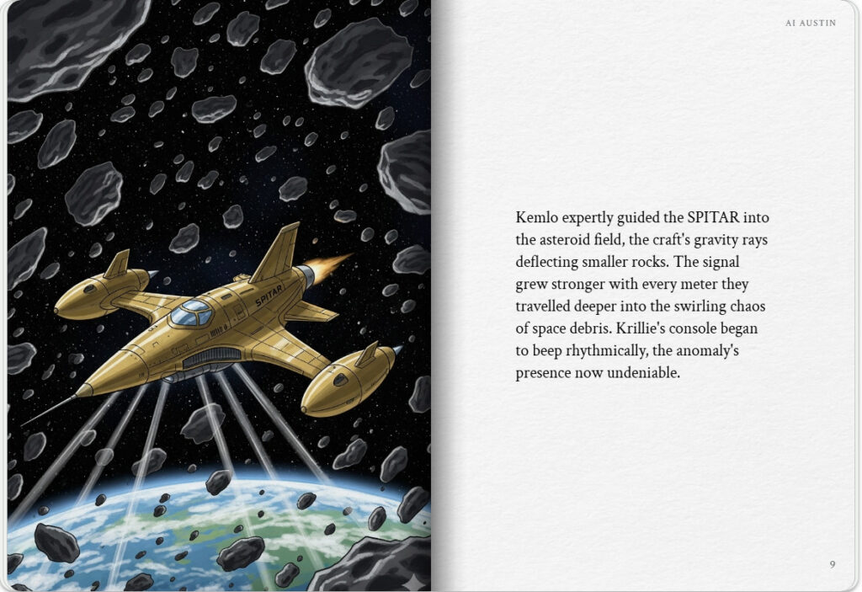
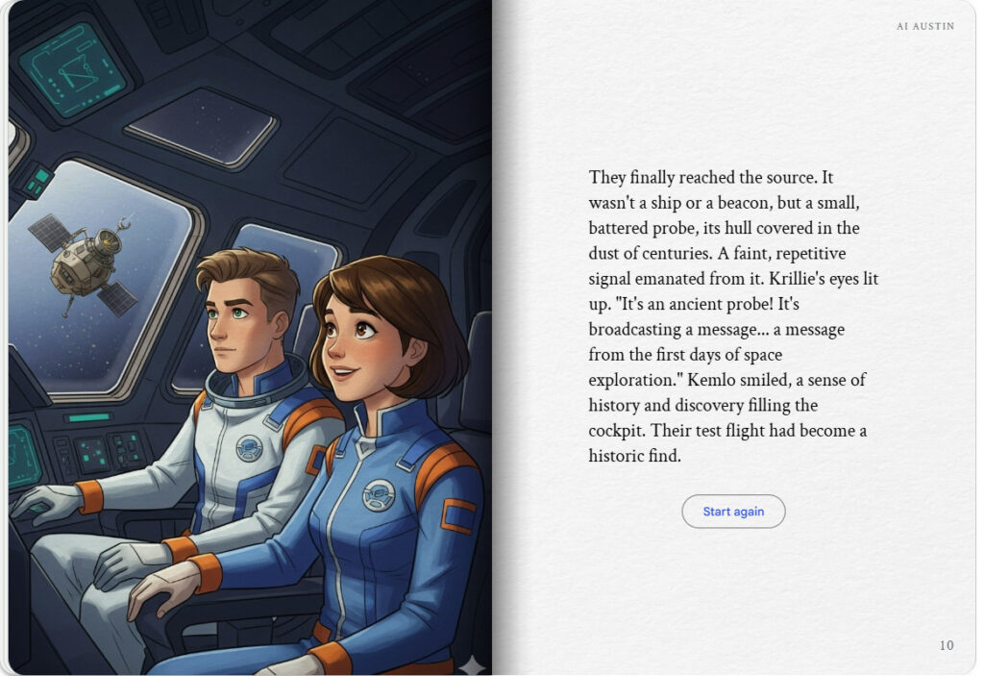

Note: version for editing (needs Ai Austin author login) is here (Development Notes).

