Kemlo & Krillie – The Gravity Ray Gambit
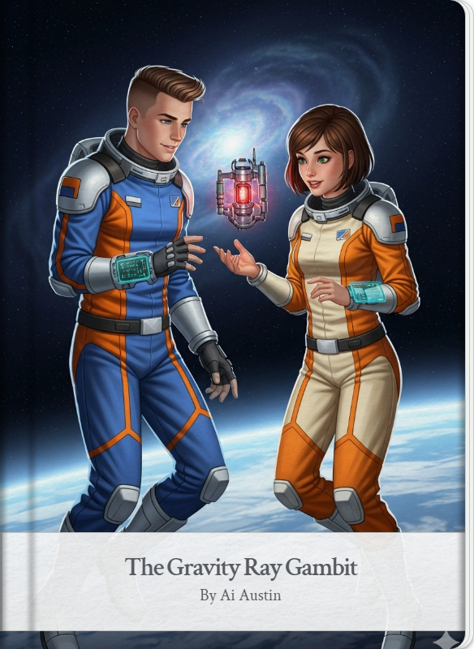
Posted on October 12, 2025 by bat
This is Storybook 7 in “The Further Adventures of Kemlo & Krillie in Space” series. It is produced using Google Gemini Storybooks AI App which lets you create a customized picture book, for either children or adults, given a topic, an optional target audience age, and an optional art style for the images.
Prompt: Use the background given in the attached document to write an exciting storybook for a teenager target audience about “The Further Adventures of Kemlo and Krillie in Space”. Kemlo and Krillie are teenagers who live on Satellite Belt K in Earth Orbit. They can fly in space with the Green “Space Runabout” pictured. Keep the character appearance and name badge label and position on clothing consistent with the attached images. Keep the spacecraft and Belt K space station designs as provided in the images. Use you imagination to come up with an original and exciting story.
The Storybook produced is available at: https://g.co/gemini/share/c2625e4ef48c or PDF Format
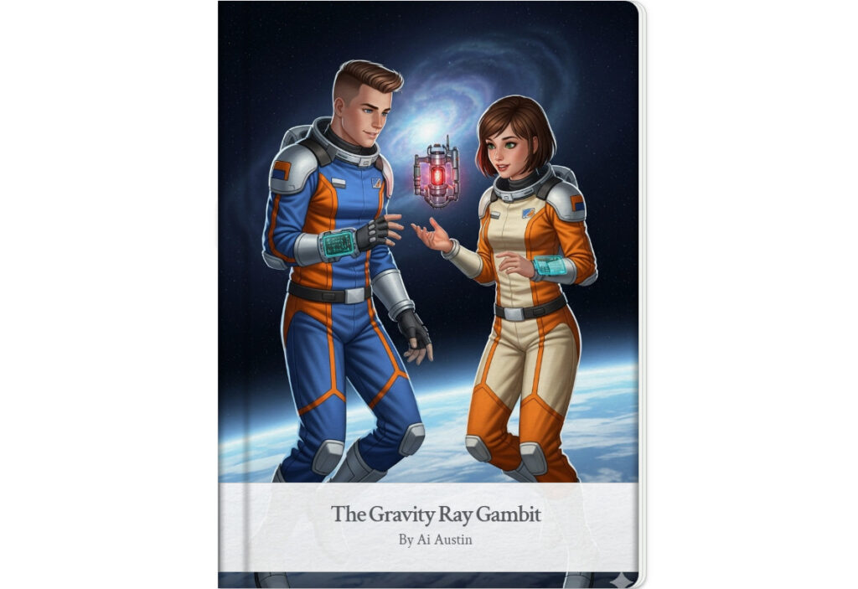
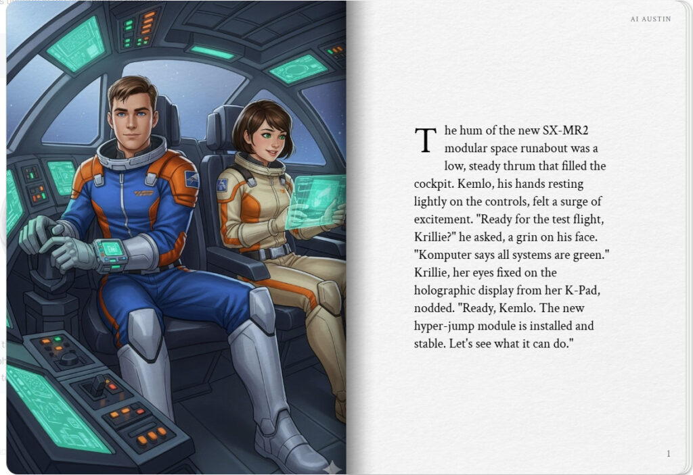
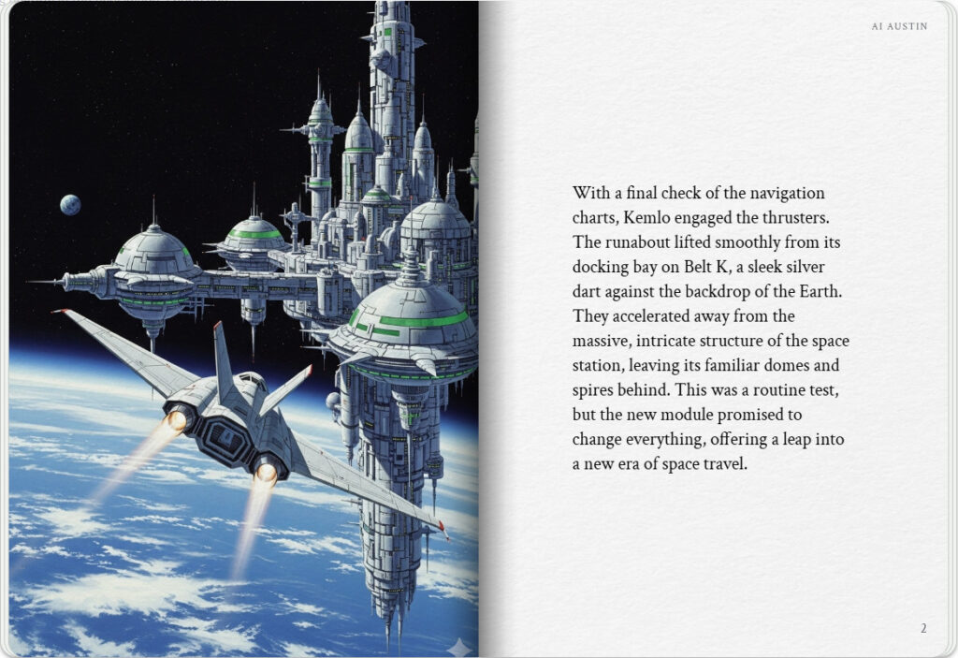

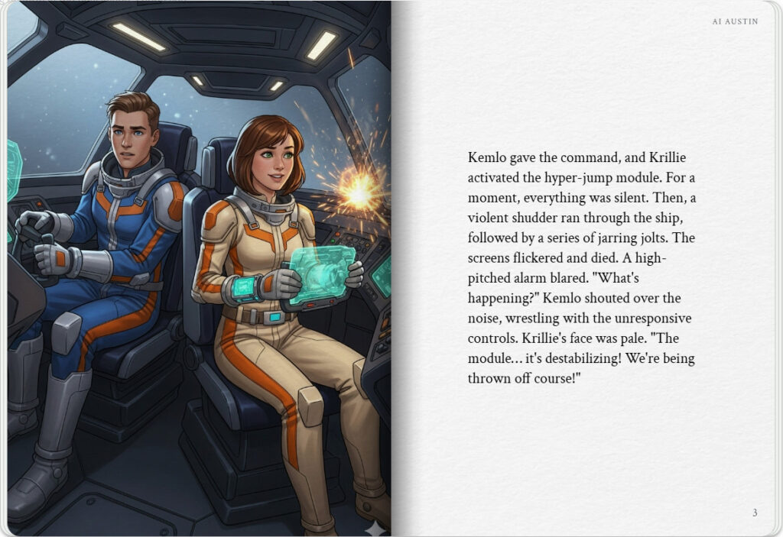
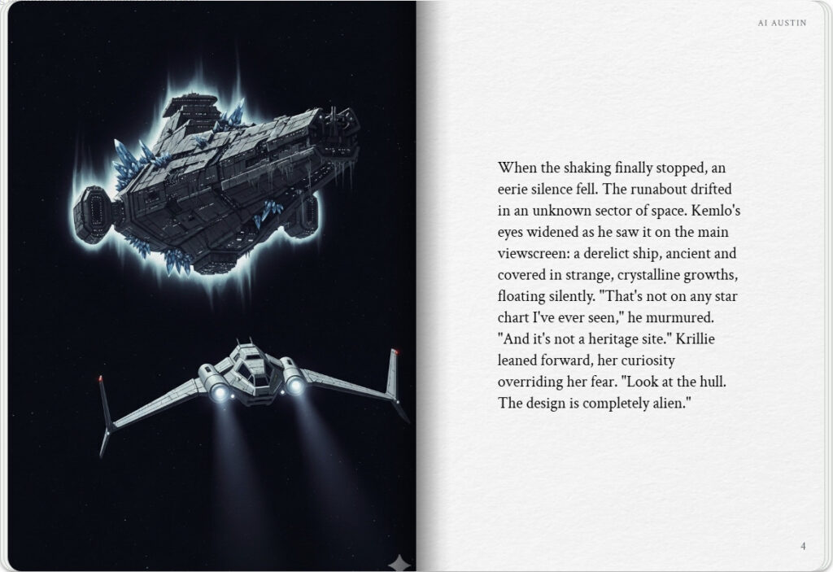

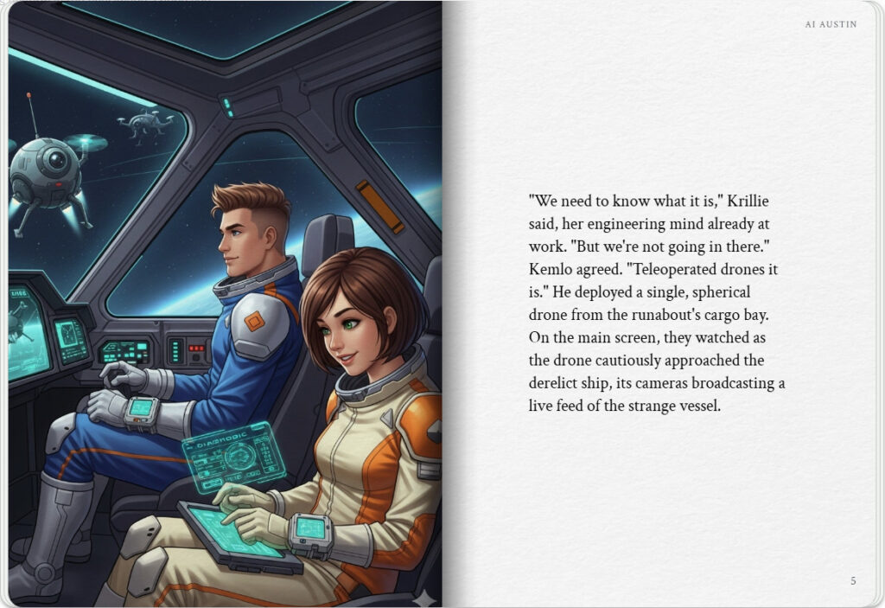
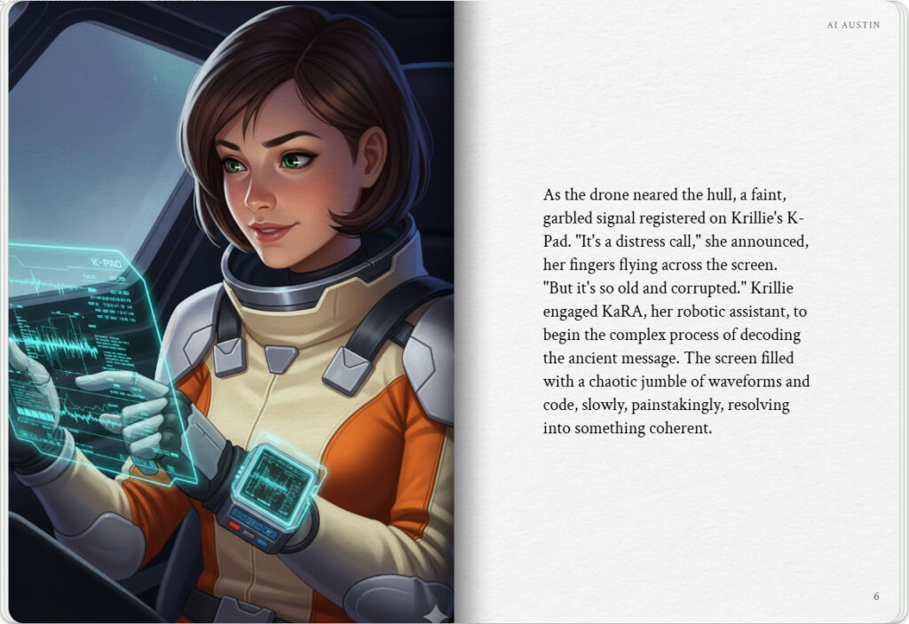

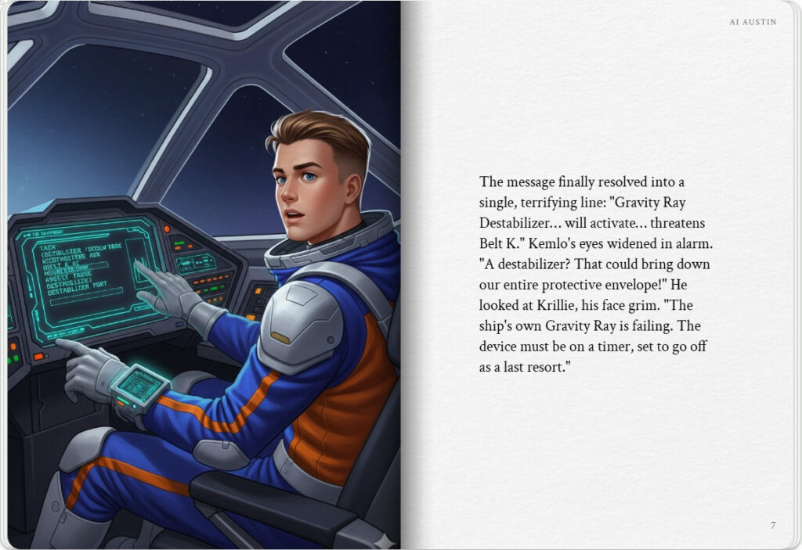
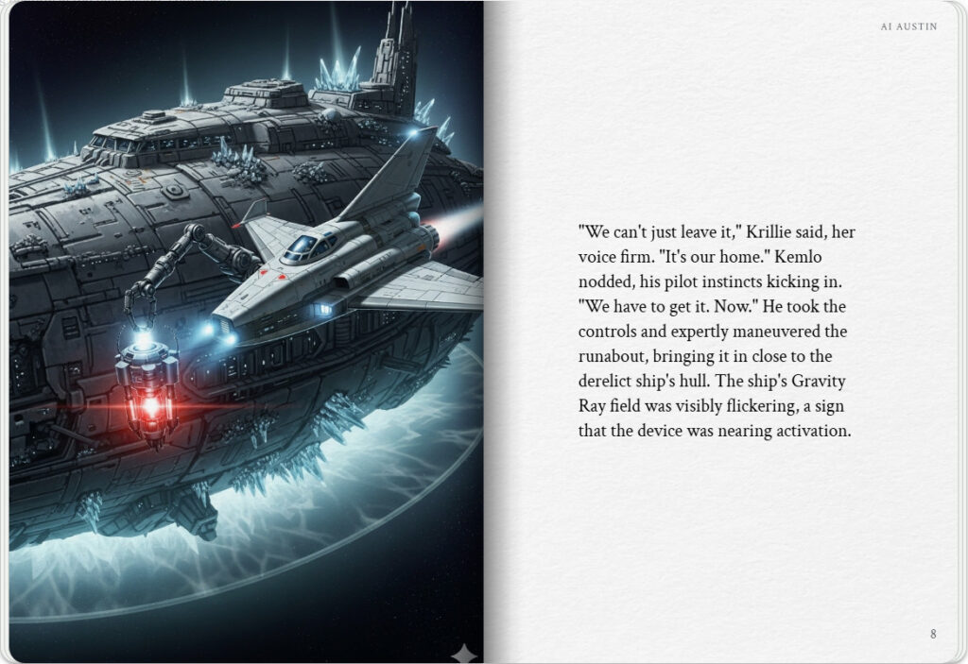

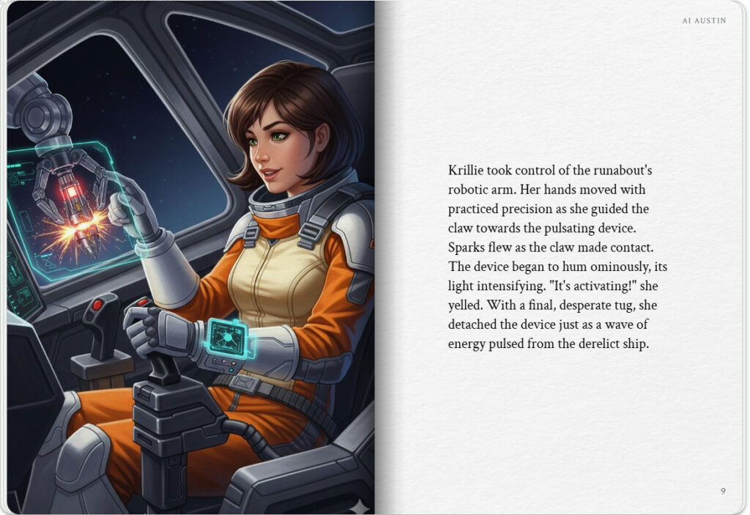
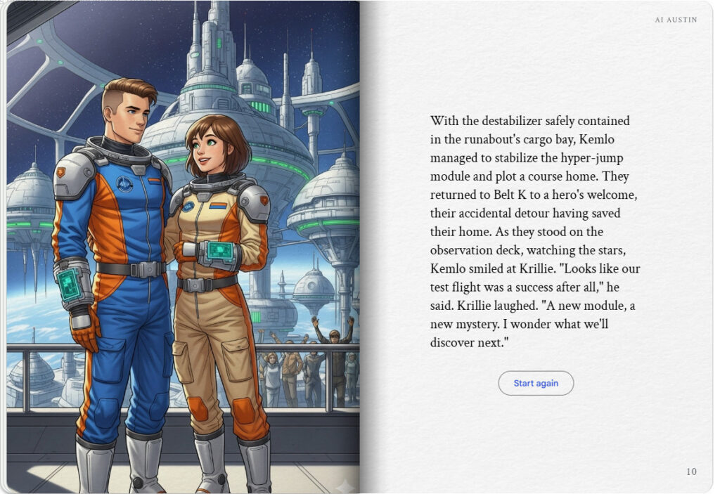

Note: version for editing (needs Ai Austin author login) is here (Development

