Far from Tranquillity
Posted on September 10, 2025 by bat
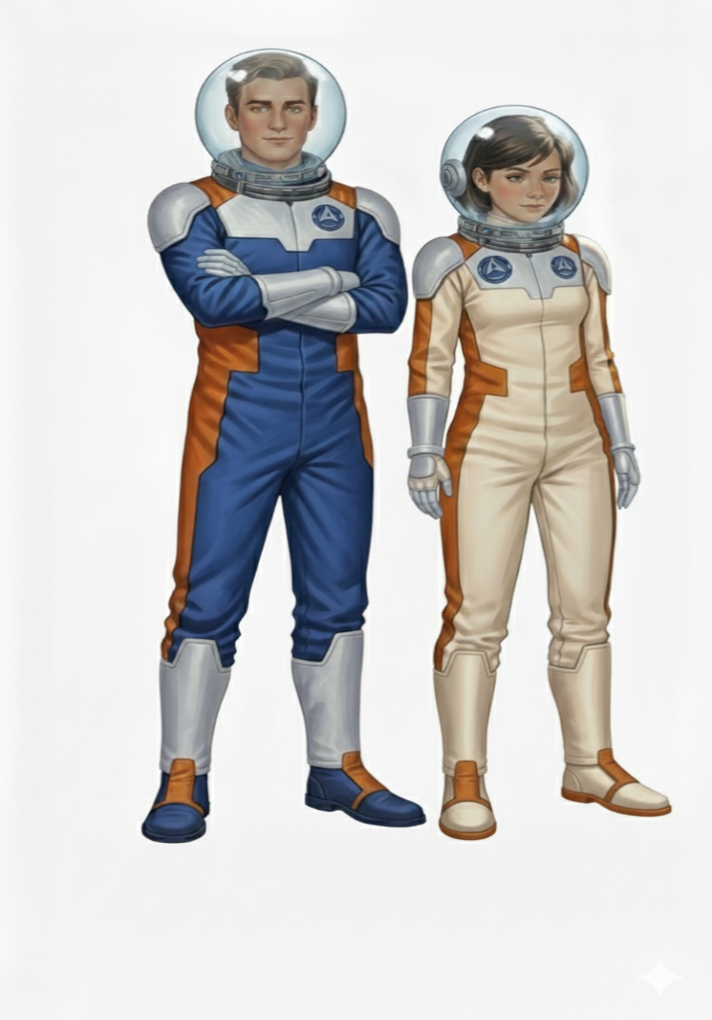
This is Storybook 6 in “The Further Adventures of Kemlo & Krillie in Space” series. It is produced using Google Gemini Storybooks AI App which lets you create a customized picture book, for either children or adults, given a topic, an optional target audience age, and an optional art style for the images.
Prompt: Create a Storybook with title “Far from Tranquillity”. Use the background given in the attached document to write a storybook for a teenager target audience about the Further Adventures of Kemlo and Krillie who are teenagers who live on Satellite Belt K in Earth Orbit. Keep the character appearance and name badge label and position on clothing consistent with the attached image. Use the appearance of the two seater green Space Runabout.
Kemlo and Krillie have been given the mission of checking on the integrity of the Apollo 11 Offworld Heritage Site on the Moon. The Satellite Belt K Officials are concerned that growing tourism poses a risk.
Kemlo an Krille are seen departing Satellite Belt K in the green Space Runabout with the Moon hanging in space ahead.
Kemlo and Krillie land on the Moon a little away from Apollo 11 and look out from their Space Runabout. The original Apollo 11 landing stage remains in place but a replica ascent stage has been added back to show the Lunar Module as it would have appeared when Neil Armstrong and Buzz Aldrin first walked on the Moon. Two Space Excursion vehicles that can accommodate about 10 people and a group of lunar tourists in bright space suits stand some 50 metres away from the lunar module.
Kemlo and Krille put on their full spacesuits and globe helmets and walk across to the tourist group. This group is well behaved and is staying away form the area of the first Moon landing as required.
But looking across to where Neil Armstrong’s “First Step for (a) Man” still is as clear as when it was first planted, they can see the potential risk from future tourists or small children.
Kemlo and Krille retrieve two large carry bags from the Space Runabout and walk back over to the area around the Lunar Module.
Kemlo and Krille start to place on the ground tennis ball sized blue neon globes taken from their carry bags. They are making a circle some 100 metres in diameter fully around the Lunar Module.
Kemlo calls Satellite Belt K Control on his “Komputer” communications device and says the globes are in position and ready to be activated.
Satellite Belt K Control activates the globe devices which creates an almost invisible shimmering barrier some 10 metres high and 100 metres in diameter fully around Apollo 11. Kemlo and Krillie look on from outside the barrier and the tourist group and their vehicles are away to the other side and outside the barrier.
Kemlo and Krillie re-enter the Space Runabout and have removed their helmets. They look out across the Apollo 11 and the tourist group who have clear views of the lunar module while having a barrier to prevent and possible future incursions into the Offworld Heritage Site space.
Include a final image of Apollo 11 with the nearby lunar tourist group still in their brightly coloured spacesuits and helmets with a number of the children having fun by running at the almost invisible barrier and using it as a vertical trampoline to bounce them far back with the reduced lunar gravity. Kemlo and Krillie laugh as they see the new barrier is already leading to some new “Lunar Fun and Games”.
The storybook uses background created previously using AI tools based on the Kemlo Spaceworld series of books by E.C. Eliott published in 1954 to 1963. It uses images and PDF of the contents of this blog post: https://blog.inf.ed.ac.uk/atate/2025/09/10/kemlo-and-krillie-briefing/
There are a few glitches that could not be resolved by repeated editing requests… On page 6 an extra Krillie is shown in the Space Runabout cockpit. And, although Kemlo and Krillie are international Satellite Belt citizens, lets assume that they added US insignia on their spacesuits to acknowledge their Moon specific mission in honour of the nation which launched Apollo 11 and made the first manned lunar landing. Kemlo and Krillie also should not really be walking where Apollo 11 moonboot footprints are located. Lets hope they one they are near is not the “first step”!
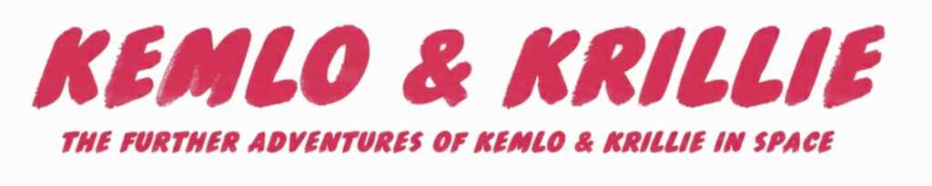
The Storybook produced is available at: https://g.co/gemini/share/9fcef6571d3c or PDF Format.
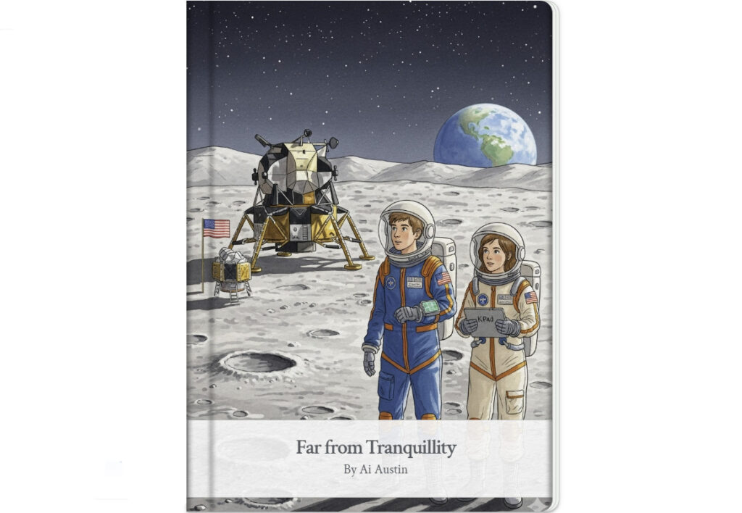
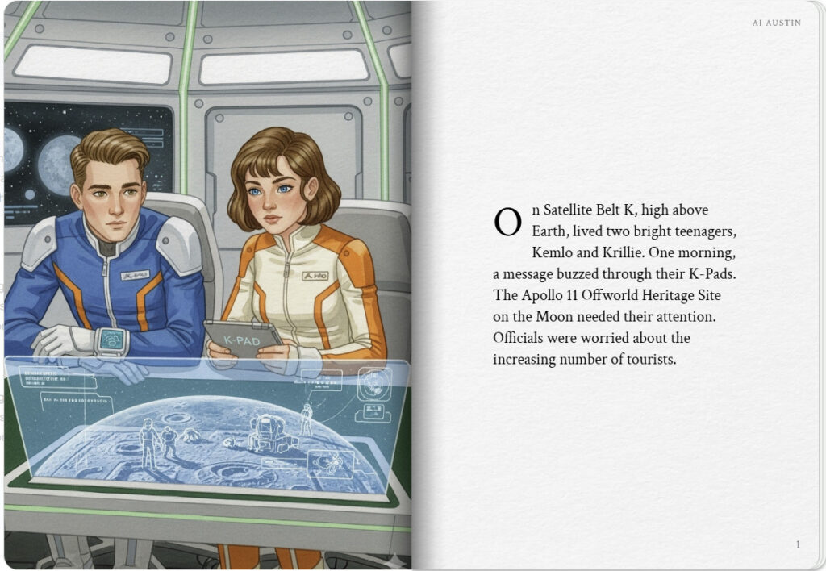
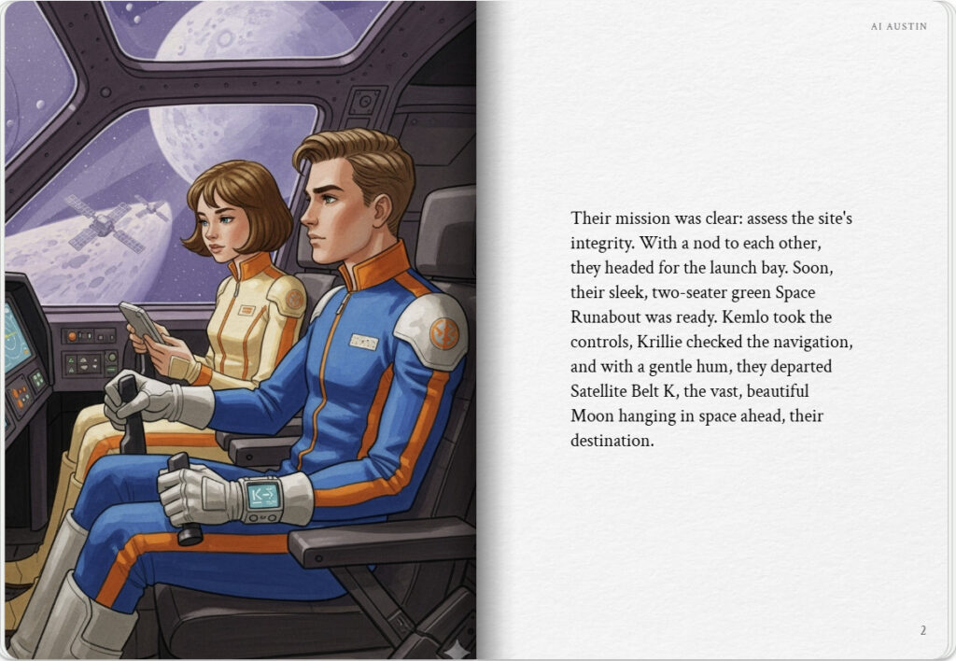

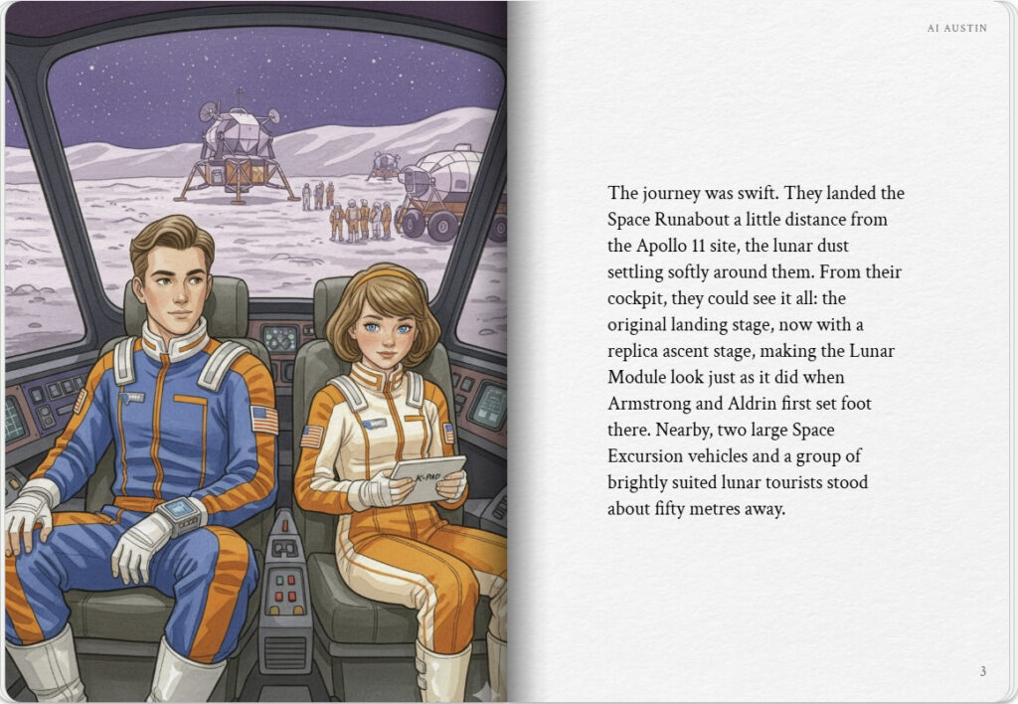
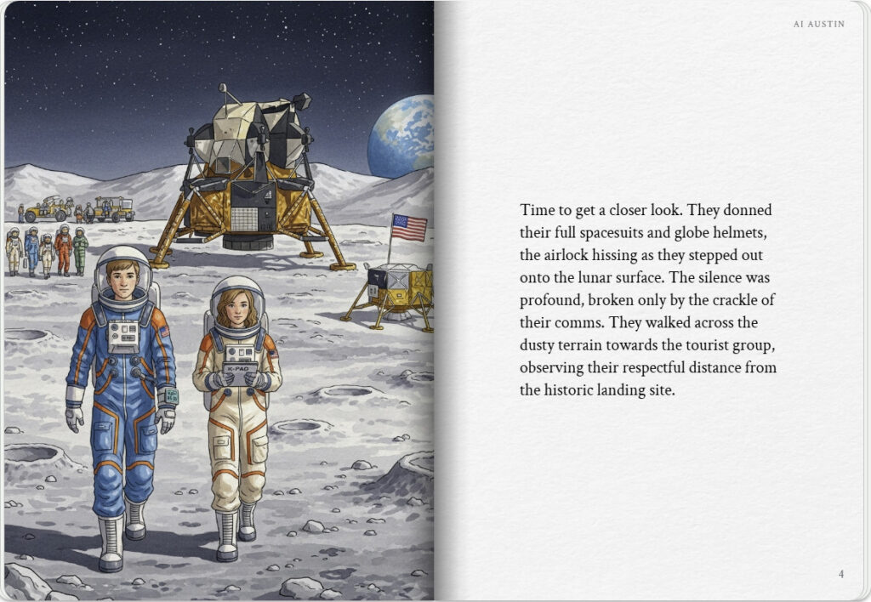

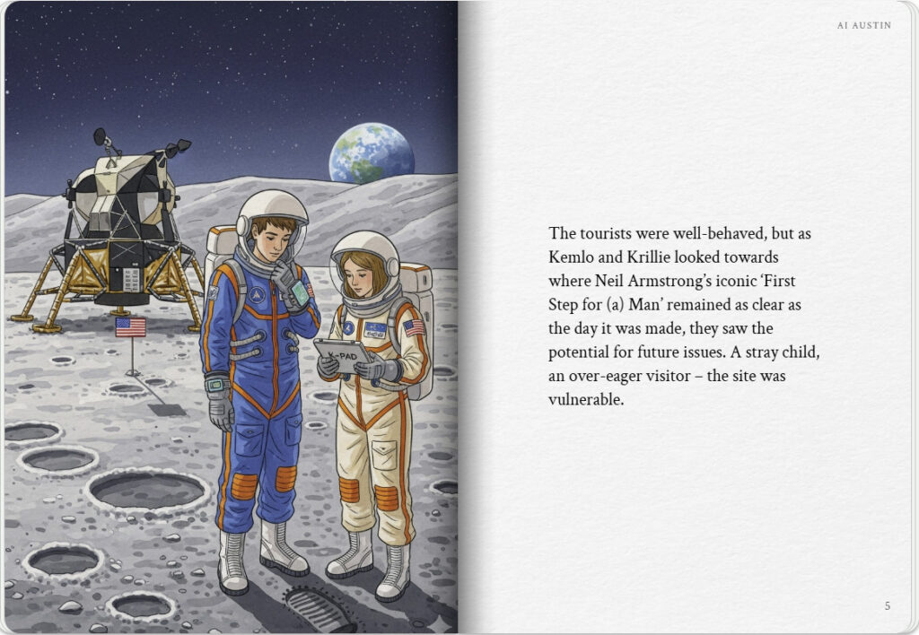
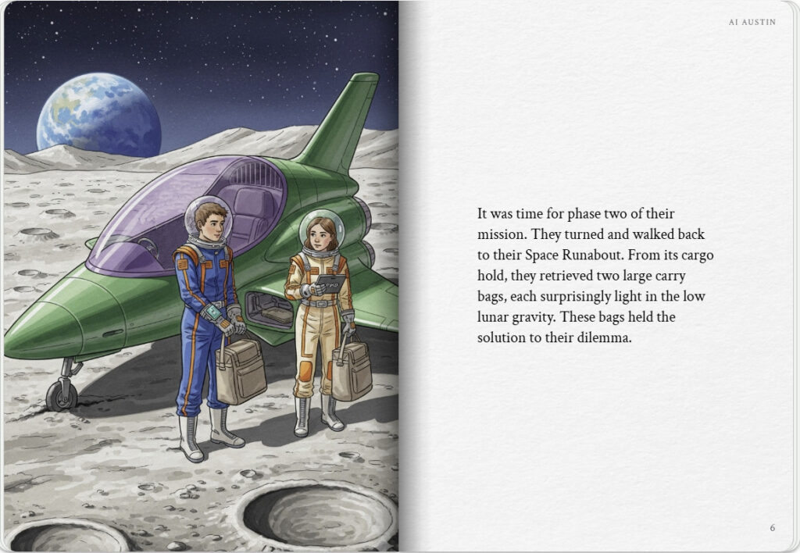

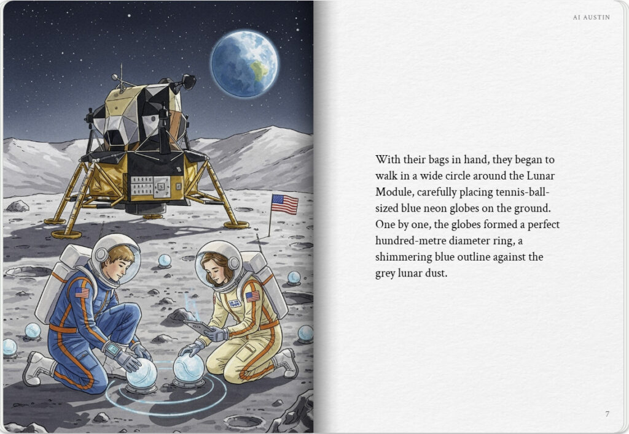
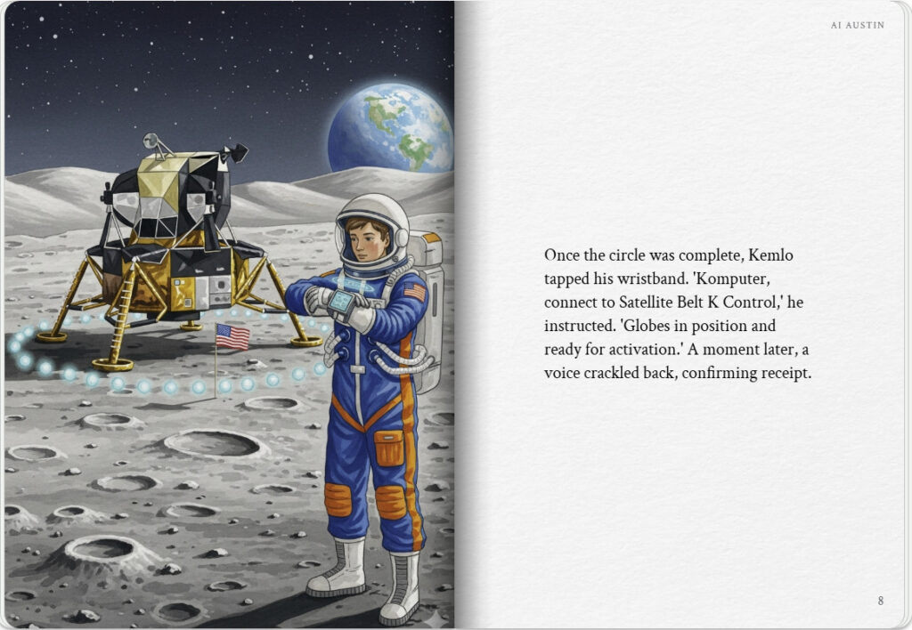

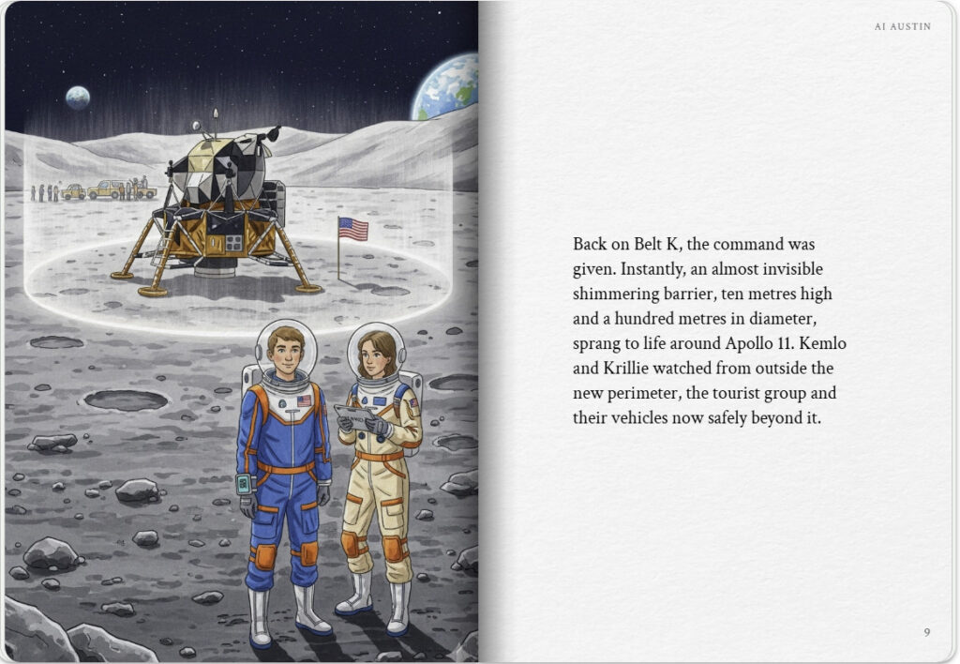
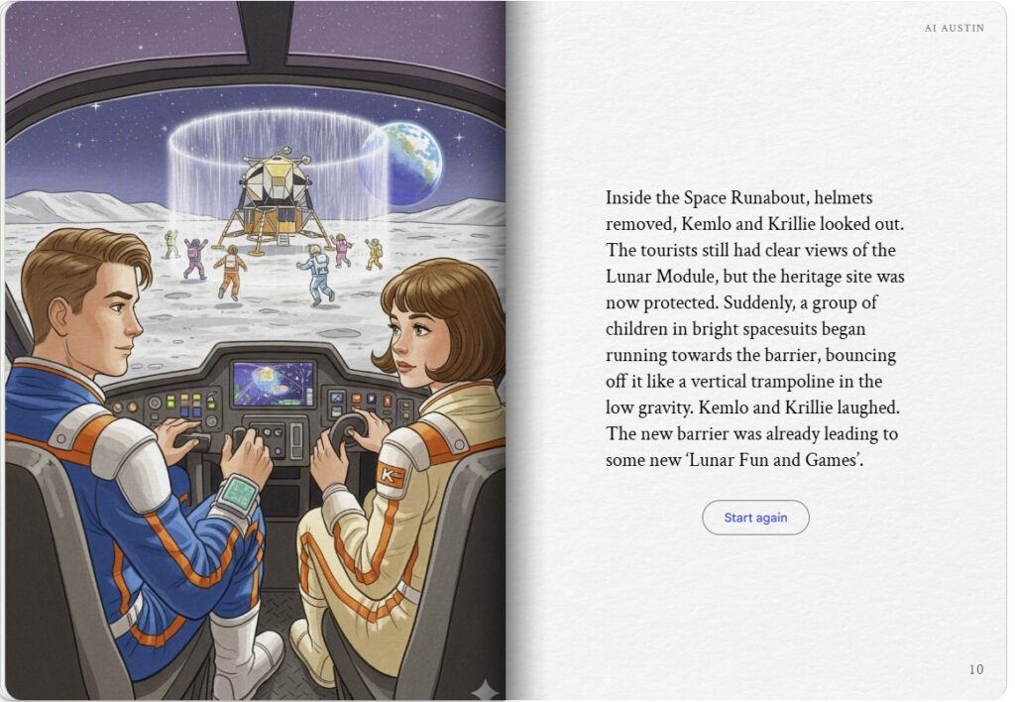

Note: version for editing (needs Ai Austin author login) is here (Development Notes).

