2001: A Birthday Odyssey
Posted on September 9, 2025 by bat
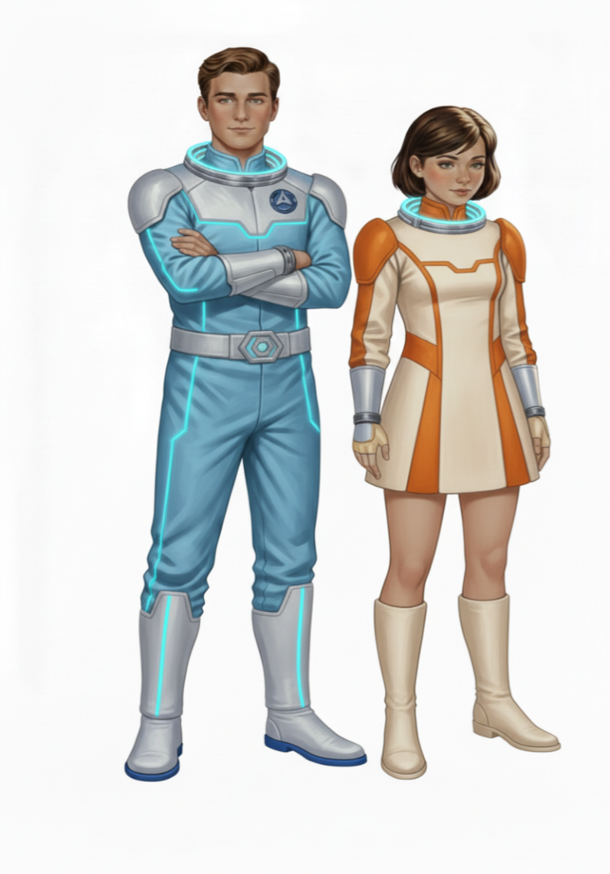
This is Storybook 5 in “The Further Adventures of Kemlo & Krillie in Space” series. It is produced using Google Gemini Storybooks AI App which lets you create a customized picture book, for either children or adults, given a topic, an optional target audience age, and an optional art style for the images.
Prompt: Create a Storybook with title “2001: A Birthday Odyssey”. Use the background given in the attached document to write a storybook for a teenager target audience about the Further Adventures of Kemlo and Krillie who are teenagers who live on Satellite Belt K in Earth Orbit. Keep the character appearance and name badge label and position on clothing consistent with the attached image. No national flags to be visible and no national or recognizable corporate insignia on clothing or spacesuits. Make sure to use design of the green “Space Runabout” spaceship as in the attached images. The occupants always face the nose when seated inside the craft which has a fully enclosed cockpit cover.
It’s Kemlo’s Birthday! Krillie is joined Kemlo in his cabin on Satellite Belt K. A large window looks out to the Earth with blue oceans shimmering below. On the cabin wall is a movie poster for the film “2001: A Space Odyssey”. Kemlo and Krillie are off duty for the day. Krillie excitedly tells Kemlo that she has made a reservation for a birthday excursion to the “2001 Station” which neither of them have visited before.
Kemlo and Krillie leave Satellite Belt K in Kemlo’s green “Space Runabout” two seater spaceship for the orbital journey across to the far side of Earth.
Kemlo and Krillie approach the “2001 Space Station” actually completed some five decades after the 2001 year in which the movie set. It has two concentric wheel shaped structures attached to a central hub. The designers deliberately used a visual appearance similar to the space station in the movie.
Kemlo pilots his Space Runabout to align with the central hub and face on to the wheels. He engages the 2001 Space Station Gravity Rays with those on his spaceship causing the space runabout to start to rotate at exactly the same rate as the space station. Krillie suggests they deploy a drone to take a selfie image of them approaching the station.
Kemlo carefully manipulates the position of the space runabout to look similar to the a shot of the “PanAm Shuttle” approaching the space station in the movie. Krillie notes that the shot will make a great addition to an article for her “Space Diary”
After landing and disembarking, Kemlo and Krillie change into fashionable 22nd Century Retro-Future clothing with neon highlights and make their way into the reception area for the fashionable “Earthrim Cocktail Lounge”.
Krillie has arranged a window table with fantastic views over the Earth and its Blue Oceans. They are served with bright colourful fruit juice cocktails. They sit looking out as the planet below rotates under them.
Kemlo and Krille have returned to the space station and both are still dressed in their 22nd Century Retro-Future clothing. Krillie is walking along the Satellite belt-K station corridors towards Kemlo’s cabin. Under her arm is a wrapped present with a box large enough for a poster.
Krillie is with Kemlo in his cabin having given Kemlo his birthday gift. It is the selfie image of their Space Runabout approaching the 2001 Space Station.
Include a final image of Kemlo and Krillie in the observation level of satellite Belt K along with a diverse group of male and female teenage Space Scouts and some smaller children cheering and waving as they look out at a colourful drone show spelling out the words “Happy Birthday Kemlo!”
The storybook uses background created previously using AI tools based on the Kemlo Spaceworld series of books by E.C. Eliott published in 1954 to 1963. It uses images and PDF of the contents of this blog post: https://blog.inf.ed.ac.uk/atate/2025/09/10/kemlo-and-krillie-briefing/
There are a number of technical issues with the illustrations even after a few correction requests. Lack of consistency of the Space Runabout, though a sample image was provided. The drones are shown with rotating blades which would not work in space. The dual concentric ring space station appears differently in various illustrations and the selfie and later poster of the selfie are not really as I was prompting and editing for.
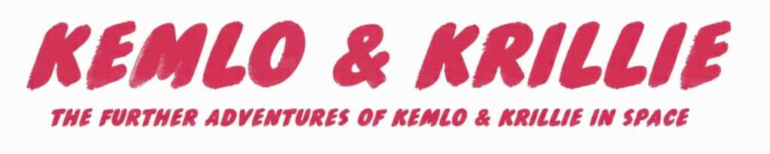
The Storybook produced is available at: https://gemini.google.com/share/51c819c809ff or PDF Format.
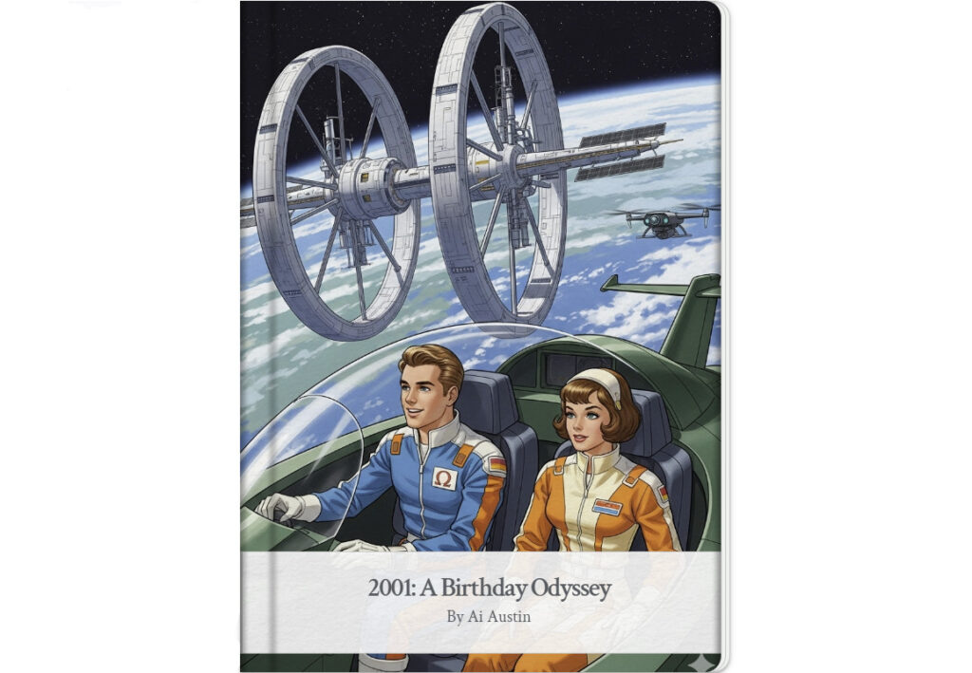
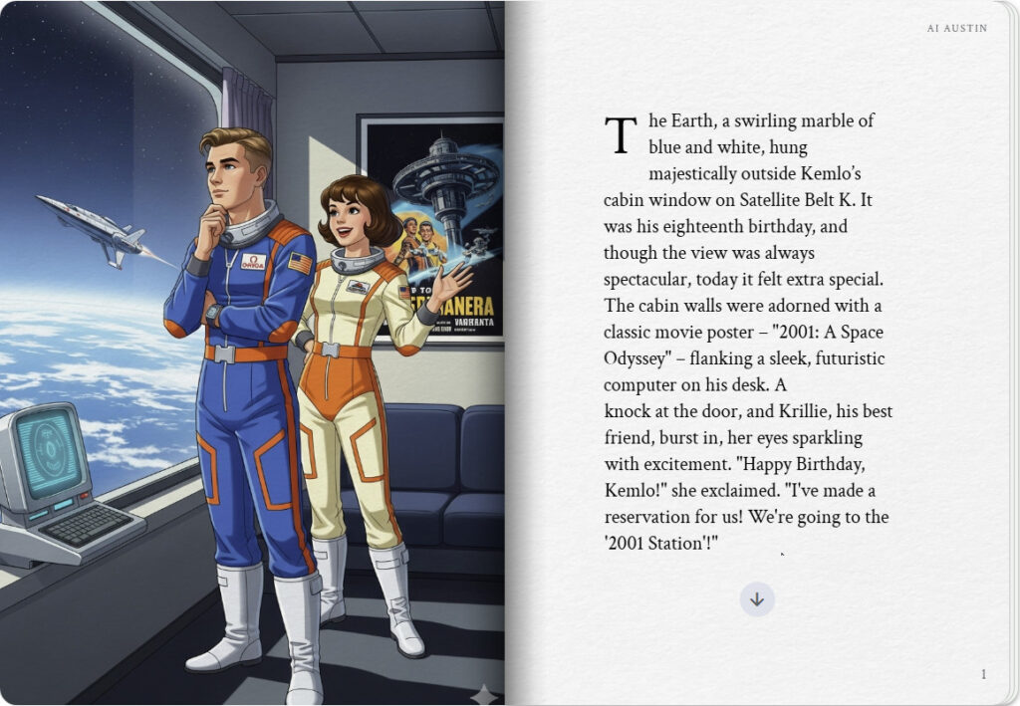
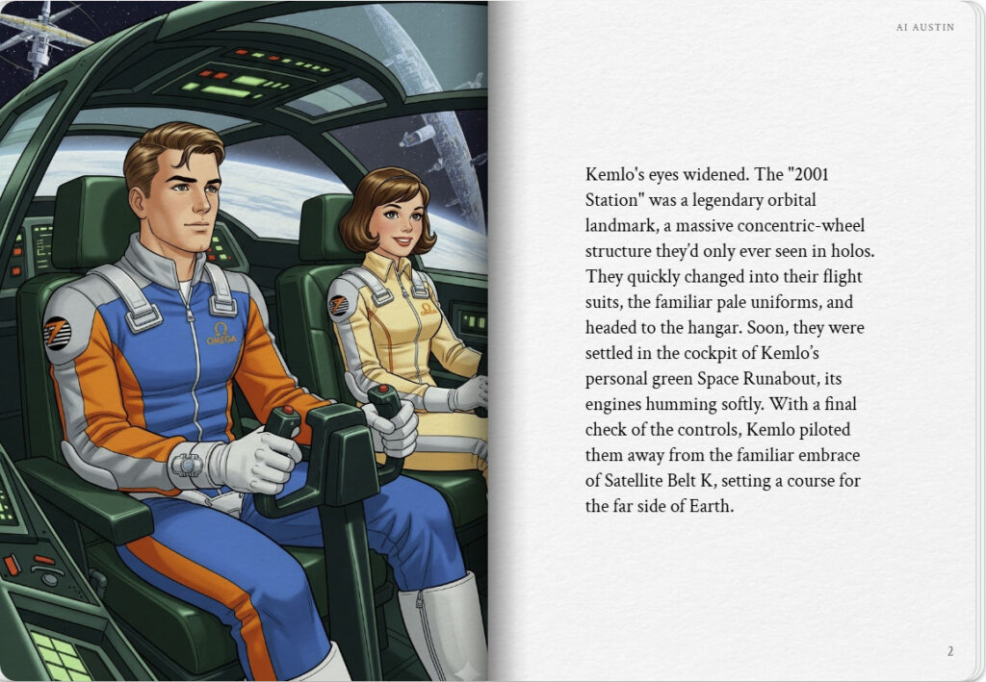

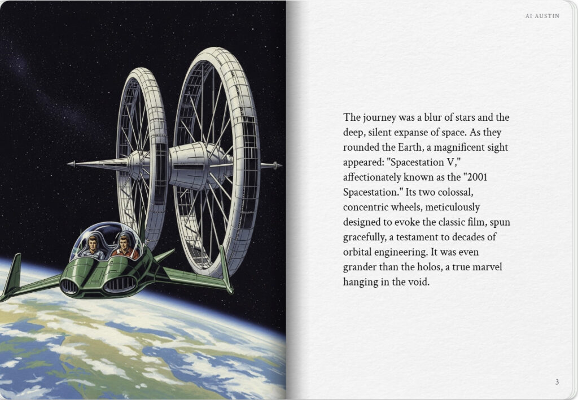
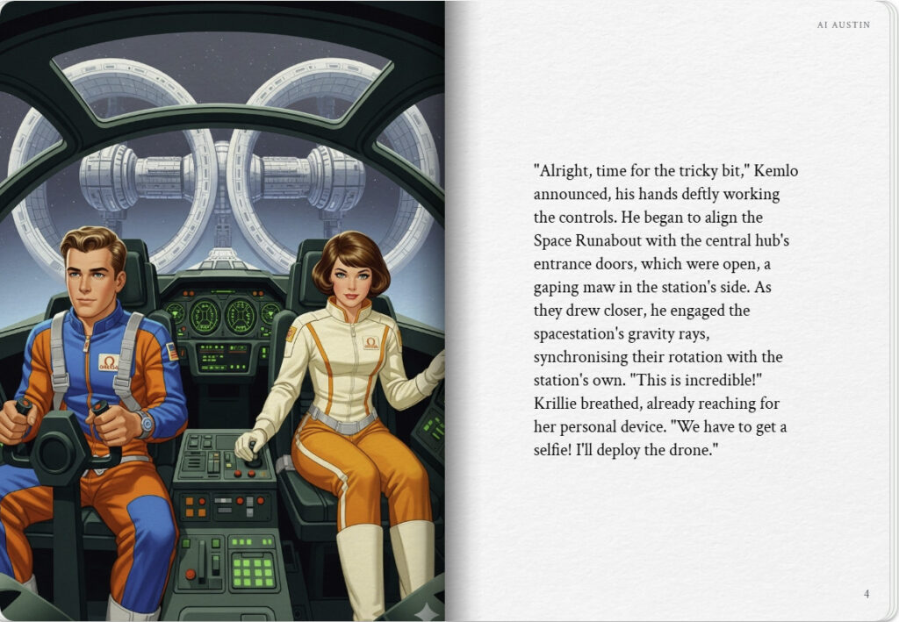

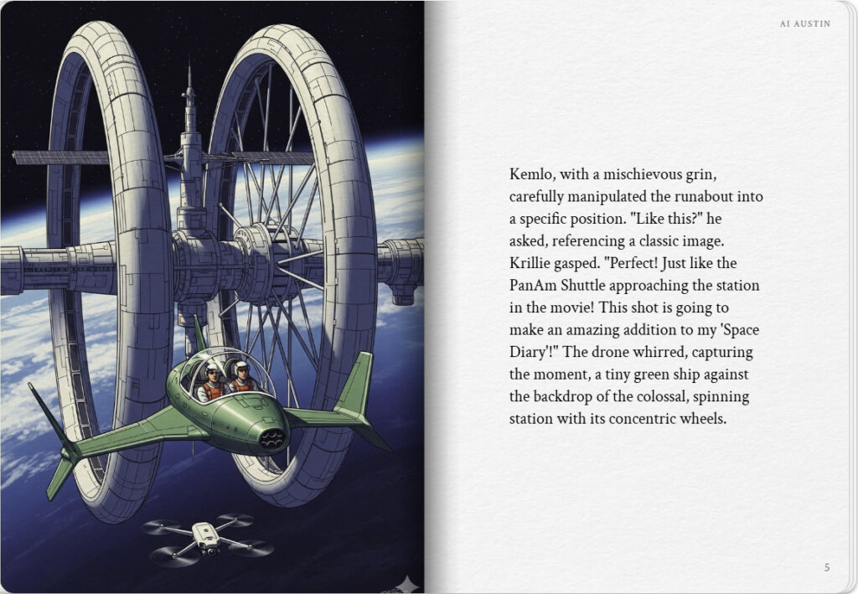
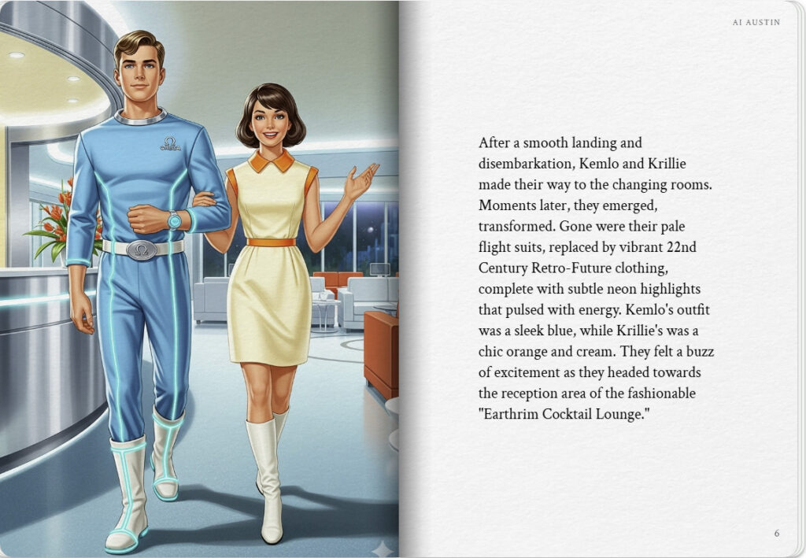

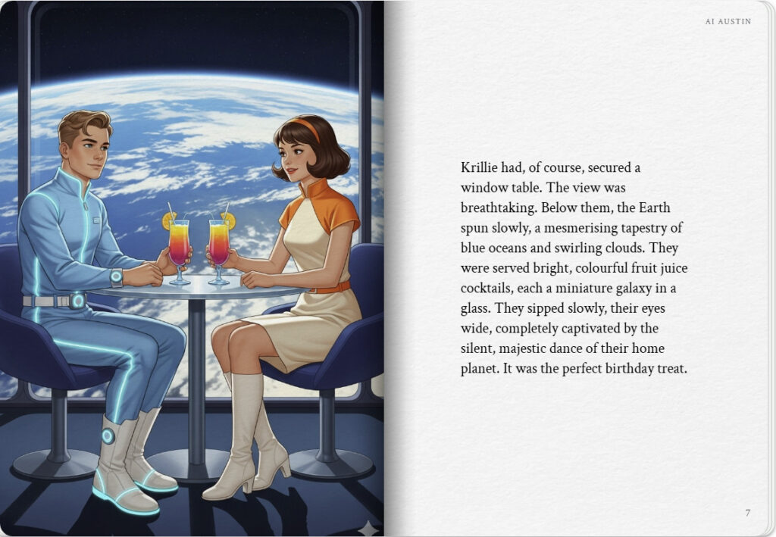
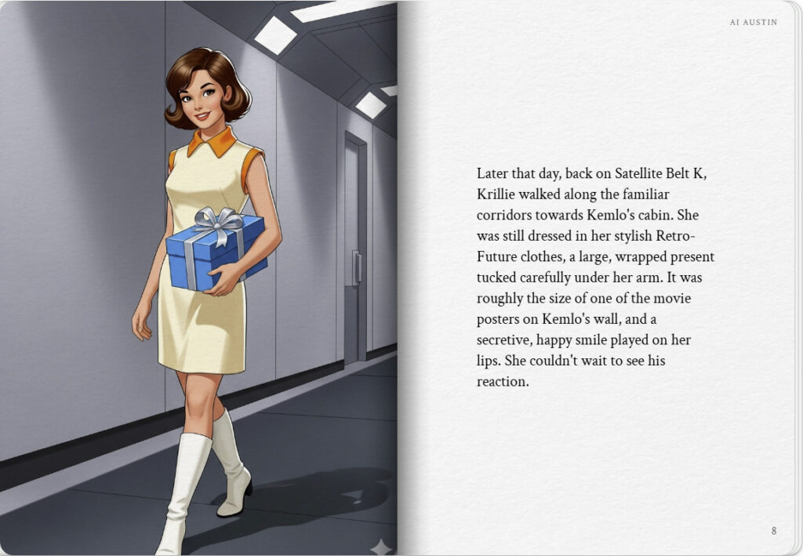

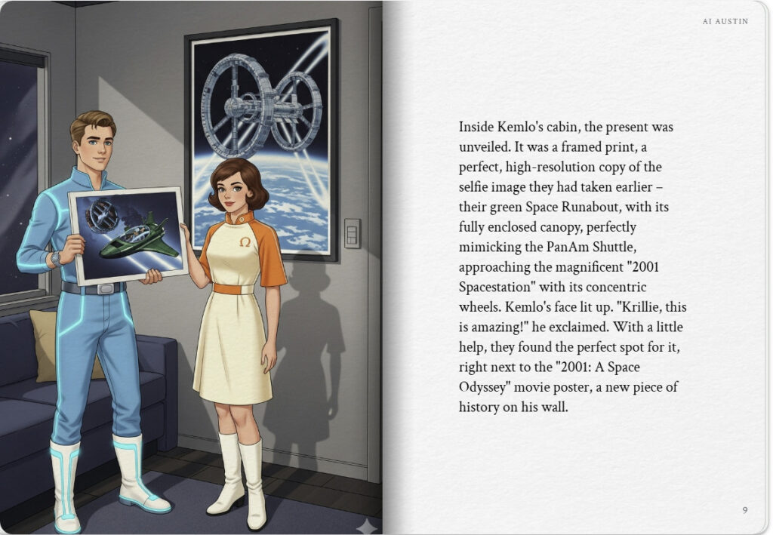
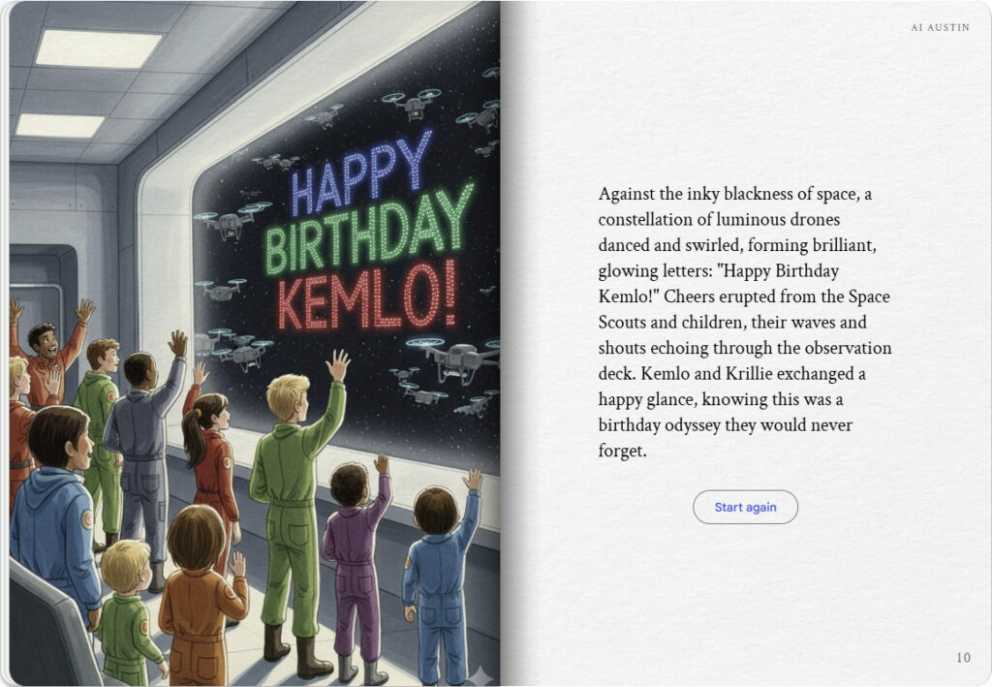

Note: version for editing (needs Ai Austin author login) is here (Development Notes).

