Kemlo and the Gravity Ray Gun
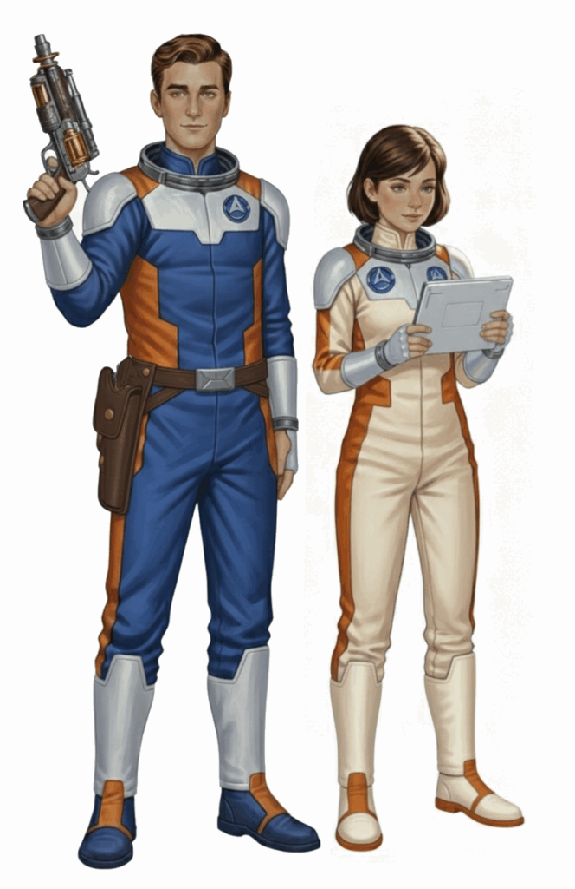
Posted on September 8, 2025 by bat
This is Storybook 4 in “The Further Adventures of Kemlo & Krillie in Space” series. It is produced using Google Gemini Storybooks which lets you create a customized picture book, for either children or adults, given a topic, an optional target audience age, and an optional art style for the images.
Prompt: Create a Storybook with title “Kemlo and the Gravity Ray Gun”. Use the background given in the attached document to write a storybook for a teenager target audience about the Further Adventures of Kemlo and Krillie, teenagers who live on Satellite Belt K in Earth Orbit. Keep the character appearance and name badge label and position on clothing consistent with the attached image. Kemlo has been given the mission to thoroughly test out a new device. This is a Ray Gun which can project “Gravity Rays”.
These are normally used on Spaceships or Spacestations for positioning and to provide safety shields. The hand held Ray Gun as pictured in the attached image is meant to allow use of gravity rays in different and restricted space situations. Kemlo has a belt and holster on his waist that could hold the Ray Gun when not in his hand. It is Kemlo’s task to identify appropriate and safe uses. Initial experiments are taking place in laboratory conditions and are going well, with Kemlo recording his experience for later analysis.
Over in the Satellite Belt K Spacestation school area with its large overhead dome facing the Earth below, Killie, Kemlo’s female friend, is assisting in an exercise for a class of young children. But a meteorite gets through the protective shield round the Spacestation and hits the dome causing a crack to appear. This puts the children and other occupants at risk.
Krillie quickly calls for emergency assistance from Kemlo, as Captain of the Space Scouts. Kemlo rushes to the scene taking the Ray Gun. He carefully aims it at the crack which is growing larger. This gives temporary stability to ensure the integrity of the school area dome. Krillie meanwhile calls up the Satellite Belt K engineering team, and they rush to the area outside the dome in space with heavy equipment to begin full repairs.
Include a final image of the children alongside Kemlo and Krillie cheering and waving through the dome at the engineering team as they complete repairs.
The storybook uses background created previously using AI tools based on the Kemlo Spaceworld series of books by E.C. Eliott published in 1954 to 1963. It uses images and PDF of the contents of this blog post: https://blog.inf.ed.ac.uk/atate/2025/09/10/kemlo-and-krillie-briefing/
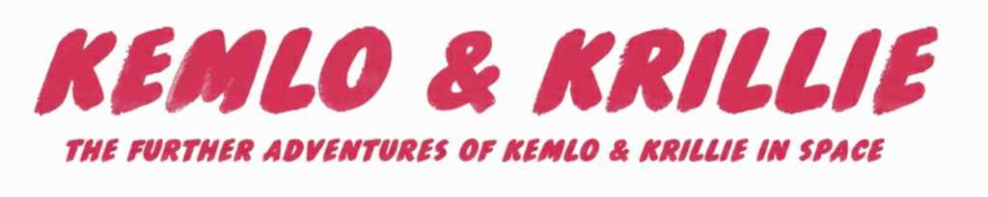
The Storybook produced is available at: https://g.co/gemini/share/6f774a0c5631 or PDF Format.
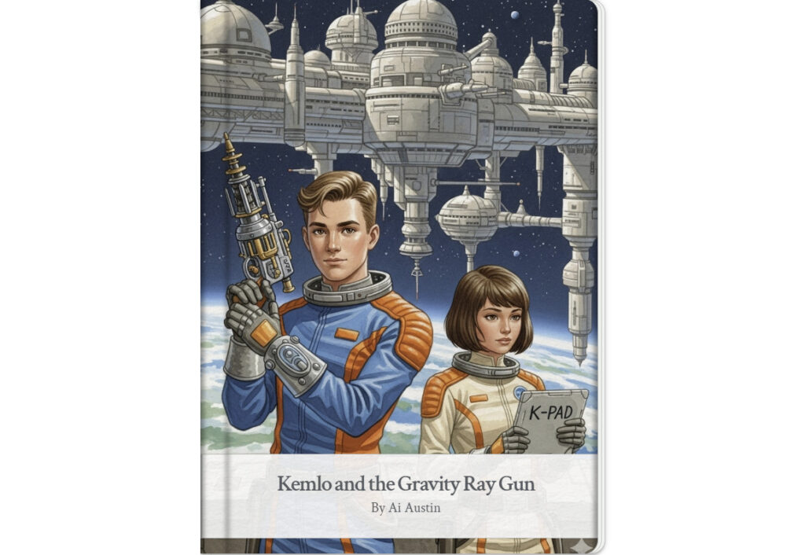
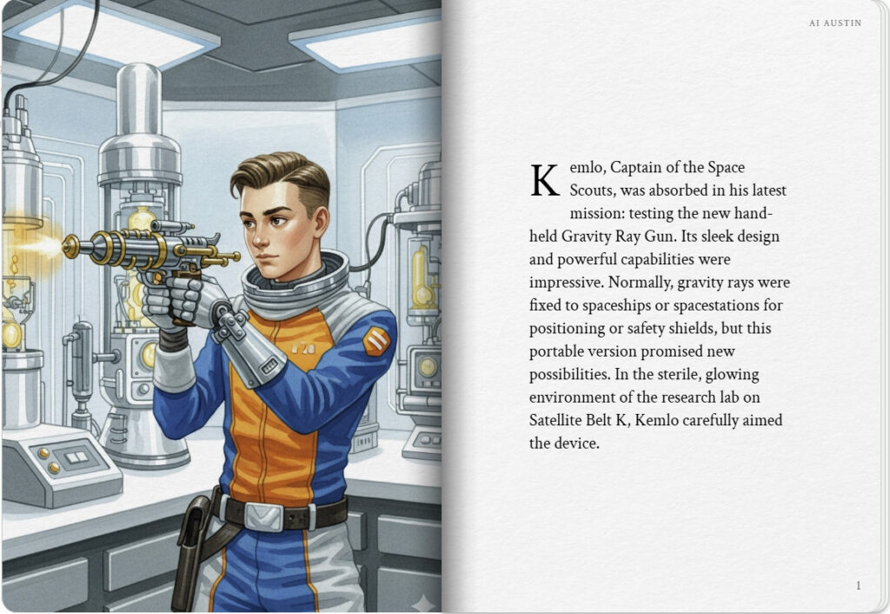
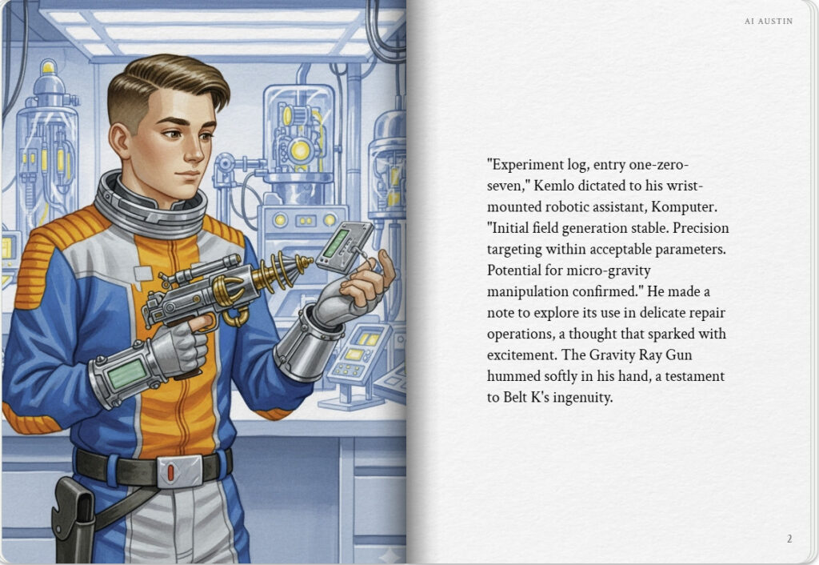

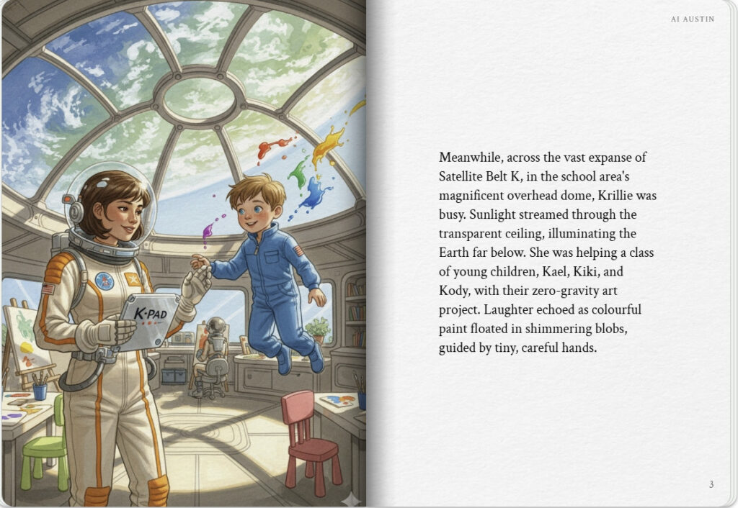
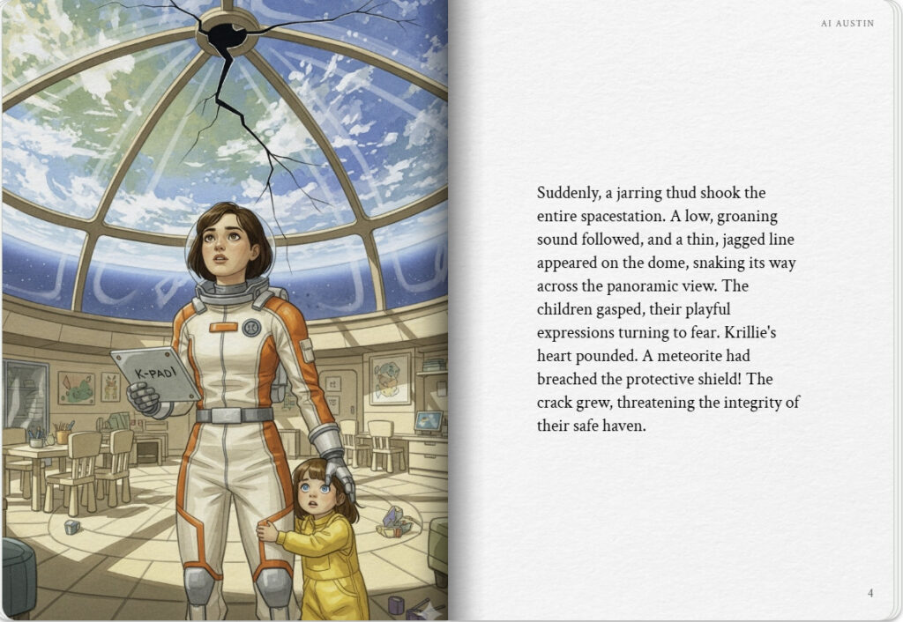

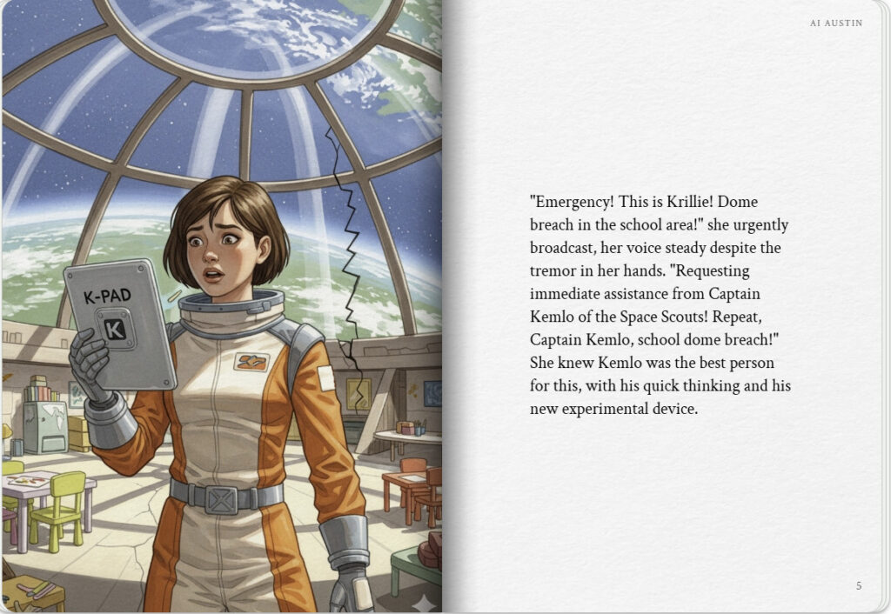
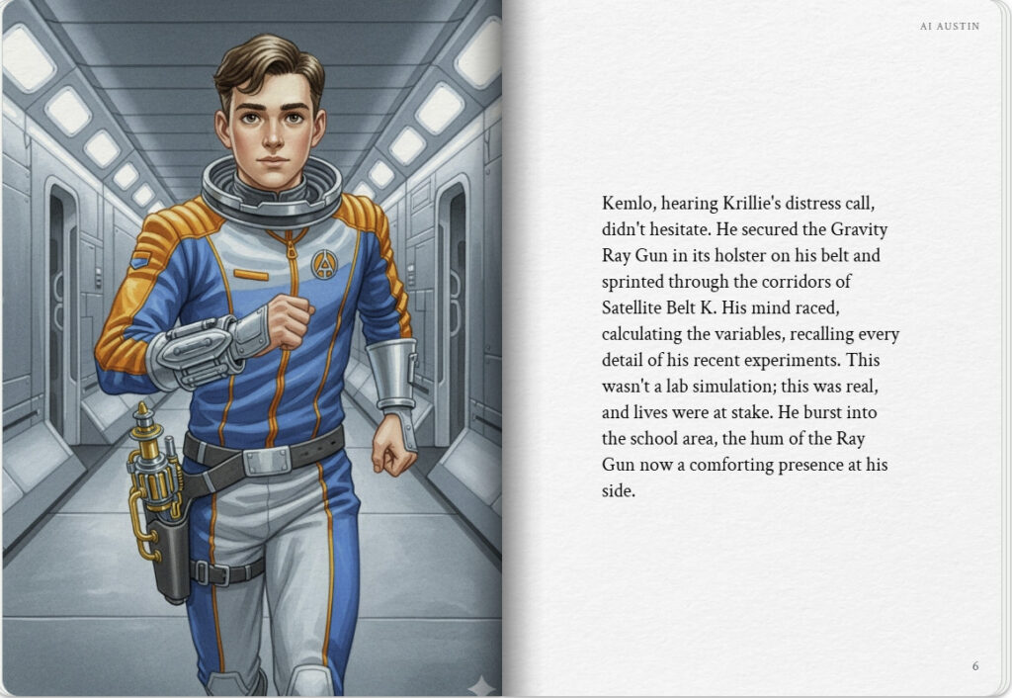

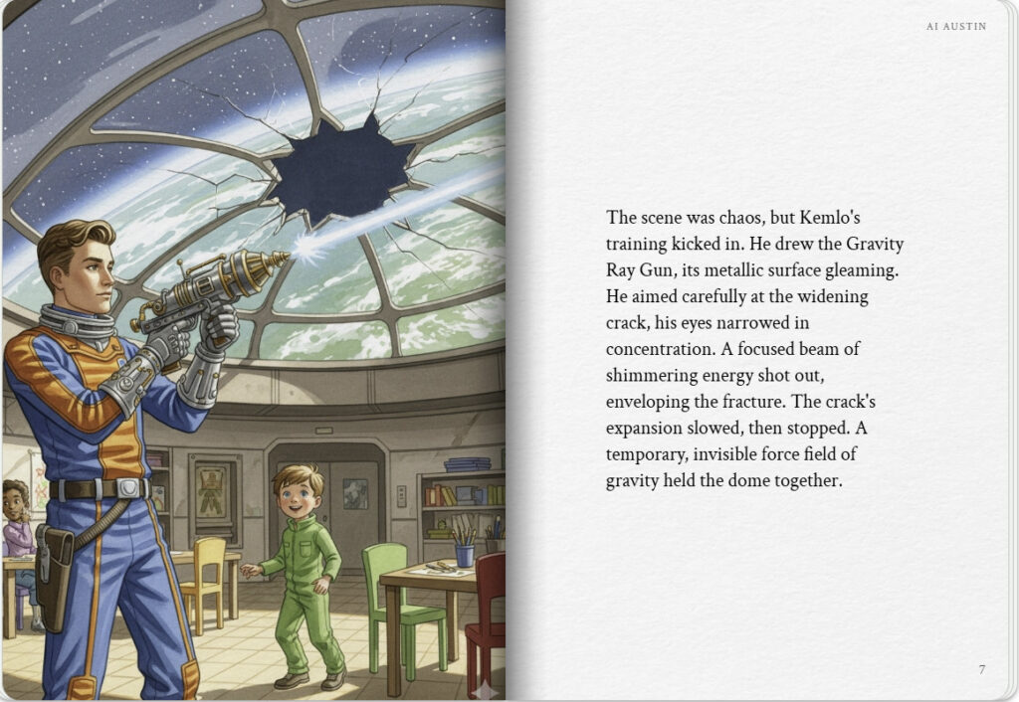
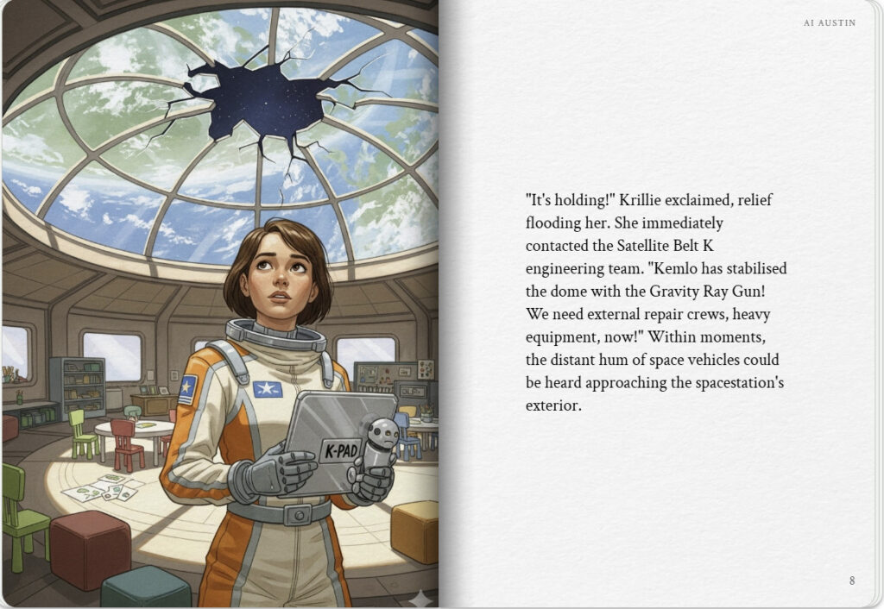

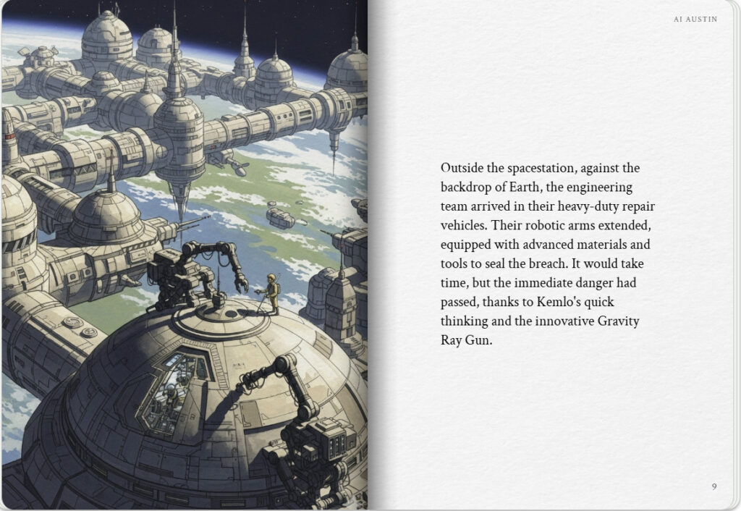
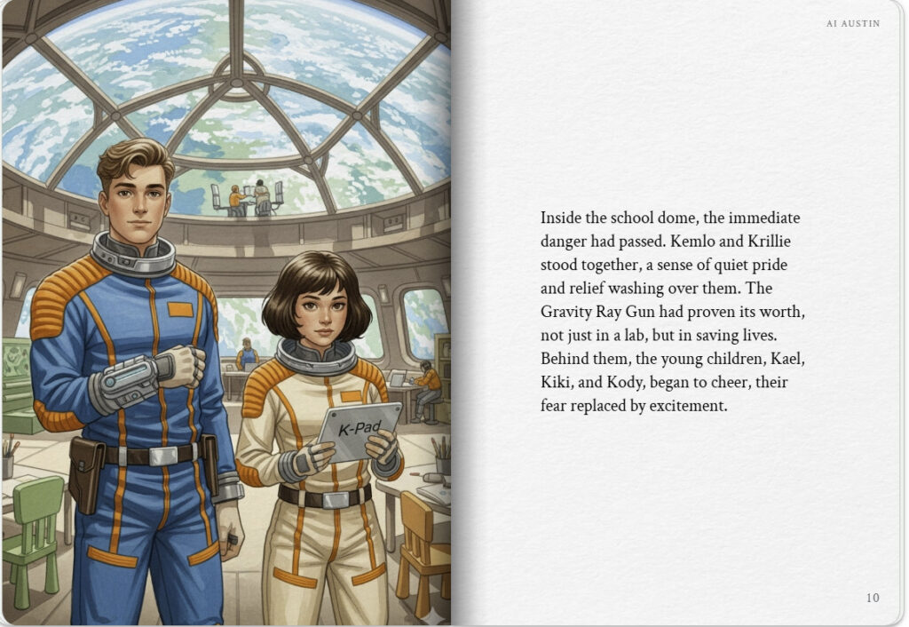

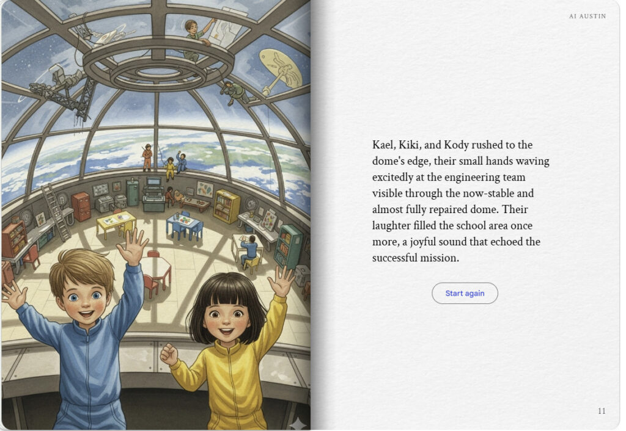

Textual Story Generation
Kemlo and the Gravity Ray Gun
Deep in space, a futuristic station called Belt K floats in orbit around Earth. This space habitat, which spans over 20 kilometres, is home to thousands, including space-born children who are given names starting with the letter “K”. Two of these teenagers are Kemlo and his friend, Krillie. Kemlo, an 18-year-old skilled pilot and captain of the Space Scouts, is involved in testing an experimental modular space runabout. His friend, Krillie, a 17-year-old engineering student and author, is a Space Girl with an interest in AI-enhanced fashion. Both Kemlo and Krillie are diligent and hardworking.
The Gravity Ray Gun
Kemlo, in his blue and orange uniform with the Space Scouts insignia, carefully put on a belt with a holster attached. He was tasked with testing a new device—a handheld Gravity Ray Gun. The purpose of this device was to allow the use of gravity rays in restricted spaces. Gravity rays were normally used on larger spaceships and space stations for positioning objects and providing safety shields. Kemlo’s job was to find safe and appropriate ways to use the new handheld version.
He began his initial tests in a laboratory. Aiming the intricate, metal ray gun at various objects, he watched as they floated and shifted according to his precise adjustments. He recorded every experiment, noting the gun’s power and potential uses for later analysis. Everything was going smoothly, but little did he know, he would soon have to use the device in a real-world emergency.
A Dangerous Situation
At the same time, in another part of the station, Krillie was in the school area assisting with a class of young children. She wore a pale, cream-colored uniform with orange accents, just like Kemlo’s. The school’s dome, a vast overhead window facing Earth, made it feel like they were floating right above the planet.
Suddenly, an alarm blared. A meteorite had somehow breached the station’s protective shield and was hurtling toward the dome! There was a loud, cracking sound as it struck the dome, leaving a spiderweb of fissures that began to grow. Everyone gasped as a small piece of the dome fell away, threatening the safety of the children and everyone in the area.
Without a second thought, Krillie used her K-Pad to call Kemlo. “Kemlo, we have an emergency in the school dome!” she shouted into the device. “A meteorite hit the dome, and it’s starting to crack!”
An Emergency Response
As the captain of the Space Scouts, Kemlo immediately understood the gravity of the situation. He grabbed the Gravity Ray Gun and holstered it before rushing toward the school dome. When he arrived, he saw the growing cracks and the look of fear on the children’s faces. He drew the Ray Gun from his holster and carefully aimed it at the largest crack.
He fired the gravity ray, creating a temporary field of stability around the fissure. The cracking stopped, and the dome held firm. It was just a temporary solution, but it bought them the time they needed. Krillie, who had been on her K-Pad the entire time, had already contacted the engineering team. Within minutes, a group of engineers in their heavy suits rushed to the outside of the dome, ready to begin full repairs with their equipment.
A Team Effort
Kemlo kept the Gravity Ray Gun steady on the crack until the engineers secured the area. As they began their repairs, Krillie and the children watched from inside, a sense of relief washing over them. It was a true team effort, with Kemlo’s quick thinking and Krillie’s swift communication saving the day. The children, now safe, gathered around Kemlo and Krillie. They looked out the window at the team working tirelessly to fix their home.
A team of engineers in bulky spacesuits worked tirelessly outside the dome, their specialized tools whirring as they sealed the crack. As the repairs neared completion, the children inside the dome cheered and waved, their fear replaced with excitement. Kemlo and Krillie, their uniforms still pristine, stood among them, their faces reflecting pride and relief. The Gravity Ray Gun had proven its worth, and thanks to their combined efforts, everyone was safe.

Note: version for editing (needs Ai Austin author login) is here (Development Notes).

