Storybook – Krillie’s Grand Graduation Adventure
Posted on September 6, 2025 by bat
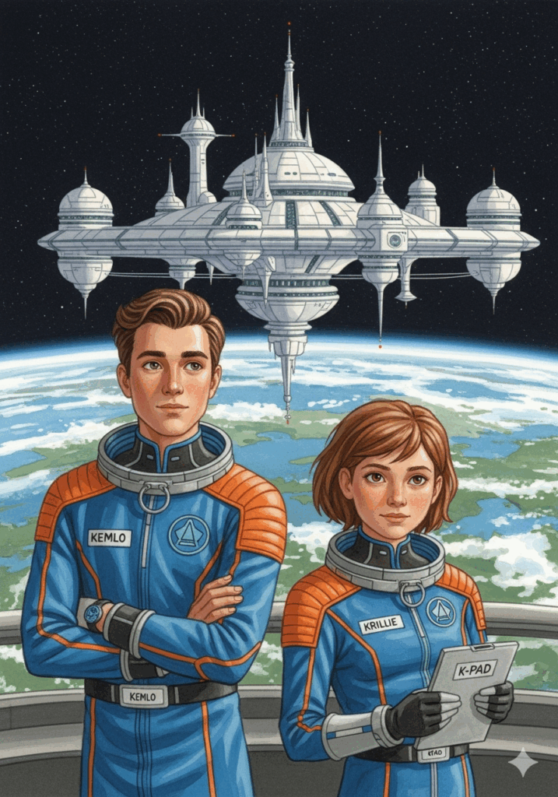
This is Storybook 2 in “The Further Adventures of Kemlo & Krillie in Space” series. It is produced using Google Gemini Storybooks AI App which lets you create a customized picture book, for either children or adults, given a topic, an optional target audience age, and an optional art style for the images.
Prompt: Use the background given in the attached document to write a storybook for a teenager target audience about the Further Adventures of Kemlo and Krillie who are teenagers who live on Satellite Belt K in Earth Orbit. Keep the character appearance and name badge label and position on clothing consistent with the attached image. Krillie has graduated with a Masters by e-Learning in AI and Robotics from the University of Edinburgh and has been invited to receive her degree certificate in a ceremony at the Open World University (OWU) situated on Atlantica Sea City as shown in an attached image. Kemlo is to transport her in an experimental spacecraft from the orbiting Satellite Belt K down to Atlantica Sea City. But something goes wrong and Kemlo and Krillie must use all their skills to correct the issue and still get to the ceremony in time for a happy ending. Include some images of the spacecraft descending and approaching Atlantica Sea City. Include a final image of the graduation ceremony with Killie receiving her certificate.
https://gemini.google.com/gem/storybook
The storybook uses background created previously using AI tools based on the Kemlo Spaceworld series of books by E.C. Eliott published in 1954 to 1963. It uses images and PDF of the contents of this blog post: https://blog.inf.ed.ac.uk/atate/2025/09/10/kemlo-and-krillie-briefing/
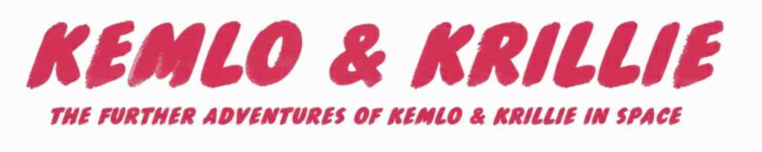
The Storybook produced is available at: https://g.co/gemini/share/5ceb6ce5de10 or PDF Format
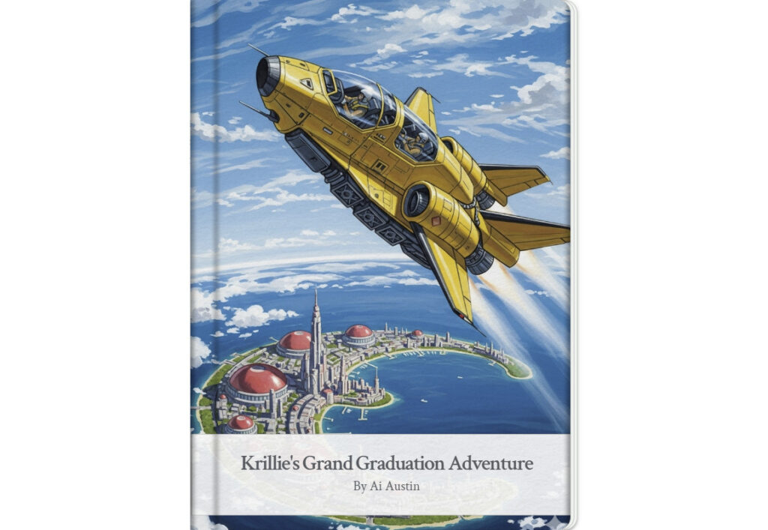
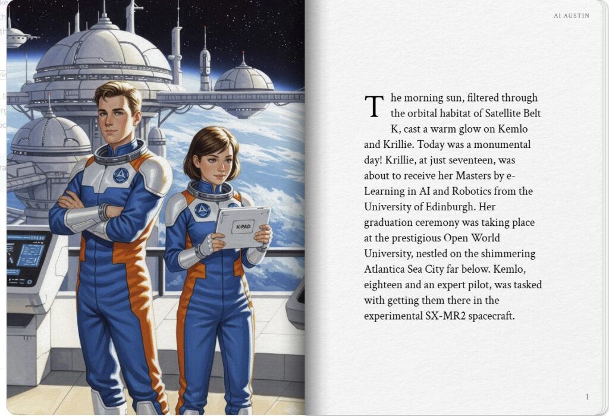
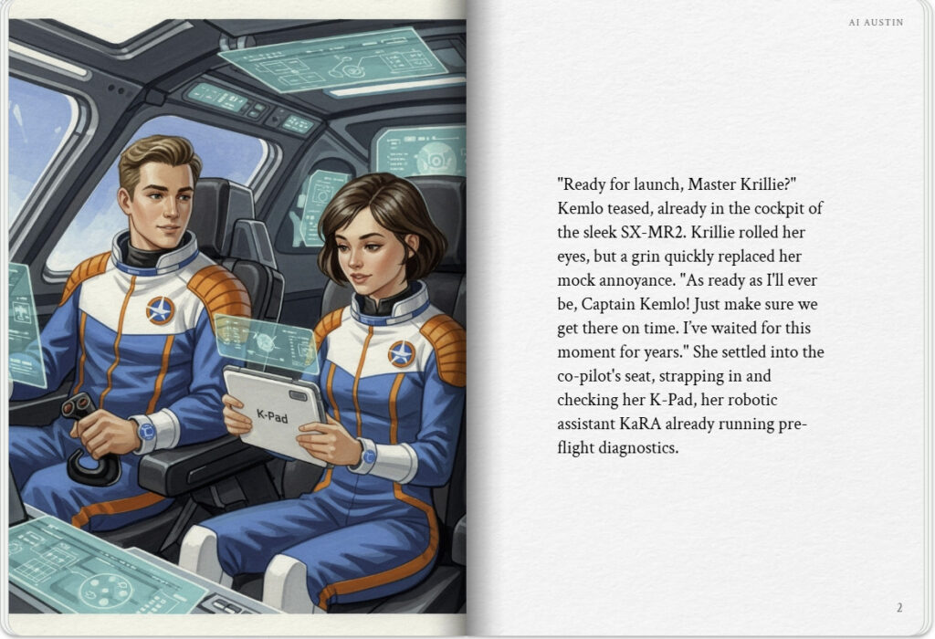

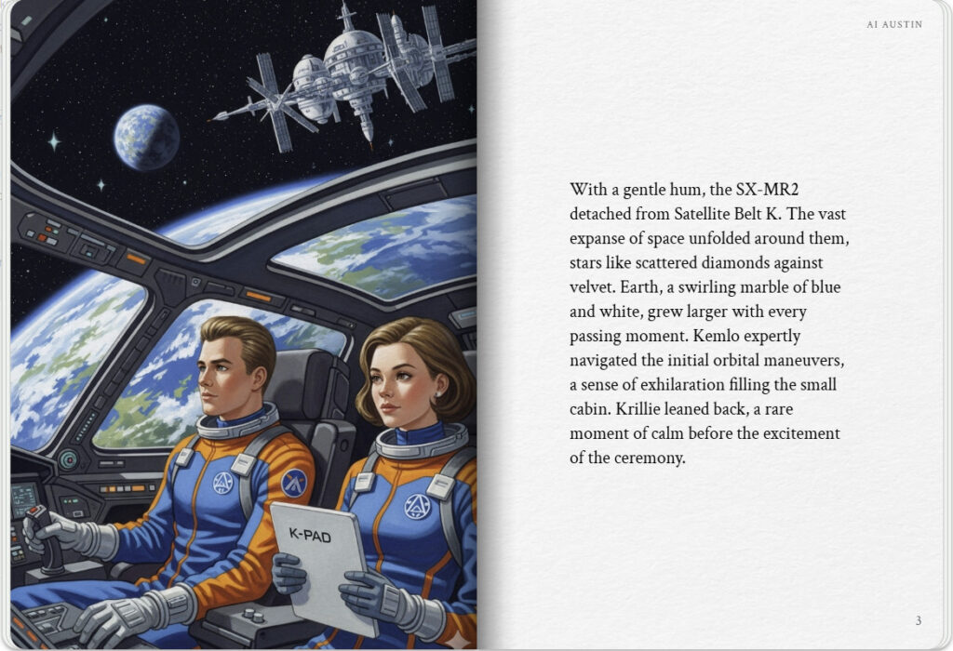
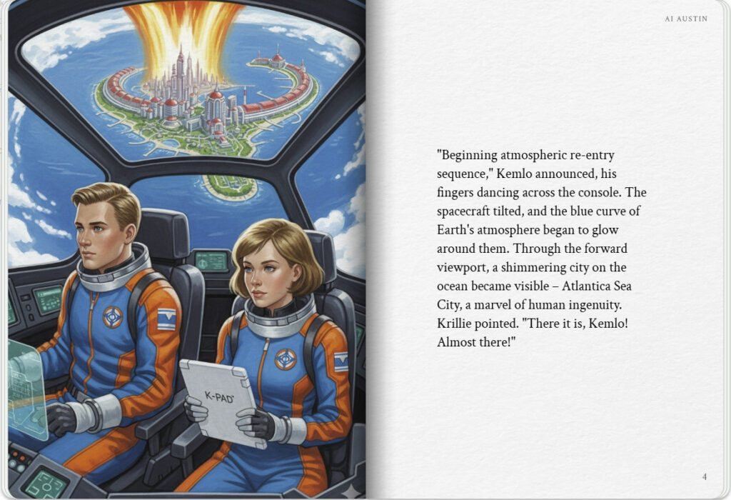

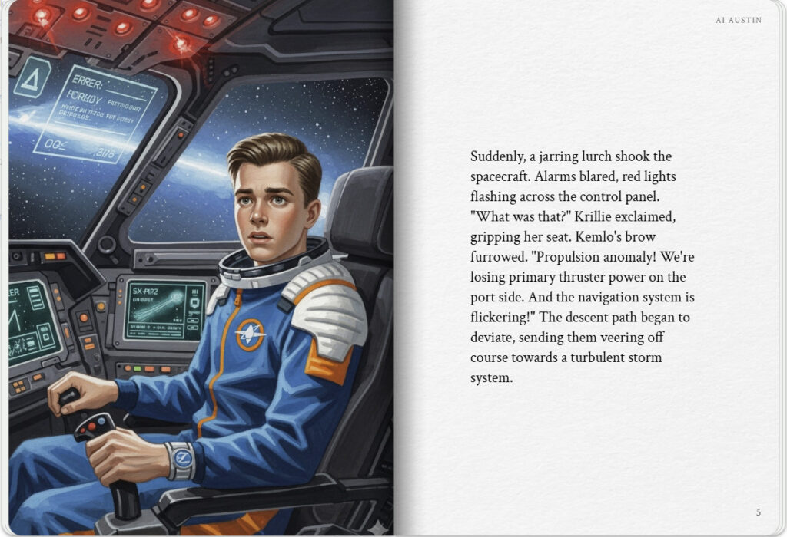
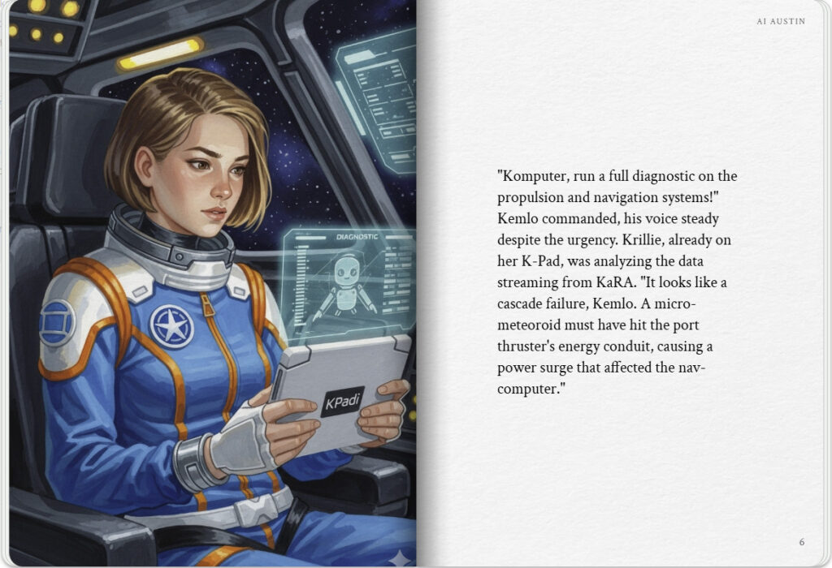

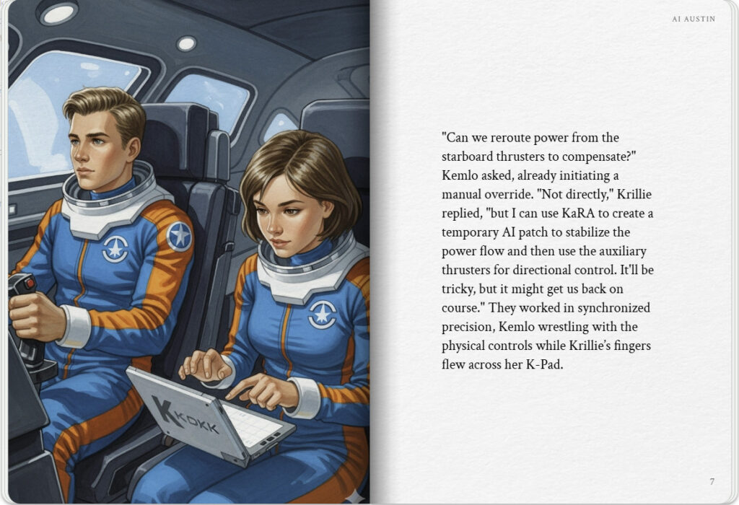
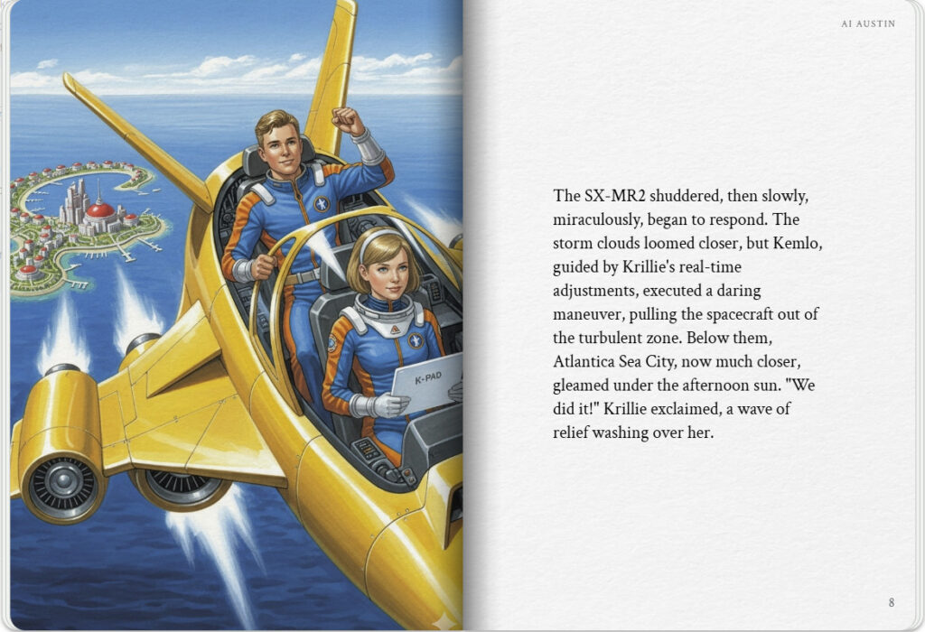

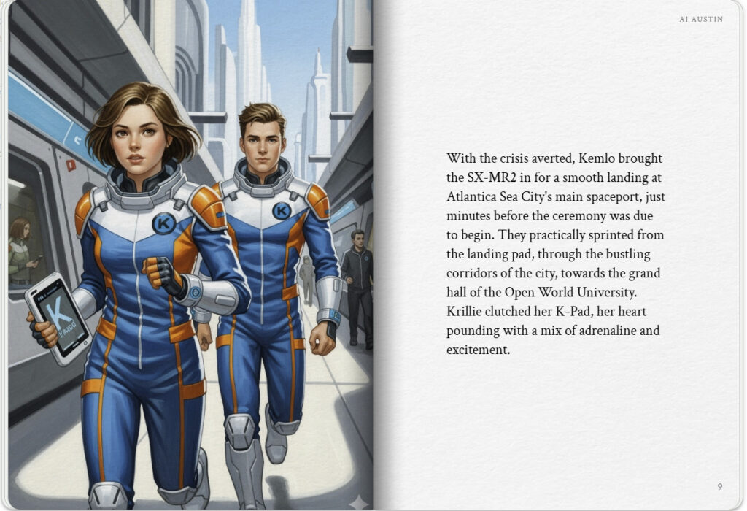
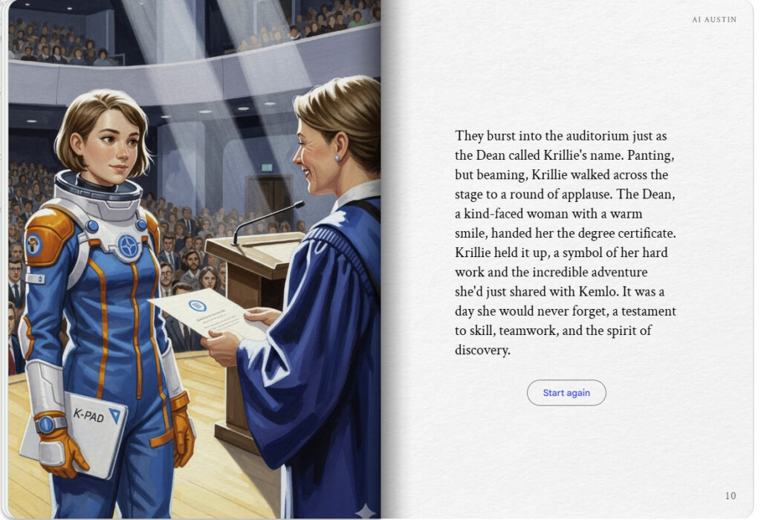

Kemlo & Krill at the Graduation Ball
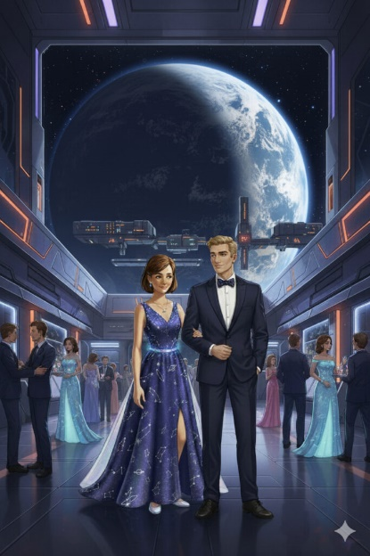
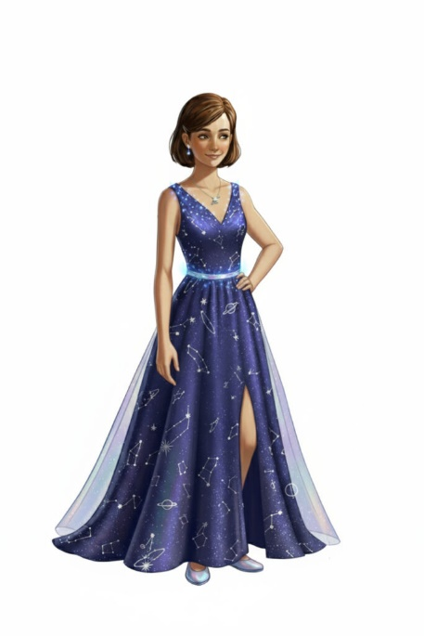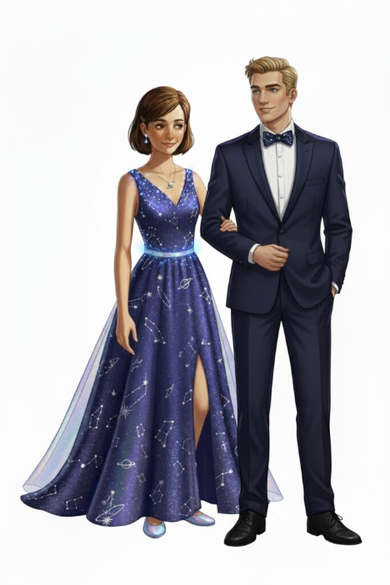

Textual Story Generation
Once upon a time, not so long from now, there was a place called
Belt K, a sprawling space habitat in orbit around Earth. It was home to many people, but none were as well known as the two space-born teenagers, Kemlo and Krillie. Kemlo, at eighteen, was an accomplished pilot and the captain of the Space Scouts. His best friend, Krillie, a year younger, was a brilliant Space Construction Engineer with a Masters in AI and Robotics from the University of Edinburgh.
It was a momentous day. Krillie was invited to receive her master’s degree in person at the
Open World University (OWU), located on the magnificent Atlantica Sea City on Earth. Kemlo, a skilled pilot, was tasked with getting her there in time for the ceremony in his experimental modular space runabout, the SX-MR2. They were both excited, dressed in their sleek blue and orange flight suits with the Kemlo and Krillie name tags in the correct position on the chest, a gift from the Belt K Operations Authority.
The journey began smoothly. Kemlo piloted the SX-MR2 away from Belt K and set a course for Earth. As they descended through the atmosphere, the view was breath-taking. The blue-green swirl of Earth’s oceans and continents grew larger and larger in the viewport, a stark contrast to the endless black of space they were so used to. They could see the vast expanse of the sea and the glittering city that was their destination.
Krillie’s heart swelled with a mix of excitement and anticipation. This was a day she had worked her whole life for. But just as they were nearing the coast, a warning light flashed on the control panel. A quick diagnostic showed a critical power drain from the main propulsion system.
“What is it, Kemlo?” Krillie asked, her voice tinged with concern.
“I’m not sure,” Kemlo replied, his brow furrowed in concentration as he ran checks. “It looks like the system is rerouting power to the wrong places. We’re losing our descent speed.”
They had to think fast. The SX-MR2 was designed for in-orbit travel, not for atmospheric descent, and a manual override was out of the question. Kemlo and Krillie knew this was the time to use their training and work as a team. Kemlo focused on maintaining a stable flight path and used their auxiliary thrusters to keep the vessel from spiralling out of control. Meanwhile, Krillie accessed the SX-MR2’s operating system with her K-Pad. Her knowledge of AI and robotics was crucial. She had to create a new program to override the faulty system and reroute power back to the main thrusters.
The seconds felt like hours. Kemlo was sweating, his knuckles white as he gripped the controls. Krillie’s fingers flew across her K-Pad, writing lines of code, her mind racing. “Almost there,” she muttered, “I’ve almost got it.”
Just as they were about to dip too low, the main engines roared to life, a triumphant sound that filled the cockpit. They were back on course. Kemlo expertly manoeuvred the SX-MR2 towards the glittering metropolis of Atlantica Sea City. It was a close call, but they had made it.
They landed just in the nick of time. Kemlo and Krillie, now out of their spacesuits, made their way to the graduation hall. They were met with the cheers of the crowd and the beaming smiles of the faculty members. Krillie walked across the stage, her head held high and received her diploma. It was a proud moment, made even more special by the adventure they had just overcome.
With her master’s degree in hand, Krillie was ready for her next adventure, and she knew she had a friend and pilot she could always count on to get her there.

Note: version for editing (needs Ai Austin author login) is here (Development Notes).

