Kemlo & Krillie – The Belt K Adventure
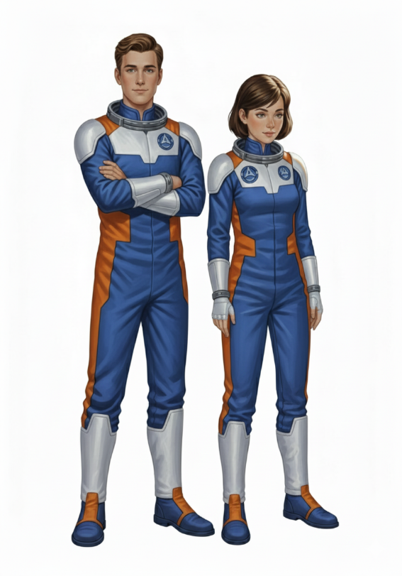
Posted on September 5, 2025 by bat
This is Storybook 1 in “The Further Adventures of Kemlo & Krillie in Space” series. It is produced using Google Gemini Storybooks AI App which lets you create a customized picture book, for either children or adults, given a topic, an optional target audience age, and an optional art style for the images.
Prompt: Use the background given in the attached document to write a storybook to introduce Kemlo and Krillie, teenagers who live on Satellite Belt K in Earth Orbit.
The storybook uses background created previously using AI tools based on the Kemlo Spaceworld series of books by E.C. Eliott published in 1954 to 1963. It uses images and PDF of the contents of this blog post: https://blog.inf.ed.ac.uk/atate/2025/09/10/kemlo-and-krillie-briefing/

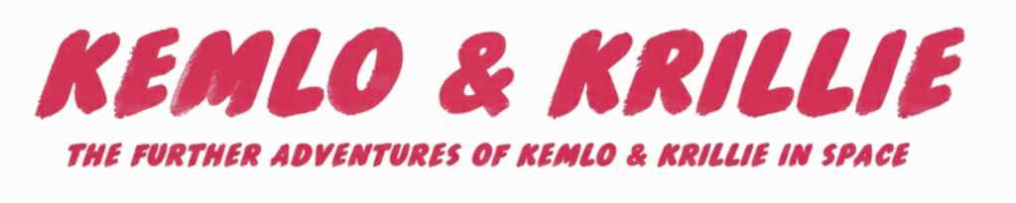
The Storybook produced is available at: https://g.co/gemini/share/b5fe7edbb426 or PDF Format
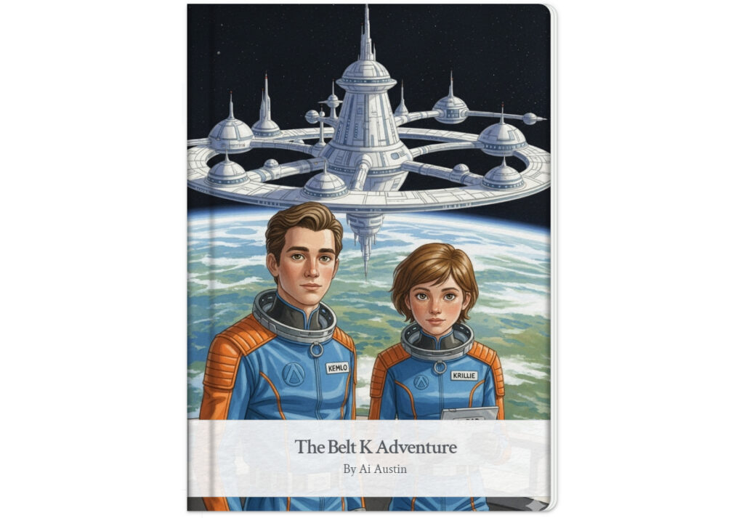
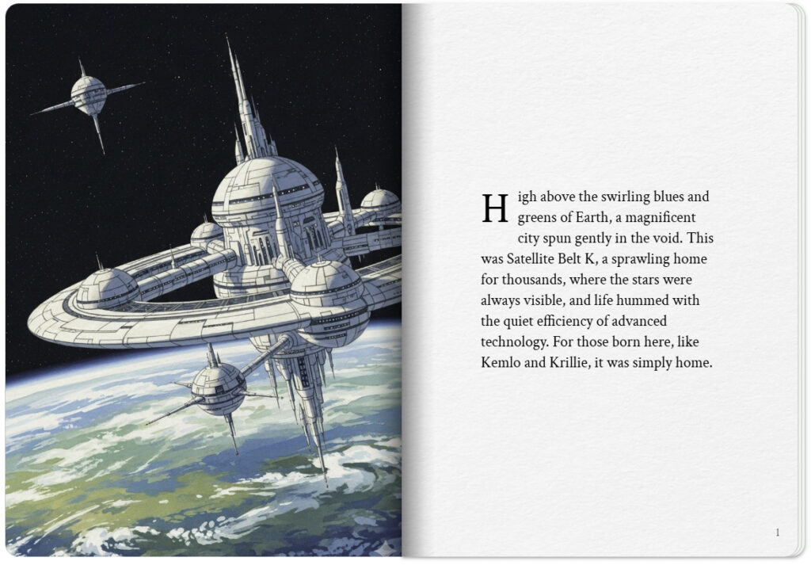
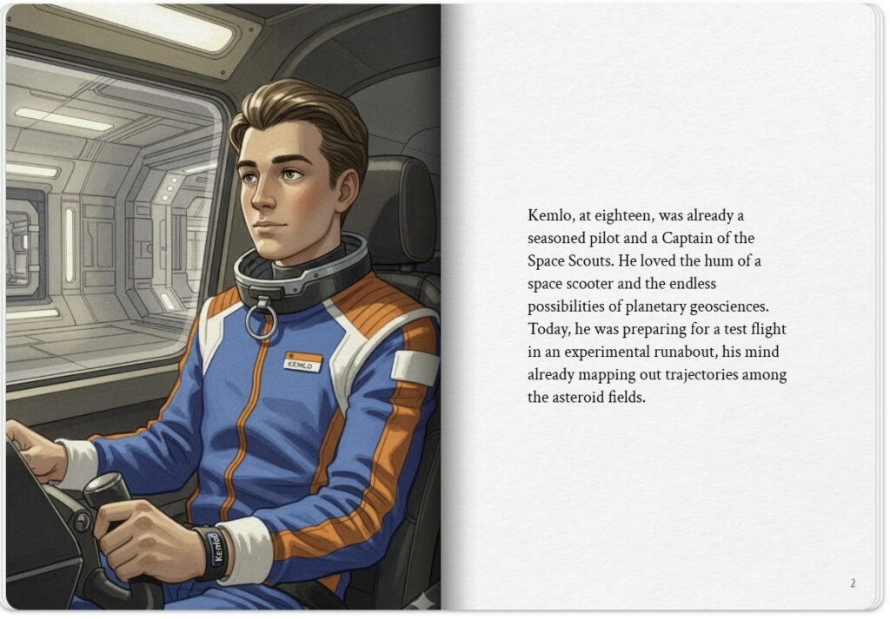

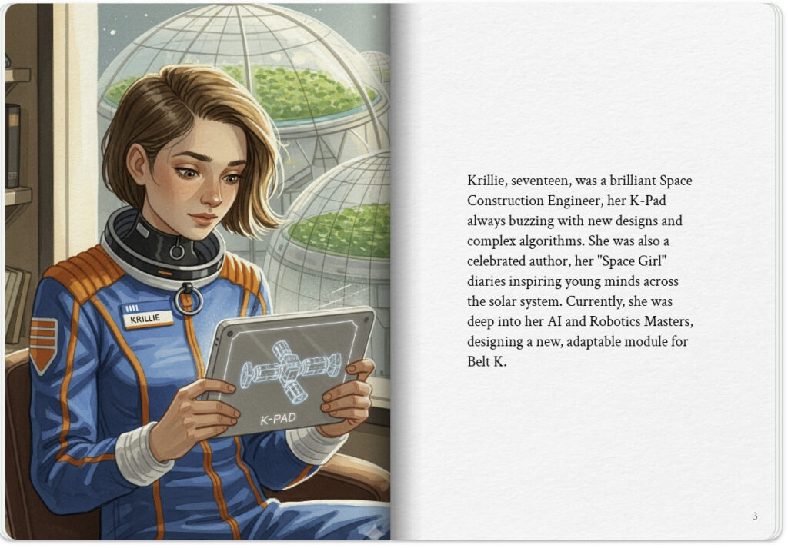
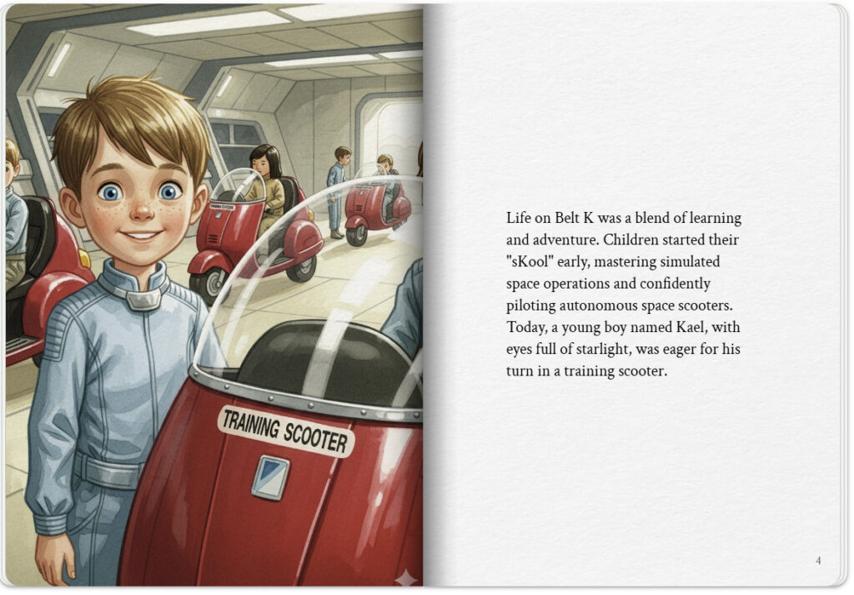

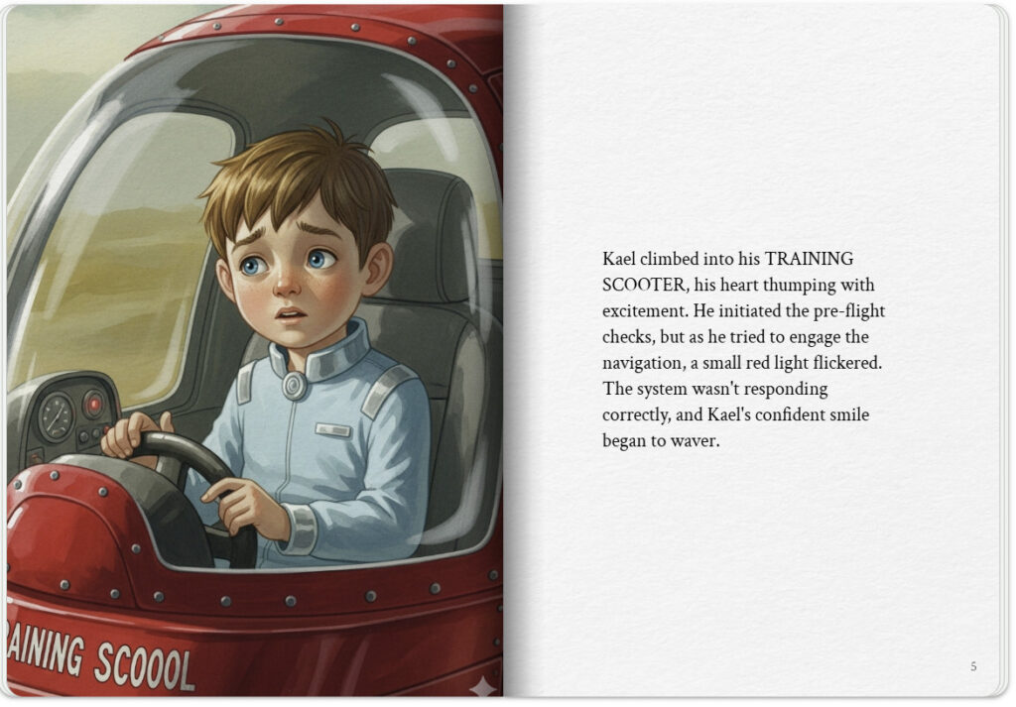
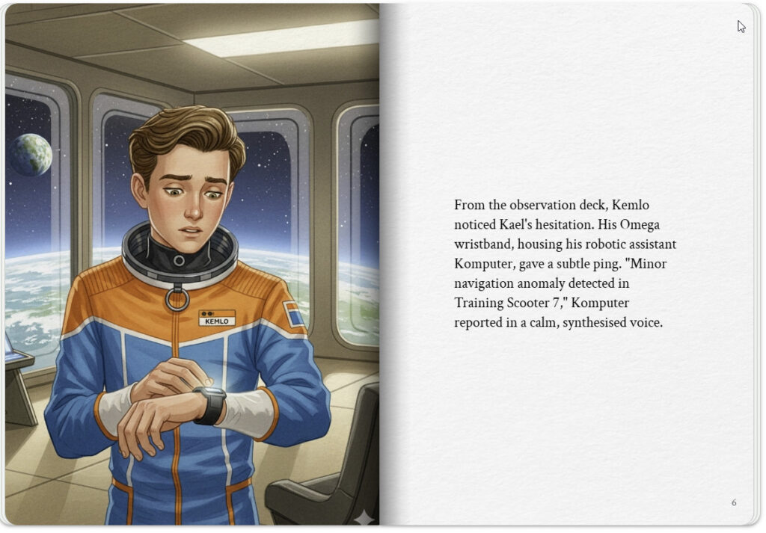

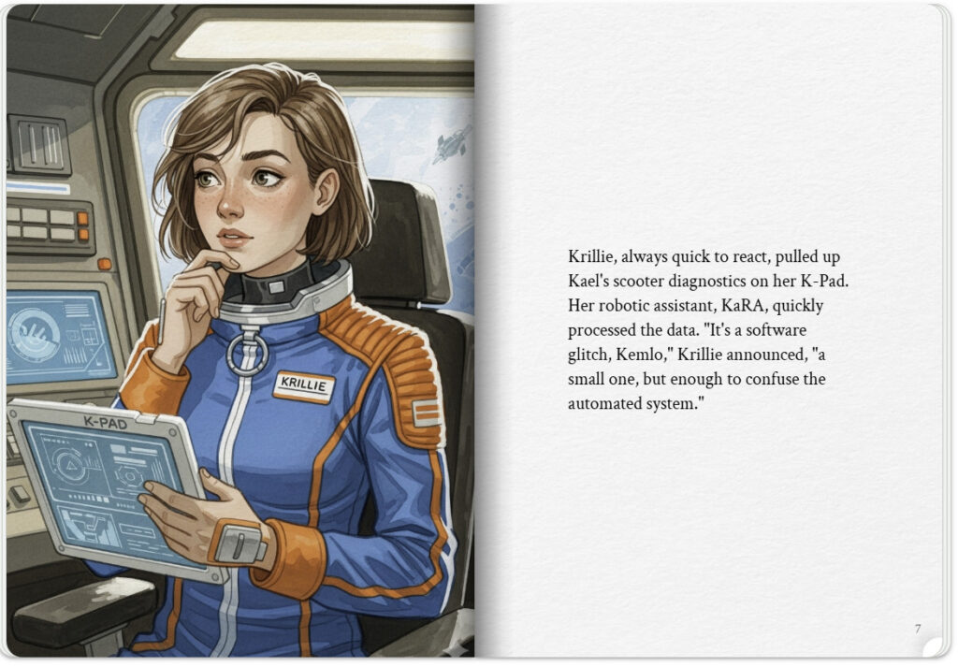
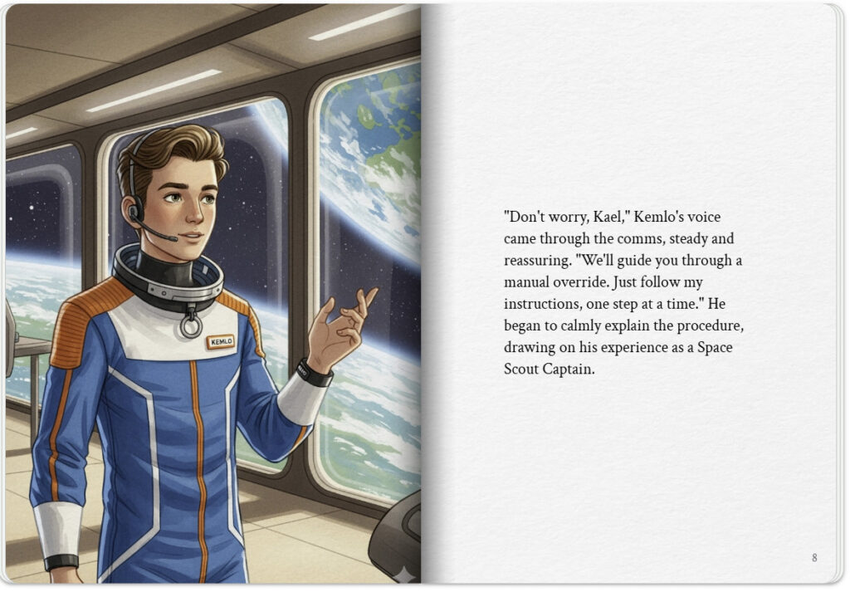

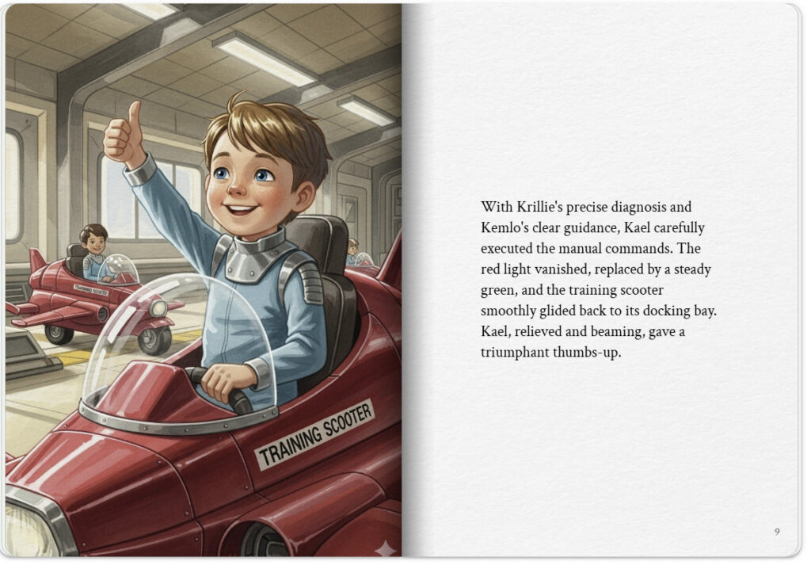
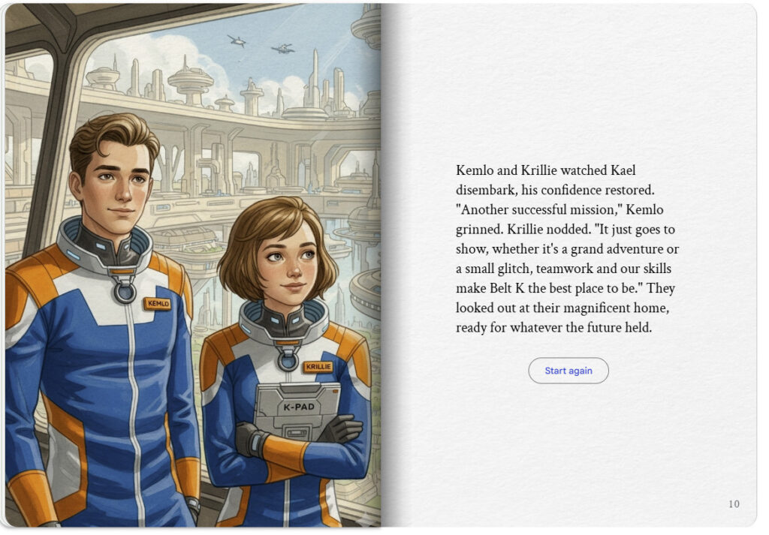

Several refinements were done to the early draft to replace the name badges for Kemlo and Krillie and to try to use consistent labelling on the Training Scooters.

