Kemlo & Krillie – Storybooks
Posted on September 7, 2025 by bat
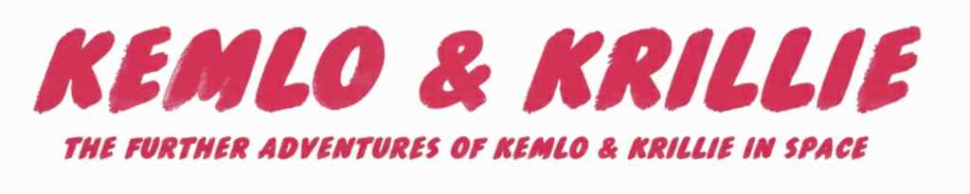
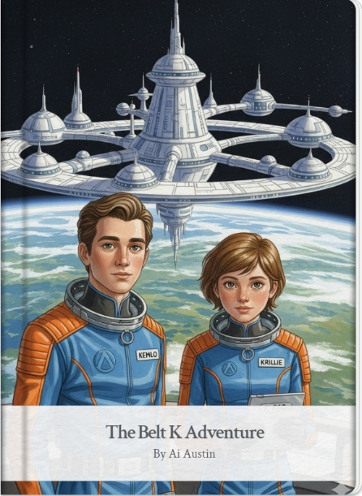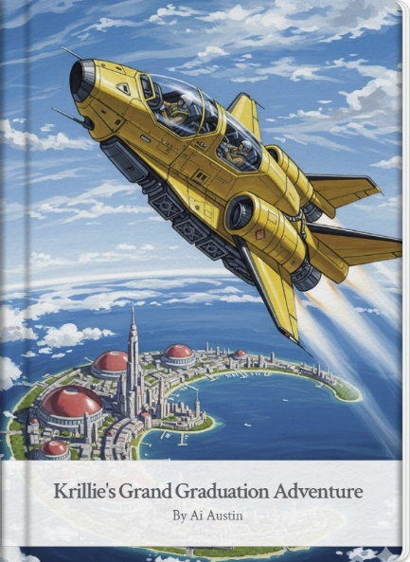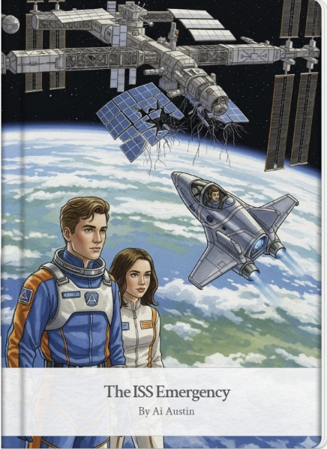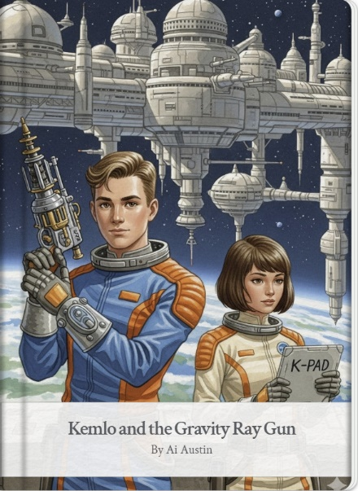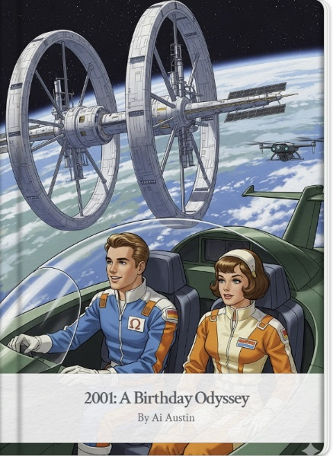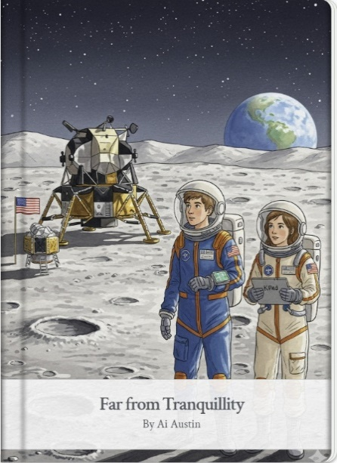

More Detail, Alternative Formats and Background
- Storybook 1: The Belt K Adventure
https://blog.inf.ed.ac.uk/atate/2025/09/05/kemlo-and-krillie-belt-k-adventure/
https://g.co/gemini/share/b5fe7edbb426 | PDF Format | Storybook 1 Images
- Storybook 2: Krillie’s Grand Graduation Adventure
https://blog.inf.ed.ac.uk/atate/2025/09/06/krillies-grand-graduation-adventure/
https://g.co/gemini/share/5ceb6ce5de10 | PDF Format | Storybook 2 Images
- Storybook 3: The ISS Emergency
https://blog.inf.ed.ac.uk/atate/2025/09/07/kemlo-and-krillie-the-iss-emergency/
https://g.co/gemini/share/dfc5a957adb8 | PDF Format | Storybook 3 Images
- Storybook 4: Kemlo and the Gravity Ray Gun
https://blog.inf.ed.ac.uk/atate/2025/09/08/kemlo-and-the-gravity-ray-gun/
https://gemini.google.com/share/6f774a0c5631 | PDF Format | Storybook 4 Images
- Storybook 5: 2001: A Birthday Odyssey
https://blog.inf.ed.ac.uk/atate/2025/09/09/2001-a-birthday-odyssey
https://gemini.google.com/share/51c819c809ff | PDF Format | Storybook 5 Images
- Storybook 6: Far from Tranquillity
https://blog.inf.ed.ac.uk/atate/2025/09/10/far-from-tranquillity/
https://g.co/gemini/share/9fcef6571d3c | PDF Format | Storybook 6 Images
- Even Further Adventures of Kemlo & Krillie in Space
- Storybook 7: The Gravity Ray Gambit https://blog.inf.ed.ac.uk/atate/2025/10/12/gravity-ray-gambit/
https://g.co/gemini/share/c2625e4ef48c | Development (user: Ai Austin) | PDF Format | Storybook 7 Images
- Storybook 8: The SPITAR Anomaly
https://blog.inf.ed.ac.uk/atate/2025/10/12/spitar-anomaly/
https://g.co/gemini/share/95941518717b | Development (user: Ai Austin) | PDF Format | Storybook 8 Images

Krillie’s ‘Space Girl’ Diary
Krillie’s Diary is aimed at those interested in what is happening in space and to describe her life as a Space Girl including education and training, living arrangements and adventures.
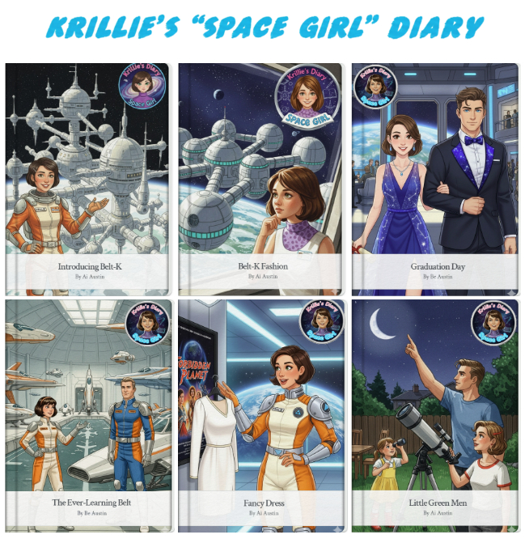

Kemlo & Krillie Figurines – Google Gemini Generated
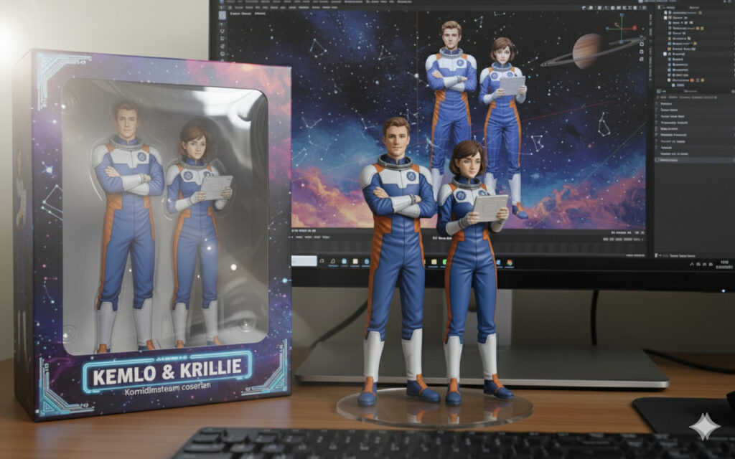
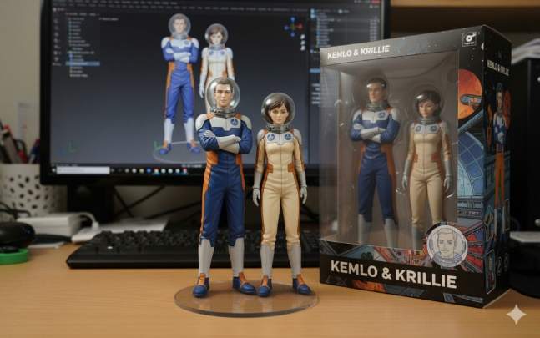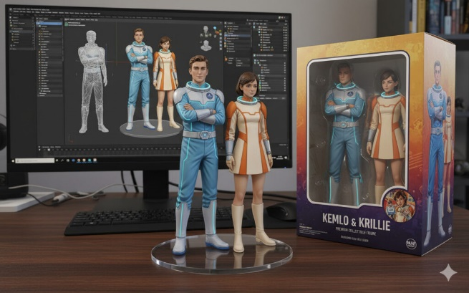

3D Models of Kemlo & Krillie with a Space Runabout (in OpenSim)
The Space Runabout model was initially created using simple shapes in OpenSim. A image was then processed by the Google Gemini AI Tool (https://gemini.google.com/) to generate a higher quality image with detail. This was then passed to Tripio3D (https://studio.tripo3d.ai/ to generate and texture a 3D model. This was exported to glTF and imported back to OpenSim. The characters were created with a similar workflow but starting with images generated by Google Gemini Storybook Mode (https://gemini.google.com/gem/storybook).
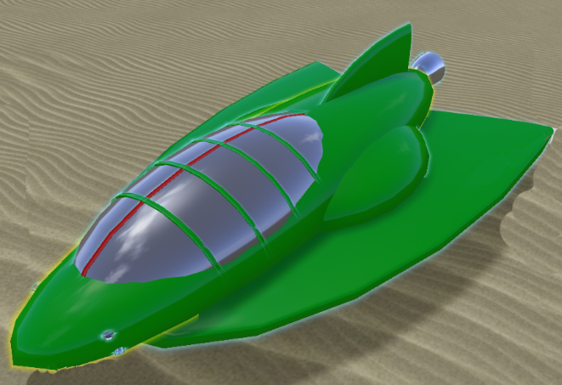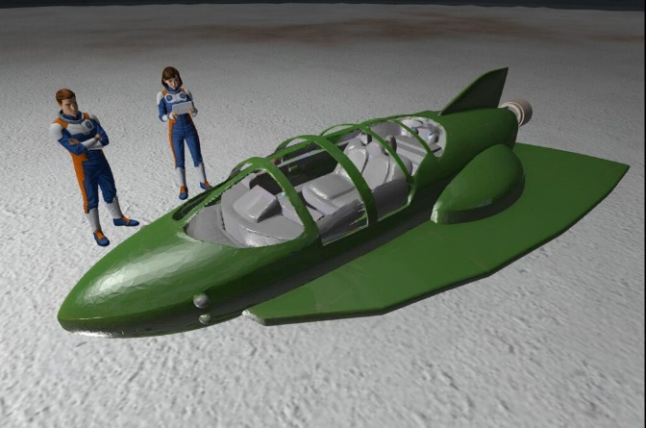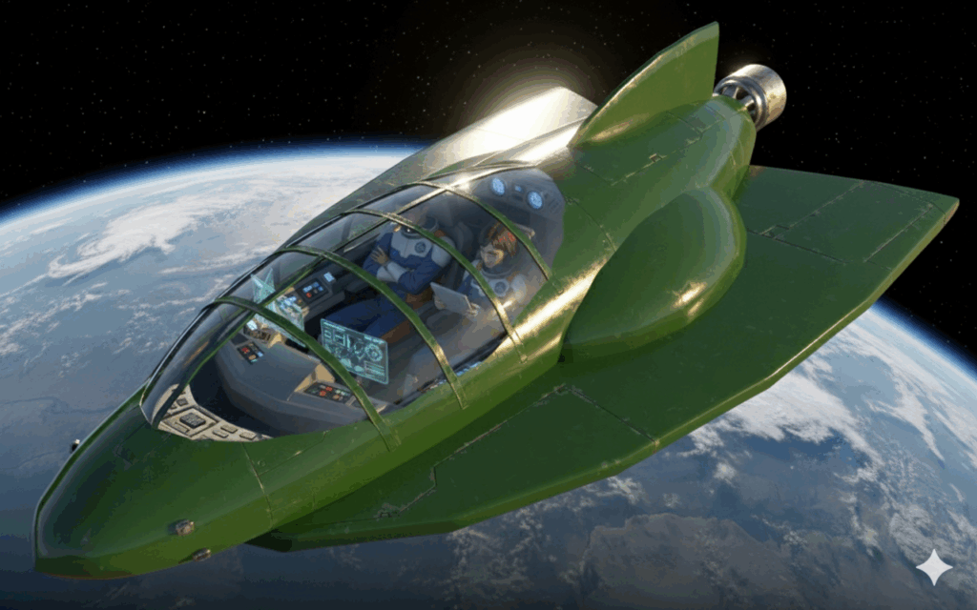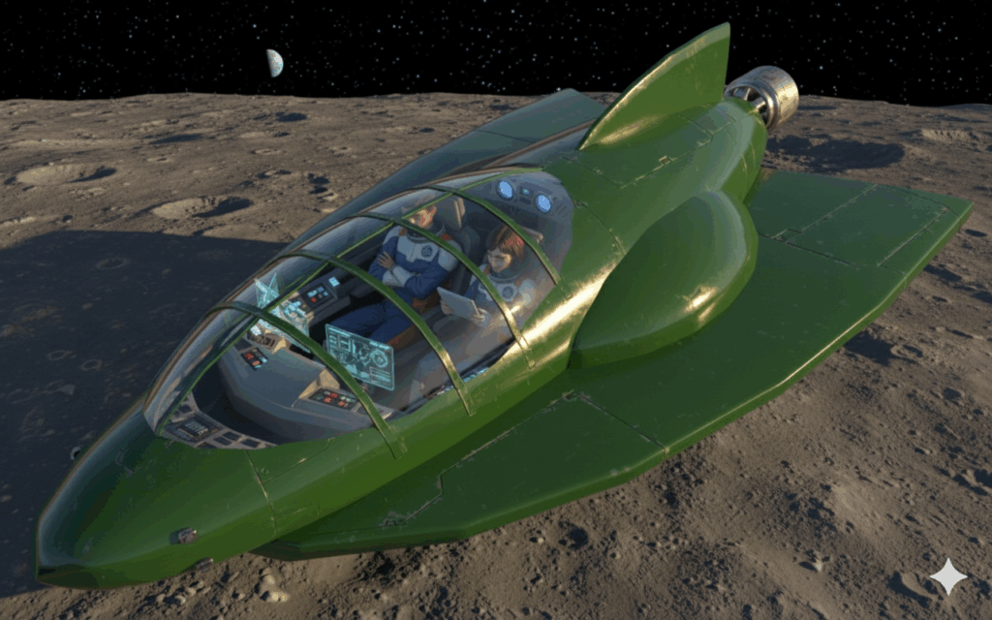

Graphics Style for Illustrations
According to Google Gemini the style of the illustrations could best be described as a retro-futuristic or atomic age aesthetic, which is often seen in classic science fiction from the mid-20th century.
Here are some key characteristics of this style seen in the images:
Clean Lines and Sleek Designs: The spaceships, uniforms, and interior spaces all feature smooth, streamlined forms and a sense of functional simplicity.
Vibrant, Limited Colour Palette: The colours are bright and distinct, often featuring primary and secondary colours like blue, orange, green, and white. This gives the images a clean, almost graphic look.
Optimistic and Idealized Vision of the Future: The illustrations depict a future that is clean, orderly, and exciting, a common theme in the science fiction of this era. The characters are portrayed in a heroic or aspirational manner.
Comic Book or Pulp Magazine Influence: The character designs, particularly the strong jawlines and expressive faces, have a style reminiscent of classic comic book art or the illustrations found on the covers of old pulp sci-fi magazines.

Kemlo & Krillie Storybooks use background created previously using AI tools based on the Kemlo Spaceworld series of books by E.C. Eliott published in 1954 to 1963. It uses images and PDF of the contents of this blog post: https://blog.inf.ed.ac.uk/atate/2025/09/10/kemlo-and-krillie-briefing/.

