Kemlo & Krillie – Characters (Fan Fiction)
Posted on October 1, 2025 by bat
An important observation as context to the information and ideas presented on this page, and in “The Further Adventures of Kemlo & Krillie in Space” series of creations… this is Fan Fiction and goes well beyond the content of the Kemlo book series written in the 1950s and 1960s by E.C. Elliott (a pseudonym of Reginald Alec Martin). It differs in important aspects which should not be confused in any future research on the Kemlo stories.
The following reports were generated with the assistance of Google Gemini “Deep Research” (developer access, user: Austin Tate) with initial prompt “Can you make a careful study of the Kemlo series of books by E.C. Eliott written in the 1950s and 1960s and make a list of all people that are named in the books. Where available list their gender, approximate age and their role in the stories” and subsequent discussion on some elements. An added Annex is provided to qualify some of the observations reported in the Deep Research Report.
Wikipedia (2025) “Kemlo”, Wikipedia, https://en.wikipedia.org/wiki/Kemlo.
Tate, A. and Google Gemini (2025) “A Meticulous Character Study and Catalogue of E.C. Eliott’s Kemlo Series (1954–1963) with Annex by Austin Tate”, Deep Research by Austin Tate using Google Gemini and added Annex, 1-Oct-2025. [Local Copy with Annex]
- Version without Annex: https://docs.google.com/document/d/1XpoNEVDIKJqDCXYfU5-6Gid6jN6bNDGK66cj722xOoA/ [Local Copy]
- Further. Exploration: “Analysis of Canonical Authority and the Administrative Structure of Satellite Belt K in E. C. Eliott’s Kemlo Series”, Deep Research by Austin Tate using Google Gemini, https://g.co/gemini/share/0c551b461b9e, 1-Oct-2025. https://docs.google.com/document/d/1qkRPS78KtInp2BOvwidJHHH1e87MYWPqTPmjgxGasWM/ [Local Copy]
In particular, all the main characters are now in their late teens. Kemlo is 18. Krillie is 17 and also now portrayed as female. Some of the Google Gemini Deep Research cited above gives a thorough analysis that may help provide more context. Gravity Rays play an important part as they did in the original Kemlo books, where they are called Holding Rays. Also, contrary to the books, outside of the gravity and protective envelope they provide even space-born people must wear full space suits with sealed helmets and gloves. The positive side of that is that space born children have no problem breathing in Earth’s atmosphere, though constant exercise is necessary to ensure muscle mass.
Now on with the Character development for “The Further Adventures of Kemlo & Krillie in Space”…

Kemlo and Krillie have already been introduced (see this blog post)…
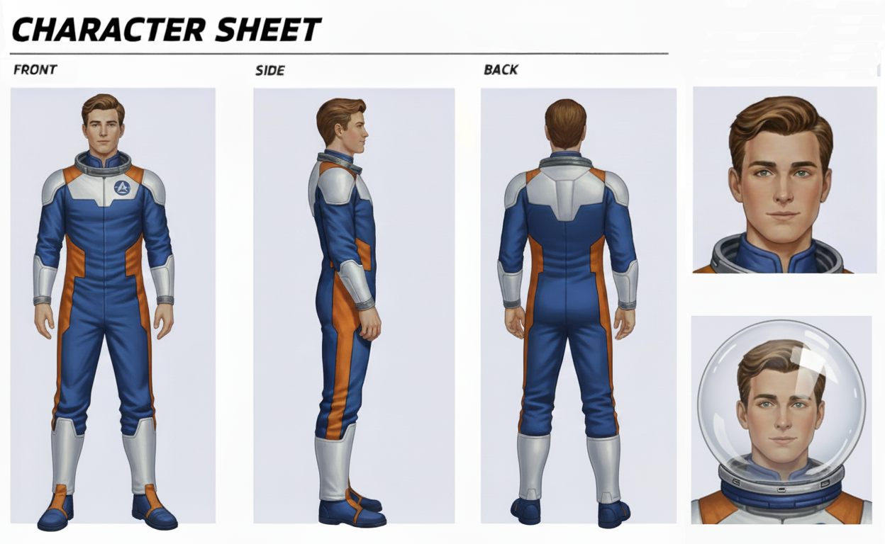
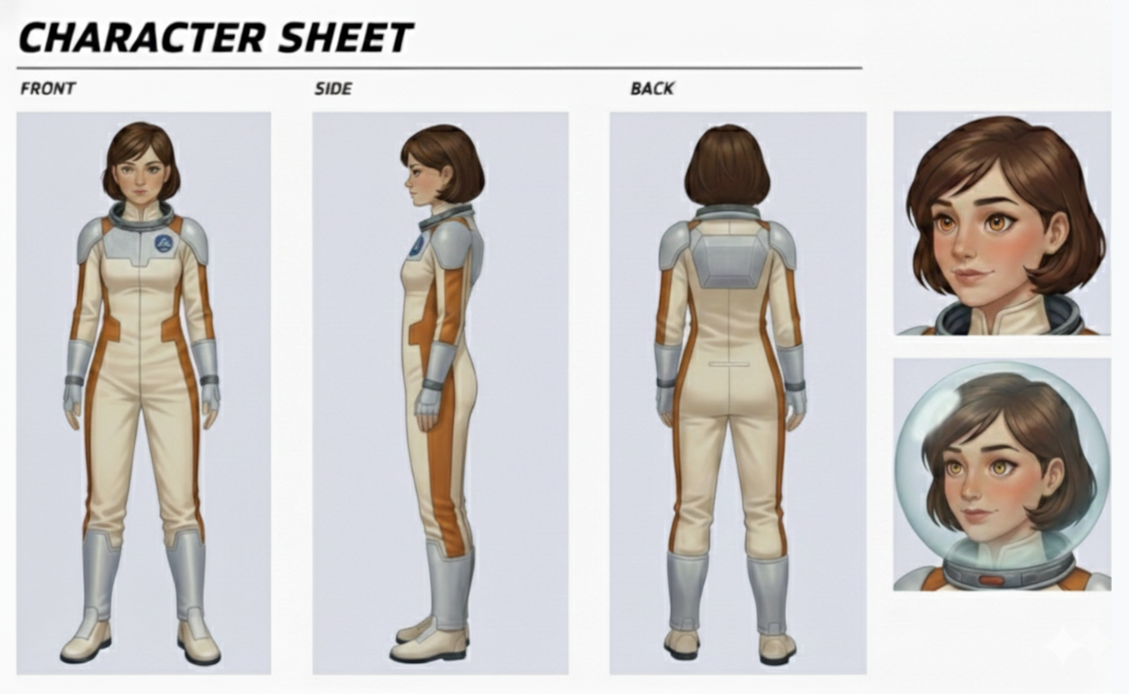

Now let’s meet the family, some friends and other characters…

Kemlo “Kem” Family:
Father: Commander Robert “Rob” Stuart, Chief Executive Officer of Belt K [born: Scotland height: 1.90m]
Mother: Eleanor “Ellie” Stuart, Teacher in First School [born: Atlantica Sea City height: 1.80m]
Siblings: Kemlo has no siblings
Friends: Kerowski and Kartin
Krillie ”Kril” Family:
Father: Alistair “Al” Calder, Space Runabout Engineer [born: Yorkshire height: 1.92m]
Mother: Margaret “Mag” Evans, Food Technologist [born: Yorkshire height: 1.75m]
Siblings: Older Sister: Krinsetta, Space Sports Coach [born: Belt K height: 1.80m]
Cousins: Dane and Lesa. Krillie’s younger cousins from Earth.
Friends: Anya and Kwen
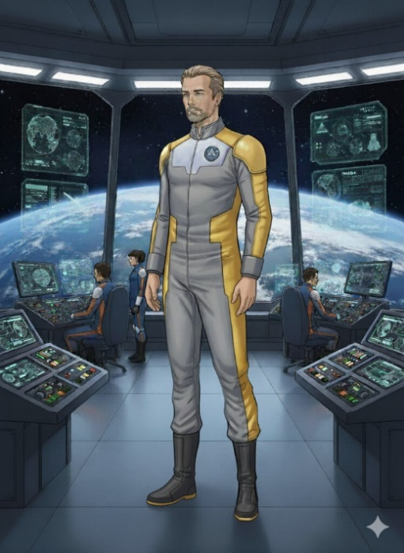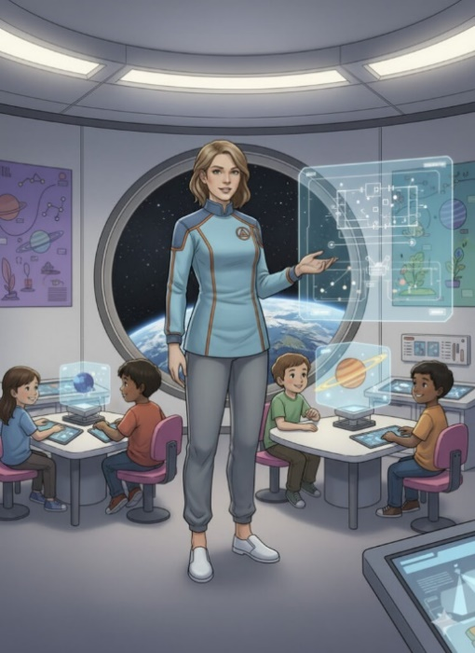


Kemlo’s father is both Chief Executive Officer of Satellite Belt K and an Elder on the Council which govern its operations. When chairing meetings of the Council he wears a ceremonial gown. Alongside her is Krillie’s older sister, Kinsetta, who works as a space sports coach along the Belts.
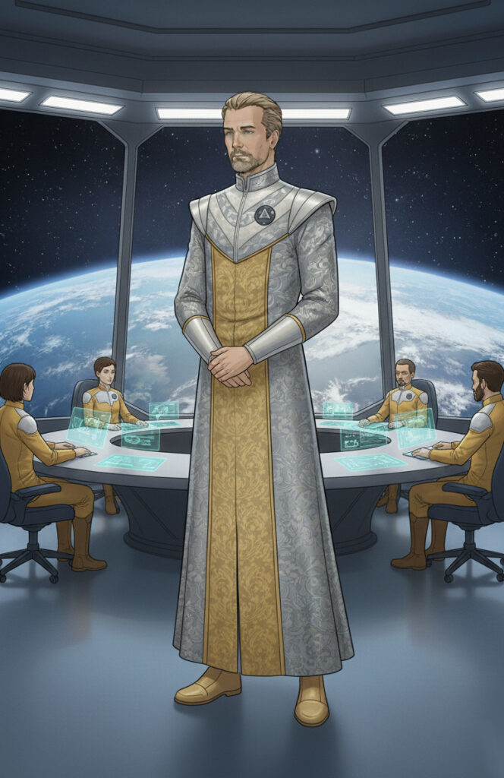

Other Characters (Based on Kemlo Books)
- Krinsetta: Krillie’s older sister. Female. 19 years old.
- Kerowski (nickname “Krow”): A friend of Kemlo’s. Male. 16 year old. Tall and lanky. Very verbose in his speech.
- Kartin: A friend of Kemlo’s. Male. 17 years old. Asian parents.
- Space Scout Section Leaders: Kalenda, Kapla
- Space Scout in Kapla’s section: Koran
- Space Scooter Technicians: Max Conelli, Russ Berriton
- Belt K Archives Operative: Karfax
- Boys from Belt S: Treated in the Kemlo Books as a rival group of Space Scouts from another Satellite Belt S.
Here are Kerowski and Kartin in their Space Scout Uniforms…
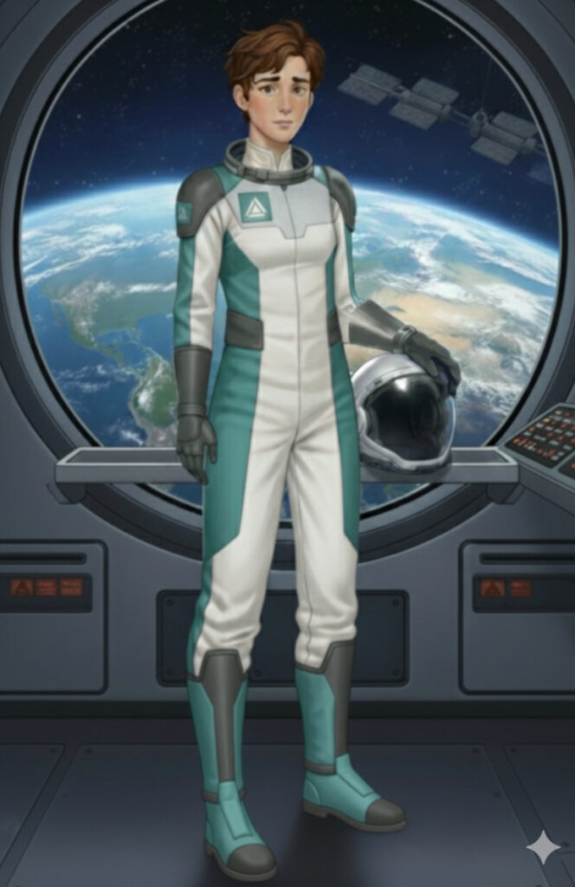

Other Characters (Not in Kemlo Books)
- Anya: A friend of Krillie’s. Female. 20 years old. Earth born (so name not necessarily start with “K”). Works on Unity Station Food Harvest Research and Production Facility.
- Kwen: A friend of Krillie’s. Female. Asian Parents. 17 years old. Medical Technologist.
- Kael: Mal. 4 year old. Nursery School attendee.
Krillie’s friends Anya (Food Technologist) and Kwen (Medical Technologist) are shown here…
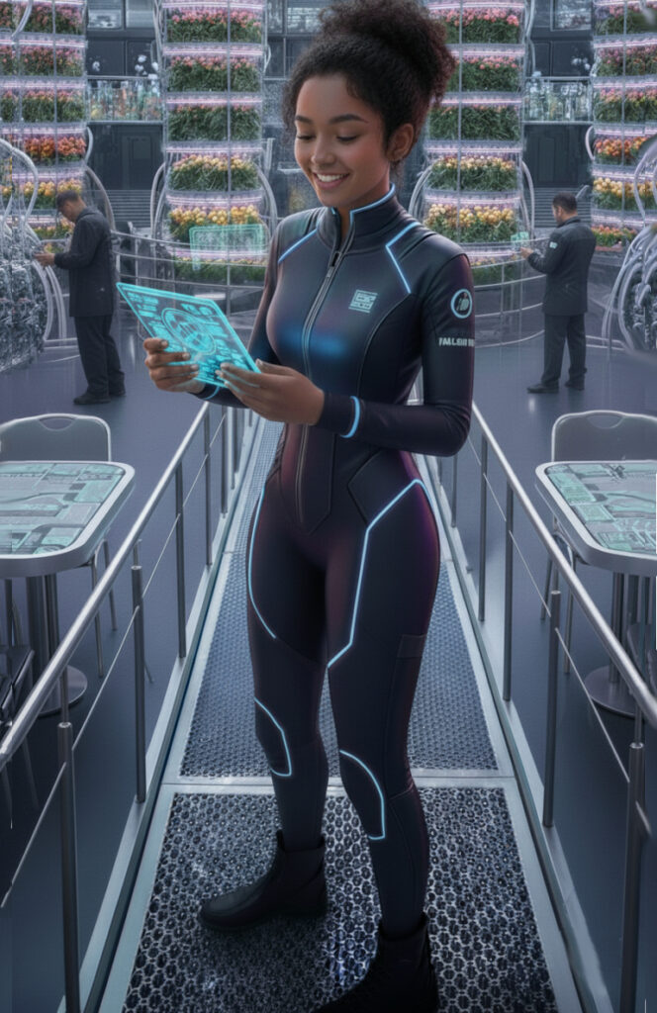

The creation of images and names for Kemlo and Krillie’s parents came originally from an exchange with Google Gemini.
Prompt: Create a comic book style page as the two 22nd Century Earth orbiting space station born teenagers, Kemlo and Krillie, fly away from Satellite Belt K in their two seater green spaceship. –sref 4099490849
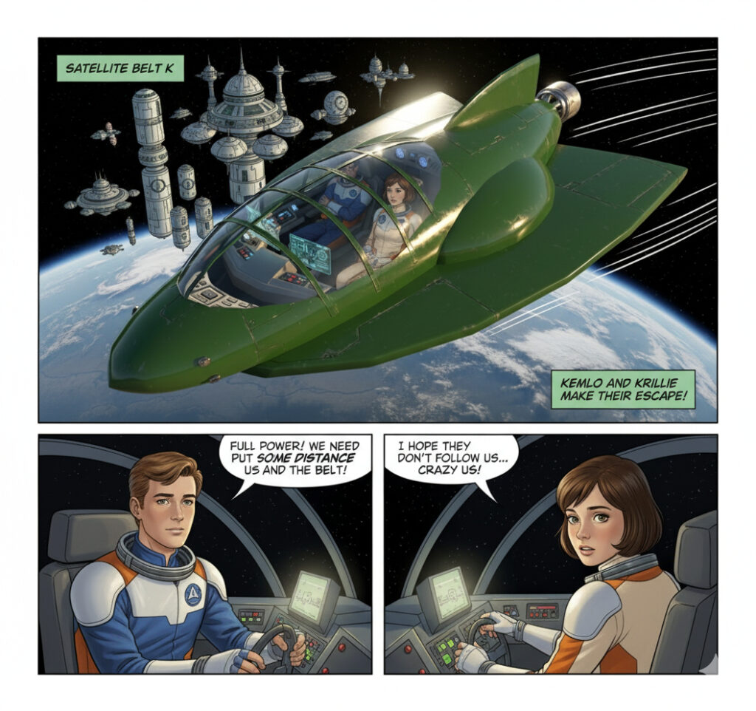
Prompt: Create a comic book style page as the two 22nd Century Earth orbiting space station born teenagers Kemlo and Krillie are asked to investigate a “Gravity Anomaly” near the Moon. They zoom away from Satellite Belt K in their two seater green spaceship headed towards the Moon. As they approach they see an old space relic glowing red and emitting Gravity Rays. They capture it in their own Gravity Ray emission system. They return it to Belt K engineers to safely disable. Mission Complete! –sref 4099490849
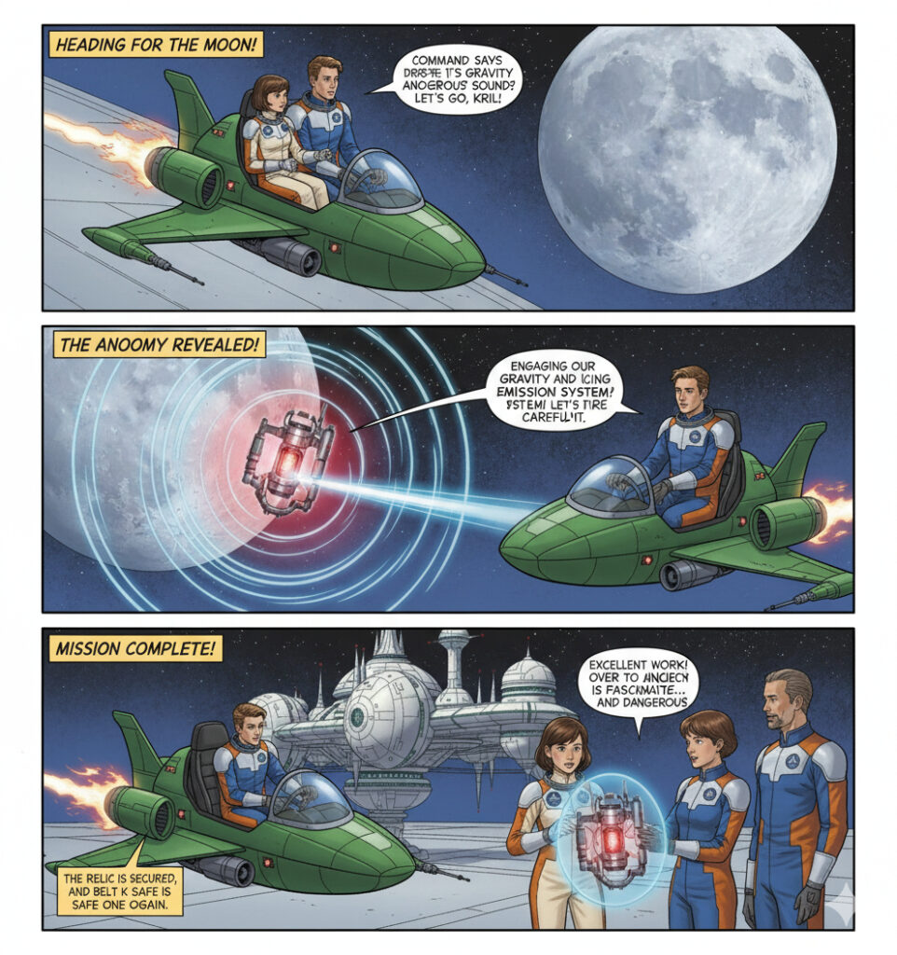
Notwithstanding an open spaceship and no helmets… Introducing Kemlo’s Parents…
Prompt: Kemlo’s father is the overall Satellite Belt K commander. Given the context can you suggest suitable names for Kemlo’s father and mother?
In the Kemlo books, while the name of Kemlo’s father, the commander of Satellite Belt K, is not explicitly stated, he is often referred to by his rank. A suitable name for his father, given the context of the 1950s and 1960s British science fiction, could be something classic and authoritative, such as Commander Robert “Bob” Stuart.
As for Kemlo’s mother, her role is primarily that of a homemaker and a loving mother, fitting the societal norms of the era in which the books were written. A fitting name for her would be something traditional and gentle, such as Eleanor “Ellie” Stuart.
Prompt: Given that Krillie’s parents are technical engineers on Satellite Belt K can you suggest suitable names to use for them in extended Kemlo and Krillie stories?
While their names aren’t mentioned in the original books, suitable names for Krillie’s parents, the technical engineers on Satellite Belt K, could be:
For her father: A name that suggests technical proficiency and a solid, reliable character. Alistair “Al” Calder or Stephen “Steve” Davies would fit the 1950s/60s British sci-fi tone.
For her mother: A name that sounds both intelligent and capable. Brenda Mills or Margaret “Meg” Evans would be appropriate for the time period and their role as engineers.
Prompt: Kemlo and Krillie have some friends and acquaintances who also were born on Belt K and therefore have names starting with K. Can you make me a complete list of all such people mentioned in the Kemlo books? Add a note on each if you know their gender, age and any role they play.
Based on the information available, the following individuals are mentioned in the Kemlo books with names starting with “K” and who were born on Satellite Belt K:
Kemlo: The central character of the series. He is a young boy who grows up as the series progresses. He is the Captain of the Space Scouts.
Krillie: A friend of Kemlo. In the first book, she is described as being precocious. She is also noted to be the youngest of the group of friends.
Krinsetta: Krillie’s sister. She is described as being “bossy” towards Kemlo.
Kerowski: A friend of Kemlo’s. He is described as being “tall, gangling, and pubertal,” with his voice breaking, which is often a source of humour.
Kartin: A friend of Kemlo’s. No additional details are provided about this character’s gender, age, or specific role.

