Belt K Technical Manual
Posted on September 19, 2025 by bat

[Belt K | Space Scooter | SR Mk.1 | SR Mk.2 | SX SR-MR2 | SX SPITAR | Drone | Gremlin]
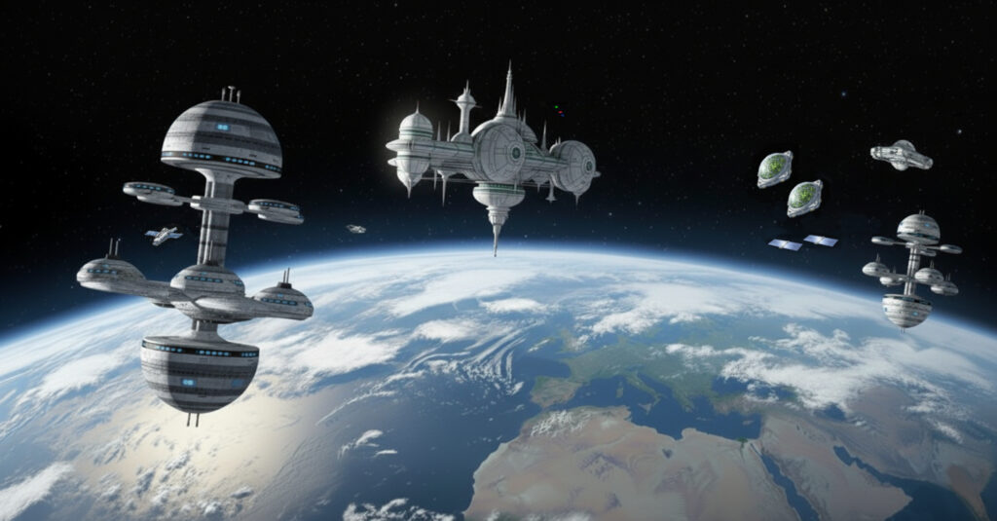
Belt K – An Earth orbit space habit spread over 20km including habitation, living spaces, educational areas, recreation, physical conditioning areas, manufacturing, solar power generation and storage, space agriculture and hydroponics in large domes (automatically positioned to maximise crop growing quality and time). Robotics and droids are used throughout the Belt. Children born on Belt K are given names starting with “K”.
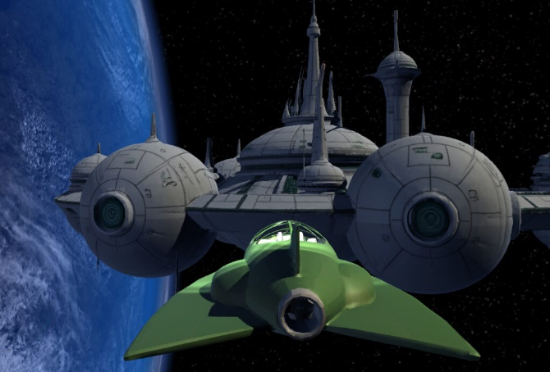
“Gravity Rays” are projected around space stations and spacecraft to protect them from meteor damage, provide an area within them with gravity and to stabilize their positions. They provide an envelope within which the occupants can breathe normally when close to their space station areas or spacecraft. But away from the protective area of the Gravity Rays helmets and full space suits must be worn.
Spacecraft – Space Scooters (SS) for intra-habitat local transport and exploration, Space Runabouts (SR) for in orbit travel, Space Transports (ST) managed by the Space Transport Authority (STA) are the workhorses for orbital and Earth-Orbit operations for cargo and passengers, and Experimental Spacecraft (SX).
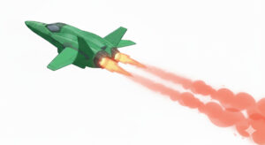
Space Scooters (SS) – small two to four seat personal spacecraft for travel within a Belt. Highly automated with remote supervisory capability for younger travellers.
Space Runabouts (SR) – two seat or larger spacecraft for travel around and between the Satellite Belts. Automation is used for safety. Fully autonomous versions provide a taxi service.
Space e(X)perimental (SX) – a range of craft under development and testing.


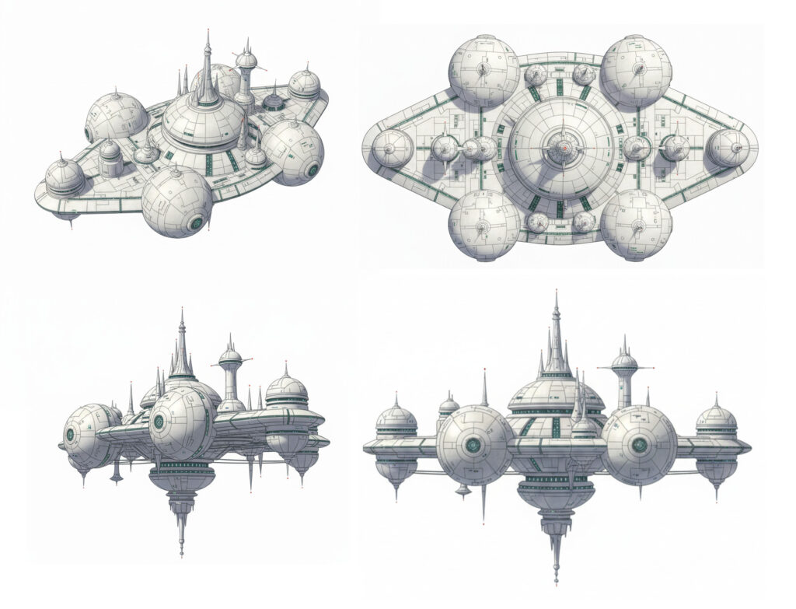
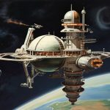
The core space station of Belt K.
Origination: Retro-futuristic space station image generation in Leonardo.ai. Used as a basis for generation of a space station image in Google Gemini. 3D model created in Tripo3D.

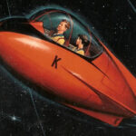
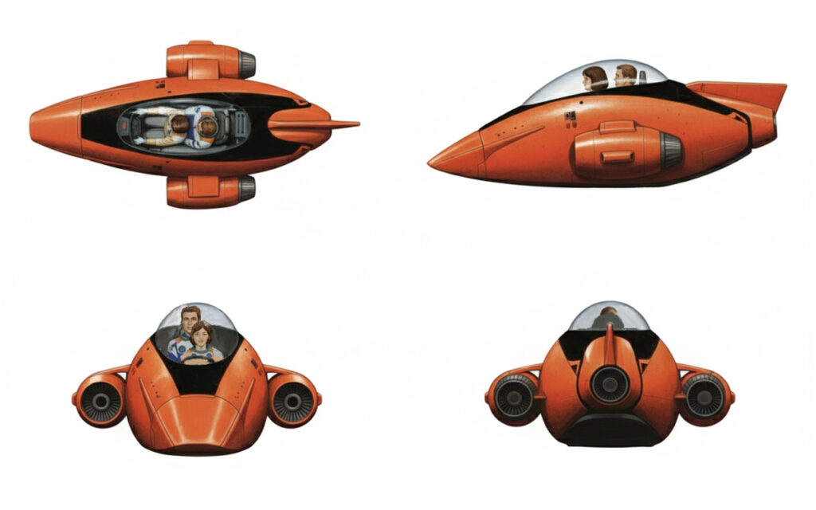
Space Scooters typically provide short distance local transport within belts. They are often fully autonomous. Multi-mode gas jet thrusters and air flow turbines allow for movement within and between space station elements. Modular engines make replacement and maintenance easier.
Origination: Original artwork from “Kemlo and the Star Men” paperback. Tidied up in Leonardo. Used as a basis for generation of a spacecraft image in Google Gemini.

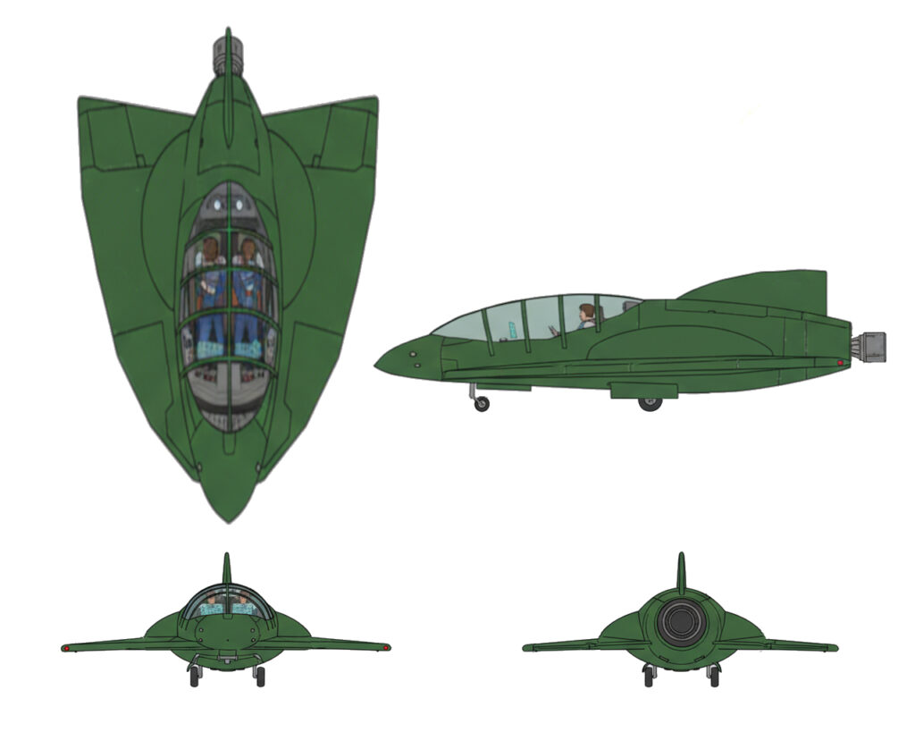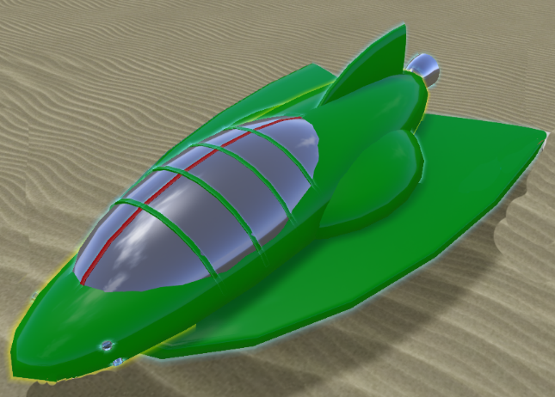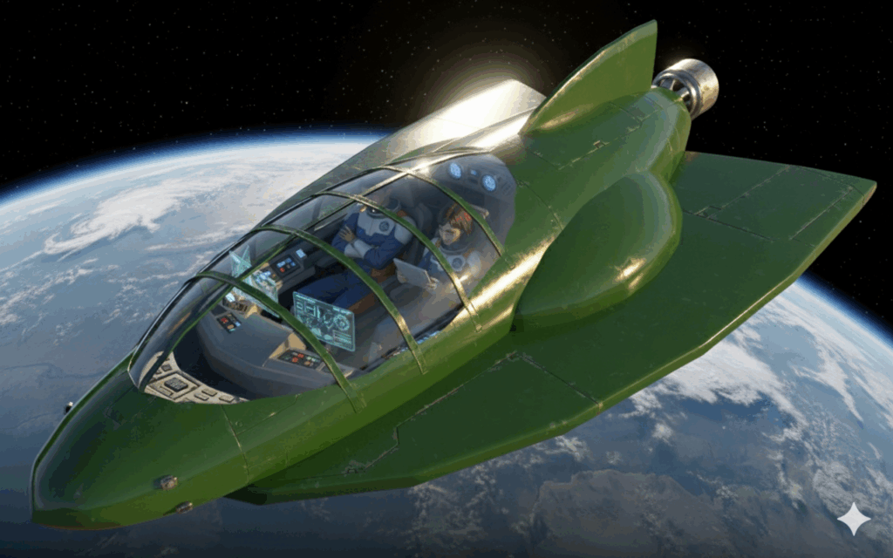

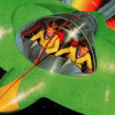
For belt, orbital and near space operations. Atmospheric entry is not available.
Origination: Original artwork from “Kemlo and the Space Lanes” paperback. Simple 3D model generated in OpenSimulator. Image of that used to generate a detailed image in Google Gemini. 3D model created in Tripo3D.

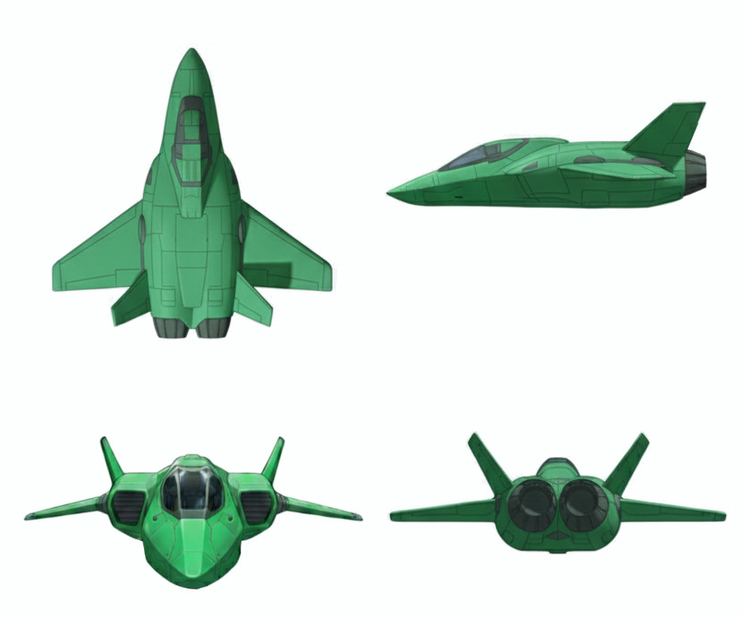
A second generation Space Runabout. Wings and control surfaces allows for atmospheric use and Earth landings as well as in orbit uses.
Origination: Google Gemini image generation and manipulation.

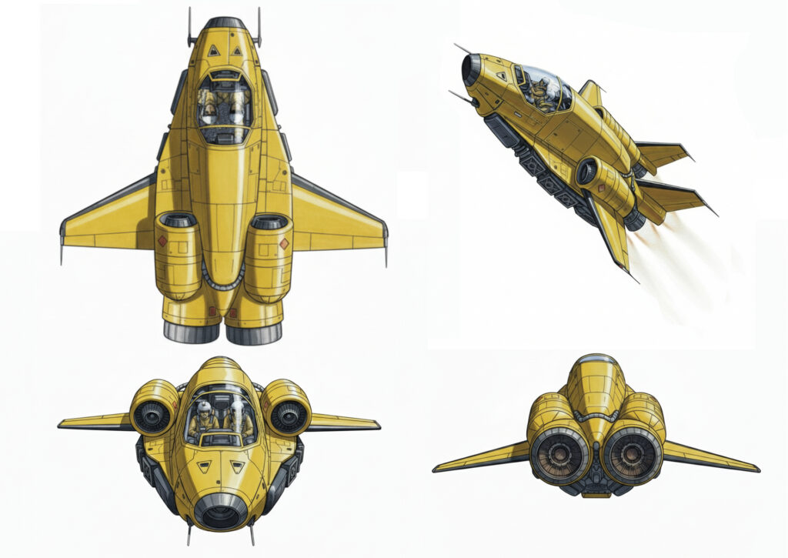
A powerful new spacecraft intended for deeper space missions. Wings and control surfaces allow for operation in earth’s atmosphere.
Origination: Google Gemini image generation and manipulation.

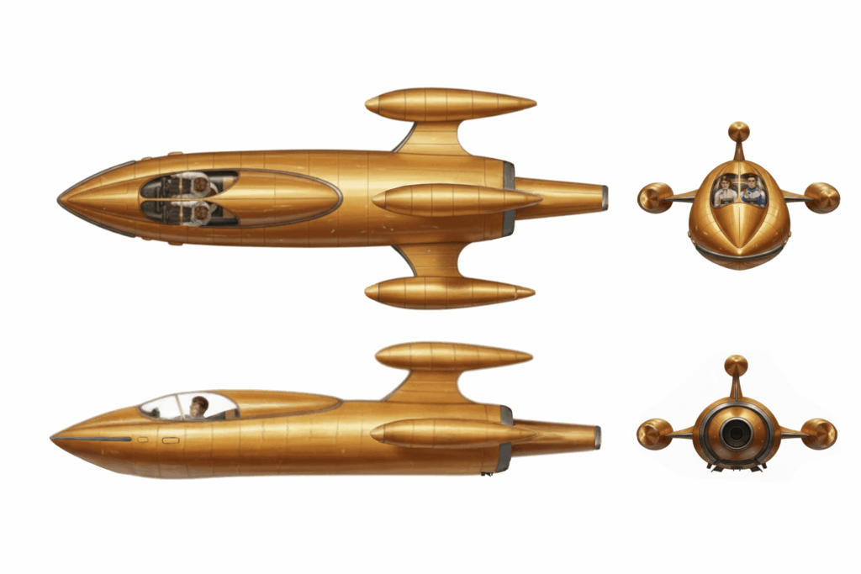
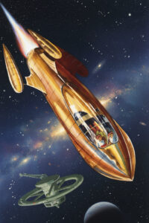
Space Personal Investigation Training and Research Craft Number XK240. The three pods on the horizontal and vertical fins can carry experimental fuels and can be easily swapped out. Kemlo is an assigned test pilot.
Origination: Original artwork by A. Bruce Cornwell from “Kemlo and the End of Time” hardback. Scenario.com was used to enhance a scan of this illustration. That was used to generate a detailed image in Google Gemini. Further manipulation in Google Gemini.

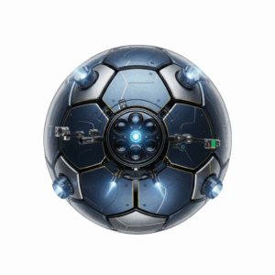
Drone as used around Satellite Belt K for inspection operations. May also be deployed from spacecraft. Comms links to [personal devices allows for teleoperation and remote viewing.
Origination: Generated in Google Gemini.

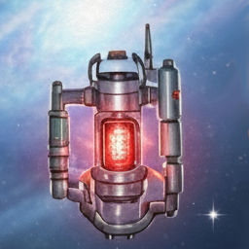
A Portable Gravity Ray Emitter (often referred to as a “Gremlin”) which allows a protective envelope and Satellite Belt Normal Gravity zone adjustable up to 50m across to be set up anywhere. Less than 20cm in size it is safely and easily carried on small spacecraft for deployment. It is powered by a long lasting pea-sized urania power source which can last for a decade or more depending on the field size chosen.
Origination: Generated in Google Gemini Storybook Mode as shown with Kemlo and Krillie below. They don’t need full spacesuits and helmets as they are within the Gremlin’s protective Gravity Ray envelope.
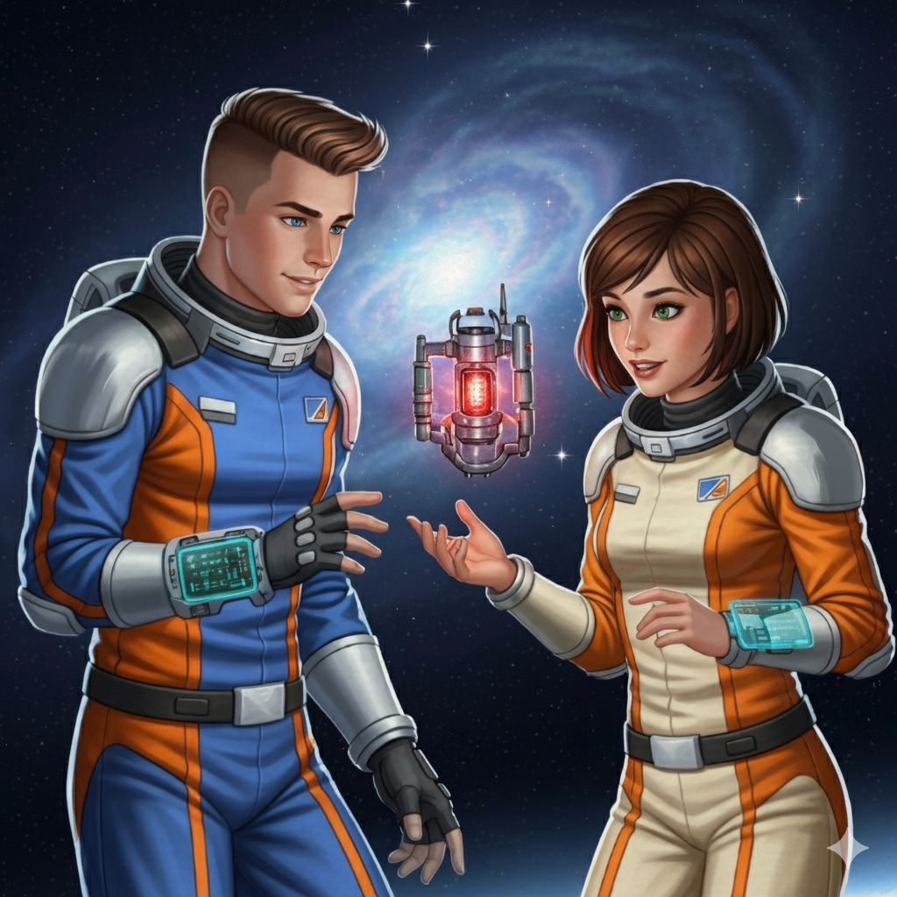

The Belt K Technical Manual uses background created previously using AI tools based on the Kemlo Spaceworld series of books by E.C. Eliott published in 1954 to 1963. It uses the contents of this blog post: https://blog.inf.ed.ac.uk/atate/2025/09/10/kemlo-and-krillie-briefing/.

