Kemlo & Krillie – Index
Posted on October 5, 2025 by bat

The Kemlo series is a collection of children’s science fiction novels written by Reginald Alec Martin, under the pseudonym of E. C. Eliott. The first book, Kemlo and the Crazy Planet was published in 1954; the fifteenth and final book in the series, Kemlo and the Masters of Space, was published in 1963. [Text from Wikipedia – Kemlo]
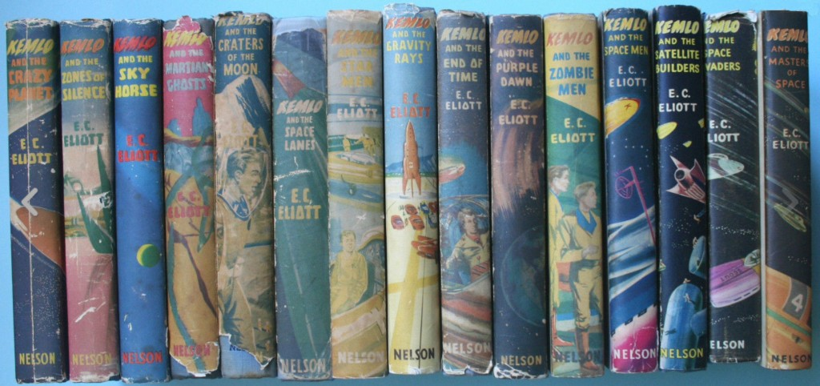
“The Further Adventures of Kemlo & Krillie in Space” is Fan Fiction by Austin Tate based on the Kemlo books with the characters now in their late teens and some other changes. This blog post acts an an index into various resources, blog posts and web pages related to their adventures. [Book Cover Mockup: Book Cover, Dust Jacket]
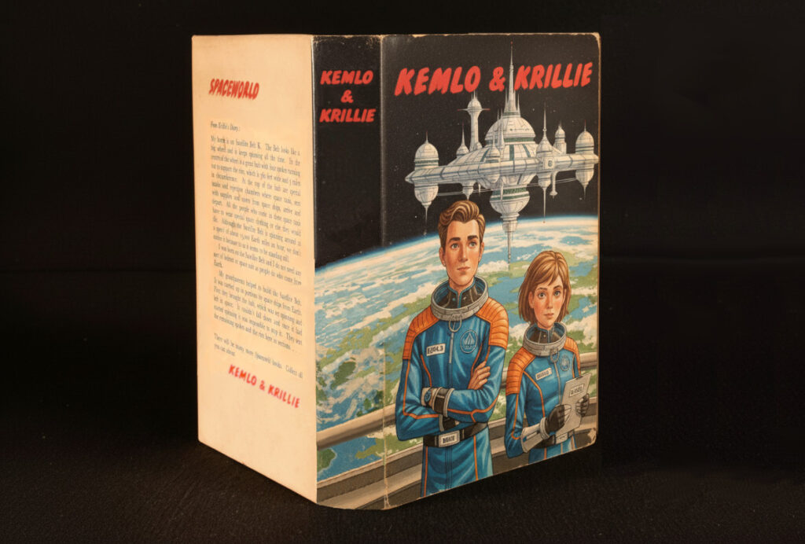
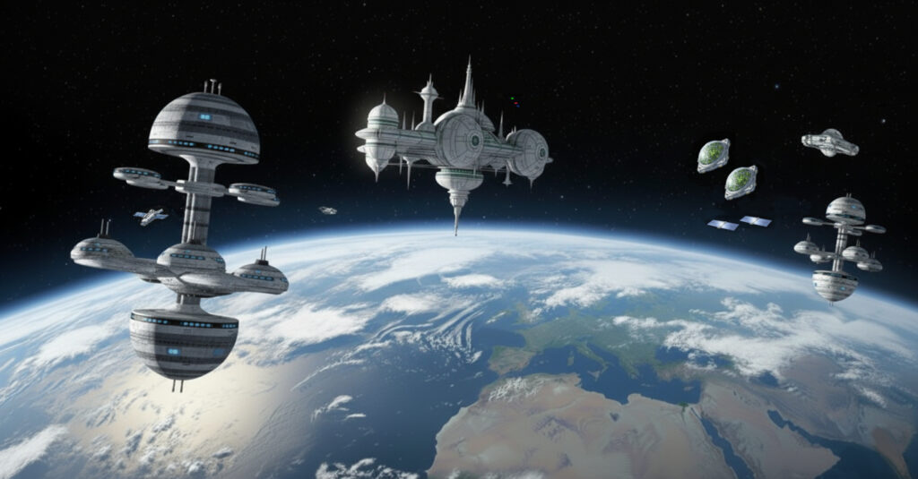
- Kemlo & Krillie Briefing – Overview of Satellite Belt K, its organisation and facilities and the main characters: Kemlo and Krillie.
[Early version before further character development]
- Belt K Technical Manual – Space Station, Spacecraft, Drones, etc.
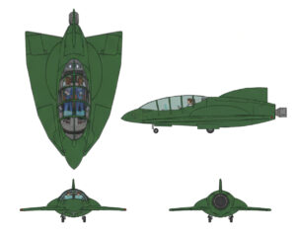 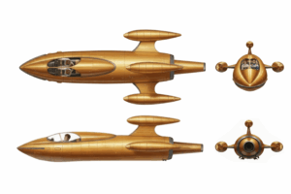

- Kemlo & Krillie – Character Sheets
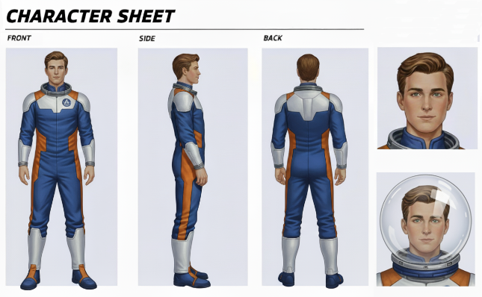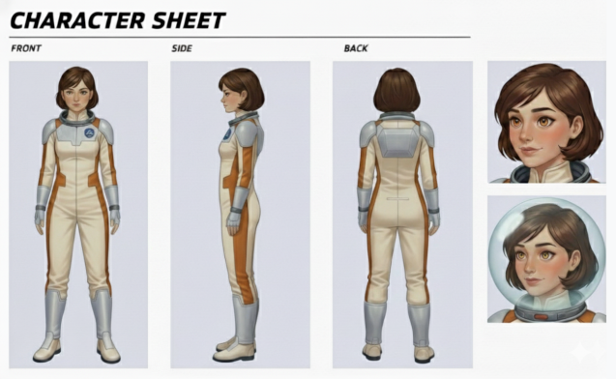

- Other Characters – Family, Friends and other Characters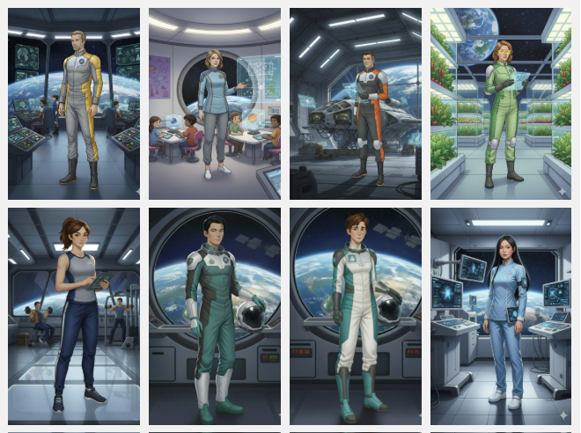
- Kemlo & Krillie Storybooks are storybooks about The Further Adventures of Kemlo & Krillie in Space.
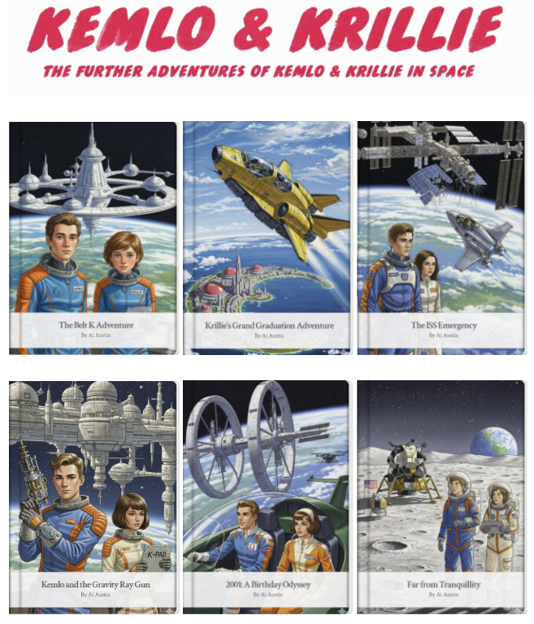

- Krillie’s Diary is aimed at those interested in what is happening in space and to describe her life as a Space Girl including education and training, living arrangements and adventures.
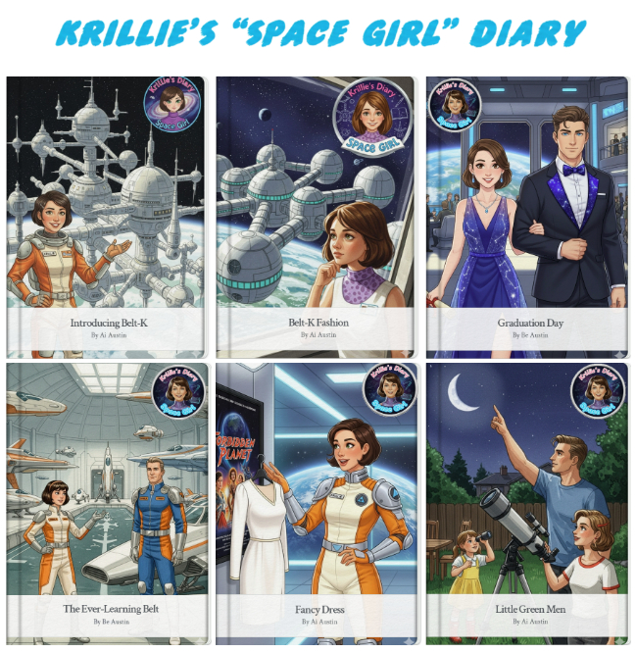

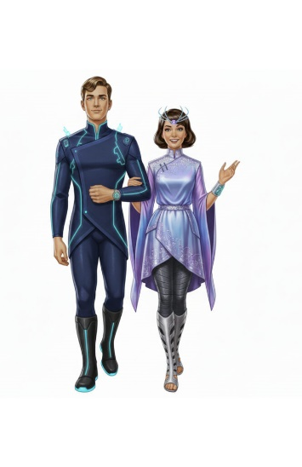
- Kemlo & Krillie Fashion [Belt K Fashion, Krillie Tries it on, Century 21 Cosplay, Fancy Dress and Movie Costumes]




- Century 22 Sports
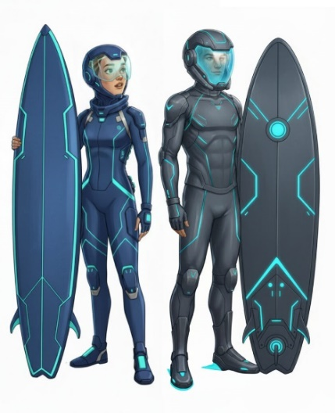 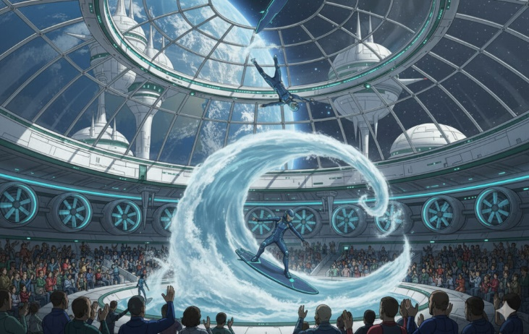
- Century 22 Food
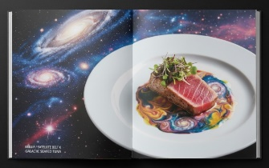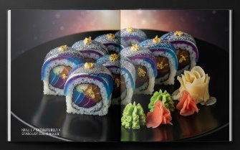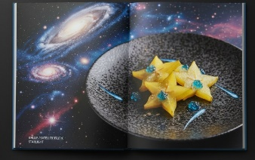

- Kemlo & Krillie Figurines, Kemlo & Krillie in LEGO
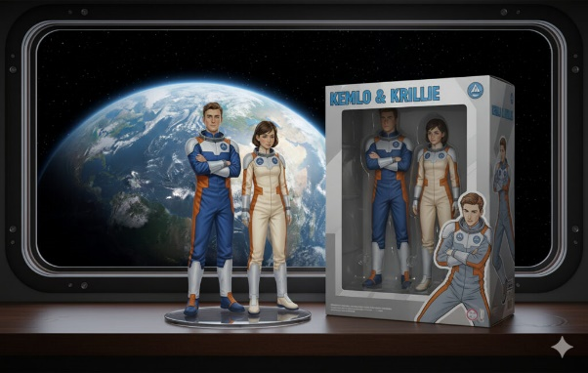 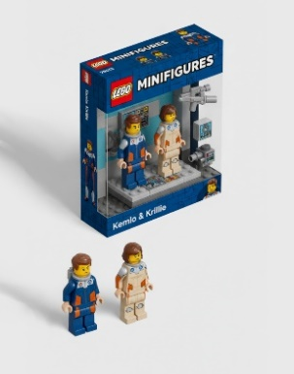 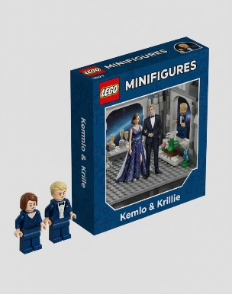
- KEMLO Font

