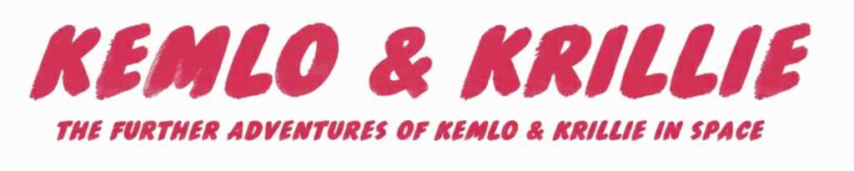
00 – Cover Contents – 1
00 – Contents - 1
00 - Index - 8
01 - Briefing - 6
02 - Technical Manual - 9
03 - Character Sheets - 2
04 - Other Characters - 9
05 - Storybooks - 6
05a - Storybook 1 - The Belt K Adventure - 7
05b - Storybook 2 - Krillies Grand Graduation Adventure - 9
05c - Storybook 3 - The ISS Emergency - 7
05d - Storybook 4 - Kemlo and the Gravity Ray Gun - 9
05e - Storybook 5 - 2001 A Birthday Odyssey - 8
05f - Storybook 6 - Far from Tranquillity - 8
05g - Storybook 7 - The Gravity Ray Gambit - 7
05h - Storybook 8 - The SPITAR Anomaly - 7
06 - Krillies Diary - 3
06a - Krillies Diary 1 - Introducing Belt K - 7
06b - Krillies Diary 2 - Belt K Fashion - 9
06b1 - Krillies Diary 2 - Supplement - Fashion - 5
06c - Krillies Diary 3 - Graduation Day - 10
06d - Krillies Diary 4 - Ever Learning Belt - 9
06e - Krillies Diary 5 - Fancy Dress - 9
06f - Krillies Diary 6 - Little Green Men - 8
06g - Krillies Diary 7 - Krillie Tries it On - 9
06h - Krillies Diary 8 - Century 21 Cosplay - 3
06i - Krillies Diary 9 - Century 22 Sports - 8
06j - Krillies Diary 10 - Century 22 Food - 6
06k - Krillies Diary 11 - Also Figurines and LEGO - 3
07 - Kemlo Books by EC Eliott - 4

TOTAL: 197 Pages

“The Further Adventures of Kemlo & Krillie in Space” uses background created previously using AI tools based on the Kemlo Spaceworld series of books by E.C. Eliott published in 1954 to 1963. As background it uses images and PDF of the contents of this blog post: https://blog.inf.ed.ac.uk/atate/2025/09/10/kemlo-and-krillie-briefing/

