**Kemlo Books by E.C. Eliott -** Posted on [January 1, 2014](https://blog.inf.ed.ac.uk/atate/2014/01/01/kemlo/) by [bat](https://blog.inf.ed.ac.uk/atate/author/bat/)

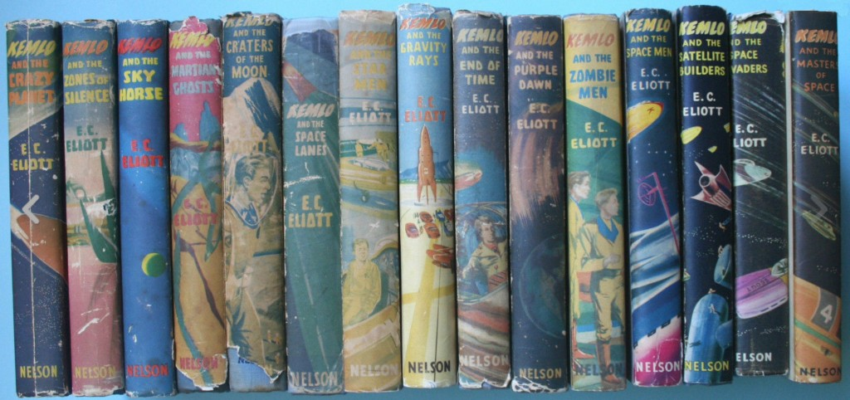

[Text from [Wikipedia – Kemlo](https://en.wikipedia.org/wiki/Kemlo), contributed by Austin Tate and others]

The Kemlo series is a collection of children’s science fiction novels written by [Reginald Alec Martin](https://en.wikipedia.org/wiki/Reginald_Alec_Martin), under the pseudonym of E. C. Eliott. The first book, Kemlo and the Crazy Planet was published in 1954; the fifteenth and final book in the series, Kemlo and the Masters of Space, was published in 1963.

The central character, Kemlo, was born and raised in space, on a satellite named Satellite Belt K (one of a number of similar space stations named after a letter of the alphabet). All children born on a space station were given names with the same initial, hence the names Kemlo, Kartin, Kerowski, Krillie, and so on. Kemlo was a Captain of the Space Scouts, who had their own “scooters” – small two-seat personal spacecraft for travel around and between the Satellite Belts. Kemlo, like all children born in space, breathed “plasmorgia” instead of air. This allowed him to breathe in space, although it meant he was unable to travel to Earth without the aid of compressed plasmorgia and “gravity rays”.

1. Kemlo and the Crazy Planet (1954)  
2. Kemlo and the Zones of Silence (1954)  
3. Kemlo and the Sky Horse (1954)  
4. Kemlo and the Martian Ghosts (1955)  
5. Kemlo and the Space Lanes (1955)  
6. Kemlo and the Craters of the Moon (1955)  
7. Kemlo and the Star Men (1955)  
8. Kemlo and the Gravity Rays (1956)  
9. Kemlo and the End of Time (1957)  
10. Kemlo and the Purple Dawn (1957)  
11. Kemlo and the Zombie Men (1958)  
12. Kemlo and the Space Men (1959)  
13. Kemlo and the Satellite Builders (1960)  
14. Kemlo and the Space Invaders (1961)  
15. Kemlo and the Masters of Space (1963)

Illustrators: [A. Bruce Cornwell](https://bearalley.blogspot.com/2012/03/bruce-cornwell-1920-2012.html) and George Craig.

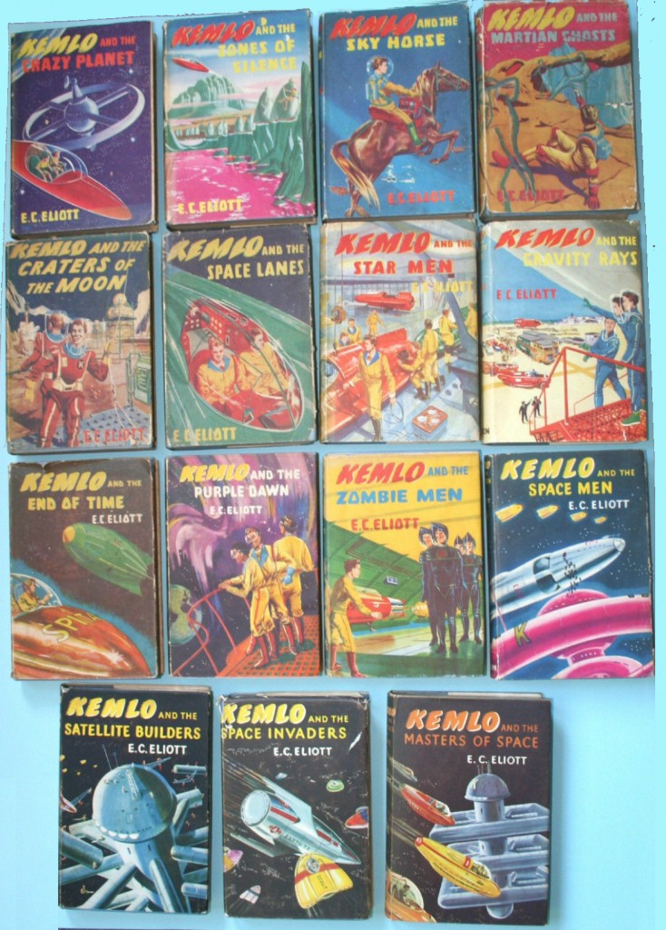

*Images from Ebay*

[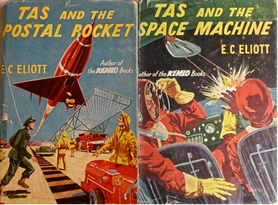](https://blog.inf.ed.ac.uk/atate/files/2014/01/Tas_series-Wikipedia.jpg)E.C. Eliott also wrote two books in the [Tas](https://en.wikipedia.org/wiki/Tas_(series)) series:

* Tas and the Postal Rocket (Nelson, 1955)
* Tas and the Space Machine (Nelson, 1955)

[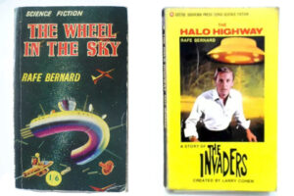](https://blog.inf.ed.ac.uk/atate/files/2014/01/Rafe-Bernard-Sci-Fi-Books.jpg)Reginald Alec Martin writing as Rafe Bernard also wrote three other Science fiction books:

* The Wheel In The Sky (Ward Lock, 1954) – a novel that could be considered as a prequel to the Kemlo books about the building of the first “satellite” and includes elements used in the Kemlo books (Holding Rays, Urania power pellets, Diathene breathing gas, etc)
* The Halo Highway (Corgi, 1967) – A Story of “The Invaders” TV Series
* Army of the Undead (Pyramid, 1967) – A Story of “The Invaders” TV Series

Note that the Merlin paperback editions publisher for some Kemlo books dropped the last ‘t’ off the spelling of Eliot(t).

**Further Resources**

* [LibraryThing.com – Kemlo Book Series](https://www.librarything.com/nseries/96533/Kemlo)
* [Collecting Books and Magazines – Kemlo and Reginald Alec Martin (aka E.C.Eliott)](http://www.collectingbooksandmagazines.com/kemlo.html)
* [sf-encyclopedia.com article on E.C.Eliott](https://sf-encyclopedia.com/entry/eliott_e_c)
* [Kemlo and the Birth of Wonder](https://howff.wordpress.com/2013/11/24/kemlo-and-the-birth-of-wonder/) – Dave Irving Blog Post, 24-Nov-2013

**Kemlo e-Pubs and iBooks**

You can read a long diary entry I wrote a long time ago and that, by some extreme foresight, Mr. E.C. Eliott included in one of his books written over two centuries ago! See Chapter 1 of “Kemlo and the Masters of Space”.

14 of the Kemlo books (minus Kemlo and the Satellite Builders) are available in e-Pub and online formats via <https://www.sfgateway.com/contributor/e-c-eliott/> (or [Kindle on Amazon Store](https://www.amazon.co.uk/s?k=kemlo+kindle)).  
[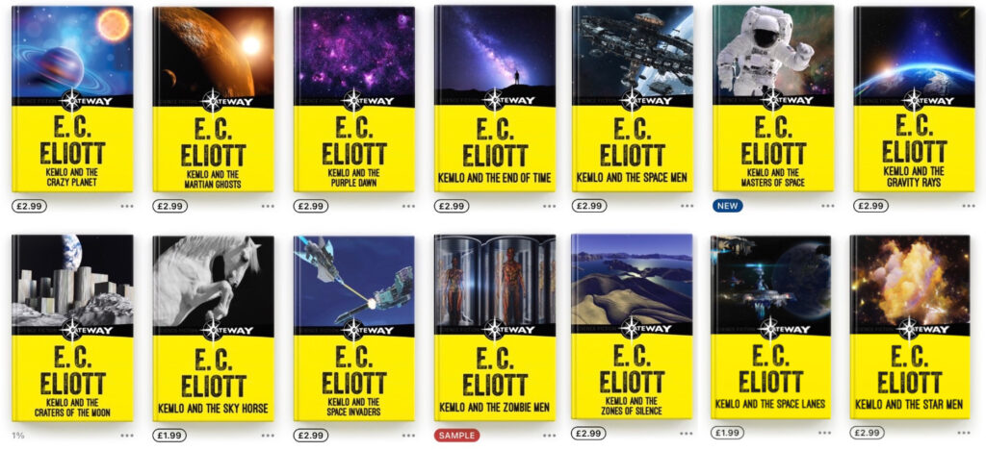](https://blog.inf.ed.ac.uk/atate/files/2014/01/Kemlo-SFGateway-ePubs.jpg)

**Kemlo & Krillie Further Information**

Kemlo & Krillie uses background created previously using AI tools based on the [Kemlo Spaceworld series of books by E.C. Eliott](https://blog.inf.ed.ac.uk/atate/2014/01/01/kemlo/) published in 1954 to 1963. It uses the contents of this blog post: <https://blog.inf.ed.ac.uk/atate/2025/09/10/kemlo-and-krillie-briefing/>

See also:

* [Kemlo Books by E.C.Eliott](https://blog.inf.ed.ac.uk/atate/2014/01/01/kemlo/)
* [Kemlo & Krillie Briefing](https://blog.inf.ed.ac.uk/atate/2025/09/10/kemlo-and-krillie-briefing/)
* [Kemlo & Krillie Storybooks](https://blog.inf.ed.ac.uk/atate/2025/09/07/kemlo-krillie-storybooks/)
* [Krillie’s ‘Space Girl’ Diary](https://blog.inf.ed.ac.uk/atate/2025/09/12/krillies-space-girl-diary/)
* [Belt K Technical Manual](https://blog.inf.ed.ac.uk/atate/2025/09/19/belt-k-technical-manual)
* [Kemlo & Krillie Character Sheets](https://blog.inf.ed.ac.uk/atate/2025/09/21/kemlo-and-krillie-character-sheets/) and [Other Characters](https://blog.inf.ed.ac.uk/atate/2025/10/01/kemlo-krillie-characters/)
* [Kemlo & Krillie Fashion](https://blog.inf.ed.ac.uk/atate/2025/09/09/kemlo-krillie-fashion/)
* [More Kemlo & Krillie Related Blog Posts](https://blog.inf.ed.ac.uk/atate/?s=kemlo)
* Further Resources: [Kemlo & Krillie character details, spacecraft, space station, Kemlo Font](https://www.aiai.ed.ac.uk/~ai/resources/Kemlo-and-Krillie/)