# **Masters of Space Diary Entry, Figurines and LEGO**

[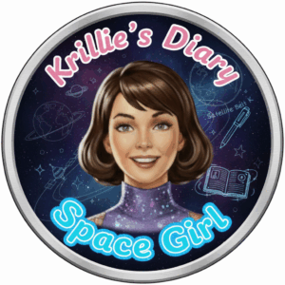](https://blog.inf.ed.ac.uk/atate/files/2025/09/Krillies-Diary-Space-Girl-Logo-Pink-and-Blue.png)Hi, I’m Krillie. I was born in space on an Earth orbiting space station called “Satellite Belt K”. I write a diary under the moniker “[Space Girl](https://blog.inf.ed.ac.uk/atate/2025/09/12/krillies-space-girl-diary/)” for those interested in what is happening in space and to describe life as a Space Girl. I cover a lot of our activities, about our education and training, our living arrangements and some of our adventures. Along with my friend Kemlo, I write some of the books in “[The Further Adventures of Kemlo and Krillie in Space](https://blog.inf.ed.ac.uk/atate/2025/09/07/kemlo-krillie-storybooks/)” series. I hope my Diary is of interest to children on Earth, in the Satellite Belts and beyond.

**Kemlo e-Pubs and iBooks**

You can read a long diary entry I wrote a long time ago and that, by some extreme foresight, Mr. E.C. Eliott included in one of his books written over two centuries ago! See Chapter 1 of “Kemlo and the Masters of Space”.

14 of the Kemlo books (minus Kemlo and the Satellite Builders) are available in e-Pub and online formats via <https://www.sfgateway.com/contributor/e-c-eliott/> (or [Kindle on Amazon Store](https://www.amazon.co.uk/s?k=kemlo+kindle)).  
[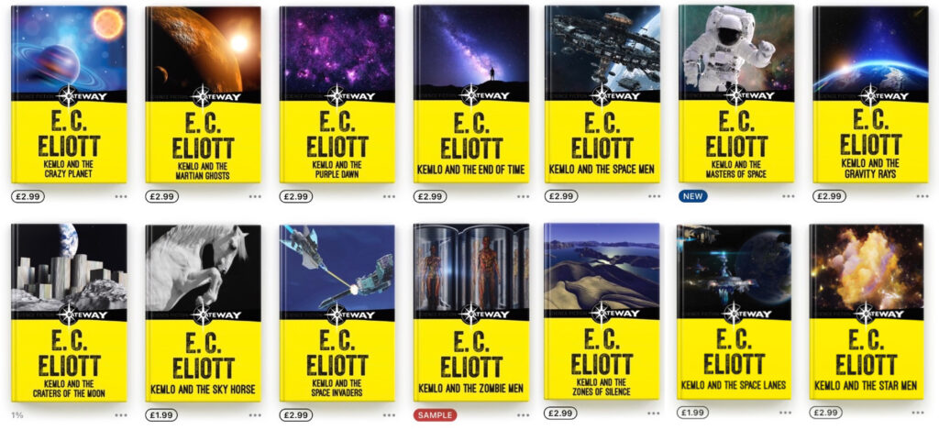](https://blog.inf.ed.ac.uk/atate/files/2014/01/Kemlo-SFGateway-ePubs.jpg)

**Kemlo & Krillie Figurines**

[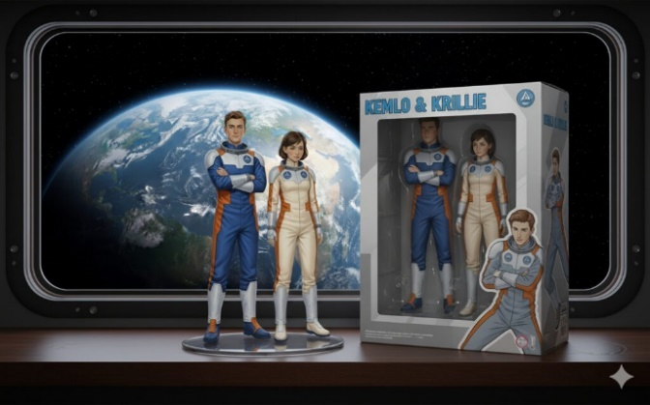](https://blog.inf.ed.ac.uk/atate/files/2025/09/Gemini-Generated-Kemlo-and-Krillie-B1.jpg) [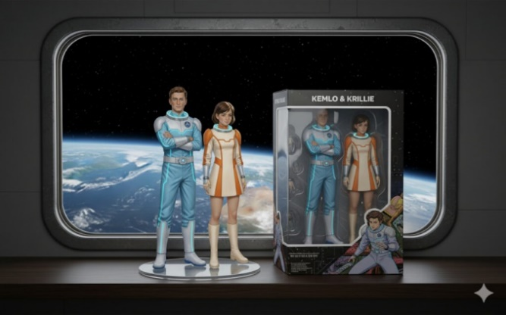](https://blog.inf.ed.ac.uk/atate/files/2025/09/Gemini-Generated-Kemlo-and-Krillie-B2.jpg)  
[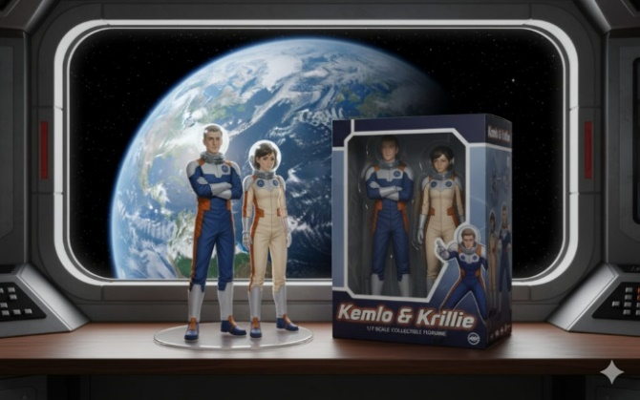](https://blog.inf.ed.ac.uk/atate/files/2025/09/Gemini-Generated-Kemlo-and-Krillie-B4.jpg) [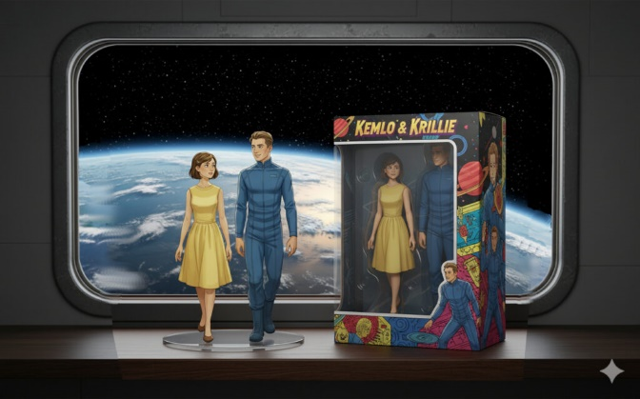](https://blog.inf.ed.ac.uk/atate/files/2025/09/Gemini-Generated-Kemlo-and-Krillie-B3.jpg)  
[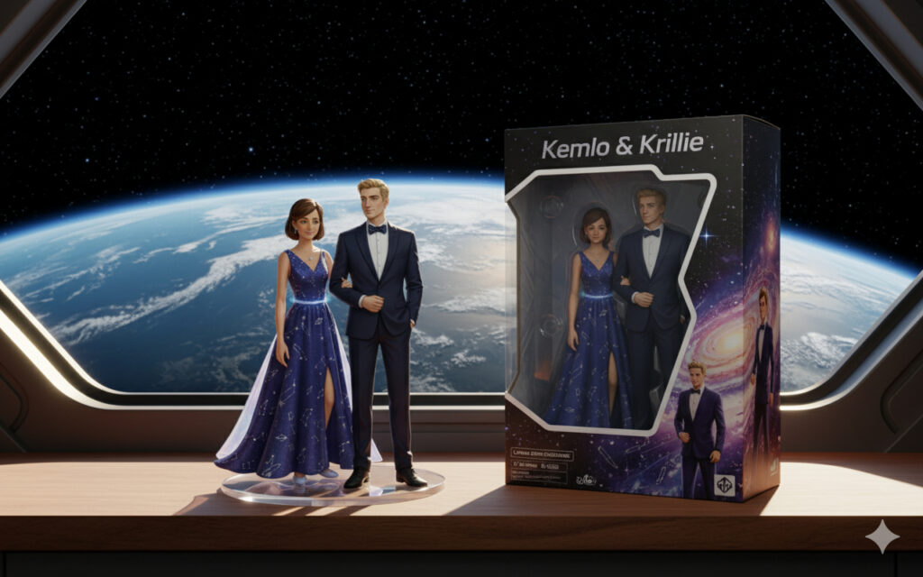](https://blog.inf.ed.ac.uk/atate/files/2025/09/Gemini-Generated-Figurine-Krillie-and-Kemlo-Prom-Outfits.jpg)

**Kemlo & Krillie in LEGO**

[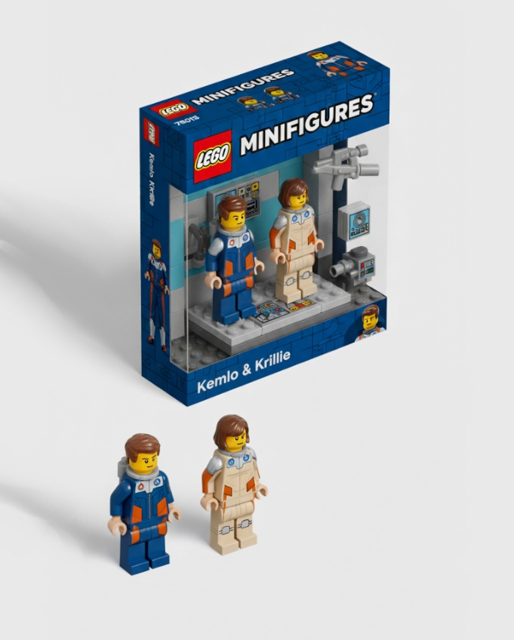](https://blog.inf.ed.ac.uk/atate/files/2025/09/Gemini_Generated_Image_Minifigures_Kemlo-and-Krillie-1-960x768-1.jpg) [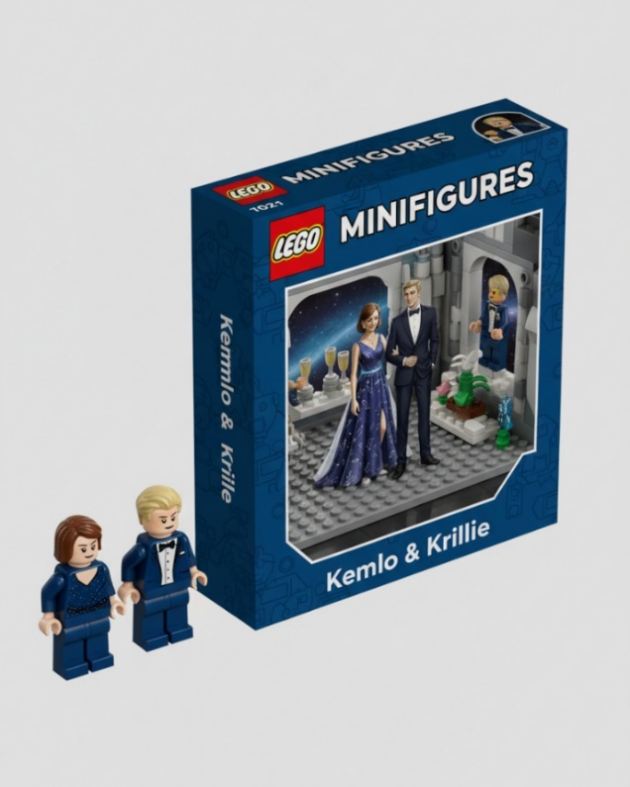](https://blog.inf.ed.ac.uk/atate/files/2025/09/Gemini_Generated_Image_Minifigures_Kemlo-and-Krillie-2-960x768-1.jpg)