# **Century 22 Food**

Posted on [September 24, 2025](https://blog.inf.ed.ac.uk/atate/2025/09/24/century-22-food/) by [bat](https://blog.inf.ed.ac.uk/atate/author/bat/)

[](https://blog.inf.ed.ac.uk/atate/files/2025/09/Krillies-Diary-Space-Girl-Logo-Pink-and-Blue.png)Hi, I’m Krillie. I was born in space on an Earth orbiting space station called “Satellite Belt K”. I write a diary under the moniker “[Space Girl](https://blog.inf.ed.ac.uk/atate/2025/09/12/krillies-space-girl-diary/)” for those interested in what is happening in space and to describe life as a Space Girl. I cover a lot of our activities, about our education and training, our living arrangements and some of our adventures. Along with my friend Kemlo, I write some of the books in “[The Further Adventures of Kemlo and Krillie in Space](https://blog.inf.ed.ac.uk/atate/2025/09/07/kemlo-krillie-storybooks/)” series. I hope my Diary is of interest to children on Earth, in the Satellite Belts and beyond.

Hey everyone! Krillie here, coming to you live from the orbital Agricultural Labs on Unity Station today. So, you’re probably wondering what we eat up here, right? Do we just munch on nutrient paste and recycled algae all day? Not a chance! We’ve got it pretty good, actually.

Remember those old movies where astronauts squeezed food out of tubes? Hilarious, but so, so wrong. While we don’t exactly have dirt-grown veggies in the traditional sense, we’ve got some amazing tech that lets us grow a huge variety of fresh stuff. Think of our hydroponic towers – they’re like vertical farms on steroids, using nutrient-rich water instead of soil. We grow everything from leafy greens like kale and spinach to juicy tomatoes and peppers. And some dishes have a very 22nd Century vibe to them.

I am visiting my friend Anya in the Orbital Harvests area on Unity Station. She has been on the Space Station there for a couple of years, but originally came from Earth as a Food Technologist.

[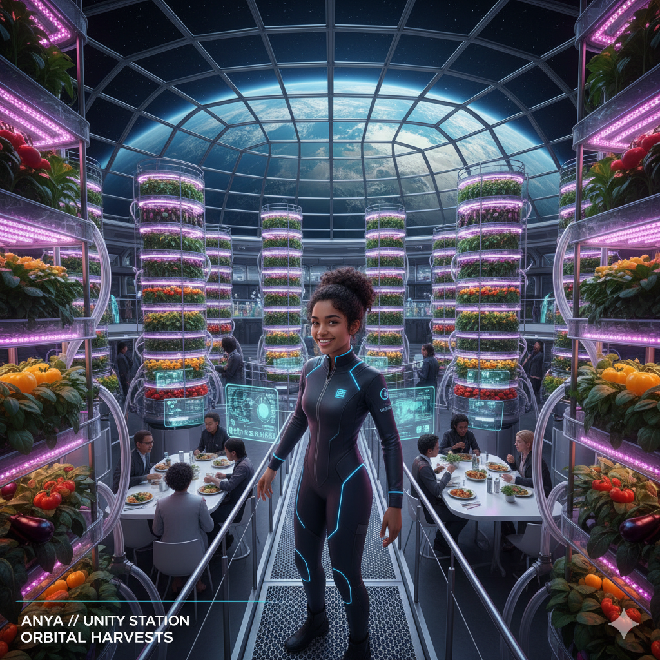](https://blog.inf.ed.ac.uk/atate/files/2025/09/Anya-Unity-Station-Food-Harvest.png)

One of the coolest things is our “protein replicators.” Sounds fancy, right? Basically, they use cellular agriculture to grow real meat, fish, and even some dairy products without needing actual animals. It’s totally sustainable and tastes exactly like the real thing. One of my favourites is the replicated tuna steak – perfect for a zero-g barbecue!

And get this: we even have our own little insect farms for sustainable protein. Before you gross out, hear me out! Crickets are actually super nutritious and when they’re processed into flour, you can’t even tell the difference. We use it in our baked goods and protein bars. Don’t knock it till you’ve tried it!

Of course, we still get some supplies from Earth, mostly things that are too energy-intensive to produce up here, like certain spices or specialty grains. But for the most part, our meals are crafted from what we grow and create right here in the Belts. It’s pretty amazing to think that almost every bite I take has been cultivated within these very domes, under the watchful eye of our beautiful blue marble planet.

**My Favourite Foods (with help from Google Gemini)**

Alright, so you want to know my absolute favourite meals up here? Where do I even begin? If I had to pick some, it would definitely be these:

[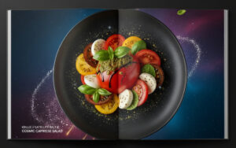](https://blog.inf.ed.ac.uk/atate/files/2025/09/Cook-Book-Stellar-Cosmic-Caprese-Salad.jpg)First up, you can’t beat a good “**Cosmic Caprese Salad**“. Seriously, it’s out of this world! We take those perfectly ripe, juicy tomatoes we grow in the hydroponics bay, slice them up thick, and layer them with fresh, house-cultured mozzarella. Then we drizzle it with basil oil – made from our own basil plants, of course – and a tiny dash of balsamic reduction that comes from Earth (some things are just worth the shipping cost!). The zero-g environment actually makes the flavours feel even more intense, and the freshness just bursts in your mouth. It’s light, it’s flavourful, and it reminds me that even in space, we can enjoy the simple, beautiful things.

[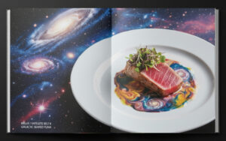](https://blog.inf.ed.ac.uk/atate/files/2025/09/Cook-Book-Galactic-Seared-Tuna.jpg)For a quick, satisfying meal that’s a bit more elegant, my go-to is “**Galactic Seared Tuna**“. Its one of my absolute favourites. This is a true testament to our orbital aquaculture labs. We take a fresh, thick-cut fillet of our space-grown tuna, season it with a touch of crystallized sea salt from our reclamation plants and a sprinkle of black pepper, then give it a super-quick sear on a high-heat quantum griddle. The outside gets this perfect, almost crust-like texture while the inside stays beautifully pink and tender. We plate it on a bed of fresh hydroponic greens and top it with a swirl of zesty lime-cilantro emulsion and a few crisped-up rings of hydroponic red onion. It’s light, protein-packed, and tastes like a breath of fresh air—or, you know, fresh space!

[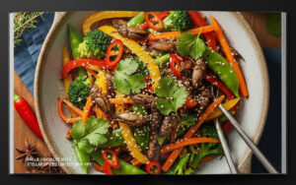](https://blog.inf.ed.ac.uk/atate/files/2025/09/Cook-Book-Stellar-Spiced-Cricket-Stir.jpg)Next on the list, and this might surprise you, is “**Stellar Spiced Cricket Stir-Fry**“, I know, I know, “cricket” sounds weird, but trust me on this! We use ground cricket protein, seasoned with a blend of Earth-imported spices like ginger, garlic, and chili. We stir-fry it with a medley of our hydroponic veggies – crisp bell peppers, tender snap peas, and crunchy carrots – all grown right here. It’s packed with protein, super flavourful, and gives you a real energy boost without feeling heavy. Plus, it’s a testament to how creative and sustainable our food systems are. You wouldn’t even know it was crickets unless someone told you!

[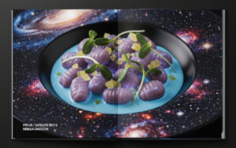](https://blog.inf.ed.ac.uk/atate/files/2025/09/Cook-Book-Nebula-Gnocci.jpg)For a vegetarian dish that’s as delicious as it is visually stunning, we have the “**Nebula Gnocchi”**. This isn’t your great-great-grandmother’s pasta; it’s made from a genetically engineered, high-protein purple potato that we grow in the biodomes. The gnocchi themselves are naturally vibrant and soft, absorbing flavours beautifully. We toss them in a light, creamy sauce derived from a rare, bioluminescent fungus cultivated in our mycological bays, giving it a soft, ethereal glow. The dish is topped with flash-fried “sunflower sprouts”—crisp, delicate greens that have a nutty flavour—and a sprinkle of crushed, crystallized ginger that adds a spicy little burst of flavour, like a supernova in your mouth. It’s a dish that looks like a miniature galaxy on your plate and is packed with all the nutrients a growing teenager in space needs.

[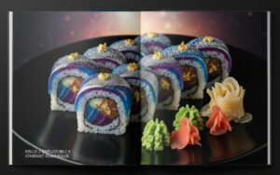](https://blog.inf.ed.ac.uk/atate/files/2025/09/Cook-Book-Stardust-Sushi-Rolls.jpg)For a bit of a culinary adventure, my go-to is “**Stardust Sushi Rolls**“. Forget those messy plates of deconstructed sushi; we make ours into these awesome, self-contained rolls. We grow our own seaweed-like sheets in the aquaculture domes and fill them with replicated tuna or salmon that tastes exactly like the real thing. Then we add in hydroponic avocado, crisp cucumber strips, and a dash of spicy aioli. The best part is the “stardust”—it’s a sprinkle of finely ground, iridescent rice crackers that gives it a cosmic sparkle. It’s the perfect zero-g snack: all the flavours in one bite, and it holds together perfectly, so you don’t have to chase rogue pieces of fish around the galley!

[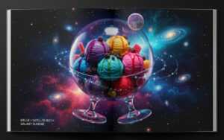](https://blog.inf.ed.ac.uk/atate/files/2025/09/Cook-Book-Galaxy-Sundae.jpg)And for a grand finale, the can’t-live-without dessert: the “**Galaxy Sundae**” (known across the Belts as “**The Big Bang**“). This isn’t just ice cream; it’s a work of edible art! We make our own ice cream from bio-cultured dairy, but instead of vanilla or chocolate, we have flavours like “Nebula” (a swirl of blueberry, raspberry, and lavender), “Supernova” (spicy cinnamon with popping candy), and “Black Hole” (a dark charcoal flavour with streaks of sweet, black liquorice). We scoop three or four different flavours into a floating, transparent orb-bowl, then drizzle it with a shimmering, iridescent syrup that looks like liquid starlight. To top it all off, we sprinkle it with crushed “meteorites”—carbonated sugar crystals that crackle and pop as they dissolve—and a single piece of freeze-dried fruit, which floats like a miniature moon. The two feet on the bowl are fun (and a challenge) for a sharing desert. It’s a full sensory experience, and every bite is a little explosion of cosmic flavour!

Okay, the last dish was just a joke. And its not even 1st April! You did realize that? No one could eat that and still fit into their spacesuit! And, come on, how would you balance the bowl on a table. It’s not real. But the next dish is.

[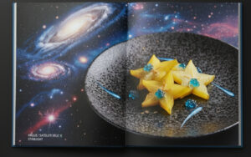](https://blog.inf.ed.ac.uk/atate/files/2025/09/Cook-Book-Starlight.jpg)For a truly elegant and light dessert that won’t weigh you down after a zero-g workout, we have “**Starlight**“. This dish is built around our beautifully cultivated starfruit, sliced thin and arranged to catch the light. Each slice is brushed with a delicate, edible “moonbeam glaze”—a slightly sweet, shimmery liquid extracted from a unique orbital succulent that provides a subtle, almost floral sweetness without extra calories. Nestled between the starfruit slices are tiny, translucent “comet jellies,” infused with sparkling, calorie-free fruit essences. The entire plate is then dusted with a fine, edible glitter that mimics distant stardust, creating a captivating sparkle. It’s a visually stunning, refreshing, and guilt-free treat that feels utterly luxurious.

[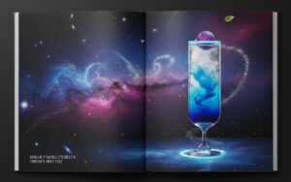](https://blog.inf.ed.ac.uk/atate/files/2025/09/Cook-Book-Orions-Belt-Fizz.jpg)And for when you want to feel truly sophisticated, there’s nothing better than the “**Orion’s Belt Fizz**“. This isn’t your average juice; it’s a layered masterpiece of flavour and science. We start with a base of cold-pressed “starfruit” juice, grown in our botanical dome, which has a crisp, slightly tangy flavour. We then carefully layer in a vibrant blue “nebula” syrup, made from a blend of fermented blueberries and edible butterfly pea flower extract, which creates a mesmerizing colour separation. A final float of sparkling, carbonated water gives it a fizzy finish. The whole concoction is served in a sleek, elegant glass with a thin, glowing rim—our version of a fancy cocktail glass—and garnished with a single, perfectly spherical “moon berry” that’s been grown to float on the surface. It’s chic, refreshing, and the perfect way to hold your head up high in any fancy orbital lounge.

So yes, space food isn’t just about survival anymore; it’s about culinary creativity and enjoying delicious, fresh meals, all thanks to the incredible engineering and agriculture we have up here!

**Google Gemini Prompting Method**

To achieve this specific “cookbook photo style” with an image that covers both pages and has text overlaid in the bottom-left, please use a prompt with this structure:

“A cookbook photo spread across two pages featuring [**your dish name**]. The dish is placed on a [**describe plate/surface**]. The background is a unified, abstract cosmic scene with galaxies and nebulae that covers both pages without any white margins. The bottom-left of the image has text over two lines that reads ‘[**KRILLIE / SATELLITE BELT K**]’ on line 1 and [**DISH NAME**]’ on line 2.”

This detailed formula gives Google Gemini all the necessary information in a clear, concise way: the subject, the style, the composition, the specific background, and the exact text and its [](https://blog.inf.ed.ac.uk/atate/files/2025/09/Cook-Book-Style-Template-V2.png)placement. By providing a template image as you have done, Google Gemini can also analyze the visual cues and replicate the look and feel more accurately.

For future requests, you can use a blank version of the template you provided to guide me. By combining a specific, formulaic prompt with a visual template, we can ensure the images are generated with consistent style and quality.