# **Century 21 Cosplay**

Posted on [September 21, 2025](https://blog.inf.ed.ac.uk/atate/2025/09/21/century-21-cosplay/) by [bat](https://blog.inf.ed.ac.uk/atate/author/bat/)

[](https://blog.inf.ed.ac.uk/atate/files/2025/09/Krillies-Diary-Space-Girl-Logo-Pink-and-Blue.png)Hi, I’m Krillie. I was born in space on an Earth orbiting space station called “Satellite Belt K”. I write a diary under the moniker “[Space Girl](https://blog.inf.ed.ac.uk/atate/2025/09/12/krillies-space-girl-diary/)” for those interested in what is happening in space and to describe life as a Space Girl. I cover a lot of our activities, about our education and training, our living arrangements and some of our adventures. Along with my friend Kemlo, I write some of the books in “[The Further Adventures of Kemlo and Krillie in Space](https://blog.inf.ed.ac.uk/atate/2025/09/07/kemlo-krillie-storybooks/)” series. I hope my Diary is of interest to children on Earth, in the Satellite Belts and beyond.

We got invited recently to a SciFi Cosplay event over in Belt M, one of our neighbouring Satellite Belts. We thought we would wear costumes that related to the mid 21st Century as envisaged a hundred years earlier by Gerry and Sylvia Anderson with their SciFi themed TV show – Supercar (actually set in the mid 20th Century), Fireball XL5, Stingray and Thunderbirds which were set in “Century 21”.

Here I am dressed as Fireball XL5’s Venus, Doctor of Space Medicine, with Kemlo as Steve Zodiac. And as “Aqua” Marina in Stingray. I used wigs (and a lotus flower, freshly picked at the Belt Botanics Dome) to complete the looks.

**](https://blog.inf.ed.ac.uk/atate/files/2025/09/Krillie-as-Marina-V5-Hair-Forward-Lotus-Flower.jpg)**

Steve, I mean Kemlo, had the great idea of going across to Unity City where they have an expo of older space and experimental craft. He posed us sitting on original Century 21 Fireball XL5 Jetmobiles for a selfie… “*Okay Krillie! Okay Steve (I mean Kemlo)!*”

[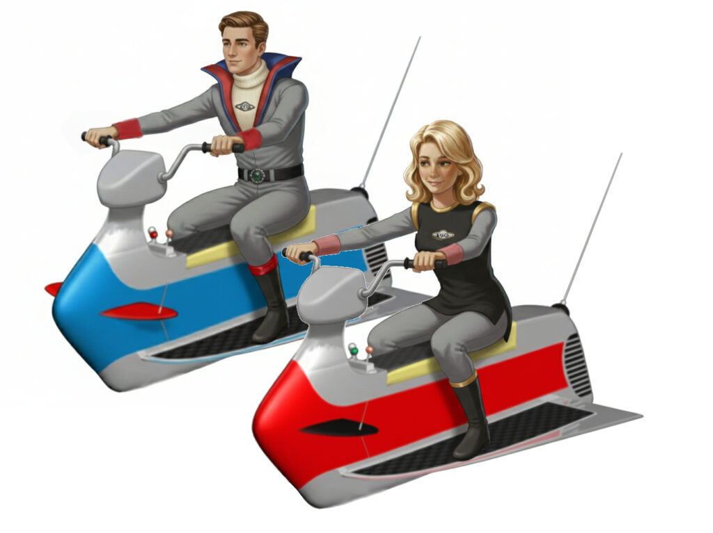](https://blog.inf.ed.ac.uk/atate/files/2025/09/Kemlo-and-Krillie-on-Jetmobiles-V3.jpg)

Once he got going there was no stopping Steve, I mean Kemlo, or should I say Mike Mercury! As once he saw the mid 20th Century experimental multimode test vehicle “Supercar” at the Unity City Expo he had to dress up for that too…

[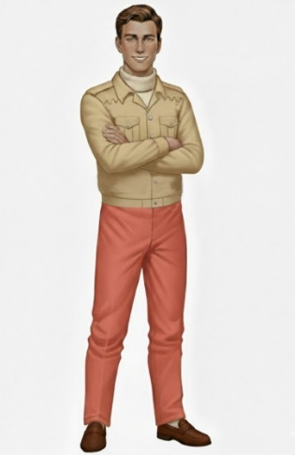](https://blog.inf.ed.ac.uk/atate/files/2025/09/Kemlo-as-Mike-Mercury.jpg) [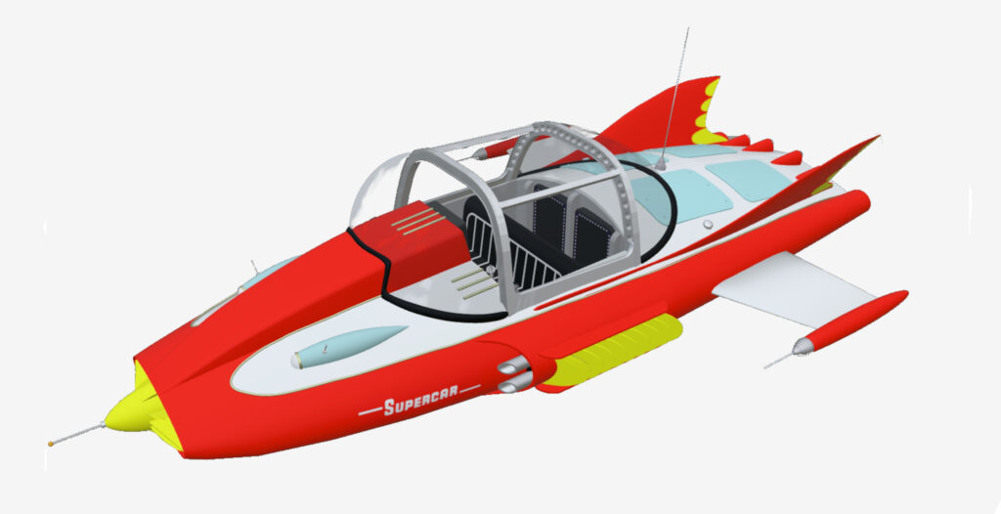](https://blog.inf.ed.ac.uk/atate/files/2025/09/Supercar-at-Unity-City-Expo-V2.jpg)

**Female Fantasy Cosplay**

Every girl has to try on a Wonder Woman outfits at some stage… right? And SciFi girls with big ray guns always go down well.

**](https://blog.inf.ed.ac.uk/atate/files/2025/09/Krillie-as-Space-Vixen-with-Cape-and-Ray-Gun-and-Holster.jpg)**

**More Fashion from Krillie’s Diary**

* [Kemlo & Krillie Fashion](https://blog.inf.ed.ac.uk/atate/2025/09/09/kemlo-krillie-fashion/)
* [Krillie Tries it On](https://blog.inf.ed.ac.uk/atate/2025/09/20/krillie-tries-it-on/)
* [Century 21 Cosplay](https://blog.inf.ed.ac.uk/atate/2025/09/21/century-21-cosplay/)