# **Krillie Tries it On**

[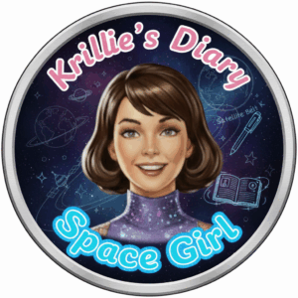](https://blog.inf.ed.ac.uk/atate/files/2025/09/Krillies-Diary-Space-Girl-Logo-Pink-and-Blue.png)Posted on [September 20, 2025](https://blog.inf.ed.ac.uk/atate/2025/09/20/krillie-tries-it-on/) by [bat](https://blog.inf.ed.ac.uk/atate/author/bat/)

Hi, I’m Krillie. I was born in space on an Earth orbiting space station called “Satellite Belt K”. I write a diary under the moniker “[Space Girl](https://blog.inf.ed.ac.uk/atate/2025/09/12/krillies-space-girl-diary/)” for those interested in what is happening in space and to describe life as a Space Girl. I cover a lot of our activities, about our education and training, our living arrangements and some of our adventures. Along with my friend Kemlo, I write some of the books in “[The Further Adventures of Kemlo and Krillie in Space](https://blog.inf.ed.ac.uk/atate/2025/09/07/kemlo-krillie-storybooks/)” series. I hope my Diary is of interest to children on Earth, in the Satellite Belts and beyond.

Our Belt K uniforms and some other clothing is described at <https://blog.inf.ed.ac.uk/atate/2025/09/09/kemlo-krillie-fashion/>

My Belt K Fashion Diary Entry is available at: <https://g.co/gemini/share/aed957af671c> [ [PDF Format](https://www.aiai.ed.ac.uk/~ai/resources/Kemlo-and-Krillie/Krillies-Diary/Krillies-Diary-2-Belt-K-Fashion.pdf) ] [ [Separate Images](https://www.aiai.ed.ac.uk/~ai/resources/Kemlo-and-Krillie/Krillies-Diary/Krillies-Diary-2-Belt-K-Fashion/) ] .

But once I got started with trying on outfits, especially as it’s so easy to use VR to “virtually wear” them, it’s tempting to “try it on” more.

Here are some gowns and a black and gold dance night dress…

**](https://blog.inf.ed.ac.uk/atate/files/2025/09/Krillie-Red-Gown-2.jpg)**

**](https://blog.inf.ed.ac.uk/atate/files/2025/09/Krillie-Sparkle-Dress.jpg)**

Trying some designer fashion dresses from a couple of centuries ago, and they still look as good today… [Little Black Dress](https://en.wikipedia.org/wiki/Little_black_dress) designs originally in the 1920s by Coco Chanel. And the [Yves Saint Laurent Mondrian Collection](https://en.wikipedia.org/wiki/Mondrian_Collection) of dresses using artwork by Piet Mondrian as inspiration and designed in 1965.

**](https://blog.inf.ed.ac.uk/atate/files/2025/09/Krillie-LBD-1.jpg)**

**](https://blog.inf.ed.ac.uk/atate/files/2025/09/Krillie-Mondrian-2.jpg)**

More designer dresses now from Mary Quant in the 1960s and from a design sketch by [X/@rjchicago](https://x.com/rjchicago/status/1972691894258864409)

**](https://blog.inf.ed.ac.uk/atate/files/2025/09/Krillie-Pink-Dress-from-Sketch-by-X-rjchicago.jpg)**

An iconic model from two centuries ago also wore timeless simple “1960s” fashion…Twiggy. Got to put on the short bob haircut cosplay wig…

**](https://blog.inf.ed.ac.uk/atate/files/2025/09/Krillie-as-Twiggy-2.jpg)**

Diana Rigg, who played Mrs. Emma Peel in the Avengers TV programme in the mid 20th century, popularised 1960s Black and White Geometric Style Go-Go Dresses…

**](https://blog.inf.ed.ac.uk/atate/files/2025/09/Krillie-1960-s-Pop-BW-4-Choice-on-BG.jpg)**

**](https://blog.inf.ed.ac.uk/atate/files/2025/09/Krillie-Diana-Rigg-3b-Large-Check-on-BG.jpg)**

In the “Fancy Dress” theme, I tried on an “Elsa” dress from the “Frozen” films, which now are at their 18th iteration. I also took inspiration from the Art3mis character in the “Ready Player One” movie for a shiny red dress. A couple of “Star Fleet” style outfits too… which is funny when we actually live on a space station. And characters from Fireball XL5 and Stingray which are set more in our own time. I had to don a (virtual) wig (and lotus flower) for those to cosplay the characters of Fireball XL5’s Venus and Stingray’s Marina.

**](https://blog.inf.ed.ac.uk/atate/files/2025/09/Krillie-Red-Gown-RP1.jpg)**

**](https://blog.inf.ed.ac.uk/atate/files/2025/09/Krillie-Star-Trek-Red-Dress.jpg)**

**](https://blog.inf.ed.ac.uk/atate/files/2025/09/Krillie-as-Marina-V5-Hair-Forward-Lotus-Flower.jpg)**

I tried the mode where you could put yourself in costume in front of a themed scenic background… how is this for a gothic dress and a Dune Desert Dweller outfit.

**](https://blog.inf.ed.ac.uk/atate/files/2025/09/Krillie-Dune-Dress-on-BG-1.jpg)**

Using VR I was able to create some fashion on avatars in [Ready Player Me](https://blog.inf.ed.ac.uk/atate/2022/09/13/ready-player-me-fashion/), and then virtually try the outfits on myself…

**](https://blog.inf.ed.ac.uk/atate/files/2025/09/Krillie-RPM-VR-Gamer.jpg)**

Now a couple of outfits with Kemlo. For the second outfit I asked Google Gemini to “Generate outfits for the two teenage characters that you think will best represent fashion as it could appear in the mid 22nd Century”.

**](https://blog.inf.ed.ac.uk/atate/files/2025/09/Kemlo-and-Krillie-22nd-Century-Fashion.jpg)**

**](https://blog.inf.ed.ac.uk/atate/files/2025/09/Krille-22nd-Century-Fashion-1-v2.jpg)**

[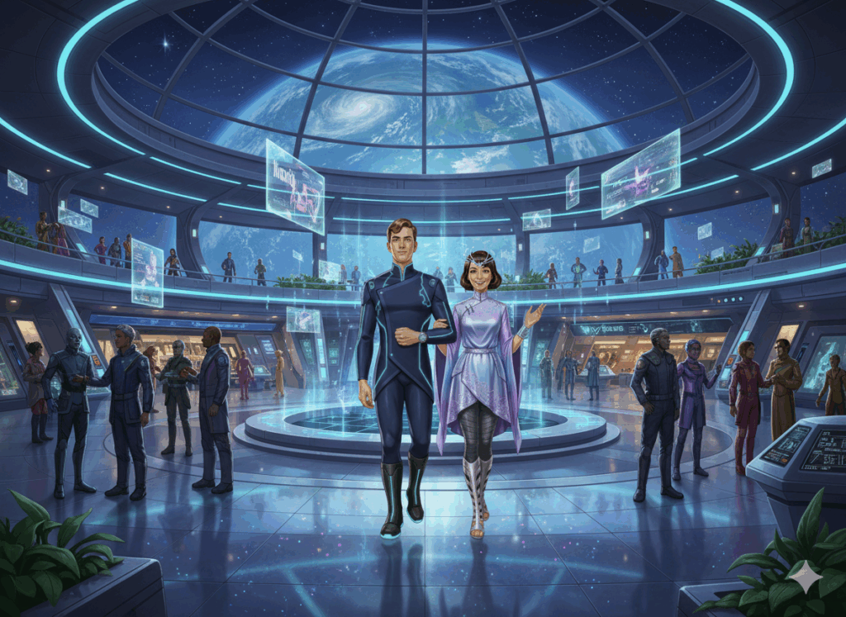](https://blog.inf.ed.ac.uk/atate/files/2025/09/Kemlo-and-Krillie-22nd-Century-Fashion-on-Belt-K.png)[Image animated by Grok (M4V)](https://www.aiai.ed.ac.uk/~ai/resources/Kemlo-and-Krillie/Video/Kemlo-and-Krillie-22nd-Future.m4v) – or via <https://x.com/aiaiaustin/status/1969446719222890889> or <https://pic.x.com/SOT7fYALC3>