# **Kemlo & Krillie Fashion**

Posted on [September 9, 2025](https://blog.inf.ed.ac.uk/atate/2025/09/09/kemlo-krillie-fashion/) by [bat](https://blog.inf.ed.ac.uk/atate/author/bat/)

[](https://blog.inf.ed.ac.uk/atate/files/2025/09/Title-The-Further-Adventures-of-Kemlo-and-Krillie-in-Space-1500x300-1.png)

From Krillie’s ‘Space Girl’ Diary… The Kemlo & Krillie fashion uses background created previously using AI tools based on the [Kemlo Spaceworld series of books by E.C. Eliott](https://blog.inf.ed.ac.uk/atate/2014/01/01/kemlo/) published in 1954 to 1963. It uses images and the contents of this blog post: <https://blog.inf.ed.ac.uk/atate/2025/09/10/kemlo-and-krillie-briefing/>

**](https://blog.inf.ed.ac.uk/atate/files/2025/09/Kemlo-and-Krillie-in-Uniform-Style-Sheet.png)[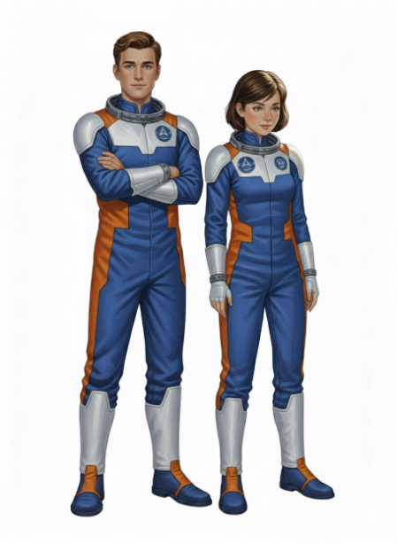](https://blog.inf.ed.ac.uk/atate/files/2025/09/Kemlo-and-Krillie-in-Blue-Uniform-Style-Sheet-on-White-with-Helmets.png)**

**[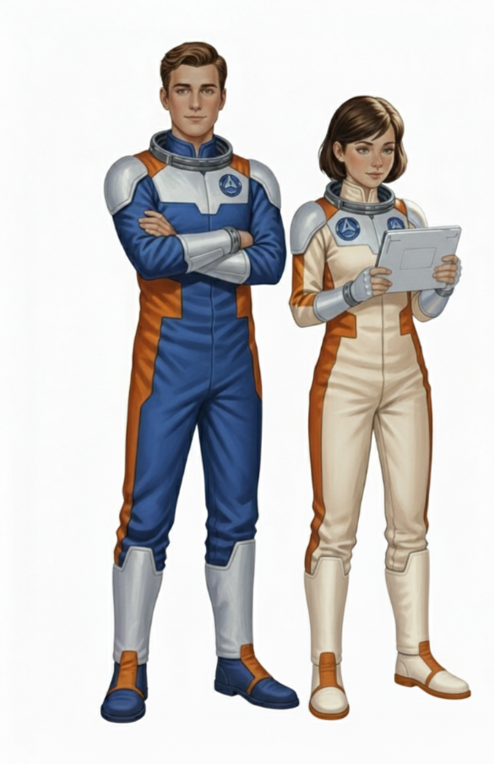](https://blog.inf.ed.ac.uk/atate/files/2025/09/Kemlo-Blue-Uniform-Krillie-Cream-Uniform-with-Ray-Guns-V5.png)**

**[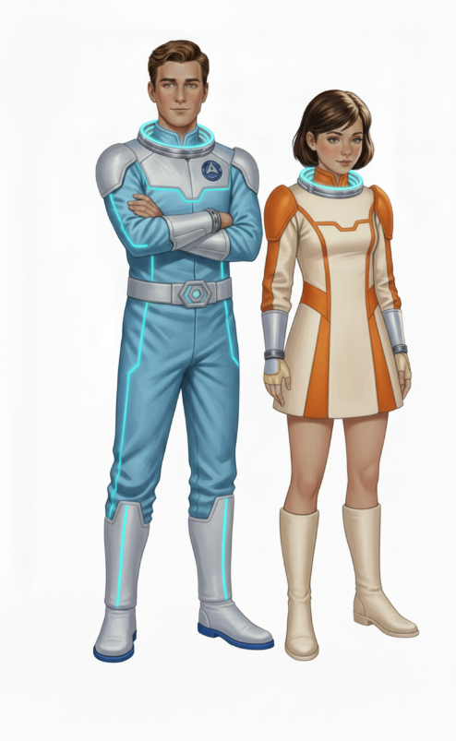](https://blog.inf.ed.ac.uk/atate/files/2025/09/Kemlo-and-Krillie-Dress-Alternative-Outfits-on-White-a.png)**

**[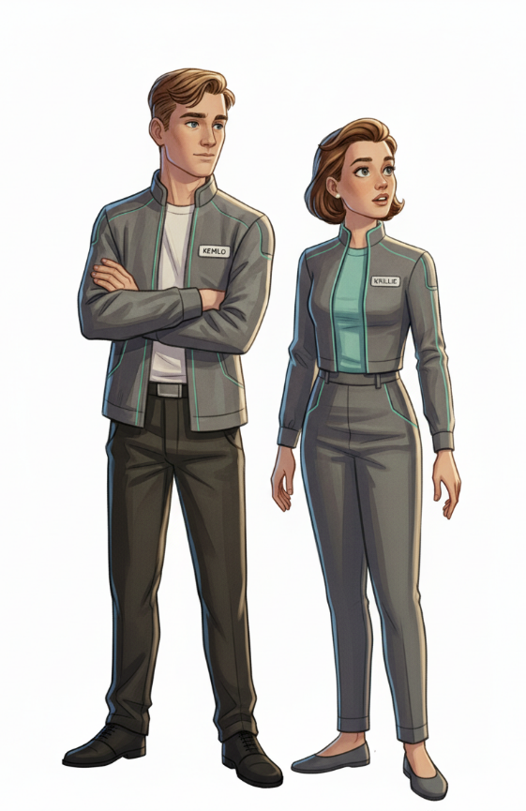](https://blog.inf.ed.ac.uk/atate/files/2025/09/Kemlo-and-Krillie-Elegant-Casual-on-White-1.png)**

**[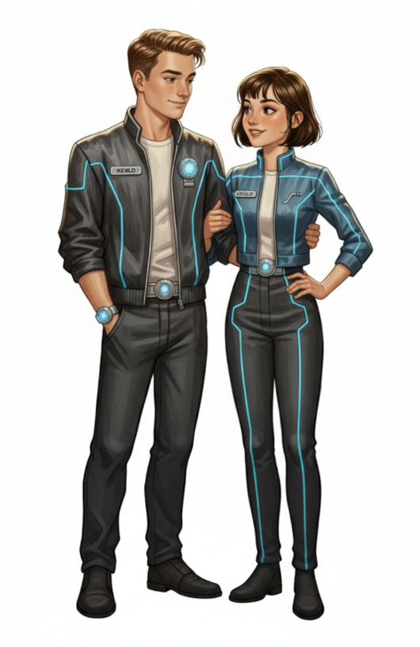](https://blog.inf.ed.ac.uk/atate/files/2025/09/Kemlo-22nd-Century-Nightclub-Krillie-22nd-Century-Nightclub.png)**

**[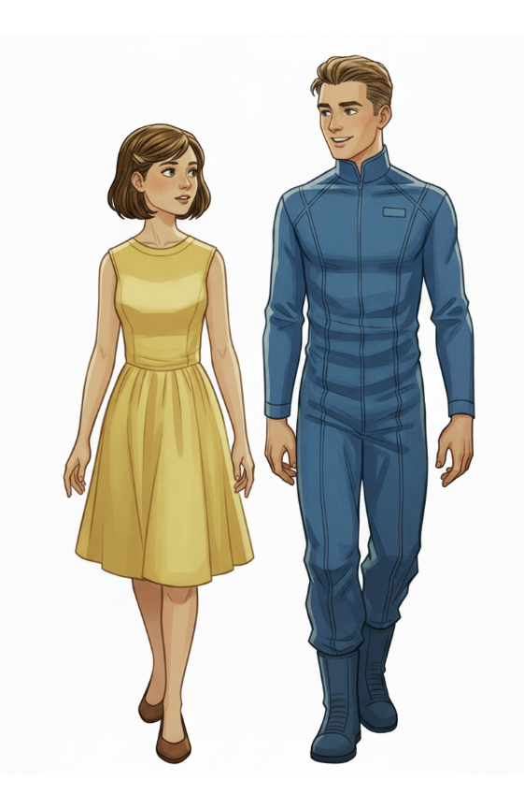](https://blog.inf.ed.ac.uk/atate/files/2025/09/Krillie-AI-Iridescent-Dress-Kemlo-Black-Suit.png)**

**](https://blog.inf.ed.ac.uk/atate/files/2025/09/Krillie-Space-Gown.jpg)**

**](https://blog.inf.ed.ac.uk/atate/files/2025/09/Krillie-Prom-Dress.jpg)**

There is also work clothing for engagement in maintenance on the Space Runabouts and Scooters…

**[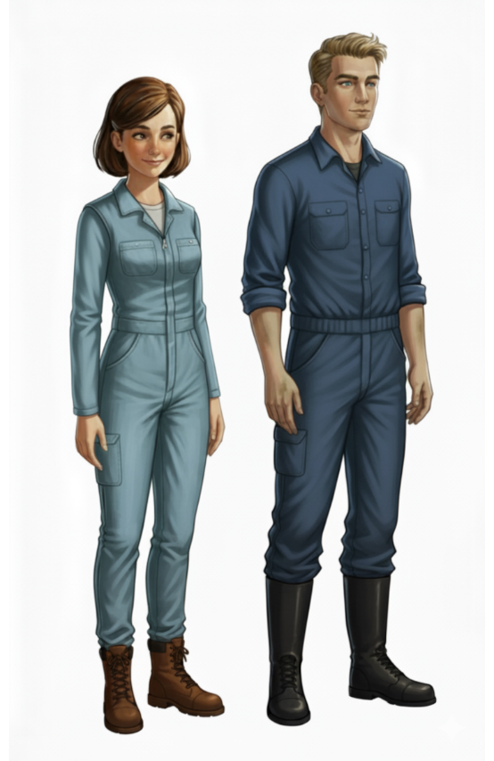](https://blog.inf.ed.ac.uk/atate/files/2025/09/Krillie-Work-Outfit-with-Hat-Kemlo-Work-Outfit-with-Hat.png)**

**More Fashion from Krillie’s Diary**

* [Krillie Tries it On](https://blog.inf.ed.ac.uk/atate/2025/09/20/krillie-tries-it-on/)
* [Century 21 Cosplay](https://blog.inf.ed.ac.uk/atate/2025/09/21/century-21-cosplay/)