# **Krillies ‘Space Girl’ Diary**

[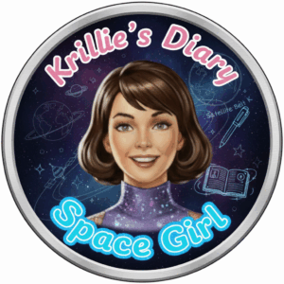](https://blog.inf.ed.ac.uk/atate/files/2025/09/Krillies-Diary-Space-Girl-Logo-Pink-and-Blue.png)Posted on [September 12, 2025](https://blog.inf.ed.ac.uk/atate/2025/09/12/krillies-space-girl-diary/) by [bat](https://blog.inf.ed.ac.uk/atate/author/bat/)

Hi, I’m Krillie. I was born in space on an Earth orbiting space station called “Satellite Belt K”. I write a diary under the moniker “Space Girl” for those interested in what is happening in space and to describe life as a Space Girl. I cover a lot of our activities, about our education and training, our living arrangements and some of our adventures. Along with my friend Kemlo, I write some of the books in “[The Further Adventures of Kemlo and Krillie in Space](https://blog.inf.ed.ac.uk/atate/2025/09/07/kemlo-krillie-storybooks/)” series. I hope my Diary is of interest to children on Earth, in the Satellite Belts and beyond.

**Satellite Belt K** is an Earth orbit space habit spread over 20km including habitation, living spaces, educational areas, recreation, physical conditioning areas, manufacturing, solar power generation and storage, space agriculture and hydroponics in large domes (automatically positioned to maximise crop growing quality and time). Robotics and droids are used throughout the Belt. Children born on Belt K are given names starting with “K”.

**Krillie** That’s me! I am 17 years old, born 11th November on Belt K, Sector A. Belt kids start their education and training early. I have an Open World University (OWU) Degree in Space Construction Engineering and am currently studying for a Masters by e-Learning in AI and Robotics from the University of Edinburgh in Scotland. I have an interest in AI-enhanced fashion. On the Belts we all have robotic assistants and mine is named “KaRA” and embedded in my K-Pad.

**Krillie’s ‘Space Girl’ Diary** – More coming soon from entries in my Diary. Stay tuned!

[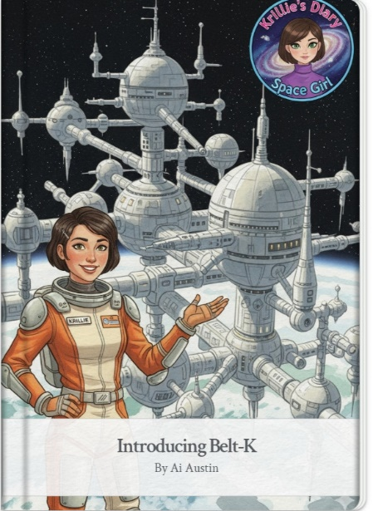](https://g.co/gemini/share/966ef14978de) [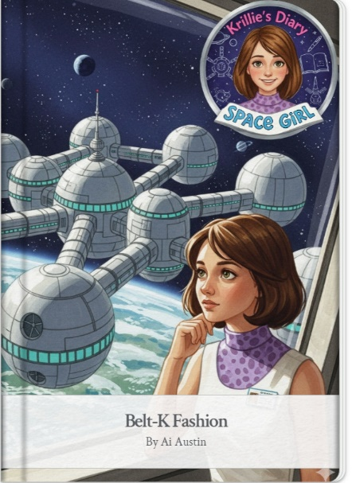](https://g.co/gemini/share/aed957af671c) [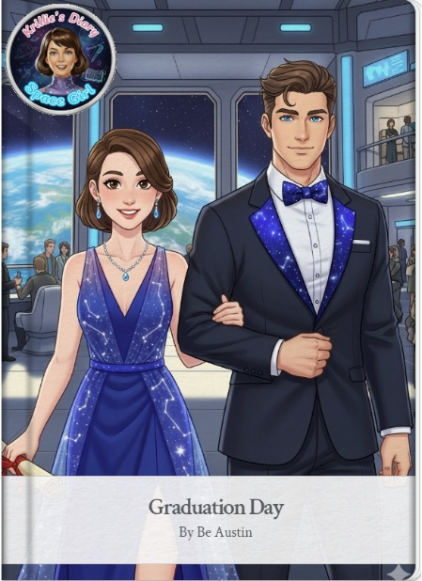](https://g.co/gemini/share/3f97cfe73eb6)  
[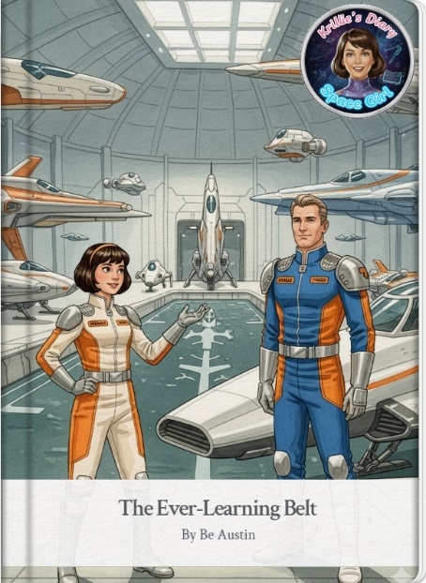](https://g.co/gemini/share/8fa4d32ae45a) [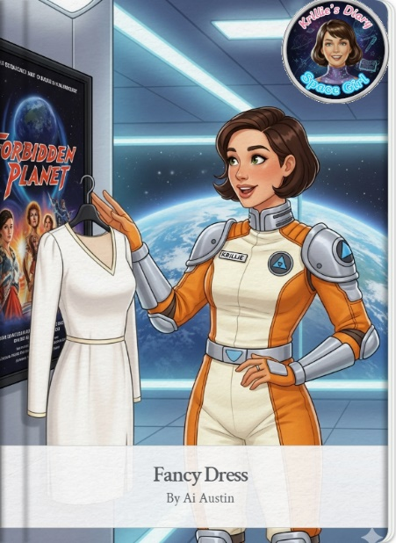](https://g.co/gemini/share/249c26806457) [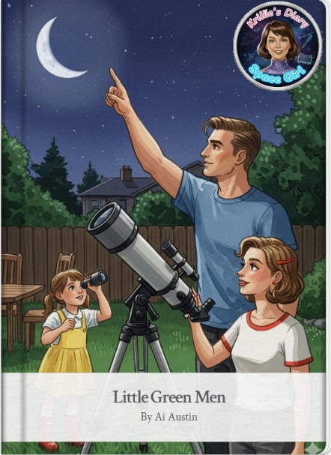](https://g.co/gemini/share/3206f844b8fe)

*Click on any Diary Entry to open the Google Gemini Storybook.*

Krillie’s ‘Space Girl’ Diary Posts:

* **Krillie’s Diary 1: Introducing Belt-K**  
  <https://blog.inf.ed.ac.uk/atate/2025/09/13/introducing-belt-k/>  
  <https://g.co/gemini/share/966ef14978de> | [PDF Format](https://www.aiai.ed.ac.uk/~ai/resources/Kemlo-and-Krillie/Krillies-Diary/Krillies-Diary-1-Introducing-Belt-K.pdf) | [Krillie’s Diary 1 Images](https://www.aiai.ed.ac.uk/~ai/resources/Kemlo-and-Krillie/Krillies-Diary/Krillies-Diary-1-Introducing-Belt-K/)
* **Krillie’s Diary 2: Belt-K Fashion**  
  <https://blog.inf.ed.ac.uk/atate/2025/09/13/belt-k-fashion/>  
  <https://g.co/gemini/share/aed957af671c> | [PDF Format](https://www.aiai.ed.ac.uk/~ai/resources/Kemlo-and-Krillie/Krillies-Diary/Krillies-Diary-2-Belt-K-Fashion.pdf) | [Krillie’s Diary 2 Images](https://www.aiai.ed.ac.uk/~ai/resources/Kemlo-and-Krillie/Krillies-Diary/Krillies-Diary-2-Belt-K-Fashion/)
* **Krillie’s Diary 3: Graduation Day**  
  <https://blog.inf.ed.ac.uk/atate/2025/09/14/graduation-day/>  
  <https://g.co/gemini/share/3f97cfe73eb6> | [PDF Format](https://www.aiai.ed.ac.uk/~ai/resources/Kemlo-and-Krillie/Krillies-Diary/Krillies-Diary-3-Graduation-Day.pdf) | [Krillie’s Diary 3 Images](https://www.aiai.ed.ac.uk/~ai/resources/Kemlo-and-Krillie/Krillies-Diary/Krillies-Diary-3-Graduation-Day/)
* **Krillie’s Diary 4: The Ever-Learning Belt**  
  <https://blog.inf.ed.ac.uk/atate/2025/09/16/ever-learning-belt/>  
  <https://g.co/gemini/share/8fa4d32ae45> | [PDF Format](https://www.aiai.ed.ac.uk/~ai/resources/Kemlo-and-Krillie/Krillies-Diary/Krillies-Diary-4-Ever-Learning-Belt.pdf) | [Krillie’s Diary 4 Images](https://www.aiai.ed.ac.uk/~ai/resources/Kemlo-and-Krillie/Krillies-Diary/Krillies-Diary-4-Cover-Ever-Learning-Belt/)
* **Krillie’s Diary 5: Fancy Dress**  
  <https://blog.inf.ed.ac.uk/atate/2025/09/16/fancy-dress/>  
  <https://g.co/gemini/share/3f97cfe73eb6> | [PDF Format](https://www.aiai.ed.ac.uk/~ai/resources/Kemlo-and-Krillie/Krillies-Diary/Krillies-Diary-5-Fancy-Dress.pdf) | [Krillie’s Diary 5 Images](https://www.aiai.ed.ac.uk/~ai/resources/Kemlo-and-Krillie/Krillies-Diary/Krillies-Diary-5-Fancy-Dress/)
* **Krillie’s Diary 6: Little Green Men**  
  [https://blog.inf.ed.ac.uk/atate/2025/09/17/little-green-men/](https://blog.inf.ed.ac.uk/atate/2025/09/167/little-green-men/)  
  <https://g.co/gemini/share/3206f844b8fe> | [PDF Format](https://www.aiai.ed.ac.uk/~ai/resources/Kemlo-and-Krillie/Krillies-Diary/Krillies-Diary-6-Little-Green-Men.pdf) | [Krillie’s Diary 6 Images](https://www.aiai.ed.ac.uk/~ai/resources/Kemlo-and-Krillie/Krillies-Diary/Krillies-Diary-6-Little-Green-Men/)

More Krillie Diary Entries to Look For…

* **Krillie’s Diary 7: Krillie Tries it On**  
  <https://blog.inf.ed.ac.uk/atate/2025/09/20/krillie-tries-it-on/>
* **Krillie’s Diary 8: Century 21 Cosplay**  
  <https://blog.inf.ed.ac.uk/atate/2025/09/21/century-21-cosplay/>
* **Krillie’s Diary 9: Century 22 Sports**  
  <https://blog.inf.ed.ac.uk/atate/2025/09/23/century-22-sports/>
* **Krillie’s Diary 10: Century 22 Food**  
  <https://blog.inf.ed.ac.uk/atate/2025/09/24/century-22-food/>

Krillie’s Diary uses background created previously using AI tools based on the [Kemlo Spaceworld series of books by E.C. Eliott](https://blog.inf.ed.ac.uk/atate/2014/01/01/kemlo/) published in 1954 to 1963. It uses the contents of this blog post: <https://blog.inf.ed.ac.uk/atate/2025/09/10/kemlo-and-krillie-briefing/>.