# **Kemlo & Krillie – The Belt K Adventure**

[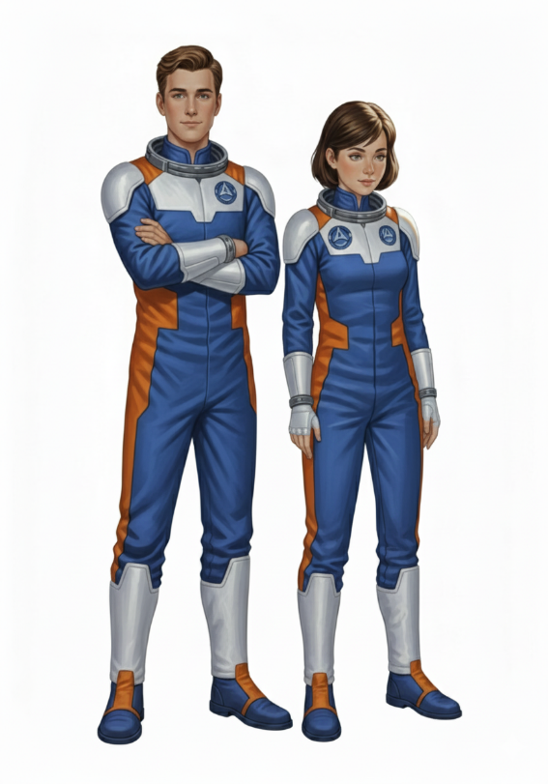](https://blog.inf.ed.ac.uk/atate/files/2025/09/Kemlo-and-Krillie-Style-Sheet-on-White-No-K-Pad.png)Posted on [September 5, 2025](https://blog.inf.ed.ac.uk/atate/2025/09/05/kemlo-and-krillie-belt-k-adventure/) by [bat](https://blog.inf.ed.ac.uk/atate/author/bat/)

This is Storybook 1 in “The Further Adventures of Kemlo & Krillie in Space” series. It is produced using [Google Gemini Storybooks AI App](https://gemini.google.com/gem/storybook) which lets you create a customized picture book, for either children or adults, given a topic, an optional target audience age, and an optional art style for the images.

**Prompt:***Use the background given in the attached document to write a storybook to introduce Kemlo and Krillie, teenagers who live on Satellite Belt K in Earth Orbit.*

The storybook uses background created previously using AI tools based on the [Kemlo Spaceworld series of books by E.C. Eliott](https://blog.inf.ed.ac.uk/atate/2014/01/01/kemlo/) published in 1954 to 1963. It uses images and PDF of the contents of this blog post: <https://blog.inf.ed.ac.uk/atate/2025/09/10/kemlo-and-krillie-briefing/>

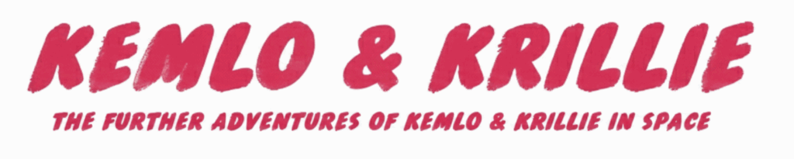

The Storybook produced is available at: <https://g.co/gemini/share/b5fe7edbb426> or [PDF Format](https://www.aiai.ed.ac.uk/~ai/resources/Kemlo-and-Krillie/Storybooks/Kemlo-and-Krillie-Storybook-1.pdf)

[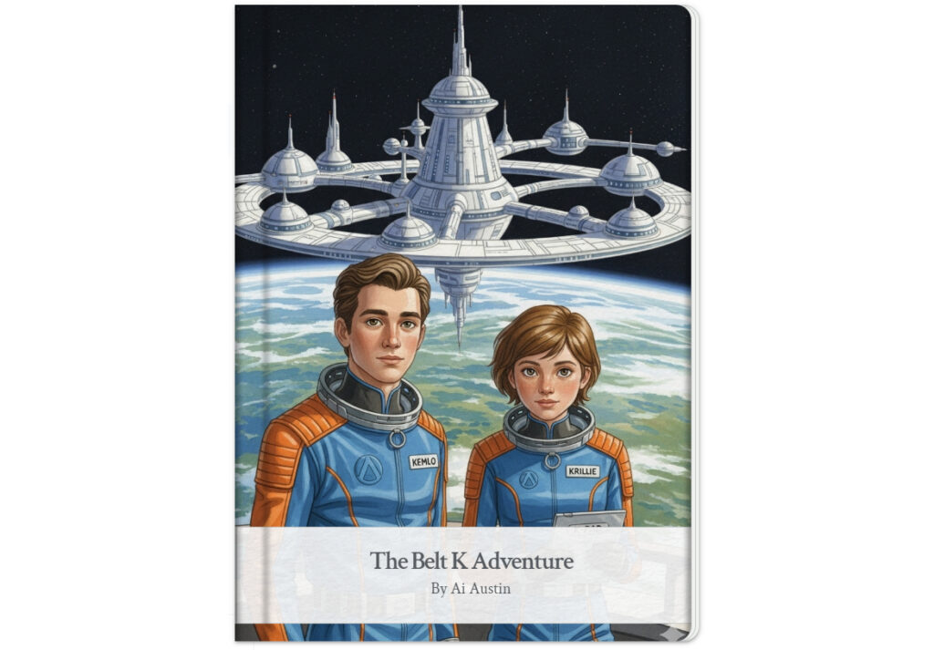](https://blog.inf.ed.ac.uk/atate/files/2025/09/Belt-K-Adventure-Page-0-Cover-V2.jpg)

**](https://blog.inf.ed.ac.uk/atate/files/2025/09/Belt-K-Adventure-Page-1.jpg)**

**](https://blog.inf.ed.ac.uk/atate/files/2025/09/Belt-K-Adventure-Page-2.jpg)**

**](https://blog.inf.ed.ac.uk/atate/files/2025/09/Belt-K-Adventure-Page-3.jpg)**

**](https://blog.inf.ed.ac.uk/atate/files/2025/09/Belt-K-Adventure-Page-4.jpg)**

**](https://blog.inf.ed.ac.uk/atate/files/2025/09/Belt-K-Adventure-Page-5.jpg)**

**](https://blog.inf.ed.ac.uk/atate/files/2025/09/Belt-K-Adventure-Page-6.jpg)**

**](https://blog.inf.ed.ac.uk/atate/files/2025/09/Belt-K-Adventure-Page-7.jpg)**

**](https://blog.inf.ed.ac.uk/atate/files/2025/09/Belt-K-Adventure-Page-8.jpg)**

**](https://blog.inf.ed.ac.uk/atate/files/2025/09/Belt-K-Adventure-Page-9.jpg)**

**](https://blog.inf.ed.ac.uk/atate/files/2025/09/Belt-K-Adventure-Page-10.jpg)**

Several refinements were done to the early draft to replace the name badges for Kemlo and Krillie and to try to use consistent labelling on the Training Scooters.