# **Kemlo & Krillie – Storybooks**

Posted on [September 7, 2025](https://blog.inf.ed.ac.uk/atate/2025/09/07/kemlo-krillie-storybooks/) by [bat](https://blog.inf.ed.ac.uk/atate/author/bat/)

](https://blog.inf.ed.ac.uk/atate/files/2025/09/Title-The-Further-Adventures-of-Kemlo-and-Krillie-in-Space-1500x300-1.png)

[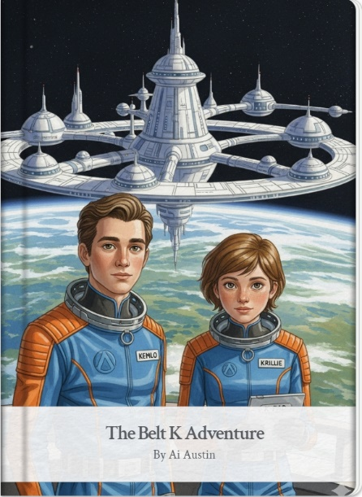](https://g.co/gemini/share/b5fe7edbb426) [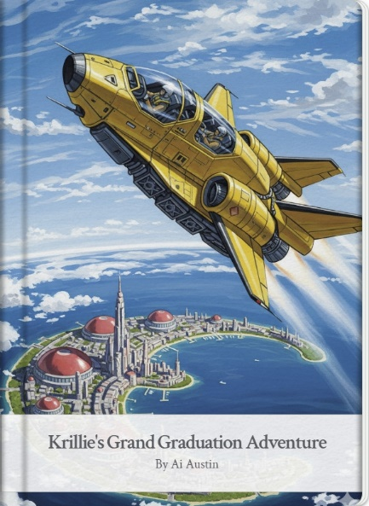](https://g.co/gemini/share/5ceb6ce5de10) [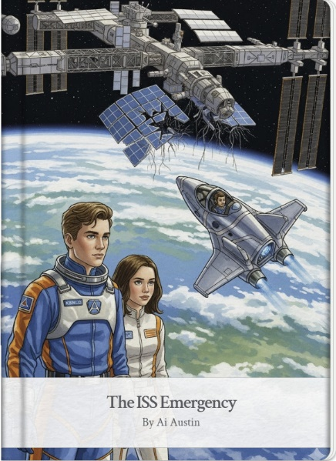](https://g.co/gemini/share/dfc5a957adb8)[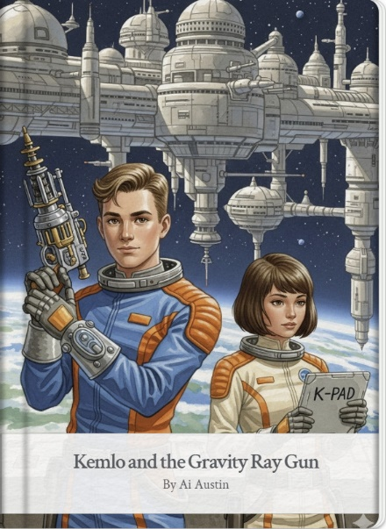](https://g.co/gemini/share/93a5ead51887)[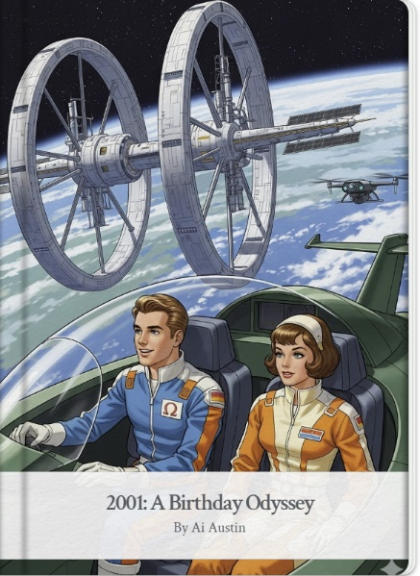](https://gemini.google.com/share/51c819c809ff)[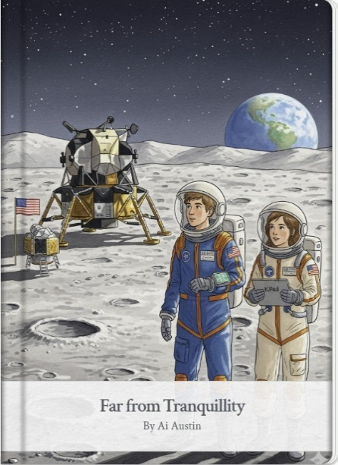](https://g.co/gemini/share/9fcef6571d3c)

**More Detail, Alternative Formats and Background**

* **Storybook 1: The Belt K Adventure**

<https://blog.inf.ed.ac.uk/atate/2025/09/05/kemlo-and-krillie-belt-k-adventure/>

<https://g.co/gemini/share/b5fe7edbb426> | [PDF Format](https://www.aiai.ed.ac.uk/~ai/resources/Kemlo-and-Krillie/Storybooks/Kemlo-and-Krillie-Storybook-1.pdf) | [Storybook 1 Images](https://www.aiai.ed.ac.uk/~ai/resources/Kemlo-and-Krillie/Storybooks/Kemlo-and-Krillie-Storybook-1/)

* **Storybook 2: Krillie’s Grand Graduation Adventure**

<https://blog.inf.ed.ac.uk/atate/2025/09/06/krillies-grand-graduation-adventure/>

<https://g.co/gemini/share/5ceb6ce5de10> | [PDF Format](https://www.aiai.ed.ac.uk/~ai/resources/Kemlo-and-Krillie/Storybooks/Kemlo-and-Krillie-Storybook-2.pdf) | [Storybook 2 Images](https://www.aiai.ed.ac.uk/~ai/resources/Kemlo-and-Krillie/Storybooks/Kemlo-and-Krillie-Storybook-2/)

* **Storybook 3: The ISS Emergency**

<https://blog.inf.ed.ac.uk/atate/2025/09/07/kemlo-and-krillie-the-iss-emergency/>

<https://g.co/gemini/share/dfc5a957adb8> | [PDF Format](https://www.aiai.ed.ac.uk/~ai/resources/Kemlo-and-Krillie/Storybooks/Kemlo-and-Krillie-Storybook-3.pdf) | [Storybook 3 Images](https://www.aiai.ed.ac.uk/~ai/resources/Kemlo-and-Krillie/Storybooks/Kemlo-and-Krillie-Storybook-3/)

* **Storybook 4: Kemlo and the Gravity Ray Gun**

<https://blog.inf.ed.ac.uk/atate/2025/09/08/kemlo-and-the-gravity-ray-gun/>

<https://gemini.google.com/share/6f774a0c5631> | [PDF Format](https://www.aiai.ed.ac.uk/~ai/resources/Kemlo-and-Krillie/Storybooks/Kemlo-and-Krillie-Storybook-4.pdf) | [Storybook 4 Images](https://www.aiai.ed.ac.uk/~ai/resources/Kemlo-and-Krillie/Storybooks/Kemlo-and-Krillie-Storybook-4/)

* **Storybook 5: 2001: A Birthday Odyssey**

[https://blog.inf.ed.ac.uk/atate/2025/09/09/2001-a-birthday-odyssey](https://blog.inf.ed.ac.uk/atate/2025/09/09/2001-a-birthday-odyssey/)

<https://gemini.google.com/share/51c819c809ff> | [PDF Format](https://www.aiai.ed.ac.uk/~ai/resources/Kemlo-and-Krillie/Storybooks/Kemlo-and-Krillie-Storybook-5.pdf) | [Storybook 5 Images](https://www.aiai.ed.ac.uk/~ai/resources/Kemlo-and-Krillie/Storybooks/Kemlo-and-Krillie-Storybook-5/)

* **Storybook 6: Far from Tranquillity**

<https://blog.inf.ed.ac.uk/atate/2025/09/10/far-from-tranquillity/>

<https://g.co/gemini/share/9fcef6571d3c> | [PDF Format](https://www.aiai.ed.ac.uk/~ai/resources/Kemlo-and-Krillie/Storybooks/Kemlo-and-Krillie-Storybook-6.pdf) | [Storybook 6 Images](https://www.aiai.ed.ac.uk/~ai/resources/Kemlo-and-Krillie/Storybooks/Kemlo-and-Krillie-Storybook-6/)

* **Even Further Adventures of Kemlo & Krillie in Space**
* **Storybook 7: The Gravity Ray Gambit** <https://blog.inf.ed.ac.uk/atate/2025/10/12/gravity-ray-gambit/>

<https://g.co/gemini/share/c2625e4ef48c> | [Development](https://gemini.google.com/gem/storybook/ecd1f6df1b6700a9) (user: Ai Austin) | [PDF Format](https://www.aiai.ed.ac.uk/~ai/resources/Kemlo-and-Krillie/Storybooks/Kemlo-and-Krillie-Storybook-7.pdf) | [Storybook 7 Images](https://www.aiai.ed.ac.uk/~ai/resources/Kemlo-and-Krillie/Storybooks/Kemlo-and-Krillie-Storybook-7/)

* **Storybook 8: The SPITAR Anomaly**

<https://blog.inf.ed.ac.uk/atate/2025/10/12/spitar-anomaly/>

<https://g.co/gemini/share/95941518717b> | [Development](https://gemini.google.com/gem/storybook/cfb06e9896d8fb31) (user: Ai Austin) | [PDF Format](https://www.aiai.ed.ac.uk/~ai/resources/Kemlo-and-Krillie/Storybooks/Kemlo-and-Krillie-Storybook-8.pdf) | [Storybook 8 Images](https://www.aiai.ed.ac.uk/~ai/resources/Kemlo-and-Krillie/Storybooks/Kemlo-and-Krillie-Storybook-8/)

**Krillie’s ‘Space Girl’ Diary**

[Krillie’s Diary](https://blog.inf.ed.ac.uk/atate/2025/09/12/krillies-space-girl-diary/) is aimed at those interested in what is happening in space and to describe her life as a Space Girl including education and training, living arrangements and adventures.

[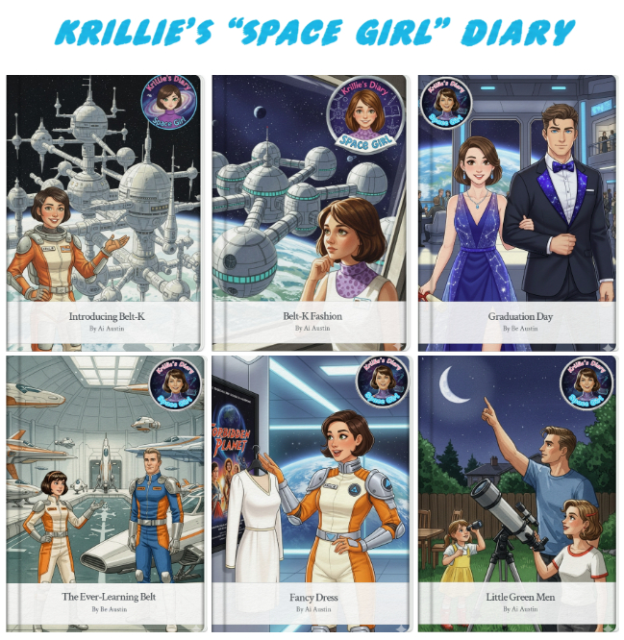](https://blog.inf.ed.ac.uk/atate/2025/09/12/krillies-space-girl-diary/)

**Kemlo & Krillie Figurines – Google Gemini Generated**

](https://blog.inf.ed.ac.uk/atate/files/2025/09/Gemini-Generated-Kemlo-and-Krillie-a.jpg)

[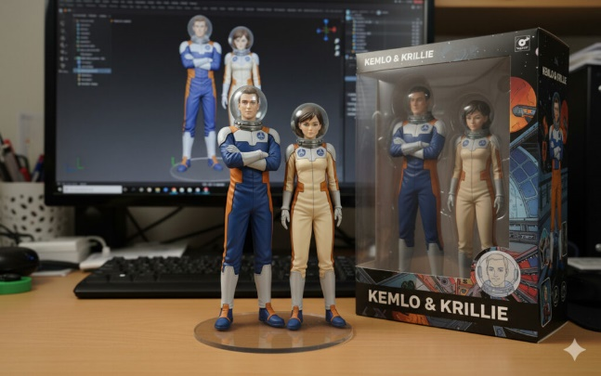](https://blog.inf.ed.ac.uk/atate/files/2025/09/Gemini-Generated-Kemlo-and-Krillie-in-Space-Helmets.jpg) [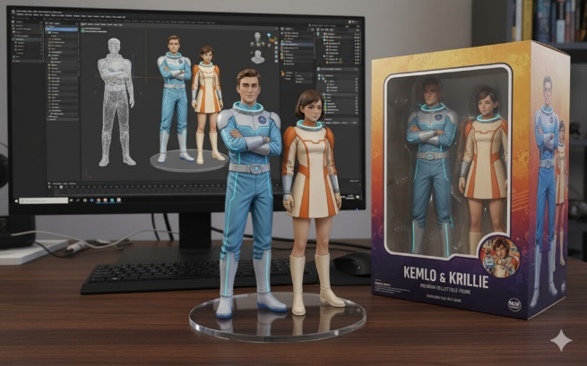](https://blog.inf.ed.ac.uk/atate/files/2025/09/Gemini-Generated-Kemlo-and-Krillie-22nd-Century-Retro-Future.jpg)

**3D Models of Kemlo & Krillie with a Space Runabout (in OpenSim)**

The Space Runabout model was initially created using simple shapes in OpenSim. A image was then processed by the Google Gemini AI Tool (<https://gemini.google.com/>) to generate a higher quality image with detail. This was then passed to Tripio3D (<https://studio.tripo3d.ai/> to generate and texture a 3D model. This was exported to glTF and imported back to OpenSim. The characters were created with a similar workflow but starting with images generated by Google Gemini Storybook Mode (<https://gemini.google.com/gem/storybook>).

[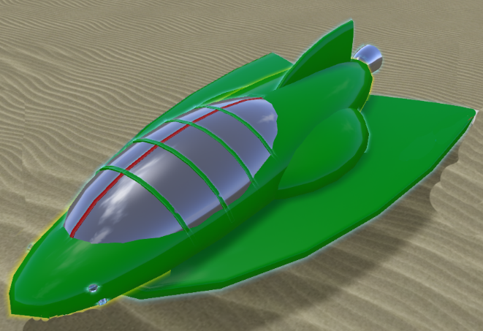](https://blog.inf.ed.ac.uk/atate/files/2025/09/Kemlo-Space-Runabout-0.png) [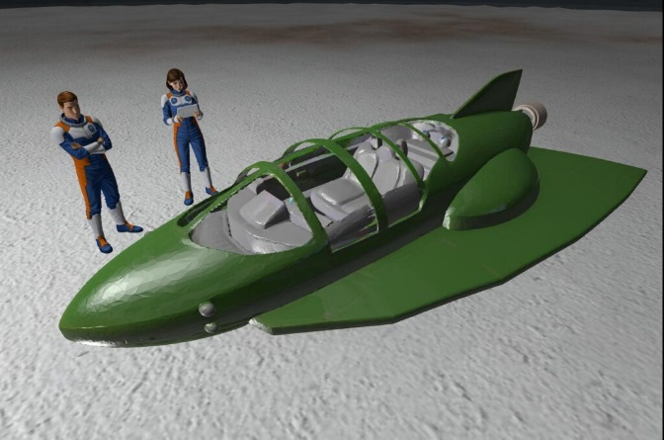](https://blog.inf.ed.ac.uk/atate/files/2025/09/Kemlo-and-Krillie-with-Space-Runabout-OpenSim.jpg)  
[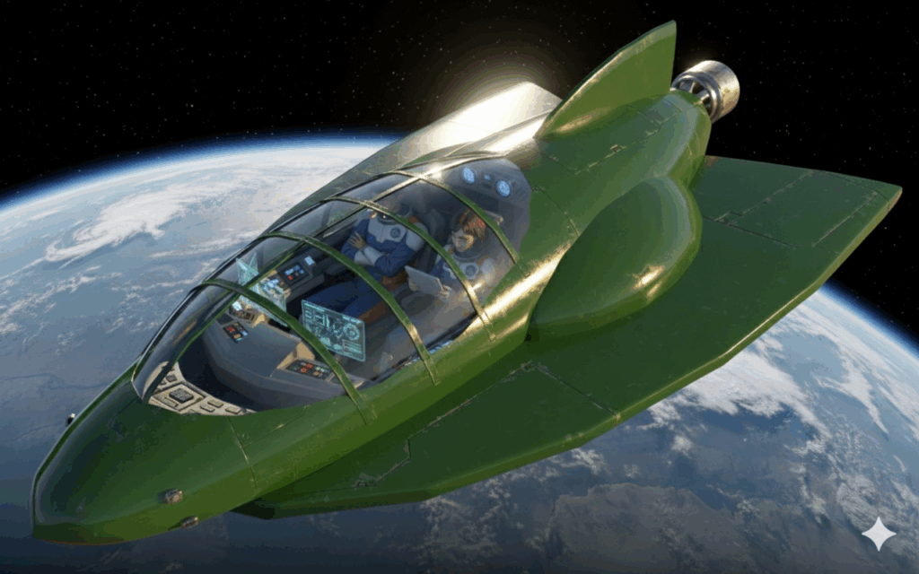](https://blog.inf.ed.ac.uk/atate/files/2025/09/Kemlo-Space-Runabout-on-Moon.png)

**Graphics Style for Illustrations**

According to Google Gemini the style of the illustrations could best be described as a *retro-futuristic or atomic age aesthetic*, which is often seen in classic science fiction from the mid-20th century.

Here are some key characteristics of this style seen in the images:

**Clean Lines and Sleek Designs:** The spaceships, uniforms, and interior spaces all feature smooth, streamlined forms and a sense of functional simplicity.

**Vibrant, Limited Colour Palette:** The colours are bright and distinct, often featuring primary and secondary colours like blue, orange, green, and white. This gives the images a clean, almost graphic look.

**Optimistic and Idealized Vision of the Future:** The illustrations depict a future that is clean, orderly, and exciting, a common theme in the science fiction of this era. The characters are portrayed in a heroic or aspirational manner.

**Comic Book or Pulp Magazine Influence:** The character designs, particularly the strong jawlines and expressive faces, have a style reminiscent of classic comic book art or the illustrations found on the covers of old pulp sci-fi magazines.

Kemlo & Krillie Storybooks use background created previously using AI tools based on the [Kemlo Spaceworld series of books by E.C. Eliott](https://blog.inf.ed.ac.uk/atate/2014/01/01/kemlo/) published in 1954 to 1963. It uses images and PDF of the contents of this blog post: <https://blog.inf.ed.ac.uk/atate/2025/09/10/kemlo-and-krillie-briefing/>.