# **Kemlo & Krillie – Character Sheets**

Posted on [September 21, 2025](https://blog.inf.ed.ac.uk/atate/2025/09/21/kemlo-and-krillie-character-sheets/) by [bat](https://blog.inf.ed.ac.uk/atate/author/bat/)

[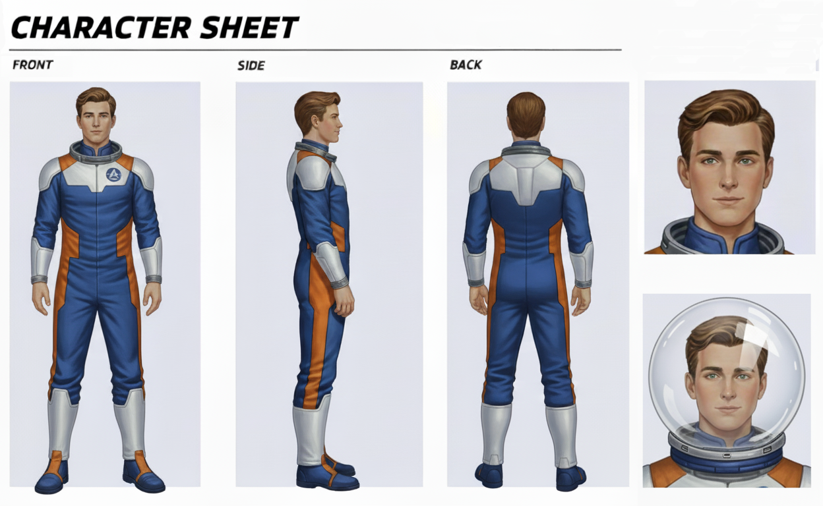](https://blog.inf.ed.ac.uk/atate/files/2025/09/Character-Sheet-Kemlo.png)

[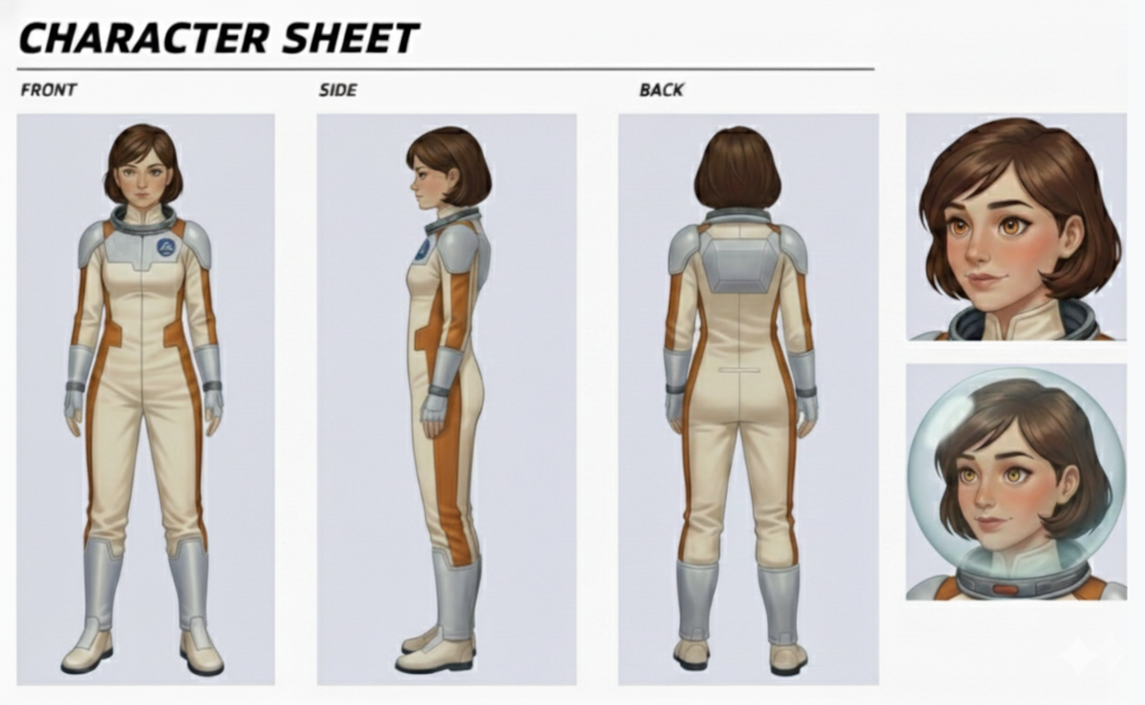](https://blog.inf.ed.ac.uk/atate/files/2025/09/Character-Sheet-Krillie-V3.png)

[](https://blog.inf.ed.ac.uk/atate/files/2025/09/Kemlo_Photorealistic.jpg)**Kemlo** – Male, 18 years old, born 3rd March on Belt K, Sector A. Kemlo has has an Open World University (OWU) Degree in Planetary Geosciences. Skilled pilot. Captain of the Space Scouts. Helps train younger children to fly and maintain space scooters. Kemlo is involved in the test programme for an experimental modular space runabout (SX-MR2). Kemlo’s robotic assistant which he calls “Komputer” is embedded in his Omega wrist band (a gift for his 18th birthday) which he wears with the screen under his left wrist in “driver-style”.

[](https://blog.inf.ed.ac.uk/atate/files/2025/09/Krillie_Photorealistic.jpg)**Krillie** – Female**, 17 years old, born 11th November on Belt K, Sector A. Krillie has an Open World University (OWU) Degree in Space Construction Engineering and is currently studying for a Masters by e-Learning in AI and Robotics from the University of Edinburgh in Scotland. Krillie is the author of a diary and series of books describing life as a Space Girl which are popular with children on Earth and in the Belts and beyond. Krillie has an interest in AI-enhanced fashion. Krillie’s robotic assistant “KaRA” is embedded in her K-Pad. *[** Gender change from the Kemlo books.]*