# **Kemlo & Krillie Briefing**

Posted on [September 10, 2025](https://blog.inf.ed.ac.uk/atate/2025/09/10/kemlo-and-krillie-briefing/) by [bat](https://blog.inf.ed.ac.uk/atate/author/bat/)

[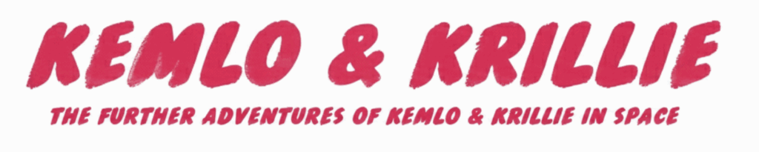](https://blog.inf.ed.ac.uk/atate/files/2025/09/Title-The-Further-Adventures-of-Kemlo-and-Krillie-in-Space-1500x300-1.png)

[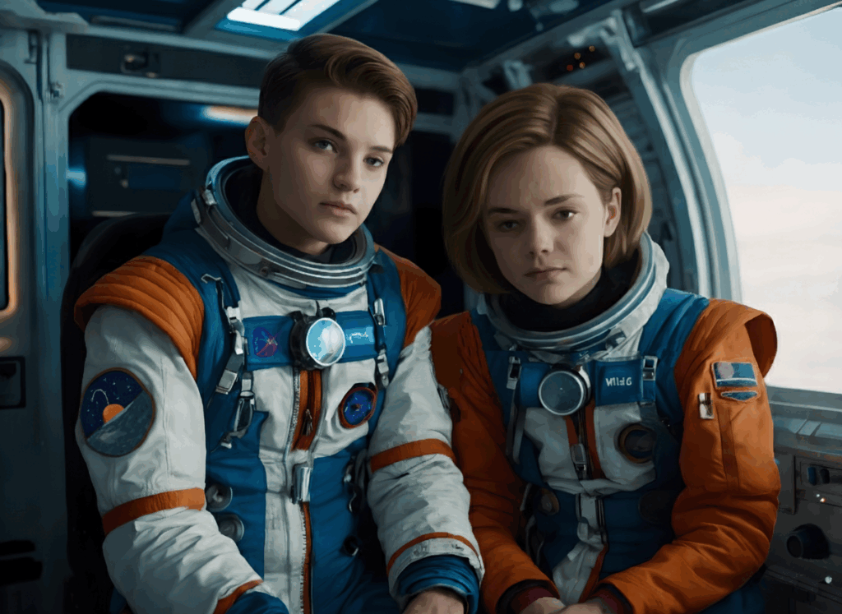](https://blog.inf.ed.ac.uk/atate/files/2025/09/Kemlo-and-Krillie-Brunette-1184x864-V2.png)

**Situation** – It is the month of May in a year in the future. Earth has an outer space presence in Earth Orbit, on the Moon and beyond. International United Nations entities are now preferred to nationalistic governments and other authorities. Education, cultural and Internet services are freely available everywhere funded by proportional contributions by all countries. Grants support the provision of equipment to access these resources where circumstances require it. The Internet is now a safe and welcoming place since the introduction of an international requirement for strong privacy protections and open source for any major platform. A Universal Basic Income is provided to everyone both on world and off world.

[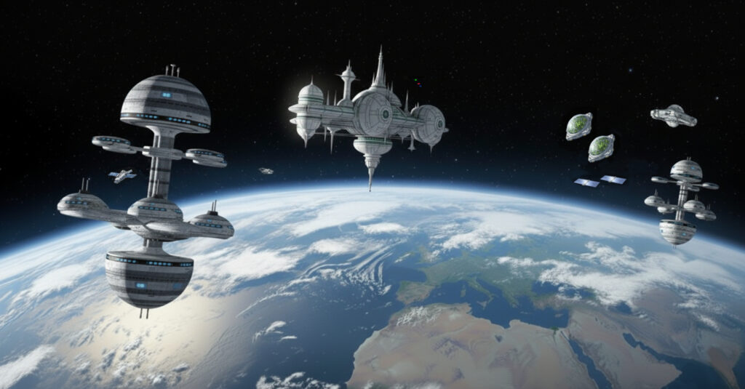](https://blog.inf.ed.ac.uk/atate/files/2025/09/Belt-K-20km-V4a.jpg)

**Belt K** – An Earth orbit space habit spread over 20km including habitation, living spaces, educational areas, recreation, physical conditioning areas, manufacturing, solar power generation and storage, space agriculture and hydroponics in large domes (automatically positioned to maximise crop growing quality and time). Robotics and droids are used throughout the Belt. Children born on Belt K are given names starting with “K”.

[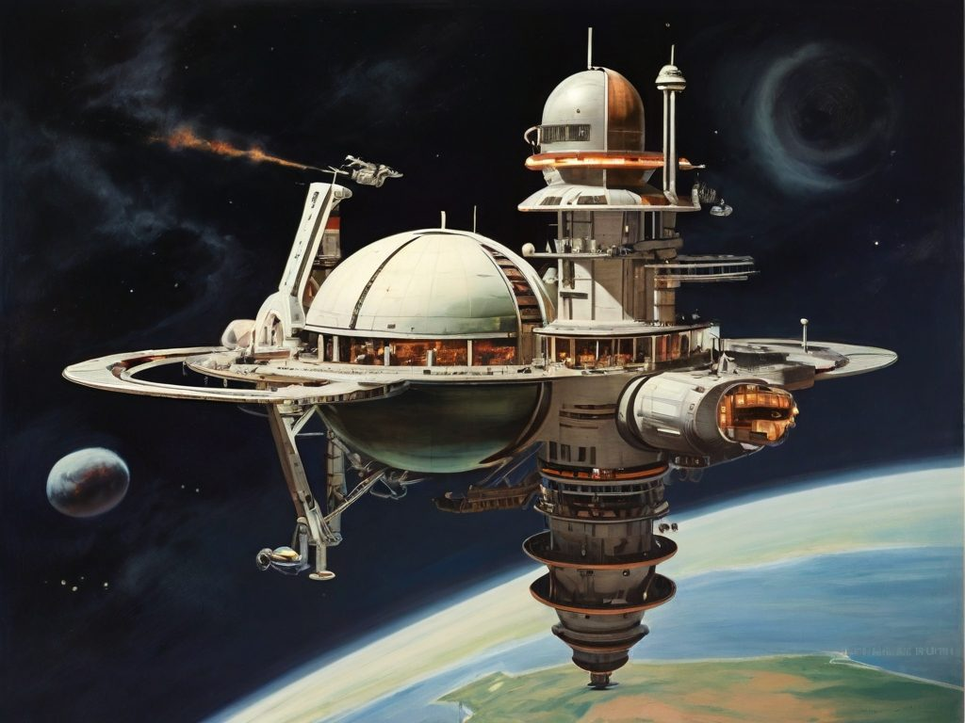](https://blog.inf.ed.ac.uk/atate/files/2024/02/Leonardo-1950s-Retro-Space-Station.jpg)

**Education** – Space-born children begin their education and practice simulated space operations very early. Classrooms and experience areas allow for e-Learning (enhanced learning), VR immersion and simulated field trips including holographic spaces and linked teleoperations of devices in many locations. Kids in the Belt call the facilities “sKool”. Belt residents engage in lifelong learning and training opportunities.

**Space Operations Training**– By the age of 11 many children have usually become familiar with space vehicle operations through simulation and play and can already use autonomous space scooters with confidence. At 13 children can take a basic flight operations test so that they can use the unsupervised mode on space scooters with appropriate oversight by the Belt K Operations Authority. At 15 they are allowed to use space scooters with limited unsupervised operations. At 18 with a pilot’s license they can use space runabouts. Belt children usually achieve their spacecraft qualifications very soon after their relevant birthdays as they make use of e-Learning, simulators and VR ahead of time. At age 20, for those wanting to use space transports professionally, they can obtain a Space Operations License (SOL) from the Space Transport Authority (STA) via exams and after logging flight experience. The SOL is renewable annually.

**Gravity Rays (Holding Rays)** – are projected around space stations and spacecraft to protect them from meteor damage, provide an area within them with gravity and to stabilize their positions. They provide an envelope within which the occupants can breath normally when close to their space station areas or spacecraft. But away from the protective area of the Gravity Rays helmets and full space suits must be worn. Sometimes Gravity Rays are known by one of their functions as “Holding Rays”.

**Spacecraft** – Space Scooters (SS) for intra-habitat local transport and exploration, Space Runabouts (SR) for in orbit travel, Space Transports (ST) managed by the Space Transport Authority (STA) are the workhorses for orbital and Earth-Orbit operations for cargo and passengers, and Experimental Spacecraft (SX).

**Space Scooters (SS)** – small two to four seat personal spacecraft for travel within a Belt. Highly automated with remote supervisory capability for younger travellers.

**Space Runabouts (SR)** – two seat or larger spacecraft for travel around and between the Satellite Belts. Automation is used for safety. Fully autonomous versions provide a taxi service.  
[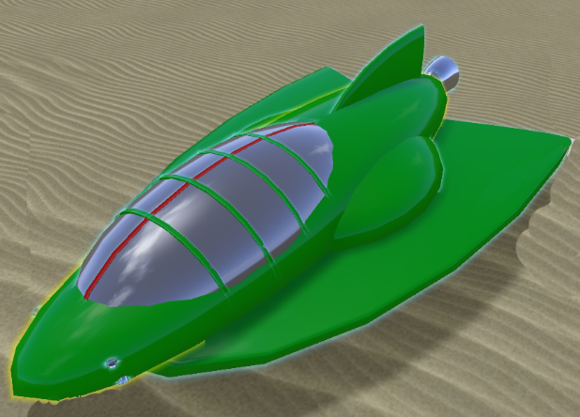](https://blog.inf.ed.ac.uk/atate/files/2025/09/Kemlo-Space-Runabout-0.png) [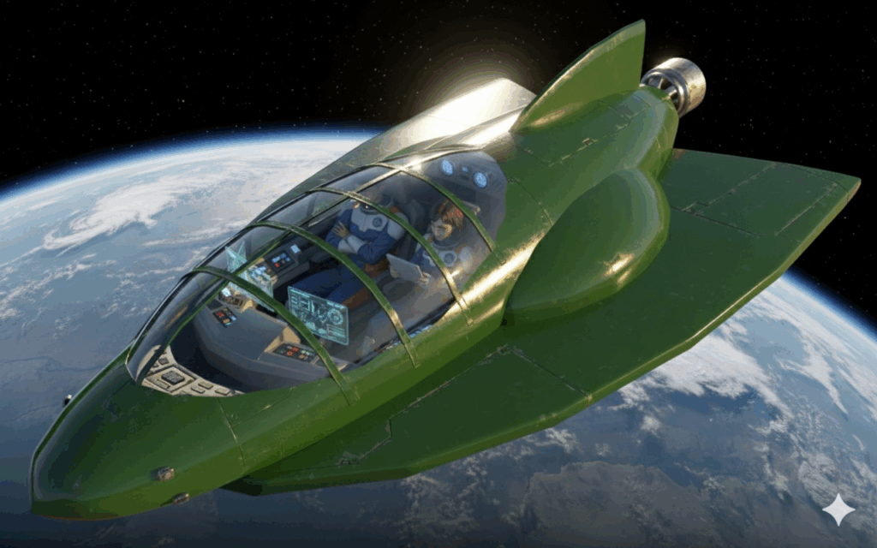](https://blog.inf.ed.ac.uk/atate/files/2025/09/Kemlo-Space-Runabout-in-Earth-Orbit-1.png)

**Robotic Assistants (RA)** – a range of intelligent agents which are implemented in a distributed fashion. They can be personalised and embedded in a range of physical forms such as a wrist device or a robot. By tradition such robots are given names starting with the initial of the belt they are deployed on (e.g. “KaRA”)

**K-Pad** – a device with screen for communications, information, augmented reality for technical operations, education, etc. Age appropriate facilities are on the device. Updates ensure the device stays appropriate to its user for life. Strong privacy protection is enforced with locally stored data entirely private to the user and not shared off device.

[](https://blog.inf.ed.ac.uk/atate/files/2024/02/Kemlo-1-Orig-1200x1200-Isolated.png)**Kemlo** – Male, 18 years old, born 3rd March on Belt K, Sector A. Kemlo has has an Open World University (OWU) Degree in Planetary Geosciences. Skilled pilot. Captain of the Space Scouts. Helps train younger children to fly and maintain space scooters. Kemlo is involved in the test programme for an experimental modular space runabout (SX-MR2). Kemlo’s robotic assistant which he calls “Komputer” is embedded in his Omega wrist band (a gift for his 18th birthday) which he wears with the screen under his left wrist in “driver-style”.

[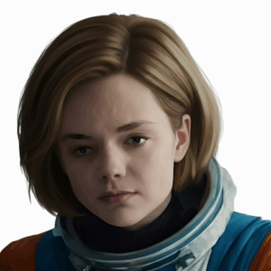](https://blog.inf.ed.ac.uk/atate/files/2025/09/Krillie-Brown-Hair-1200x1200-1.png)**Krillie** – Female**, 17 years old, born 11th November on Belt K, Sector A. Krillie has an Open World University (OWU) Degree in Space Construction Engineering and is currently studying for a Masters by e-Learning in AI and Robotics from the University of Edinburgh in Scotland. Krillie is the author of a diary and series of books describing life as a Space Girl which are popular with children on Earth and in the Belts and beyond. Krillie has an interest in AI-enhanced fashion. Krillie’s robotic assistant “KaRA” is embedded in her K-Pad. *[** Gender change from the Kemlo books.]*

**Open World University (OWU)** – the main provider of educational opportunities and experiences to on-world and off-world learners of all ages. OWU physical bases and computing centres are on and under sea islands named Atlantica Sea City and Pacifica Sea City run by the international United Nations (UN) Organization. OWU programmes are run for all ages and support lifelong learning. *e-Learning* (enhanced learning) using distance education is employed with group and social functions, VR simulated field trips and experimental labs. Advanced courses including Masters degrees are provided through OWU by specialised Educational Institutions across the world and beyond.

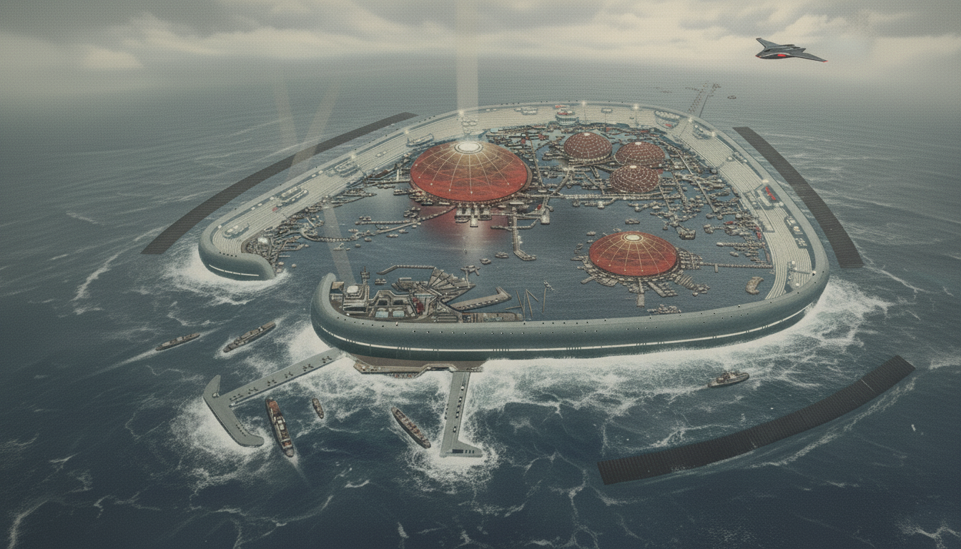

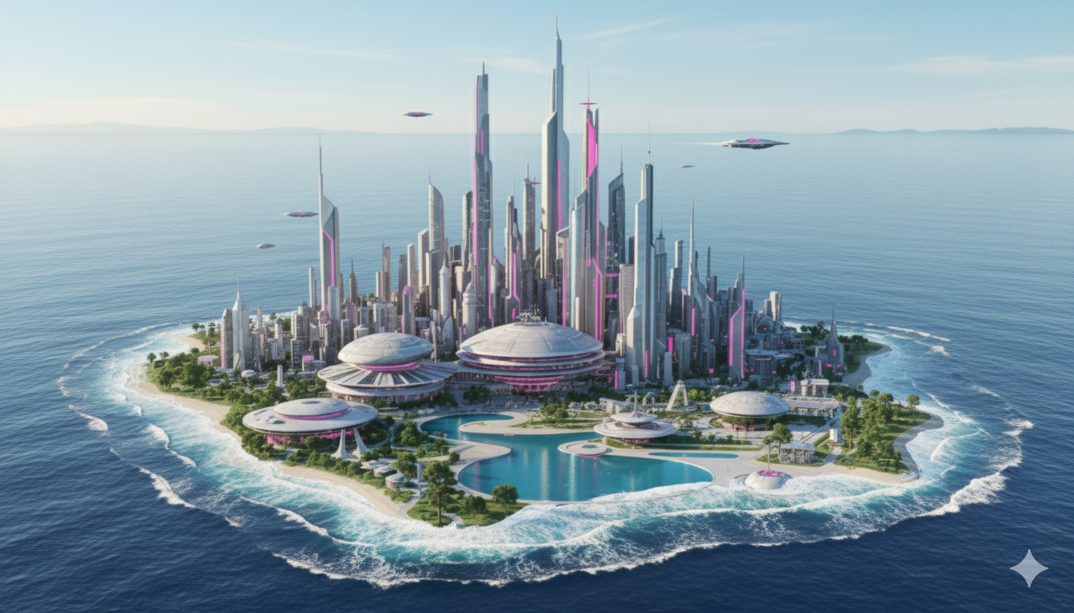

**Offworld Heritage Sites and International Monuments**

Some early space age activities on the Moon and in Earth Orbit have been kept intact and preserved for future generations. The International Space Station (ISS) constructed in the late 1990s, and the first dual concentric wheel shaped rotating space station (often referred to as the 2001 Space Station as a nod to the film 2001 that depicted such a station) are in orbit and can be visited externally or in detail via remote VR operated telerobotics.

