[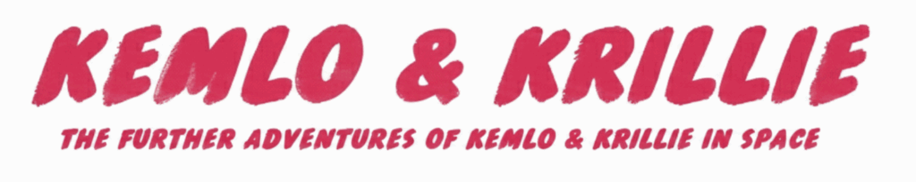](https://blog.inf.ed.ac.uk/atate/files/2025/09/Title-The-Further-Adventures-of-Kemlo-and-Krillie-in-Space-1500x300-1.png)

00 – Cover Contents – 1

00 – Contents - 1

00 - Index - 8

01 - Briefing - 6

02 - Technical Manual - 9

03 - Character Sheets - 2

04 - Other Characters - 9

05 - Storybooks - 6

05a - Storybook 1 - The Belt K Adventure - 7

05b - Storybook 2 - Krillies Grand Graduation Adventure - 9

05c - Storybook 3 - The ISS Emergency - 7

05d - Storybook 4 - Kemlo and the Gravity Ray Gun - 9

05e - Storybook 5 - 2001 A Birthday Odyssey - 8

05f - Storybook 6 - Far from Tranquillity - 8

05g - Storybook 7 - The Gravity Ray Gambit - 7

05h - Storybook 8 - The SPITAR Anomaly - 7

06 - Krillies Diary - 3

06a - Krillies Diary 1 - Introducing Belt K - 7

06b - Krillies Diary 2 - Belt K Fashion - 9

06b1 - Krillies Diary 2 - Supplement - Fashion - 5

06c - Krillies Diary 3 - Graduation Day - 10

06d - Krillies Diary 4 - Ever Learning Belt - 9

06e - Krillies Diary 5 - Fancy Dress - 9

06f - Krillies Diary 6 - Little Green Men - 8

06g - Krillies Diary 7 - Krillie Tries it On - 9

06h - Krillies Diary 8 - Century 21 Cosplay - 3

06i - Krillies Diary 9 - Century 22 Sports - 8

06j - Krillies Diary 10 - Century 22 Food - 6

06k - Krillies Diary 11 - Also Figurines and LEGO - 3

07 - Kemlo Books by EC Eliott - 4

TOTAL: 197 Pages

“The Further Adventures of Kemlo & Krillie in Space” uses background created previously using AI tools based on the [Kemlo Spaceworld series of books by E.C. Eliott](https://blog.inf.ed.ac.uk/atate/2014/01/01/kemlo/) published in 1954 to 1963. As background it uses images and PDF of the contents of this blog post: <https://blog.inf.ed.ac.uk/atate/2025/09/10/kemlo-and-krillie-briefing/>