Demonstration Scenarios Synopsis

Introduction
For scenarios have been prepared within the DARPO small unit operations (SUO) situation awareness (SAS) program to test the technologies developed on the program in a varied range of terrain and combat conditions. Two of these scenarios will be used to demonstrate the planning decision aids (PDA) component of the program:
- Operation San Roberto (OSR) succeeds "Operation Quick Strike" that has secured an airhead in the country of Southland. The objective of OSR is to neutralize a number of enemy observers located in village who are directing artillery fire on to the airport secured in "Operation Quick Strike" and to free civilian hostages with in the village. OSR has been designed to test the SUO SAS technologies in the context of a Military Operation in Urban Terrain (MOUT) scenario.
- Defensive Operation (Scenario 3) Restrictive Terrain has been sketched by Ken Sharpe to AIAI in December 1998. The essence of the operation is the blocking of enemy force in restrictive terrain.

This section provides a brief synopsis of these operations and pointers to the detailed descriptions held on the small unit operation Web site. Each synopsis begins with pointers to these source documents before describing the world situation, general situation, special situation and concept of operations.

Operation San Roberto

Source Documents
Documents detailing this operation are available from the SUO Web site at: ftp://suoteam@dtsn.darpa.mil/suo/Technical_Papers/SUO_CONOPS/MAPEX_Files/Scenario_2/

These documents include:
- SUO_MOUT_Document.doc: textual description of the world situation in which the operation is to be performed and a description of the operation itself.
- SUO_DD.ppt: maps of the overall area in which the operation will take place.
- mck23Jun.ppt: Annotated maps depicting the movement of forces during the operation.
- Matrix2.ppt: Synchronization matrix describing the order in which the major activities of the operation will be execution.
- moutgrid.xls: Mapping of scenario entities (buildings, landing zones) to grid locations.
- OPFOREV.xls: Instruction to individuals taking the role of the opposition force in the scenario.
- MOUT_Annex_A-LOI.doc: Letter of instruction detailing how the scenario will be conducted.

World Situation
The Islamic fundamentalist regime in Algeria has invaded neighbouring Morocco. The U.S. has committed a significant force to assist to Morocco repel the invasion. Taking advantage of the United States' focus on North Africa, both North Korea and Iraq began to act bellicosely. Exacerbating the situation was a coup d'etat in Southland. The coup caused strong reaction in the Organization of American States, which looked to the United States to provide both political and military leadership in restoring the democracy of Southland. Reacting to international pressure, the President of the United States reluctantly agreed to commit a small U.S. force to Southland with the proviso that other South American countries would send follow-on forces to assist in the operation.

General Situation
Southland is a small and impoverished South American nation. It neighbors are Navoto to the West and La Cinda to the East. Navato government maintains proper relations with the United States and is desirous of US enhanced economic aid but is reluctant to permit any significant US presence in the Country. La Cinda has a week government which has been corrupted by the forces leading the coup de'etat in Southland.

Special Situation
23 March 2003
The JTF 780 using Army Airborne and Marine SUO SAS infantry seized a regional airfield in Southland. The airhead was quickly secured with minimal US casualties. This operation was named "Operation Quick Strike."

Souhtlandian forces fled the battlefield into the adjacent mountains and neighbouring villages of El McKenna and Jolon. El McKenna, located approximately five kilometres east of the Airfield, is the local country seat and has approximately 20 buildings. Figure 1 shows the area surrounding El McKenna and Figure 2 the buildings within the village. The principle buildings include the town hall, a small regional hospital and San Roberto. San Roberto is a Franciscan mission dating to the 17th Century and it has great historic and culture significance. The remainder of the village is composed of small commercial buildings and dwellings.
During the afternoon of the 23 March, the airfield is struck sporadically by artillery fire. Crater analysis reveals that the airfield is being targeted from a number of directions by artillery of varied calibers. Aerial reconnaissance is unable to locate the attack platforms. However, surveillance of El McKenna and Jolon indicates no signs of the local civilian populations and some indication that Southlandian forces are occupying the villages.

24 March 2003
Intercepts of messages from the leader of the opposing force in the village of El McKenna indicate the following situation (also shown in Figure 2):
- Enemy force consists of 17 solders. Two are lightly wounded and in the hospital along with two other soldiers who are guarding five hospitalized El McKenna natives, and 15 civilian hospital staff.
- Remaining inhabitants are gathered in the local church.
- Enemy command post is in the town hall
- The enemy will continue to direct fire onto the airfield.
- The enemy has supplies to remain in the village for seven to ten days.
- If attacked, the enemy will draw on reinforcements from Jolon.

As a result of this intelligence, US forces have been tasked to neutralize the air field threat so that coalition forces can be brought in as soon as possible to relieve US forces. The President also directs that there be no civilian casualties, not damage to any significant historical, cultural, or religious site, and the damage to other property be minimized.

Concept of Operations
The Marine Ground Combat Element, 1/8 Marines will use one company, Alpha Company, augmented with four robots and robot operations and reinforced by an airborne infantry platoon, 1/A/1-504th Inf (ABN), to neutralize Objective San Roberto.

Alpha Company has the mission of occupying the village of El McKenna. The airborne infantry platoon will monitor and interdict the OPFOR light infantry platoon occupying Jolin and the mechanized company located vicinity of King City.

The concept of operations is as is described below. Figure 3, which shows the start positions for the operation, and Figure 4, which shows the actual assault on San Roberto, supplement the description.
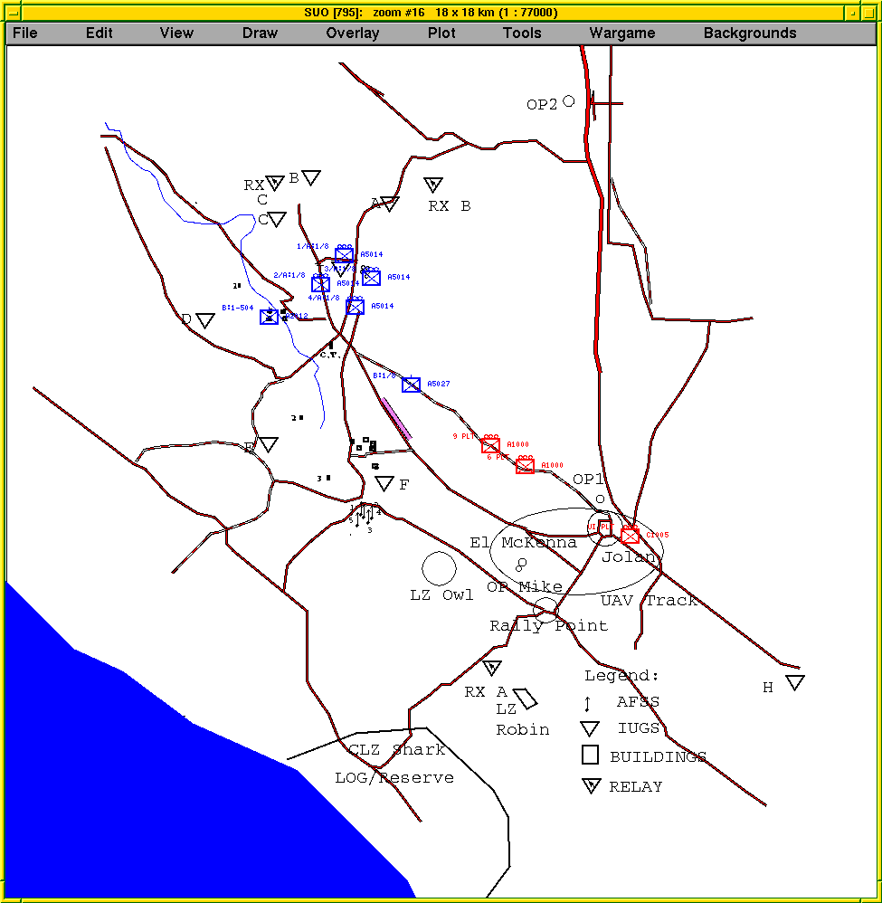

- Figure 1: Area surrounding the village of El McKenna
- At H-10:30 Team A 3rd Platoon will land at LZ OWL. Its mission is to move to OBSERVATION POINT MIKE and conduct a detailed reconnaissance of OBJECTIVE SAN ROBERTO. Specifically, it will locate all enemy observation/ listing posts, identify all buildings as occupied or unoccupied, and identify the location of personnel in Mission San Roberto, El Mckenna Regional Hospital, and the town hall. It will then assist 4th Platoon in evacuating noncombatants.
- At H-4 the ground assault element consisting of the 4th platoon and Team B 3rd platoon will land at LZ ROBIN. They will move to POSITION TOM. At H hour the ground assault element will conduct a three-phase operation.
- Assault and secure OBJECTIVE WEASEL (Building Aa) from the southeast.
- Assault OBJECTIVE FERRET (Building N, San Roberto)
- Clear the southern half of OBJECTIVE SAN ROBERTO

Town Hall
- OPFOR Command Post
Hospital
San Roberto
- Imprisoned Civilian Population

- Figure 2: Village of El McKenna
- At H-4 the 1st Platoon will air land at LZ OWN, move to POSITION JERRY, and on order, assault OBJECTIVE FOX (Building J - El McKenna Regional Hospital) and clear the northwest quadrant of OBJECTIVE SAN ROBERTO.
- At H-4, the 2nd Platoon will air land at LZ OWL, move to POSITION JERRY, an on order, assault OBJECTIVE COYOTE (Building L - town hall) and clear the northeast quadrant of OBJECTIVE SAN ROBERTO.
- Team A, First Platoon, Alpha Company, 1-504 Infantry move into OBSERVATION POINT ONE (OP1) by vehicle and foot NLT H1-12 to observe and interdict OPFOR forces in Jolon.
- Team B, First Platoon, Alpha Company, 1-504 Infantry fly to LZ SPARROW and move into OBSERVATION POINT TWO (OP2) by foot NLT H1-12 to observe and interdict OPFOR mechanized forces coming from vicinity of King City.

- Figure 3: Operation El McKenna - Start positions
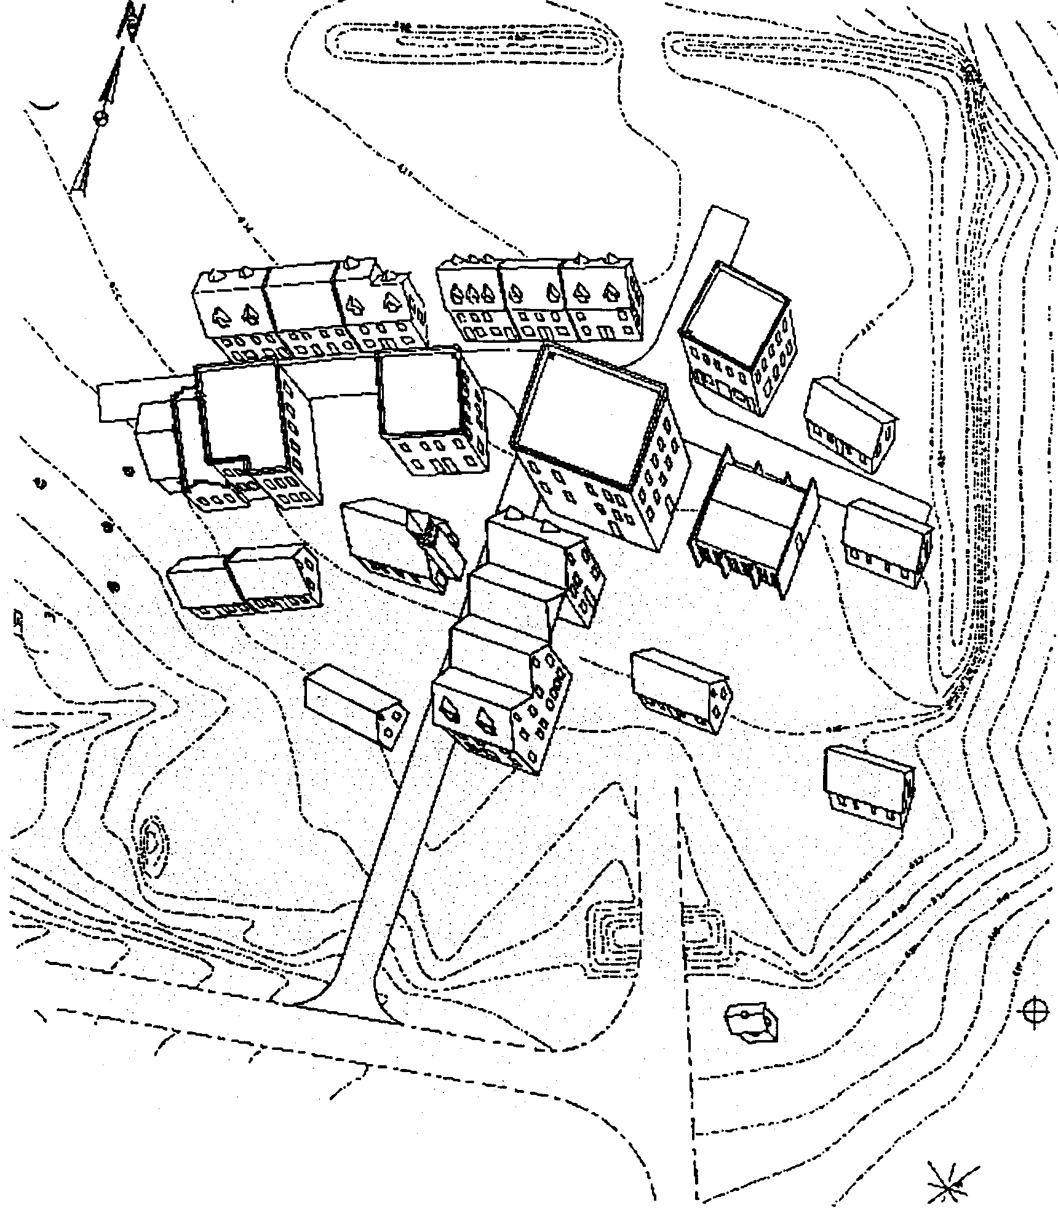
1
2
3
2
1
3
1st
Plt
2nd
Plt
OP “M” 3rd
Plt
4th
Plt
TOWN HALL
NEUTRALIZE
OPFOR
CHURCH
TAKE OUT OP4
FREE CIVILIANS
2
HOSPITAL
FREE CIVILIANS
1
3
BLUE SNIPER
TEAMS
MINEFIELD
TUNNEL
COMPLEX
MANHOLE
OPFOR OP
OPFOR KIA
4
D-II-4

- Figure 4: Operation San Roberto Execution Phase

Defensive Operation (Scenario 3) Restrictive Terrain

Source Documents
This description is based on the briefing given by Ken Sharpe at AIAI during the 15th, 16th and 17th December 1998. No further information available to date.

World Situation
Unknown

General Situation
Unknown

Special Situation
Unknown

Concept of Operation
Opposition forces are expected to advance through an area. Friendly forces are ordered to intercept this advance. Figure 5 shows a schematic of this operation. The terrain is composed of two passes through raised ground. Opposition forces are expected to move from the top of the figure at Phase Line One and advance down the figure along the paths. It is anticipated that the opposition forces will use both path ways through the raised ground. Upon exiting the raised ground, the opposition forces have a choice of routes. It is anticipated that they will take the central route. The actual route taken by the opposition forces will be known by the time these forces reach phase line two.
Phase
Line
One
Phase
Line
Two
Restrictive Terrain - Marsh?

- Figure 5: Schematic of Defensive Operation (Scenario 3) Restrictive Terrain - based upon diagram from Ken Sharpe
This operation will use two platoons (one section absent from the diagram). Friendly forces are positioned on top of the raised ground and the central path in squad groupings (rectangle with two dots). These positions are expected to allow fire to put down upon the advancing opposition forces. The two squads not positioned on high ground offer the flexibility to move to the path on the right of the figure in the event of opposition forces taking this route.

Operational Order (OPORD) Representation

Aim
This section describes the content of the Operational Orders issued within the US Army. It then takes the first step towards developing an automated planing application by proposing a mapping of this content to a plan ontology.

Approach
The content of US Army Operational Orders was identified primarily through the document "FM-105 Staff Organization and Operations". This document is "the Army's doctrinal source for the military decision making process" (FM-105 pvii) and contains an appendix defining the content of OPORDs (pp H-12 to H-24). This phase was also supported by the "Do-It-Yourself Warning and Operation Order Handbook" by Tscherne and two OPORDs describing an ambush operation obtained by Austin Tate at Fort Beaning. The results of this analysis are presented in a structure preserving that given in FM-105. Specifically, that an OPORD has the major section: Situation, Mission, Execution, Service Support, and Command and Signal. The contents of each major section are presented in tabular format with a row for each attribute. Each attribute is defined before an example specification is given.

With the content of US Army OPORDs identified, the first step towards developing an automated planning application is taken by mapping each attribute that can occur within an OPORD to a plan ontology; in this case the DARPA Shared Process and Activity Representation or SPAR ontology. The principal scope of SPAR is to represent past, present and possible future activity and the command, planning and control processes that create and execute plans meant to guide or constrain future activity. It can be used descriptively for past and present activity and prescriptively for possible future activity. Automated planning systems require that a domain be described in terms of the concepts within a plan ontology such as SPAR. The following section provides the first stage of this mapping back taking each concept within an OPORD and mapping it to concept(s) in SPAR. The SPAR ontology is itself is shown in Figure 6.

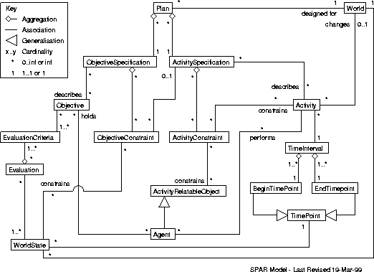

- Figure 6: Plan Ontology - SPAR Model
The Activity Constraint entity in the SPAR ontology us specialised into the following categories for use within an AI planning system.
- Temporal Constraints
- Activity-Relatable-Objects
- World State Constraints
- Resource Constraints
- Spatial Constraints
- Authority Constraints
- Other Constraints
- Annotations.

Source Documents
The following domain documents were used to identify the content and context of US Army OPORDs.
- FM-105 Staff Organization and Operation, US Army publication. No year or source URL.
- The Do-It-Yourself Warning and Operation Order Handbook, Rick Tscherne, Ricks Books, no year of publication.
- Combat Leader's field Guide (11th Edition) J. Gallagher, Stackpole, 1994, Books, USA.
- RB1R13 FTX-1 Platoon Operation Order (Ambush) 4, Feb 1998. OPORD acquired by Austin Tate at Fort Beaning, USA.
- RB1R13 FTX-1 Squad Warning Order (Ambush) 14, May 1998, Acquired by Austin Tate at Fort Beaning, USA.

OPORD Content Analysis
This section presents the content of US Army OPORDs together with a proposed mapping of each attribute to a plan ontology.

Identification
The identification section sits outside the five-paragraph structure of Situation, Mission, Execution, Service Support, and Command and Signal but is an essential component of an OPORD.

Attribute | Meaning | Example | Plan Ontology Mapping
Classification | ?Security classification? |  | Attribute of a PLAN entity
Change from Oral Orders | If the formal order differs from a previous verbal order, this section summarizes the differences and highlights the location of those differences within the order |  | Referring to a relationship between versions of a PLAN. It will potentially include any entity within a plan.
Copies | Identifies this copy within the set of copies | 4 of 5 | Used to differentiate copies of a PLAN instance. This would be an attribute of the PLAN entity.
Issue HQ | Name of issue HQ |  | Assume that the Issuing HQ is an AGENT that holds some or all of the OBJECTIVES that a PLAN instance is to achieve. This is the identity of that agent.
Place of Issue | Location of the issue HQ | EDINBURGH | Attribute of the Issuing HQ
Time Zone | Operations over multiple time zones need to specify times in relation to a common time reference. | ZULU (equivalent to GMT) | Could map to the Calendar attribute within the ENVIRONMENT concept
Message Reference Number | Used by the sending location to enable the addressee the acknowledge receipt of the order |  | Attribute of the message entity with which a copy of a PLAN instance is communicated
Order Number | Uniquely identifies an OPORD. These are generally numbered sequentially through a calendar year. |  | Attribute of a PLAN entity. This could uniquely identify plan entities.
Reference Material | List of the documents referenced by the OPORD. Examples include maps, tables etc. |  | Visualisations of the ACTIVITY CONSTRAINTS, ACTIVITY-RELATABLE-OBJECTS, and potentially all entities in the SPAR ontology used in a PLAN
Task Organization | Describes the allocation of available assets available to the issuing commander to subordinate commander. The structure also establishes command and support relationships. |  | List of ACTIVITY-RELATABLE-OBJECTS that the AGENT who is to further refine or execute a PLAN instance has some AUTHORITY constraints over. These ACTIVITY-RELATABLE-OBJECTS are expected to take on the role of RESOURCE constraints.

Situation
This section outlines the current operational situation in terms of enemy forces, friendly forces, and attachments and detachments.

Enemy Forces
The OPORD must reference enemy forces up two echelons below the level of the issuing unit.

Attribute | Meaning | Example | Plan Ontology Mapping
Enemy's most likely course of action | Specifies the most likely course of action that the enemy will take. | The enemy platoon operating in our area will continue to conduct limited squad size ambushes. | A PLAN Instance. The AGENT holding the objectives that this plan achieves is expected to be the enemy.
Enemy's most dangerous course of action. | Specifies the most dangerous course of action that the enemy may take. |  | A PLAN Instance. The AGENT holding the objectives that this plan achieves is expected to be the enemy.
Size | Specifies the believed size of the enemy force | The enemy platoon is numbered at 22 to 24 men operating in squad size (7 to 8 men) elements | The ACTIVITY-RELATABLE-OBJECTS available to the enemy. It is expected that these will take the role of RESOURCE-CONSTRAINTS.
Activity | Describes the recent activities of the enemy force | The enemy has been conducting resupply operations and aggressive offensive operations such as squad size ambushes and sniper attacks. | A series of PLAN Instances describing the enemy's previous activates
Locations | Describes the believed location of the enemy force | The enemy platoon is located north of Highway 137 | ACTIVITY-RELATABLE-OBJECTS corresponding to geographical locations. It is expected that this will take part in SPATIAL-CONSTRAINTS on the enemy and friendly force plans.
Identification | Describes how to identify the enemy | The enemy has been identified as the Peoples National Revolutionary Movement. The enemy wears a combination of desert camouflage uniforms with civilian clothes | Attribute of the ACTIVITY-RELATABLE-OBJECTS available to the enemy.
Moral and capabilities | Describes the believed moral of the enemy and its capabilities | The guerillas morale is excellent due to their recent success in inflicting numerous casualties on or forces. The guerillas are well trained and capably lead. They are familiar with the land and can live of the land with the help of the local population. | Property of the ACTIVITY-RELATABLE-OBJECTS available to the enemy. It is expected that this will form an ACTIVITY-CONSTRAINT on the enemy and friendly plans. Currently assigned as an OTHER-CONSTRAINT.

Friendly forces
Attribute | Meaning | Example | Plan Ontology Mapping
Mission of the next higher unit | Outlines the higher commander's intent and concept of operations for headquarters one and two levels up. | US forces will conduct ambushes in the assigned area to destroy enemy personal and equipment in order to prevent enemy logistical re supply | Presentation of the PLAN showing the OBJECTIVES held by the next higher unit AGENT. It will also include some high level ACTIVITY SPECIFICATIONS and mention the enemy OBJECTIVES that the mission will counter.
Unit to our front | Action to be carried out by friendly forces at our front | First platoon will depart point x and time y and will parallel our route to the west and will conduct squad sized ambush in zone 2 | Presentation of the PLAN showing the OBJECTIVES held by friendly AGENTS with activities SPATIALLY CONSTRAINED to occur to this unit's front. It will also include some high level ACTIVITY SPECIFICATIONS and mention the enemy OBJECTIVES that the mission will counter.
Unit to our right | Action to be carried out by friendly forces at our right | First platoon will depart point x and time y and will parallel our route to the west and will conduct squad sized ambush in zone 2 | As above, expect unit's to this unit's right.
Unit to our left | Action to be carried out by friendly forces at our left | First platoon will depart point x and time y and will parallel our route to the west and will conduct squad sized ambush in zone 2 | As above, expect unit's to this unit's left.
Unit to our rear | Action to be carried out by friendly forces at our rear | First platoon will depart point x and time y and will parallel our route to the west and will conduct squad sized ambush in zone 2 | As above, expect unit's to this unit's rear.
Fire support provided by | Non organic assets available to provide indirect fire support | The first field artillery is located at location Y. 81mm mortars are located at location z Request all fires through battalion | List of the ACTIVITY-RELATEABLE-OBJECTS that can take on the role of RESOURCE in activates for providing fire support. It will include the ACTIVITY-SPECIFICATION for accessing these resources and some EVALUATION CRITERION on the priority requests will be serviced.

Attachments and Detachments
Attribute | Meaning | Example | Plan Ontology Mapping
Lists the attachments and detachments made between friendly units for this mission. |  |  | Definition of the AUTHORITY-CONSTRAINTS between the friendly ACTIVITY-RELATABLE-OBJECTS taking part in this plan.

Weather Forecast
Attribute | Meaning | Example | Plan Ontology Mapping
General weather for the next n hours will be: | Obvious |  | Potentially a WORLD STATE ACTIVITY CONSTRAINT
High and low tides | Obvious |  | Potentially a WORLD STATE ACTIVITY CONSTRAINT
Wind speed and direction | Obvious |  | Potentially a WORLD STATE ACTIVITY CONSTRAINT
Illumination | Obvious |  | Potentially a WORLD STATE ACTIVITY CONSTRAINT
Moon rise and set | Obvious |  | Potentially a WORLD STATE ACTIVITY CONSTRAINT
Sun rise and set | Obvious |  | Potentially a WORLD STATE ACTIVITY CONSTRAINT

Terrain
Attribute | Meaning | Example | Plan Ontology Mapping
Observation and Fields of Fire | The average distances that the terrain and vegetation enables one to see and fire over | Observation is limited to 50 to 75 meters due to the vegetation. Fields of fire are limited to 75 meters due to the rolling slope of the terrain. | SPATIAL ACTIVITY CONSTRAINT
Cover and Concealment | Details how the vegetation and terrain enable both friendly and enemy forces to conceal themselves and equipment. |  | SPATIAL ACTIVITY CONSTRAINT
Obstacles | Lists key obstacles to movement. | Erosion ditches located north of Highway 137 channelize movement and slow our dismounted movement. | SPATIAL ACTIVITY CONSTRAINT
Key Terrain | Areas that are key either because of psychological or tactical significance. | The village of Bunea Vista holds psychological significance, as it is the home of the leader of Buena Vista. | SPATIAL ACTIVITY CONSTRAINT
Avenue of Approach | General effect on movement of the terrain and vegetation | Dismounted movement is easily conducted throughout our area of operation. | SPATIAL ACTIVITY CONSTRAINT

Mission
Attribute | Meaning | Example | Plan Ontology Mapping
Mission Statement | A succinct statement of the mission the receiving unit is to perform. The mission statement must include who will do what, where, when, and why. | First platoon of first company conducts area ambush of selected named areas of interest in zone n to destroy enemy personal and equipment in order to prevent re supply and reinforcement of enemy positions. | Statement of the OBJECTIVES of a PLAN together with a high level view of its ACTIVITY SPECIFICATION, RESOURCE CONSTRAINTS, SPATIAL CONSTRAINTS, and TIME CONSTRAINTS.

Execution

Concept of Operations
This is based on upon the COA statement created during the MDMP. The concept of operation will detail:

Attribute | Meaning | Example | Plan Ontology Mapping
Maneuver | Describes the movement of friendly forces during the operation |  | Presentation of a PLAN showing only those ACTIVITY-SPECIFICATIONS pertaining to movement
Fires | Describes the scheme of fires to support the overall operation |  | Presentation of a PLAN showing only those ACTIVITY-SPECIFICATIONS pertaining to fires
Reconnaissance and Surveillance | Describes the reconnaissance and surveillance plan and that that plan fits into the overall operation plan. |  | Presentation of a PLAN showing only those ACTIVITY-SPECIFICATIONS pertaining to Reconnaissance and surveillance
Intelligence | Describes the intelligence plan for supporting the operation. This includes target and battle damage assessment as well as counterintelligence. |  | Presentation of a PLAN showing only those ACTIVITY-SPECIFICATIONS pertaining to intelligence
Engineer | Describes how engineering assets will support the plan. Examples include obstacle clearance. |  | Presentation of a PLAN showing only those ACTIVITY-SPECIFICATIONS pertaining to engineers
Air Defense | Describes the air defense support for the scheme of maneuver. |  | Presentation of a PLAN showing only those ACTIVITY-SPECIFICATIONS pertaining to air defense

Task to manoeuvre units
Clearly state the missions or tasks for each manoeuvre unit that reports directly to the headquarters issuing the order. List units in the same sequence as in the task organization.

Tasks to combat support unit
Attribute | Meaning | Example | Plan Ontology Mapping
Intelligence | Instructions to intelligence units |  | Presentation of a PLAN showing only those ACTIVITY-SPECIFICATIONS pertaining to intelligence
Engineer | Instruction to engineer units |  | Presentation of a PLAN showing only those ACTIVITY-SPECIFICATIONS pertaining to Engineer
Fire Support | Include Air support, field artillery, navel gunfire and fire support coordinating measures |  | Presentation of a PLAN showing only those ACTIVITY-SPECIFICATIONS pertaining to fire support
Air Defense | Organization for combat, missions, priorities for protection |  | Presentation of a PLAN showing only those ACTIVITY-SPECIFICATIONS pertaining to air defense
Signal | Communications plan |  | Presentation of a PLAN showing only those ACTIVITY-SPECIFICATIONS pertaining to signal
NBC | How NBC support will be given |  | Presentation of a PLAN showing only those ACTIVITY-SPECIFICATIONS pertaining to NBC
Provost Marshall | Military Police |  | Presentation of a PLAN showing only those ACTIVITY-SPECIFICATIONS pertaining to Provost Marshall
PSYOP |  |  | Presentation of a PLAN showing only those ACTIVITY-SPECIFICATIONS pertaining to PSYOPS
Civil Military Operations |  |  | Presentation of a PLAN showing only those ACTIVITY-SPECIFICATIONS pertaining to civil military operations

Coordinating instructions
Attribute | Meaning | Example | Plan Ontology Mapping
Time or condition when a plan or an order becomes effective |  |  | ACTIVITY CONSTRAINTS that must be satisfied before execution of a plan can commence.
Commanders critical information requirements | Priority Intelligence Requirements, Essential elements of friendly force information, friendly force information requirements |  | Outstanding issues in a plan relating to the gathering of information. These may be issues to find out facts about the WORLD-STATE.
Risk reduction control measures | Mission specific guidance on troop safety, vehicle recognition signals, and fratricide prevention measures. |  | A component of a plan that has been added for the OBJECTIVE of reducing risk.
Rules of Engagement |  |  | Other ACTIVITY CONSTRAINT
Environmental considerations |  |  | Other ACTIVITY CONSTRAINT
Force Projection

Service Support
Attribute | Meaning | Example | Plan Ontology Mapping
Overall concept |  |  | Presentation of a plan showing only service support element.
Material and services |  |  | Presentation of a PLAN showing how materials and services will be provided
Medical evacuation and hospitalization |  |  | Presentation of a PLAN showing how casualty events will be handled
Personal support

Command and Signal
Attribute | Meaning | Example | Plan Ontology Mapping
Command | Identify the chain of command and the location of command posts
Signal | List signal instruction not specified in SOPs

Issues Remaining
The initial scoping document for the PDA component of SUO states two primary capabilities. Issues relating to each are identified below.

Plan functionality
"The ability to "understand" and interpret mission requirements of a human-in-the-loop generated plan received from higher headquarters, access relevant information from applicable databases, and automatically perform the steps of the decision-making process. The outcome will be a doctrinally correct, tactically sound course of action with selected supporting annexes."

To achieve this objective, we need to determine the precise content of the OPORD that the PDA system will receive from the higher headquarters. We then need to determine the precise content of the OPORD that the PDA system must output. This information will "bound" the application. We will then be able to concentrate on identifying the doctrine and tactics that are currently used in this refinement.

Battlespace monitoring
"The capability to monitor events as they are reported in the battlespace. The PDA will "infer" the progress of events relative to a plan developed under the provisions of the previous paragraph, provide updated reporting to a military user, and provide a warning to the user when battlespace events are such that the plan is no longer viable"

To achieve this objective, we need to determine the process of reporting progress of the execution of plans currently used by the US Army. We then need to determine the repair process. The assumption is that units have an authority to repair their plans to a given level before issues have to be reported to a higher headquarters and that the decision-making process is repeated.

KA Plan for Phase 2
In overview, the KA in phase 2 should concentrate on the inter echelon process followed in the production and repair of plans. This will give us a model of the planning application we are to build and enable us to focus the KA on the doctrine and tactics relevant to that application. It will also enable us to determine the scope of localised plan repair on the process of requesting global repairs from higher echelons.

Operation Quick Strike itself will not be considered by the planning decision aids component of the program.
http://www.aiai.ed.ac.uk/~arpi/spar/

