Copy _____ of _____ copies
A/1/8 IN USMC
USS INCHON, off the coast of
Southland
241640ZMAR03
Msg Ref #

OPERATION ORDER 2003-22 (M^{C}KENNA’S GOLD)

References: Maps ______________________________________________________________ _______________________________________________________________
______________________________________________________________

Time Zone Used Throughout the Order: LIMA

Confirmation:

Task Organization A1/8 USMC:

[NOTE: ALPHA Company of the 1st Battalion 8th Marine Regiment is a “SUO-series” light infantry unit. It has 46 assigned personnel, and is comprised of 4 platoons and a 2 man CMD section. The platoons each have 11 troops, including a 1-man command section and two 5-man squads designated ALPHA and BRAVO. The Robot section from the S2/1-8 USMC consists of an NCOIC/Senior Robot handler, and 3 robot handlers, one per robot (4 total). 1/A/504AIB is also a SUO-series unit consisting of two 5 man squads and a platoon leader.]

A/1/8 USMC
1/A/1/8

2/A/1/8

3/A/1/8
ATT ROBOT TM1/S2/1-8USMC
ROBOT TM2/S2/1-8USMC
ROBOT TM3/S2/1-8USMC
ROBOT TM4/S2/1-8USMC

4/A/1/8

OPCON
1/A/1-504AIB

- SITUATION

Annex A (Sketch)

- Enemy Forces.
- Elements of a Southland Commando Infantry (IN) Battalion (BN) reinforced with a MECH IN CO have been operating in the BN’s area which encompasses the Jolon Military Encampment (16SGA145839), and the towns of M^{C}Kenna (), and Box Springs (16SGM01501950). Last reported enemy dispositions show platoon strengths IN units in the Jolon Military Encampment and M^{C}Kenna, elements of a Mechanized (MECH) Company (CO) in Box Springs. Motorized (Mtz) or MECH patrols of up to company strength have been observed in the battalion area of interest.

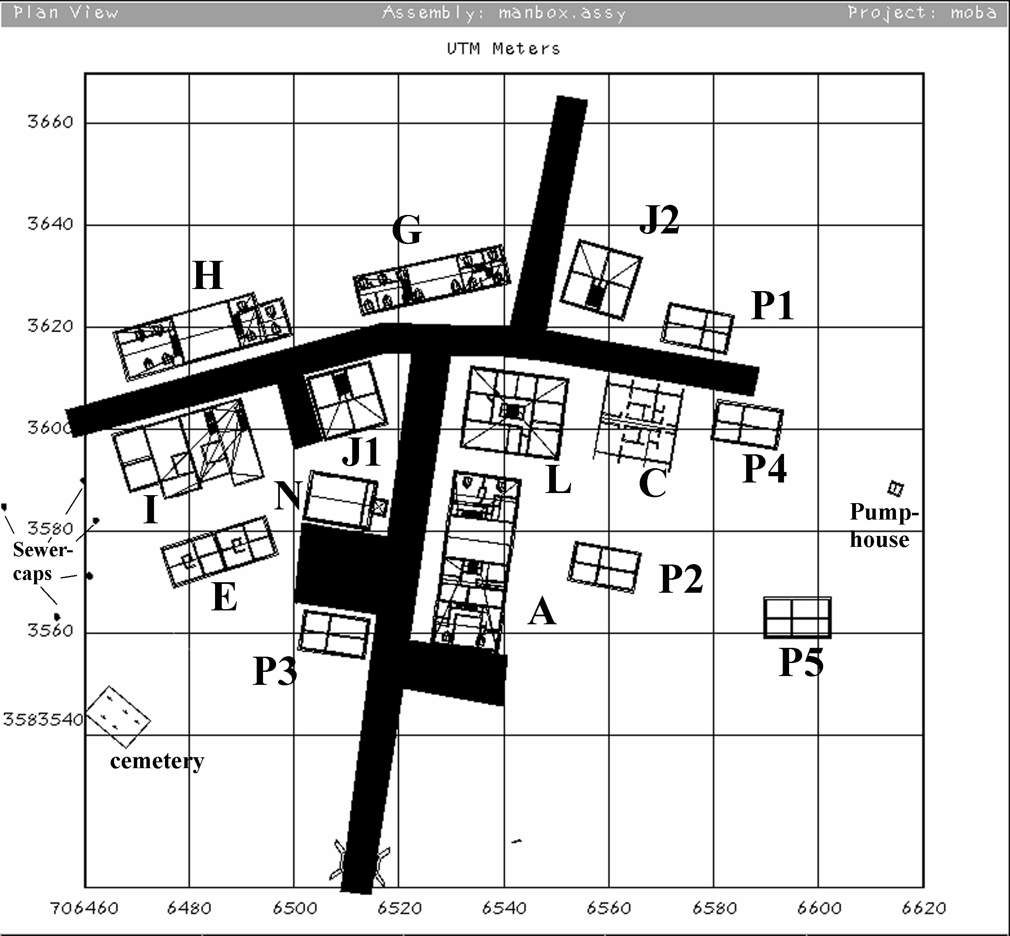
ANNEX A Sketch: Objective McKenna Town Layout (Blds Annotated)

- A Southland platoon occupies OBJ M^{C}KENNA (16SGA0683). Elements of approximately squad size have been spotted vicinity the Hospital (GA06518361), the Old Stone Church (GA06518359), and the Town Hall (GA06548360). Two suspected sniper / security locations have been spotted vicinity the large building to the South, designated building A and North of the Town Hall, designated building J2.

- Other security teams are suspected to be operating covering the eastern and western approaches to OBJ M^{C}KENNA. Location of these teams is a PIR for the mission; the obvious unconfirmed location is the church tower. The enemy has been observed emplacing mines protecting the defilade positions east and west of OBJ M^{C}KENNA and at the highspeed approach intersection SSW of town. Organic mortars capable of covering the defiladed minefields are suspected but not yet identified. (see intel sketch 250005ZMAR03)

Current task organization and composition of the enemy forces are not known at this time. They appear to be elements of the 1st Commando IN BN (Light), the 1st MECH IN BN and 1st MTZD IN BN. The parent unit organizations:

- 1st Commando IN BN (Light).
(a)Task Org
1st Commando IN HQ CO
1st Commando IN CO
2^{d} Commando IN CO
3^{d} Commando IN CO
3^{d} Recon PLT (2 sect BRDM)
4th Recon PLT (AT) (2 sect BRDM)
4th MECH Mortar BTRY
2^{d} Compost AA PLT
37MM (towed) SECT (2 Guns)
SA-7 SECT (2 SQD)
(b) Last known disposition
Bn (-) location - UNKNWON.
Bn HQ location - UNKNOWN
Last reported strengths show up to PLT strengths in Jolon Military Encampment and M^{C}KENNA.

CO HQs locations - UNKNOWN

- 1st MECH IN BN
- Task Org
1st MECH IN CO
2d MECH IN CO
3d MECH IN CO
1st Recon PLT (2 sect BRDM)
1st Recon PLT (AT) (2 sect BRDM)
1st MECH Mortar BTRY
1st Composite AA PLT
ZSU23-4 SECT
SA-9 SECT

(b) Last known disposition
Up to a CO TM appears to be securing Box Springs.
PLT or PLT (+) patrols have been spotted intermittently in the 1-8’s AO on high speed avenues of advance. No mounted patrols have been observed since emplacement of the minefield SSW of M^{C}KENNA.
Locations of other MECH elements and the 1st MECH BN HQ - UNKNOWN

(3) 1st MTZD IN BN
1st MTZD IN CO HQ
1st MTZD IN CO
2d MTZD IN CO
3d MTZD IN CO
1st Recon PLT (2 sect BRDM)
1st Recon PLT (AT) (2 sect BRDM)
1st Mortar PLT
1st Composite AA PLT
37MM (towed) SECT (2 Guns)
SA-7 SECT (2 SQD)
(b) Last known disposition
In earlier situations, at least 1/3 of its combat elements were engaged in platoon level combat patrols or forward positioned at key locations (bridges, key intersections, airfields, etc.) at any time. However, no more than a single platoon has been observed at one time in the 1-8’s AO. Patrol schedules, routes, and prepositioning do not appear to follow a set schedule or pattern but appear to be coordinated with those of the 1st MECH BN. 1st MTZD and 1st MECH patrols have never been observed in the 1-8 AO concurrently.
Locations of 1st MTZD elements – UNKNOWN

- Friendly Forces.
(1)
(2)
- -

- Attachments and Detachments

(1) Attachments. ROBOT TMs 1-4/S2/1-8 USMC
(2) OPCON 1/A/1-504AIB effective now.

- MISSION
B/1-8 USMC conducts air infiltration beginning 250000 (H-4) and attacks 250400ZMAR03 (H Hour) to free hostages in OBJ M^{C}KENNA (). Be prepared to secure OBJ M^{C}KENNA until reinforcement or to exfiltrate on order. The mission will be executed in four phases. H+00 (250400ZMAR03) is the beginning of PHASE III.
3. EXECUTION

- Commanders Intent.
PHASE I - Recce and security (Now to H-4:30). Monitor primary MAA, insert sensors and recce team, and gather detailed intel about the OBJ. 1/A/1-504AIB has already established OPs on the primary MAA. 3PLT(-) is enroute to establish BP INDIGO (16SGA064835), OP MIKE (16SGA065835), and positions for sniper teams covering the eastern approaches to the OBJ. Robot teams will begin gather detailed intel upon establishment of INDIGO while OP MIKE observes southern MAA.

PHASE II – Entry into AO and preparation for hostage extraction (H-4:30 to H Hour). Limit the enemy time and capability to react by V22 insertion near the OBJ and rapid movement to hide positions outside perimeter road (except 4PLT hides inside the perimeter). Complete MAV & video reconnaissance by H-30 . Disseminate latest situation, takedown OPs, FRAGO as necessary, and move to rapidly to assault positions after OP takedown. Eliminate enemy OPs near simultaneously and rapidly using our advantages in night operations and situational awareness. Preferably eliminate enemy outposts before they can report. Be position to simultaneously initiate hostage rescue at H hour, 250400ZMAR03.

PHASE III – Hostage extraction (H Hour to ?). At H+00, Use the advanced fire support system (AFSS) for the close-in support while suppressing the far side of the objective or reinforcing enemy elements with USMC or other aerial assets. I envision hitting known and primary suspected hostage locations simultaneously to minimize the enemy’s opportunity to harm hostages. Overwatching fires will be provided by organic elements. 1/A/1-504AIB will provide security OPs on HS MAA to N. Collateral damage to be minimized but not by needless jeopardizing of our forces. The goal is minimum hostage casualties before first light to facilitate defensive preparation and receipt of follow-on forces or exfiltration before the enemy can respond with reinforcements. Once hostage sare secure I will consolidate them in a safe location.

PHASE IV – Security of M^{C}KENNA/exfiltration (H+? until relieved/extracted).
Security of M^{C}KENNA will by the clock system with 12:00 being due north. Each platoon will have responsibility for 1 (Main (Motorized) Avenue of Approach) MAA except 3PLT. I envision engaging the enemy as far from our position as possible with supporting USMC and coalition air and rotary assets while saving remaining AFSS for the close-in battle or exfiltration support.
If exfiltration is required I envision exfiltrating elements not in contact and the hostages to the objective rally point then withdrawing a single team per platoon in contact. Once the exfiltrating teams have withdrawn to overwatch positions, we will use remaining AFSS and air support to break contact. Units will leapfrog until clear of direct fires and then move out to rejoin the company formation.

- Concept of Operation. Annex __ (Operation Overlay)

- Maneuver
- PHASE I – Ongoing
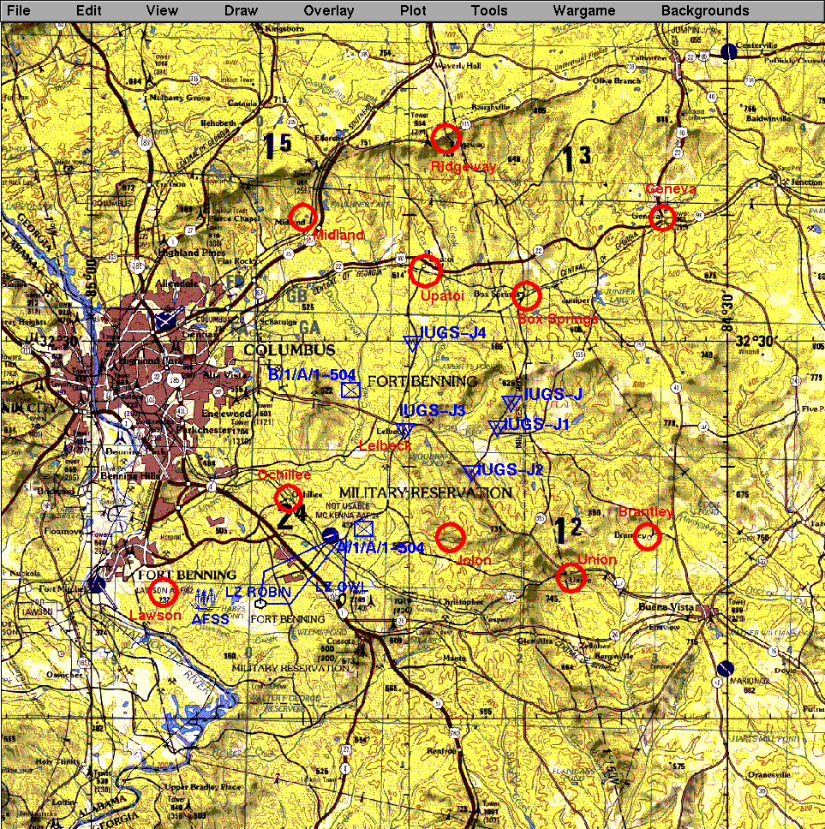

Annex B: Area of Operations {AFSS, LZs, OPs, Deep IUGS, annotated}

- Initial Main effort1/A/1-8.
PHASE II – Air Insert into LZ ROBIN (16SGA008787) 250001ZMAR03 move E/NE behind 3/A/1-8 to vic BP INDIGO (GA064835). Move by covered and concealed routes to assault position.
PHASE II - Takedown enemy forces in the primary hostage location, the old stone church (GA06518359), at 25040OZMAR03. Collect hostages rescued by other teams with those in the stone church. After collection and treatment of any wounds, be prepared to escort hostages and any POW to the ORP vic BP INDIGO.
PHASE IV – Support SW/hostage C&F and POW security. Your defensive responsibility is from 07:15 (ORP) to 08:30, the narrowest sector with the next to least like MAA at 08:30. Responsible for collection, traige, care, safety, and hand-over or exfiltration of rescued hostages and POWs.
- Secondary effort, NW Quadrant, 2/A/1-8.
PHASE II - Insert into LZ ROBIN, grid (16SGA008787), 250001ZMAR03 move N/NE, then E to overwatch and assault positions to takedown enemy forces in the Hospital (GA06518361). Maximize covered and concealed routes. You are responsible for taking out the enemy OP in building J1.
PHASE III - Takedown enemy forces and free hostages located in the Hospital (GA06518361) at 25040OZMAR03. Evacuate former hostages and any POWs to 1PLTs’ collection. Be prepared to continue attack to assist 1PLT if required.
PHASE IV – Support NW quadrant. Your defensive responsibility is from 08:30 to 1:00 (NW) including the MAA [Major avenues of approach] at 11:00. This is the 2nd most probable avenue of enemy MECH/MTRZ or IN reinforcement/attack.
(c) Supporting effort, Security and Reconnaissance, SE Quadrant & sniper, 3/A/1-8.
PHASE I – Inserted ALPHA SQD into LZ OWL, grid (16SGA067790) 250001ZMAR03. Established BP INDIGO, grid (16SGA064835). Dispatched elements to OP MIKE, grid (16SGA065835) and to establish 2 sniper teams to positions outside perimeter road approximately 2:30 and 3:45. Overwatch movement of other CO elements. Conduct ROBOT & MAV video recon of objective area.
PHASE II – Continue recon. Insert BRAVO SQD into LZ ROBIN, grid (16SGA008787). Lead movement of 1PLT E/NE ROBIN to INDIGO (16SGA064835). Takeout enemy OPS in East. Backup responsibility for taking out the enemy OP in building “A”. Mark routes for exfiltration and for relief forces.
PHASE III –Maintain Recon and security effort. Be prepared to respond to unforeseen contingencies in any area or assume mission of element.
PHASE IV - Your defensive responsibility is from 04:00 to 7:15 (SE) including the MAAs at 5:00 and 07:00. These are the least probable avenues of enemy reinforcement/attack. The MAA at 07:00 is our primary avenue for reinforcement, extraction, or relief other than by air.
(d) Initial supporting effort, SE quadrant, 4/A/1-8. Main effort (NE quadrant) PHASE IV.
PHASE II - Insert into LZ OWL (16SGA067790) 250001ZMAR03. Move West vic road junction at 5:00. Move East to overwatch and assault positions to takedown enemy forces in the Hospital (GA06518361). Maximize covered and concealed routes. You are responsible for taking out the enemy OP in building A. Coordinate assistance/overwatch with 3PLT PHASE III - Takedown enemy forces and free hostages located in the Hospital (GA06518361) at 25040OZMAR03. Evacuate former hostages and any POWs to 1PLTs’s collection.

PHASE IV – Main effort. Your defensive responsibility is from 1:00 to 4:00 (NE) and includes the MAA at 1:00, the most likely enemy MAA.

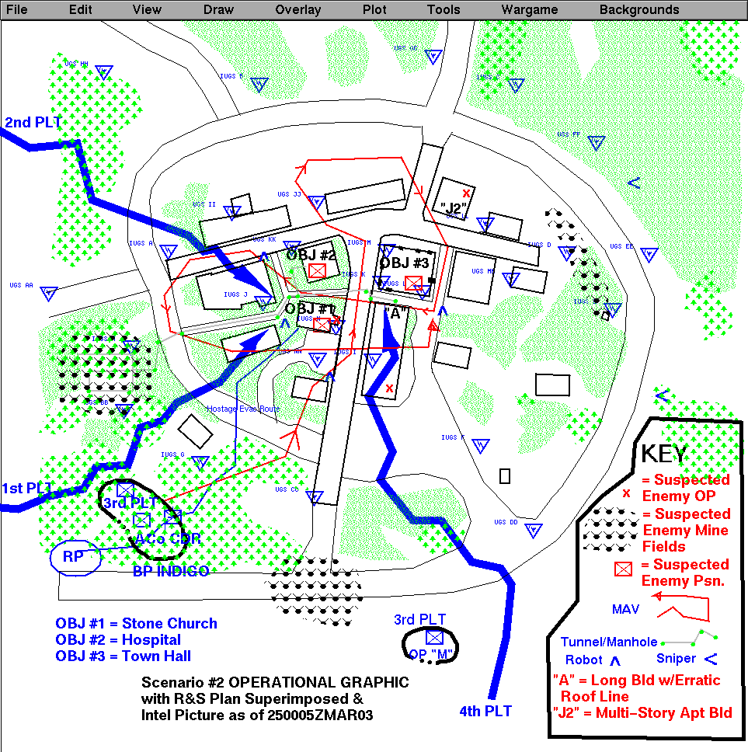
Annex C: Combined Phase II Operational Graphic

COMMENT: This Co Commander’s sketch would be used to brief all platoons except ALPHA Squad 3rd PLT. A much more abbreviated sketch would have been used as the higher orders and Intel picture had not been published by the time this unit needed to have wheels up. That abbreviated sketch is provided at the 3rd PLT’s section of the PLT Extracts.
The finalized R&S plan, shown here combined for clarity, would be a combined effort of the Commander and ALPHA 3rd Platoon on the ground. Data would be sent back and forth electronically. ALPHA 3rd Platoon would know instantly through his WTA of any changes.

- OPCON, supporting effort, N, 1/A/1-504AIB.

PHASE I – After being released from 1-504AIB, 1/A/1-504AIB, moved to and established OP1 (ALPHA SQD/1/A/1-504AIB at 16SGA084841) and OP2 (BRAVO SQD/1/A/1-504AIB at 16SGA014941) on the most probable MAA north of OBJ M^{C}KENNA. The OPs are approximately 10 and 15 KM north of M^{C}KENNA. Engage only to exfiltrate if spotted. They will maintain sensors and report and coordinate FS as required.
PHASE III - Engage only to exfiltrate if spotted. Maintain sensors and report. Coordinate FS as required.
PHASE IV - Engage only to exfiltrate if spotted. Maintain sensors and report. Coordinate FS as required. Be prepared to delay /engage enemy forces on order. If ordered to exfiltrate your priority is linkup with parent unit. If linkup with parent is not possible, move to SSW bypassing OBJ M^{C}KENNA for linkup with A/1-8 or aerial extraction after breaking contact.

- Fires
(a) JTF fires directed by SOF inserted prior to our operation will take out known enemy air defenses other than individual weapons or light machine guns.
(b) Elements of TF783 will maintain CAP over our AO. They will also be equipped with HARM for any surviving enemy ADA assets.
(c) Advanced Fire Support System (AFSS)
- Two long range and four short range AFSS systems will be inserted to support our operation. AFSS will be the primary close support FS asset.
- AFSS1 through AFSS4 (short range, 24 rounds per) are DS to A/1-8 platoons (PLT1-PLT4 respectively).
- AFSS5 (long range, 30 rounds) is DS to HQ’s
- AFSS6 (long range, 30 rounds) is DS to 1/A/1-504AIB
- USMC AH1 killer teams (GS) may be available NET H-10. Request per SOP.
- TG 784.3 HMM-261 (USMC) Air Combat Element (GS) will provide objective area suppressive fires as required against mounted elements company strength or greater when released from the JTF main effort.
- CAS from TG783 may be available for emergency fire support or engagement of mounted elements company strength or greater if cut from the JTF main effort.

- Counterair Operations-Conducted by TF 783. Omitted

- Intelligence. Omitted except as above and sketch (see intel sketch 250005ZMAR03)

- Electronic Warfare. Omitted

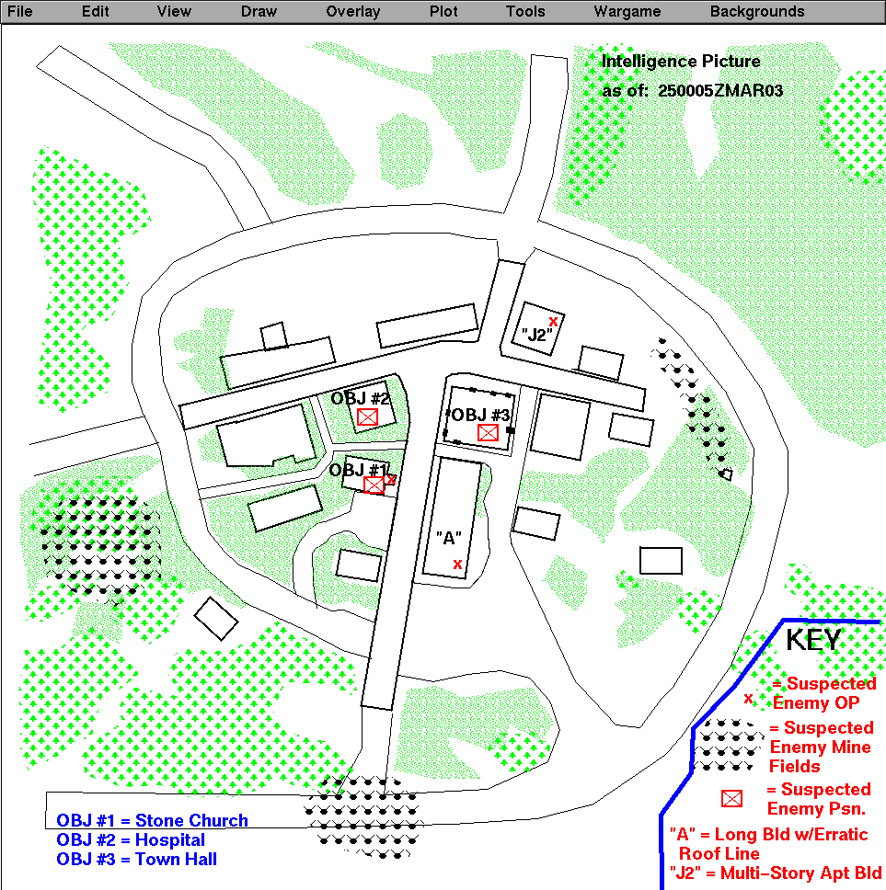

Annex D: Intelligence Picture as of 250005ZMAR03

- Engineer. Engineer elements not available until link-up of follow-on forces or coalition forces.. Additional info - omitted.

- Deception. TF783 will conduct heaviest preparations and electronic deception at sites other than our objectives. Other omitted.

- Tasks to Maneuver Units.

- See concept of operations
- No elements are to cross the perimeter road until ordered by this HQ’s or until 3PLT reports OP MIKE and sniper teams 1 and 2 are established.
- Priority structures in OBJ M^{C}KENNA are known hostage locations. Currently those are the Stone Church (GA06518359), Hospital (GA06518361), and Town Hall (GA06548360). Though we want to preserve as much of the town as neccessary, other buildings can be taken out to preserve the force after H hour.
- McKenna is a small town. Much of the sewer system is too small to support operations without significant preparation, which the OPFOR has not had. However, The tunnel system west of the town is larger to support runoff from those portions of the town on higher ground as is the main east-west drain and a feeder running from it south about 100 yards south of the church. Be aware of possible enemy movement using this system. In the east, 2PLT be prepared to clear the tunnel system if occupied.
- Maximize all-round security moving to assault position.
- Deploy robots to develop enemy picture. Pin down enemy forces with majority of firepower while assaulting.
- Deploy on line at assault position to maximize suppressive fires and eyes on the target.
- Assault squad use entry methods appropriate for situation. Secure initial subobjectives and provide base of fire for further assault.
- 1PLT. 2PLT, & 4PLT outline your concept of clearing of your building to me after the briefback.
- Briefback here in 20 minutes, by platoon, by phase.

- All
- (a) Report operationally ready on LZ
(b) Report location/size of OPFOR encountered or observed
- Report location(s) of assault force
- Use of robots to:
- secure video building exteriors
- penetrating radar reports of building interiors
- penetrating radar reports of tunnels/sewers
- Sniper in non key buildings/take out building if you can’t take them out with first shots
- Conduct link-ups and coordination with adjoining elements after securing objective.

- Tasks to Combat Support Units
None. Basic combat load (all classes) carried by all elements. Cross level supplies IAW unit SOPs on the objective. Request emergency resupply of CLV, and CLVIII IAW SOP.

- Coordinating Instructions.

(1) Briefback of this order will be at this location 20 minutes after time check.
(2) Proposed subordinate objectives and schemes of maneuver will be included as part of your briefback.
(3) I’ll attend 4PLT’s order and 1PLT’s sand table exercise. XO with 2PLT, 1SG with 3PLT. I expect the BN S-3 at 1 PLT’s order.

- SERVICE SUPPORT

a. Concept of Logistic Support. Annex __.

- Material and Services.

(1) Supply. What we take is what we got! Emergency resupply requests by SOP.

(2) Transportation – V22 in. Hopefully we ride out, otherwise its shanks mare.

(3) Services – omitted.

c. Medical Evacuation and Hospitalization.

- d. Personnel. – omitted.

e. Civil-Military Cooperation – omitted.

f. Miscellaneous – omitted.

5. COMMAND AND SIGNAL

a. Command.

- I’ll move with 3PLT to BP INDIGO (16SGA064835) and leave my communications unit (WTA) and Astrow co-located with 3PLT LDR as the Alt CO CP. I plan to move forward with 1PLT and my IWSAS.

(2) Main BN CP remains airborne until seizure complete. Future location is TBD.

(3) Alternate BN CP remains at sea until bridgehead is secure..

(5) Chain of command: Commander, XO, 1, 2, 3, 4, 504 in order.

b. Signal.

(1) CEOI Index ________________

- Annex ____ (Communications-Electronics) to BN order. Exception is the slant report. Modify slant report to account for hostages.

/#1 (#Troops mission capable) /
/#2 (# of Civilian Hostages Recovered/Alive)
/#3 (# of Troops Wounded dash Wounded hostages)
/#4 (# of KIA dash Hostages KIA)
/#5 (# of POWs)

(3) Sensor feeds to IWSAS and WTA from joint platforms and unattended ground sensors.

- Individual Warrior Situation Awareness System (IWSAS).
- Limited resupply of batteries will be carried (2/squad). Basic resupply arrives with follow-on forces or emergency resupply through CLZ when established.
- Nets are configured around squad/team organization.
- Squad leaders provide platoon leaders reports for integration and forwarding.
- Platoon leaders fuse squad reports and forward reports forwarded to company commanders via dedicated nets. Squad leaders systems may be configured to match platoon leader capabilities as backup.
- Informational reports will be reported down the organization to an infantryman’s IWSAS as necessary.

- Warfighter Tactical Associate (WTA).
(a) Battalion base WTA will be located CLZ.
(b) I or Astrow will integrate forwarded reports and forward them as necessary to other company commanders’ and the battalion commander’s WTA stations (JTF FWD)
(c) Links to the platoon leader IWSAS are provided via a dedicated net.
(d) The battalion commander’s WTA receives reports from subordinate company WTA stations and other WTA netted in to provide information management support.
(e) Reports are forwarded up to the Brigade SAS/SADS as necessary. Reports can be forwarded down the chain to the IWSAS as necessary.
(f) Company and Battalion commander WTA will have linked supporting WTA expressing knowledge interest in Intel, Operations, Logistics, Fires, and Information Management.

- . Internetted Unattended Ground Sensor (IUGS). IUGS suites will be deployed (air dropped or placed by SOFs) in sector. These sensors will feed both SAS and Guardian Angel (GA) systems through WTAs. AFSS or other FS may be targeted on confirmed contacts. Three relays will be deployed in support of IUGS. Sensor and relay positions will be show on your SAS as restrictive fire areas.

- . Unattended Ground Sensor (UGS). UGS suites will also be deployed (air dropped or placed by SOFs) in sector. These sensors will feed my WTA to provide another level of early warning. UG locations will also be shown on your SAS as restrictive fire areas.

[Notes: IUGS and UGS are remote multi-function sensors used for perimeter/lines of approach surveillance. Sensor types include thermal, seismic, magnetic, and acoustic.
- IUGS and UGS are employed to provide layered and targeted advanced warning of a flanking or movement to contact maneuver by the opposing forces.
- IUGS and UGS can be air-dropped, fired from artillery or hand-placed.
- Detection reports for IUGS are automatically forwarded to battalion WTAs.
BN Intel/OPs evaluate and forward reports down to company WTAs as necessary.
- Detection reports for UGS are automatically forwarded to the controlling entities WTA.]

- Use ROBOTs to get videos/radar reports of real situation and place explosives.
- Use ROVING EYEs per unit SOP.

Acknowledge

KELLEY
CPT

OFFICIAL

ASTROW
CO DRVR

Annexes: A- McKenna Layout D- Intel 250005ZMAR03
B- Area of Operations E- OWL & ROBIN Infiltration Routes
C- Combined Phase II F-

Distribution:
A+
Control (), DARPA (), SSW ()

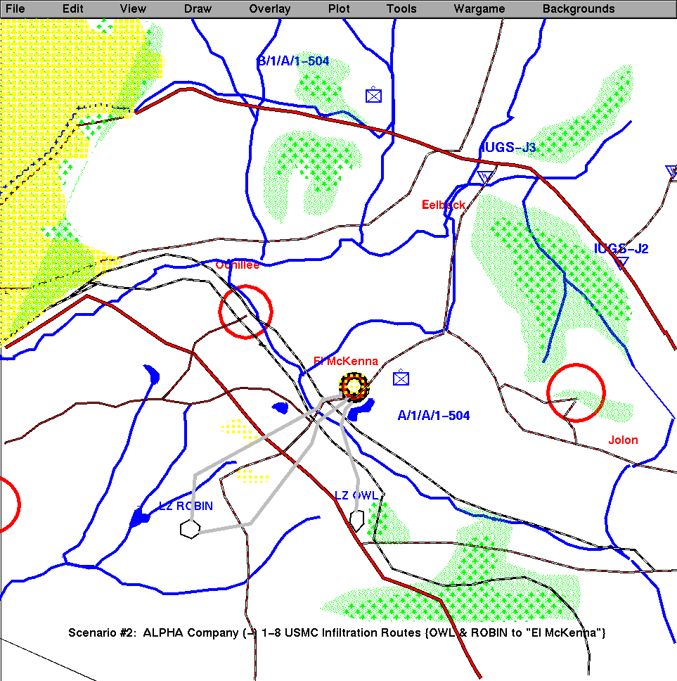

ANNEX E: Operational Graphic: OWL & ROBIN Infiltration Routes

