Small Unit Operations – Planning & Decision Aids

Phase 2 – Demonstration Scenarios

Period of Performance Report Number
April 1999 to June 1999 AIAI/O-Plan/99-2

Prepared by Date
Austin Tate 30 June 1999
Jeff Dalton
Peter Jarvis
John Levine

Address for Correspondence
Artificial Intelligence Applications Institute
University of Edinburgh
80 South Bridge Tel: UK (+44) 131 650 2732
Edinburgh EH1 1HN, UK Fax: UK (+44) 131 650 6513

Contact for Technical Issues Contact for Administration and Contracts
Prof. Austin Tate Mr. Kenneth Baird
Technical Director, AIAI Finance and Admin. Manager, AIAI
E-mail: a.tate@ed.ac.uk E-mail: k.j.baird@ed.ac.uk

Status Use and Disclosure of Data - FAR 15.609(a)
Released No Restriction

Contents
1.0 Introduction 3
2.0 The Context for SUO Planning and Decision Aids 5
2.1 Relationship to the Planning Process Described in FM 7-10 and 7-20 5
2.2 What Kind of Planning is Realistic for SUO? 7
2.3 What Type of Planning is Appropriate for SUO? 8
2.4 But I Don’t Plan – I Just Know What to Do 9
3.0 Demonstration Scenarios 12
3.1 Introduction 12
3.2 Reasons for Choosing Two Scenarios 12
3.3 Military Operations in Urban Terrain (MOUT) 13
3.4 Halt An Attack In Restrictive Terrain 27
4.0 Domain Models 29
4.1 Introduction 29
4.2 Modeling Strategy 29
4.3 Representing the Threads 29
4.4 Encoding the Threads in O-Plan's Task Formalism 34
5.0 Outline of SUO-PDA System 42
5.1 Overall Architecture 42
5.2 Different Planners at Different Echelons, or for Different Phases? 44
5.3 Technical Preparation 44
6.0 SUO Planning-related Modules Study 47
6.1 Aim 47
6.2 JointSAF 49
6.3 Joint Mapping Toolkit (JMTK) 51
6.4 Battle Command System (BCS) 53
7.0 Summary 55
7.1 Results of Phase 2 55
7.2 Evaluation of the PDA Demonstration 55
7.3 Summary of Contributions from SUO/PDA to SUO/SAS Program 57
8.0 Acknowledgements 60
9.0 References 61

Introduction

The O-Plan Transition Project aims to transfer O-Plan (Currie & Tate, 1991; Tate, Drabble & Kirby, 1994; Tate, Drabble & Dalton, 1996; Tate, Dalton & Levine, 1998) concepts, techniques and technology into productive use. It is doing this by engaging in a number of studies or demonstrators with DARPA and AFRL Programs. The main effort in 1999 is directed towards support to the soldier in US Army Small Unit Operations (SUO).

The project at AIAI is divided into four phases, as shown in Figure 1.
Phase 1: Familiarization
& Domain
Modeling
Dec98--Mar99
Phase 2:
Demo Storyboard,
Concept Proofs
& Further
Domain Modeling
Apr99--Jun99
Jul99--Dec99
Jan00--Mar00
Phase 4: Transfer of
Results
Phase 3:
System Adaptation
& Demo

Production

- Figure 1: AIAI SUO-PDA Workplan

This report documents work performed during phase two of the project over the period April 1999 to June 1999 in which SUO related scenarios were defined and domain models were refined. During phase one, AIAI’s aim was to understand the application requirements by studying two scenarios nominated by Mr. Ken Sharpe of SAIC, acting on behalf of Dr. Mark McHenry, the SUO Program Manager at DARPA. The two scenarios were chosen since they had suitable support materials available to help brief AIAI project members, and because they were felt to offer a suitable base to explore the potential of AI planning methods in SUO. Phase 2 involved a more detailed study of militarily plausible, relevant and interesting scenarios and discussions with Subject Matter Experts (SMEs) to refine the proposed demonstration scenarios. AIAI and SRI International have collaborated during phase 2 of the project and will do so for the remaining phases.

This report builds upon the foundational work in the phase 1 report (AIAI/O-Plan/99-1) and will not repeat relevant material provided there. Therefore the phase 1 report is considered to be an essential document to associate with the phase 2 report.

The report begins in section 2 by relating the planning methods being demonstrated within SUO/PDA to the military command and control processes as described in Field Manuals and Training Plans as used in the US Army. A comparison of the AI planning methods that could be employed is made against techniques of natural decision making and problem solving in humans involved in time critical situations.

This main purpose this phase 2 report is to document the demonstration scenarios (section 3) and underlying domain models (section 4) which have been created with the help of SUO program participants and a number of Subject Matter Experts (SMEs) at Fort Benning and Fort Knox. Some early proofs of concept for methods of encoding the domain knowledge being acquired in a form which an AI planner can use are also described – though this is properly the subject of studies in phase 3.

Section 5 provides an architectural sketch of how the AIAI and SRI teams propose to combine their systems to address the SUO scenarios, as far as they are understood at the moment. This has been created to act as a framework for discussions about how to address the demonstrations now proposed.

The final part of work during phase 2, reported in section 6, was a continuation of work in phase 1 involving a study of a range of planning-related modules. These were thought to be relevant for integration with an AI planning system in any eventual Planning and Decision Aid incorporated within a SUO Situation Awareness System. It had not proved possible to get information on each module of potential relevance during phase 1 and some contacts only became available late in the phase 1 study period. Hence a number of module studies completed during phase 2 are now reported here.

The report concludes with some observations on the potential military value of a SUO/PDA and relates this to the technical advances being demonstrated.

The Context for SUO Planning and Decision Aids

Relationship to the Planning Process Described in FM 7-10 and 7-20
US Army, The Infantry Battalion, FM 7-20, Chapter 2 Command and Control, 14 December 1990, http://www.adtdl.army.mil (select Field Manuals of type Infantry).

US Army, The Infantry Rifle Company, FM 7-10, Chapter 2 Command and Control, 6 April 1992, TRADOC Army Doctrine and Training Digital Library (ADTDL) http://www.adtdl.army.mil (select Field Manuals of type Infantry).

Chapter 2 in both of the US Army Field Manuals FM 7-10 and FM 7-20 describes good practice in the development of plans for infantry operations at the battalion and company levels from the moment of receipt of orders or mission to the execution of activities. It shows the relationship between command, planning, synchronization and execution control. As in other training manuals and courses (e.g., the US Army Military Decision-Making Process – MDMP - CD Course), the process suggests the development of a number of options appropriate to the circumstances and an evaluation of their respective merits. The presentation of the results in the form of a COA Evaluation Matrix is suggested. This is very much in line with the overall approach taken in the Edinburgh planning work and user interfaces (e.g., in the Air Campaign Planning Process Panel – ACP3. This presents a COA Evaluation Matrix as a co-ordination aid and uses this to support the planning process as well as presenting planning products and results to the users

Jim Madden of IDA has prepared a figure (Figure 2) based on Chapter 2 of FM 7-10 to show some of the principal activities involved in the development of any single COA within this process. As can be seen there are a number of preparatory steps before actual COA development can take place. It is essential that planning can make use of situational date both for deliberative planning ahead of time, and in the adaptation and modification of plans during execution.

Not surprisingly, the planning technology developed in the US Planning Initiative and being demonstrated by AIAI and SRI on the SUO/PDA project is mostly related to the right hand column of Jim Madden's figure (Develop Course of Action). AI planning work principally supported the activities represented across boxes 2 to 5 of the 7 boxes in that column. Box 1 in that column is being addressed in related research on plan advice giving and objectives selection. E.g., in work which identifies centers of gravity for air operations (in the Planning Initiative ACP work, and in DARPA’s HPKB Program). Box 8 is related to plan visualisation and presentation which is work that is also being undertaken in the Planning Initiative and HPKB. Plan representations worked on by the DARPA and NIST communities can also be

- Figure 2 Planning Activities - Extracted from FM 7-20 by Jim Madden, IDA

used to forge relationships between areas across the whole of the process shown in the figure and could promote improved communication and understanding between the participants. In summary, the contribution of the SUO/PDA work could have some potential for a level of representational element across the whole process, and could provide some level of reasoning support for most of the Develop COA portion.

Planning and decision aids may be more suited to support novel situations, those requiring new or unusual equipment, or situations in which the participants have less experience. However, it is also possible that coordination between different participants could be improved for all those involved if the system was well integrated into their Situational Awareness Systems.

What Kind of Planning is Realistic for SUO?
There is a question about how planning and decision aids, however well designed in the future, could be utilised in SUO – primarily because the core of SUO missions are often high tempo. They involve close combat situations in which it would appear that little time would be available for deliberative planning, generating options and evaluating their individual merits. In our early work with Subject Matter Experts (from January 1999) we worked to understand the points where plan information would become available, could be further developed and could potentially be brought to the attention of soldiers in a useful and militarily plausible way.

We have found that a separation of a number of distinct types of planning and decision support concerning action selection and monitoring is helpful to ensure that appropriate mechanisms are considered when thinking of the different situations involved in SUO. We anticipated that aids for deliberative, in advance, planning and rehearsal would be important, and this is recognised in Fort Benning’s own MOUT ACD work where one of the requirements is a Virtual Mission Planning Tool to assist in such advance preparations and rehearsals. We could also see support for en-route to the area of operation re-planning aids as problems occur, or as new intelligence become available. We were even optimistic enough to hope that a link between the SUO/SAS information gathering systems and a soldier borne PDA would be of help in the lower tempo movement into position and preparation for an assault or other high tempo phase. The subsequent tidy up operations could also usefully gather actual status data from the SUO/SAS environment and assist in a rapid and clean egress in a very uncertain situation which could not be adequately planned in advance.

What surprised us from the earliest meetings with SMEs was that even in high tempo situations it may be possible to provide appropriate planning and decision aids that could plausibly be of use. Even when confronted with an unexpected situation needing rapid decision making, there are situations where platoon or fire team leaders get their soldiers into a safe state to regroup or to re-approach the target – often needing coordination with other parts of a company.

What Type of Planning is Appropriate for SUO?
Our discussions with SMEs showed that there was a belief that a SUO/PDA could potentially be of use and that it was worth seeking to demonstrate it. But it is certainly the case that the aids would have to be appropriate to the situation one is in. If planning is defined in a very narrow way as the search for a solution with evaluation of all alternatives until the “best” is found, then there is little prospect of a useful PDS that would be able to be used by soldiers in the core parts of SUO missions. The traditional “training school” approach of identifying all relevant options, developing them, and then evaluating each according to established criteria seems unrealistic to many who understand from first hand experience the “heat of battle” or who have actually had to make command decisions in the field. This is so, even if humans are closely involved in the major planning decisions (as in the mixed initiative systems typical of ARPI research now). Those with experience understand that it is often the case that selecting any suitable course of action quickly is the key. If time permits, they might then consider others or “war game” (or mentally run through) the chosen COA or some obvious alternatives.

What we need to establish from the outset of our work to promote the use of planning and decision aids in SUO is that there are a variety of approaches and techniques that can be drawn upon. All are facilitated by a common belief that the use of knowledge-rich plan representations can be of value in a variety of circumstances right across the whole command, planning and control, process at all echelons and at all paces of use. There is no single style of planning we are specifically seeking to demonstrate – though of course the participants (AIAI and SRI International) do have their own planning systems and tools which limit what aspects they can usefully and practically demonstrate within the time scale of the current project.

We have identified the stages in the overall process at Company level from receipt of mission through to a successful outcome and after action processes. Within this process there are many opportunities for a range of planning and decision aids, all facilitated by a common approach to representing the objectives and plans involved. An outline of this is shown in Figure 3.

Overall Process from Receipt of Mission to Success

In Advance
During Mission

Consolidation

Deliberative Planning & Rehearsal
En-route
Rehearsal & Replanning
Low Tempo
Adaptation &
Plan Repair

High Tempo Monitoring & Plan Selection

Consolidation and Reorganisation

- Figure 3 Phases of Planning and Execution in the MOUT Scenario

But I Don’t Plan – I Just Know What to Do
Klein, G. (1998) Sources of Power – How People Make Decisions, MIT Press, 1998.

There are different types of planning technology available from the ARPI and AI communities. This is not restricted to a simple kind of search from some known initial state to some final desired state seeking the best solution according to some predefined criteria. Gary Klein’s book [Klein, 1998] on how people make decisions in situations such as military operations, fire fighting, or other life threatening environments provides a rich set of case studies to show that in relatively few situations were deliberative planning techniques in obvious use. People just seemed to be making the “right” choices - or a choice that worked which was all that was required. They attributed their rapid selection of a suitable course of action to training, experience, or even ESP! Where options were deliberated over and evaluated, the situation for those involved was novel or unusual to their previous experience.

Klein’s studies show how people in stressful environments select a course of action and adapt it as circumstances alter. Many of the decisions made by the subjects relate to issues which AI planning researchers are addressing. However, they are far removed from the traditional search style of deliberative plan generation. So we need to establish for the outset that the techniques we are calling upon to address potential SUO requirements also are much wider than these simple fully-automated search methods. We are seeking to use rich plan representations in a variety of ways. These are listed below, along with cross references to Klein’s book, to show how we can address a variety of decision methods which he is advocating, and which are in use by real problem solvers and commanders . The hope is that SUO requirements we are identifying can be mapped to some of the AI concepts we are bringing to bear on the SUO environment.

- Overall management of the command, planning and control process steps to improve coordination.

- Situation dependent option filtering (sometime reducing the choices normally open to one “obvious” one [Klein p.17-18].

- Satisficing search to find the first suitable plan that meets the essential criteria [Klein p. 20].

- Anytime algorithms which seek to improve on the best previous solution if time permits.

- Expansion of a high level abstract plan into greater detail where necessary.

- High level “chunks” of procedural knowledge (Standard Operating Procedures, Tactics Techniques and Procedures, etc.) at a human scale – typically 5-8 actions - can be manipulated within the system [Klein, p. 52 & p. 58].

- Ability to establish that a feasible plan exists, perhaps for a range of assumptions about the situation, while retaining a high level overview. [Klein, p.227, “Include only the detail necessary to establish a plan is possible – do not fall into the trap of choreographing each of their movements”].

- Analysis of potential interactions as plans are expanded or developed [Klein, p 53].

- Identification of problems, flaws and issues with the plan [Klein p. 63 & p. 71].

- Deliberative establishment of a space of alternative options perhaps based on different assumptions about the situation involved – of especial use ahead of time, in training and rehearsal, and to those unfamiliar with the situation or utilising novel equipment [Klein p. 23].

- Monitoring of the execution of events as they are expected to happen within the plan, watching for deviations that indicate a necessity to re-plan (often ahead of this becoming a serious problem) [Klein p. 32-33].

- AI planning techniques represent the dynamic state of the world at points in the plan and can be used for “mental simulation” of the execution of the plan [Klein, p. 45].

- Pruning of choices according to given requirements or constraints [Klein, p. 94 “singular strategy”].

- Heuristic evaluation and prioritisation of multiple possible choices within the constraint search space [Klein, p. 94].

- Repair of plans while respecting plan structure and intentions.

- Uniform use of a common plan representation with embedded rationale to improve plan quality, shared understanding, etc. [Klein, p. 275 – 7 types of information in a plan].

Gary Klein was asked to comment upon this review of AI techniques as compared to his observations of natural problem solving and decision making in humans. On 24th June 1999 he observed:

“The variety of decision methods you are studying is impressive. I felt a strong kinship with what you are attempting. The effort to use satisficing criteria, the use of anytime algorithms to permit continual improvement, the shift from abstract to detailed plan when necessary, the analysis of interactions in a plan, the identification of flaws in a plan, the monitoring of execution, the use of mental simulation, the representation of a singular strategy, heuristic evaluation, plan repair, and so forth are all consistent with what I think needs to be done.
My primary concern is how you are going to do these things. The discipline of AI can provide constraints that will help you understand any of these strategies in richer detail. But those constraints may also prevent you from harnessing these sources of power.”

Demonstration Scenarios

Introduction
This section of the report describes the two SUO SAS scenarios that were chosen for the PDA work – MOUT and Halt an Attack in Restrictive Terrain. We have concentrated our effort on the MOUT scenario in work to date. We describe the scope for planning, replanning and plan repair in the MOUT scenario and present two detailed threads within the MOUT scenario that will form the basis for the PDA demonstration. We then go on to describe the “Halt an Attack” scenario, which is a larger operation than MOUT and may therefore offer more opportunities that MOUT for plan coordination between units. This section does not provide a complete overall description of the two scenarios, since this can be found in the SUO-PDA Phase 1 report (Tate et al., March 1999).

Reasons for Choosing Two Scenarios
Two scenarios have been chosen for the SUO-PDA work for a number of reasons:

- The two scenarios are interestingly, operationally and significantly different from each other:
- different sources of sensor information (e.g. JSTARS)
- high speed mechanized movement in “Halt an Attack” versus foot soldier movement in MOUT
- long distances between OPs in “Halt an Attack” versus short distances in MOUT
- different weapons and resources for the two scenarios
- MOUT is an offensive operation, “Halt an Attack” is defensive
- MOUT is a closely confined urban operation, “Halt an Attack” is performed in open terrain

- We need to show the generality of our approach for all possible SUO scenarios, rather than demonstrating a PDA which operates well in a single domain. This would be of particular concern if only the MOUT scenario was covered, since MOUT is perceived as being a particularly specialised operation.

- Related to this, we need to demonstrate the adaptability of our approach
to new scenarios and planning problems. By doing two different scenarios, we think we can demonstrate that the approach taken to construct a PDA for the MOUT domain has sufficient adaptability to be used to construct a PDA for the “Halt an Attack” scenario.

The properties of the two chosen scenarios can be summarised as follows:

MOUT (Operation San Roberto):
- company-sized operation
- urban terrain
- the enemy force are foot soldiers holding hostages
- mission: to overcome enemy force and rescue hostages

Halt an Attack in Restrictive Terrain (Operation Golden Manacle)
- battalion-sized operation
- restrictive wooded terrain
- enemy are mechanized infantry trying to move through a pass
- mission: delay enemy threat for 72 hours

Military Operations in Urban Terrain (MOUT)

Introduction
The MOUT scenario section of this report consists of two parts. In the first part, we describe the actions involved in performing Operation San Roberto, assuming that everything goes to plan. This is a complete description of everything that goes on, from receipt of mission to successful execution. We have identified five distinct stages in this operation, corresponding to range of possible planning and decision aids that could be used (see Figure 3). In the description of the operation, we concentrate mainly on the actions performed by 1st platoon, who are the main effort.

Throughout this scenario, we will consider two distinct types of plan modification: first, the potential for plan repairs or plan adjustments to deal with problems encountered while executing the plan; and second, replanning to deal with new information received which means that the future plan is no longer appropriate.

In the second part, we describe two detailed threads within the San Roberto scenario where the plan has to be adjusted or re-planning is required. In the first thread, an obstacle is encountered by one of the platoons during the low tempo phase of the mission – the movement from the landing zone to the objective. In this thread, the PDA can be used to see what options are available for dealing with the obstacle, given the platoon and company resources available, and what impact dealing with the obstacle may have on the overall plan. The second thread occurs during the combat phase, when one of the platoons comes under sniper fire. This thread is designed to show the military benefits of a PDA in an actual high tempo combat situation.

Operation San Roberto
The action on Operation San Roberto starts when the company commander receives his mission, which is to clear El McKenna of 17 OPFOR soldiers and release the hostages they are holding in the church, town hall and hospital.

Stage 1: Deliberative Planning and Rehearsal
The commander constructs a plan to meet this objective, using his forces as follows:

1st platoon: land at LZ ROBIN, move into position and secure the church
2nd platoon: land at LZ ROBIN, move into position and secure the hospital
3rd platoon: Alpha squad: land at LZ OWL, move to position and recon
3rd platoon: Bravo squad: attached to 1st platoon to take out enemy OPs
4th platoon: land at LZ OWL, move into position and secure the town hall

The operation consists of four phases:

Phase I: Recce and security (now to H-4.30)
Phase II: Entry into AO and preparation for hostage extraction (H-4.30 to H)
Phase III: Hostage extraction (H hour to ?)
Phase IV: Security of McKenna/exfiltration (H+? until relieved/extracted)

This plan, expressed as the company OPORD is passed to the commanders of each platoon, who further refine the plan to produce platoon OPORDs.

Having completed the initial planning phase, the action starts for real with the recon team (3rd plt, Alpha squad) being dispatched to LZ OWL to begin their movement towards El McKenna. They have 4 robot teams attached to perform their recce. Their job is to gather detailed intelligence about the objective and establish OPs.

It should be noted that information coming from the recon team may cause the commander and/or the platoon leaders to replan. When the recon team is on the ground collecting information, the main forces are either back at base, preparing for the mission, or in the air, en route to LZ ROBIN and LZ OWL. This is a possible point in the scenario where the PDA could be used to make adjustments to the plan, switch to a previously prepared alternative course of action, or replan the mission.

Meanwhile, back at base: the recon team has just been dispatched and the remaining forces now begin their preparation for the mission ahead. We will follow the progress of the force consisting of the 1st platoon and Bravo squad of the 3rd platoon.

Back at base (now to H-4.30): the platoon commander will do a map recon and examine such things as the avenue of approach, noting any potential problems. The platoon will rehearse their operation verbally and maybe physically if there is time. The commander will make sure that his troops know exactly what they are doing and what other friendly forces around them will be doing, using sketch maps drawn on the ground. The company commander will allocate chalks to helicopters, to maximize the distribution of skills and equipment in case one or more of the helicopters do not make it to the landing zone.

It is unlikely that anything can go wrong while the platoon are executing these actions. In contrast, it is highly likely that the recon squad will send in information which leads to a replanning of later parts of the plan: for example, if OPFOR have concentrated its forces and the hostages within a single building and have booby trapped potential toehold buildings.

Stage 2: En-route Rehearsal and Replanning
Fly to landing zone (H-4.30 to H-4): the platoon breaks into chalks and loads itself and its equipment onto the helicopters and is flown to LZ ROBIN. During the flight, the platoon commander will continue with the briefing and rehearsal. The helicopters land at the landing zone, the platoon lands, reconstitutes and performs a standard security halt.

It is possible that something could go wrong during this phase and a plan repair or adjustment would be needed. For example, a helicopter may develop a fault shortly into the flight and be forced to return to base. The company commander would have to decide whether to use another helicopter (if one is available), wait for the original helicopter to be repaired, or to proceed with the mission with smaller forces. Another example: the helicopters have to be diverted to LZ OWL because of enemy activity in the vicinity of the original landing zone, LZ ROBIN.

The future plan may also require replanning while the platoon is in the air. The commander may decide, based on recon, to take the platoon in via a different avenue of approach. This will need to be communicated to the platoon leader in the air who will then decide how to move via this new avenue of approach and then brief his forces on the new plan. Another example: the company commander may have decided to bring the time of the main mission forward due to detection of enemy activity.

Stage 3: Low Tempo Adaptation and Plan Repair
Landing zone to target (H-4 to about H-1.30): having established their security halt, the platoon will begin their movement. They will observe a strict marching pattern, based on a wedge formation. Two scouts will be out in front, looking for trouble. Known obstacles, such as crossing a given road, will be assigned to a particular squad in advance. The rate of march will have been planned in advance, as will initial actions to be performed on encountering an obstacle, or contact with enemy forces. The platoon will rest every so often and perform a security halt. The commander will designate rally points along the route where the platoon will retreat to upon contact with the enemy. At about 100 metres from the target, the platoon commander will form an ORP. This forms a base, where the platoon members will perform their final weapons check and get ready to execute the mission. Any equipment that is not required during the mission ahead will be left at base. A base guard of two soldiers will be left behind.

During the execution of this phase many things may not go to plan. The first detailed thread from the scenario occurs during this stage and shows what happens if the platoon encounters an obstacle en route to the target. Another example: the platoon may encounter enemy forces and require more time or assistance in order to continue with their mission. The company commander may be able to help by assigning resources appropriately.

As should be clear by now, the future plan will constantly be refined and changed in response to incoming data. For example, while the platoon is moving from the LZ to the target, recon may reveal that OPFOR have moved forces to try to resist attack from the West. This means that the 1st platoon should either change their attack to come in from another direction, or be prepared for more resistance in gaining their toehold building.

Commander's recon (about H-1:30 to H hour): at best, all platoon commanders and the company commander will probably meet up and move around the entire village. At the least, the commanders will recon their own area or sector. The squad leaders will accompany the platoon commanders during this phase. They will have fire capability with them in case they are detected and the enemy open fire on them. The commanders and leaders will meet up for a final discussion of the mission. Before leaving, the company commander will brief the ORP on what to do in the event of enemy contact.

During this phase, detection is possible, which could lead to the main operation being started earlier than planned.

More importantly, the commanders may find things out during their recce which will lead to modifications of the future plan.

Stage 4: High Tempo Monitoring and Plan Selection
Platoon assault (H hour to ?): the platoon assault using a carefully staged approach which is always supported with fire. At any one time, only one squad will be moving, with the other two squads supporting (there are three squads rather than two since an additional squad is attached to 1st plt from 3rd plt). The first squad places its machine gun team out from the buildings in a position with good covering fire. Once the fist squad is in position, the second squad moves closer to the toehold building and establishes a covering position. The third squad moves through the first and second squad and into the toehold building, which it secures and establishes its position in. The first squad now moves in closer to the buildings. The platoon is now in position to start on the assault of the church. There is now a coordination point: 1st plt, 2nd plt and 4th plt will all assault their target buildings simultaneously and we enter the high tempo phase of the mission: the second squad then moves through the third squad and moves to secure the church. Once all three target buildings are secure, another coordination point is reached and we move into the final phase.

During the assault, it is unlikely that any modifications will be made to the future plan, due to the high tempo of operations. However it is certainly possible that events will occur during the assault which will require plan adjustment. The second thread concerns one of these, that of two snipers opening fire on 1st plt during their movement between the toehold building and the church. In these cases, a decision needs to be made quickly: the SUO Situation Awareness System will provide the data needed by the PDA to filter the range of options, so that the platoon leaders and company commander can make a decision quickly.

Stage 5: Consolidation and Reorganisation
Hostage recovery (H+? until relieved/extracted): the platoons will search, silence, segregate and secure OPFOR. Hostages are searched and secured. The hostages will then be moved to a designated position, to be dealt with by the 3rd plt Alpha squad (who were previously performing recon duties). The movement is tricky and there may need to be a hand-shaking protocol established in advance so that the recon squad know who is approaching.

PDA Thread 1 - Obstacle Breaching
The original plan is shown in Figure 4.

1
2
3
3
1st Plt
2nd Plt
OP “M” 3rd Plt
4th Plt
4

- Figure 4 Original Assault Plan
While the main force is en route to the landing zone in the helicopters, the company commander is contacted by the recon team. It is detected that OPFOR have booby-trapped the toehold building that the 4th platoon were planning to use. Therefore, the avenue of approach for the 4th platoon ought to be reconsidered.

The company commander decides to use the two buildings to the West of the target building as the toehold (see Figure 5), but this involves using a new avenue of approach (see Figure 6). There is a known minefield to be dealt with, and the PDA is consulted to see what the options are for dealing with this. It is found that 4th platoon can deal with this using their existing assets, so the plan is updated and briefed to the platoon leaders via their PDAs.

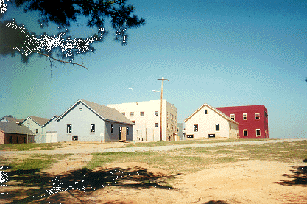

- Figure 5 New Toehold Buildings for the 4th Platoon
1
2
3
3
1st Plt
2nd Plt
OP “M” 3rd Plt
4th Plt
4

- Figure 6 Changed Avenue of Approach for the 4th Platoon
Later in the scenario, during the movement from the landing zone to the ORP, 4th platoon are required to move out of a gully (see Figure 7) into the open ground between the wooded area and the toehold building (see Figure 5). The two scouts at the front observe an unexpected obstacle in the open ground, which, for the purposes of this thread, we will assume is a double layer of concertina wire. The platoon leader is alerted to the presence of the obstacle and needs to decide what to do.

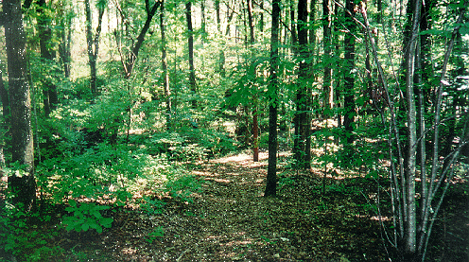

- Figure 7 Gully on 4th Platoon's Approach from where Obstacle is Observed
The PDA can give the platoon leader a number of possibilities, such as the following. Which are applicable will depend on the obstacle and the situation.
This table shows what the possibilities are for dealing a general obstacle:

Option | Selection Criteria | Evaluation Criteria
Bypass obstacle by moving around it | - Platoon must maintain cover and concealment  - No enemy positions set up | - Mission proceeds as planned.  - Increased risk.
Breach obstacle using  organic assets | - Platoon must hold the appropriate assets to breach the obstacle | - Small delay.  - Does not disrupt other units.  - May require replanning of main mission due to delay.
Breach using assets to be assigned from another friendly unit | - Requires other friendly units with appropriate equipment nearby. | - Moderate delay for 4th plt and the unit giving assistance.  - Uses up valuable assets.  - May require replanning of main mission due to delay.
Retreat and enter target using new avenue of approach | - New avenue of approach is available. | - Significant delay.  - May require replanning of main mission due to delay.
Stay in position. | - Remaining forces can complete the mission. | - Increased risk of mission failure due to depleted forces.

Some of these options will not apply to specific obstacles. For example, for a rockslide in a deep valley, bypass may not be an option, and organic assets may not be powerful enough to break through. For the various obstacles we have identified, various options are possible. For each option, we list whether the assets required are likely to be organic to a platoon and whether or not the operation will stay covert if this option is chosen:

Obstacle | Options | Organic? | Covert?
Minefield | - Bypass  - Use plough  - Use flail  - Breach and stride with tank | Yes  No  No  No | Yes  No  No  No
Concertina wire | - Bypass  - Cut through  - Destroy with satchel charges  - Destroy with Bangalore torpedoes  - Call for engineers | Yes  Yes  Maybe  Maybe  Maybe | Yes  Yes  No  No  Maybe
Abatis | - Bypass  - Break through  - Destroy with explosives  - Call for engineers | Yes  Yes  No  Maybe | Yes  Maybe  No  Maybe
Rockslide | - Bypass  - Make passage through  - Destroy with explosives  - Call for engineers | Yes  Yes  Maybe  Maybe | Yes  Maybe  No  Maybe
Locked door | - Use alternative entry point  - Use RLIM  - Force entry manually  - Destroy with explosives | Yes  Maybe  Yes  Maybe | Yes  No  No  No
Barriers | - Bypass  - Go over the top  - Destroy with satchel charges  - Destroy with Bangalore torpedoes  - Call for engineers | Yes  Yes  Maybe  Maybe  Maybe | Yes  Yes  No  No  Maybe
Flash flood | - Bypass  - Wade through  - Construct bridge  - Call for engineers | Yes  Yes  No  Maybe | Yes  Yes  Yes  Maybe

In this particular case, the leader of 4th platoon has to deal with concertina wire in the open space between the gully and the toehold building. The 4th platoon has no Bangalore torpedoes, but 2nd platoon does. Therefore the options are as follows:

- Bypass concertina wire by going around – risk of this being covered by OPFOR or running into a minefield. Mission remains covert.
- Cut through concertina wire – this is bad since it channels 4th platoon into a single line as they pass through. Mission remains covert.
- Try to destroy wire with organic satchel charges – risk is that these may be insufficiently powerful to destroy the wire. Not covert – see below.
- Ask for Bangalore torpedoes to be assigned from 2nd platoon – risk is that these may be required later by 2nd platoon itself. Not covert – see below.
- Choose new avenue of approach for target building – risk is that this will take too long and the operation will lose the cover of darkness.

In the case of charges or Bangalore torpedoes being used, the covert phase of the mission will cease when these are used. Therefore, if either of these options are taken, the plan as a whole must be updated so that the destuction of the concertina wire is taken as the first non-covert action. The overall action involving the company commander and all 4 platoons must be coordinated so that every unit involved knows what is going to happen. This could be done automatically by the PDA, since it knows what changes have taken place to the overall plan.

PDA Thread 2 - Platoon Pinned Down by Snipers during the Assault
Characteristics: the second thread is designed to show the military benefits of a PDA in a close combat situation. It differs significantly from the first thread due to the tempo and constraints of combat. Specifically, the time pressure on decisions is increased and the ability to seek assistance from other friendly units is reduced due to their own contact with the enemy.

Situation: the 1st Platoon element of the assault force has secured its toehold within Building 34 and is ready for its assault on the church. Alpha Squad is providing cover fire with the Platoon's M60s about 50m from the west entrance of Building 34. Bravo Squad is occupying Building 34 and is ready to provide covering fire. Charlie Squad is in Building 34 and is about to pass through Bravo Squad and onto the Church. The plan is for Charlie Squad to exit the building by breaching the wall in line with the door to the Church. The Squad will have to cover around 10m of open land between the breach point and the church. 1st Platoon's leader is inside Building 34 with Charlie Squad.

2nd Platoon is ready in Building 31 for its assault on Building 32 and 4th Platoon is waiting on the far side of the minefield by Building 43. The assault force is waiting for the Company Commander's order. 3rd Platoon (Recon.) has reported that the OPFOR has shown no sign of detecting the imminent assault. The positions occupied by friendly forces are shown Figure 8.
1
2
3
3
1st Plt
2nd Plt
OP “M” 3rd Plt
4th Plt
4

- Figure 8 Friendly Forces Positions

On order from the Company Commander the three Platoons of the assault force move forward as planned. In 1st Platoon, Charlie Squad blows the predetermined wall and begins rushing across the open ground to the Church. The first two solders through the breach are taken down with accurate small arms fire to the head. Seconds latter accurate small arms fire to the south wall of Building 31 takes down a member of Bravo Squad exposed by a window.

1st Platoons response (based on its battle drill) is as follows. Alpha Squad lays down suppressing fire with M60s on the locations it believes the snipers to be firing from (Buildings 41 and 46). Fire on Building 41 is difficult as Building 32 is between the guns and 41. Bravo Squad also lays down covering fire on the locations it believes the snipers to be firing from (again Buildings 41 and 46). The Platoon's medic is attending to the wounded member of Bravo Squad inside Building 34. Charlie Squad has tossed smoke grandees into the open ground between Building 34 and the Church and is requesting permission to move their fallen comrades to cover. The medic reports that the wounded member of Bravo Platoon has a severe pelvic arterial bleed and is in immediate need of a Medical Evacuation.

The fields of fire open to the snipers are shown here. Figure 9shows Sniper One's view of Building 34 and Figure 10 shows Sniper Two's. The Snipers can lay down fire on three sides of the building. Only Sniper One can place effective fire on the open space between the building at the Church.

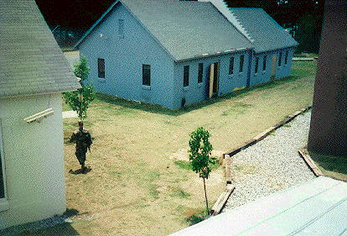

- Figure 9 Sniper One's Field of Fire on Building 34

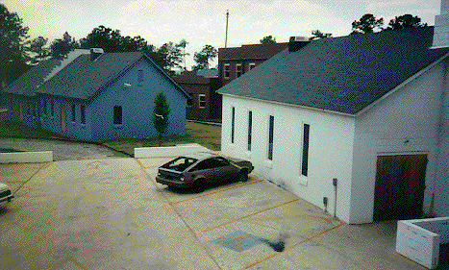

- Figure 10 Sniper Two's Field of Fire on Building 34
1st Platoon is awaiting its Platoon leader's decision.
The leader of 1st Platoon has the following information:
- 2nd Platoon is operating between 10 and 20m north of his position in Buildings 31 and 32. He can here them advancing and firing. He can not determine the level of resistance they are encountering
- 4th Platoon is operating around 200 to 100m East of his position in Buildings 41, 42 and 43. He cannot determine if they are firing as 2nd Platoon is drowning out noise form that distance.
- Two members of Charlie Squad are lying in open ground between his position and the Church. From the impact of the sniper rounds and the way the soldiers fell, he assumes that they are dead.
- One member of Bravo Squad is critically wounded and needs an immediate Medical Evacuation. He will quickly bleed to death, and with a pelvic arterial bleed there is no way to stop the bleeding without surgery.
- His platoon is receiving well-aimed fire from concealed positions of three sides.
- Suppressing fire is being laid by his platoon on the believed locations of the Sniper(s)

The following information is not available to 1st Platoon's leader.

- His Platoon's M60 fire is not suppressing Snipe One as Building 32 is shielding the Sniper's position in building 41.
- Sniper One will not be isolated quickly in the assault by second platoon due to construction of building 41 making it difficult to get to the top floor where the sniper is held up.
- 4th Platoon has changed their avenue of approach so building 46 is now open for indirect fire.
Both snipers are using passive night viewing aids. They have positioned active sets to confuse the attacking force about their position and therefore draw fire away from themselves.

The following options are open to the Leader of 1st Platoon.

Option | Selection Criteria | Evaluation Criteria
Fight through with smoke to conceal movement. | - Rate of enemy fire in the area to be crossed must be low. | - Mission proceeds (almost) as planned.  - Increased risk of friendly casualties.  - Little collateral damage.
Call indirect fires onto the Snipers' locations. | - Proximity of self and other friendly units to the target.  - Collateral Damage  - Time to gain access to inorganic indirect fire assets. | - Casualties OK.  - Collateral Damage Warning.  - Fratricide Warning.
Call upon other friendly units of assistants. | - Immediate availability of other friendly units.  - Time to get permission to call upon a friendly unit. | - Other friendly unit's freedom to manoeuvre on the enemy relative that of own unit.  - Importance of other friendly unit's current task.  - Elapsed time before other friendly unit can offer assistance.
Withdraw from the Battlefield | - Require permission or  - Unit is in immediate danger of being destroyed. | - Unit free from danger  - Friendly position on the battlefield is lost.

The following notes on the MOUT were taken during the SME meeting with David Miller and Ken Sharpe at SAIC during June 1999.

- In most situations the reaction to a sniper would be to through smoke and fight through. However, this is only practical when the rate of fire is low. If a "big gun" is deployed in a confined area, it is almost impossible to pass through its field of fire even with smoke deployed.
- The "smoke and run" response to the sniper has a serious consequence. The sniper will pose a threat during the consolidation and reorganisation phase. This could be handled in a number of ways. First, the sniper could be aggressively suppressed as before through AFSS etc. The advantage of the consolidation and reorganisation phase is the friendly forces will have much more time available to handle the sniper or move to a safe location for the sniper to be attacked with indirect fires. Other options include the re-routing of the exfiltration operation to avoid the sniper's line of fire or the movement of the exfilitration rally point. The first option may be difficult if there are large numbers of wounded. The second option is dangerous as the new rally point will take time to establish and secure. If it is in an area not previously secured, there is a real danger that OPFOR may have ran into the area during the assault.

Halt An Attack In Restrictive Terrain
The other SUO SAS scenario that was chosen for the PDA work is Operation Golden Manacle (see at EA Iron and EA Steel.). This is a battalion-sized defensive operation to halt a mechanized enemy attack in restrictive terrain. The operation consists of sending SUO forces to place obstacles on the terrain which will force the enemy to move into an area where they can be attacked with remote fires. The battalion consists of three companies: two are sent forward to prepare obstacles and lay ambushes, the other prepares the main ambush in the rear at EA Iron and EA Steel.

- Figure 11 Halt an Attack in Restrictive Terrain

We have studied the OPORDs for this scenario and similar comments apply about the potential for deliberative planning, replanning and plan repair. The commander will dispatch forces to conduct recon, lay obstacles and prepare the kill zone and during the mission, the current plan and future plan may change as discussed above.

Ken Sharpe (SAIC) described the following planning process for this scenario:

- The areas through which the enemy forces can move are identified. These are labelled as either: go, slow-go, or no-go.
- The enemy's doctrinal template is used to predict how the he will move in the situation at hand.
- Friendly forces then determine which corridors of movement they wish to deny the enemy. This usually effected through the erection of obstacles.
- Areas where friendly forces wish to detect the enemy's movement are labelled as "named areas of interest". Areas where friendly forces wish to engage the enemy are labelled as "target areas of interest".

Following a review of the SUO/PDA project with Dr. Mark McHenry on 16th June 1999, it was felt that the halt an Attack scenario provided a better opportunity than MOUT to demonstrate the potential of a PDA of utility to the soldier in Small Unit Operations. It is currently thought that this scenario will provide the PDA with better opportunities to demonstrate plan adjustment and coordination between friendly units. This is due to the larger number of platoons involved and the amount of coordination required to prepare a successful ambush, adjusting the effort where necessary to pose the most effective threat to the enemy forces. It is also felt that planning for the use of sensors will be of more utility in the halt and Attack scenario, and that such sensor use is an area where a PDA could provide good assistance to the soldier.

SRI International has lead on scenario and domain modelling for the Halt an Attack scenario. The plan is to work as quickly as possible to get to a similar stage, with respect to this scenario, that we are now at with MOUT.

Domain Models

Introduction
This section describes the development in the second phase of the project of the action model presented in the first phase report (Tate et al, 1999 pp 27-41). The models were enriched with knowledge gained from the May 1999 meeting with the SMEs at Fort Benning, GA, then encoded using an IDEF-3 style presentation and Polyak's Common Domain Editor for tool support. Experiments were then carried out to determine that the models could be represented and reasoned with in the O-Plan system. This section is structured around these two phases with the IDEF-3 style models presented before the O-Plan encoding experimentation. We introduce first the overall domain modelling strategy for the MOUT scenario.

Modeling Strategy
The modelling strategy is presented in Figure 12. We have produced a shallow encoding of the entire MOUT operation. By "shallow", we mean that we have represented only in an abstract way the operations involved. This ensures that we can quickly represent the breadth of actions used in the whole operation. The shallow encoding has been more fully developed in two areas to represent the low-tempo obstacle thread and the high-temp sniper thread. This deepening supports experimentation with O-Plan's capability to not only represent but also reason with the actions in the MOUT operation.

Overall Operation
PreparationsInfiltrateMarchRecognisance Assault Consolidation
Low-tempo thread
High-tempo thread

- Figure 12: Phase 2 Modelling Strategy
In the following sections we describe in detail the deepening of the model and show screen shots of the resultant demonstration. We also give details on how the reader can access the demonstration over the World Wide Web.

Representing the Threads
The process of a platoon preparing for and executing a mission and the sniper thread are described in the IDEF-3 style below.

Platoon Preparation and Execution Process
The IDEF3 diagram describing the overall platoon preparation and execution process is shown in Figure 13. The decomposition of this process is shown in Figure 14. This second figure shows the main constituent activities of this process. Figure 15 through Figure 20 present the Unit of Behaviour Elaboration Documents for each of the activities shown in Figure 14.

Mission Execution at Platoon Level
¹

Figure 13: Mission Execution

Preparations at Base
^{1.1.1}
Flight from Base to Landing Zone
^{1.1.2}
March from Landing Zone to Target
^{1.1.3}
Commander Reconn-aissance
^{1.1.4}
Assault Phase
^{1.1.5}
Consolidation and Reorganisation
^{1.1.6}

Figure 14: high level description of mission execution

UOB Name | Preparations at Base
UOB Number | 1.1.1
Objects
Selection Criteria | Always include.
Conditions and Effects | Unit understands the layout of the objective, the terrain surrounding the objective, and how the assault will proceed.
Description | A minimum map recon is completed to determine avenues of approach, noting any potential obstacles. The platoon will rehearse their operation verbally and maybe physically. The commander will make sure that his troops know exactly what they are doing and what other friendly forces around them will be doing. The commander will allocate chalks, to maximise the distribution of skills and equipment in case a helicopter is lost.
- Figure 15: Unit of Behaviour Elaboration document for Preparations at Base

UOB Name | Flight from Base to Landing Zone
UOB Number | 1.1.2
Objects
Selection Criteria
Conditions and Effects | Unit is briefed on the operation and equipment has been obtained.
Description | It is possible that something could go wrong during this phase and a plan adjustment initiated. For example, a helicopter may develop a fault shortly into the flight and be forced to return to base. Upon landing, the force will be reconstituted quickly and move from the landing zone.
- Figure 16 Unit of Behaviour Elaboration Document for Flight from Base to Landing Zone

UOB Name | March from Landing Zone to Target
UOB Number | 1.1.3
Objects
Selection Criteria
Conditions and Effects
Description | The platoon will march in a well-defined pattern to the target. The march will end with the setting up of an ORP close to the target.
- Figure 17 Unit of Behaviour Elaboration Document for March From Landing Zone to Target

UOB Name | Commanders' Reconnaissance
UOB Number | 1.1.4
Objects
Selection Criteria
Conditions and Effects
Description | The Platoon Leaders, Company Commander and Squad Leaders will move around the target. Information gained at this phase may change the assault plan.
- Figure 18 Unit of Behaviour Elaboration Document for the Commanders' Reconnaissance

UOB Name | Assault Phase
UOB Number | 1.1.5
Objects
Selection Criteria
Conditions and Effects
Description
- Figure 19: Unit of Behaviour Elaboration Document for the Assault Phase

UOB Name | Consolidation and Reorganisation
UOB Number | 1.1.6
Objects
Selection Criteria
Conditions and Effects
Description | Hostages and surviving OPFOR will be secured. The hand over of prisoners and hostages requires careful co-ordination
- Figure 20: Unit of Behaviour Elaboration Document for the Secure and Exfiltration phase.

Sniper Thread
In the sniper thread, there are three methods available for suppressing a sniper. The Unit of Behaviour Elaboration Document for each method is shown in Figure 21 to Figure 23.

UOB Name | Suppress Sniper with Indirect Fires from AFSS
UOB Number | 2.2.1
Objects
Selection Criteria | Friendly forces are not in the building with the sniper and no friendly forces plan to enter that building. AFSS must be available to the unit. Collateral damage to the building occupied by the sniper must not be prohibited
Conditions and Effects
Description | Unit fires organic an AFSS into the building occupied by the sniper thereby suppressing him.
- Figure 21: Unit of Behaviour elaboration document for suppressing a sniper with indirect fires from AFSS
UOB Name | Suppress Sniper with other Friendly Unit
UOB Number | 2.2.2
Objects
Selection Criteria | Friendly forces must be able to put direct fire on the Snipers location.
Conditions and Effects
Description | Unit collaborates with second friendly unit to suppress sniper with direct fires.
- Figure 22: Unit of Behaviour elaboration document for suppressing a snipe with the aid of another friendly unit

UOB Name | Suppress Sniper with well aimed smoke
UOB Number | 2.2.3
Objects
Selection Criteria | Unit must have smoke grenades. Only effective if sniper does not have visual enhancement capabilities for seeing through smoke.
Conditions and Effects
Description | Unit places smoke to obscure snipers vision.
- Figure 23 Unit of Behaviour Elaboration Document for Suppressing Sniper with Well Aimed Smoke

Documenting the Sniper Thread in CDE
The Sniper thread has been documented in Polyak's Common Domain Editor. The screen shot in Figure 24 shows one of sniper suppression options:

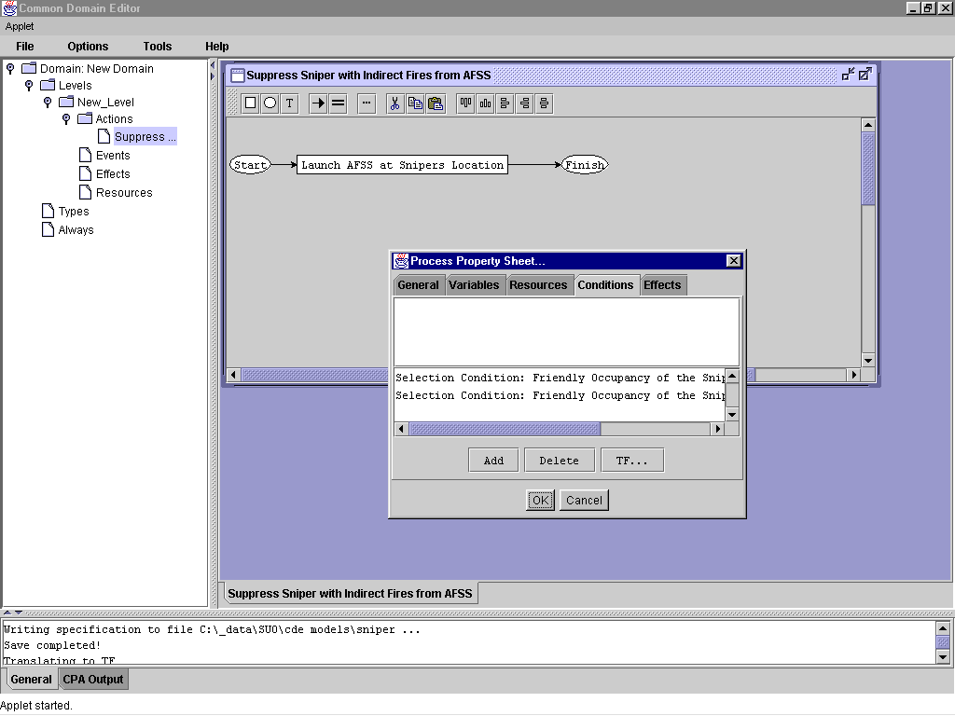
- Figure 24: AFSS Suppression Option in CDE

Encoding the Threads in O-Plan's Task Formalism
The primary focus of this work element has been on prototyping the PDA threads outlined in the previous sections to determine that it is technically feasibility to represent and reason with them in the O-Plan system. This experimentation has included both threads. In this section we describe only the "platoon receiving sniper fire" thread for brevity. Our description is structured as follows. First, we introduce the Task Formalism (TF) representation of the thread. Second, we show the plans synthesized from this representation for a particular situation. Third, we outline the representational issues raised in the last report and identify which have been addressed. We also add the new modeling issues identified during this phase to the issue list. Finally, we present screen shots of the O-Plan demonstrator created during this phase.

Encoding the Pinned Platoon thread in O-Plan TF
The first stage of the encoding, shown in Figure 25, captures the entities within the scenario and their relationships. Considering an example from the Types element, 1st_Platoon is stated as being of the type Platoon. The squads, buildings, and snipers in the scenario are specified in the same format. Relationships between entities are captured in the Always element. The first squads_in statement specifies that teams Alpha through Charlie are in 1st platoon. The line_of_fire_from statements specify the direct fire relationships between buildings. For example, it is possible to fire directly from Building31 to Building32.

Types
Platoon = (1st_Platoon
…
4th_Platoon),
Squad = (Team_A_1st_Platoon
…
Team_C_1st_Platoon),
Building = (Building31
…
Building46),
Sniper = (Sniper1
Sniper2);
Always
{squads_in 1st_platoon} = {Team_A_1st_Platoon
Team_B_1st_Platoon
Team_C_1st_Platoon},
{line_of_fire_from Building31 to Building32},
{line_of_fire_from Building31 to Building33},
{line_of_fire_from Building31 to Building34};

- Figure 25: Types and Always facts

Determining the direct line of fire relationships is a modeling issue raised below. It is argued there that it will be possible to construct this information from a tool such as Sextant VPT.

The second stage of the encoding captures the tasks that the Leader of 1st Platoon in the thread wishes to achieve together with the state of the world at that moment. The encoding of this information is shown in Figure 26. The nodes element captures the tasks. In this case: suppression of Sniper1, suppression of Sniper2, and assault on Building33. The orderings element states that the suppression elements must be completed before the assault on Building33 commences.

task PDA_thread_2;
nodes
1 start,
2 finish,
3 action {suppress Sniper1 1st_Platoon},
4 action {suppress Sniper2 1st_Platoon},
5 action {clear_under_suppressed_sniper_fire Building33
Team_C_1st_Platoon Team_B_1st_Platoon};
orderings
1 ---> 3, 1 ---> 4, 3 --->5, 4--->5, 5--->2;
effects
{historic_interest Building33} = valuable at 1,
…
{friendly_occupancy Building31} = actual at 1,
{friendly_occupancy Building32} = planned at 1,
…
{location_of Sniper1} = Building32 at 1,
{location_of Sniper2} = Building46 at 1,
…
{location_of Team_A_1st_Platoon} = Cover_Positions_Building34 at
1,
{location_of 2nd_Platoon} = Building31 at 1,
…
{status_AFSS 1st_Platoon} = available at 1,
{status_TACAir 1st_Platoon} = available at 1;
end_Task;
- Figure 26: Task definition for suppressing snipers to clear a building
The effects element specifies the state of the world in which the platoon leader wants to achieve the tasks. These facts would come both from the platoon leader and from the battlespace information held within the SAS. The effects capture a number of facts. First, the historic_interest clause captures the fact that Building33 (the Church) is of historic interest. The friendly_occupancy clauses shows which buildings friendly forces currently occupy or plan to occupy in the near future. The location_of clauses state the current locations of the snipers and other friendly units. The final two effects state that the Advanced Fires Support System (AFSS) and Tactical Air Support is available to 1st Platoon.

The third stage of the encoding is the methods that describe how to achieve the tasks set by the platoon leader. Each is augmented with the selection criteria that determine the situation in which they can be used. The first of these methods is shown in Figure 27. This method uses the AFSS to destroy the building occupied by a sniper. The only_use_if statements encode the situation in which this form of suppression can be used. In the case of the AFSS, it may only be used when friendly forces are not in the building with the sniper and the building is not of historic or culture significance. The AFSS must also be available to the platoon. The historic and cultural significance selection criteria are not currently encoded in this method. Please see the issues at the end for an explanation for their absence.

schema Suppress_Sniper_with_Indirect_Fires_AFSS_Option;
vars
?the_sniper = ?{type Sniper},
?sniper_location = ?{type Building},
?unit = ?{type Platoon};
expands
{suppress ?the_sniper ?unit};
nodes
1 action {lauch_AFSS_at ?sniper_location ?unit};
conditions
only_use_if {friendly_occupancy ?sniper_location} = not_planned,
only_use_if {status_AFSS ?unit} = available;
end_schema;
- Figure 27: Method of Suppressing a Sniper with AFSS
Figure 28 shows the method of using another friendly unit for suppressing a sniper's fire. This method can only be used if the second friendly unit is in a position where it can put direct fire onto the sniper's position. This selection criteria is again encoded as an only_use_if statement.

schema Suppress_Sniper_with_other_friendly_unit;
vars
…
expands
{suppress ?the_sniper ?unit};
nodes
1 action {lay_suppressing_fire ?sniper_location ?friendly_unit};
conditions
only_use_if {can_fire_from ?friendly_unit_location to
?sniper_location};
end_schema;
- Figure 28: Method for suppressing a sniper through another friendly unit
The final method shown in Figure 29 suppresses a sniper's fire with well-aimed smoke. This method is applicable in any situation and therefore does not have selection criteria attached.

schema Suppress_Sniper_with_well_aimed_smoke;
vars
…
expands
{suppress ?the_sniper ?unit};
nodes
1 action {lay_accurate_smoke ?sniper_location ?unit};
end_schema;
- Figure 29: Method for suppressing a Sniper with well aimed smoke
With the encoding of the tasks for suppressing sniper fire and the methods for achieving them introduced, the next section outlines the courses of action synthesized by the O-Plan system.

Planning
The current implementation filters inapplicable methods through the selection criteria attached to methods and returns to the platoon leader courses of action that both achieve the tasks he set and are appropriate in the current situation. The following table lists the courses of action (COA) synthesized by O-Plan in response to the task and world state specified in Figure 26.

Course of Action | Task | Action
COA1 | Suppress Sniper 1 | Suppressing fire from 2nd Platoon
 | Suppress Sniper 2 | AFSS
COA2 | Suppress Sniper 1 | Accurate smoke from 1st Platoon
 | Suppress Sniper 2 | AFSS
COA3 | Suppress Sniper 1 | Accurate smoke from 1st Platoon
 | Suppress Sniper 2 | Tactical Air Strike
COA4 | Suppress Sniper 1 | Accurate smoke from 1st Platoon
 | Suppress Sniper 2 | Accurate Smoke from 1st Platoon
COA5 | Suppress Sniper 1 | Suppressing fire from 2nd Platoon
 | Suppress Sniper 2 | Tactical Air Strike
COA6 | Suppress Sniper 1 | Suppressing fire from 2nd Platoon
 | Suppress Sniper 2 | Accurate Smoke from 1st Platoon

In summary, O-Plan has not suggested the use of indirect fires on Sniper 1 as that sniper is located in a building soon to be occupied by friendly forces. Similarly, suppression with another friendly unit (2nd Platoon in this case) is only suggested for Sniper 1 as Sniper 2's position is outside of the influence of direct fires from any friendly unit.

Modeling Issues
In this section we outline progress in Phase 2 on addressing the modelling issues stated in the Phase 1 report (page 40) and and outline the new modelling issues identified in Phase 2. We conclude with a full list of modelling issues at the end of Phase2.

Progress on issues from the phase 1 report
- Dynamic aggregation: the knowledge acquisition performed in Phase 2 leads us to believe that this will not become a serious issue for PDA. O-Plan TF enables elements to be assigned and reassigned to units dynamically. Reasoning problems only occur when methods are needed that iterate over these dynamic structures. From the exploratory encoding completed to date, it does not appear that this will be necessary in PDA. Further experimentation is needed to confirm this; hence, the new issues raised in the following section.
- Branches: while O-Plan cannot synthesize plans that contain branches, it does support the definition of distinct methods for achieving a task and the reasoning capabilities to select the methods appropriate for a situation. Branches are not then explicitly recorded in the plan, but are instead synthesized as the situation dictates.
- Loops: reasoning about repeating actions is an open research issue within the AI planning community. It is unlikely that SUO will provide time to address this issue any further. Repeating actions will have to be represented as a single aggregated "repeat until action".

Issues raised during phase 2
- Linking from TF to other systems: Two items in the sniper scenario motivate this issue. The first was the need to determine the set of buildings that could be fired upon from a given building in order to complete the "line_of_fire_from ?building to ?building" facts. The second was the need to minimize collateral damage on the church. In the first case, O-Plan needs to be interfaced to a system capable of returning line of fire information between points or buildings. In the second case, O-Plan needs to be interfaced to a system capable of returning the set of buildings that will be affected by a weapon system hitting a given location. It is possible this could be determined dynamically using another tool (e.g. ModSAF, Sextant VPT) rather than building this information into the domain mode. Such a capability would enable O-Plan to determine if firing an AFSS rocket at a given building will damage the church unacceptably. O-Plan computer conditions are a likely implementation mechanism for this.
- Iteration in O-Plan: The iteration constructs in O-Plan have been used in previous applications of the system. This issue is simply to note that no experimentation has been done within them within SUO. It is raised to ensure that some experimentation in this area is done early in phase 3.

Resultant modelling issues
No | Significance | Status | Description | Responsible
1 | Medium | OK | Reasoning over groups of objects | P Jarvis and J Dalton
2 | High | OK | Dealing with changes in the anticipated world state, also known as branches | P Jarvis
3 | Low | Not Addressable | Repeating actions until a situation occurs | P Jarvis
4 | High | To be considered | Linking with other tools from TF to provide information via compute conditions | P Jarvis and J Dalton
5 | High | To be considered | Experimentation with O-Plan "iterate" and "for each" as the required constructs in SUO | P Jarvis and J Dalton

Phase 2 Demonstration
The Phase 2 MOUT demonstrator in available over the World Wide Web at the following URL: http://www.aiai.ed.ac.uk/~oplan/web-demo/any-tf-matrix.html. Select the "SUO Thread 2" domain from the opening menu and enter "test match" as the password.

In this demonstration, O-Plan can be run in one of two "authority modes". Each mode is discussed in turn below:

"Ask User" mode
In this mode, the planning system pauses at each decision point, presents the options applicable in the current situation (note, it has filtered the inapplicable options), and asks the user to make a selection. The choice of options for suppressing the first sniper is shown in Figure 30. Only two options are presented: suppress with other friendly unit or suppress with smoke. Options such as AFSS strikes have been discounted as Sniper one is in a building where other friendly units are either located or plan to be located. At this point the user can selects the option he or she prefers.

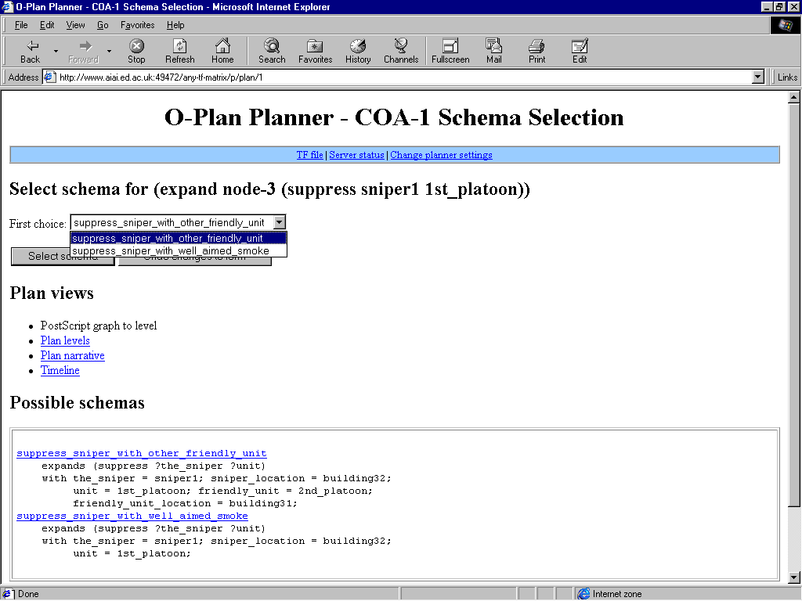

- Figure 30: Options for suppressing the first sniper

The options for suppressing the second sniper are shown in Figure 31. A different set of options is available in this situation as the sniper is in a relatively isolated area that enables AFSS and TacAir to be deployed.

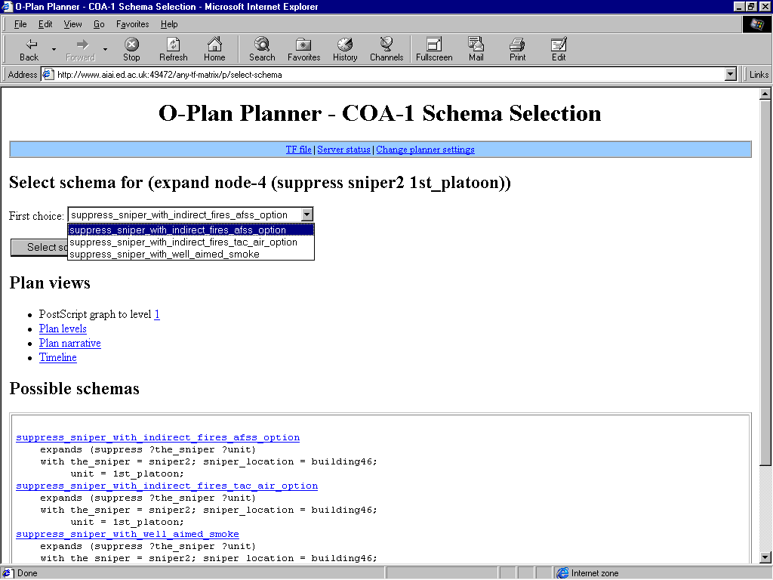

- Figure 31: Options for suppressing the second sniper.
In summary, in the "ask user" mode the planner will guide a user through the planning decision to be made. At each decision point, the user will be presented only with the options applicable in the current situation. In applicable options will be filtered by the planner.

"Automatic" mode
In automatic mode, the planner generates each of the courses of action applicable in the current situation and returns them in a course of action comparison matrix like the one shown in Figure 32. Plan evaluation criteria are listed in the middle part of the left-hand column. These criteria can be used to evaluate and then rank the courses of action. Typical evaluation criteria might be collateral damage, risk to own combat power, enemy attrition rate, etc. After evaluation, the user is presented with a table of ranked courses of action. This enables the user to quickly determine the trade-offs between each course (little risk to own combat power but high collateral damage for example) and select one.

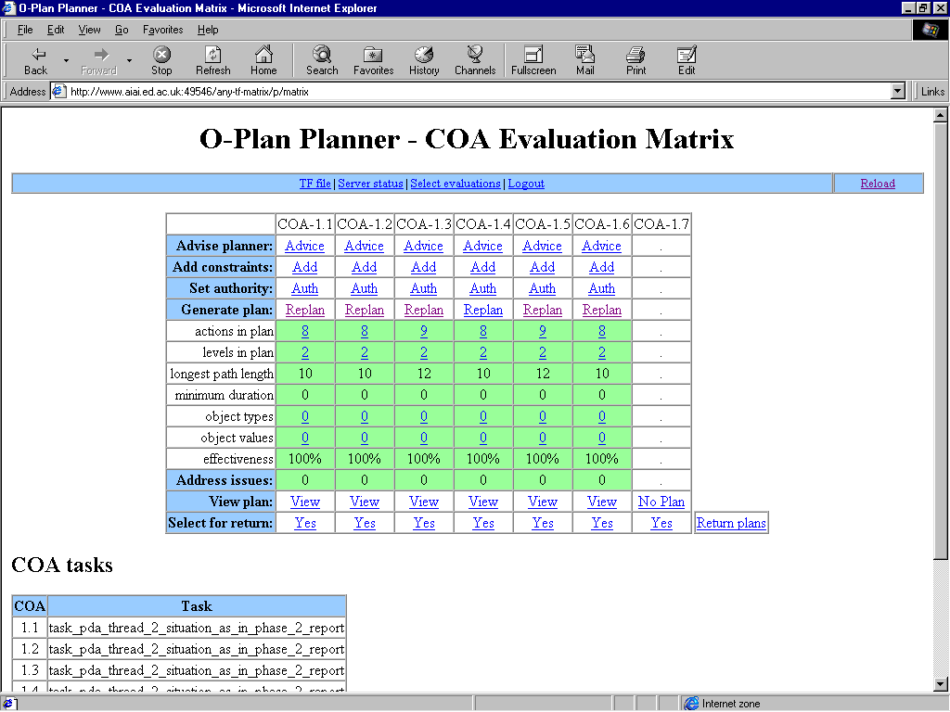

- Figure 32: automatic generation of the 6 COAs open in the demonstration scenario

Outline of SUO-PDA System

Overall Architecture
During discussions between AIAI and SRI International on the feasibility of using AI planning concepts, techniques and systems to address the nominated scenarios for US Army Small Unit Operations, an initial conceptual approach was sketched. An earlier version was presented in the Phase 1 report. An amended version reflecting the current approach is presented here. In particular this reflects a demonstration of suport to planning and execution at 3 echelons rather than the 2 originally proposed.

The planning demonstration provides support to three levels (echelons) of planning and execution. This shows the relationships getween any one level and its superior and subordinate echelons. The particular focus is likely to be on planning, execution and plan repair support at the Company, Platoon and Fire Team level as that is the level at which the SUO program is focussed. This also complements other work on applying planning systems a higher echelons (Battalion and above) such as in the ARPI and HPKB Programs.

The aim is to demonstrate an approach to domain modelling and information capture which is scaleable and could address the need to maintain the domain knowledge of standard operating procedures (SOP), tactics techniques and procedures (TTP), etc., in a machine manipulable format sharable between humans and systems. This is shown in the figure below. The resulting domain models and activity/process descriptions will be able to be used by planning and execution suport systems at an appropriate level/echelon.
Process Modelling
Methods
& Tools
Modeller or
Knowledge
Engineer
Army CALL Bulletins
Doctrine, SOP, TTP
Subject Matter Experts

Domain Model
Activity
Templates &
Constraints

- Figure 33: SUO-PDA Architecture Part 1

A planning and execution system at one echelon (labelled “Echelon N” – say at Platoon Level) would take as input an OPORD (or later related FRAGOs) from a higher echelon level (labelled “Echelon N-1”) to give its requirements or task description and constraints. This system would make use of the process and information in the domain model repository to refine these plans, to consider options for performing the required task, etc. In doing this it would interface to any of a number of planning-related modules relevant to the specific issues being considered at this level of planning and execution support. It would pass on guidance, plans and constraints to units at lower echelons (labelled “Echelon N+1”) as required. It would also provide required reporting to upper echelons, in particular to indicate task completion, or to seek variances required, etc. In response to reports coming back from lower echelons it would respond by modifying plans as needed, or by reporting issues that needed to be dealt with by higher echelons.
Echelon N
Planning &
Execution
System
Other Modules
Echelon N
Planning
Related
Modules
OPORD
FRAGO
Reports
Echelon N+1
Planning &
Execution
System
Other Modules
Echelon N+1
Planning
Related
Modules
OPORD
FRAGO
Reports
Platoon Level
Fire Team Level

Domain Model
Activity
Templates &
Constraints
Echelon N-1
Planning &
Execution
System
Echelon N-1
Planning
Related
Modules
Company Level

- Figure 34: SUO-PDA Architecture Part 2

The planning and execution system at the next level (labelled “Echelon N+1”) would perform similar functions but would deal with a different level of model of the domain, and involve different, more detailed, planning-related modules.

Different Planners at Different Echelons, or for Different Phases?
Another possibility that is suggested by the domain knowledge being gained from the MOUT scenario is that we do reconsider the use of different planners at different echelon levels as is reflected in the architectural approach diagrams. We could instead use an overall process support framework for all phases of the mission from receipt of orders through planning, rehearsal, deployment, employment and egress. Within this overall process framework, a single planner and execution support system could support all three levels (company, platoon and squad) for some phases (say the preparation of plans and mission rehearsal). Specialized planners could then be used for some phases of the mission. For example, a separate planner could be used for the "attack" phase of the overall process, and this could be distinct from the planner used during the preparation and training phase. One would take the output of the first planner and move it to the SUO/SAS device for execution support - and expect different styles of support at that stage – such an not having the heavier-weight planning-related modules accessible.

Technical Preparation
During Phases 1 and 2, a number of steps were taken to prepare for the main demonstration-creation phase of the project. Since it was likely there would be a need for plan execution-monitoring and plan repair technologies in the demonstration, the O-Plan modules that provide those functions have been reactivated and new web-based interfaces designed and implemented to support decision-making during plan repair. Improved ways for a user to guide planning have been incorporated into the O-Plan web demonstrations, and more flexible ways to develop demonstrations in new domains, while using the COA Evaluation Matrix web interfaces, have been developed.

Steps taken during phase 1 were reported in the Phase 1 report. The next sections report on the preparatory steps taken in phase 2.

Plan Execution and Repair Technology
The SUO-PDA demonstration system is likely to use plan execution and repair technology that was part of earlier versions of O-Plan [Drabble et. al., 1997] and that has been reactivated and made part of the current system. The demonstration is also likely to use our existing Web-browser based interface to O-Plan running as an HTTP server [Tate et. al, 1998].

Web Interfaces
We have continued the development of our Web-browser COA Evaluation Matrix interface to O-Plan.

The interface is now implemented in a more thoroughly object-oriented fashion that makes it possible to "plug in" elements tailored to particular domains. Each interface class can define its own methods for such things as the production of the HTML form that allows the user to specify the planning task, or the list of "views" available when the user wishes to examine a plan. The plug-in facility has also been used to provide a generic interface that can be used with any domain that has been defined for O-Plan in the task Formalism (TF) language; and this has allowed us to experiment with a number of SUO-related planning problems. Support for plan execution and repair is provided via "mix-in classes" that can be added to the definition of
an interface class, and we have begun the development of both HTML and Java-based panels that would handle user interaction during that process.

The matrix interface allows plans to be developed in a mixed-initiative fashion. Certain decisions can be made by the user, when more than one choice is available, or O-Plan can be given the authority to make them automatically. In earlier versions of the interface, the user was able to select the best "schema" used when an action was introduced into the plan, thus determining how the action should be performed. In the current system, the user can also select the preferred objects from among the candidates for the value of a variable in the plan. For instance, the user could indicate that helicopters of one type were preferable to those of another from some particular task, or that it's better to use the 1st Platoon rather than the 2nd or 3rd.

The "plan levels" or "expansion tree" view of the plan is now available at these user-decision points, instead of being possible only when planning is finished. (This view shows, in textual form, how the actions in the plan have been broken down into sub-actions and which actions could be further expanded if the planner were to continue.) In addition, a new "timeline" plan view is now available. It takes the form of a table, which can be displayed horizontally or vertically, in which the actions in the plan are grouped into blocks, with the actions within a block able to happen in parallel, and the blocks then listed in chronological order. The timeline could form the basis of a sync-matrix in SUO applications.

We have begun to experiment with XML representations of plans and with style sheets that can be used to convert the XML to other representations such as HTML. In addition to its use for traditional mark-up tasks, XML can also serve as a general-purpose syntactic framework for such things as communication between different applications. A grammar is provided as a DTD, and then any system that contains an XML parser will be able to read the corresponding XML.

Portability and Linux Platforms
A number of internal changes have been made to make it easier to port O-Plan to different implementations of Common Lisp. O-Plan can currently be used with GCL, Allegro Common Lisp, or Liquid Common Lisp on Suns and with GCL on PCs and other machines that are running a suitable version of Unix such as SunOS, FreeBSD, or NetBSD. We are working with several users of O-Plan to add Linux to that list. Both GCL and Allegro Common Lisp are available for Linux, and O-Plan has been used successfully with Allegro on Linux machines. However, there are still some problems that have to be solved before O-Plan can be distributed in a Linux-ready form.

Other Technical Preparation
The TF compiler has been changed to work better with the sorts of domain descriptions that are used with tailored versions of the web-browser matrix interface. These descriptions are often incomplete from the point of view of earlier versions of O-Plan, because the tasks (problem descriptions) are defined interactively by the user rather than being built in.

The compiler has also been changed to provide more information to the user when run as a syntax-checker or verifier, and a web-based interface to this facility has been provided. It can be used to check a domain definition at any specified HTTP URL.

A number of changes have been made to the internal workings of the planner, both to improve performance and to provide more information. The planner is now able to tell the user why each variable in the plan was introduced, which allows the user to make meaningful decisions about what values the variables should have. This information is used in the web-browser matrix interface.

“After-points” for “achieve” conditions have been implemented. These conditions specify optional sub-actions of a parent action that can be introduced to satisfy a condition that it not satisfied in some other way. (For instance if an area must be clear of enemy forces, there may already be an action in the plan that would clear it, or it may be necessary to introduce a new action.) The after-point specifies whether the optional action must be placed within the time boundaries of the parent action or whether it may be placed outside those boundaries, at earlier points in the plan. Formerly, O-Plan provided only the less restrictive rule while other planners typically provide only the more restrictive one. This gave O-Plan the ability to find plans that the more restrictive planners could not but could also make it more expensive to find plans when the ability to introduce the optional action outside the temporal scope of the parent was not needed.

More theoretical work has continued at the same time. In conjunction with Eva Onaindia of the University of Valencia, we've investigated variations in the planning algorithms used in O-Plan and in O-Plan's handling of different types of conditions.

SUO Planning-related Modules Study

Aim
Work during phase 2 continued the study of planning-related modules. This work began in phase 1 and was reported upon in the phase 1 report. These modules were thought to be relevant for integration with an AI planning system in any eventual Planning and Decision Aid incorporated within a SUO Situation Awareness System. It had not proved possible to get information on each module of potential relevance during phase 1 and some contacts only became available late in the phase 1 study period. Hence a number of module studies completed during phase 2 are now reported here.

The table below summarises each module (studied in phase 1 and phase 2, as well as others identified but for which no useful contacts were found or usage information made available. The table gives a number of aspects that we considered in the initial study. The details of the studies which led to productive results are marked “Y” in the “More Detailed Report” column. Y1 shows those reported on in the phase 1 report. Y2 shows those reported on in this report. The “Suitability Rating” gives a subjective numeric measure of how much information is available and the apparent potential for incorporating this module into a demonstration within the time scale of the current project.

The person nominating each package as a potentially relevant planning-related module is shown by their initials as follows:

MM - Dr. Mark McHenry (DARPA SUO Program Manager)
BP - Dr. Barbara Perry (Lockheed Martin)
KS - Mr. Ken Sharpe (SAIC and SUO Program Support)
AT - Prof. Austin Tate (Principal Investigator)
MT - Ms. Mary Tamucci (SUO Researcher, Sterling Software)

The modules for which significant information was available during phase 2 are described in the following subsections. Two were suggested by Mary Tamucci of Sterling Software during discussions concerning other planning related modules. These are the Joint Mapping Toolkit (JMTK) and the Battle Command System (BCS). Also during discussions concerning other modules provided by Lockheed Martin, Barbara Perry suggested that we explore JointSAF as an alternative to the previously nominated ModSAF.

 | Nominated by | Contact Available | System Available | Platforms | Open API/Interfacing | AI System Links | Interest Shown | MOUT Scenario | Halt Attack Scenario | More Detailed Report | Suitability Rating
Object Raku Sextant VPT  Plan Visualization | MM | Y | Y | PC | Y | Y | Y | Y | N | Y1 | 9
STRICOM ModSAF  Simulation, COA Analysis | KS | Y | Y | Unix | Y | Y | Y | Y | N | Y1 | 5
STRICOM JointSAF Simulation, COA Analysis | BP | Y | Y | Unix | Y | Y | Y | Y | N | Y2 | 6
Lockheed Martin ADST II  Terrain Reasoner | KS | Y |  |  |  |  | N |  |  |  | 1
Sterling ASAS/Rasputin  Blue/Red Force Laydown | KS | Y |  |  |  |  | N |  |  |  | 1
Mitre  Fire Control Support | KS | N |  |  |  |  |  |  |  |  | 0
Sterling Software  Sensor Laydown | KS | Y |  |  |  |  | N |  |  |  | 1
Sterling Software Intell. Preparation of Battlefield | KS | Y |  |  |  |  | N |  |  |  | 1
?  CSS Movement Planner | KS | N |  |  |  |  |  |  |  |  | 0
?  Air Movement Planner | KS | N |  |  |  |  |  |  |  |  | 0
DARPA HPKB Program  Plan Sketch Tool/ArcView | AT | Y | Y | PC, Mac, Unix | Y | Y | Y | N | N | Y1 | 7
JMTK Joint Mapping Toolkit | MT | Y | Y | PC, Unix? | Y |  | N | N | N | Y2 | 3
Sterling BCS Battle Command System | MT | Y | ? | PC, Unix? | Y |  | N | N | N | Y2 | 2

JointSAF

Description
JointSAF is a further development of ModSAF to include High level Architecture (HLA) standards compliance and to improve functionality and efficiency.

A Full description of ModSAF appears in the Phase 1 report and is valid for JointSAF as well. This short additional section adds new contact information and web resources specific to JointSAF.

Contacts
- Mr. Wing Young, PM ATCCS, Tel: (732) 427-2731, E-mail: wyoung@c3smail.monmouth.army.mil
Army Representative on DII COE Mapping Charting Geodes & Imagery (MCG&I) Technical Working Group. Responsible for communicating JMTK related information to the US Army.
- Paul Bell, Sterling Software, Rt. 26N, Beeches Technical Campus, Rome, NY 13440, Tel: (315) 336-0500; Fax: (315) 336-4455. E-mail: paul_bell@sterling.com
- Cheryl Blake, national Imagery Mapping Agency, mail Stop D-85, 4600 Sangamore Road, Bethesda, MD 20816-5003, Tel: (301) 227-3947; Fax: (301) 227-2988; E-mail: blakec@nima.mil

Availability
JointSAF is available in beta test format from DMSO (http://hla.dmso.mil/hla/).

Web Resources
- http://www.hla.dmso.mil/hla DMSO web site for HLA including access to JointSAF releases (see under “compliance testing” and then “compliant federates”).
- http://www.stricom.army.mil/PRODUCTS/ADSTII/ Advanced Distributed Simulation Technology II contract home page. Lockheed Martin is the prime contractor on this contract and through it.
- http://www.stricom.army.mil/STRICOM/E-DIR/ES/MODSAF provides more information on the ADSTII ModSAF. Susan Rodio is the STRICOM lead on this effort.
- http://stow2000.spawar.navy.mil/ Synthetic Theater Of War (STOW) program includes the effort to extend ModSAF to JointSAF.
- http://stow2000.spawar.navy.mil/STOWFAQ/index.html provided additional information on JointSAF.
- http://ms.ie.orf/cfor/ Command Forces Simulation Web Site.

Comments
Suggestion to look at JointSAF and other information and contacts provided by Barbara Perry at Lockheed Martin.

Joint Mapping Toolkit (JMTK)

Description
JMTK is a collection of Application Program Interfaces (APIs) which enable applications to access mapping and terrain related data.

Role
To provide standard terrain map access and simple terrain reasoning facilities to other applications.

Capabilities for the Planning Process
Its capabilities with respect to planning, in Verb/Noun Phrase format are:

IMPORT, MANAGE, QUERY, RETRIEVE and EXPORT
- Standard NIMA data products
- User or application created data sets

ANALYSE
- Perform terrain analyses on geospatial information exported from the system

VISUALIZE
- Standard national Imagery mapping Agency (NIMA) data products
- Analysis results

CONVERT
- Geocoded conversions, datum transformations and coordinate conversions

Interconnectivity and Shared Models
JMTK support an open API and standard mapping formats.

Relevant Scenarios
It has not been possible to establish whether JMTK has already been applied to the Fort Benning McKenna MOUT Site or to a suitable Halt an Attack in Restrictive Terrain scenario.

Contacts
- Mr. Wing Young, PM ATCCS, Tel: (732) 427-2731, E-mail: wyoung@c3smail.monmouth.army.mil
Army Representative on DII COE Mapping Charting Geodes & Imagery (MCG&I) Technical Working Group. Responsible for communicating JMTK related information to the US Army.
- Paul Bell, Sterling Software, Rt. 26N, Beeches Technical Campus, Rome, NY 13440, Tel: (315) 336-0500; Fax: (315) 336-4455. E-mail: paul_bell@sterling.com
- Cheryl Blake, national Imagery Mapping Agency, mail Stop D-85, 4600 Sangamore Road, Bethesda, MD 20816-5003, Tel: (301) 227-3947; Fax: (301) 227-2988; E-mail: blakec@nima.mil

Machine, OS, and Software Requirements
“Standard Workstations”.

Implementation Languages
Unknown.

Availability
Available via password protected site. Usernames and passwords alocated on request.

Web Resources
- http://www.jmtk.org Joint mapping Toolkit Web Site

Comments
Suggestion to look at JMTK and information provided by Mary Tamucci, Sterling Software.

Battle Command System (BCS)

Description
BCS is an integrated system which allows a range of standard mapping and graphical displays to be visualized, manipulated and shared.

Role
Battalion and below automation to support command, operations and intelligence decision and staff processes.

Capabilities for the Planning Process
Its capabilities with respect to planning, in Verb/Noun Phrase format are:

IMPORT
- Mapping and graphical products from JMTK
- Mapping and graphical products from echelons above Battalion level.

MANIPULATE
- Mapping and graphical products.
- Intelligence data.

COMMUNICATE
- Relevant information to other echelons using low bandwidth

VISUALIZE
- COA Analyses
- Terrain overlays
- Obstacle overlays
- Synchronization matrices
- Blue Situation
- Red Situation
- Common Operating Picture
- Mission planning and rehearsal overlays

Interconnectivity and Shared Models
BCS provides a number of built in interfaces for importing mapping and graphical products. Links to SALUTE reporting is possible via interfaces provided.

Relevant Scenarios
Unknown.

Contacts
- Sterling Software, 1650 Tysons Boulevard, Suite 800, McLean, VA 22102-3915. Tel: (703) 506-0800; Fax: (703) 506-0154.

Machine, OS, and Software Requirements
Unix, Linux, Windows 98 and Windows NT.

Implementation Languages
Unknown.

Availability
May be available for US government purposes. Would probably require Sterlling to be part of the contracting team.

Web Resources
- Only Sterling Software internal web sites are available for BCS.

Comments
Suggestion to look at BCS and information provided by Mary Tamucci, Sterling Software.

Summary

Results of Phase 2
Phase 2 of the project was mainly intended to develop the Small Unit Operations demonstration scenarios in which the contributions of the project could be shown. The work concentrated on the MOUT scenario for which materials were available and for which Subject Matter Expert input was provided. However, as planned, initial work on the Halt an Attack in Restrictive Terrain was also performed. During a review of the scenarios on 16th June 1999, it was determined that the most promising scenario to show the military value of the SUO/PDA was likely to be the Halt and Attack scenario. The MOUT scenario is expected to be used to show the generality and broader applicability of the approach.

Phase 2 also involved the provision of more detailed domain models for SUO operations, deep enough to allow encoding of the domains and tasks to an AI planner to begin. A few example encodings were performed to check the detail was sufficient – though this work is more properly the subject of phase 3 work starting in July 1999.

Phase 2 also saw the completion of initial studies of potential planning related modules to which the SUO/PDA demonstration could be connected.

Technical preparation of O-Plan and related software continued to position the system to be able to meet anticipated requirements arising from the domain modelling and scenario development. The O-Plan web interfaces have been considerably generalised in order to allow the easy plug-in of new domains and task descriptions. The web interfaces can also now support simple plan execution demonstrations – considered an important aspect needed for the SUO work.

Evaluation of the PDA Demonstration

Potential Evaluation Methods
A number of potential methods to evaluate the results of the SUO/PDA project have been discussed during phase 2. They are listed here for further discussion and selection.

- Program value: did the PDA demonstration produce technology relevant to the SUO-SAS program as a whole?

- Technology transfer: was the PDA technology taken up by the SUO-SAS Phase 3 Contractor?

- Evaluation of the military utility of PDA demonstration:
- speed, accuracy, coverage, consistency, facilitates decision making
- use panel of independent judges/critics
- count of “communication acts” of interactions needed and modality required:
- for manual situation with no SAS or PDA
- with SAS only
- with SAS and PDA

Evaluation Methods from the Human Computer Interaction Community
In this section we review the evaluation techniques developed by the Human Computer Interaction (HCI) community to determine their suitability for the SUO PDA system. This review is based on two core texts: Dix et al. (1993) and Preece et al. (1994)

This community's methods are designed to answer three questions:

- Does the system's functionality accord with the users' task requirements?
- Does the user interface work?
- What are the outstanding problems that further development efforts should address?

We introduce the available techniques before discussing which might be suitable for inclusion in the overall SUO PDA evaluation suite.

- Cognitive Walkthrough. An expert in cognitive psychology walks through a system's design identifying problems against psychological criteria. This is comparable to a software engineer walking through code to identify potential problems (divide by zero etc).
- Heuristic Evaluation. This is similar to the cognitive walkthrough method, but it is less structured and demanding on the evaluator. In this approach a set of usability criteria or heuristics is identified and the design examined for when instances of these are violated. For example, system behaviour is predictable, feedback is provided, dialogue is task-oriented, etc.
- Review Based Evaluation. The HCI literature is searched to identify evidence that supports or refutes aspects of a design.
- Model-Based. Uses models to predict user performance with a particular interface. The modeling methods are sophisticated and can predict user performance.
- User evaluation. Users' interactions with a system can be monitored in a number of ways. For example, they can "think aloud" while operating a system or their key strokes and body language (frustration etc) can be recorded and later analyzed. After interacting with a system, users' experiences can be analyzed with interviews and questionnaires.

All three HCI evaluation questions are relevant to the SUO PDA, with the most important being the first for this project. It is essential that the PDA be justified in terms of the support it provides for user decision making. The second question is less important as the focus of our work in on the provision of planning functionality, not the interface through which it is provided. However, it is still important that we consider this issue and provide at least an interface that can feasibly operate in the demanding environment of the battlefield. The results of answering the first two questions will feed into the third.

Evaluating the system's functionality against the users' task requirements is the key contribution offered by the HCI community. This would entail using the model-based method know as task analysis to identify the steps currently taken by soldiers when planning. To do this, we would need to observe military decision-makers in the field to identify the actual steps they take when addressing planning problems. This would need to be followed up with a class-room based questioning session with the individuals observed to verify the observations. The results would show the complexity of current planning decisions in terms of the task structure (particularly the sub-task depth) of current planning practice. It should then be possible to demonstrate how a PDA can reduce this complexity.

The user-interface can be evaluated using both heuristic evaluation and review based evaluation. A brief review of the HCI literature on small hand-held devices should identify evidence of best practice for this medium (e.g. don't use drop down menus, use check boxes, etc). The results could be used to produce a set of heuristics against which the PDA's interface could be evaluated.

Summary of Contributions from SUO/PDA to SUO/SAS Program

Long-term Contributions of PDA to the Soldier

This section lists the potential contributions which an SUO/PDA could offer to those invoilved in Small Unit Operations.

- Shared plan representations cognizant of military principles, doctrine, SOPs and TTPs. Makes possible the following:

- Doctrinally correct plan usable by everyone.

- Fast generation of multiple distinct COAs, including ones the commander may not have considered.

- Support commander creativity through human guidance.

- Uniformly high plan quality, even during high-stress crises.

- Continuous analysis of the plan using multiple metrics.

- Monitor plan execution and respond quickly to events, helping the commander modify the plan appropriately.

- Provide relevant information to other echelons, allowing fast communication while preserving bandwidth.

Of course, the automated tools will not be used when under fire, but can be consulted when there is a chance to think about options. This could eventually allow tighter co-ordination between units (especially at the platoon level) than current doctrine allows.

Technical Contributions by SRI/AIAI to SUO
This section summarizes the technical contributions which the project could make during the SUO/PDA project.

- Contribution to the representation of shared objectives, plans, processes, SOPs and TTPs in SUO.

- Generation of multiple qualitatively distinct alternative COAs dependent upon alternative assumptions and advice about the situation.

- Support for mixed-initiative incremental plan development, manipulation and use.

- Plan repair as situation changes.

- Systems integration framework for modular planning and plan analysis systems.

- Management of planning and execution process - promotion of intelligent process management and workflow concepts.

SUO/PDA Input to the SUO/SAS Program
This section describes the ways in which the SUO/PDA project hopes to input to the SUO/SAS program.

- Aim is to communicate and transfer some of the relevant results of the ARPI/PDA work to SUO.

- To do this by joining in the SUO. Community and understanding its requirements.

- To demonstrate some appropriate and relevant Advanced Planning & Decision Aids Technology.

- To be helpful to the contracting teams.

- AIAI/SRI want to act as a conduit to the work of others where they can see its potential relevance.

Acknowledgements
The O-Plan project is sponsored by the Defence Advanced Research Projects Agency (DARPA) and the U.S. Air Force Research Laboratory (AFRL) under grant number F30602-99-1-0024. Mr. Wayne Bosco at AFRL (Rome) monitors the O-Plan project. Dr. Doug Dyer, Dr. Mark McHenry and Dr. Jim Hendler at DARPA, and Mr. Ken Sharpe of SAIC also guide the project.

We would like to thanks the Subject Matter Experts who assisted us in this study. They are Andy Fowles, Chris Kearns, David Miller of the US Army Dismounted Battlespace Battle Laboratory (DBBL) Fort Benning, Cpt. Dan Ray of the Mounted Maneuver Battlespace Laboratory (MMBL) at Fort Knox and Jim Madden of the Institute of Defense Analyses. Ken Sharpe of SAIC also provided much valuable input as a SME.

The U.S. Government is authorized to reproduce and distribute reprints for governmental purposes notwithstanding any copyright annotation hereon. The views and conclusions contained herein are those of the authors and should not be interpreted as necessarily representing official policies or endorsements, either express or implied, of DARPA, AFRL or the US Government.

References
[Currie and Tate, 1991] Currie, K.W. and Tate, A. (1991) O-Plan: the Open Planning, Artificial Intelligence Vol. 52, pp 49-86, 1991.

[Dix et. al., 1997] Dix, A., Finlay, J., Abowd, G., and Beale, R., 1993, Human Computer Interaction, Prentice Hall.

[Drabble et. al., 1997] Drabble, B., Dalton, J. and Tate, A. (1997) Repairing Plans on the Fly, Proceedings of the NASA Workshop on Planning and Scheduling for Space, Oxnard CA, USA, October 1997.

[Klein 1998] Klein, G. (1998) Sources of Power – How People Make Decisions, MIT Press, 1998.

[Myers, 1996] Myers, K. (1996) Advisable Planning Systems, in Advanced Planning Technology, (ed. Tate, A.), AAAI Press, Menlo Park, CA, 1996.

[Preece et. al., 1994] Preece, J., Rogers, Y., Sharp, H., Benyon, D., Holland, S., and Carey, T., 1994, Human Computer Interaction, Addison-Wesley.

[Reece and Tate, 1994] Reece, G. and Tate, A. (1994) Synthesizing Protection Monitors from Causal Structure, Proceedings of the Second International Conference on AI Planning Systems (AIPS-94), AAAI Press, Chicago, USA, June 1994.

[SPAR Core Group, 1999] SPAR Core Group (eds. Polyak, S. and Tate, A.) (1999) SPAR: Shared Planning and Activity Representation – Request For Comment Version 0.2, 29-Mar-99, http://www.aiai.ed.ac.uk/~arpi/spar

[Tate, 1998] Tate, A. (1998) Roots of SPAR – Shared Planning and Activity Representation, Knowledge Engineering Review, Vol. 13. No. 1, pp. 121-128, Cambridge University Press, March 1998.

[Tate, 1999] Tate, A. (1999) I-X: Technology for Intelligent Agents & Tools, Web Page at http://www.aiai.ed.ac.uk/project/ix, March 1999.

[Tate et. al., 1994a] Tate, A., Drabble, B. and Kirby, R. (1994) O-Plan2: An Architecture for Command, Planning and Control, in Intelligent Scheduling (eds. Fox, M. and Zweben, M.), Morgan Kaufman, 1994

[Tate et. al., 1996] Tate, A., Drabble, B. and Dalton, J. (1996) O-Plan: a Knowledge-Based Planner and its Application to Logistics, in Advanced Planning Technology (ed. Tate, A.), Morgan Kaufman, May 1996.

[Tate et. al., 1998] Tate, A., Dalton, J. and Levine, J. (1998) Generation of Multiple Qualitatively Different Plan, Proceedings of AIPS-98, Pittsburgh
PA, USA, June 1998

[Tate et.al., 1999] Tate, Dalton, J., Levine, J. and Jarvis, P. (1999) Small Unit Operations – Planning & Decision Aids – Phase 1 - Familiarization Study and Domain Models, Report AIAI/O-Plan/99-1, 29 March 1999.

[Wilkins, 1988] Wilkins, D.E. (1988) Practical Planning: Extending the Classical AI Planning Paradigm, Morgan-Kaufmann.

US Army and Related Materials

- FM-105 Staff Organization and Operation, US Army publication. No date of publication.
- The Do-It-Yourself Warning and Operation Order Handbook, Rick Tscherne, Ricks Books, no date of publication.
- Combat Leader's field Guide (11th Edition) J. Gallagher, Stackpole, 1994, Books, USA.
- RB1R13 FTX-1 Platoon Operation Order (Ambush) 4, Feb 1998. OPORD acquired by Austin Tate at Fort Beaning, USA.
- RB1R13 FTX-1 Squad Warning Order (Ambush) 14, May 1998, Acquired by Austin Tate at Fort Benning, USA.
- US Army MDMP Training CD based on FM 101-5, Version 1.1, 1 May 1998
- US Army Brigade Battle Captain Training CD, Vol 1.0, 15 April 1998
- Small Unit Night Fighter's Handbook, No. 96-3, Centre for Army Lessons Learned, March 1996. http://call.army.mil
- Combat Leader's Field Guide by CSM J.J. Gallagher (11th edition), Stackpole Books, Mechanicsburg, PA, 1994
- US Army, The Infantry Rifle Company, FM 7-20, Chapter 2 Command and Control, 14 December 1990, TRADOC Army Doctrine and Training Digital Library (ADTDL) http://www.adtdl.army.mil (select Field Manuals of type Infantry).
- US Army, The Infantry Battalion, FM 7-10, Chapter 2 Command and Control, 6 April 1992, TRADOC Army Doctrine and Training Digital Library (ADTDL) http://www.adtdl.army.mil (select Field Manuals of type Infantry).

Other Potentially Relevant Documents Not Consulted to Date

- FM 7-8 Infantry Rifle Platoon and Squad, 22 April 1992
- FM 101-5-1 Operational Terms and Symbols, October 1985
- FM 71-123 Tactics and Techniques for Combined Arms Hv Forces: Armored Bde, Bn TF, and Co Tm, 30 Sept 1992
- FM 7-70 The Light Inf Platoon/Squad, September 1986
- FM 71-1 The Tank and Mechanized Infantry Company Team, November 1988
- FM 7-7J The Mech Inf Platoon and Squad (Bradley), February 1986
- FM 17-15 Tank Platoon, October 1987
- FM 17-98 The Scout Platoon, October 1987
- FM 34-130 Intelligence Preparation of the Battlefield, 8 June 1994

Modelling Methods Used

- IBM's Business Systems Development Method (BSDM): described in two reports from IBM UK Ltd, titled "Business Mapping Part 1: Entities" and "Business Mapping Part 2: Processes", May 1992.

- IDEF3 process modelling: described in the report "Information Integration for Concurrent Engineering (IICE): IDEF3 Process Description Capture Method Report" by R. Mayer et al, Technical Report AL-TR-1992-0057, Armstrong Laboratory, Wright-Patterson Air Force Base, Ohio, May 1992.

- TF method: described in the paper "TF Method: An Initial framework for Modelling and Analysing Planning Domains" by Austin Tate, Steve Polyak and Peter Jarvis, Workshop on Knowledge Engineering and Acquisition, AIPS-98, Pittsburgh, PA, USA, AAAI Press, 1998.

http://www.aiai.ed.ac.uk/~oplan/cpf
Text in this section was contributed to by David Wilkins of SRI International.

