Small Unit Operations – Planning & Decision Aids

Proposed Demonstration Scenarios

Period of Performance Report Number
December 1998 to March 1999 AIAI/O-Plan/99-1.2

Prepared by Date
Peter Jarvis 29 March 1999
Jeff Dalton
John Levine
Austin Tate

Address for Correspondence
Artificial Intelligence Applications Institute
University of Edinburgh
80 South Bridge Tel: UK (+44) 131 650 2732
Edinburgh EH1 1HN, UK Fax: UK (+44) 131 650 6513

Contact for Technical Issues Contact for Administration and Contracts
Prof. Austin Tate Mr. Kenneth Baird
Technical Director, AIAI Finance and Admin. Manager, AIAI
E-mail: a.tate@ed.ac.uk E-mail: k.j.baird@ed.ac.uk

Status Use and Disclosure of Data - FAR 15.609(a)
Released No Restriction
Contents
1.0 Introduction 3
2.0 Demonstration Scenarios Synopsis 3
2.1 Introduction 3
2.2 MOUT Operation San Roberto 4
2.3 Defensive Operation in Restrictive Terrain 9
3.0 Acknowledgements 10

Introduction
The O-Plan Transition Project aims to transfer O-Plan concepts, techniques and technology into productive use. It is doing this by engaging in a number of studies or demonstrators with DARPA and AFRL Programs. The main effort in 1999 is directed towards support to the soldier in US Army Small Unit Operations.

This report describes two potential demonstration scenarios nominated by Mr. Ken Sharpe of SAIC, acting on behalf of Dr. Mark McHenry, the SUO Program Manager at DARPA. The two scenarios were chosen since they had suitable support materials available to help brief AIAI project members, and because they were felt to offer a suitable base to explore the potential of AI planning methods in SUO.

Demonstration Scenarios Synopsis

Introduction
Four scenarios have been prepared within the DARPO Small Unit Operations (SUO) Situation Awareness System (SAS) program to test the technologies developed on the program in a varied range of terrain and combat conditions. Two of these scenarios will be used to demonstrate the Planning and Decision Aids (PDA) component of the program:

- Military Operation in Urban Terrain (MOUT) Operation San Roberto (OSR) succeeds "Operation Quick Strike" that has secured an airhead in the country of Southland. The objective of OSR is to neutralize a number of enemy observers located in village who are directing artillery fire on to the airport secured in "Operation Quick Strike" and to free civilian hostages with n the village. OSR has been designed to test the SUO Situation Awareness System (SAS) technologies in the context of a Military Operation in Urban Terrain (MOUT) scenario.
- Defensive Operation (Scenario 3) Restrictive Terrain has been sketched by Ken Sharpe to AIAI in December 1998. The essence of the operation is the blocking of enemy forces in restrictive terrain.

This section provides a brief synopsis of these operations and pointers to the detailed descriptions held on the Small Unit Operation web site. Each synopsis begins with pointers to these source documents before describing the world situation, general situation, special situation and concept of operations.

MOUT Operation San Roberto

Source Documents
Documents detailing this operation are available from the SUO Web site at: ftp://suoteam@dtsn.darpa.mil/suo/Technical_Papers/SUO_CONOPS/MAPEX_Files/Scenario_2/

These documents include:
- SUO_MOUT_Document.doc: textual description of the world situation in which the operation is to be performed and a description of the operation itself.
- SUO_DD.ppt: maps of the overall area in which the operation will take place.
- mck23Jun.ppt: Annotated maps depicting the movement of forces during the operation.
- Matrix2.ppt: Synchronization matrix describing the order in which the major activities of the operation will be execution.
- moutgrid.xls: Mapping of scenario entities (buildings, landing zones) to grid locations.
- OPFOREV.xls: Instruction to individuals taking the role of the opposition force in the scenario.
- MOUT_Annex_A-LOI.doc: Letter of instruction detailing how the scenario will be conducted.

World Situation
The Islamic fundamentalist regime in Algeria has invaded neighbouring Morocco. The U.S. has committed a significant force to assist Morocco to repel the invasion. Taking advantage of the United States' focus on North Africa, both North Korea and Iraq began to act bellicosely. Exacerbating the situation was a coup d'etat in Southland. The coup caused strong reaction in the Organization of American States, which looked to the United States to provide both political and military leadership in restoring the democracy of Southland. Reacting to international pressure, the President of the United States reluctantly agreed to commit a small U.S. force to Southland with the proviso that other South American countries would send follow-on forces to assist in the operation.

General Situation
Southland is a small and impoverished South American nation. It neighbours are Navoto to the West and La Cinda to the East. The Navato government maintains proper relations with the United States and is desirous of US enhanced economic aid but is reluctant to permit any significant US presence in the Country. La Cinda has a weak government which has been corrupted by the forces leading the coup de'etat in Southland.

Special Situation
23 March 2003
The JTF 780 using Army Airborne and Marine SUO SAS infantry seized a regional airfield in Southland. The airhead was quickly secured with minimal US casualties. This operation was named "Operation Quick Strike."

Souhtlandian forces fled the battlefield into the adjacent mountains and neighbouring villages of El McKenna and Jolon. El McKenna, located approximately five kilometres east of the Airfield, is the local administration centre and has approximately 20 buildings. The principal buildings include the town hall, a small regional hospital and San Roberto. San Roberto is a Franciscan mission dating to the 17th Century and it has great historic and culture significance. The remainder of the village is composed of small commercial buildings and dwellings.

During the afternoon of the 23 March, the airfield is struck sporadically by artillery fire. Crater analysis reveals that the airfield is being targeted from a number of directions by artillery of varied calibre’s. Aerial reconnaissance is unable to locate the attack platforms. However, surveillance of El McKenna and Jolon indicates no signs of the local civilian populations and some indication that Southlandian forces are occupying the villages.

24 March 2003
Intercepts of messages from the leader of the opposing force in the village of El McKenna indicate the following situation:

- Enemy force consists of 17 solders. Two are lightly wounded and in the hospital along with two other soldiers who are guarding five hospitalized El McKenna natives, and 15 civilian hospital staff.
- Remaining inhabitants are gathered in the local church.
- Enemy command post is in the town hall.
- The enemy will continue to direct fire onto the airfield.
- The enemy has supplies to remain in the village for seven to ten days. If attacked, the enemy will draw on reinforcements from Jolon.

As a result of this intelligence, US forces have been tasked to neutralize the air field threat so that coalition forces can be brought in as soon as possible to relieve US forces. The President also directs that there be no civilian casualties, no damage to any significant historical, cultural, or religious site, and the damage to other property be minimized.

El McKenna - 24 1400L
OPFOR OCCUPATION
Bldg. J1
OP 2 (1)
Bldg. N
CHURCH
3 + 1 in OP 4
~ 30 Civilians
Bldg. J2
HOSPITAL
2/FLOOR (4)
~ 20 Civilians
Bldg. L
TOWN HALL
OPFOR CP (3)
SECURITY (3)
1
2
3
Bldg. Aa
OP 3 (1)
4
Bldg. Ha
OP 1 (1)
Ha
J2
L
J1
N
Aa
MINEFIELD
TUNNEL
COMPLEX
MANHOLE
OPFOR OP

- Figure 1: Village of El McKenna

Concept of Operations
The Marine Ground Combat Element, 1/8 Marines will use one company, Alpha Company, augmented with four robots and robot operations and reinforced by an airborne infantry platoon, 1/A/1-504th Inf (ABN), to neutralize Objective San Roberto.

Alpha Company has the mission of occupying the village of El McKenna. The airborne infantry platoon will monitor and interdict the OPFOR light infantry platoon occupying Jolin and the mechanized company located in the vicinity of King City.

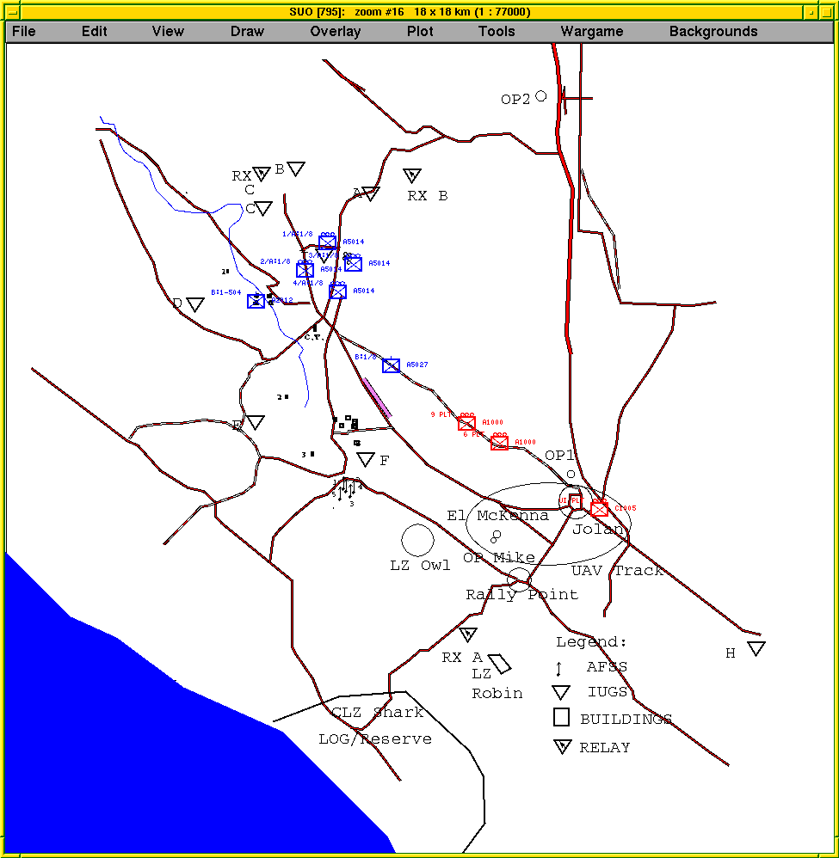

- Figure 2: Area Surrounding the Village of El McKenna

The concept of operations is described here (El McKenna village buildings have code letters such a Aa, J, N, etc. on operations maps for the scenario):

- At H-10:30 Team A 3rd Platoon will land at LZ OWL. Its mission is to move to OBSERVATION POINT MIKE and conduct a detailed reconnaissance of OBJECTIVE SAN ROBERTO. Specifically, it will locate all enemy observation/ listing posts, identify all buildings as occupied or unoccupied, and identify the location of personnel in Mission San Roberto, El McKenna Regional Hospital, and the town hall. It will then assist 4th Platoon in evacuating non-combatants.

- At H-4 the ground assault element consisting of the 4th platoon and Team B 3rd platoon will land at LZ ROBIN. They will move to POSITION TOM. At H hour the ground assault element will conduct a three-phase operation.
- Assault and secure OBJECTIVE WEASEL (Building Aa) from the south east.
- Assault OBJECTIVE FERRET (Building N, San Roberto)
- Clear the southern half of OBJECTIVE SAN ROBERTO

- At H-4 the 1st Platoon will air land at LZ OWN, move to POSITION JERRY, and on order, assault OBJECTIVE FOX (Building J - El McKenna Regional Hospital) and clear the north west quadrant of OBJECTIVE SAN ROBERTO.

- At H-4, the 2nd Platoon will air land at LZ OWL, move to POSITION JERRY, an on order, assault OBJECTIVE COYOTE (Building L - town hall) and clear the north east quadrant of OBJECTIVE SAN ROBERTO.

- Team A, First Platoon, Alpha Company, 1-504 Infantry move into OBSERVATION POINT ONE (OP1) by vehicle and foot NLT H1-12 to observe and interdict OPFOR forces in Jolon.

- Team B, First Platoon, Alpha Company, 1-504 Infantry fly to LZ SPARROW and move into OBSERVATION POINT TWO (OP2) by foot NLT H1-12 to observe and interdict OPFOR mechanized forces coming from vicinity of King City.

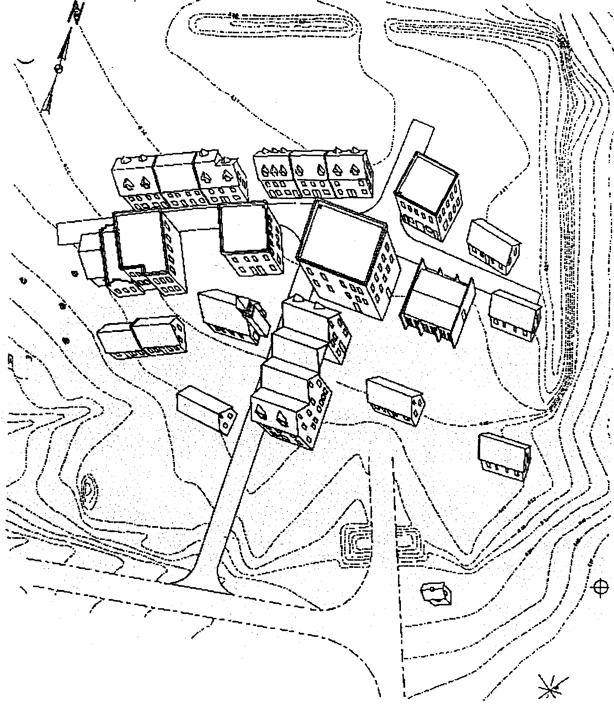
1
2
3
2
1
3
1st
Plt
2nd
Plt
OP “M” 3rd
Plt
4th
Plt
TOWN HALL
NEUTRALIZE
OPFOR
CHURCH
TAKE OUT OP4
FREE CIVILIANS
2
HOSPITAL
FREE CIVILIANS
1
3
BLUE SNIPER
TEAMS
MINEFIELD
TUNNEL
COMPLEX
MANHOLE
OPFOR OP
OPFOR KIA
4
D-II-4

- Figure 3: Operation San Roberto - Execution Phase

Defensive Operation in Restrictive Terrain

Source Documents
This description is based on the briefing given by Ken Sharpe at AIAI during the 15th, 16th and 17th December 1998.

World Situation
Unknown

General Situation
Unknown

Special Situation
Unknown

Concept of Operation
Opposition forces are expected to advance through an area. Friendly forces are ordered to intercept this advance. The terrain is composed of two passes through raised ground. Opposition forces are expected to move from the top of the figure at Phase Line One and advance down the figure along the paths.
It is anticipated that the opposition forces will use both pathways through the raised ground. Upon exiting the raised ground, the opposition forces have a choice of routes. It is anticipated that they will take the central route. The actual route taken by the opposition forces will be known by the time that these forces reach phase line two.
Phase
Line
One
Phase
Line
Two
Restrictive Terrain - Marsh?

- Figure 4: Defensive Operation in Restrictive Terrain

This operation will use two platoons. Friendly forces are positioned on top of the raised ground and the central path in squad groupings (rectangle with two dots in the figure). These positions are expected to allow fire to be put down upon the advancing opposition forces. The two units not positioned on high ground offer the flexibility to move to the path on the right of the figure in the event of opposition forces taking this route.

Acknowledgements
The O-Plan project is sponsored by the Defence Advanced Research Projects Agency (DARPA) and the U.S. Air Force Research Laboratory (AFRL) under grant number F30602-99-1-0024. Mr. Wayne Bosco at AFRL (Rome) monitors the O-Plan project. Dr. Doug Dyer, Dr. Mark McHenry and Dr. Jim Hendler at DARPA, and Mr. Ken Sharpe of SAIC also guide the project. The U.S. Government is authorized to reproduce and distribute reprints for governmental purposes notwithstanding any copyright annotation hereon. The views and conclusions contained herein are those of the authors and should not be interpreted as necessarily representing official policies or endorsements, either express or implied, of DARPA, AFRL or the US Government.

Operation Quick Strike itself will not be considered by the planning decision aids component of the program.

