Kemlo & Krillie – The ISS Emergency
Posted on September 7, 2025 by bat
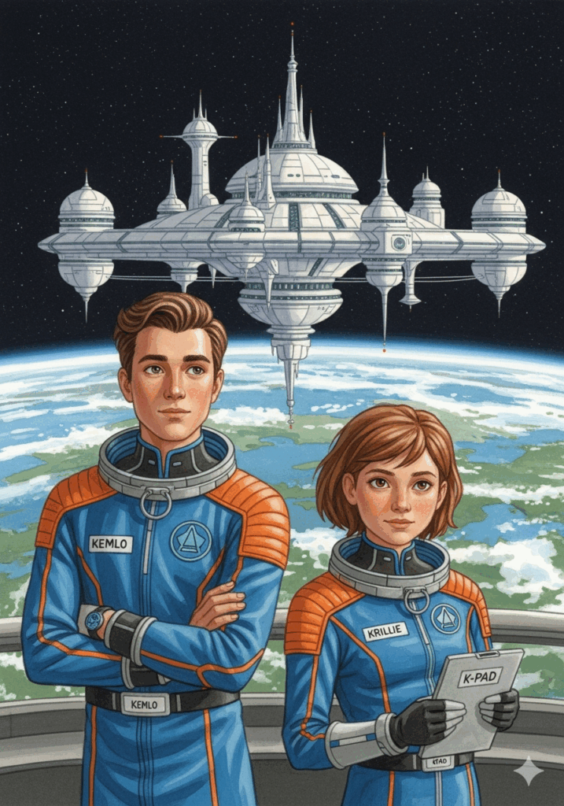
This is Storybook 3 in “The Further Adventures of Kemlo & Krillie in Space” series. It is produced using Google Gemini Storybooks AI App which lets you create a customized picture book, for either children or adults, given a topic, an optional target audience age, and an optional art style for the images.
Prompt: Use the background given in the attached document to write a storybook for a teenager target audience about the Further Adventures of Kemlo and Krillie who are teenagers who live on Satellite Belt K in Earth Orbit. Keep the character appearance and name badge label and position on clothing consistent with the attached image. Kemlo and Krillie head out from Satellite Belt K on a mission to check on the condition and status of the International Space Station which is still in Earth orbit and which has been designated as an “Offworld Heritage Site”. The site has become a popular anchor location for nearby orbital vacation homes. As they approach the ISS, it is clear that something is terribly wrong. A large section of one of the solar panels has become almost entirely detached and is hanging by loose cables. This will pose a very serious risk to the surrounding space vacation homes as well as risking much higher levels of damage to the ISS itself. Time is short and Kemlo and Krillie call upon the other Space Scouts on Belt K to come and assist using the “Gravity Rays” on their small spaceships to help repair the ISS temporarily until engineers can be sent to effect a full repair. Include some images of the ISS and the spacecraft in its vicinity during the initial inspection and in the work by the Space Scouts to effect the temporary repair. Include a final image of the engineering team’s larger repair spacecraft approaching the ISS.
The storybook uses background created previously using AI tools based on the Kemlo Spaceworld series of books by E.C. Eliott published in 1954 to 1963. It uses images and PDF of the contents of this blog post: https://blog.inf.ed.ac.uk/atate/2024/02/19/kemlo-and-krillie/
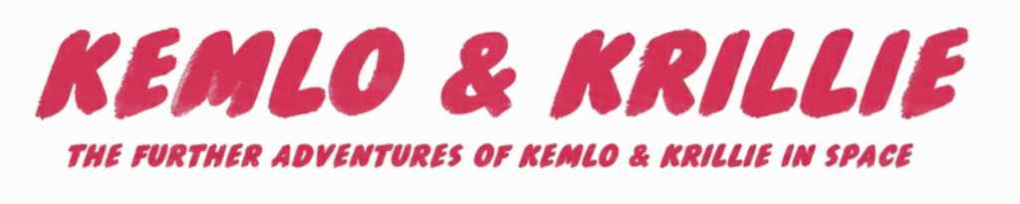
The Storybook produced is available at: https://g.co/gemini/share/dfc5a957adb8 or PDF Format
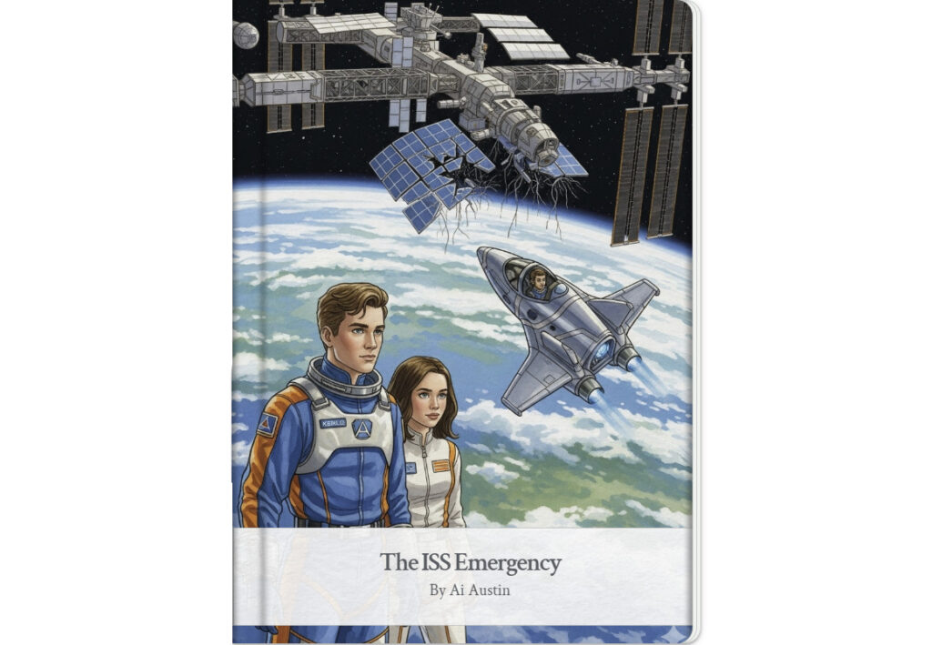
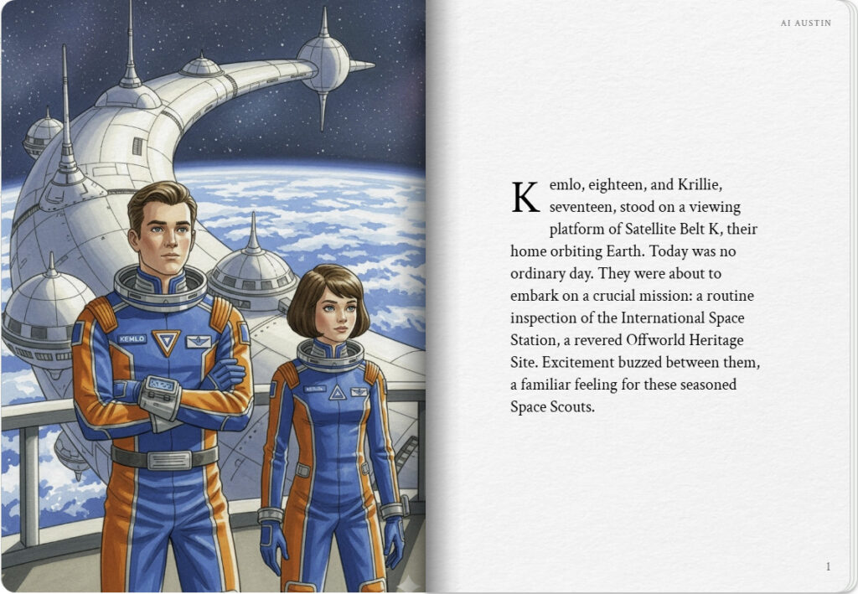
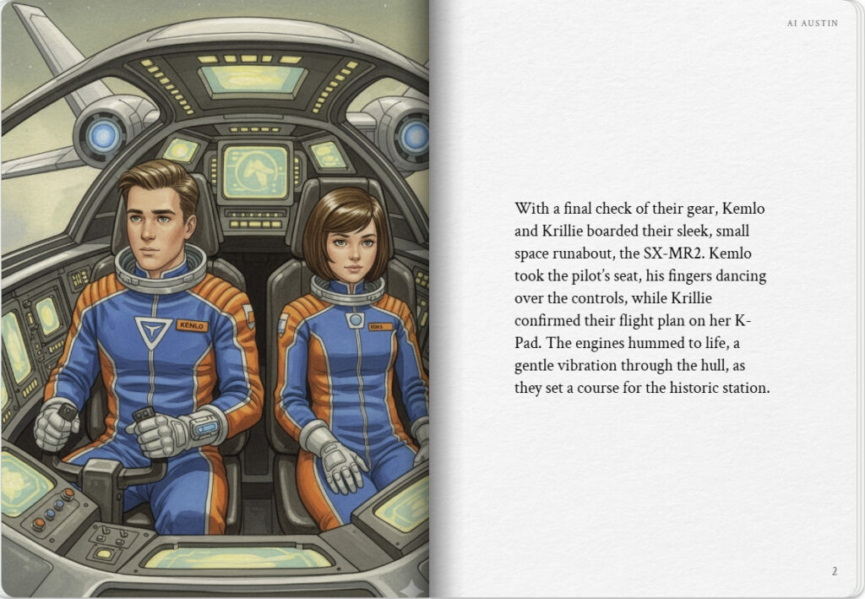

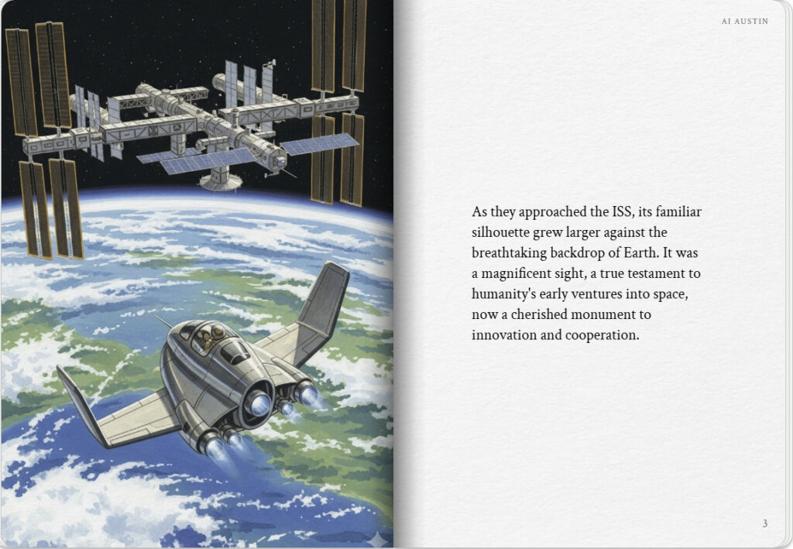
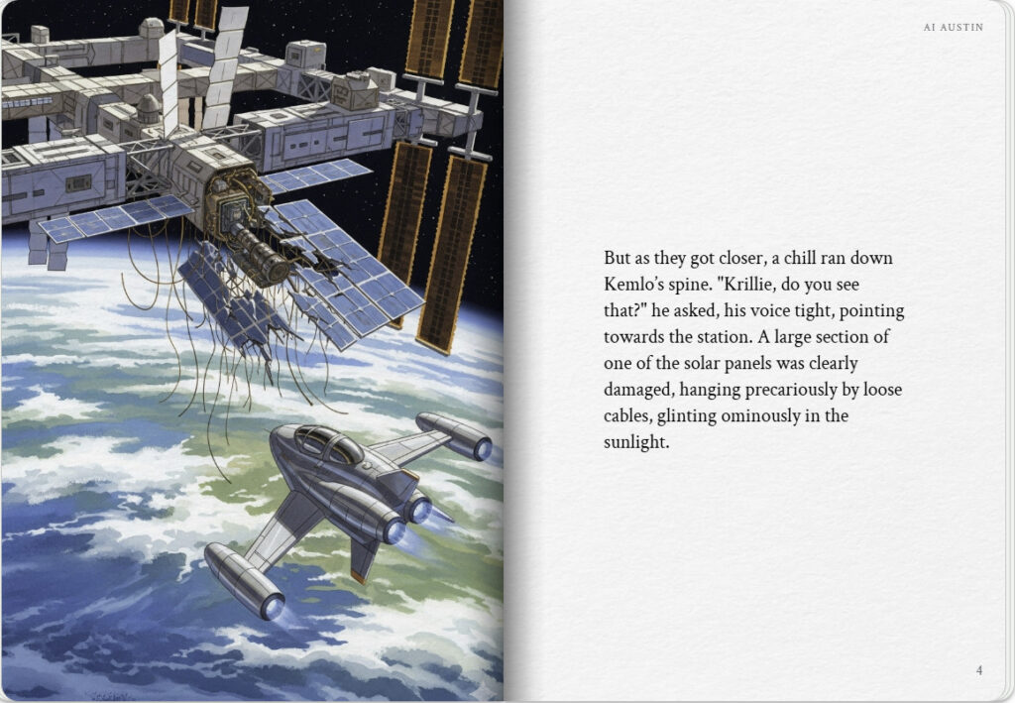

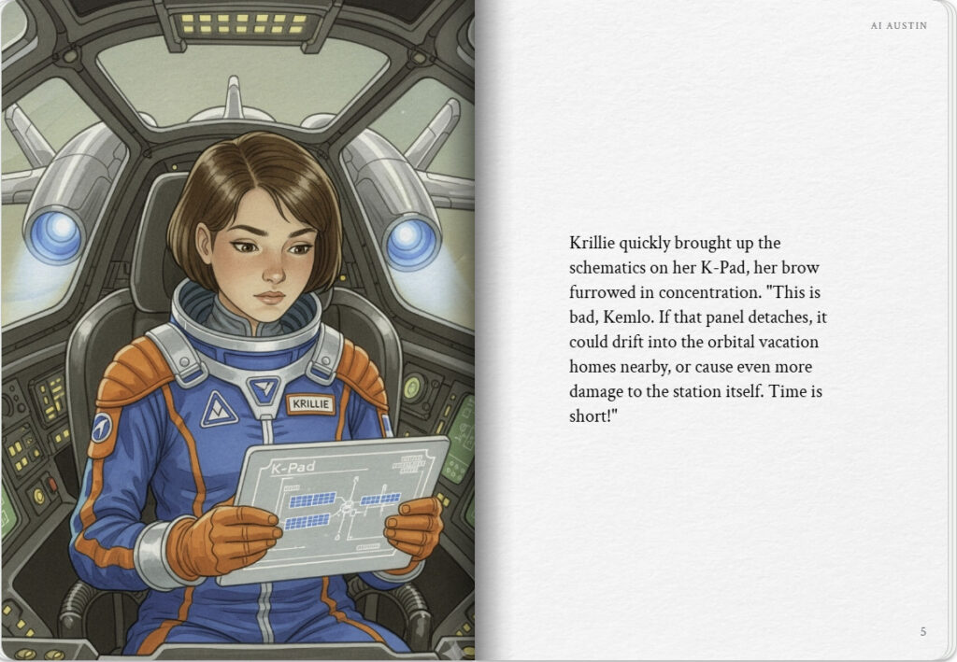
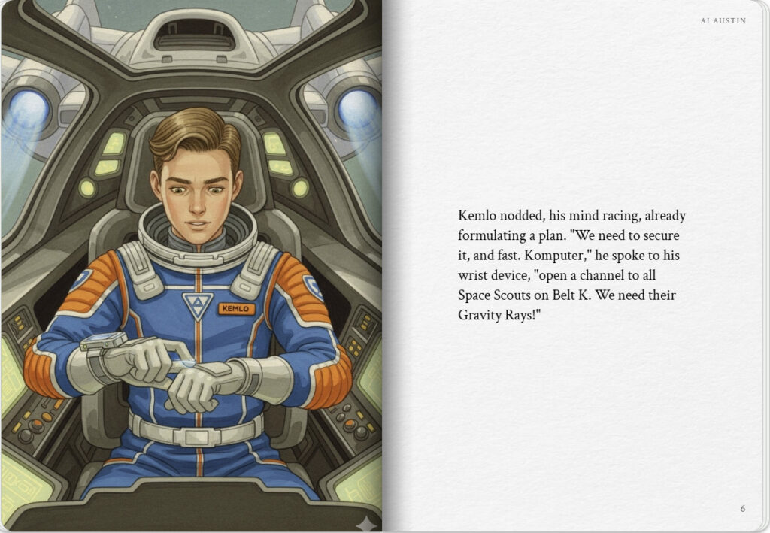

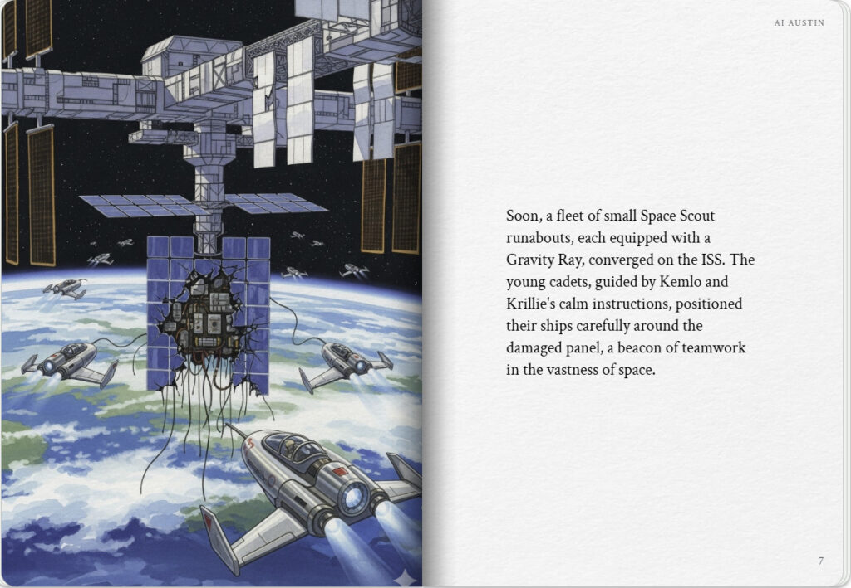
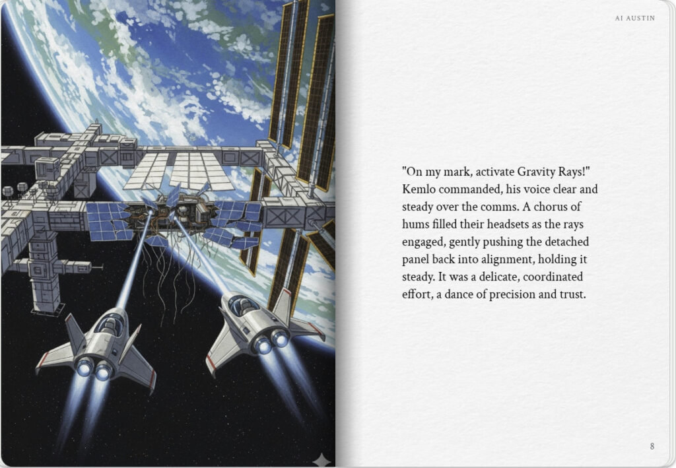

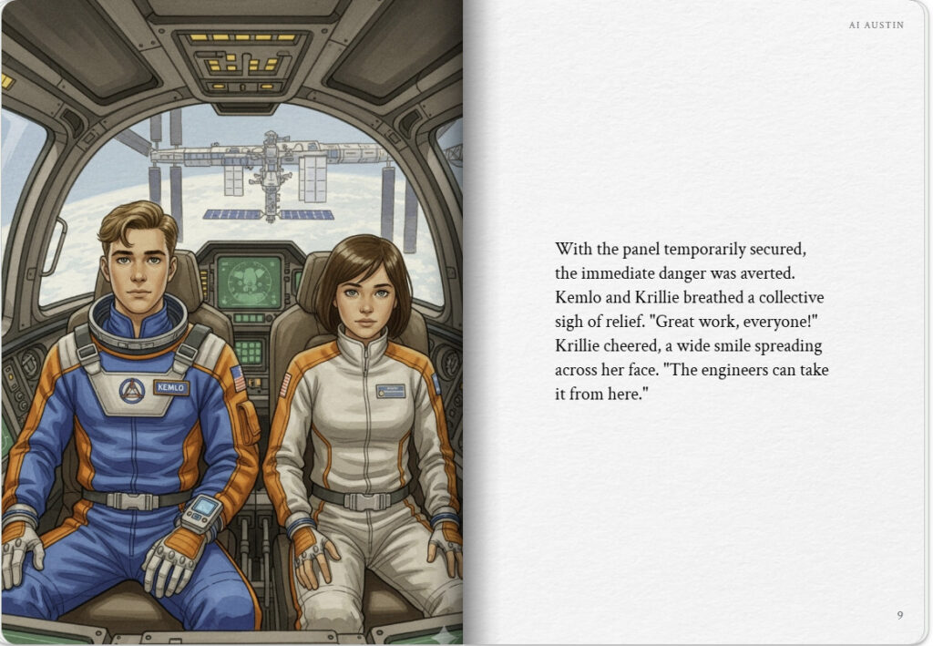
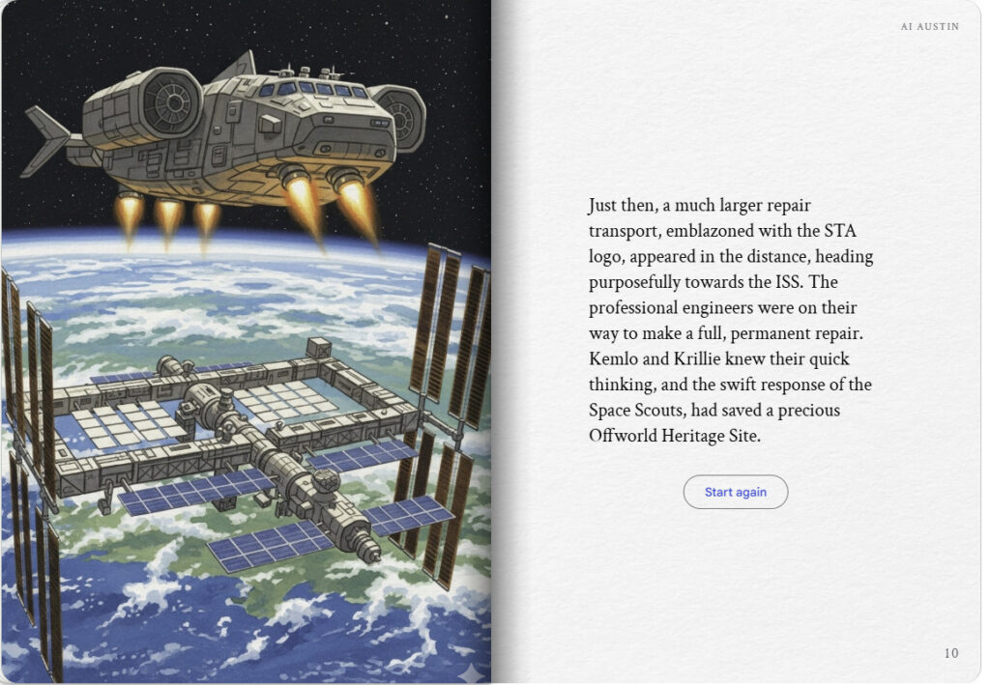

Note: version for editing (needs Ai Austin author login) is here (Development Notes).

