Merlin Rocket

Professional solution for digital content management, sharing and broadcasting.

Merlin Rocket is the effective answer to the increasing difficulties related to digital flow management inside and outside companies or organizations.

This plateform provides tools, to manage a project and its digital content (image, audio, video, text…) from the design to its delivery to the customer.

During the production process, the visibility is total and the security is guaranteed.

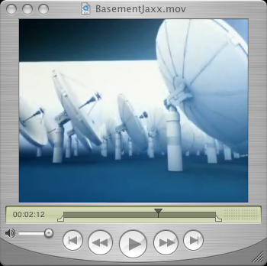 |  | BasementJaxx  Copyright Pleix  The video file is uploaded to a workspace on the server and next published into a public section.  Net surfers access a dynamic web page displaying the video and metadata (Dublin Core).  The video flow is sent by a streaming server that makes it available outside the web browser (video player, mobile phone or simulator)

DIGITAL SHARING ET PERSONALIZED SERVICES

In particular, MerlinRocket allows collaborative workspace setup (internal and external) where every steps of the design process are managed.

This shared platform is a database with the ability to communicate with the customer who will appreciate being able to examine the project status, and to transmit data files by means of a private space. Certain kind of files (video or audio) can be particularly big during the download. Merlin Rocket allows previews as well as an adequate compression setup.

Thus it makes great improvements in the production process and the client relationship. Its improved usability and does not require any data-processing knowledge.

Production process improvement

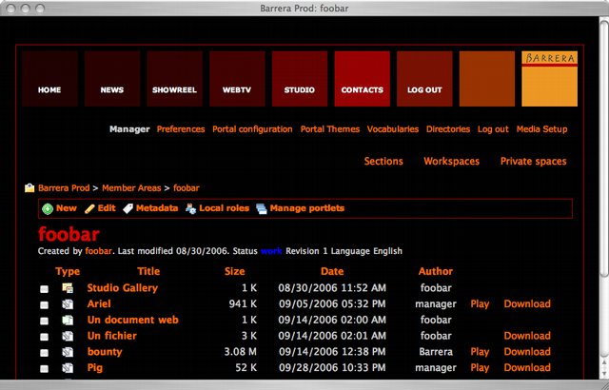 |  | Merlin Rocket management system  Allows server administration and media management in collaborative spaces and publication spaces.

- Increased productivity (time saving, centralized files),
- Real time project visibility (traceability, history management),
- Costs reduced (mailing, dispach riders).

Optimised customer and supplier relationship

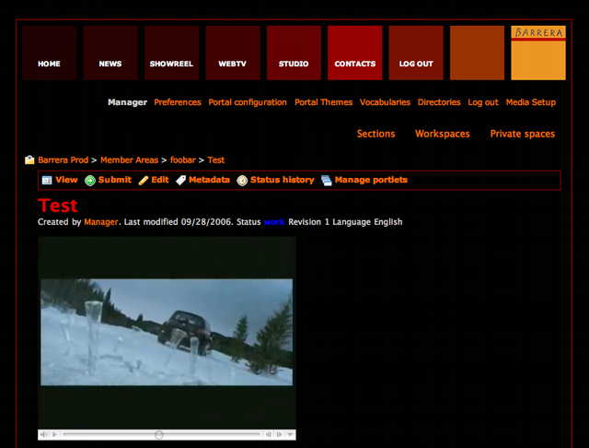 |  | Video preview  The customer validates a step in the production process by accessing a private space.

- Large file sharing (tramline),
- Reduced transfert times (previews),
- Accelerated decision-making process.

Security and reliability

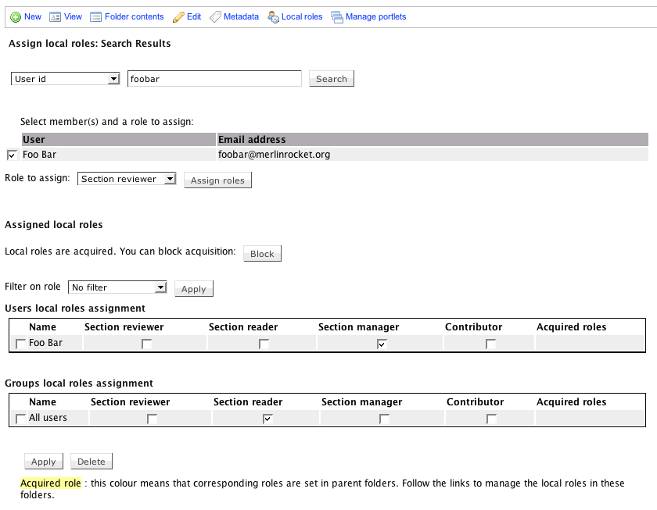

- Secured protocol (https / ssh tunnel) and certificates.
- Access rights management with roles and permissions.
- Automated backups and data restauration.
- Dedicated servers for intensive use for high availability.

Usability

- No technical requirements to manage media files.
- Simple text editor included.

Leading representation - Web TV

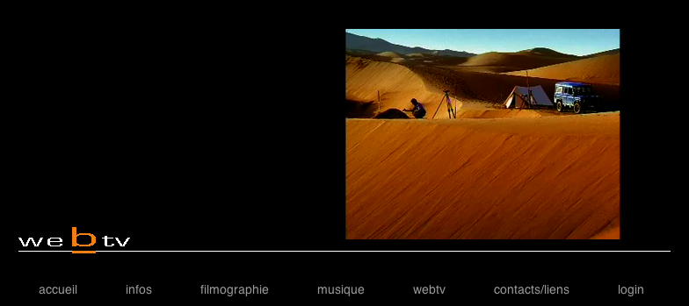

- Trailers,
- TV channels,
- Advertizing.

Quick and easy integration

Merlin Rocket facilitates publication processes and data updates while preserving the customer corporate indentity.
Merlin Rocket brings all the advanced technologies related to intranets and internet ( RSS, mailing, instant message, directories).

Web, mobile phones and simulators (Second Life)

The media content is available on dedicated sections for web portals as well as mobile phones. A specific integration allows access to the Merlin Rocket Server from virtual worlds (Media Center).

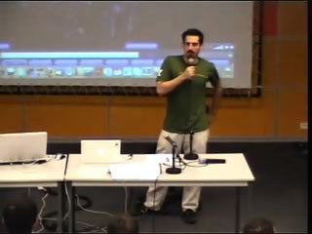 | 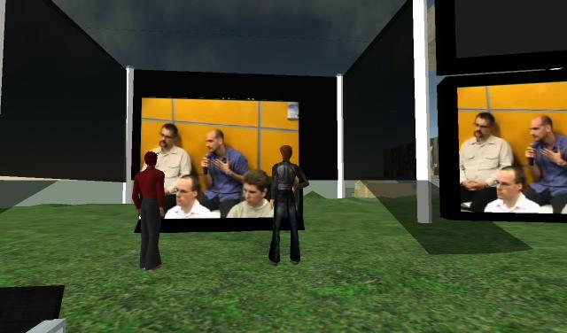 |  | Python Days  Live broadcasting from the sciences and industry city in Paris  Audience :  - real 80%  - virtual 20%

Database management

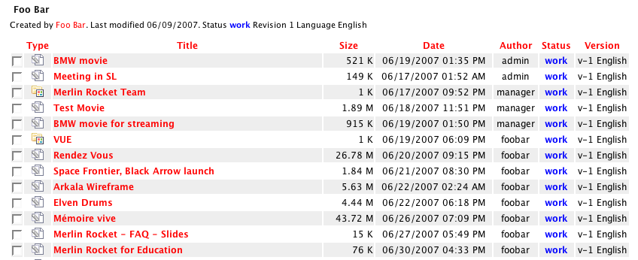

- Remote administration through the web,
- Files and content indexation,
- Advanced search engine with keywords and metadata.

Applications

Education and e-learning

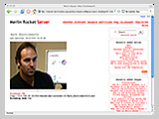 |  | Flexible delivery model for Web, mobile phones, pocket computers and virtual worlds.  Communication and interaction management between students, tutors, content authors, lecturers.  Distance education in virtual environement.

- Workspaces for teachers, tutors and administrators, to store and review content.
- Sections for students with delivery model : web portals, pocket computers, mobile phones and virtual worlds.
- Private spaces dedicated to members.
- Templates for classrooms, auditoriums, mediatheques.

- Available directories allowing administrators to manage members, groups and roles.

- Themes manager : WYSIWYG editor.
- Per space customization : portlets, filter rules, dynamic navigation, user action bar.

- Flexible content with Metadata (Dublin Core) : texts (including images), posters (Image galleries), audio files (speech or music), video files (download or streaming), audio/video playlists , web pages, interactive pages.

- Compatibility with last file formats and codecs (proprietary or open source) : mp4, mov, ogg, mp3, wav, aiff, H.263, H.264, theora, mpeg4, vorbis.
- Compatibility with broadcasters, Mpeg4live, VLC, Quicktime, scalability, streaming relay servers.

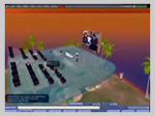 |  | Export features (Second Life)  Image galleries  Movies, audio, playlists  Cross grid broadcast  RL to SL broadcast (conferences)  SL to RL broadcast (events)  Feeds reader

Accademic conference

Film, music and advertising production

Technology

Merlin Rocket Server relies on Open Source products such as :
- Apache, Squid,
- Exim, Courier,
- OpenLDAP,
- Python, Zope, CPS, Plone,
- Jabber, OpenWengo,
- Darwin Streaming Server, Gstreamer, Flash Media Server.

