The Virtual Oil Rig – Simulation-based Immersive Training
Jo-Anne Tait (RGU), Colin Hetherington (RGU) & Austin Tate (University of Edinburgh)

The Oil & Gas Institute in the School of Engineering at Robert Gordon University (RGU) in Aberdeen, Scotland has made significant investment in developing methods to ensure its graduates are “industry-ready”. As visits to oil rigs are not often possible or practical for students it was decided to develop a virtual space for students to familiarise themselves with aspects of the offshore environment in a virtual environment. Such simulation tools give students immersive experiences that can increase their desirability to employers.

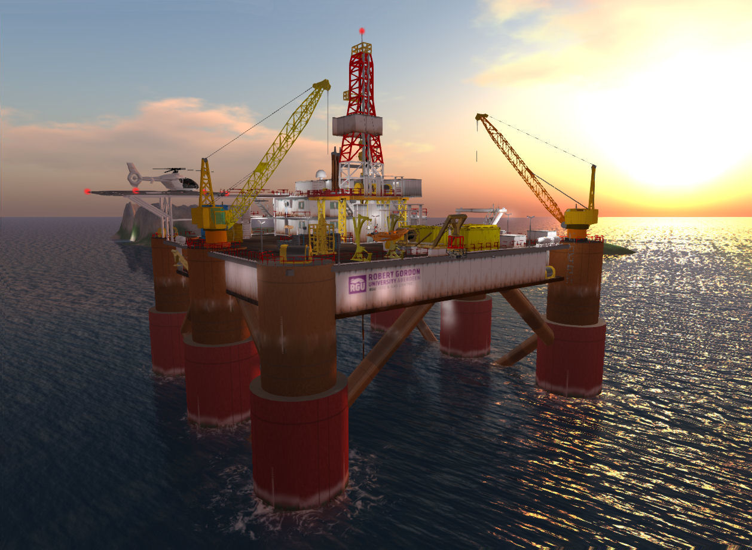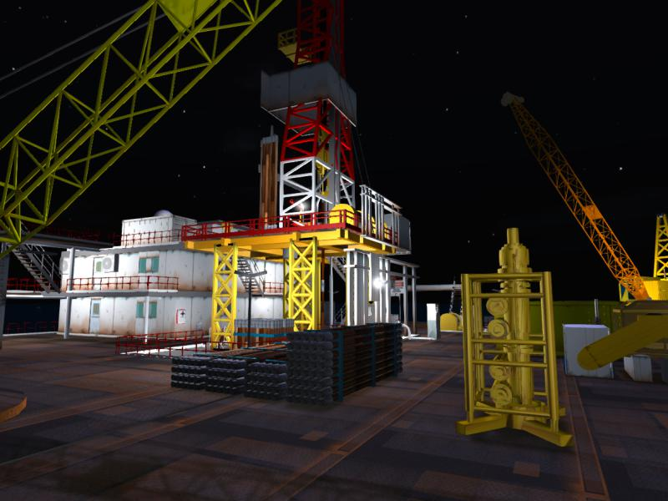Virtual Oil Rig

- Development of semi-submersible rig in 3D Modeller
- Deployment in OpenSimulator (OpenSim)
- Set in ocean environment with sea life
- Moving parts and detailed machinery
- Realistic, loud, 3D sound
- Visitors click on objects for information and linked videos
- Hard hat, ear defenders and boiler suit dispensers for avatars
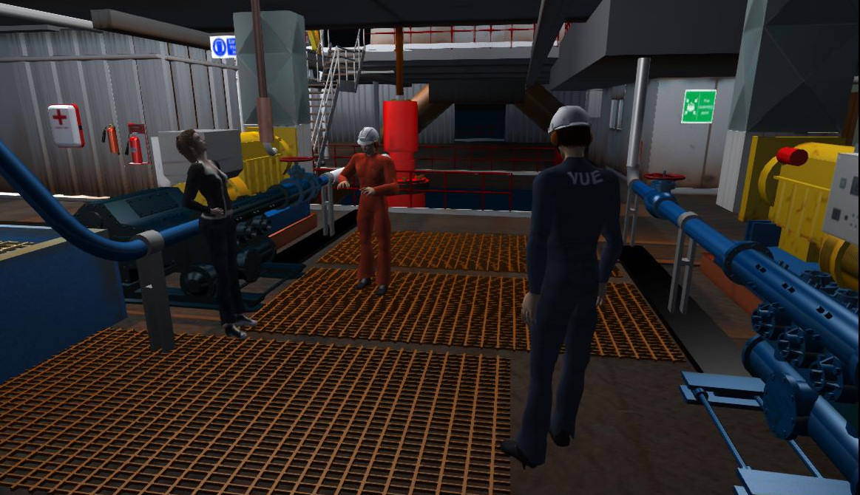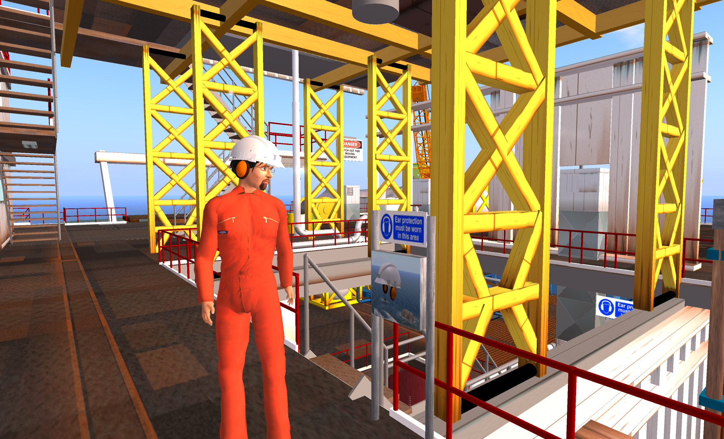
Seabed Equipment
- Seabed “Christmas Tree” equipment
- Blow Out Preventer
- Remote-controlled inspection robot
- Diving suit outfit for avatars
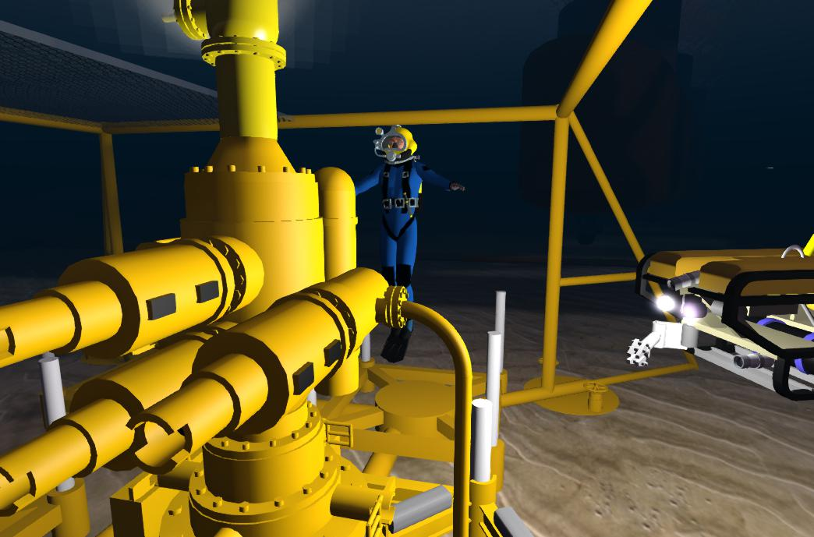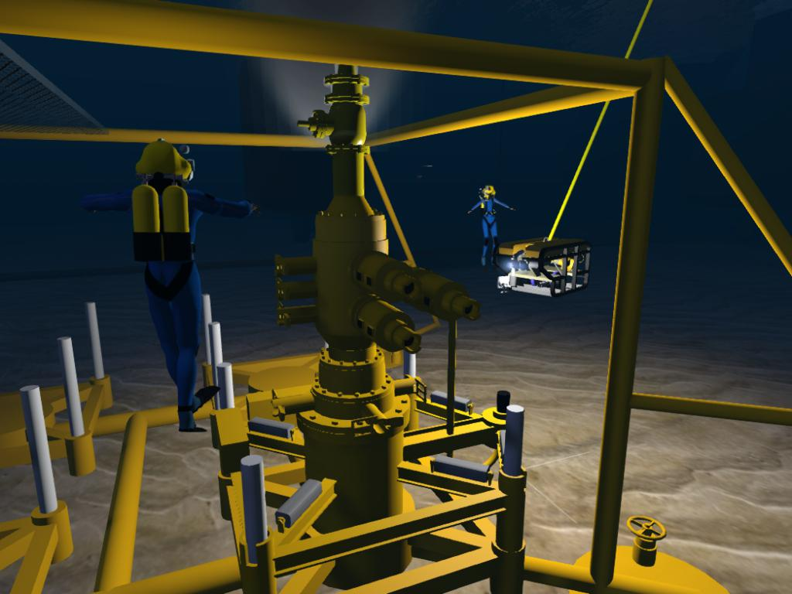

Onshore Campus
- Buildings “onshore” to showcase posters and further educational materials
- Lecture Hall for live streaming events and presentations
- Social areas for staff and students
- 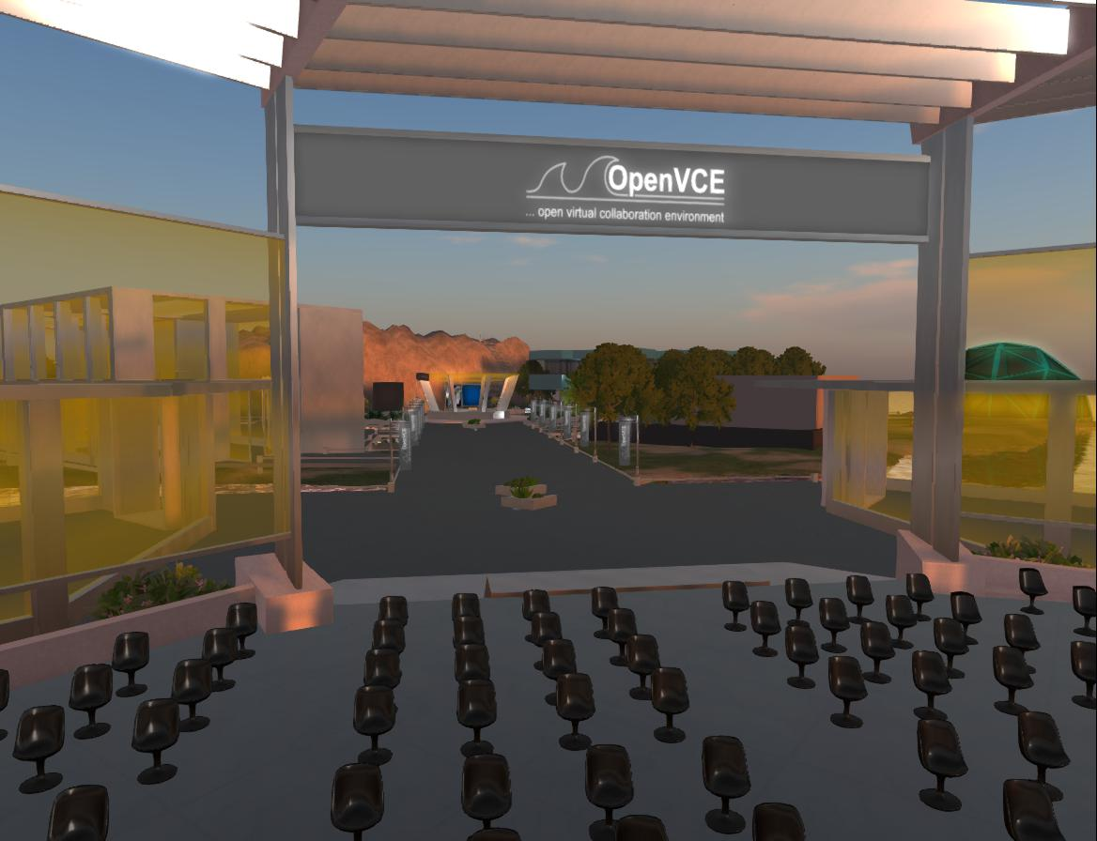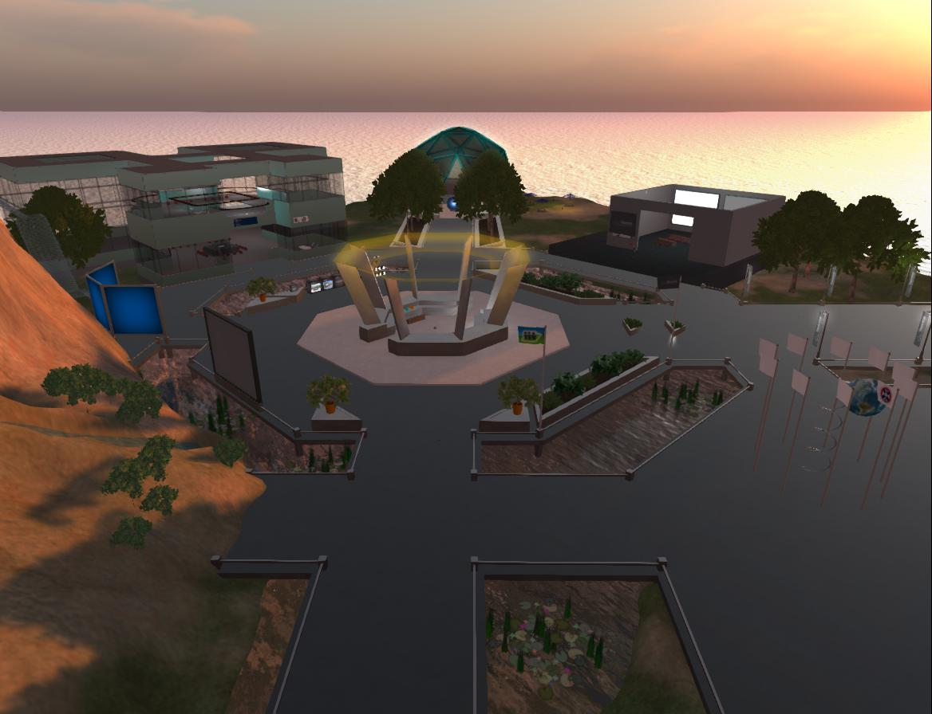Based on the OpenVCE Collaboration Region (open source from OpenVCE.net project)
Collaboration – University of Edinburgh
- Experimenting with porting the Virtual Oil Rig via the OpenSim OAR Converter to Unity3D.
- Experimenting with porting to multi-user collaborative virtual worlds such as Sine.Space.
- 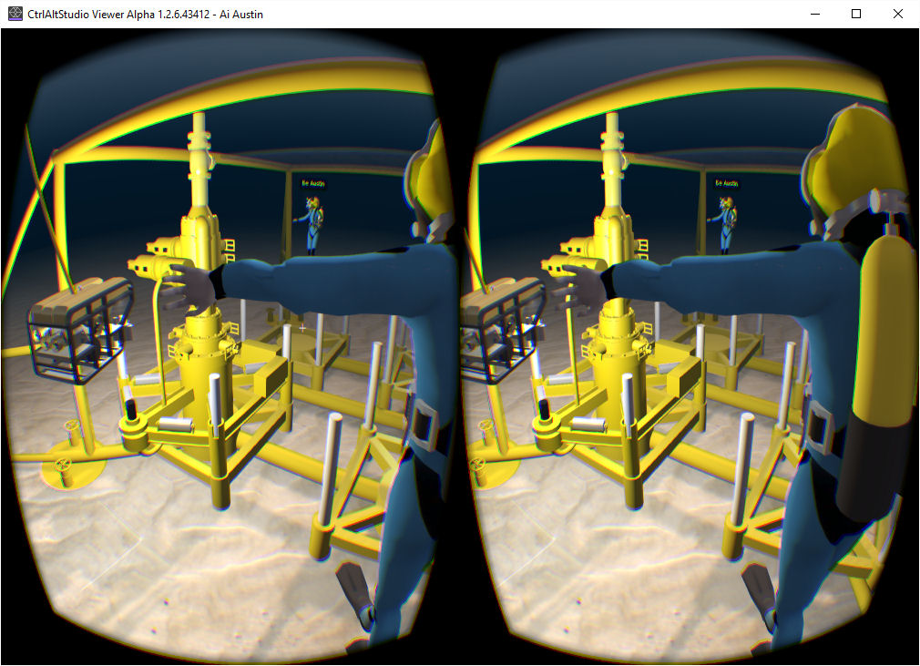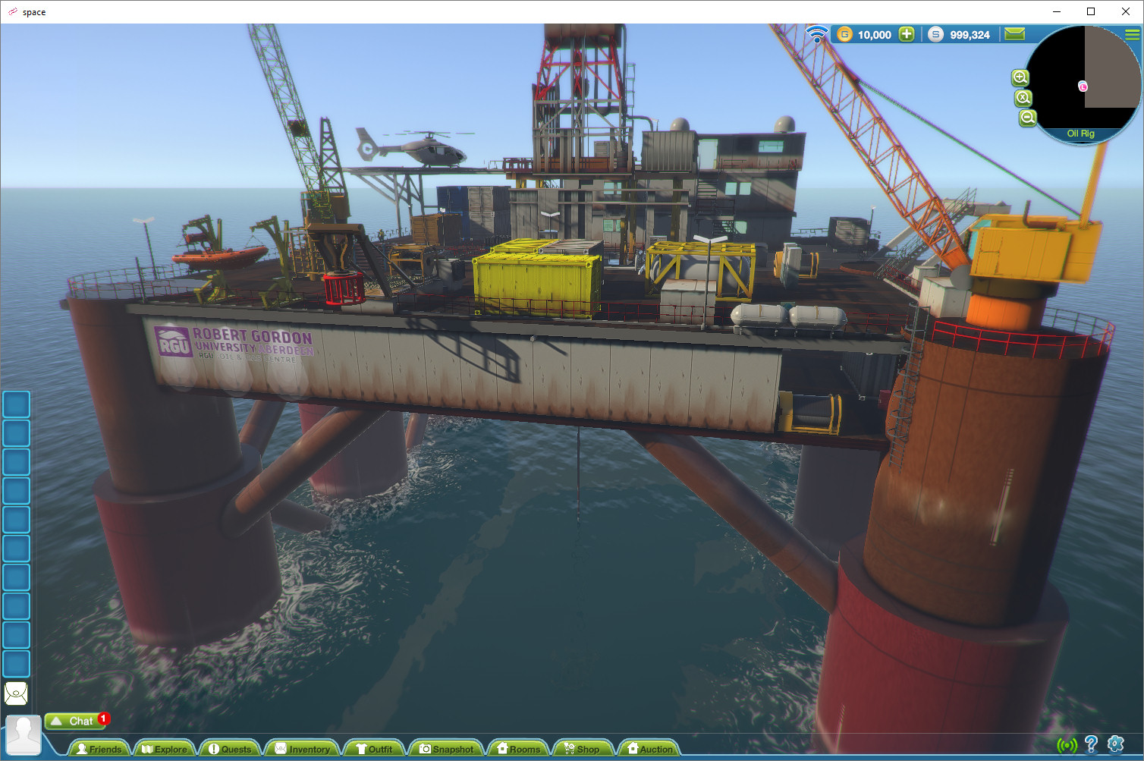Investigating use in virtual environments designed for immersive experiences using VR headsets.

Next Steps
- Further integration into taught modules
- Use the Virtual Oil Rig for assessment of key skills
- VR simulations
- Increasing student partnership

More Information and Image Sources
- RGU Oil and Gas Institute: http://www.rgu.ac.uk/ogi/
- Virtual Oil Rig: http://blog.inf.ed.ac.uk/atate/2013/05/08/aberdeen-oil-rig-visit-on-rgu-islands-in-opensim/
- Blog Post featuring OpenSim OAR Converter to Unity3D: http://blog.inf.ed.ac.uk/atate/2015/10/24/opensim-oar-convert-to-unity-scene-with-windows-interface/
- Blog Post featuring Virtual Oil Rig in Unity3D/Sine.Space: http://blog.inf.ed.ac.uk/atate/2017/01/24/sine-space-rgu-oil-rig-region-live/
- Blog Post featuring Virtual Oil Rig in Oculus Rift VR: http://blog.inf.ed.ac.uk/atate/2016/07/20/oil-rig-training-environment-in-vr/
- Open Virtual Collaboration Environment Region http://openvce.net/vwassets/

Contacts
- Jo-Anne Tait: j.e.tait@rgu.ac.uk
- Colin Hetherington: c.hetherington@rgu.ac.uk
- Austin Tate: a.tate@ed.ac.uk

Acknowledgements
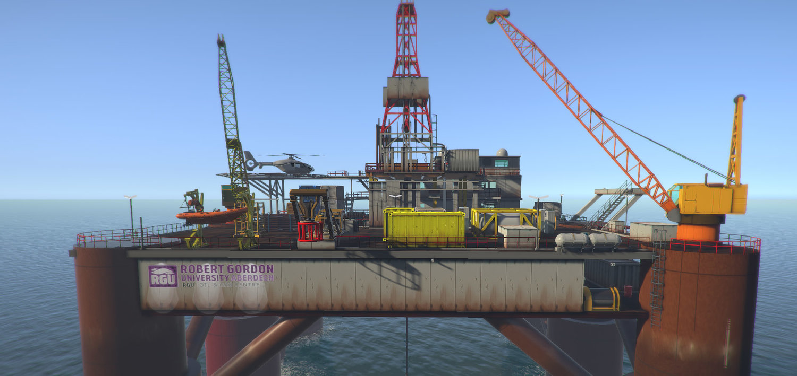
Article based on Tait, J., Hetherington, C. and Tate, A. (2017) Enhancing Student Employability with Simulation: The Virtual Oil Rig and DART, Poster Presentation, 3rd International Enhancement in Higher Education Conference: Inspiring Excellence - Transforming the Student Experience, 6th-8th June 2017, Radisson Blu Hotel, Glasgow, UK. The Quality Assurance Agency for Higher Education, UK.

