Chapter 18: The Fish4Knowledge Virtual World Gallery
Yun-Heh Chen-Burger, University of Edinburgh and Heriot-Watt University and Austin Tate, University of Edinburgh and Virtual University of Edinburgh (Vue)
The technologies for 3D interactive environments for multiple simultaneous users are quite advanced and virtual environments are widely used in many areas, inc. gaming, movies, animation, design, engineering, health and safety testing, informational, educational and multi-media applications. As the Fish4Knowledge project has an important visual aspect to show marine life observations, it will be a natural and useful step to be able to use such media to communicate the Fish4Knowledge project results, in addition to traditional academic outlets, such as web sites, scientific conferences and journal publications.
Among several 3D virtual world environments, we have chosen to build our project exhibition in a virtual exhibition gallery in Second Life (SL) for several reasons. One of the project partners, the University of Edinburgh, already owned virtual land in SL. On this land, there is the well-established Virtual University of Edinburgh (Vue), sponsored and presented by several schools and institutes within the university, including the School of Informatics, Information Services, e-Learning, Business School, Veterinary Medicine, Social and Political Sciences and Alumni Services, etc. In addition, on a part of this virtual land, some of the long-distance learning courses are supported directly through the Vue facilities. Interested readers are directed to http://vue.ed.ac.uk/ for more details.
The University of Edinburgh, at the time of consideration, already had a long history of SL deployment and its virtual land is well populated and used. It would therefore be ideal, if F4K could build its virtual gallery as a part of Vue. Furthermore, and probably more importantly, is the fact that SL allows its users to relatively easily develop and program its environment. That is essential for us, as we plan to provide a tailored 3D environment to suit our needs.
As a result, we have selected Second Life as an experimental platform to host our F4K 3D Virtual Gallery. We were also able to secure a piece of virtual land within Vue to build our gallery. What distinguishes this 3D virtual project demonstration area from our other standard project web sites is that the project demonstration is intended to be fun, interactive and educational. It is not just for academics, but also for everyone who has an interest in marine life and ocean conservation. We intended to use this virtual platform to attract younger people and their educators who have an interest in using computing technologies for educational purposes to get curious about our work and marine research in general. Figure 1 shows the front of the F4K virtual gallery:
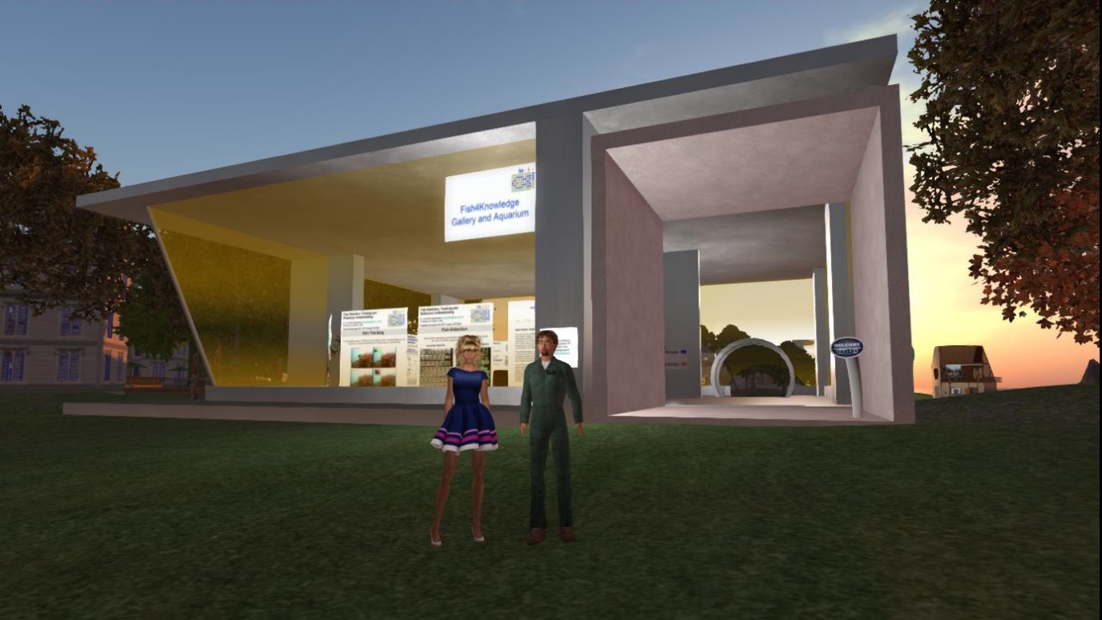
Figure 1: Front of the F4K Virtual Gallery
18.1 The Fish4Knowledge Second Life Gallery – Ground Level
The Fish4Knowledge virtual exhibition gallery is situated at a beauty spot by a lagoon at the heart of Vue. In this gallery, visitors are able to "walk" leisurely around our virtual building, via their avatars, to read about our project work and watch our underwater fish monitoring movies. They are able to learn and be entertained in a surreal environment where the sunset is reflected by the nearby lagoon shining through the large floor-to-ceiling glass window walls. Alternatively, visitors can choose to visit our gallery on starry nights, or at any other times of the (virtual) day to enjoy the shimmery sea waves. Figure 2-5 shows our ground level project exhibit area.
Upon arriving at the ground level exhibition hall, the visitors can “sit” on our comfy virtual sofas to enjoy the surrounding or walk around the posters to view them. They can interact with or meet others there or arrange to meet project representatives to talk about the project and its results. Once a poster is selected for viewing, the visitor can use a combination of [left-click] for locating and arrow keys to navigating their view. Currently, there are about a dozen project posters on display, with topics ranging from high performance computing, image processing, human-computer interaction, marine biology and virtual workflow machines.

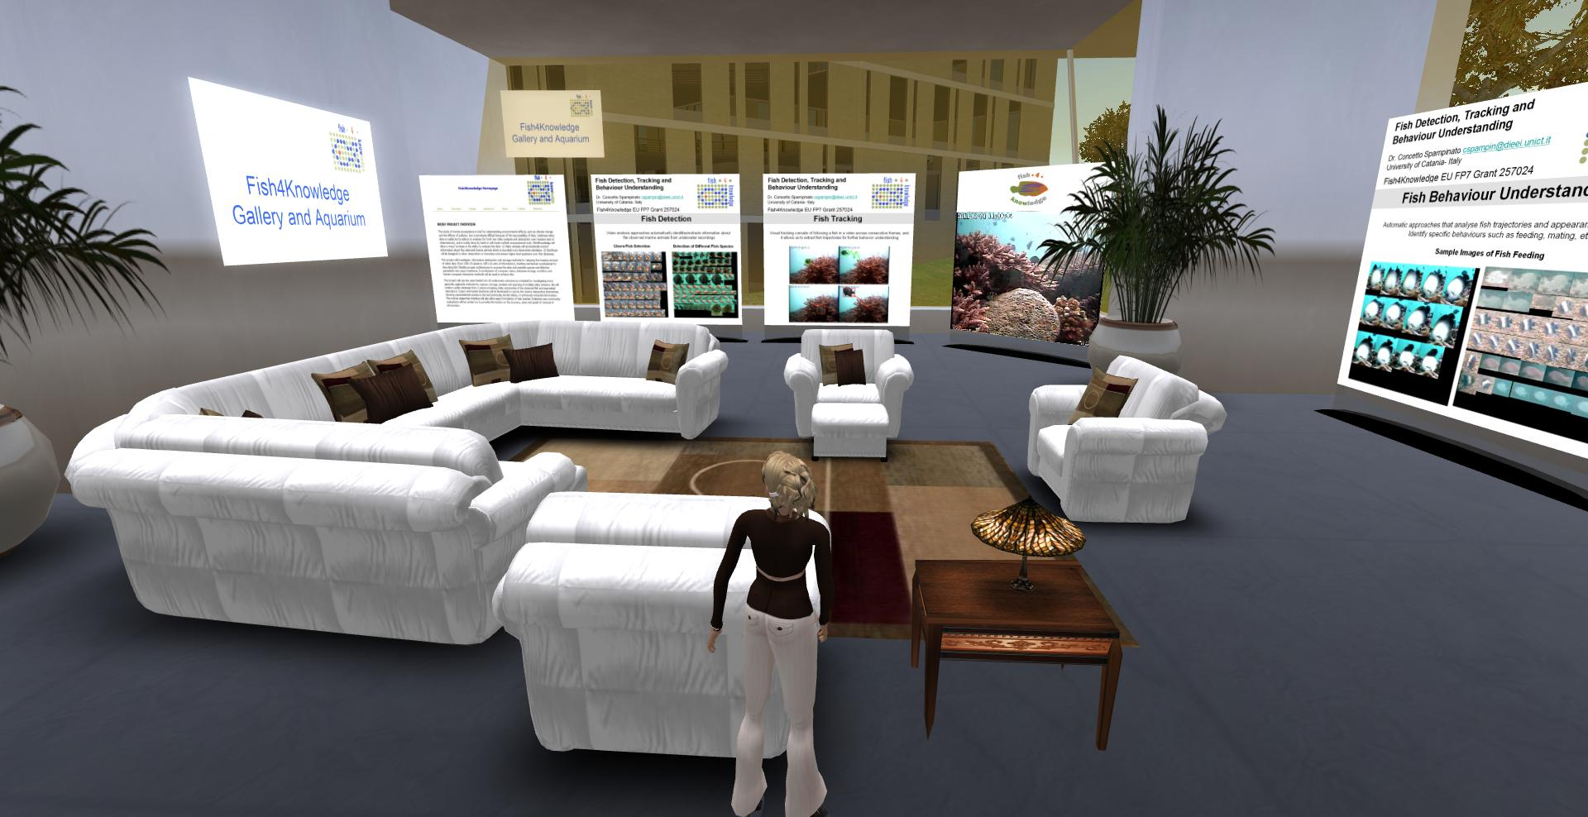Figure 2: Ground Level of the Exhibition Hall (East Facing)

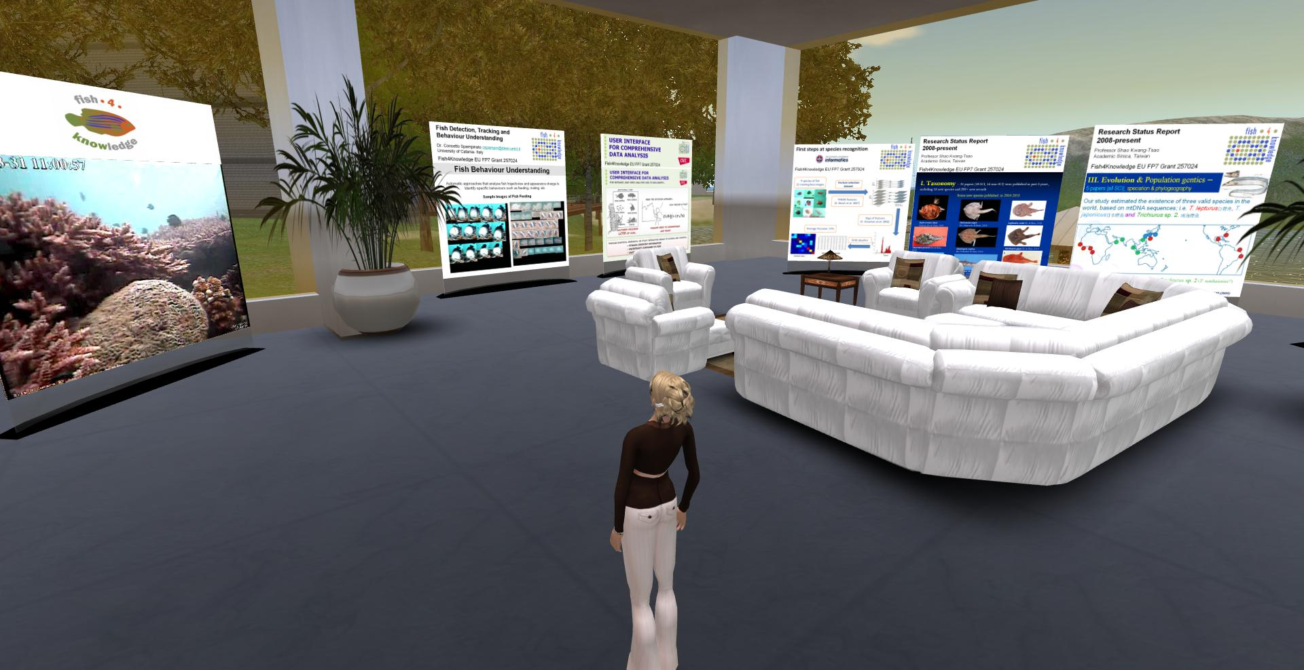
Figure 3: Ground Level of the Exhibition Hall (South-West Facing)
On the left hand side of Figure 3, there is a large screen displaying a looped marine life video that was captured in the coastal sea off South Taiwan. This video is an example of the videos that the Fish4Knowledge team process.
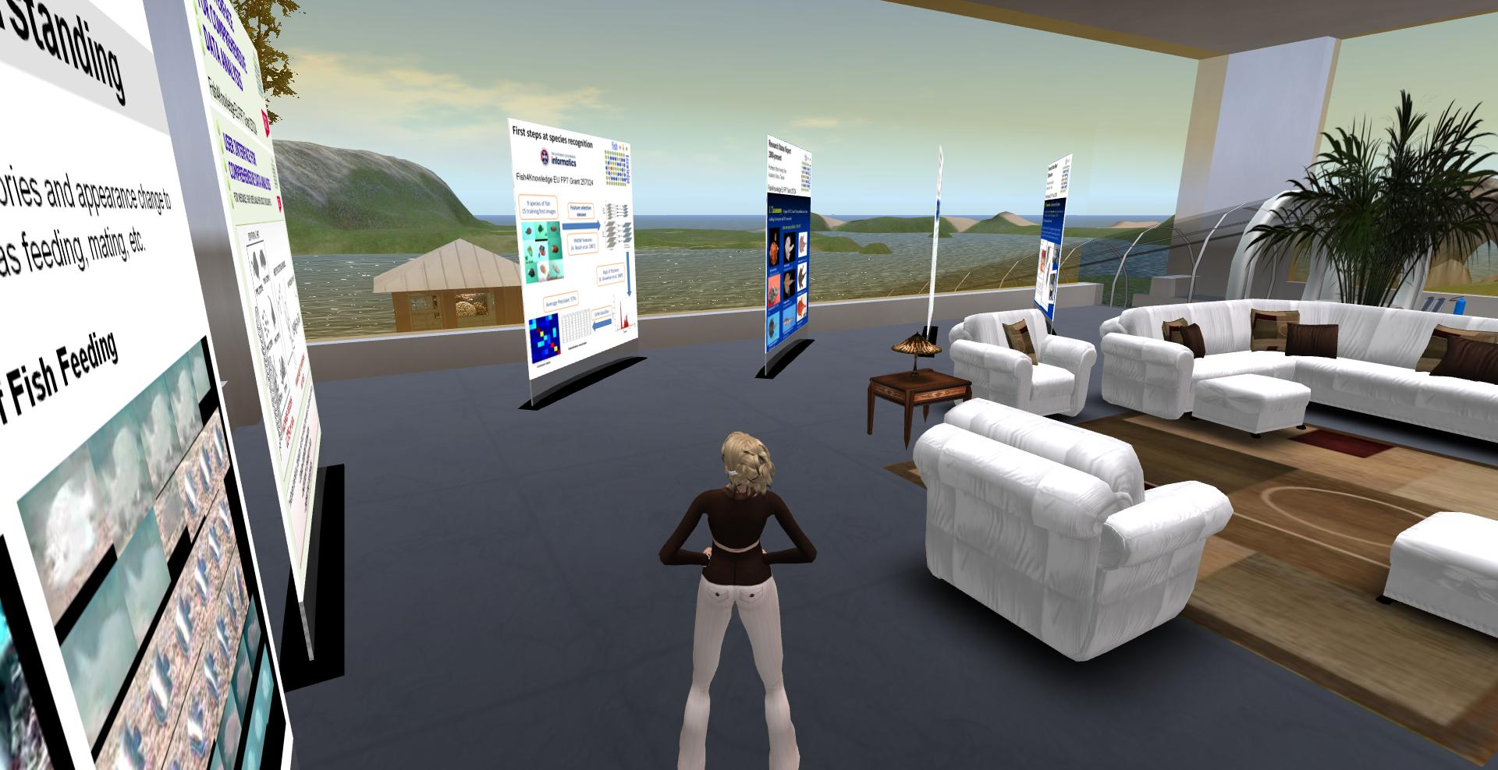
Figure 4: Ground Level of the Exhibition Hall (West Facing)

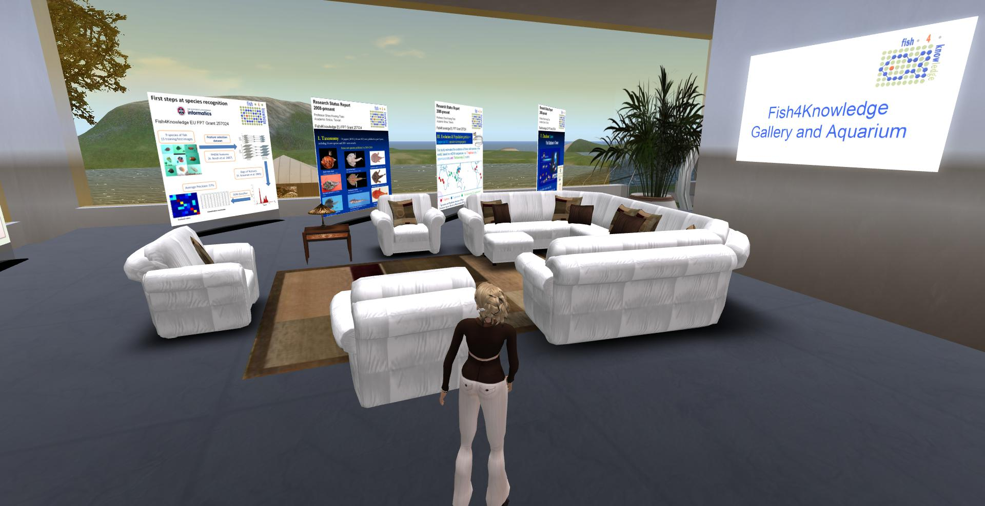
Figure 5: Ground Level of the Exhibition Hall (West-North Facing)

18.2 The Fish4Knowledge Second Life Gallery – Underwater Level
On the north side of this gallery, there is a passageway that leads visitors down to an underwater virtual aquarium. We call this the "Virtual Fish Lab". Here we exhibit example fish that we observe in real life. Some of our virtual fish are interactive and will react in different ways when stumbled upon or interacted with. Our virtual fish will “talk” to visitors about their lives, via some simple conversational skills. Figure 6 shows the tunnel entrance to the underwater level. Figure 7 and 8 show sample screen shots of the lower level. Similarly, on the left hand side of Figure 8, there is a large screen displaying a looped marine life video that was captured in the coastal sea off South Taiwan and that is a part of videos that have been processed by the Fish4Knowledge Team.
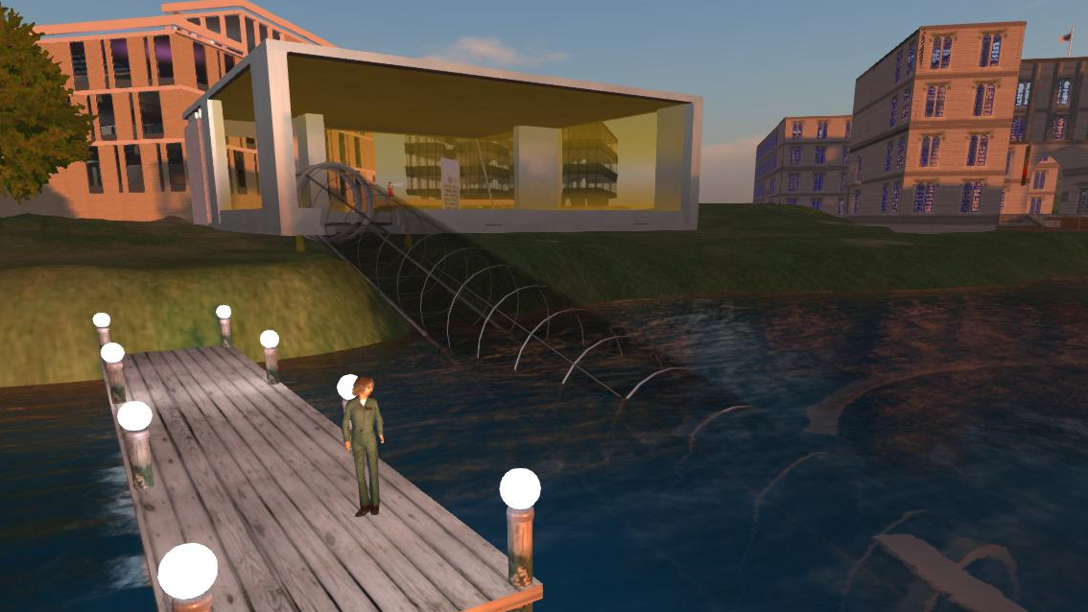
Figure 6: Tunnel Entrance to the Underwater Level
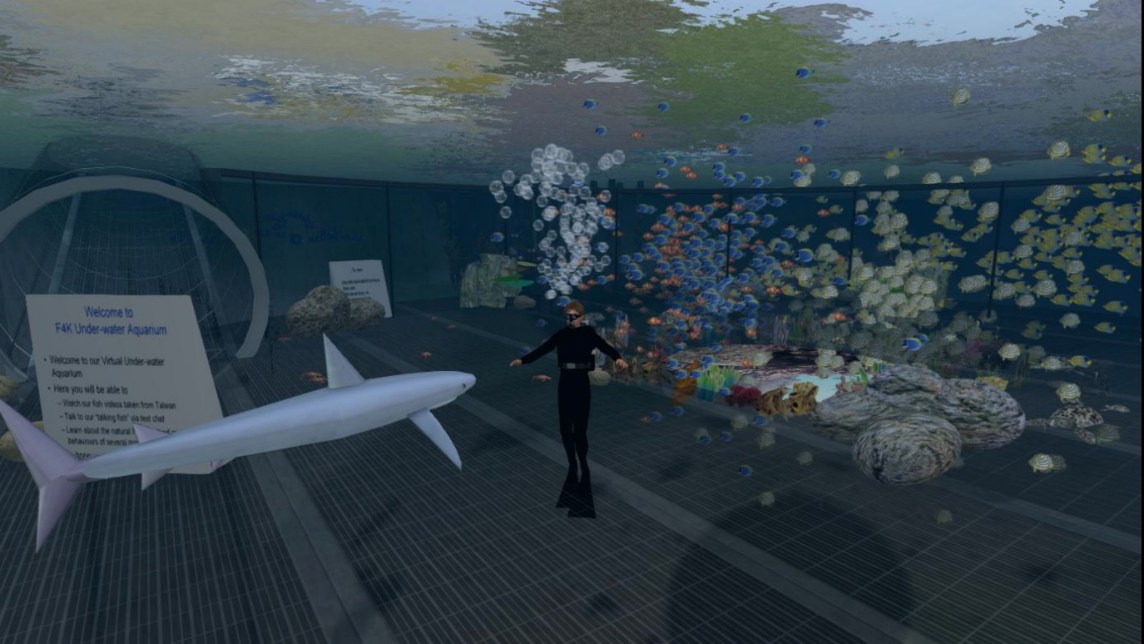
Figure 7: Sample View to the Underwater Level – 1
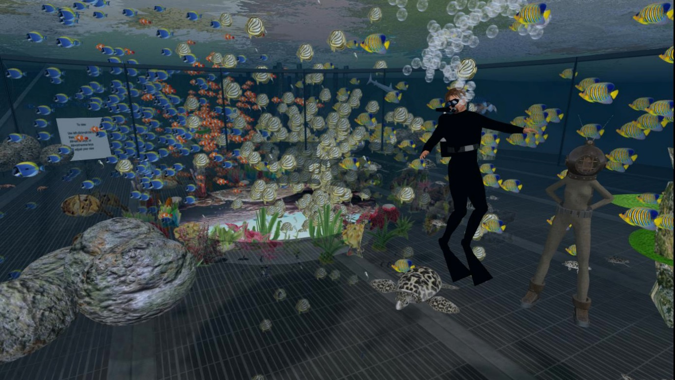
Figure 8: Sample View to the Underwater Level – 2

18.3 Conclusion
The central design idea of the underwater virtual aquarium is to provide a fun, interactive and educational space that gives its visitors a "surreal" experience - in that visitors can "walk about", "touch" things, interact with objects or “talk” with virtual fish. When there is more than one visitor in this space, people can choose to share their experiences through Second Life's live voice and text-chat facilities. When appropriate, the Fish4Knowledge team can hold exhibition events where project works can be presented. This learning experience is intended to be different from those provided by conventional publications, web sites and 2D media.

Useful Web Resources
- Access to Fish4Knowledge Virtual World Gallery and Aquarium can be obtained via http://www.aiai.ed.ac.uk/project/f4k/
- Fish4Knowledge 3D Second Life Virtual Gallery Web Resources are listed at http://groups.inf.ed.ac.uk/f4k/secondlife.htm

Acknowledgement:
We would like to thank the OpenVCE.net project for the building shell and the Virtual University of Edinburgh (Vue) for co-sponsoring the cost of the virtual land in Second Life and OpenSimulator which host copies of our gallery.
Fish4Knowledge is funded by the European Union Seventh Framework Programme [FP7/2007-2013] under grant agreement 257024, addressing Objective ICT-2009.4.3: Intelligent Information Management, Challenge 4: Digital Libraries and Content. The University of Edinburgh and research sponsors are authorised to reproduce and distribute reprints for their purposes notwithstanding any copyright annotation hereon.
We also would like to thank NCHC (National Center for High-performance Computing), Taiwan and Academic Sinica, Taiwan, for their efforts in capturing those valuable under-water marine life videos and their tireless endeavours to combat regular typhoons and open sea conditions in maintaining the high quality of videos, to assist us achieve the best possible processing results.

