Vue – Virtual University of Edinburgh – Development in Second Life and OpenSimulator
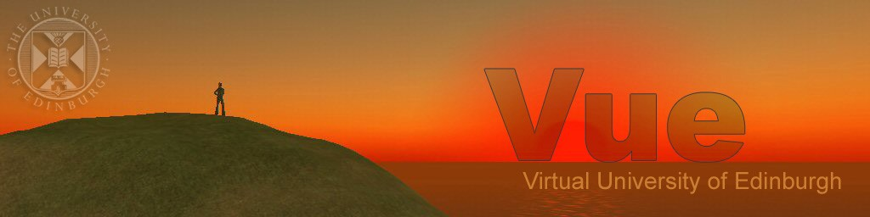
Austin Tate, Coordinator, Virtual University of Edinburgh – http://vue.ed.ac.uk
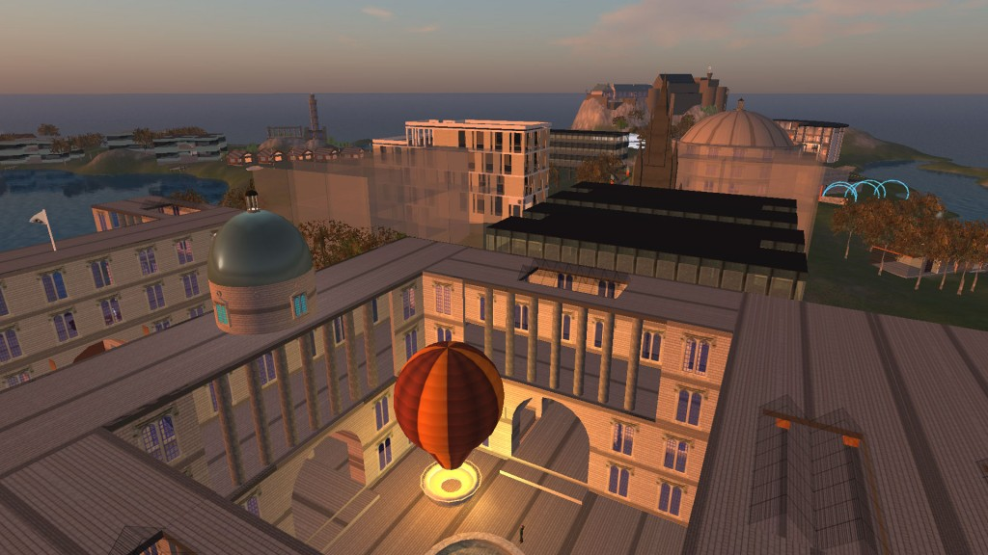
Vue – the Virtual University of Edinburgh – is a virtual educational and research institute bringing together all those interested in the use of virtual worlds for teaching, research and outreach related to the University of Edinburgh in Scotland.
Following separate developments during 2006 by various University of Edinburgh individuals and groups using plots on the Second Life “Mainland”, the group met for the first time in March 2007 and decided to acquire and develop a shared mini-continent to be called “Vue”, with the core long term planned stable region also to be called “Vue”. Various regions for schools and projects would cluster around this and come and go as needed. The activity was given support at the highest levels of the University with the Principal (himself an educational innovator), several Vice-Principals, the Development and Alumni Office and others all offering support and seed funding.
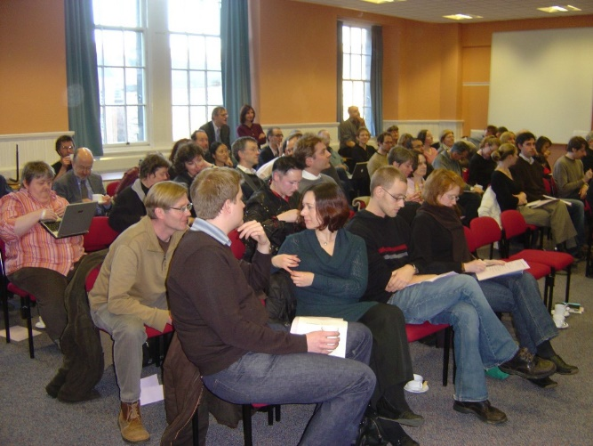
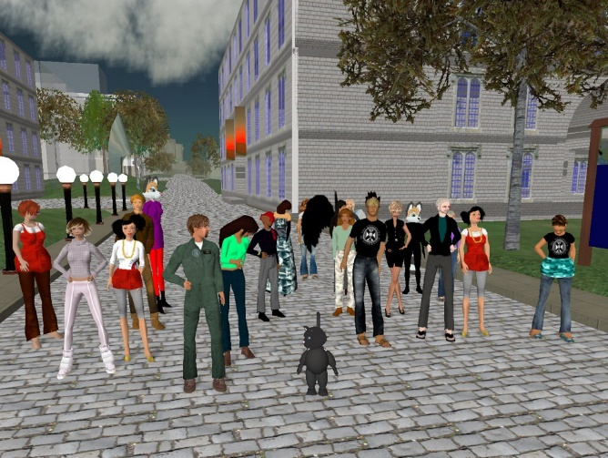
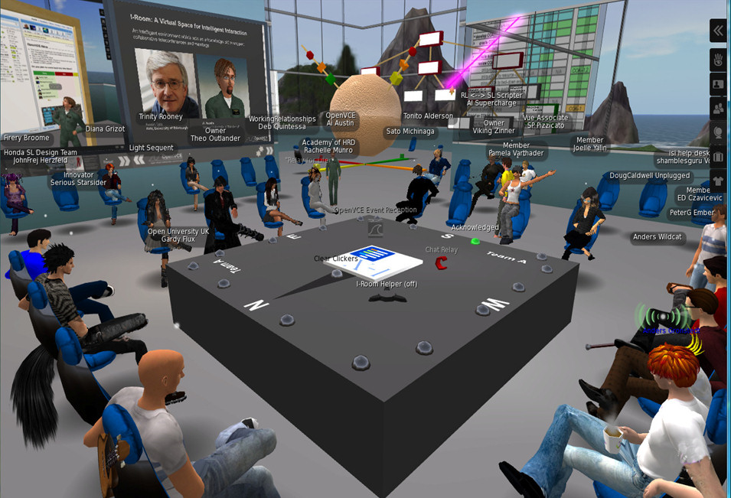
Since then, the Vue facilities in Second Life have been used for many University activities including the annual EDUBlog award winning virtual graduation ceremonies for several departments, at the shared meeting space called “The Venue@Vue”, for collaboration in the US Federal Consortium for Virtual Worlds award winning I-Room – a Virtual Space for Intelligent Interaction, for the Open Virtual Collaboration Environment used for emergency response community support, and for a range seminars, research projects, conferences and events.
Unusually, the Vue group was also allowed a top level domain name within the University as vue.ed.ac.uk to reflect its University wide coverage and potential longevity as a type of educational infrastructure that would outlast specific platforms. It was envisaged that developments would occur rapidly and that content might be moved between platforms as developments occurred. A “Vue Regional Planning Authority” (VRPA) steering group was formed to coordinate activities across colleges, schools and central offices within the University, to coordinate the building and usage of shared areas, to assign virtual spaces for teaching, research and outreach or demonstration projects, and to assist in fund raising to pay for the facilities.
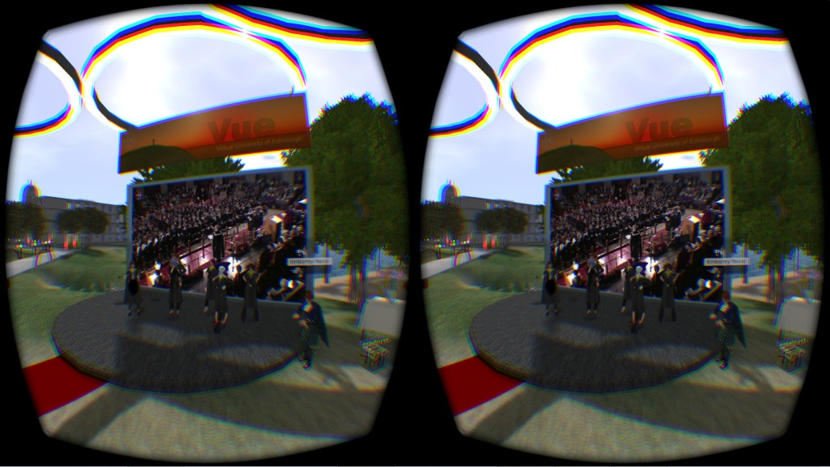
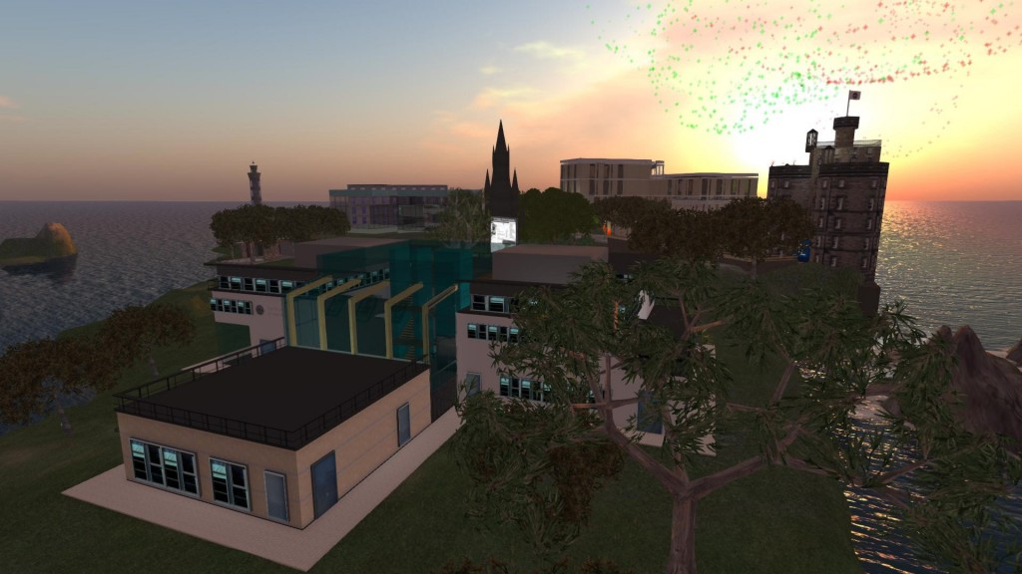

Vue Regions in Second Life
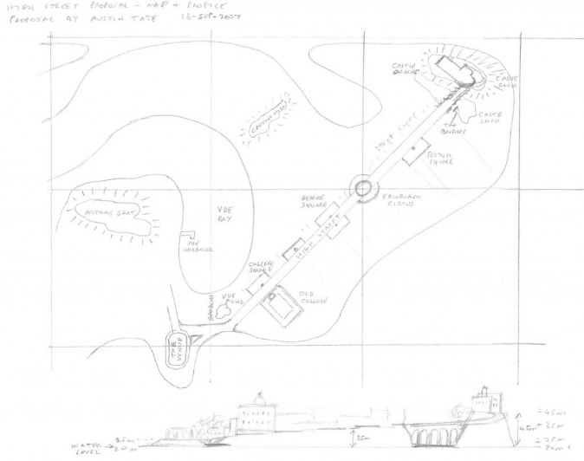
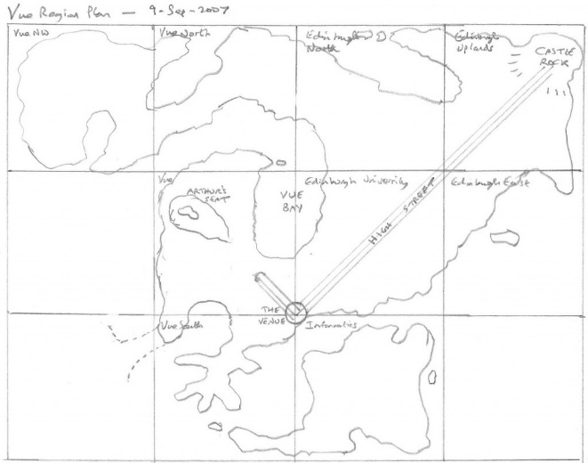
The original sketch designs from March 2007 to November 2007 by avatar Ai Austin (RL: Prof. Austin Tate, Coordinator for the Virtual University of Edinburgh) include:

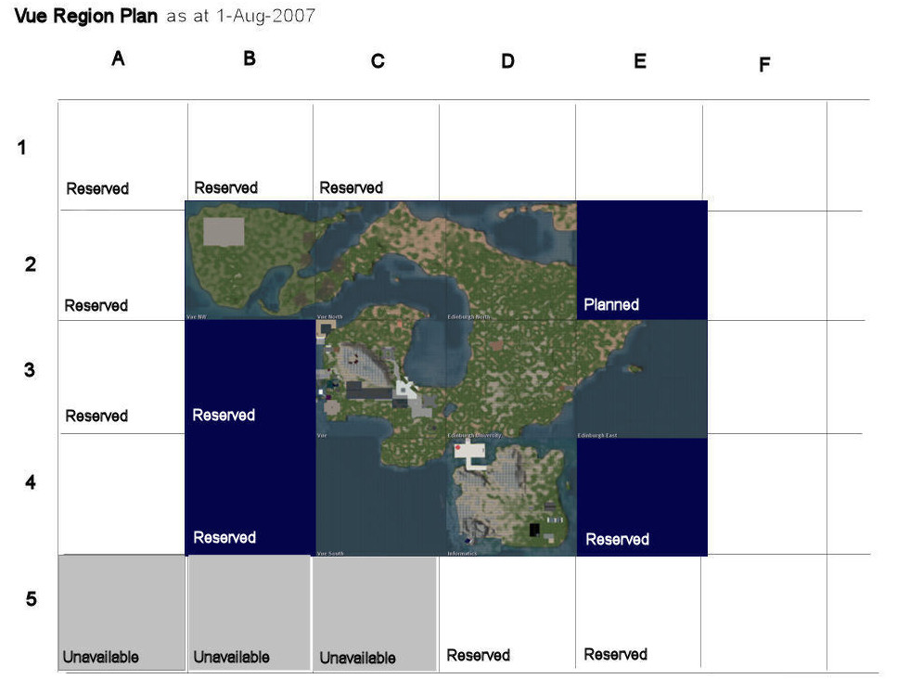
The design was intended to reflect iconic Edinburgh skyline landmarks and buildings, such as Edinburgh Castle and the Calton Hill Monuments, as requested by the University authorities. The first, almost ready to use, design and layout just ahead of the first academic year of use in 2007 is show here:

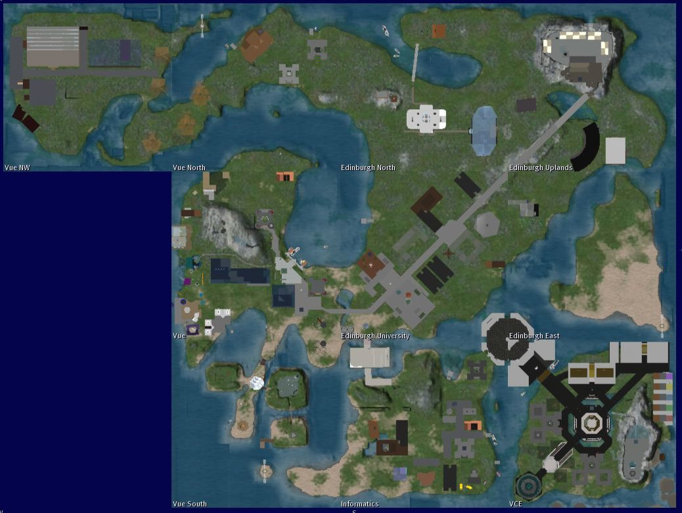
At its full extent the Vue regions (along with a “VCE” project area) looked like this:

Since that time some lower-use regions have been vacated, project areas reused and some regions adopted by different schools.
OpenSim Openvue
The original complete 9 region Vue mini-continent setup, along with the OpenVCE collaboration region that was in Second Life around 2008 along with additional welcome, sandbox and “hypergrid” teleport regions was preserved in its entirety and is replicated and continues to be available on the OpenSimulator-based Openvue grid… http://vue.ed.ac.uk/openvue/
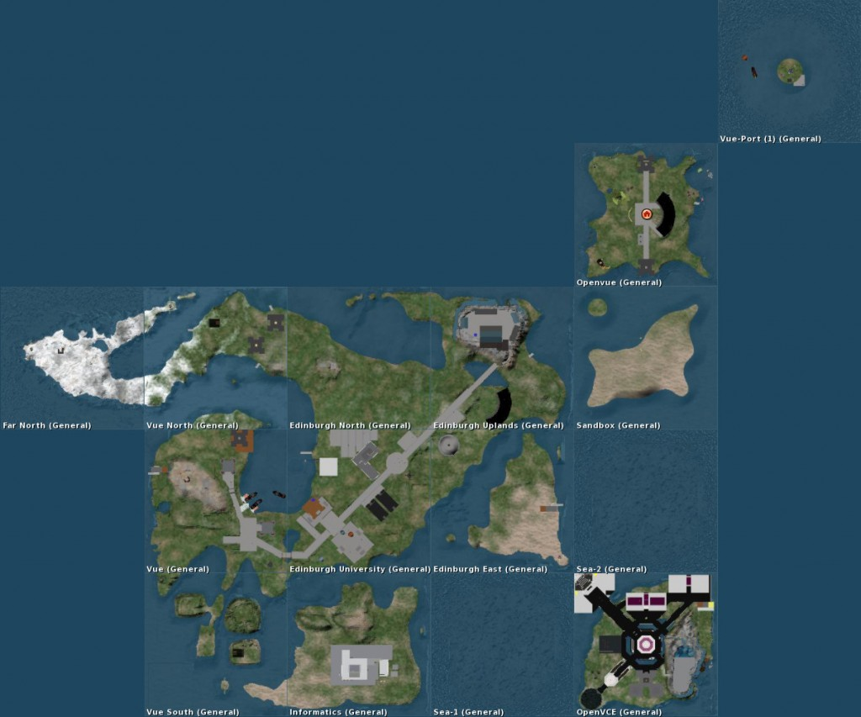
Virtual University of Edinburgh – 2006-2016 - One Decade On
The Virtual University of Edinburgh (Vue) began in 2006-7 to help coordinate virtual world and game-based activities by educational innovators at the real University of Edinburgh and remains active a decade later. Several new platforms have been experimented with and demonstrated between Vue members as technological developments continue in this space. Virtual Reality (VR) experimentation is also underway with existing and potential future platforms. We anticipate that Vue will remain a part of the activities of the University of Edinburgh going into the future.

