Novakian Concept Mapping in Virtual Collaboration Environments
Brian Moon, Jeffrey T. Hansberger and Austin Tate
Draft at 13th April 2010

Introduction
Crisis response situations require collaboration across many different organizations with different backgrounds, training, procedures, and goals. Indeed, the overwhelming nature of such events calls for a diversified response that addresses the multitude of cascading effects. Compounding the challenges associated with collaboration during crisis situations is the distributed nature of the supporting organizations—in most cases, a single leader or office is not designated to integrate and advance participants from military, government and non-government organizations—thus, disparate organizations often plan and execute disparate plans. As a result, opportunities for leveraging expertise and resources across organizations are lost, and response to the crisis can appear as chaotic as the crisis itself.
Seeking more effective and efficient means to facilitate crisis response, the US Army Research Laboratory’s Human Research and Engineering Directorate (ARL HRED), under the direction of one of the authors (Hansberger), in 2009 launched a program to design and evaluate a virtual collaboration environment (VCE) to support a crisis response community of interest during crisis action planning activities. The ultimate goal of the program was to demonstrate the potential value in a VCE for addressing the challenges of distributed crisis response planning. More broadly, the program sought to discover implications for any distributed collaborative activity.
Among the design concepts proposed was the use of Novakian Concept Mapping in the context of the VCE. Specifically, Cmapping was proposed as an approach to enable the planning process, and CmapTools was proposed as the software toolkit for integration into the VCE. This chapter provides an overview of the role of Cmapping and CmapTools in the program, with an eye toward highlighting the benefits and challenges discovered during the program. In so doing, we seek to suggest the boundary conditions for successful use in virtual collaboration environments, and more importantly, to suggest a roadmap for pushing the boundaries in the future. As such environments continue to grow, we are confident that the benefits of Novakian Concept Mapping can extend into the virtual world—as fruitfully as they have in the corporeal world.

Design of the VCE
In addition to ARL HRED, developers of the VCE included the University of Edinburgh, University of Virginia, and Carnegie Mellon University, and Perigean Technologies LLC. Together, the team created the design for an overarching approach to crisis response—i.e., information technologies, protocols, and strategies to support planning across a distributed community of interest—centered around a VCE. The design of the VCE was guided through a cognitive work analysis (CWA) (Lintern, 2009; Vincente, 1999) for distributed collaboration. A CWA consists of multiple phases that systematically analyze the constraints across work tasks, collaborators/colleagues, organizations, and activities. A CWA typically focuses on how work can be done compared to other types of task analyses that focus on how work should be done in a limited set of situations, which can decrease the flexibility and adaptability of the socio-technical system. The CWA identified the critical functions to facilitate distributed collaboration and allowed us to select the appropriate technology to support those functions (Pinelle, Gutwin, & Greenberg, 2003). It also guided the design, presentation, and structure of information and processes in the three primary components of the VCE, 1) a collaboration protocol, 2) visualization tools, and 3) collaboration tools.
The VCE consists primarily of collaboration and visualization tools, and a collaboration protocol meant to guide distributed collaborative activities across the tools and diverse set of organizations typically involved in crisis response. The collaboration protocol is tied to Tuckman’s (1965) “Forming, Storming, Norming, and Performing” collaboration model and how individuals communicate and collaborate through social networks (Cross and Parker, 2004). It addresses some of the unique capabilities and challenges of distributed collaboration within a virtual environment such as virtual presence and trust, asynchronous planning, and virtual activity awareness. The next section describes the VCE toolset.

The VCE Toolset
The collaboration tools and visualization tools envisioned for the VCE were intended to support a number of functions for distributed collaboration.

Collaboration
The collaboration tools consist of both a collaborative web portal of Web 2.0 tools and a 3D virtual collaboration space. All tools were selected to support the key functions identified in the CWA and their open-source or open access nature to make them accessible and available to the wide range of organizations that make-up the crisis response community. The open source nature also allows us to integrate new or better capabilities as new technology is developed and made available. A combination of social networking capabilities for team and activity awareness, microblogging for transmission of messages to and from users on mobile devices, and collaboration on shared and persistent knowledge through wikis are some examples. The 3D space represents a range of collaborative spaces to facilitate meetings with audio and text communication allowing smaller meeting spaces for 5-25 people and larger auditoria for 100-400 individuals, presentations or live streaming video to a distributed audience, and sharing of information through an expo pavilion and other virtual spaces.
The Open Virtual Collaboration Environment (OpenVCE.net) has been created as the means to support the community of interest in its activities. It consists of:
- a web-based Community Portal (CP) for asynchronous collaboration, communication and for creating and sharing of assets and resources. After some experimentation and discussion, a Drupal-based system augmented by a range of modules, and with the addition of MediaWiki is used for this element.
- A virtual world 3D Spaces to support a range of types of meetings, events, training sessions, and possibly real missions. Second Life™ and OpenSim environments are used for the element.
- A “protocol” and associated set of standard operating procedures (SOP) for virtual collaboration guides the use of the facilities.
A long-standing theory dealing with communication media is the social presence theory (Short, Williams, & Christie, 1976). This theory describes media along a continuum of social presence that provides a range of awareness of the people involved in the communication. Communication is most effective when the level of interpersonal involvement matches the communication medium being used. For example, face-to-face interactions have the highest level of social presence while text-based communications have the least. The dynamic and complex collaboration activities involved within crisis response and planning requires a moderate to high level of interpersonal interactions, particularly when it is across different organizations. The use of virtual environments and avatars has shown higher levels of social presence than text-chat and audio conference (e.g., Sallnas, 2005). The VCE is intended to support the higher levels of social presence through its virtual 3D spaces like the “I-Room”.
One element within the OpenVCE 3D space is an “I-Room” (Tate et al., 2009, 2010). An I-Room can provide support for formal business meetings, tutorials, project meetings, discussion groups and ad-hoc interactions. The I-Room can be used to organize and present pre-existing information as well as displaying real-time information feeds from other systems such as sensor networks and web services. It can also be used to communicate with participants, facilitate interactions, record and action the decisions taken during the collaboration.
Using the I-Room concept within virtual worlds gives collaboration an intuitive grounding in a persistent 3D space in which representations of the participants (their “avatars”) appear and the artifacts and resources surrounding the collaboration can be effectively presented. 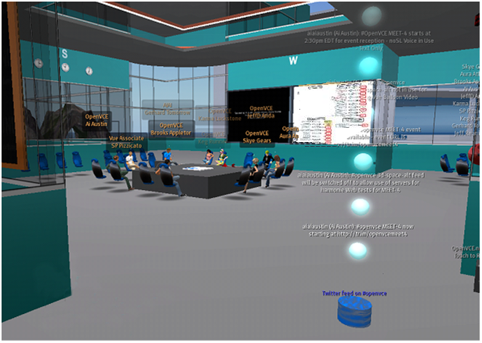

Figure 0: Virtual World 3D Space - I-Room showing Concept Map and Other Information Feeds

Visualization
The use of Concept Maps was, primarily, as a visualization technique to provide a centralized perspective on the emergent plan without imposing centralization of the development process. The inspiration for such use came from previous work by Hoffman and Shattuck (2006), who demonstrated the potential to improve the basic process for creating, sharing, and using operational orders and operational plans for military operations. Figure 1 shows the vision they demonstrated.
<<INSERT FIGURE 1 HERE>>
In experiments with the US Army, Hoffman and Shattuck found benefits in comprehension and efficiency for information transfer when traditional five-paragraph Operational Orders (OPORDs) were represented as Cmaps, and hyperlinked to other, more detailed Cmaps that expand on the overarching order. They also discovered resistance to the notion of recasting a format deeply entrenched in Army culture. To mitigate this resistance, they developed templates that call out the essential components of the OPORD that could be filled in by planners.
Other prior work also suggested the potential benefit of using Cmaps during planning. Fourie & van der Westhuizen (2008), in exploring through experimentation the value and use of Cmaps in the alignment process of the strategic intent of a business, found that Cmaps are “a valuable tool in the alignment of business strategy by visually representing the strategic intent, alignment and misalignment amongst the identified concepts by different hierarchical levels of the organization. Cmaps can visually represent the complex and abstract nature of business strategy, making it easier to plan, describe, define, craft, communicate, implement and measure.”
The vision, then, for the integrated toolset was to embed the use of CmapTools in the virtual collaboration environment in order to realize the potential benefits of both simultaneously. The next section discusses the outcome of the integration.

Cmaps in Second Life
Figure 2 shows the most basic implementation of the integration—the “projection” of Cmaps into a virtual space within Second Life. This particular space was the virtual office of Perigean Technologies LLC, created by the University of Edinburgh. The Cmap projected onto the wall in the space represented the entire VCE program, and it the diagram is being viewed by “PerigeanTechnologiesLowbeam”—one of the authors’ (Moon) avatar in Second Life.
<<INSERT FIGURE 2 HERE>>
This basic implementation raised a number of key boundary conditions for the integration of CmapTools into Second Life. The projection is facilitated through a media player in Second Life, which includes the capability to show images, display a website, run slideshows, and play media files (e.g., movies and audio). There are several approaches to projecting a Cmap into the media player. The Cmap can be uploaded as an image, or be shown in .html by uploading a URL (served from a CmapServer), or shown as a window from a Cmapper’s computer using screenshare software (in our work, we used Desktop Presenter and Wirecast from Telestream Inc.). Projecting static Cmaps introduced one set of challenges. First, the media player screen size in Second Life is fixed. Second, the field of view in Second Life is adjustable for each avatar by the use of various camera angles. These two factors called for trial-and-error experimentation with the appropriate size and scope of the Cmaps—i.e., we wanted to provide robust Cmaps but also to ensure that they were viewable with little effort on the part of the avatars. The Cmap in Figure 1, while robust, required significant effort with camera adjustments on the part of the avatar to review. In many cases, the Cmaps were simply not viewable due to resolution interactions with the media player. In the section below titled “Future Capabilities”, we discuss a new solution to the effort issue made available by “Shared Media”incorporated into the release of the “Second Life Viewer 2”. Finding the proper size and scope of any Cmap will likely always require a bit of trial-and-error, as a Cmapper searches for the right level of information to provide while trading-off the limitations of screen size. Such trade-offs, however, are not confined to the virtual world, as Moon, Hoffman and Eskridge noted in Chapter XXX.
Projecting dynamic Cmaps—i.e., Cmaps that are shown in their evolutionary stages—presented another set of challenges. In any collaborative Cmapping session, it is desirable to enable all participants to view and direct, in real-time, the development of the Cmap. Indeed, this capability underlies the development of some of the collaborative features in CmapTools (e.g., simultaneous editing). This is easily accomplished in a co-located environment with the use of a projector and screen—not so in a distributed environment. We experimented with several approaches to enable this need. First was the use of screenshare software. While this approached worked in terms of enabling dynamic projection of the dynamic (by projecting the Cmap from a controlling Cmapper’s computer), it was limited by security requirements for many of the avatars. Firewalls often limit the use of streamed media in government contexts A second approach involved projecting the .html version of the dynamic Cmap, which was enabled by pointing the media player at the URL of the Cmap served by the CmapServer. This approach was limited in its usability due to technical issues on caching of the web pages involved.. The .html version of Cmaps are not served dynamically. The third approach, which we used frequently, was to provide the URL of the updated Cmaps directly to the avatars to enable them to view the .html versions of the updated Cmaps via a web browser, either within Second Life or externally to it. In most cases, we simultaneously projected the Cmap in the media player so that avatars watching only the media player viewed the current Cmap. By serving the Cmaps in a web browser, we were able to finesse the size and scope issue, as Cmaps viewed in a browser can be viewed in entirety by scrolling vertically and horizontally, which cannot be done in the media player.
With lessons learned from the basic implementation, we subjected the approach for Cmapping in Second Life to two experiments aimed at evaluating the entire VCE—i.e., the protocol, toolsets and strategies. The next section highlights the experiments and the potential benefits and challenges we identified therein.

VCE-Experimentation
<<JEFF TO WRITE. Provide an overview the experiments – e.g., number of participants, represented organizations. One to two pages – no figures.>>
Two experiments were designed to investigate the effects the VCE had on a number of variables important to collaboration including patterns of communication, trust, uncertainty, and the plan itself. Experiment 1 focused only on the effect the collaboration protocol had on the dependent variables mentioned above while experiment 2 included the VCE in its entirety to investigate its effect on the dependent variables. Both experiments were scenario based planning efforts for a pandemic flu outbreak and were done in a virtual and distributed fashion.
Experiment 1
Experiment 1 consisted of two small distributed crisis response teams with similar expertise across the teams over a four-day planning period. The objective of this experiment was to investigate how the collaboration protocol affected collaboration and planning. The control group therefore did not have access to the collaboration protocol and its corresponding web forms. The control group used an ad-hoc process to guide their actions, similar to what is seen with collaborative efforts across multiple organizations with no pre-defined leader. The experimental group used the collaboration protocol to guide their collaboration and planning efforts. Both planning teams used the virtual environment of Second Life to conduct their meetings and had separate but identical meeting room facilities. Both teams consisted of four members each that had experience with crisis and emergency response and planning and were presented with the same biological outbreak scenario.
Experiment 2
Experiment 2 consisted of two moderate sized distributed crisis response teams with similar expertise across the teams over a four-day planning period. The objective of this experiment was to investigate how the VCE as a whole affected collaboration and planning. The control group for this experiment was asked to use traditional means to collaborate and communicate among their distributed members using primarily teleconference and e-mail capabilities. Like the control group in experiment 1, they were not given a collaboration protocol to guide their collaborative and planning efforts. The experimental group used the VCE to support both their synchronous and asynchronous efforts and the collaboration protocol to guide their interactions. Similar to experiment 1, all the participants were volunteers. The control group consisted of nine participants while the experimental group consisted of twelve participants. Both teams consisted of roughly similar experts in biological outbreaks, crisis and emergency response and planning.

The participants in experiment 1 were provided a mock scenario to initiate their activities. Briefly, they were instructed on an outbreak of “reindeer flu” (which resembled the real-world outbreak of swine flu), provided a list of “17 Emergency Support Functions” (which resembled real-world functions of the Virginia (USA) Emergency Operations Center [VEOC]), and their role and task:
You will be assigned to one of these support functions in support of the VEOC’s periodic review of its influenza response plan. Others on your team will also be assigned to support these roles. By the close of experiment 1, your team should provide a plan for response to reindeer flu.

The task in experiment 1 was purposefully vague, as we anticipated that much effort in experiment 1 would focus in gaining familiarity with the VCE, not on substantive planning activities. In VCEE-2, tasking was more specific and the urgency of the situation was increased:
Emerging Events
There are currently two major events scheduled for late-March to take place in Hampton Roads, Virginia, USA. The International Computer Games Conference and Exhibition, for which around 6,000 delegates and visitors from all around the world are expected, commences March 29. Given the subject of the event, there are likely to be a lot of young people amongst the delegates. The launch ceremony for a new hospital ship, for which high-ranking military personnel and government officials are expected, including a delegation from Canada who are considering commissioning a similar ship for their Navy, is scheduled for March 31.
The VEOC has been tasked to provide an influenza response plan for reindeer flu. Your team will integrate with the VEOC. Once prepared, the plan will be enacted to mitigate the potential consequences to the upcoming international events.By the close of VCEE-2, your team should provide an influenza response plan for reindeer flu, specifically addressing the international events.

Proposed Uses
The primary use of Cmaps during both VCEEs was in support of the integration of the planning team’s artifacts. By artifacts, we mean the content generated by the planning team in executing their tasks. The collaboration protocol called out a specific role for such an “Integrator: [responsible for] Ensuring that task deliverables are integrated and consistent, regardless of how the tasks are performed.”
Also, the collaboration protocol called for sequenced planning activities—articulation and matching of the problem dimensions and expertise of the team members, followed by specification solutions and assignment of accountability, and completing with integration and documentation of the full plan. For each activity, the protocol recommended templates to facilitate both ease of capture of the artifacts, and to stimulate thinking at each stage.
Following Hoffman and Shattuck, integrating the details of the emergent plan in Cmaps was a natural fit with the integrator role. However, there were key challenges in the integration of planning artifacts from distributed planning activities across diverse contributors. First was data format. While an integrator could certainly create Cmaps from diverse data formats—e.g., text documents, tables and spreadsheets, audio—and indeed such formats would likely be the types expected from a real-world sources, the collaboration protocol suggested using templates for the planners to focus their inputs into. Hoffman and Shattuck also found value in templating. This led us to the second challenge, data structure. Here we faced the competing demands of providing a data structure that 1) did not require significant training to use, 2) was usable across tools, and 3) lent itself to integration with the overall structure of the collaboration protocol. An early suggestion by Moon was to use Cmaps for the data structuring by providing templates to the participants, as suggested in Figure 3.
<<INSERT FIGURE 3 HERE>>
We also decided that a representation of the collaboration protocol was vital to the efficiency and effectiveness of the participants—they needed to know where they were in the protocol, what they had accomplished, and what was ahead. The protocol structure was primarily linear, but some of the underlying rules applied across the protocol. Moreover, many steps in the protocol required input. Thus, representation in CmapTools, while not a strictly Novakian Cmap, offered a singular view of the entire protocol, could be resourced with the various templates and other documents, and could be used to help participants track their place along the protocol’s path, for example by updates represented as font, or color change, or timestamp, as shown in Figure 4.
<<INSERT FIGURE 4 HERE>>
We suspected that the advantage of this approach would be realized at the integration stage of the protocol, as all inputs would be in the same format and structure, and could readily be integrated across participants, facilitated with the flexibility of CmapTools in manipulating data—i.e., placing, moving, merging concepts, links and propositions. We knew that the disadvantage, however, lied in the fact that participants would need some degree of training with CmapTools, and the data structure—i.e., the underlying set of concepts, links and propositions—may not be as robust as necessary for use in other VCE tools. Of greater concern, however, was the necessity of flexibility of the Cmaps. Because the protocol was recommended as essentially a linear process, requiring inputs that were, for all intents and purposes, tabular, the advantages did not clearly outweigh the disadvantages. It was easier to provide a capability to enable the participants to move through the protocol (linearly) and enter their inputs in tabular formats that could be, automatically, “rolled up” for a view on the entire team’s input. Because the entire VCE experience would be new to most of the participants, we resisted the temptation to mix tools and approaches where advantages we not patently clear. The proposed Cmapping approach was an all-or-nothing proposition—if participants initiated with the Cmaps, they would need to continue to use them throughout the experiment, or risk significant reformatting of their inputs mid-stream. Thus, we initiated both experiments with the use of browser-based forms for the templates and a checklist for the protocol steps. These capabilities were implemented by the University of Edinburgh team, in tabular style forms linked to the underlying collaboration portal data base content shown in Figure 5.
<<INSERT FIGURE 5 HERE>>

Actual Uses
Our early suspicions were realized quickly in both experiments. While the advantages of the tabular data entry were apparent as participants worked in the early steps—i.e., the individual data input steps—moving to integrated team activities brought the limitations of tabular formats into high relief. The VCE template forms were automatically viewable in the virtual environment, projected as slideshows in the media player. In both experiments, as participants began discussing their individual suggestions for the problem dimensions, they quickly realized that the inputs needed to be categorized, and that the categories needed to be prioritized to focus the resources of the team. Participants envisioned the categories, and made them known in the virtual environment through chat messages and voice. However, the tabular forms did not provide an easy mechanism for capturing the categories and teaming the associated dimensions under them. Manipulating the data became a serious constraint, leading to palpable confusion amongst the participants.
Moreover, as the discussion progressed, the initial inputs transformed. Participants clarified their statements, gave examples to illustrate their points, and reconsidered their original category classifications. They made these considerations known verbally or via chat messages, and it quickly became apparent that mechanisms to capture the team considerations—not just the individual inputs—became the primary requirement during integration.
While Cmapping and CmapTools were briefly introduced at the start of each experiment, the advanced uses that our team had envisioned were mostly lost upon the participants, and understandably so. They needed to learn what the VCE was, what their roles were, what the scenario called for, and who their teammates were, among other things. Recognizing this, we decided to assign the role of integrator during the first experiment to one of our team (Moon), a highly experienced Cmapper. While the participants ultimately were responsible for integrating their inputs, Moon supported the process by converting—on-the-fly during synchronous team meetings— their form-based inputs into Cmaps, which was a manual task, as the data forms did not export to a data structure that Cmaps could readily import. This sort of on-the-fly Cmapping is an example of what Moon, Hoffman and Eskridge describe in Chapter XX. Moon initially shared privately with the role of Process Coordinator who was chiefly responsible for moving the team through the collaboration protocol. By introducing the Cmaps through the Process Coordinator, the Cmaps brought a level of credibility that might not have otherwise accompanied them. The Process Coordinator could immediately see the value of the Cmaps, which were not only representing the individual inputs but also the points of discussion, to include the categories and their priority. The team’s spoken and written words were becoming the team’s plan. Once introduced to the team, the Cmaps were provided via media player projection, and URL so that the team could track their development in the mode they desired. Figure 6 shows a Cmap (the updated collaboration protocol) projected into a team meeting, as well as the chatbox, which provides the URLs.
<<INSERT FIGURE 6 HERE>>
As the team continued through the Collaboration protocol, Moon continued the on-the-fly development of the Cmaps, maintaining the connections between prior work and decisions and the current status of the plan through the use of “nested nodes,” which effectively “bottled up” the completed work and tied it directly to the new directions. Throughout the first experiment, the team completed their work in the provided forms, and used the Cmap representations as an aide for visualizing the plan. The final Cmap representation of the plan is shown in Figure 7. Of note are the crosslinks between the subsets of the plans—by showing where the subsets were related to, or dependent upon, other subsets, the plan was truly integrated. Figure 8 shows a sub-set of the plan for one of the developed categories—Containment. On the subset level, other subsets were indicated by different colors, with other subsets resourced. Of additional note in this example is the use of italicized font, which was used to indicate data that were captured in the team meeting but not otherwise captured in the data forms.
<<INSERT FIGURE 7 HERE>>
<<INSERT FIGURE 8 HERE>>
The final plan was drafted in a text document by the Process Coordinator, using both the data entries from the tabular forms and the Cmap representation. The Concept Maps were also included as images in the text document and the wiki that documented the final results.
During the second experiment, we observed many of the same desires in the participants—needs to categorize and prioritize, to see the big picture, to capture the discussion and integrate new data with data already captured. And we followed essentially the same approach—data forms to capture and present initial inputs, with on-the-fly Cmapping to aide in organization, big picture representation and additional data collection. The Process Coordinator, however, was less inclined to make use of the Cmaps during team meetings. We were also less inclined to “drive” the integration process using Moon as the Integrator, instead leaving the integration work for the team to accomplish. The heavy lifting of integration was accomplished by the volunteer Integrator, who chose a wiki format in which to capture the integration and allowed the team to provide additional inputs post-integration.

Observations
Across both experiments, we made the following observations.
1. Cmapping in CmapTools clearly enables plan development, particularly during integration phases. From the moment the teams began reviewing the individual inputs, they required capabilities that are the hallmarks of Concept Mapping and native to CmapTools.
2. Deploying CmapTools in Second Life introduces important benefits to the collaboration process. From multi-modal communications to use of the common projection of Cmaps, the distributed teams made use of the combined capabilities to move through plan development in ways that are not possible using each tool singularly.
3. Deploying CmapTools in Second Life may contribute to overwhelming a planning team. While the multi-modal approaches to both collaboration (e.g., verbal and chat communications, data entry forms) and visualization (e.g., projecting slideshows and Cmaps, URLs for Cmaps) can introduce a range of options to planners, the options may also overwhelm them. Figure 6 provides only a partial sense of everything that is going on during a team meeting—to say that one is multitasking during a meeting is an understatement.
4. In-depth introductions to, and/or training in, Cmapping and/or CmapTools is required to mitigate Observation #3. Observations #1 and #2 were made despite only brief exposure to Cmapping, and no exposure to CmapTools. While the benefits of Cmapping should be immediately apparent for planners (otherwise, the benefits should be called into question), an appreciation for the potential uses of Cmapping invariably leads to more effective deployment of Cmaps. Moreover, knowing the boundary conditions for use in Second Life is necessary to shape expectations of what is possible in order to exact maximum benefit.
5. Cmapping in virtual environments requires deep skill. The skills identified by Moon, Hoffman and Eskridge in Chapter XX must be taken as a given for effective deployment. Indeed, even an expert Cmapper will likely become overwhelmed during a synchronous virtual meeting. A lesser experienced Cmapper will struggle under the weight of the multi-tasking.
6. Individual preferences may determine the ultimate benefits for Cmapping during planning, in virtual and corporeal environments. Hoffman and Shattuck discovered resistance to the notion of recasting a format deeply entrenched in Army culture. We suspect this resistance is also due to individual preferences. Our Process Coordinators and Integrators clearly demonstrated individual preferences for integrating the overall plan, and their preferences drove the approaches of the entire team. Nevertheless, we suspect that once properly introduced and demonstrated, planning teams will be inclined to adopt the approaches we have developed.

Future Capabilities
<<AUSTIN TO WRITE DRAFT>>
Especially new media player. Note that the Cmaps will still need to be properly sized and (somehow???) pushed from a URL.
Significant new functionality in terms of shared media, shared tool use by several users simultanesouly and uses of collaborative technologies are expected in all virtual worlds intended for serious use in future. Second Life Viewer 2 introduced in March 2010 provides a more capable set of facilities for such tool use. Instead of a single media URL in each 3D space, it is possible to make use of any URL (including with active content such as dynamic HTML, Flash content web pages, JavaScript, etc) on every separate face of every 3D object, and on avatar attachments of Head up Display (HUD) objects. We have already experimented with the projection of Concept Maps into such displays, and continue to investigate how proper multi-user shared interaction with such displays can be achieved. The way in which concept maps are served and updated, and the means by which and shared interaction takes place, needs to account for synchronous use by users with and without edit permissions to make this work in an intuitive way.
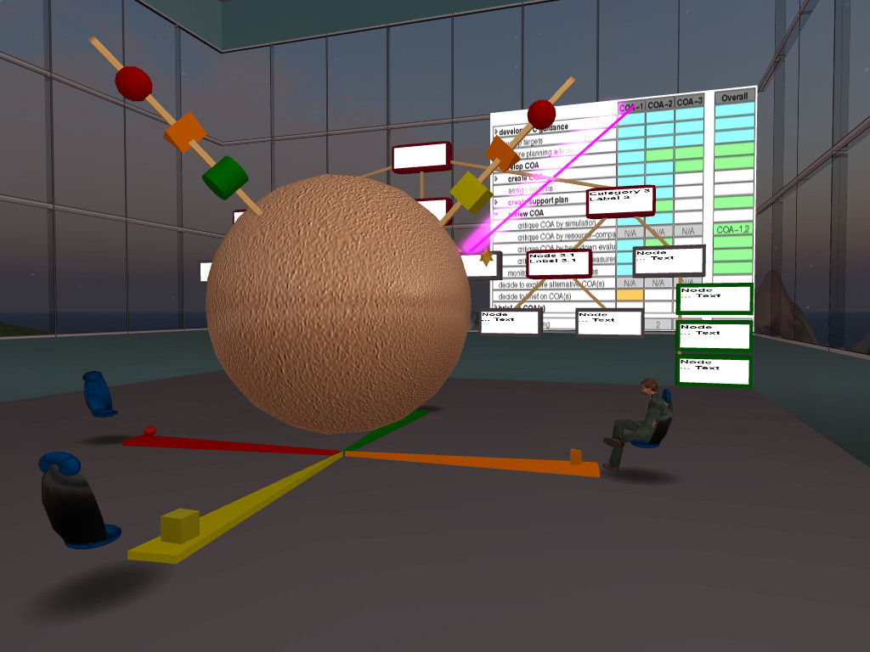
Figure 9: Experimental visualizations in 3D space for concept maps, semantic nets and issue argumentation
The more exciting possibility is the use 3D displays of concept maps perhaps with shared media content projection and updates on the faces of the 3D elements and inter activity via active 3D elements to truly bring to life concepts maps and make better use of the 3D space opportunities offered by which virtual worlds and the virtual collaboration environment.

References
Cross, R. and Parker, A. (2004). The Hidden Power of Social Networks. Harvard Business School Press, Boston, MA.
Fourie, L. and van der Westhuizen, T. (2008), The Value and Use of Concept Maps in the Alignment of Strategic Intent. In Concept Mapping: Connecting Educators, Proc. of the Third Int. Conference on Concept Mapping. Tallinn, Estonia & Helsinki, Finland.
Lintern, Gavan (2009). The Foundations and Pragmatics of Cognitive Work Analysis: A systematic approach to design of large-scale information systems [On-line]. Available: www.cognitiveSystemsDesign.net.
Hoffman, R. and Shattuck, L. (2006). Should We Rethink How We Do OPORDS? Military Review. pp. 100-107.
Pinelle, D., Gutwin, C, and Greenberg. S. (2003). Task analysis for teamware usability evaluation: Modeling shared-workspace tasks with the mechanics of collaboration, ACM Transactions on Computer-Human Interaction (TOCHI), 10 (4), 281-311.
Sallnas, E. (2005). Effects of communication mode on social presence, virtual presence, and performance in collaborative virtual environments. Presence, 14 (4), 434-449.
Short, J., Williams, E., and Christie, B. (1976). The Social Psychology of Telecommunications. London, England: John Wiley.
Tate, A., Potter, S. and Dalton, J. (2009), I-Room: a Virtual Space for Emergency Response for the Multinational Planning Augmentation Team, Proceedings of the Fifth International Conference on Knowledge Systems for Coalition Operations (KSCO-2009).
Tate, A., Chen-Burger, Y-H., Dalton, J., Potter, S., Richardson, D., Stader, J., Wickler, G., Bankier, I., Walton, C. and William, P.G. (2010) I-Room: A Virtual Space for Intelligent Interaction, IEEE Intelligent Systems.

Tuckman, B. (1965). Developmental sequence in small teams. Psychological Bulletin, 63 (6), 384-399.
Vicente, K. J. (1999). Cognitive Work Analysis. Lawrence Erlbaum Associates, Mahwah, NJ.
Figure 0: Virtual World 3D Space - I-Room showing Concept Map and Other Information Feeds
Figure 0: Virtual World 3D Space - I-Room showing Concept Map and Other Information Feeds
Figure 1: Concept Map-based Operational Order
Figure 2: Cmap projection in Second Life
Figure 3: Protocol Template in Cmap format
Figure 4: Collaboration protocol in Cmap format
Figure 5: Integrated Problem Map data entry form
Figure 6: Team meeting Second Life with Cmaps
Figure 7: Integrated plan
Figure 8: Sub-plan – Containment
Figure 9: Experimental visualizations in 3D space for concept maps, semantic nets and issue argumentation

