I-Room: Integrating Intelligent Agents and Virtual Worlds
Austin Tate
Artificial Intelligence Applications Institute (AIAI)
School of Informatics, The University of Edinburgh, UK
[E-mail: a.tate@ed.ac.uk Avatar: Ai Austin Time Zone: GMT]

An I-Room is an environment for intelligent interaction. It can provide support for formal business meetings, tutorials, project meetings, discussion groups and ad-hoc interactions. The I-Room can be used to organise and present pre-existing information as well as displaying real-time information feeds from other systems such as sensor networks and web services. It can also be used to communicate with participants, facilitate interactions, record and action the decisions taken during the collaboration.

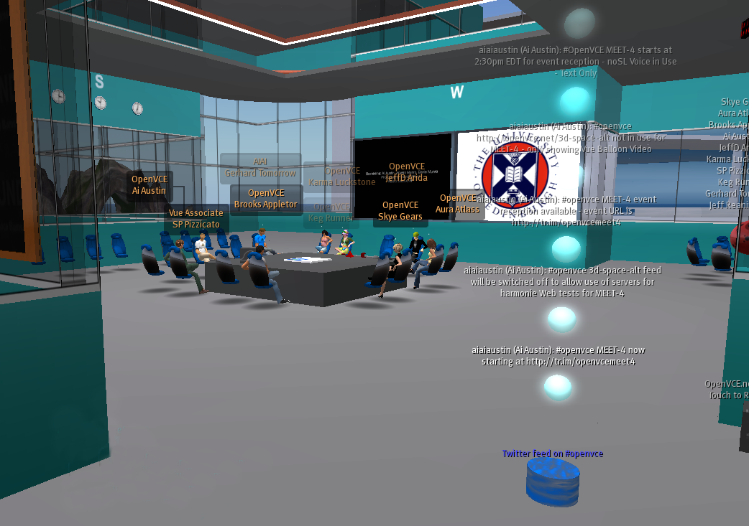

Using the I-Room concept within virtual worlds gives a collaboration an intuitive grounding in a persistent 3D space in which representations of the participants (their “avatars”) appear and the artifacts and resources surrounding the collaboration can be granted a surrogate reality – which, where these items consist of information, might be more meaningful or compelling than their physical reality.
Beyond the advantages conferred by a shared interaction space, the I-Room can be used to deliver intelligent systems support for meetings and collaborative activities. In particular, the I-Room is designed to draw on I-X Technology (Tate 2000) which provides intelligent and intelligible (to human participants) task support, process management, collaborative tools and planning aids to participants. The I-Room can also utilise a range of manual and automated capabilities or agents in a coherent way. The participants share meaningful information about the processes or products they are working on through a common conceptual model called <I-N-C-A> (Tate 2003). The I-Room framework is flexible enough to provide participants in I-Room meetings with access to knowledge-base content and natural language generation technology that tailors utterances to specific experience levels of users.
I-Rooms have been in use since early 2008 for a range of collaborative groups, meetings and training exercises. Some I-Rooms are constantly available to their users through publicly accessible virtual worlds like Second Life™.
References
I-Room (2009) I-Room: A Room for Intelligent Interaction. http://www.aiai.ed.ac.uk/project/i-room/
Tate, A. (2000) Intelligible AI Planning. In Proceedings of ES2000, The Twentieth British Computer Society Special Group on Expert Systems International Conference on Knowledge Based Systems and Applied Artificial Intelligence, 3-16, Springer.
Tate, A. (2003) <I-N-C-A>: an Ontology for Mixed-Initiative Synthesis Tasks. In Proceedings of the Workshop on Mixed-Initiative Intelligent Systems (MIIS) at the International Joint Conference on Artificial Intelligence (IJCAI-03). Acapulco, Mexico, August 2003.
Tate, A., Chen-Burger, Y-H., Dalton, J., Potter, S., Richardson, D., Stader, J., Wickler, G., Bankier, I., Walton, C. and William, P.G. (2010) I-Room: A Virtual Space for Intelligent Interaction, IEEE Intelligent Systems (to appear).
Tate, A., Dalton, J. and Potter, S (2009) I-Room: a Virtual Space for Emergency Response for the Multinational Planning Augmentation Team, Proceedings of the Fifth International Conference on Knowledge Systems for Coalition Operations (KSCO-2009), Chilworth Manor, Southampton, UK, 31st March to 1st April 2009.
Tate, A., Dalton, J., and Stader, J. (2002) I-P2 – Intelligent Process Panels to Support Coalition Operations. In Proceedings of the Second International Conference on Knowledge Systems for Coalition Operations (KSCO-2002). Toulouse, France, April 2002.

http://secondlife.com

