Cognitively Engineering a Virtual Collaboration Environment for Crisis Response

Jeffrey T. Hansberger
Army Research Laboratory
115 Lake View Parkway
Suffolk, VA 23435, USA
+1 757-203-3431
jeff.hansberger@us.army.mil
Austin Tate
AIAI, University of Edinburgh
Appleton Tower, Crichton St
Edinburgh EH8 9LE, UK
+44 131 650 2732
a.tate@ed.ac.uk
Brian Moon
Perigean Technologies
brian@perigeantechnologies.com
Rob Cross
University of Virginia
robcross@virginia.edu

ABSTRACT
Crisis response situations require collaboration across many different organizations with different backgrounds, training, procedures, and goals. The Indian Ocean Tsunami in 2004 and the Hurricane Katrina relief efforts in 2005 emphasized the importance of effective communication and collaboration. In the former, the Multinational Planning Augmentation Team (MPAT) supported brokering of requests for assistance with offers of help from rapidly deployed military and humanitarian assistance facilities. In the aftermath of Hurricane Katrina, the National Guard Soldiers and active component Army Soldiers assisted other state, federal, and non-government organizations with varying degrees of efficiency and expediency. Compounding the challenges associated with collaboration during crisis situations is the distributed nature of the supporting organizations and the lack of a designated leader across these military, government, non-government organizations. The Army Research Laboratory is collaborating with the University of Edinburgh, University of Virginia, Perigean Technologies, and Carnegie Mellon University in the design a virtual collaborative environment (VCE) to support a crisis response community of interest and crisis action planning activities.

The design of the VCE was guided through a cognitive work analysis (CWA) [3, 7] for distributed collaboration. A CWA consists of multiple phases that systematically analyze the constraints across work tasks, collaborators/colleagues, organizations, and activities. A CWA typically focuses on how work can be done compared to other types of task analyses that focus on how work should be done in a limited set of situations, which can decrease the flexibility and adaptability of the socio-technical system. The CWA identified the critical functions to facilitate distributed collaboration and allowed us to select the appropriate technology to support those functions [4]. It also guided the design, presentation, and structure of information and processes in the three primary components of the VCE, 1) a Net-centric protocol, 2) visualization tools, and 3) collaboration tools.

The VCE consists primarily of visualization and collaborative tools and a net-centric protocol that guides distributed collaborative activities across the tools and diverse set of organizations typically involved in crisis response. The net-centric protocol is tied to Tuckman’s [6] “Forming, Storming, Norming, and Performing” collaboration model and how individuals communicate and collaborate through social networks [1]. It addresses some of the unique capabilities and challenges of distributed collaboration within a virtual environment such as virtual presence and trust, asynchronous planning, and virtual activity awareness.

The visualization tools developed for the VCE support a number of functions for distributed collaboration. A dynamic network visualization tool provides relationship information across the crisis response community of interest members, organizations, projects, areas of expertise, and geographical areas of interest. It allows a community member to find and explore other members with needed expertise for possible collaboration efforts. The use of concept maps is also being used as a visualization technique to provide a centralized perspective on the emergent plan without imposing centralization of the development process. Concept maps have been used in a related way to improve the basic process for creating, sharing, and using operational orders and operational plans for military operations [2].

The collaboration tools consist of both a collaborative portal consisting of a suite of Web 2.0 tools and a 3D virtual collaboration space (Figures 1 & 2). All tools were selected to support the key functions identified in the CWA and based upon their open-source nature in order to make them accessible and available to the wide range of organizations that make-up the crisis response community. The open source nature also allows us to integrate new or better capabilities as new technology is developed and made available. A combination of social networking capabilities for group and activity awareness, microblogging for transmission of messages to mobile devices, and collaboration on shared and persistent concepts through wikis are some examples. The 3D space is currently represented in Second Life and Opensim and represents a range of collaborative spaces to facilitate meetings with audio and text communication from 100-400 individuals, presentations or live streaming video to a distributed audience, and sharing of information through the expo center and other virtual resources.
More details can be found at http://openvce.net.
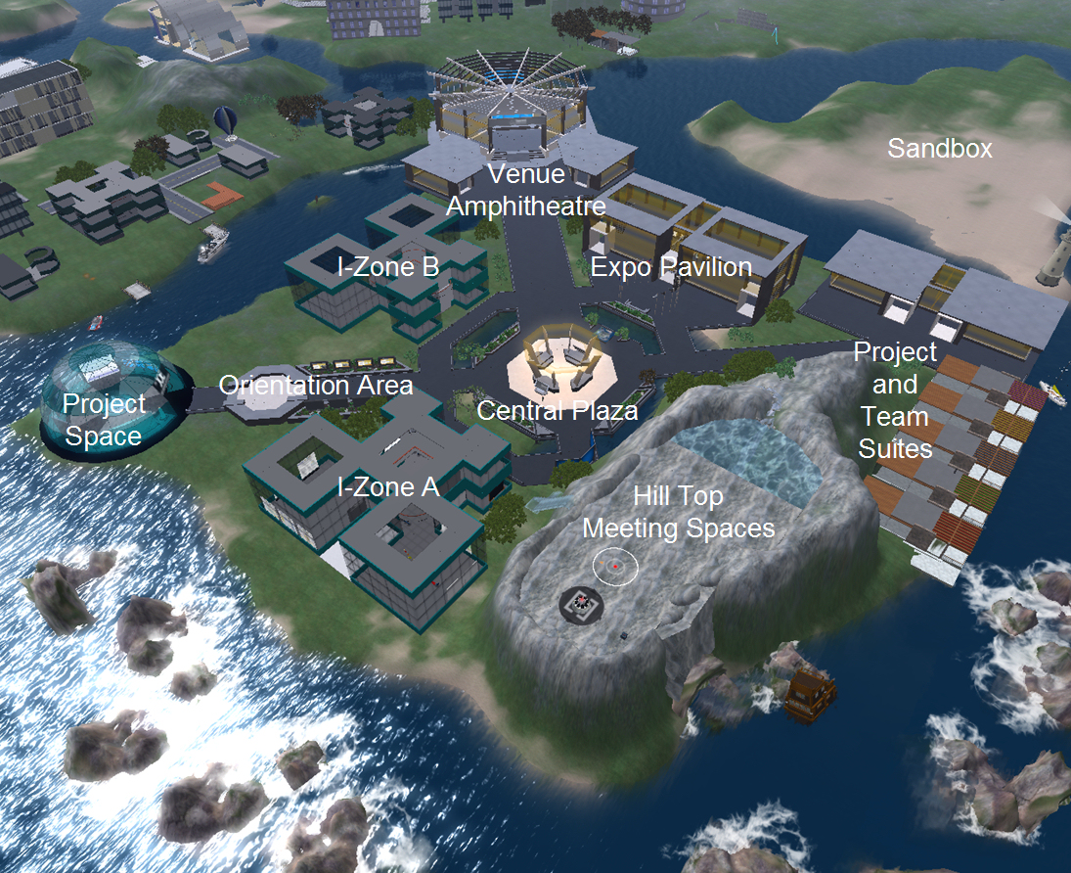
Figure 1. 3D virtual environment for synchronous collaboration.

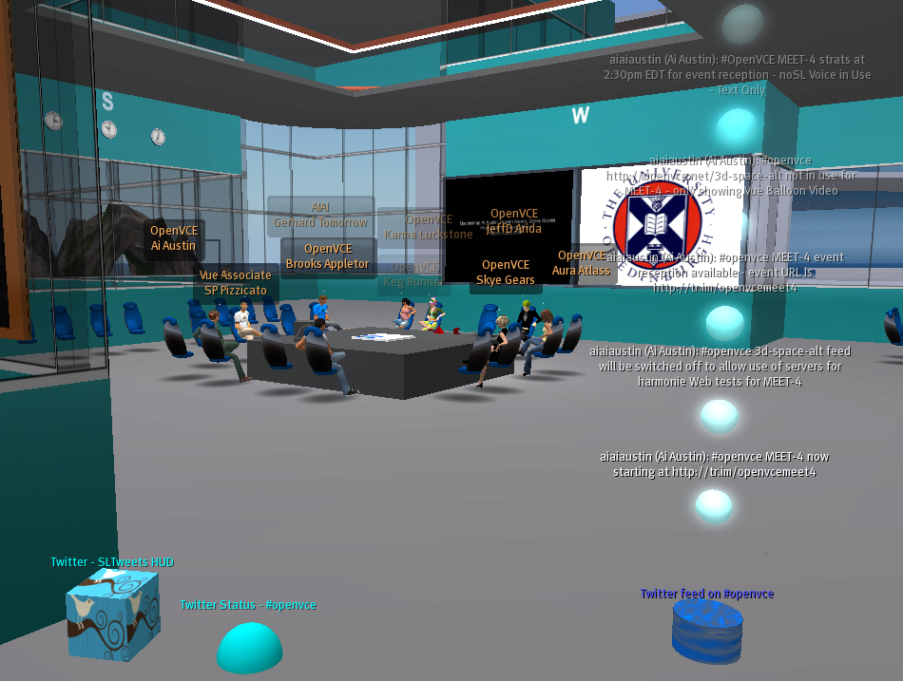
Figure 2. 3D virtual meeting area for small group collaboration and planning efforts.

A series of experiments are planned to test the effectiveness of the net-centric protocol and the visualization and collaboration tools compared to current processes and technology widely used today for collaborative efforts across organizations for crisis response. The variables of interest are how the VCE affects access to subject matter experts, trust, uncertainty, information flow, and planning. The intention of the VCE project is to create a socio-technical system that facilitates distributed collaboration across crisis response organizations and agencies that typically do not collaborate well when their collaboration is needed most.

ACKNOWLEDGEMENTS
The authors, their organizations and project funding partners are authorized to reproduce and distribute reprints and on-line copies for their purposes notwithstanding any copyright annotation hereon. The views and conclusions contained herein are those of the authors and should not be interpreted as necessarily representing the official policies or endorsements, either expressed or implied, of other parties.

REFERENCES
[1] Cross, R. and Parker, A. (2004). The Hidden Power of Social Networks. Harvard Business School Press, Boston, MA.
[2] Hoffman, R. & Shattuck, L. (2006). Should we rethink how we do OPORDS? Military Review, March-April, 100-107.
[3] Lintern, Gavan (2009). The Foundations and Pragmatics of Cognitive Work Analysis: A systematic approach to design of large-scale information systems [On-line]. Available: www.cognitiveSystemsDesign.net
[4] Pinelle D., Gutwin C., Greenberg, S. (2003). Task analysis for groupware usability evaluation: Modeling shared-workspace tasks with the mechanics of collaboration, ACM Transactions on Computer-Human Interaction (TOCHI), 10 (4), 281-311.
[5] Tate, A., Potter, S. and Dalton, J. (2009), I-Room: a Virtual Space for Emergency Response for the Multinational Planning Augmentation Team, Proceedings of the Fifth International Conference on Knowledge Systems for Coalition Operations (KSCO-2009) (Lawton, J., Patel, J. and Tate. A. eds.).
[6] Tuckman, Bruce (1965). Developmental sequence in small groups. Psychological Bulletin, 63 (6), 384-399.
[7] Vicente, K. J. (1999). Cognitive Work Analysis. Lawrence Erlbaum Associates, Mahwah, NJ.

