Using I-X Process Panels as Intelligent To-Do Lists for Agent Coordination in Emergency Response

Stephen Potter  AIAI, University of Edinburgh  s.potter@ed.ac.uk | Austin Tate  AIAI, University of Edinburgh  a.tate@ed.ac.uk
Gerhard Wickler
AIAI, University of Edinburgh
g.wickler@ed.ac.uk

ABSTRACT
The aim of this paper is to describe the I-X system with its principal user interface, the I-X Process Panel, its underlying ontology, <I-N-C-A>, and how this panel can be used as an intelligent to-do list that assists emergency responders in applying pre-defined standard operating procedures in different types of emergencies. In particular, multiple instances of I-X Process Panels can be used as a distributed system to coordinate the efforts of independent emergency responders as well as responders within the same organization. Furthermore, it can be used as an agent wrapper for other software systems such as web services to integrate these into the emergency response team as virtual members. The heart of the I-X system is an automated planner that can be used to synthesize courses of action or explore alternative options manually.

Keywords
HTN planning; agent capabilities; domain modeling; agent coordination.

INTRODUCTION
There are a number of tools available that help people organize their work. One of these is provided with virtually every organizer, be it electronic or paper-based: the “to-do” list. This is because people are not good at remembering long lists of potentially unrelated tasks. Writing these tasks down and ticking them off when they have been done is a simple means of ensuring that everything that needs to be done does get done, or at least, that a quick overview of unaccomplished tasks is available. In responding to an emergency this is vital, and the larger the emergency is, the more tasks need to be managed.
I-X is a framework that can be used to create an application in which multiple agents adopt a task-centric view of a situation, and which supports the necessary coordination of their activities to respond to that situation. The I-X Process Panel provides the functionality of a to-do list and thus, it is a useful tool when it comes to organizing the response to an emergency. The idea of using a to-do list as a basis for a distributed task manager is not new (Kreifelts, Hinrichs and Woetzel, 1993). However, I-X goes well beyond this metaphor and provides a number of useful extensions that facilitate the finding and adaptation of a complete and efficient course of action.
The remainder of this paper is organized as follows: Firstly, we will describe the ontology underlying the whole system and approach. This is necessary for understanding the philosophy behind I-X Process Panels, the user interface that provides the intelligent to-do list. Next, we will describe how the intelligence in the to-do list part is achieved using a library of standard operating procedures, an approach based on HTN (Hierarchical Task Network) planning (Sacerdoti, 1975; Tate 1977). The HTN planning system built into I-X is seamlessly integrated into the system. I-X is not meant to only support single agents in responding to an emergency, but it also provides mechanisms for connecting a number of I-X Process Panels and supporting a coordinated multi-agent response. The key here is a simple agent capability model that automatically matches tasks to known capabilities for dealing with these tasks.

Using I-X Process Panels
I-X Process Panels constitute the primary user interface to an I-X application. A panel more or less directly reflects the ontology underlying the whole I-X system, the <I-N-C-A> ontology (Tate, 2003), which is a generic description of a synthesis task, dividing it into four major components: Issues, Nodes, Constraints, and Annotations. Of these, nodes are the activities that need to be performed in a course of action, thus functioning as the items in an intelligent to-do list. The other elements contain issues as questions remaining for a given course of action, information about the constraints involved and the current state of the world, and notes such as reports or the rationale behind items in the plan.

The <I-N-C-A> Ontology
In <I-N-C-A>, both processes and process products are abstractly considered to be made up of a set of Issues which are associated with the processes or process products to represent potential requirements, questions raised as a result of analysis or critiquing, etc. They also contain Nodes (activities in a process, or parts of a physical product) which may have parts called sub-nodes making up a hierarchical description of the process or product. The nodes are related by a set of detailed Constraints of various kinds. Finally there can be Annotations related to the processes or products, which provide rationale, information and other useful descriptions.
<I-N-C-A> models are intended to support a number of different uses:
- for automatic and mixed-initiative generation and manipulation of plans and other synthesized artifacts and to act as an ontology to underpin such use;
- as a common basis for human and system communication about plans and other synthesized artifacts;
- as a target for principled and reliable acquisition of knowledge about synthesized artifacts such as plans, process models and process product information;
- to support formal reasoning about plans and other synthesized artifacts.
These cover both formal and practical requirements and encompass the requirements for use by both human and computer-based planning and design systems.

Issues
The issues in the representation may give the outstanding questions to be handled and can represent decisions yet to be taken on objectives to be satisfied, ways in which to satisfy them, questions raised as a result of analysis, etc. Initially, an <I-N-C-A> artifact may just be described by a set of issues to be addressed (stating the requirements or objectives). The issues can be thought of as implying potential further nodes or constraints that may have to be added into the specification of the artifact in future in order to address the outstanding issues.
In work on I-X until recently, the issues had a task or activity orientation to them, being mostly concerned with actionable items referring to the process underway – i.e., actions in the process space. This has caused confusion with uses of I-X for planning tasks, where activities also appear as nodes. This is now not felt to be appropriate, and as an experiment we are adopting the gIBIS orientation of expressing these issues as questions to be considered (Selvin, 1999; Conklin, 2003). This is advocated by the Questions–Options–Criteria approach (MacLean, Young, Bellotti and Moran, 1991) – itself used for rationale capture for plans and plan schema libraries in earlier work (Polyak and Tate, 1998) and similar to the mapping approaches used in Compendium (Selvin et. al, 2001).

Nodes
The nodes in the representation describe components that are to be included in the design. Nodes can themselves be artifacts that can have their own structure with sub-nodes and other <I-N-C-A> described refinements associated with them. The node constraints (which are of the form “include node”) in the <I-N-C-A> model set the space within which an artifact may be further constrained. The “I” (issues) and “C” (constraints) restrict the artifacts within that space which are of interest.

Constraints
The constraints restrict the relationships between the nodes to describe only those artifacts within the design space that meet the objectives. The constraints may be split into “critical constraints” and “auxiliary constraints” depending on whether some constraint managers (solvers) can return them as “maybe” answers to indicate that the constraint being added to the model is okay so long as other critical constraints are imposed by other constraint managers. The maybe answer is expressed as a disjunction of conjunctions of such critical or shared constraints. More details on the “yes/no/maybe” constraint management approach used in I-X and the earlier O-Plan systems are available in Tate (1995).
The choices of which constraints are considered critical and which are considered as auxiliary are decisions for an application of I-X and specific decisions on how to split the management of constraints within such an application. It is not pre-determined for all applications. A temporal activity-based planner would normally have object/variable constraints (equality and inequality of objects) and some temporal constraints (maybe just the simple before {time-point-1, time-point-2} constraint) as the critical constraints. But, for example in a 3D design or a configuration application, object/variable and some other critical constraints (possibly spatial constraints) might be chosen. It depends on the nature of what is communicated between constraint managers in the application of the I-X architecture.

Annotations
The annotations add additional human-centric information or design and decision rationale to the description of the artifact. This can be of assistance in making use of products such as designs or plans created using this approach by helping guide the choice of alternatives should changes be required.

I-X Process Panels as Intelligent To-Do Lists
The user interface to the I-X system, the I-X Process Panel, shows four main parts that reflect the four components of the <I-N-C-A> ontology just described. They are labeled “Issues”, “Activities”, “State”, and “Annotations”, as shown in figure 1.
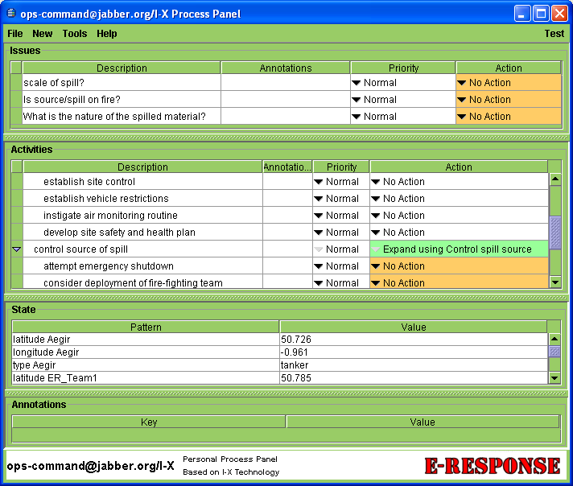
Figure 1: An I-X Process Panel, shown here addressing a simulated oil spill incident.
In the case of the artifact to be synthesized being a course of action, the nodes that will eventually make up the artifact are activities, and these play the central role in the view of an I-X panel as an intelligent to-do list. Users can add an informal description of a task to be accomplished to the activities section of the panel where it will appear as the description of that activity. Each activity consists of four parts listed in the four columns of the activities part of the panel:
- Description: This can be an informal description of a task such as “do this” or it can be a more formal pattern consisting of an activity name (verb) followed by a list of parameters such as
(deploy ?team-type)
where the words preceded by a question mark are variables that need to be bound before the task can be dealt with.
- Annotation: This can be used to add arbitrary pieces of information to a specific activity.
- Priority: This defines the priority of the activity. Possible values are Highest, High, Normal, Low, or Lowest.
- Action: This field contains a menu that gives the various options that are available to deal with the activity.
It is the last field that allows the user to mark the task as “Done”, which corresponds to ticking off an item in a to-do list. Other options that are always available are “No action”, the default value until the task has been dealt with, or “N/A” if the activity does not make sense and is “not applicable” in the current context.
The entries in the action menu related to an activity are determined by the activity handlers. These are modules that can be plugged into the I-X system and define ways in which activities can be dealt with. If an activity handler matches an activity it can add one or more entries to the according action menu. The most commonly used activity handler in the context of HTN planning adds “Expand” items to this menu, and this is the point where the to-do list becomes intelligent.
Instead of just being able to tick off an activity, users can use the knowledge in a library of standard operating procedures to break an activity down into sub-activities that, when all performed, accomplish the higher-level task. Of course, sub-activities can themselves be broken down further until a level of primitive actions is reached, at which point the library of procedures no longer contains any refinements that mach the activities. This mechanism supports the user in two ways:
- The library of standard operating procedures may contain a number of different refinements that all match the present activity. All of the applicable procedures are added to the action menu by the activity handler, thus giving the user a comprehensive and quick overview of all the known standard procedures available to deal with this task.
- When a refinement for an activity is chosen, the I-X Process Panel shows all the sub-activities as new items in the to-do list. This ensures that users do not forget to include sub-activities, a common problem especially for infrequently applied procedures.
Both of these problems become only more severe when the user is under time pressure and lives depend on the decisions taken.
Note that the intelligence of the to-do list comes in through the underlying HTN planner that finds applicable refinements in the library and, on demand, can complete a plan to perform a given task automatically, propagating all constraints as it does so. Equally important, however, is the knowledge contained in the library of standard operating procedures. From the perspective of the user this means that I-X can actively suggest ways of performing an activity on the to-do list or allowing the user to explore the set of options currently available.

Other Features
As activities are the nodes that make up a course of action, it is only natural that the activity part of the I-X Process Panel forms the centre of attention for our view of I-X as an intelligent to-do list. In fact, we have implemented a cut-down interface called Post-IX which only shows this part of the panel (and so provides a minimal or ‘entry level’ interface to the system). We shall now briefly describe the other parts of a panel and how they are used.
World state constraints are used to describe the current state of the world. Essentially, these are a state-variable representation of the form “pattern = value” allowing the user to describe arbitrary features of the world state. They are displayed in the I-X Process Panel in the constraints section. However, it is not expected that users will find this list of facts about the world style representation very useful. Thus, I-X allows for the registration of world state viewers that can be plugged into the system. For example, BBN Openmap (Openmap, 2005) has been used in a number of applications to provide a 2D world map with various features. Most importantly, it can be automatically synchronized with the world state constraints such that icons in the map always represent current positions of the entities they represent. Constraints are propagated and evaluated by constraint managers that are plugged into the I-X system.
Issues can be seen as a meta to-do list: instead of listing items that need to be done to deal with an emergency in the real world, they list the questions or outstanding items that need to be dealt with to make the current course of action complete and consistent. Often, these will be flaws in the current plan, but they can also be opportunities that present themselves, or simply facts that need to be verified to ensure a plan is viable. Issues can be either formal, in which case registered issue handlers can be used to deal with them just like activity handlers deal with activities, or they can be informal.
Annotations are used for arbitrary comments about the course of action as a whole, stored as “keyword = value” patterns.

Standard Operating Procedures
As outlined above, standard operating procedures describe the knowledge underlying the intelligent to-do list. The formalism is based on refinements used in HTN planning and will be explained next. However, users are not expected to learn this formalism, but they can use a domain editor and its graphical user interface to define the library of procedures.

Activity Refinements in HTN Planning
What are known as standard operating procedures to domain experts are called methods in HTN planning (Ghallab, Nau and Traverso, 2004). Methods formally describe how a task can be broken down into sub-tasks. The definition of a method consists of four main parts:
- Task pattern: an expression describing the task that can be accomplished with this method;
- Name: the name of this method (there may be several for the same task);
- Constraints: a set of constraints (e.g. on the world state) that must hold for this method to be applicable; and
- Network: a description of the sub-tasks into which this method refines the given task.
The task pattern of a method is used for matching methods to items in the activity list. If the task pattern matches the activity the method will appear in the action menu of the activity in the panel as a possible expansion. This is also where the name of the method will be used: the menu displays an entry “Expand using <name>” where name is the name of the method. In this way, the user can easily distinguish the different options available. The constraints are used to decide whether the method is applicable in the current world state. If they are satisfied, the method can be selected in the action menu, otherwise the unsatisfied constraints can be seen as issues, namely sub-goals that need to be achieved in some way. Finally, the network contains the list of sub-tasks that will be added as activities to the panel when the method is selected. The ordering constraints between sub-tasks are used to show in the interface those sub-tasks that are ready for tackling at any given time.

The I-X Domain Editor
Figure 2 shows an example of the I-X Domain Editor for defining standard operating procedures. The panel on the left lists all the currently defined procedures by name, and the task pattern they match. One, called “Oil Spill Response (General)”, is shown being edited. There are a number of views available to edit a refinement. The one shown is the graphical view which shows all the direct sub-tasks with their begin and end time points. Arrows between these activities indicate temporal ordering constraints, for example, the activity “Control source of spill” cannot be started before “Ensure safety of public and response personnel” has been completed. However, the activities “Control source of spill” and “Manage coordinated response effort” can then be performed in parallel. Other views show the conditions and effects that can be defined for refinements.
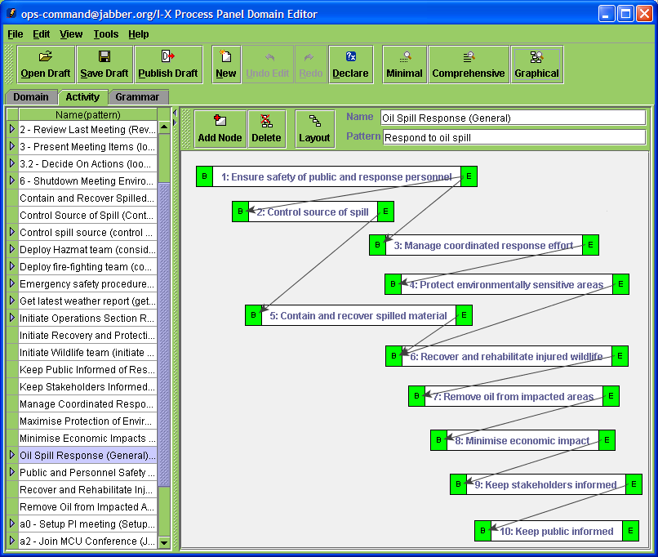
Figure 2: The I-X Domain Editor, here shown modelling an oil spill response standard operating procedure.

Agent Coordination with Multiple Panels
So far we have described I-X as a tool for assisting a single person in organizing and executing the response to an emergency. However, I-X is also a tool that supports the coordination of the response of multiple agents. I-Space is a tool in which users can register the capabilities of other agents. These capabilities can then be used from an I-X panel through inter-panel communication. Augmented instant messaging can be used to directly communicate with other responders via their panels.

I-Space
Every I-X panel can be connected to a number of other I-X agents. Each I-X agent represents an agent that can potentially contribute to the course of action taken to respond in an emergency. The I-Space holds the model of the other agents and can be managed with a simple tool as shown in figure 3.
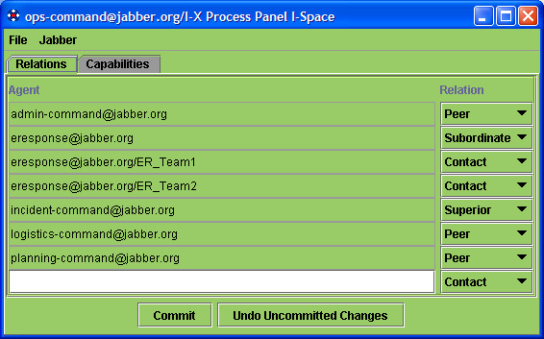
Figure 3: The I-Space Tool. The agents’ relations to each other governs the nature of interactions between them.
Associated with each agent are one or more communication strategies which define how messages can be sent to this agent. By default, a built-in communication strategy simply sends XML-formatted messages to a given IP-address and socket. Alternatively, a Jabber-strategy (Jabber, 2006) is available for using a chat-based mechanism for communication. New communication strategies can be added to communicate with agents implemented using different frameworks.
Usually users will not be concerned with the question of how communication takes place as long as the system can find a way, but more with the relationships between the different agents in the I-Space. Within an organization a hierarchical structure is common, so collaborating agents are usually either superiors or subordinates. They can also be modelled as peers, which is also how agents from other organizations can be described. If the agent to be integrated into the virtual organization is a software agent it is described as a (web) service. Finally, a generic relation “contact” is available, but it does not specify what exactly the relationship to this agent is.

Agent Capabilities
At present there is only a relatively simple capability model implemented in I-X. The idea behind this model is that activities are described by verbs in natural language and thus, a task name can be used as a capability description. Parameter values are currently not used to evaluate a capability. Each agent is associated with a number of capabilities that can be called upon.
In the future it will be possible to use a much more sophisticated model. The problem with more complex representations is often that matching capabilities to tasks can be computationally expensive, and when the number of known capabilities becomes large, this can be a problem, which is why the current model is so simple. On the other hand, capabilities can often only be distinguished by a detailed description. One approach to this trade-off is to provide a representation that is flexible, allowing for a more powerful representation where required, but retaining efficiency if the capability description is simple (Wickler, 1999).
Conceptually, the description of a capability is similar to that of an action, which is not surprising as a capability is simply an action that can be performed by some agent. A capability description essentially consists of six components:
- Name: The name of a capability corresponds to the verb that expresses a human-understandable description of the capability.
- Inputs: These are the objects that are given as parameters to the capability. This may be information needed to perform the capability, such as the location of a person to be recovered, objects to be manipulated by the capability, such as paper to be used in a printing process, or resources needed to perform the capability.
- Outputs: These are objects created by the capability. Again, this can be information such as references to hospitals that may have been sought, or they can be new objects if the capability manufactures these.
- Input constraints: These are effectively preconditions, consisting of world state constraints that must be true in the state of the world just before the capability can be applied. Usually, they will consist of required relations between the inputs.
- Output constraints: These are similar to effects, consisting of world state constraints that are guaranteed to be satisfied immediately after the capability has been applied. Usually, they will consist of provided relations between the outputs.
- I-O constraints: These cross constraints link up the inputs with the outputs. For example, a prioritization capability might order a given list of options according to some set of criterions. A cross constraint, referring to both the situation before and after the capability has been applied is necessary to say that the given list of options and the prioritized list contain the same elements.
This capability model can be used to describe the abilities of real-world agents that ultimately must be deployed to do things, or for software agents that provide information that can be used to guide the activity in the physical world.

Handling Activities through Task Distribution
From a user’s perspective, task distribution is integrated into the user interface through the “action” menu in the activities part of the panel as just another option available to deal with an activity. The agent relationship is used to determine in which way the activity can be passed to another agent, for example, if the other agent is a subordinate the activity can simply be delegated to the agent.
The capability model is used to filter the options that are listed in the action menu. Currently there is the option of specifying no capabilities for an agent in which case the agent will always be listed. If there is a list of capabilities associated with an agent than these options will only be listed if there is an exact match of the verb capability.

Structured Instant Messaging
Another tool that is widely used for the coordination of efforts in response to an emergency is instant messaging. Like a to-do list, it is very simple and intuitive, but it lacks the formal structure that is needed when the scale of the event that needs to be addressed increases. As for the to-do list, I-X builds on the concept of instant messaging, extending it with the <I-N-C-A> ontology, but also retaining the possibility of simple and informal messages. Thus, users can use structured messaging when this is appropriate, or continue to use unstructured messaging when this is felt to be more useful.
The structured version can be activated by selecting a message type: issue, activity, constraint or annotation, rather than a simple chat message. An <I-N-C-A> object with the content of the message will then be created and sent to the receiving I-X agent. Since all messages between agents are <I-N-C-A> objects, the receiving agent will treat the instant messenger generated message just like any other message from an I-X panel, e.g. the message generated when a task is delegated to a subordinate agent. In this way, structured instant messaging can be seamlessly integrated into the I-X framework without loosing the advantages of informal communications.

Applications
I-X has been applied to a number of application scenarios in the area of emergency response. Two projects are currently under way in this context: Co-OPR and FireGrid.
Personnel recovery teams must operate under intense pressure, taking into account not only hard logistics, but "messy" factors such as the social or political implications of a decision. The Collaborative Operations for Personnel Recovery (Co-OPR) project has developed decision-support for sensemaking in such scenarios, seeking to exploit the complementary strengths of human and machine reasoning (Buckingham Shum, Selvin, Sierhuis, Conklin, Haley and Nuseibeh, 2006; Tate, Dalton, and Stader, 2002). Co-OPR integrates the Compendium sensemaking-support tool for real time information and argument mapping, with the I-X artificial intelligence planning and execution framework to support group activity and collaboration. Both share a common model for dealing with issues, the refinement of options for the activities to be performed, handling constraints and recording other information. The tools span the spectrum from being very flexible with few constraints on terminology and content, to knowledge-based relying on rich domain models and formal conceptual models (ontologies). In a personnel recovery experimental simulation of an UN peacekeeping operation, with roles played by military planning staff, the Co-OPR tools were judged by external evaluators to have been very effective.
An example project which needs, and is helping to develop, an integrated and inter-disciplinary approach is FireGrid (Berry et. al, 2005; FireGrid, 2005). This is a UK project to address emergency response in the built environment, where sensor grids in large-scale buildings are linked to super-real time grid-based simulations, and used to assist fire responders to work with the building’s internal response systems and occupants to form a "team" to deal with the emergency.
FireGrid will integrate several technologies, extending them where necessary:
- High Performance Computing involving fire models and structural models
- Wireless sensors in extreme conditions with adaptive routing algorithms, including input validation and filtering
- Grid computing including sensor-guided computations, mining of data streams for key events and reactive priority-based scheduling
- Command and Control using knowledge-based planning techniques with user guidance

Conclusions
In this paper we have described the I-X framework and I-X Process Panels, which can be seen as providing a distributed and intelligent to-do list for agent coordination in emergency response. The to-do list analogy provides users with a familiar metaphor that should make an I-X application easy to understand. However, I-X extends this concept in two important ways.
- Firstly, items on the to-do list can be expanded using pre-defined standard operating procedures. Such procedures are available in many scenarios but usually only in the form of books or manuals that, even if they are to hand, are often too cumbersome to use in a real emergency. The encoding of such standard operating procedures in I-X is supported by a graphical domain editor. The intention is, of course, that this takes place before an emergency occurs. As a result, this knowledge is at hand and can be used when it is most needed. The HTN planner that is available in I-X uses the library of standard operating procedures to update the Process Panel, showing the user the various ways in which an item on the to-do list can be refined. Thus, the apparent intelligence of the panel is in fact based on the knowledge encoded by a domain expert before an emergency occurs.
- The second extension provided by I-X is the capability model. This allows for a number of panels to be linked to respond in related ways to an emergency. For the user this means that the panel can suggest other agents that may be able to deal with an item if they choose to advertise a matching capability. Furthermore, the panel provides support for the management of such task distribution by sending activities with their parameters and keeping track of reports relating to that activity as they come back.
Both these extensions are integrated into the panel in a seamless way. Together these technologies are used to effectively support emergency responders in organizing a collaborative response quickly and efficiently.

ACKNOWLEDGMENTS
The I-X project is sponsored by the Defense Advanced Research Projects Agency (DARPA) under agreement number F30602-03-2-0014. Parts of this work are supported by the Advanced Knowledge Technologies (AKT) Interdisciplinary Research Collaboration (IRC) sponsored by the UK Engineering and Physical Sciences Research Council by grant no. GR/N15764/01. The University of Edinburgh and research sponsors are authorized to reproduce and distribute reprints and on-line copies for their purposes notwithstanding any copyright annotation hereon. The views and conclusions contained herein are those of the authors and should not be interpreted as necessarily representing the official policies or endorsements, either expressed or implied, of other parties.

REFERENCES
- Berry, D., Usmani, A., Terero, J., Tate, A., McLaughlin, S., Potter, S., Trew, A., Baxter, R., Bull, M. and Atkinson, M. (2005) FireGrid: Integrated Emergency Response and Fire Safety Engineering for the Future Built Environment, UK e-Science Programme All Hands Meeting (AHM-2005), 19-22 September 2005, Nottingham, UK.
- Buckingham Shum, S., Selvin, A., Sierhuis, M., Conklin, J., Haley, C. and Nuseibeh, B. (2006). Hypermedia Support for Argumentation-Based Rationale: 15 Years on from gIBIS and QOC. In: Rationale Management in Software Engineering (Eds.) A.H. Dutoit, R. McCall, I. Mistrik, and B. Paech. Springer-Verlag: Berlin
- Conklin J. (2003) Dialog Mapping: Reflections on an Industrial Strength Case Study. In: P.A. Kirschner, S.J. Buckingham Shum and C.S. Carr (eds.) Visualizing Argumentation: Software Tools for Collaborative and Educational Sense-Making. Springer-Verlag: London, pp. 117-136.
- FireGrid (2005) FireGrid: The FireGrid Cluster for Next Generation Emergency Response Systems.
http://firegrid.org/
- Ghallab M., Nau D., and Traverso P. (2004) Automated Planning – Theory and Practice, chapter 11. Elsevier/Morgan Kaufmann.
- Jabber (2006) Jabber: Open Instant Messaging and a Whole Lot More, Powered by XMPP. http://www.jabber.org/
- Kreifelts Th., Hinrichs E., and Woetzel G. (1993) Sharing To-Do Lists with a Distributed Task Manager. In: de Michelis G. and Simone C. (eds.) Proceedings of the 3rd European Conference on Computer Supported Cooperative Work, pp 31-46, Milano, 13-17 September 1993, Kluwer, Dordrecht.
- MacLean A., Young R., Bellotti V. and Moran T. (1991) Design space analysis: Bridging from theory to practice via design rationale. In Proceedings of Esprit '91, Brussels, November 1991, pp 720-730.
- Openmap (2005) Open Systems Mapping Technology. http://openmap.bbn.com/
- Polyak S. and Tate A. (1998) Rationale in Planning: Causality, Dependencies and Decisions. Knowledge Engineering Review, Vol.13(3), pp 247-262.
- Sacerdoti E. (1975) The Nonlinear Nature of Plans. In Proceedings of the International Joint Conference on Artificial Intelligence (IJCAI), pp 206-214.
- Selvin A.M. (1999) Supporting Collaborative Analysis and Design with Hypertext Functionality, Journal of Digital Information, Volume 1 Issue 4.
- Selvin A.M., Buckingham Shum S.J., Sierhuis M., Conklin J., Zimmermann B., Palus C., Drath W., Horth D., Domingue J., Motta E. and Li G. (2001) Compendium: Making Meetings into Knowledge Events. Knowledge Technologies 2001, Austin TX, USA, March, pp 4-7.
- Tate A. (1977) Generating Project Networks. . In Proceedings of the International Joint Conference on Artificial Intelligence (IJCAI), pp 888-893.
- Tate A. (1995) Integrating Constraint Management into an AI Planner. Journal of Artificial Intelligence in Engineering, Vol. 9, No.3, pp 221-228.
- Tate, A., Dalton, J., and J. Stader, J. (2002) I-P2- Intelligent Process Panels to Support Coalition Operations. In Proceedings of the Second International Conference on Knowledge Systems for Coalition Operations (KSCO-2002). Toulouse, France, April 2002.
- Tate A. (2003) <I-N-C-A>: An Ontology for Mixed-initiative Synthesis Tasks. Proceedings of the Workshop on Mixed-Initiative Intelligent Systems (MIIS) at the International Joint Conference on Artificial Intelligence (IJCAI-03), Acapulco, Mexico, August 2003, pp 125-130.
- Wickler G. (1999) Using Expressive and Flexible Action Representations to Reason about Capabilities for Intelligent Agent Cooperation. PhD thesis, University of Edinburgh.
- Wickler, G., Tate, A. and Potter, S. (2006) Using the <I-N-C-A> Constraint Model as a Shared Representation of Intentions for Emergency Response, Proceedings of the First International Workshop on Agent Technology for Disaster Management (ATDM), at the Fifth International Joint Conference on Autonomous Agents and Multiagent Systems (AAMAS 2006), Future University, Hakodate, Japan, May 8-12, 2006.

