Interim Technical Report (Final DAML Program Technical Report)

Coalition Search and Rescue - Task Support
Intelligent Task Achieving Agents on the Semantic Web

Austin Tate and Jeff Dalton - AIAI, Edinburgh, UK
Jeffrey M. Bradshaw and Andrzej Uszok - IHMC, Pensacola, FL

Artificial Intelligence Applications Institute
The University of Edinburgh
Appleton Tower, Crichton Street, Edinburgh EH8 9LE, UK

Principal Investigator: Prof. Austin Tate. Tel: +44 131 650 2732

Contract No. F-30602-03-2-0014 (DARPA Order No. P105/00)
Contract No. F-30602-00-2-0577 (for IMHC)

Effective Date of Contract: 1 January 2003
DAML Work Expiration Date: 31 December 2004
Report Date: 13-Dec-2004

The views and conclusions contained in this document are those of the authors and should not be interpreted as representing the official policies, either expressed or implied, of the Defense Advanced Research Projects Agency, US Air Force Research Laboratory, or the U.S. Government.

Intentionally Blank

Acknowledgements

This material is based on research sponsored by the Defense Advanced Research Projects Agency (DARPA) and US Air Force Research Laboratory under agreement numbers F30602-00-2-0577 and F30602-03-2-0014. The U.S. Government, IHMC, and the University of Edinburgh are authorized to reproduce and distribute reprints and on-line copies for their purposes notwithstanding any copyright annotation hereon. The views and conclusions contained herein are those of the authors and should not be interpreted as necessarily representing the official policies or endorsements, either expressed or implied, of other parties.

Thanks to the other members of the KAoS project team: Maggie Breedy, Larry Bunch, Renia Jeffers, Matthew Johnson, Hyuckchul Jung, Shri Kulkarni, James Lott, William Taysom, and Gianluca Tonti. We are also grateful for the contributions of Mark Burstein, Pat Hayes, Luc Moreau, Grit Denker, Darren Marvin, Mike Surridge, Ron Ashri, Terry Payne, Katia Sycara, Massimo Paolucci, Naveen Srinivasan, Niranjan Suri, Paul Feltovich, Richard Fikes, Jessica Jenkins, Bill Millar, Deborah McGuinness, Rich Feiertag, Timothy Redmond, Rebecca Montanari, Sue Rho, Ken Ford, Mark Greaves, Jack Hansen, James Allen, Lars Olson, and Robert Hoffman.

Thanks to the other members of the I-X project team: Stuart Aitken, Jessica Chen-Burger, John Levine, Natasha Lino, Stephen Potter, Clauirton Siebra, Jussi Stader and Gerhard Wickler.

Intentionally Blank

Contents

1. Summary 3
2. Introduction 3
3. I-X Technology 3
3.1 I-X Process Panels 3
3.2 I-Plan 3
3.3 Other I-X Tools 3
3.4 I-X Message Formats 3
3.5 Reports and Current State 3
3.6 <I-N-C-A> Ontology 3
3.6.1 Issues 3
3.6.2 Nodes 3
3.6.3 Constraints 3
3.6.4 Annotations 3
4. KAoS Technology 3
4.1. KAoS Policy and Domain Management Services 3
4.2 Ontological Representation of KAoS Policies 3
4.3 Important KAoS Features 3
4.4 Beyond Description Logic for Policy Representation 3
4.5 Generic Semantic Web Service Policy Enforcer 3
5. CoSAR-TS Scenario 3
5.1 Binni Scenario 3
5.2 CoSAR-TS Scenario 3
6. I-K-C 3
6.1 I-X new capabilities supporting I-K-C 3
6.2 KAoS new capabilities supporting I-K-C 3
6.2.1 Mapping the OWL-S Representation of Process to the KAoS Concept of Action 3
6.2.2. KAoS Capabilities for Analyzing Action Classes 3
7. Conclusions 3
References 3
Appendix A: List of Publications 3
Joint AIAI and IHMC Publications 3
AIAI Author Only Publications 3
IHMC Author Only Publications 3
Appendix B: List of Software and On-line Demonstrations Available 3
Appendix C: Project Web Sites 3
Appendix D: Technology and Research Demonstration History 3

Abbreviations

The following abbreviations and acronyms are used within this report. They are collected together here to act as a reminder wherever the context is not clear.

AIAI Artificial Intelligence Applications Institute
CoABS Control of Agent-Based Systems DARPA Program
CoAKTinG Collaborative Advanced Knowledge Technologies in the Grid
CoAX Coalition Agents eXperiment
CISA Centre for Intelligent Systems and their Applications
CMU Carnegie Mellon University
DAML DARPA Agent Markup Language
DAML-S DAML Services (ontology)
I-K-C I-X/KAoS Composition Tool
<I-N-C-A> Issues – Nodes – Constraints – Annotations Ontology
I-DE I-X Domain Editor
IHMC Institute for Human & Machine Cognition
I-P² I-X Process Panel
I-Plan I-X Planning System
I-X Intelligent Technology Research Program
KAoS KAoS Policy and Domain Services Framework
O-Plan Open Planning Architecture
OWL Web Ontology Language
OWL-S OWL Services (ontology)
Table of Figures

Figure 1: I-X Process Panel and Tools for a Coalition Search and Rescue Task 3
Figure 2: Anatomy of an I-X Process Panel 3
Figure 3: I-X Instant Messaging Style Interface 3
Figure 4: I-P2 Context-sensitive “Action” Menu 3
Figure 5: I-Space Organizational Relationships Tool 3
Figure 6: I-X Custom State Viewer – Map View 3
Figure 7: KAoS KPAT - OWL policy editor and administration tool 3
Figure 8: Map of Binni Region of the Red Sea 3
Figure 9: CoSAR-TS demo elements 3
Figure 10: Cooperation between I-X and KAoS for semantic workflow composition 3
Figure 11: I-Plan Web Service – Search & Rescue example 3

Intentionally Blank

1. Summary

The Coalition Search and Rescue Task Support (CoSAR-TS) has been a DARPA DAML Program project to provide advanced capabilities linking models of organizational structures, policies, and doctrines with intelligent task support software. The project integrates AIAI’s I-X planning and collaboration technology, IHMC’s KAoS policy and domain services, and Semantic Web Services of various kinds. Search and rescue operations by nature require the kind of rapid dynamic composition of available policy-constrained services making it a good use case for Semantic Web technologies. Other participants in the application include BBN Technologies, SPAWAR, AFRL, and Carnegie Mellon University.

At the beginning of the project, the joint AIAI/IHMC aims were:

- Development of base technologies respectively I-X/I-Plan and KAoS Policy and Domain Services,
- Deployment of the technology in a realistic CoAX agents demonstrator scenario,
- Persuasion of closer integration of these two technologies with a perspective of a uniform tool release in the future.

These goals were achieved in the subsequent years of the project as follows:

- Year 1: Distributed multi-agent systems were developed and integrated with the semantic web in a realistic coalition search and rescue scenario. This culminated in an AAAI-2004 Intelligent Systems Demonstrator for CoSAR-TS.
- Year 2: An initial web services composition and policy analysis tool for semantic web services (I-K-C) was implemented. The activity culminated in an IEEE Intelligent Systems journal article and an ISWC 2004 conference paper.

Results of the project are available from several web sites including: the CoSAR-TS Project web site, the DAML-program results related SemWebCentral web site, and the I-K-C project web pages at AIAI and IHMC (please see Appendix C for details).

The software developed during the project is available for download from the above-mentioned web pages. The projected also produced an impressive list of quality publications that thoroughly documented and publicized the project results in the research and military communities.

The technology developed by the project is being used in a further transition effort with JFCOM/JPRA in the Co-OPR project, a seedling for DARPA’s Integrated Battle Command program (http://www.aiai.ed.ac.uk/project/co-opr/).

2. Introduction

The project showcases intelligent agents and artificial intelligence planning systems working in a distributed fashion, with dynamic policies originating from various groups and individuals governing who is permitted or obligated to do what. The agents use semantic web services to dynamically discover medical information and to find local rescue resources.

The objective is to study and develop a demonstrator for Task Support in a realistic and highly dynamic Coalition Search and Rescue scenario. Research at AIAI on I-X Task Support is linked with IHMC work on KAoS policy and domain services concepts. OWL representations and OWL-S descriptions of agents and services are used. Feedback to the OWL-S and Semantic Web Services development community has been provided.

The work enables software and human agents to cooperate using a common shared intelligible model of tasks, processes, organizational structure, capabilities, agent status and presence, secure communication, and authorization and obligation policies. Pre-existing ontologies (such as those provided in the DAML/OWL and DAML-S/OWL-S work) and tools (such as the CMU Matchmaker, CMU Notification Agent and BBN SONAT Elements of National Power Knowledge Base) are reused within the work, showing the value of semantically represented and shared models. The technology is demonstrated in the context of a coalition search and rescue scenario.

3. I-X Technology

I-X Process Panels (http://i-x.info; Tate, 2003, Tate et al., 2004) provide task support by reasoning about and exchanging with other agents and services any combination of Issues, Activities, Constraints and Annotations represented in the <I-N-C-A> ontology. I-X can therefore provide collaborative task support and exchange of structured messages related to plans, activity and the results of such activity. These types of information can be exchanged with other tools via OWL, RDF or other languages. The system includes an AI planner that can compose a suitable plan for the given tasks when provided with a library of standard operating procedures or processes, and knowledge of other agents or services that it may use.

Figure 1 shows an I-X Process Panel (I-P2) and associated I-X Tools. I-X can make use of multiple communications methods ranging from simple XML instant messaging (e.g. Jabber) to sophisticated agent communications environments (e.g. CoABS Grid). Agent relationships are maintained by the I-Space tool. The relationships can be defined within and accessed from services such as KAoS if that is used to describe agents, domains and policies. Communication methods and new contacts can be added or changed dynamically while an I-X system is running. I-X Process Panels can also link to semantic web information and web services, and can be integrated via “I-Q” adaptors (Potter et al., 2003) to appear in a natural way during planning and in plan execution support.

Figure 1: I-X Process Panel and Tools for a Coalition Search and Rescue Task

Constraints sent to I-X immediately change the model state that is visualized in all views used throughout the system. These changes can trigger preconditions on actions and affect the action options presented in the selection menus. So, for example, web services availability information, agent presence or status, and agent or people GPS positions can be sent to I-X as world state constraint messages and appear immediately. This allows for high levels of dynamic workflow support.

3.1 I-X Process Panels
We “deliver” useful functionality based on the I-X and <I-N-C-A> ontology via I-X Process Panels (I-P²). These support a user or collaborative users in selecting and carrying out “processes” and creating or modifying “process products”. An I-X Process Panel can be seen, at its simplest, as an intelligent ‘to-do’ list for its user. However, and especially when used in conjunction with other users’ panels, it can become a workflow, reporting and messaging ‘catch all’, allowing the coordination of activity, and hence facilitating more successful and efficient collaborations. I-X Process Panels thus provide a user interface to support user tasks and cooperation.

A panel corresponds to its user’s ‘view’ onto the current activity, through the presentation of the current items (from the user’s perspective) of each of the four sets of entities comprising the <I-N-C-A> model. The contents of these sets, along with the current context and state of the collaboration, are used to generate dynamically the support options the tool provides. For example, associated with a particular activity node might be suggestions for performing it using known procedural expansions, for invoking an agent offering a corresponding capability, or for delegating the activity to some other agent in the environment.

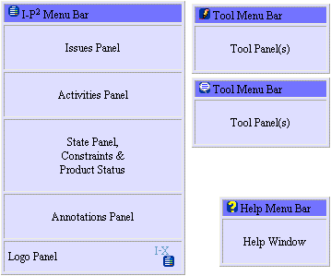
Figure 2: Anatomy of an I-X Process Panel
An I-X Process Panel:

Can take requests to:
- Handle an issue
- Perform an activity
- Add a constraint
- Note an annotation

Deals with these via:
- Manual (user) activity
- Internal capabilities (perform)
- External capabilities (invoke or query/answer)
- Reroute or delegate to other panels or agents (pass)
- Plan and execute a composite of these capabilities (plan or expand)

Receives “progress” or “completion” reports and other event-related messages and, where possible, interprets them to:
- Understand current status of issues, activities and constraints
- Understand current world state, especially status of process products
- Help control the situation
- Improve annotations

An I-X Process Panel can cope with partial knowledge and can operate even where little or no pre-built knowledge of the domain or knowledge of relationships to other panels or services is available – effectively becoming a simple “to-do” list aid in that case.

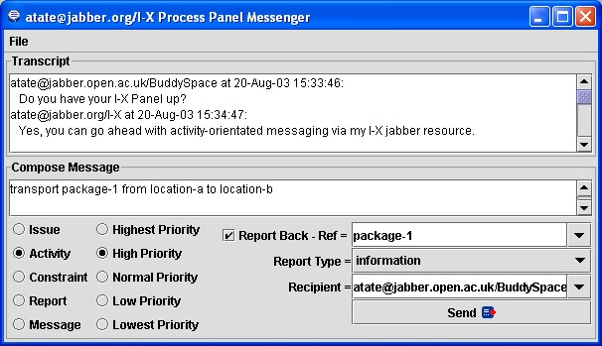
Figure 3: I-X Instant Messaging Style Interface

Trial use of I-X/I-P² in 2001 by users at the Navy Warfare Development Command (NWDC) at Newport, Rhode Island during the testing of advanced technologies appropriate for deployment in a large-scale training exercise called “Millennium Challenge” led to a major change in the direction for our systems development. Prior to that we had provided a test interface panel, which allowed us to send testing messages both to a local panel (the user’s own panel – labeled as “me”) and to any other named panel accessible via the communications method that was in use. NWDC was using I-P² alongside an Instant Messaging tool to log communications between countries and commands in a coalition. Both the simple Instant Messenger and I-P² were running over the CoABS Grid and KAoS to show how useful agent technology could be employed over secure channels. It quickly became clear that the messages being passed back and forth often related to entities that the process panels could handle – such as issues, activities and various types of preferences and constraints related to these. The test panel was quickly turned into an Instant Messaging style of interface in which simple text format “chat” was still possible, but the interface encouraged the use of more structured forms of messaging when this was natural. So it became easy to express and transmit the structured items related to task support. It then became easier to explain what the I-X Process Panels offered by referring to them as providing “augmented” instant messaging where process, activity and task support along with accompanying progress and completion reporting was desirable.

Since that time, this has been the preferred interface for I-X Process Panels and we have adopted this “intelligible messaging” style of interface. As I-X Process Panels have further developed and been used in more cooperative and human-centric applications (such as in support of scientific meeting and group work – Buckingham Shum et al., 2002), this style of interface has been further refined and made more central to our approach. We have also incorporated the use of a Jabber (Jabber, 2003) communications strategy, which provides for Instant Messaging using XML content. This has allowed for simpler and larger scale “out of the box” deployments of the I-X Process Panels.

3.2 I-Plan
The facilities available in the I-X Process Panels include an AI planner (I-Plan) used to provide context sensitive options for the handing of issues (such as the achievements of stated objectives), the performance of activities, and the satisfaction of constraints.

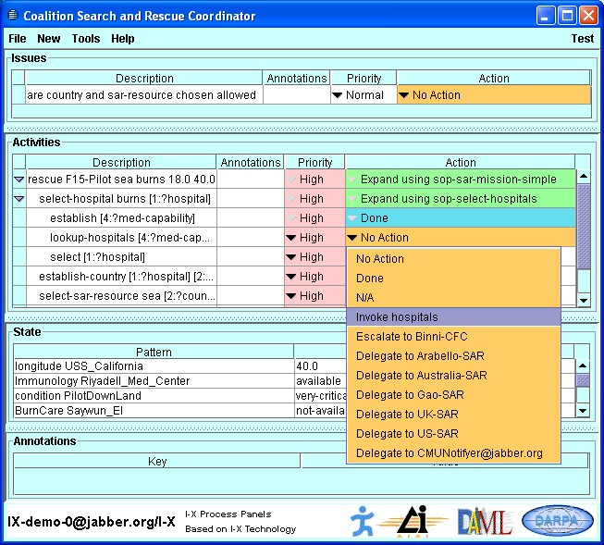
Figure 4: I-P2 Context-sensitive “Action” Menu

For any activity on the panel, an “Action” column shows its current status and the available options to perform the activity. Colours indicate the readiness of the item for current execution.

White indicates that the item is not currently ready for execution (i.e., some temporal ordering, preconditions or other constraints might not be met).

- Orange indicates that the action is ready to perform and that all preconditions and constraints are met.
- Green indicates that the item is currently being performed.
- Blue indicates successful completion.
- Red indicates a failure for which failure recovery planning steps might be initiated.

The set of “Actions” available to perform any item on the panel is available through a menu. This is dynamically generated and context-sensitive – reflecting the knowledge of the capabilities of other panels and services available. It also draws on the inbuilt planner – I-Plan – to select from any known plans or “Standard Operating Procedures (“plan schemas”) that match the item.

I-Plan can perform hierarchical partial-order composition of plans from a library of single level plan schemas or “Standard Operating Procedures”. This library can be augmented during planning either with a simple “activity details” interface to add in specific ways to expand a given action (intended for use by users familiar with the application domain but not AI planning techniques) or with a more comprehensive graphical domain editor. Grammars and lexicons for the domain are built automatically during domain editing to assist the user.

Future developments of I-Plan will provide more assistance with a “How do I do this?” option under the Action menu which will be able to account for other concurrent items on the panel, and account for mutual satisfaction of open variables and other constraints.

3.3 Other I-X Tools
There are other tools in the I-X suite include messaging tools and various information viewers (e.g. map, 3D VRML and PDA interfaces) and editors, along with three specific tools: I-DE, I-Q and I-Space:

- I-DE (I-X Domain Editor) allows the creation, maintenance and, ultimately, the publication of Standard Operating Procedures (SOPs), generic approaches to archetypal activities.

- I-Q (I-Query) is a generic I-X agent shell which, when embodied with the appropriate mechanisms, provides an agent with the capability of interacting with a query service of some kind. It usually responds by adding facts or constraints into the current state of the panel. A typical application, for instance, is for the retrieval of information from some external source such as the semantic web.

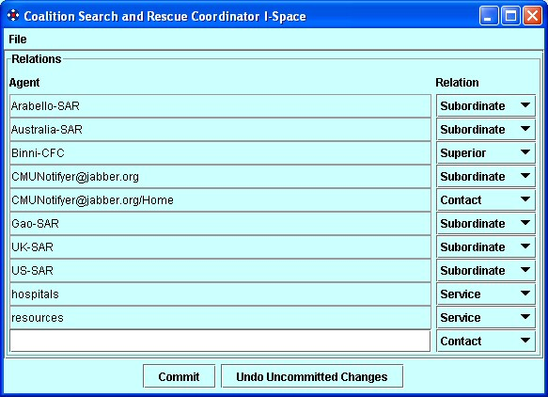
Figure 5: I-Space Organizational Relationships Tool

- I-Space is used to maintain organizational relationships with other agents in the environment. The nature of the relationship (for instance, supervisor-supervisee) will influence the nature of the activity-based interactions between these agents; the choices available to an agent will depend (amongst other things) both on its position in the organizational scheme of things and on its awareness of the capabilities and dynamic status (e.g. the current ‘presence’) of other agents. Exchange of agent and organization relationships with tools such as the KAoS Policy Administration Tool (KPAT) is possible.

3.4 I-X Message Formats
There are a number of messages that are used within the I-X Process Panels and that can be passed between panels and other services and agents.

- Issues, Activities, Constraints and Annotations
- Current state information (world state constraints)
- Plans (composites of Issues, Activities, Constraints and Annotations)
- Reports on progress or completion of nominated activities
- Text-orientated “chat” messages.

The first 3 relate to the core underlying ontology on which I-X is based. The other two message types provide status and other contextual information.

3.5 Reports and Current State

Activities (and other panel items) can be passed from one panel to another (or to capable services or other agents). These can pass back “progress” and “completion” (success/fail) reports to the original sender of the item. This provides a way to monitor activity progress, receive back milestone reports, and check off the completion of activities.

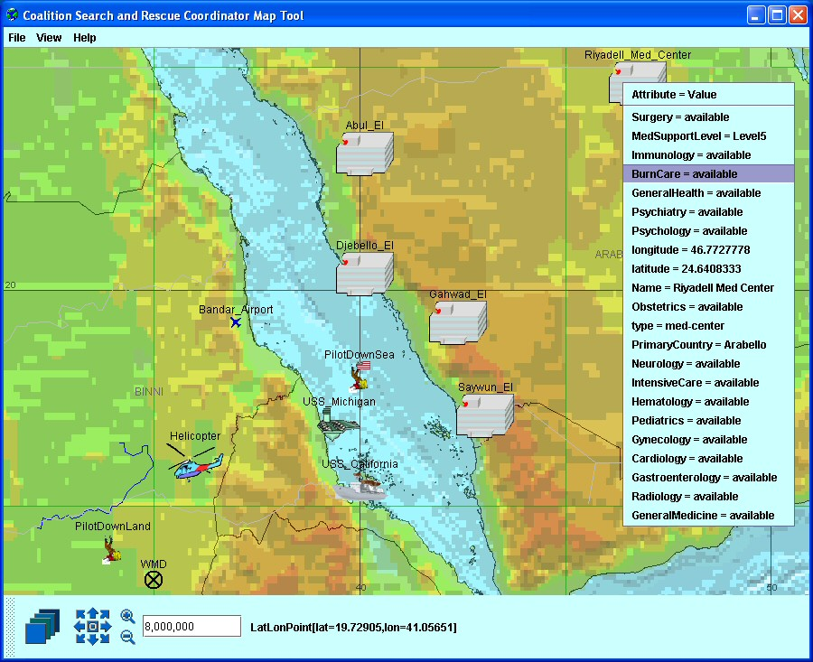
Figure 6: I-X Custom State Viewer – Map View

Information on the current state of the environment can be passed to panels via “world state” constraints. These might come from sensors directly, or from some analysis or reporting system.
A specific type of current state we have found useful is the presence or status information maintained by instant messaging systems, so one can tell if another agent, panel or person is active and available for communications. Jabber (Jabber, 2003) for example maintains such information and makes it available for registered users/addresses of interest (kept in “buddy lists”) to any client. This information comes in as current state/constraint information to a process panel.

Incoming completion reports and information about the current state sent as constraints can trigger later activities to be executable as temporal or other constraints are satisfied. As an example, incoming presence or location information about a person might be sent between users. This would appear on the state panel for the receiver, and could trigger activities awaiting specific status or presence (e.g. waiting for a user to come on-line).

I-X also allows custom state viewers to be added to augment or replace the simple tabular current state view in a normal I-P² panel. An example of a viewer for such state information could be the BBN OpenMap™ tool (BBN, 2003). Changes to information in any viewer, or coming in via messages from outside of panels are synchronized.

3.6 <I-N-C-A> Ontology

<I-N-C-A> (Issues - Nodes - Constraints - Annotations) is the basis of the ontology that underpins the I-X approach. It provides the framework for the representation used to describe processes and process products within I-X Process Panels and the structure for the main types of activity-orientated I-X Messages. <I-N-C-A> is a conceptual model that can be shared between human users and system components cooperating to carry out shard tasks.

In <I-N-C-A>, both processes and process products are abstractly considered to be made up of a set of "Issues" which are associated with the processes or process products to represent potential requirements, questions raised as a result of analysis or critiquing, etc. They also contain "Nodes" (activities in a process, or parts of a physical product) which may have parts called sub-nodes making up a hierarchical description of the process or product. The nodes are related by a set of detailed "Constraints" of various kinds. Finally there can be "Annotations" related to the processes or products, which provide rationale, information and other useful descriptions. The I-X systems integration approach is based on the <I-N-C-A> Model of Synthesized Artifacts that provides it with a simple abstraction that provides an extremely flexible, extendable and intelligible representation of the processes and process products in I-X. It is well suited to communication between human and system agents engaged in some common task, each possibly taking the initiative over which parts they can handle at various stages.

The forerunner of <I-N-C-A>, <I-N-OVA> (Tate, 1996), when first designed, was intended to act as a bridge to improve dialogue between a number of communities working on formal planning theories, practical planning systems and systems engineering process management methodologies. It was intended to support new work then emerging on automatic manipulation of plans, human communication about plans, principled and reliable acquisition of plan information, and formal reasoning about plans. It has since been utilized as the basis for a number of research efforts, practical applications and emerging international standards for plan and process representations. For some of the history and relationships between earlier work in AI on plan representations, work from the process and design communities and the standards bodies, and the part that <I-N-OVA> played in this see Tate (1998).

At various stages of the development of the I-X research the typography for rendering <I-N-C-A> has varied as the components have received clarification. <I-N-CA> originally stood for Issues, Nodes, Critical and Auxiliary Constraints. The aspect of separating critical (shared communications) constraints from auxiliary (separately managed) constraints is still important within the I-X architecture, but is now considered a part of managing the "C" (constraints) component. The annotations were always present in the ontology and can be attached to all components, but the top level annotations that capture the rationale behind the synthesized product or the process/plan being described have required more prominence as the work has continued and as mixed-initiative and human communications aspects have become more important. Hence, the rendering <I-N-C-A> with the extra hyphen now stands for Issues, Nodes, Constraints and Annotations.

3.6.1 Issues
The issues in the representation may state the outstanding questions to be handled and can represent unsatisfied objectives, questions raised as a result of analysis, etc. The I constraints can be thought of as implying potential further constraints which may have to be added into the design in future in order to address the outstanding issues. In work on I-X until recently, the issues had a task or activity orientation to them, being mostly concerned with actionable items referring to the process underway - i.e., actions in the process space. This is now not felt to be appropriate, and we are adopting the gIBIS (Conklin and Begeman, 1988) orientation of expressing these issues as any of a number of specific types of question to be considered (Selvin, 1999; Conklin, 2003). The types of questions advocated are:

- Deontic questions - What should we do?
- Instrumental questions - How should we do it?
- Criterial questions - What are the criteria?
- Meaning or conceptual questions - What does X mean?
- Factual questions - What is X? or Is X true?
- Background questions - What is the background to this project?
- Stakeholder questions - Who are the stakeholders of this project?
- Miscellaneous questions - To act as a catch all.

The first 5 of these are likely to be the most common in our task support environment. This is similar to the Questions - Options- Criteria approach (MacLean et al., 1991) - itself used for rationale capture for plans and plan schema libraries in our earlier work (Polyak and Tate, 1998; 1999) and similar to the mapping approaches used in Compendium (Selvin et al. 2001). Compendium can in fact exchange its set of issues, activities and some types of constraints and annotations with I-P² (Buckingham Shum et al., 2002; Chen-Burger and Tate, 2003).

3.6.2 Nodes
The nodes in the specifications describe components that are to be included in the design. Nodes can themselves be artifacts that can have their own structure with sub-nodes and other <I-N-C-A> described refinements associated with them.

The node constraints (these are of the form “include node”) in the <I-N-C-A> model set the space within which an artifact may be further constrained. The “I” (issues) and “C” constraints restrict the artifacts within that space which are of interest.

When <I-N-C-A> is being used to describe processes, the nodes are usually the individual activities or their sub-activities. They are usually characterized by a “pattern” composed of an initial verb followed by any number of parameter objects, noun phrases, and qualifiers or filler words describing the activity. E.g.,

(transport package-1 from location-a to location-b)

Others have recognized the special nature of the inclusion of nodes (or activities) into a synthesized artifact (or plan) compared to all the other constraints that may be described. In the planning domain, Khambhampati and Srivastava (1996) differentiate Plan Modification Operators into “progressive refinements” which can introduce new actions into the plan, and “non-progressive refinements” which just partition the search space with existing sets of actions in the plan. They call the former genuine planning refinement operators, and think of the latter as providing the scheduling component.

3.6.3 Constraints
The constraints restrict the relationships between the nodes to describe only those artifacts within the design space that meet the requirements. The constraints may be split into “critical constraints” and “auxiliary constraints” depending on whether some constraint managers (solvers) can return them as “maybe” answers to indicate that the constraint being added to the model is okay so long as other critical constraints are imposed by other constraint managers. The maybe answer is expressed as a disjunction of conjunctions of such critical or shared constraints. More details on the “yes/no/maybe” constraint management approach used in I-X and the earlier O-Plan systems are available in Tate (1995).

The choices of which constraints are considered critical and which are considered auxiliary is itself a decision for an application of I-X and specific decisions on how to split the management of constraints within such an application (not a complete sentence?). It is not pre-determined for all applications. A temporal activity-based planner would normally have object/variable constraints (equality and inequality of objects) and some temporal constraints (maybe just the simple “before” constraint: {before time-point1 time-point-2}) as the critical constraints. But, in a 3D design or a configuration application object/variable and some other critical constraints (possibly spatial constraints) might be chosen. It depends on the nature of what is communicated between constraint managers in the application of the I-X architecture.

3.6.4 Annotations
The annotations add additional human-centric information or design and decision rationale to the information describing the artifact.

4. KAoS Technology

The process descriptions used by I-X Process Panels are kept in a domain library. This can be loaded when a panel is started, and can be added to dynamically by a user of a panel. The domain library as well as policy repository is implemented by KAoS.

4.1. KAoS Policy and Domain Management Services
KAoS is one of the first efforts to represent domain structure and policy using a Semantic Web language - in this case OWL. KAoS services and tools allow for the specification, management, conflict resolution, and enforcement of policies within the specific contexts established by complex organizational structures represented as domains (Bradshaw et al., 2004; Bradshaw et al., 2003; Uszok et al., 2003). While initially oriented to the dynamic and complex requirements of software agent applications, KAoS services have been extended to work equally well with both agent and traditional clients on a variety of general distributed computing platforms (e.g., CORBA, Web Services, Grid Computing).

4.2 Ontological Representation of KAoS Policies
KAoS uses ontology concepts (encoded in OWL) to build policies. During its bootstrap, KAoS first loads KAoS Policy Ontologies (KPO) defining concepts used to describe a generic actor’s environment and policies within this context (http://ontology.ihmc.us/). Then KAoS loads additional ontologies, extending the generic concepts, with notions specific to the particular controlled environment and application.

KAoS distinguishes between authorizations (i.e., constraints that permit or forbid some action) and obligations (i.e., constraints that require some action to be performed when a state- or event-based trigger occurs, or else serve to waive such a requirement) (Damianou et al., 2000). Other policy constructs (e.g., delegation, role-based authorization) are built out of the basic primitives of domains plus these four policy types.

To shield users from the burden of defining policies directly in OWL, we have defined the KAoS Policy Administration Tool (KPAT; Uszok et. al. 2003). Each KAoS policy, generated automatically by KPAT, is an instance of one of four basic policy classes, that is: PositiveAuthorization, NegativeAuthorization, PositiveObligation or NegativeObligation. The property values determine management information for a particular policy (e.g., priority). The type of policy instance determines the kind of constraint KAoS should apply to the action, while a policy’s action class is used to determine a policy’s applicability in a given situation. The action class uses OWL restrictions to narrow scopes-of-action properties to a particular policy’s needs. Every action contains a definition of the range of actors performing it. This range can be defined using any available OWL construct. For example, the range can be an enumeration of actor instances, a class of actors defining its type, or any description of the actor context (for instance, the class of actors executed on some host and possessing a given resource). The same is true for the action class’s other properties but additionally XML Schema expressions can be used to restrict ranges of datatype properties. Consequently, policy can contain arbitrarily complex definitions of a situation. So, KAoS policies represent policies without conditional rules, relying instead on the context restrictions associated with the action class to determine policy applicability in a given situation.

Figure 7: KAoS KPAT - OWL policy editor and administration tool

An action class helps classify action instances that actors intend to take or are currently undertaking. Components (such as KAoS Guards) that are interested in checking policy impact on these actions construct RDF descriptions of action instances. KAoS classifies these instances, relying on the inference capabilities of Stanford University’s Java Theorem Prover (JTP, www.ksl.stanford.edu/software/JTP). It then obtains a list of any policies whose action classes are relevant to the current situation. In the next step, KAoS determines the relative precedence of the obtained policies and sorts them accordingly in order to find the dominating authorization policy. If the dominating authorization is positive, KAoS then collects, in order of precedence, obligations from any triggered obligation policies. KAoS returns the result to the interested parties—in most cases, these parties are the enforcement mechanisms that are jointly responsible for blocking forbidden actions and assuring the performance of obligations.

Representing policies in OWL facilitates reasoning about the controlled environment, policy relations and disclosure, policy conflict detection, and harmonization. It also facilitates reasoning about domain structure and concepts exploiting the description logic subsumption and instance classification algorithms. KAoS can identify and, if desired, harmonize conflicting policies through algorithms that we have implemented in JTP.

4.3 Important KAoS Features

We highlight a few important features of KAoS below:

- Homogeneous policy representation. Because all aspects of KAoS policy representation are encoded purely in OWL, any third-party tool or environment supporting OWL can perform specialized analyses of the full knowledge base completely independently of KAoS itself, thus easing integration with an increasingly sophisticated range of new OWL tools and language enhancements in the future.

- Maturity. Over the past few years, KAoS has been used in a wide range of applications and operating environments.

- Comprehensiveness. Unlike many approaches that deal with only simple forms of access control or authorization, KAoS supports both authorization and obligation policies. In addition, a complete infrastructure for policy management has been implemented including a full range of capabilities from sophisticated user interfaces for policy specification and analysis to a generic policy disclosure mechanism. Facilities for policy enforcement automation (i.e., automatic generation of code for enforcers) are under further development.

- Pluggability. Platform-specific and application-specific ontology is easily loaded on top of the core concepts. Moreover, the policy enforcement elements have been straightforwardly adapted to a wide range of computing environments, both traditional distributed computing platforms (e.g., Web Services, Grid Computing, CORBA) and various software and robotic agent platforms (e.g., Nomads, Brahms, SFX, CoABS Grid, Cougaar).
- Scalability and performance. We optimized the policy disclosure methods such that response to a query from an enforcer is provided on average in less than 1 ms. This performance is due in part to our reliance on efficient and logically decidable description logic subsumption and classification methods. Furthermore, queries can be executed concurrently by multiple enforcers, letting KAoS export multiprocessor machines. In rigorous evaluations in the DARPA UltraLog program, we’ve found that performance is acceptable even in large societies of more than a thousand agents, running on a dozen or more platforms, with hundreds of policies. Here, dynamic policy updates can be committed, deconflicted, and distributed in a matter of a few seconds. Further enhancements to underlying reasoners and advances in computer hardware will continue to improve this performance.

4.4 Beyond Description Logic for Policy Representation
Until recently, KAoS used only OWL-DL (initially DAML) to describe policy-governed entities and their actions. The semantic richness OWL enables in comparison to traditional policy languages allowed us much greater expressivity in specifying policies. However, we found ourselves limited in situations where we needed to define policies where one element of an action’s context depended on the value of another part of the context. A simple example is an action of loop communication, where you must constrain the source and the destination of communication so that they’re one and the same. A more complex example would be when we want to constrain the action to return the results of a calculation to only the parties that provided the data used to perform it (or to the specific entities the data’s providers authorized). Such an action description might be needed to specify a policy controlling the distribution of calculation results. All such action descriptions go beyond what OWL-DL can express.

The required missing aspect of representational semantics has, however, been well studied under the name of role-value maps (McIlraith, et al., 2001). These maps should express equality or containment of values that has been reached through two chains of instance properties. The emerging standard for OWL rules, the Semantic Web Rule Language (SWRL, www.daml.org/2003/11/swrl), allows the use of role-value-map semantics. However, the required syntax is complex, and we’ve begun to think that an OWL-based representation expressing this same semantics might be valuable for a broad range of uses. For instance, the OWL-S developers found the need to express similar dataflow semantics and developed their own formulation (process:sameValues) that allowed the representation of such chains, albeit with the limitation that they could contain only single-chain elements (McIlraith et al., 2001).

We have equipped KAoS with mechanisms that will allow adding role-value-map semantics to defined policy action using the KAoS Policy Administration Tool. For the interim, we’re basing our syntax for this semantics on the current version of the SWRL OWL ontology. However, the code that generates this syntax is encapsulated in a specialized Java class allowing later modification if the SWRL ontology changes or if an OWL-based syntax eventually emerges. Our classification algorithm can also use this information to classify action instances. This algorithm verifies if an instance satisfies the OWL-DL part of the action class and, if so, checks the appropriate role-value-map constraints. For example, if KAoS needs to determine whether an intercepted communication is a loop communication, it would determine whether the current communication source is also one of the values of the property describing the communication’s destination.

To perform more complex policy analyses relying on role-value-map semantics, we’ve begun joint exploration with Stanford on extending JTP to allow subsumption reasoning on role-value-map semantics.

4.5 Generic Semantic Web Service Policy Enforcer
KAoS provides generic enforcers tailored for Semantic Web Services environment that intercept SOAP messages and filter results consistent with coalition policies. Our implementation of a SOAP-enabled enforcer is capable of understanding arbitrary Semantic Web Service invocations so it can apply appropriate authorization policies to them. Additionally, it is equipped with a mechanism to perform obligation policies, which is in a form of other Web Service invocations. For instance, an obligation policy may require the recording of certain kinds of service transactions through a remote logging service.

5. CoSAR-TS Scenario

The CoSAR-TS demonstrations took place within a suitably realistic scenario. We adopted and expanded the fictional "Binni" scenario (Rathmell, 1999) developed for The Technology Co-operation Programme (TTCP), which involves Australia, Canada, New Zealand, UK and the USA.

5.1 Binni Scenario
The scenario is set in the Binni domain used for multi-national research in Command and Control (Rathmell, 1999; see Figure 8). The scenario follows on from the events of the Coalition Agents eXperiment (CoAX) which involved some 20 participating organizations from four countries, and which demonstrated intelligent agent technology in a coalition setting (Allsopp et al., 2001; Allsopp et al., 2002; Allsopp et al., 2003; Wark et. al, 2003).

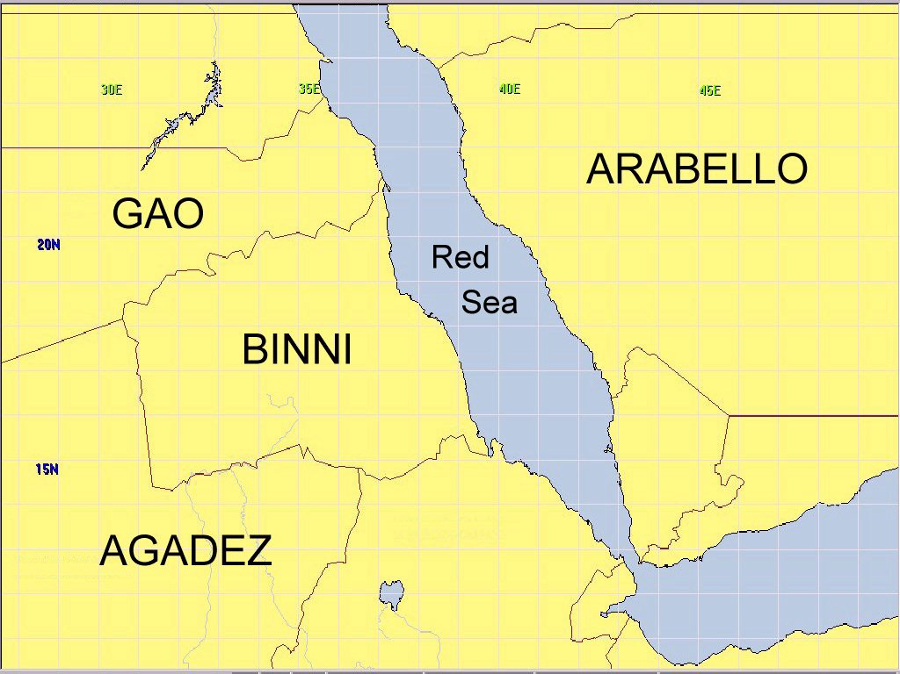
Figure 8: Map of Binni Region of the Red Sea

5.2 CoSAR-TS Scenario
The story begins with an event that reports a downed airman in the Red Sea between the coastlines of two fictional nations: Binni (to the West) and Arabello (to the East). In this initial scenario it is assumed that excellent location knowledge is available, and that there are no local threats to counter or avoid in the rescue. The airman reports his own injuries via his suit sensors. Next is an investigation of the facilities available to rescue the airman. There will be three possibilities: a US ship-borne helicopter; a helicopter from the fictional country of Gao located on a land base in Binni; or a patrol boat situated off the Arabello coastline. Finally, there is a process to establish available medical facilities for the specialized injury reported using the information provided about the countries in the region. Arabello’s hospital is best placed to provide the facilities, due to the fact that it has the necessary treatment facilities for burns. But the selection of the rescue resource is policy-constrained since no Gaoan helicopters may enter Arabello airspace.

Figure 9: CoSAR-TS demo elements

9shows the agents used in the project, representing the roles and functions of the Coalition SAR coordinator, US SAR officer, hospital information provider, SAR resource provider and a Notification Agent. The Coalition SAR Coordinator and US SAR Officer each has an I-X process panel, which can be used for messages about collaborative activity, and is also used to select, refine and execute a suitable standard operating procedure or plan. A query is made on a BBN Technologies semantic web service of OWL-encoded facts about country medical infrastructure. The selection of a SAR resource is made using the CMU Semantic Matchmaker to find a suitable service. The current descriptions of the rescue resources include information about their areas of operations and countries of origin. This information is based on ontology developed for the DARPA SONAT experiment. Because the current number of services registered in the Matchmaker is not big the most time consuming part of the matching process is loading and preprocessing all the ontologies used to describe services and the query. These lookups comply with KAoS policies as they are set by authorized personnel using the IHMC KAoS Policy Administration Tool (KPAT). Finally, the CMU Notification Agent uses knowledge of the recipients to make notifications to hospital administrators or pilots.

6. I-K-C

In the context of CoSAR-TS project, the integration of KAoS and I-X was achieve letting I-X obtain information about the role relationships among human and software actors (peers, subordinates, and superiors, for example) represented in domains and stored in KAoS as ontological concepts. I-X can also use the KAoS policy disclosure interface to learn about policy impact on its planned actions. This was the first step toward mutual integration of the planning and policy verification components.

Figure 10: Cooperation between I-X and KAoS for semantic workflow composition

The I-K-C tool goes beyond the initial integration of I-X and KAoS to enable Semantic Web Services workflow composition consistent with policies that govern composition and enactment (see Figure 10). This approach lets I-X import services described in OWL-S into the planner, augmenting any predefined processes already in the process library. KAoS verifies constructed partial plans for policy compliance. We can export the final plan, represented in OWL-S ontology form, and use it in various enactment systems or to guide the dynamic reactive execution of those plans in I-P2.

In order to support I-K-C functionality both KAoS and I-X has been extended with new capabilities described below.

6.1 I-X new capabilities supporting I-K-C
New capabilities extend the I-DE Process editor and I-Plan planning elements to allow for the creation of composed workflows ahead of execution. This allows for the import of services described in OWL-S to be used within the planner (augmenting any predefined processes in the process library). The plans created can be exported for to other enactment systems, be used for further analysis (e.g. policy compliance checks in KAoS) and can be used to guide the dynamic reactive execution of those plans in I-P2 or other tools.

Figure 11: I-Plan Web Service – Search & Rescue example

6.2 KAoS new capabilities supporting I-K-C

6.2.1 Mapping the OWL-S Representation of Process to the KAoS Concept of Action
The OWL-S concept of Process maps semantically to the KAoS concept of Action1. Unfortunately, OWL-S made a dramatic change in representing workflow processes in the transitioning from the earlier ontology called DAML-S. In DAML-S, processes were represented as classes whose instances were process executions and whose input and output parameters were defined as properties of those classes. Parameter restrictions were represented as range constraints on those parameter properties. In contrast, OWL-S represents processes as instances, and parameters are defined as instances of the class Parameter or its subclasses Input and Output, with their corresponding parameter restrictions defined by the value of the process:parameterType property for each parameter. This significant change does not allow for a straightforward mapping between OWL-S and KAoS concepts using owl:equivalentClass and owl:equivalentProperty as it had been previously possible in the case of DAML-S. OWL-S will define process executions as instances of a ProcessInstance class that refers to its process type. This approach is similar to that taken in the Process Specification Language (PSL; Schlenoff et al., 2000).

In order to use KAoS reasoning capabilities it is now necessary to create an OWL class based on the OWL-S process definition instance. This is done by changing the process:parameterType mentioned above to represent the appropriate restrictions. We are using OWL-S API2 to load OWL-S process workflows, to find all processes within a workflow, and then to get detailed definitions in order to build, using Jena1, the corresponding OWL class which is a subclass of the KAoS Action class.

6.2.2. KAoS Capabilities for Analyzing Action Classes
After KAoS extracts a particular action from the workflow and converts it to a corresponding action class, we examine the action to determine its compliance with the relevant policies in force. The process of workflow policy compliance checking differs from that of checking authorization and obligations of an action instance in policy enforcement that we described earlier. In workflow policy compliance checking, we’re not dealing with an action instance but an action class. So, we must use subsumption reasoning instead of classification reasoning - KAoS must find relations between the current action class and action classes associated with policies. Fortunately, we use this kind of reasoning to perform policy analyses such as policy deconfliction.8 These analyses also involve discovering relations (subsumption or disjointness, for example) between action classes associated with policies.

Such analyses will often lead to deterministic conclusions - for example, that a given process will be authorized or forbidden or that it will definitely generate an obligation. Results will always be deterministic if the given action class representing the investigated process is a subclass of either a single policy action class or a union of some policy action classes, respectively representing either authorization or obligation policies.

Sometimes, however, the analyses can be nondeterministic—that is, we might be able to conclude only that a given process instance could possibly be authorized or that it might generate obligations. This kind of result will occur if the given action class, representing the process in question, is neither fully subsumed nor fully disjoint, with a single policy action class or their unions respectively representing either authorization or obligation policies. In this case, KAoS can build a representation of the action class (either the class that corresponds to the portion of the action class in the authorization request or the one that generates a given obligation) by computing the difference between the current action class and the relevant policy action class. The algorithm is identical to the one we have previously described (Bradshaw et al., 2003) for policy harmonization. However, we’re still working out how to generically translate that new class to an OWL-S process instance representation.

We’ve developed a first cut of additional KAoS ontology components, enabling workflow annotation with the results of the policy analyses we described. The appropriate markup was added to the original OWL-S workflow using the OWL-S API and sent back from KAoS to the I-X planner.

7. Conclusions

The CoSAR-TS project added new sophisticated functionalities both to AIAI’s intelligent planning technology and IHMC’s KAoS services. Both these tools are now also fully OWL compliant. The cooperation between AIAI and IHMC was significantly strengthened and their common goal is to collaborate on future projects and release tools integrating both technologies.

The project deepened understanding of the Semantic Web technology in general, putting it into trial use in realistic military scenarios. It also served as a tested for technologies developed by other DAML program participants. Finally, through our participation in OWL and OWL-S committees and forums, we were able to make sure that the value of lessons learned on the project were incorporated into new versions of the standards.

References

Allsopp, D., Beautement, P., Bradshaw, J.M., Carson, J., Kirton, M., Suri, N. and Tate, A. (2001) Software Agents as Facilitators of Coherent Coalition Operations, 6th International Command and Control Research and Technology Symposium, US Naval Academy, Annapolis, Maryland, USA, 19-21 June 2001.

Allsopp, D.N., Beautement, P., Bradshaw, J.M., Durfee, E.H., Kirton, M., Knoblock, C.A., Suri, N. and Tate, A. and Thompson, C.W. (2002) “Coalition Agents Experiment: Multi-Agent Co-operation in an International Coalition Setting”, Proceedings of the Second International Conference on Knowledge Systems for Coalition Operations (KSCO-2002), Toulouse, France.

Allsopp, D., Beautement, P., Kirton, M., Tate, A., Bradshaw, J.M., Suri, N. and Burstein, M. (2003) The Coalition Agents Experiment: Network-Enabled Coalition Operations, Special Issue on Network-enabled Capabilities, Journal of Defence Science, Vol. 8, No. 3, pp. 130-141, September 2003.

BBN (2003) OpenMap™ Open Systems mapping Technology - http://openmap.bbn.com

Bradshaw, J. M., Beautement, M. Breedy, L. Bunch, S. Drakunov, P. Feltovich, P., Raj, A., Johnson, M., Kulkarni, S., Suri, N. & A. Uszok (2004). Making agents acceptable to people. In N. Zhong & J. Liu (Ed.), Intelligent Technologies for Information Analysis: Advances in Agents, Data Mining, and Statistical Learning. (pp. 361-400). Berlin: Springer Verlag.

Bradshaw, J. M., Uszok, A., Jeffers, R., Suri, N., Hayes, P., Burstein, M. H., Acquisti, A., Benyo, B., Breedy, M. R., Carvalho, M., Diller, D., Johnson, M., Kulkarni, S., Lott, J., Sierhuis, M., & Van Hoof, R. (2003). Representation and reasoning for DAML-based policy and domain services in KAoS and Nomads. Proceedings of the Autonomous Agents and Multi-Agent Systems Conference (AAMAS 2003). Melbourne, Australia, New York, NY: ACM Press,

Buckingham Shum, S., De Roure, D., Eisenstadt, M., Shadbolt, N. and Tate, A. (2002) CoAKTinG: Collaborative Advanced Knowledge Technologies in the Grid, Proceedings of the Second Workshop on Advanced Collaborative Environments, Eleventh IEEE Int. Symposium on High Performance Distributed Computing (HPDC-11), July 24-26, 2002, Edinburgh, Scotland.

Conklin, J. and Begeman, M. L. (1988). gIBIS: A hypertext tool for exploratory policy discussion. ACM Transactions on Office Information Systems, 4(6), 303-331.

Conklin, J. (2003) Dialog Mapping: Reflections on an Industrial Strength Case Study. In: P.A. Kirschner, S.J. Buckingham Shum and C.S. Carr (Eds.), Visualizing Argumentation: Software Tools for Collaborative and Educational Sense-Making. Springer-Verlag: London, ISBN 1-85233-6641-1, pp. 117-136.

Chen-Burger, Y. and Tate, A. (2003) Concept Mapping Between Compendium and I-X, Informatics Report Series, University of Edinburgh, EDI-INF-RR-0166, May 2003.

Damianou, N., Dulay, N., Lupu, E. C., & Sloman, M. S. (2000). Ponder: A Language for Specifying Security and Management Policies for Distributed Systems, Version 2.3. Imperial College of Science, Technology and Medicine, Department of Computing, 20 October 2000.

Jabber (2003) Jabber XML Instant Messaging, http://www.jabber.org.

McIlraith, S. A., Son, T. C., & Zeng, H. (2001). Semantic Web Services. IEEE Intelligent Systems, 46-53.

Khambhampati, S. and Srivastava, B. (1996) Unifying Classical Planning Approaches, Arizona State University ASU CSE TR 96-006, July 1996.

MacLean, A., Young, R., Bellotti, V. and Moran, T. (1991) Design space analysis: Bridging from theory to practice via design rationale. In Proceedings of Esprit '91, pages 720-730, Brussels, November 1991.

Polyak, S. and Tate, A. (1999) A Common Process Ontology for Process-Centred Organisations, Knowledge based Systems, 2000. Earlier version by S. Polyak published as University of Edinburgh Department of Artificial Intelligence Research paper 930, 1998. See http://www.aiai.ed.ac.uk/project/oplan/documents/1999/99-sebpc-cpm.pdf

Rathmell, R.A. (1999) “A Coalition Force Scenario ‘Binni — Gateway to the Golden Bowl of Africa’”, Proceedings of the International Workshop on Knowledge-Based Planning for Coalition Forces, (ed. Tate, A.) pp. 115-125, Edinburgh, Scotland, 10th-11th May 1999.

Schlenoff, C., Gruninger M., Tissot, F., Valois, J., Lubell, J., Lee, J. (2000). The Process Specification Language (PSL): Overview and Version 1.0 Specification," NISTIR 6459, National Institute of Standards and Technology, Gaithersburg, MD.

Selvin, A.M. (1999) Supporting Collaborative Analysis and Design with Hypertext Functionality, Journal of Digital information, Volume 1 Issue 4.

Selvin, A.M, Buckingham Shum, S.J., Sierhuis, M., Conklin, J., Zimmermann, B., Palus, C., Drath, W., Horth, D., Domingue, J., Motta, E. and Li, G. (2001) Compendium: Making Meetings into Knowledge Events, Knowledge Technologies 2001, Austin TX, USA, March 4-7, 2001.

Tate, A. (1996) The <I-N-OVA> Constraint Model of Plans, Proceedings of the Third International Conference on Artificial Intelligence Planning Systems, (ed. Drabble, B.), pp. 221-228, Edinburgh, UK, May 1996, AAAI Press.

Tate, A. (1998) Roots of SPAR, in Special Issue on Ontologies, Knowledge Engineering Review, Vol. 13(1), March, 1998, Cambridge University Press.

Tate, A. (2000a) “<I-N-OVA> and <I-N-CA> - Representing Plans and other Synthesized Artifacts as a Set of Constraints”, AAAI-2000 Workshop on Representational Issues for Real-World Planning Systems, at the National Conference of the American Association of Artificial Intelligence (AAAI-2000), Austin, Texas, USA, August 2000.

Tate, A. (2000b) “Intelligible AI Planning”, in Proceedings of the Twentieth British Computer Society Special Group on Expert Systems International Conference on Knowledge Based Systems and Applied Artificial Intelligence, Cambridge, UK, December 2000.

Tate, A., Dalton, J. and Levine, J. (2000a) “O-Plan: a Web-based AI Planning Agent”, AAAI-2000 Intelligent Systems Demonstrator, in Proceedings of the National Conference of the American Association of Artificial Intelligence (AAAI-2000), Austin, Texas, USA, August 2000.

Tate, A., Levine, J., Dalton, J. and Nixon, A. (2001) “Task Achieving Agents on the World Wide Web”, in “Creating the Semantic Web”, Fensel, D., Hendler, J., Liebermann, H. and Wahlster, W. (eds.), MIT Press, 2001.

Uszok, A., Bradshaw, J. M., Jeffers, R., Suri, N., Hayes, P., Breedy, M. R., Bunch, L., Johnson, M., Kulkarni, S., & Lott, J. (2003). KAoS policy and domain services: Toward a description-logic approach to policy representation, deconfliction, and enforcement. Proceedings of Policy 2003. Como, Italy.

Wark, S., Zschorn, A., Perugini, D., Tate, A., Beautement, P., Bradshaw, J.M. and Suri, N. (2003) Dynamic Agent Systems in the CoAX Binni 2002 Experiment, Special Session on Fusion by Distributed Cooperative Agents at the 6th International Conference on Information Fusion (Fusion 2003), Cairns, Australia, July, 2003.

Intentionally Blank

Appendix A: List of Publications

All available via http://www.aiai.ed.ac.uk/project/ix/documents/ or http://i-x.info/documents/

Joint AIAI and IHMC Publications

2003

Wark, S., Zschorn, A., Perugini, D., Tate, A., Beautement, P., Bradshaw, J.M. and Suri, N. (2003) Dynamic Agent Systems in the CoAX Binni 2002 Experiment, Special Session on Fusion by Distributed Cooperative Agents at the 6th International Conference on Information Fusion (Fusion 2003), Cairns, Australia, July, 2003.

Allsopp, D., Beautement, P., Kirton, M., Tate, A., Bradshaw, J.M., Suri, N. and Burstein, M. (2003) The Coalition Agents Experiment: Network-Enabled Coalition Operations. Special Issue on Network-enabled Capabilities, Journal of Defense Science. 8:3, September, 2003.

2004

Uszok, A., Bradshaw, J.M., Jeffers, R., Johnson, M., Tate, A., Dalton, J. and Aitken, S. (2004) Policy and Contract Management for Semantic Web Services, AAAI Spring Symposium, Stanford University, California, USA, March 2004.

Tate, A., Dalton, J., Siebra, C., Aitken, S., Bradshaw, J.M. and Uszok, A. (2004) Intelligent Agents for Coalition Search and Rescue Task Support, Intelligent Systems Demonstrator, Nineteenth National Conference of the American Association of Artificial Intelligence, (AAAI-2004), San Jose, California, USA, July 2004.

Uszok, A., Bradshaw, J.M., Jeffers, R., Johnson, M., Tate, A., Dalton, J. and Aitken, S. (2004) KAoS Policy Management for Semantic Web Services, IEEE Intelligent Systems, pp. 32-41, July/August 2004.

Tate, A., Dalton, J., Siebra, C., Aitken, S., Bradshaw, J.M. and Uszok, A. (2004) Intelligent Agents for Coalition Search and Rescue Task Support, AAAI-2004 Intelligent Systems Demonstrator, in Proceedings of the Nineteenth National Conference of the American Association of Artificial Intelligence, (AAAI-2004), San Jose, California, USA, July 2004.

Tate, A., Dalton, J., Bradshaw, J.M., and Uszok, A. (2004) Agent Systems for Coalition Search and Rescue Task Support, in Knowledge Systems for Coalition Operations (KSCO-2004), Czech Technical University Press, Prague, Czech Republic.

Uszok, A., Bradshaw, J.M., Jeffers, R., Tate, A. and Dalton, J. (2004) Applying KAoS Services to Ensure Policy Compliance for Semantic Web Services Workflow Composition and Enactment, in Proceedings of the Third International Semantic Web Conference (ISWC 2004), Hiroshima, Japan, 7-11 November 2004. Published as Lecture Notes in Computer Science, LNCS 3298, Springer.

AIAI Author Only Publications

2003

Tate, A., Levine, J., Dalton, J. and Nixon, A. (2003) Task Achieving Agents on the World Wide Web, in Spinning the Semantic Web, Fensel, D., Hendler, J., Liebermann, H. and Wahlster, W. (eds.), Chapter 15, pp. 431-458, MIT Press, 2003.

Tate, A. (2003) <I-N-C-A>: a Shared Model for Mixed-initiative Synthesis Tasks, Proceedings of the Workshop on Mixed-Initiative Intelligent Systems (MIIS) at the International Joint Conference on Artificial Intelligence (IJCAI-03), Acapulco, Mexico, August 2003.

Tate, A. (2003) Coalition Task Support using I-X and <I-N-C-A>, in Proceedings of the 3rd International Central and Eastern European Conference on Multi-Agent Systems (CEEMAAS 2003), Prague, Czech Republic, June 2003, pp.7-16, Springer Lecture Notes in Artificial Intelligence LNAI 2691.

Lino, N., Tate, A., Siebra, C. and Chen-Burger, J. (2003) Delivering Intelligent Planning Information to Mobile Devices Users in Collaborative Environments, Workshop on Artificial Intelligence, Information Access and Mobile Computing (AI-IA-MC) at the International Joint Conference on Artificial Intelligence (IJCAI-03), Acapulco, Mexico, August 2003.

Siebra, C. and Tate, A. (2003) I-Rescue: A Coalition Based System to Support Disaster Relief Operations, The Third International Association of Science and Technology for Development (IASTED) International Conference on Artificial Intelligence and Applications (AIA-2003), Benalmadena, Spain, September 2003.

Potter, S., Tate, A. and Dalton, J. (2003) I-X: Task Support on the Semantic Web, Poster Abstract, Second International Semantic Web Conference (ISWC-2003), Sanibel Island, Florida, October 2003

Lee, J., Grunninger, M., Jin. Y., Malone, T.W. Tate, A., Yost, G., and other members of the PIF Working Group (2003) The PIF Process Interchange Format and Framework, pp 553-575, Organizing Business Knowledge - The MIT Process Handbook (eds. Malone, T.W., Crowston, K. and Herman, G.A), MIT Press.

Tate, A. and Dalton, J. (2003) O-Plan: a Common Lisp Planning Web Service, invited paper, in Proceedings of the International Lisp Conference 2003, October 12-25, 2003, New York, NY, USA, October 12-15, 2003.

2004

Potter, S., Tate, A. and Dalton, J. (2004) Collaborative Task Support and e-Response, AISB Quarterly, No. 115, Winter 2004.

Lino, N. and Tate, A. (2004) M-Planning: A Mobile Tool to Support Collaborative Planning. Proceedings of the International Conference on Artificial Intelligence and Applications (AIA-2004), as part of the Twenty-Second IASTED International Multi-Conference on Applied Informatics, Innsbruck, Austria, February 2004.

Siebra, C. and Tate, A. (2004) Implementing Hierarchical Agent-Human Teamworks via Constraint-Based Models. Proceedings of the International Conference on Artificial Intelligence and Applications (AIA-2004), as part of the Twenty-Second IASTED International Multi-Conference on Applied Informatics, Innsbruck, Austria, February 2004.

Siebra, C., Tate, A. and Lino, N. (2004) Planning and Representation of Joint Human-Agent Space Missions via Constraint-Based Models, Fourth International Workshop on Planning and Scheduling for Space (IWPSS-04), Darmstadt, Germany, 23-25 June 2004.

Lino, N. and Tate, A. (2004) A Visualisation Approach for Collaborative Planning Systems Based on Ontologies, in Proceedings of the 8th International Conference on Information Visualisation (IV 2004), London, UK, 14-16 July 2004, IEEE Computer Society Press, 2004.

Wollan, H. (2004) Incorporating Heuristically Generated Search Patterns in Search and Rescue, Master of Science Dissertation, School of Informatics, University of Edinburgh, September, 2004.

Tate, A., Dalton, J. and Potter, S. (2004) Activity-oriented Instant Messaging for Coalition Operations, in Knowledge Systems for Coalition Operations (KSCO-2004), Czech Technical University Press, Prague, Czech Republic.

IHMC Author Only Publications

2003

Bradshaw, J. M., Cabri, Giacomo & Montanari, Rebecca (2003). Taking back cyberspace. IEEE Computer,July, pp. 89-92.

Uszok, A., Bradshaw, J. M., Jeffers, R., Suri, N., Hayes, P., Breedy, M. R., Bunch, L., Johnson, M., Kulkarni, S., & Lott, J. (2003). KAoS policy and domain services: Toward a description-logic approach to policy representation, deconfliction, and enforcement. Proceedings of the IEEE Fourth International Workshop on Policy (Policy 2003). Lake Como, Italy, 4-6 June, Los Alamitos, CA: IEEE Computer Society, pp. 93-98.

Bradshaw, Jeffrey M. (2003). Making agents acceptable to people. In V. Marik, J. Muller, & M. Pechoucek (Eds.), Multi-Agent Systems and Applications III: Proceedings of the Third International Central and Eastern European Conference on Multi-Agent Systems (CEEMAS 2003), Prague, Czech Republic, June 16-18. LNAI 2691. Berlin, Germany: Springer, pp. 1-3.

Suri, N., Bradshaw, J. M., Burstein, M., Uszok, A., Benyo, B., Breedy, M, Carvalho, M., Diller, D., Jeffers, R., Johnson, M., Kulkarni, S., & Lott, J. (2003). DAML-based policy enforcement for semantic data transformation and filtering in multi-agent systems. . In V. Marik, J. Muller, & M. Pechoucek (Eds.), Multi-Agent Systems and Applications III: Proceedings of the Third International Central and Eastern European Conference on Multi-Agent Systems (CEEMAS 2003), Prague, Czech Republic, June 16-18. LNAI 2691. Berlin, Germany: Springer, pp. 122-135.

Bradshaw, J. M., Uszok, A., Jeffers, R., Suri, N., Hayes, P., Burstein, M. H., Acquisti, A., Benyo, B., Breedy, M. R., Carvalho, M., Diller, D., Johnson, M., Kulkarni, S., Lott, J., Sierhuis, M., & Van Hoof, R. (2003). Representation and reasoning for DAML-based policy and domain services in KAoS and Nomads. Proceedings of the Autonomous Agents and Multi-Agent Systems Conference (AAMAS 2003).14-18 July, Melbourne, Australia. New York, NY: ACM Press, pp. 835-842.

Suri, N., Bradshaw, J. M., Burstein, M. H., Uszok, A., Benyo, B., Breedy, M. R., Carvalho, M., Diller, D., Groth, P. T., Jeffers, R., Johnson, M., Kulkarni, S., & Lott, J. (2003). DAML-based policy enforcement for semantic data transformation and filtering in multi-agent systems. Proceedings of the Autonomous Agents and Multi-Agent Systems Conference (AAMAS 2003). 14-18 July, Melbourne, Australia. New York, NY: ACM Press, pp. 1132-1133.

Johnson, M., Chang, P., Jeffers, R., Bradshaw, J. M., Soo, V.-W., Breedy, M. R., Bunch, L., Kulkarni, S., Lott, J., Suri, N., & Uszok, A. (2003). KAoS semantic policy and domain services: An application of DAML to Web services-based grid architectures. Proceedings of the AAMAS 03 Workshop on Web Services and Agent-Based Engineering.July, Melbourne, Australia.

Tonti, G., Bradshaw, J. M., Jeffers, R., Montanari, R., Suri, N., & Uszok, A. (2003). Semantic Web languages for policy representation and reasoning: A comparison of KAoS, Rei, and Ponder. Proceedings of the International Semantic Web Conference (ISWC 03). Sanibel Island, Florida, October.

Uszok, A., Bradshaw, J. M., Hayes, P., Jeffers, R., Johnson, M., Kulkarni, S., Breedy, M. R., Lott, J., & Bunch, L. (2003). DAML reality check: A case study of KAoS domain and policy services. Internal technical report. Short version of this paper appears in Proceedings of the International Semantic Web Conference (ISWC 03). Sanibel Island, Florida, October.

2004

Bradshaw, J. M., Beautement, P., Breedy, M., Bunch, L., Drakunov, S. V., Feltovich, P. J., Hoffman, R. R., Jeffers, R., Johnson, M., Kulkarni, S., Lott, J., Raj, A., Suri, N., & Uszok, A. (2004). Making agents acceptable to people. In N. Zhong and J. Liu (Eds.),Intelligent Technologies for Information Analysis: Advances in Agents, Data Mining, and Statistical Learning, Berlin: Springer Verlag, pp, 355-400.

Uszok, A., Bradshaw, J. M., & Jeffers, R. (2004). KAoS: A policy and domain services framework for grid computing and grid computing and semantic web services. In C. Jensen, S. Poslad, & T. Dimitrakos (Eds.),Trust Management: Second International Conference (iTrust 2004) Proceedings,Oxford, UK, March/April, Lecture Notes in Computer Science 2995, Berlin: Springer, pp. 16-26.

Bradshaw, J. M., Uszok, A. & Jeffers, R. (2004). Toward semantically-rich policy representation: Issues and applications. Conference on the Human Impact and Application of Autonomic Computing Systems (CHIACS2).Yorktown Heights, NY: IBM T.J. Watson Research Center, 21 April 2004.

Tonti, G., Montanari, R., Bradshaw, J. M., Bunch, L., Jeffers, R., Suri, N. & Uszok, A. (2004) Automated generation of enforcement mechanisms for semantically-rich policies in Java-based multi-agent systems. Proceedings of the First IEEE Symposium on Multi-Agent Security and Survivability (MAS&S 2004).Philadelphia, PA: Drexel University, 30-31 August 2004.

Uszok, A. & Bradshaw, J. M. (2004). Applications of KAoS policy and domain services to coalition operations, survivable logistics support, and human-robotic teamwork. Proceedings of the International Workshop on Monitoring, Security, and Rescue Techniques in Multiagent Systems (MSRAS 2004), Plock, Poland, 7-9 June. Also to be published in the volume Advances in Soft Computing, Springer-Verlag, 2004 and a special issue of Fundamenta Informaticae, 2005

Appendix B: List of Software and On-line Demonstrations Available

CoSAR-TS AAAI-2004 Intelligent Systems Demonstrator
http://www.aiai.ed.ac.uk/project/cosar-ts/isd/

KAoS KPAT Java Web Start demonstration
http://norma.coginst.uwf.edu:8080/coalition/KPAT-TCP.jnlp

I-K-C tool demonstrations
http://www.aiai.ed.ac.uk/project/i-k-c
http://projects.semwebcentral.org/projects/i-k-c

Web service composition examples
http://todday.inf.ed.ac.uk/linux/web-demos/web-service-demos/web-service- examples.html

Demonstration on-line web services composer running via a SOAP interface
http://todday.inf.ed.ac.uk/linux/web-plan/web-plan.html

Appendix C: Project Web Sites

Main CoSAR-TS project web site http://www.aiai.ed.ac.uk/project/cosar-ts/

I-X project web site http://www.aiai.ed.ac.uk/project/ix/
http://i-x.info

KAoS project web site http://www.ihmc.us/research/projects/KAoS/
http://ontology.ihmc.us

I-K-C tool web site http://www.aiai.ed.ac.uk/project/i-k-c

Co-OPR project web site http://www.aiai.ed.ac.uk/project/co-opr/

Appendix D: Technology and Research Demonstration History

October 18th 2003, DAML PI Meeting, Sanibel Island, FL

Presentation of the up-to-date project results; including enchantments to I-X and KAoS as well develop demonstration of CoSAR-TS Binni rescue scenario including DAML-S described services and integration with SONAT, Matchmaker and CMU Notification Service.

October 21st 2003, International Semantic Web Conference, Sanibel Island, FL; Poster and Demo Session

Presentation of KAoS, I-X and CoSAR-TS semantic services demo, similar to the October 18th 2003, DAML PI Meeting demonstration.

March 22nd 2004, AAI 2004 Spring Symposium Series, Stanford, CA

Presentation of the paper “Applying KAoS Services to Ensure Policy Compliance for Semantic Web Services Workflow Composition and Enactment”.

May 19th 2004, DAML PI Meeting, Austin, TX

Presentation of the up-to-date project results; including further enchantments to I-X and KAoS towards closer integration in the form of I-C-K; a tool allowing for planning and policy analyses of created workflow with feedback to the planner. As well enhanced demonstration of CoSAR-TS Binni rescue scenario including OWL-S described services and integration with SONAT, Matchmaker and CMU Notification Service. Additionally, IHMC sophisticated ontology proxy tool was presented.

July 27th 2004, Nineteenth National Conference on Artificial Intelligence, San Jose, CA; Intelligent Systems Demonstrations Session

Presentation of “Intelligent Agents for Coalition Search and Rescue Task Support” to the conference participants. The demonstration included demonstration of integrated I-X and KAoS in the scope of the CoSAR-TS demo Binni rescue scenario.

November 9th 2004; International Semantic Web Conference, Hiroshima, Japan

Presentation of the paper “Applying KAoS Services to Ensure Policy Compliance for Semantic Web Services Workflow Composition and Enactment”

November 15th - 19th 2004; JFCOM and the JPRA;

Presentation of I-X and KAoS to US JFCOM and senior military and DARPA members in the Co-OPR - Collaborative Operations for Personnel Recovery - demonstration: http://www.aiai.ed.ac.uk/project/co-opr/

Pronounced KAY-pat.

