Agent Systems for Coalition Search and Rescue

Task Support

Austin Tate, Jeff Dalton

Artificial Intelligence Applications Institute (AIAI), University of Edinburgh

{a.tate,j.dalton}@ed.ac.uk

Jeffrey M. Bradshaw, Andrzej Uszok

Institute for Human and Machine Cognition (IHMC)

{auszok,jbradshaw}@ihmc.us
Abstract. The Coalition Search and Rescue Task Support project shows cooperative agents supporting a highly dynamic mission in which AI task planning, inter-agent collaboration, workflow enactment, policy-managed services, semantic web queries, semantic web services matchmaking and knowledge-based notifications are employed.
1 Introduction
The Coalition Search and Rescue Task Support (CoSAR-TS) project integrates AIAI’s I-X planning and collaboration technology, IHMC’s KAoS policy and domain services, and semantic web services of various kinds. Search and rescue operations by nature require the kind of rapid dynamic composition of available policy-constrained services making it a good use case for Semantic Web technologies. Other participants in the application include BBN Technologies, SPAWAR, AFRL, and Carnegie Mellon University.
2 CoSAR-TS Scenario
The scenario is set in the Binni domain used for multi-national research in Command and Control (Rathmell, 1999; see Figure 1). The scenario follows on from the events of the Coalition Agents eXperiment (CoAX) which involved some 20 participating organisations from four countries, and which demonstrated intelligent agent technology in a coalition setting (Allsopp et al., 2001; Allsopp et al., 2003; Wark et. al, 2003).
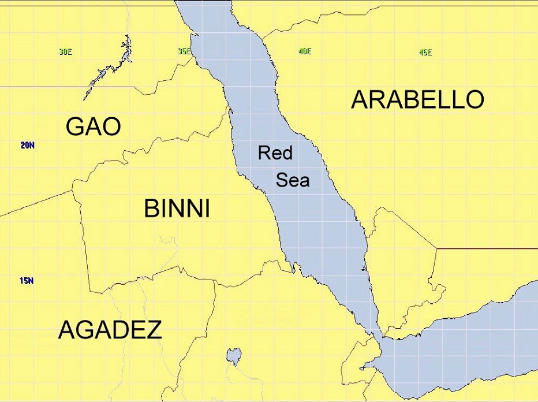
The story begins with an event that reports a downed airman in the Red Sea between the coastlines of two fictional nations: Binni (to the West) and Arabello (to the East). In this initial scenario it is assumed that excellent location knowledge is available, and that there are no local threats to counter or avoid in the rescue. The airman reports his own injuries via his suit sensors. Next is an investigation of the facilities available to rescue the airman. There will be three possibilities: a US ship-borne helicopter; a helicopter from the fictional country of Gao located on a land base in Binni; or a patrol boat situated off the Arabello coastline. Finally, there is a process to establish available medical facilities for the specialized injury reported using the information provided about the countries in the region. Arabello’s hospital is best placed to provide the facilities, due to the fact that it has the necessary treatment facilities for burns. But the selection of the rescue resource is policy-constrained since no Gaoan helicopters may enter Arabello airspace.

Figure 1: Binni Operation Map

Figure 2 shows the agents used in the project, representing the roles and functions of the Coalition SAR coordinator, US SAR officer, hospital information provider, SAR resource provider and a Notification Agent. The Coalition SAR Coordinator and US SAR Officer each has an I-X process panel, which can be used for messages about collaborative activity, and is also used to select, refine and execute a suitable standard operating procedure or plan. A query is made on a BBN Technologies semantic web service of OWL-encoded facts about country medical infrastructure. The selection of a SAR resource is made using the CMU Semantic Matchmaker to find a suitable service. The current descriptions of the rescue resources include information about their areas of operations and countries of origin. This information is based on ontology developed for the DARPA SONAT experiment. Because the current number of services registered in the Matchmaker is not big the most time consuming part of the matching process is loading and preprocessing all the ontologies used to describe services and the query. These lookups comply with KAoS policies as they are set by authorized personnel using the IHMC KAoS Policy Administration Tool (KPAT). Finally, the CMU Notification Agent uses knowledge of the recipients to make notifications to hospital administrators or pilots.
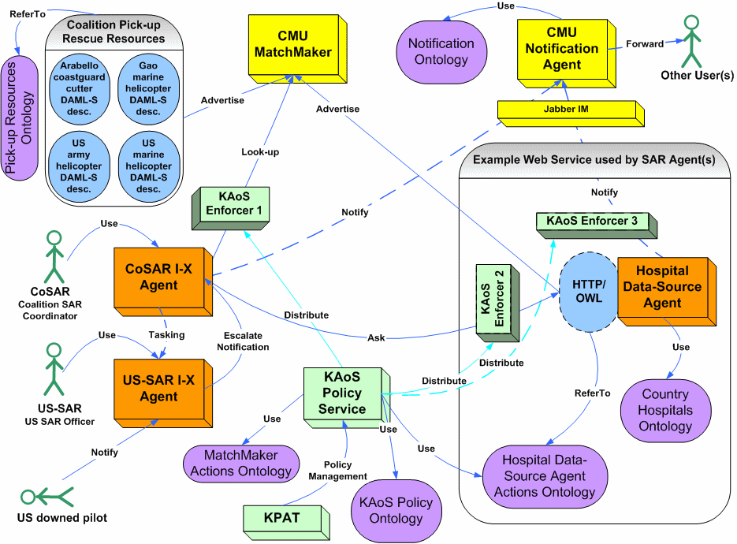
Figure 2: CoSAR-TS Demo Components
3 I-X Technology
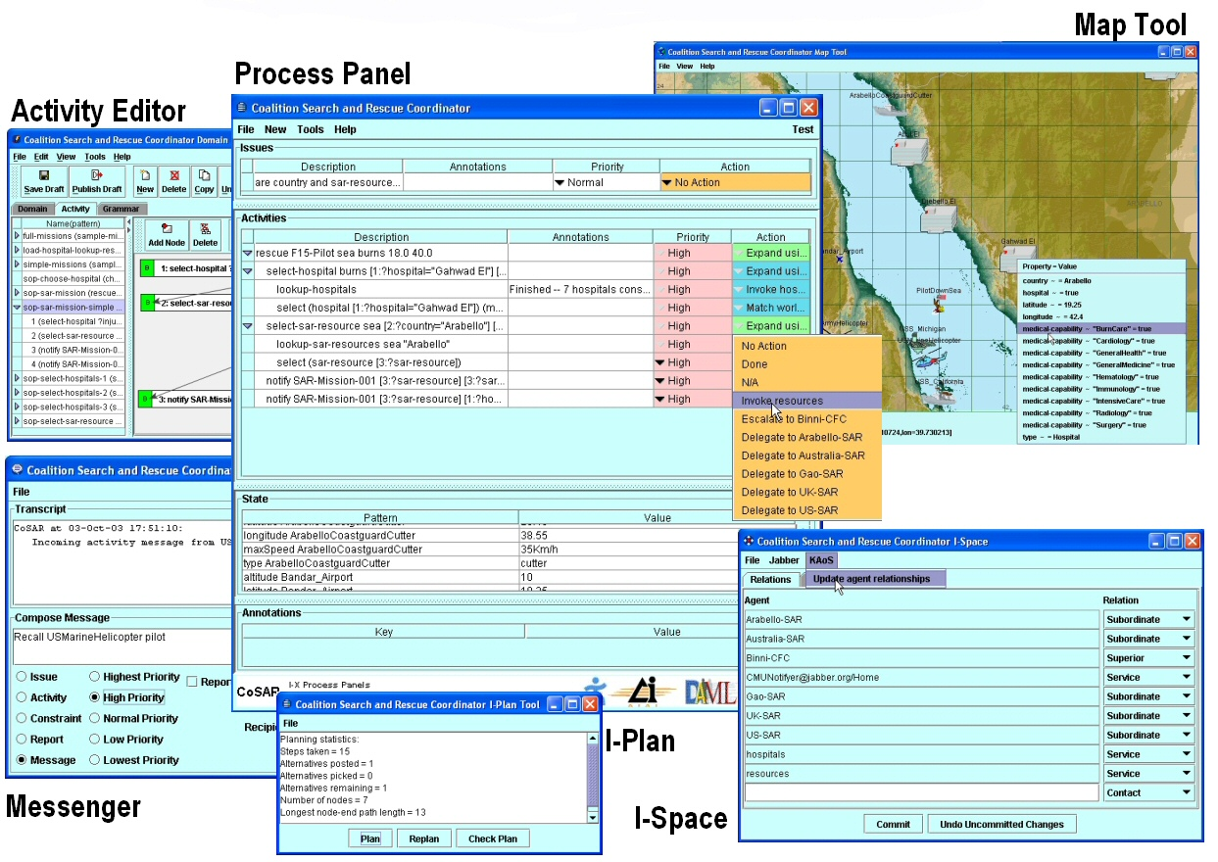
Figure 3: I-X Process Panel and Associated Tools
I-X Process Panels (http://i-x.info - Tate et al., 2002; Tate, 2003) can provide task support by reasoning about and exchanging with other agents and services any combination of Issues, Activities, Constraints and Annotations (in the <I-N-C-A> ontology). I-X can therefore provide collaborative task support and exchange of structured messages related to plans, activity and the results of such activity. These types of information can be exchanged with other I-X panels and with other tools using OWL, RDF or other languages.
Figure 3 shows an I-X Process Panel (I-P2) and associated I-X Tools. I-X can make use of multiple communications methods ranging from simple XML instant messaging (e.g. via Jabber) to sophisticated policy constrained agent communications environments (e.g. CoABS Grid, KAoS). The I-Space tool maintains agent relationships. The relationships can be obtained from agent services such as KAoS. I-X Process Panels can also link to semantic web information and web services though an I-Q query adaptor.
I-X includes a process editor for creating process models (I-DE) to populate the domain model and an AI planner (I-Plan) that can compose a suitable plan for the given tasks when provided with a library of standard operating procedures or processes, and knowledge of other agents or web services that it may use. I-Plan can support hierarchical plan creation, precondition achievement, consistent binding of multiple variables, temporal constraint checking, and so forth.
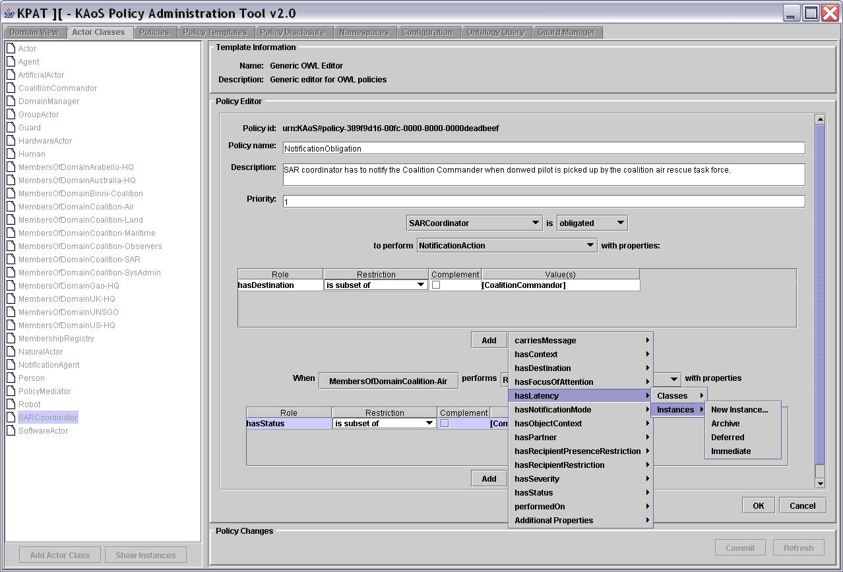
4 KAoS Policy and Domain Services
Figure 4: KAoS Policy Administration Tool
Figure 4 shows the KAoS Policy Administration Tool. Through it, policies constraining usage of resources and agents’ actions are inserted into the system. The policies are expressed using OWL. This allows the use of Description Logic reasoning algorithms to perform sophisticated queries and analysis of policies; supported by Stanford University’s Java Theorem Prover (JTP) inference engine. Loading relevant application specific ontologies can dynamically extend the KAoS Services. The layer of guards and enforcers integrated with the application facilitates the enforcement of the policies. A more complete technical description of how KAoS is being applied in a coalition setting may be found in (Bradshaw, 2003; Uszok, 2004).
Within CoSAR-TS, we are using KAoS for two purposes:
- Verification for policy compliance in semantic web services workflow composition
- Enforcement of policies during workflow enactment
4.1 Verification for Policy Compliance in Semantic Web Services Workflow Composition
Using output from I-X, KAoS verifies constructed partial plans for policy compliance. The final plan, represented in OWL-S ontology form, can be exported for use in various enactment systems or can be used to guide the dynamic reactive execution of those plans in I-P².
For example, in the CoSAR-TS scenario, each time a new search and rescue situation is undertaken the SAR coordinator gathers available information about the accident and constructs an appropriate goal for the I-X planner. The goal could, for instance, contain information about the kind of injuries sustained and the approximate location of the victim. The planner begins with the selection of an initial plan template that is best for the given situation. It then builds OWL-S profiles for each of the necessary services and queries the Coalition Matchmaker to learn about OWL-S descriptions of registered search and rescue resources. This results in the first approximation of the plan expressed as the OWL-S Process Model. For instance, if the downed pilot has serious burn injuries, the planner will ask the Matchmaker about which services are offered by the burn injuries treatment unit in each medical care center. Subsequently it will ask for available rescue resources, which can pick-up pilot from the sea and deliver it to the chosen hospital (i.e., Arabello). The best result is selected and the OWL-S Process Model is submitted for verification. During workflow analysis, KAoS determines that there is an obligation policy requiring notification of the coalition commander when the downed pilot is successfully recovered. The appropriate atomic process invoking the Notification Service available in the environment as the Web service is inserted into the model and returned to the planner.
4.2 Enforcement of Policies during Workflow Enactment
Not every aspect of policy compliance can be checked at planning time. Thus we have designed KAoS so that the policy service can independently enforce policies during workflow execution. The policies governing both authorization and obligation of clients and servers are stored in KAoS and checked by authorized parties. Whereas other approaches to securing Semantic Web Services are limited to either marking service advertisement with requirements for authentication and communication and enforcing compliance with these requirements or by attaching conditions to inputs, outputs and effects of services, KAoS can automatically enforce any sort of policy by integration of Semantic Web Services with KAoS enforcers.. KAoS is able to reason about the entire action performed by the services. Additionally, KAoS is used to generate obligations created during use of the services, for instance related to different notification requirements depending on dynamic steps in the rescue operation.
While annotation of the Semantic Matchmaker service profiles could allow registered service providers to describe required security profiles, it does not allow owners of infrastructure resources (e.g., computers, networks), client organizations (coalition organizations, national interest groups), or individuals to specify or enforce policy from their unique perspectives. For example, the policy that coalition members cannot use Gaoan transports is not something that can always be anticipated and specified within the Matchmaker service profile. Neither would Matchmaker service profile annotations be an adequate implementation for a US policy obligating encryption, prioritizing the allocation of network bandwidth, or requiring the logging of certain sorts of messages.
Moreover, the semantics of these policies cannot currently be expressed in terms of the current OWL-S specification of conditional constraints. Even if they were expressible, organizations and individuals may prefer to keep policy stores, reasoners, and enforcement capabilities within their private enclaves. This may be motivated by both the desire to maintain secure control over sensitive components as well as to keep other coalition members from becoming aware of private policies. For example, coalition members may not want Gao to be aware that the offer of their helicopters to rescue the downed airman will be automatically filtered out by policy.
4.3 Future Enhancements
We have defined enforcers that intercept SOAP messages from the Matchmaker and filter results consistent with coalition policies. In our CoSAR-TS demonstration, these policies prevent the use of Gaoan resources. Now we are actively working on the SOAP-enabled enforcer to understand arbitrary Semantic Web Service invocations so it can apply appropriate authorization policies to them. Additionally, we plan to equip the enforcer with a mechanism to perform obligation policies, which will be in the form of other Web Service invocations. For instance, it can be imagined that some policy may require consultation or registration of performed transactions in some logging service available as a Web Service audit entity.
Future work will also investigate how to take a context surrounding the atomic process in a given workflow into account—this means other processes and control constructs.
Currently KAoS is able to analyze OWL-S encoded workflows, however it can be straightforwardly extended to understand other form of descriptions, for instance the emerging WSMO standard1, as they share concept of process and basic workflow composition abstractions.

Acknowledgements
This material is based on research sponsored by the Defense Advanced Research Projects Agency (DARPA) and US Air Force Research Laboratory under agreement numbers F30602-00-2-0577 and F30602-03-2-0014. The U.S. Government, IHMC, and the University of Edinburgh are authorized to reproduce and distribute reprints and on-line copies for their purposes notwithstanding any copyright annotation hereon. The views and conclusions contained herein are those of the authors and should not be interpreted as necessarily representing the official policies or endorsements, either expressed or implied, of other parties.
References
Allsopp, D., Beautement, P., Bradshaw, J.M., Carson, J., Kirton, M., Suri, N. and Tate, A. (2001) Software Agents as Facilitators of Coherent Coalition Operations, 6th International Command and Control Research and Technology Symposium, US Naval Academy, Annapolis, Maryland, USA, 19-21 June 2001.

Allsopp, D., Beautement, P., Kirton, M., Tate, A., Bradshaw, J.M., Suri, N. and Burstein, M. (2003) The Coalition Agents Experiment: Network-Enabled Coalition Operations, Special Issue on Network-enabled Capabilities, Journal of Defence Science, Vol. 8, No. 3, pp. 130-141, September 2003.

Bradshaw, J. M., Uszok, A., Jeffers, R., Suri, N., Hayes, P., Burstein, M. H., Acquisti, A., Benyo, B., Breedy, M. R., Carvalho, M., Diller, D., Johnson, M., Kulkarni, S., Lott, J., Sierhuis, M., & Van Hoof, R. (2003). Representation and reasoning for DAML-based policy and domain services in KAoS and Nomads. Proceedings of the Autonomous Agents and Multi-Agent Systems Conference (AAMAS 2003). Melbourne, Australia, New York, NY: ACM Press.

Rathmell, R.A. (1999) A Coalition Force Scenario 'Binni - Gateway to the Golden Bowl of Africa', in Proceedings of the International Workshop on Knowledge-Based Planning for Coalition Forces, (ed. Tate, A.) pp. 115-125, Edinburgh, Scotland, 10-11 May 1999.

Tate, A., Dalton, J., and Stader, J. (2002) I-P² - Intelligent Process Panels to Support Coalition Operations, Proceedings of the Second International Conference on Knowledge Systems for Coalition Operations (KSCO-2002), Toulouse, France, 23-24 April 2002.

Tate, A. (2003). Coalition Task Support using I-X and <I-N-C-A>. Proceedings of the Third International Central and Eastern European Conference on Multi-Agent Systems (CEEMAS 2003), 16-18 June, Prague, Czech Republic, LNAI 2691. (pp. 7-16). Berlin: Springer.

Tate, A., Dalton, J., Siebra, C., Aitken, S., Bradshaw, J.M. and Uszok, A. (2004) Intelligent Agents for Coalition Search and Rescue Task Support, AAAI-2004 Intelligent Systems Demonstrator, in Proceedings of the 9th National Conference of the American Association of Artificial Intelligence, (AAAI-2004), San Jose, California, USA, July 2004.

Uszok, A., Bradshaw, J. M., Jeffers, R., Tate, A. & Dalton, J. (2004). Applying KAoS services to ensure policy compliance for semantic web services workflow composition and enactment. in Proceedings of the 3rd International Semantic Web Conference (ISWC 2004), Hiroshima, Japan, November 7-11.

Wark, S., Zschorn, A., Perugini, D., Tate, A., Beautement, P., Bradshaw, J.M. and Suri, N. (2003) Dynamic Agent Systems in the CoAX Binni 2002 Experiment, Special Session on Fusion by Distributed Cooperative Agents at the 6th International Conference on Information Fusion (Fusion 2003), Cairns, Australia, July, 2003.

http://www.ihmc.us/research/projects/KAoS
1 http://www.wsmo.org/

