<I-N-C-A>: a Shared Model for Mixed-initiative Synthesis Tasks

Austin Tate

Artificial Intelligence Applications Institute

Centre for Intelligent Systems and their Applications

School of Informatics, The University of Edinburgh
Appleton Tower, Crichton Street, Edinburgh EH8 9LE, UK
a.tate@ed.ac.uk

Abstract

I-X is a research programme intended to create a well-founded approach to allow humans and computer systems to cooperate in the creation or modification of some product such as a design, physical entity or plan – i.e. it supports mixed-initiative synthesis tasks. The I-X mixed-initiative approach involves the use of shared models for task-orientated communication between human and computer agents who are jointly exploring (via some process) a range of alternative options for the synthesis of an artifact such as a design, configuration or plan (termed a process product).

The <I-N-C-A> (Issues – Nodes – Constraints – Annotations) ontology is used as a shared model between the human and system agents. It represents a specific artifact as a set of constraints on the space of all possible artifacts in an application domain. It can be used to describe the initial requirements or objectives to be met and the emerging solutions. It can also describe the (perhaps dynamically generated) process(es) or plans involved in mixed-initiative collaboration.

This paper gives an overview of <I-N-C-A> as a potential knowledge representation framework or shared model suitable for use in mixed-initiative collaborative task support.

1 Introduction

I-X is a research programme with a number of different aspects intended to create a conceptually simple approach to allow humans and computer systems to cooperate in the creation or modification of some product or products such as documents, plans, designs or physical entities – i.e., it supports mixed-initiative synthesis tasks.

The I-X research draws on earlier work on Nonlin (Tate, 1977), O-Plan (Currie and Tate, 1991; Tate, 1995; Tate et. al., 1998; Tate et. al., 2000b, Levine et. al. 2000), Optimum-AIV (Aarup, 1994), <I-N-OVA> (Tate, 1996; 2000a) and the Enterprise Project (Fraser and Tate, 1995; Uschold, et. al., 1998; Stader, 1996) but seeks to make the framework generic and to clarify terminology, simplify the approach taken, and increase re-usability and applicability of the core ideas.

The I-X research programme includes the following threads or work areas:

- I-Core, which is the core modular systems integration architecture.

- <I-N-C-A>, which is an underlying ontology for synthesised artifacts.

- I-P², which are I-X Process Panels used to support user tasks and cooperation.

- I-Plan, which is the I-X Planning System. This is also used within I-P² and other applications as it provides generic facilities for supporting planning, process refinement, dynamic response to changing needs, etc.

- I-DE, which is the I-X Domain Editor. This is itself an I-X application but is also used to create and maintain the domain models, including especially the process models and activity specifications used throughout I-X systems.

- I-Views, which are viewers for processes and products, and which are employed in other applications of I-X. I-Views can be for a wide range of modalities of interface and types of user.

- I-Faces, which are underlying support utilities to allow for the creation of user interfaces, inter-agent communications and repository access.

- I-X Applications, which include:
- Coalition Operations (CoAX, CoSAR-TS)
- Emergency and Unusual Procedure Assistance (I-Rescue)
- Collaborative meeting and task support (I-Room, CoAKTinG).
2 I-X Mixed-Initiative Approach

The I-X approach involves the use of shared models for task-directed cooperation between human and computer agents who are jointly exploring (via some predefined or dynamically created process) a range of alternative options for the synthesis of one or more artifacts such as a design, configuration or plan (termed a process product).

<I-N-C-A> (Issues – Nodes – Constraints – Annotations) is the ontology that underpins the I-X mixed-initiative approach, and provides the framework for the representation used to describe the collaborative processes and products in I-X systems and agents. The <I-N-C-A> model provides an extremely flexible, extendable and intelligible representation of the processes and process products in I-X. It is well suited to communication between human and system agents engaged in a mixed-initiative fashion on some common task, each possibly taking the initiative over which parts they can handle at various stages.

The model of mixed-initiative synthesis taken is to allow for human and system agents to work in harmony to “mutually constrain” the set of products of interest by each adding constraints on the space of possible products. Human and system agents are not seen as at a higher level or “in charge” as far as the I-X architecture is concerned. However, orderings and priorities can be applied to impose specific styles of initiative within the system. One extreme can be a user-driven approach followed by system agents “filling-in” the details, or the opposite extreme of a fully automatic system-driven approach (with perhaps occasional appeals to a user to take predefined decisions). In more practical use, we envisage a mixed-initiative form of interaction in which the human and system agents proceed by mutually constraining the space of artifacts of interest using their own areas of strength.

Earlier work on mixed-initiative planning in O-Plan (Tate, 1994) was used as a basis for the I-X approach, In that we sought to classify where the focus of initiative could be for different types of system and human agents. It looked at the various roles that such agents could play: “strategic” task setting; “tactical” solution proposal and analysis; and “operational” enactment levels. It sought to describe the types of <I-N-C-A> entities that the various agents could share in such collaborative synthesis tasks.

In some practical situations it was found that the human and system agents could be characterised as playing the following roles in <I-N-C-A> terms:

- humans add or answer questions posed as “issues”;
- humans decide to add specific new “nodes” into the process product;
- system components manage and propose consistent solutions for the set of detailed “constraints”;
- both humans and system components add “annotations” to record their decision rationale.

I-X also involves a modular systems integration architecture that strongly parallels and supports the abstract view described. This is a Model – Viewer – Controller style of architecture. Plug-in components for Issue Handlers, Constraint Managers, I/O Handlers and Viewers allow for specific I-X systems to be created using this abstract architecture.

3 <I-N-C-A> Ontology

In <I-N-C-A>, both processes and process products are abstractly considered to be made up of a set of “Issues” which are associated with the processes or process products to represent potential requirements, questions raised as a result of analysis or critiquing, etc. They also contain “Nodes” (activities in a process, or parts of a physical product) which may have parts called sub-nodes making up a hierarchical description of the process or product. The nodes are related by a set of detailed “Constraints” of various kinds. Finally there can be “Annotations” related to the processes or products, which provide rationale, information and other useful descriptions.

The forerunner of <I-N-C-A>, <I-N-OVA> (Tate, 1996), when first designed, was intended to act as a unifying representation for work in a number of communities concerned with formal planning theories, practical mixed-initiative planning systems, plan representation, workflow, business and systems engineering process management methodologies, etc. It was intended to support new work then emerging on human communication about plans, principled and reliable acquisition of plan information, automatic manipulation of plans, and formal reasoning about plans. It has since been utilised as the basis for a number of research efforts, practical applications and emerging international standards for plan and process representations. For some of the history and relationships between earlier work in AI on plan representations, work from the process and design communities and the standards bodies, and the part that <I-N-OVA> played in this, see Tate (1998).

<I-N-C-A> models are intended to support a number of different uses:

- for automatic and mixed-initiative generation and manipulation of plans and other synthesised artifacts and to act as an ontology to underpin such use;
- as a common basis for human and system communication about plans and other synthesised artifacts;
- as a target for principled and reliable acquisition of knowledge about synthesised artifacts such as plans, process models and process product information;
- to support formal reasoning about plans and other synthesised artifacts.

These cover both formal and practical requirements and encompass the requirements for use by both human and computer-based planning and design systems.

3.1 Issues

The issues in the representation may give the outstanding questions to be handled and can represent decisions yet to be taken on objectives to be satisfied, ways in which to satisfy them, questions raised as a result of analysis, etc. Initially, an <I-N-C-A> artifact may just be described by a set of issues to be addressed (stating the requirements or objectives). The issues can be thought of as implying potential further nodes or constraints that may have to be added into the specification of the artifact in future in order to address the outstanding issues.

In work on I-X until recently, the issues had a task or activity orientation to them, being mostly concerned with actionable items referring to the process underway – i.e., actions in the process space. This has caused confusion with uses of I-X for planning tasks, where activities also appear as “nodes”. This is now not felt to be appropriate, and as an experiment we are adopting the gIBIS orientation of expressing these issues as questions to be considered (Selvin, 1999; Conklin, 2003). This is advocated by the Questions – Options – Criteria approach (MacLean et. al., 1991) – itself used for rationale capture for plans and plan schema libraries in our earlier work (Polyak and Tate, 1998; 1999) and similar to the mapping approaches used in Compendium (Selvin et. al. 2001).

3.2 Nodes

The nodes in the specifications describe components that are to be included in the design. Nodes can themselves be artifacts that can have their own structure with sub-nodes and other <I-N-C-A> described refinements associated with them. The node constraints (which are of the form “include node”) in the <I-N-C-A> model set the space within which an artifact may be further constrained. The “I” (issues) and “C” constraints restrict the artifacts within that space which are of interest.

3.3 Constraints

The constraints restrict the relationships between the nodes to describe only those artifacts within the design space that meet the objectives. The constraints may be split into “critical constraints” and “auxiliary constraints” depending on whether some constraint managers (solvers) can return them as “maybe” answers to indicate that the constraint being added to the model is okay so long as other critical constraints are imposed by other constraint managers. The maybe answer is expressed as a disjunction of conjunctions of such critical or shared constraints. More details on the “yes/no/maybe” constraint management approach used in I-X and the earlier O-Plan systems are available in Tate (1995).

The choices of which constraints are considered critical and which are considered as auxiliary are decisions for an application of I-X and specific decisions on how to split the management of constraints within such an application. It is not pre-determined for all applications. A temporal activity-based planner would normally have object/variable constraints (equality and inequality of objects) and some temporal constraints (maybe just the simple before{time-point1, time-point-2} constraint) as the critical constraints. But, for example in a 3D design or a configuration application, object/variable and some other critical constraints (possibly spatial constraints) might be chosen. It depends on the nature of what is communicated between constraint managers in the application of the I-X architecture.

3.4 Annotations

The annotations add additional human-centric information or design and decision rationale to the description of the artifact. This can be of assistance in making use of products such as designs or plans created using this approach by helping guide the choice of alternatives should changes be required.

3.5 Observation

If we consider the process of synthesis as a large constraint satisfaction task, we may try to model this as a Constraint Satisfaction Problem (CSP) represented by a set of variables to which we have to give a consistent assignment of values. In this case we can note that the addition of new nodes (“include node” constraints in <I-N-C-A>) is the only operation that can add variables dynamically to the CSP. The Issue (I) and their handlers may be separated into two kinds: those that may (directly or indirectly) lead to the addition of nodes to the product and those that cannot. The handling of “I” constraints that can lead to the inclusion of new nodes are of a different nature in the process to those that cannot.

Others have recognised the special nature of the inclusion of nodes (or activities) into a synthesised artifact (or plan) compared to all the other constraints that may be described. In the planning domain, Khambhampati and Srivastava (1996) differentiate Plan Modification Operators into “progressive refinements” which can introduce new actions into the plan, and “non-progressive refinements” which just partition the search space but use the existing activities in the plan. They call the former genuine planning refinement operators, and think of the latter as providing the scheduling component.

4 I-X Process Panels
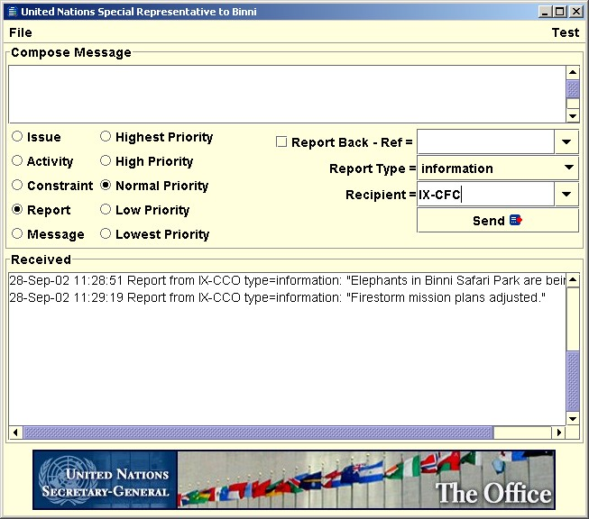
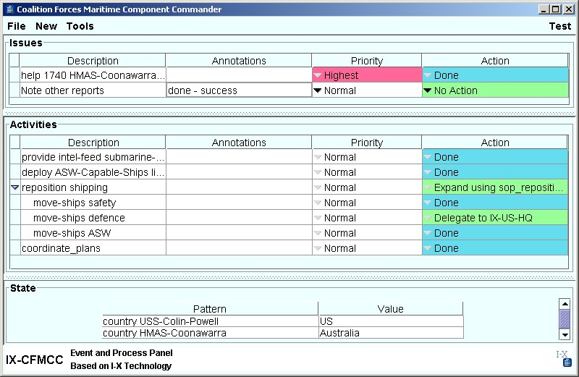
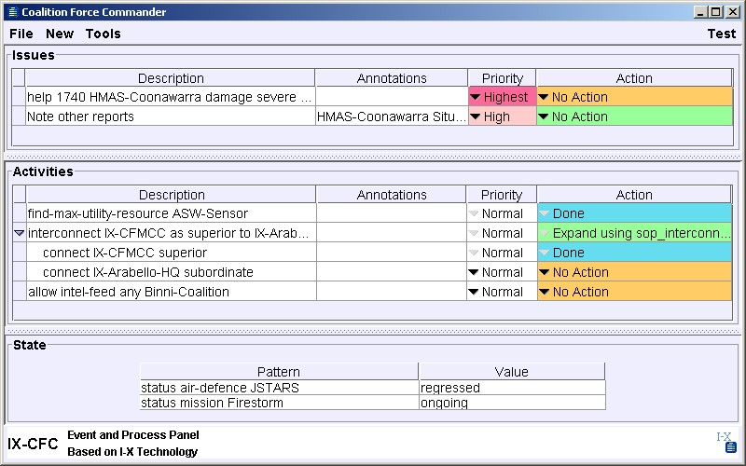
We “deliver” useful functionality based on I-X and the <I-N-C-A> ontology via “I-X Process Panels” (I-P²). These support a user or collaborative users in selecting and carrying out “processes” and creating or modifying “process products”. The aim of an I-X Process Panel is to act as an intelligent task and workflow support aid, reporting and messaging “catch all” for its user. It can act in conjunction with other panels for other users if desired.
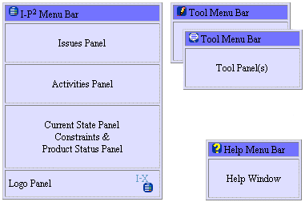

Figure 1: Anatomy of an I-X Process Panel

An I-X Process Panel:

- Can take requests to:
- Handle an issue
- Perform an activity
- Add a constraint
- Note an annotation

- Deals with these via:
- Manual (user) activity
- Internal capabilities provided by the panel
- External capabilities (invoke or query) provided by services known to the panel
- Reroute or delegate to other panels or agents (pass)
- Plan and execute a composite of these capabilities (plan or expand)

- Receives reports and messages and, where possible, interprets them to:
- Understand current status of issues, activities, constraints and annotations
- Understand current world state, especially status of process products
- Help control the situation
- Improve annotations

- Copes with partial knowledge and can operate in support of its user even where little or no pre-built knowledge of the domain is available.

Figure 2: CoAX I-X Process Panels

I-X and I-X Process Panels (I-P²) concepts have been demonstrated in a number realistic scenarios such as in Air Campaign Planning (Tate et. al. 1998), Military Operations In Urban Terrain (Tate, et. al., 2000b), the Coalition Agents eXperiment – CoAX (Allsop et. al., 2001; 2002), and new work on Coalition Search and Rescue (CoSAR-TS) and Scientific Meeting support (CoAKTinG). I-X Process Panels are being used in or are being considered for use in a number of future joint and multi-national forces experiments and demonstrations.

6 Summary

I-X is aimed at supporting a range of collaborative mixed-initiative synthesis tasks – such as planning, design and configuration. It is intended to simplify and provide uniform component boundaries and naming conventions for use in the construction of such systems and seeks to make the concepts more re-usable for a broad range of such tasks.

I-X is based on the <I-N-C-A> constraint ontology - a powerful and flexible representation of the products of the synthesis process. This represents a product as a set of constraints on the space of all possible products within the model of the domain that the I-X system has. All human and system agents involved in a mixed-initiative synthesis task can see their role as adding constraints into the emerging description of the products of interest.

Both processes and process products are abstractly considered to be made up of a set of “Issues” which are associated with the processes or process products and may represent outstanding questions with respect to the products, unsatisfied requirements, problems raised as a result of analysis or critiquing, etc. They also contain “Nodes” (activities in a process, or parts of a product) which may have sub-parts called sub-nodes making up a hierarchical description of the process or product. The nodes are related by a set of detailed “Constraints” of various kinds. Finally there can be “Annotations” related to the processes or products, which provide rationale, information and other useful descriptions.

Acknowledgements

Thanks to my co-workers on the I-X, CoAKTinG and CoSAR-TS project – especially Stuart Aitken, Jeff Bradshaw, Jessica Chen-Burger, Clauirton de Siebra, Jeff Dalton, John Levine, Natasha Lino, Stephen Potter and Jussi Stader.

This material is based on research within the I-X and CoSAR-TS projects sponsored by the Defense Advanced Research Projects Agency (DARPA) and US Air Force Research Laboratory under agreement number F30602-03-2-0014 and under the Advanced Knowledge Technologies (AKT) Interdisciplinary Research Collaboration (IRC) and its Collaborative Advanced Knowledge Technologies in the Grid (CoAKTinG) project, which is sponsored by the UK Engineering and Physical Sciences Research Council under grant number GR/N15764/01. The AKT IRC comprises the Universities of Aberdeen, Edinburgh, Sheffield, Southampton and the Open University.

The U.S. Government, the University of Edinburgh, the AKT IRC research partners and sponsors are authorised to reproduce and distribute reprints and on-line copies for their purposes notwithstanding any copyright annotation hereon. The views and conclusions contained herein are those of the authors and should not be interpreted as necessarily representing the official policies or endorsements, either express or implied, of other parties.

References

Aarup, M., Arentoft, M.M., Parrod, Y., Stokes, I., Vadon, H. and Stader, J. (1994) Optimum-AIV: A Knowledge-Based Planning and Scheduling System for Spacecraft AIV, in Intelligent Scheduling (eds. Zweben, M. and Fox, M.S.), pp. 451-469, Morgan Kaufmann.

Allsopp, D.N., Beautement, P., Bradshaw, J.M., Durfee, E.H., Kirton, M., Knoblock, C.A., Suri, N. and Tate, A. and Thompson, C.W. (2002) Coalition Agents Experiment: Multi-Agent Co-operation in an International Coalition Setting, Special Issue on Knowledge Systems for Coalition Operations (KSCO), IEEE Intelligent Systems, Vol. 17 No. 3 pp. 26-35. May/June 2002.

Conklin, J. and Begeman, M. L. (1988). gIBIS: A hypertext tool for exploratory policy discussion. ACM Transactions on Office Information Systems, 4(6), 303-331.

Conklin, J. (2003) Dialog Mapping: Reflections on an Industrial Strength Case Study. In: P.A. Kirschner, S.J. Buckingham Shum and C.S. Carr (Eds.), Visualizing Argumentation: Software Tools for Collaborative and Educational Sense-Making. Springer-Verlag: London, ISBN 1-85233-6641-1, pp. 117-136. See www.VisualizingArgumentation.info

Currie, K.W. and Tate, A. (1991) O-Plan: the Open Planning Architecture, Artificial Intelligence 52(1), Autumn 1991, North-Holland.

Fraser, J. and Tate, A. (1995) The Enterprise Tool Set - An Open Enterprise Architecture, Proceedings of the Workshop on Intelligent Manufacturing Systems, International Joint Conference on Artificial Intelligence (IJCAI-95), Montreal, Canada, August 1995.
Khambhampati, S. and Srivastava, B. (1996) Unifying Classical Planning Approaches, Arizona State University ASU CSE TR 96-006, July 1996.
Kunz, W. and Rittel, H.W.J (1970) Issues as Elements of Information Systems, Institute of Urban & Regional Development, University of California, Berkeley, CA, USA, Working Paper WP-131, July 1970. Available as http://www-iurd.ced.berkeley.edu/pub/abstract_wp131.htm
Levine, J., Tate, A. and Dalton, J. (2000) O-P³: Supporting the Planning Process using Open Planning Process Panels, IEEE Intelligent Systems, Vol. 15, No. 6, November/December 2000.
MacLean, A., Young, R., Bellotti, V. and Moran, T. (1991) Design space analysis: Bridging from theory to practice via design rationale. In Proceedings of Esprit '91, pages 720-730, Brussels, November 1991.
Polyak, S. and Tate, A. (1998) Rationale in Planning: Causality, Dependencies and Decisions, Knowledge Engineering Review, Vol.13(3), pp. 247-262, September, 1998, Cambridge University Press. See http://www.aiai.ed.ac.uk/project/oplan/documents/1998/ 98-rationale.pdf
Polyak, S. and Tate, A. (1999) A Common Process Ontology for Process-Centred Organisations, Knowledge based Systems, 2000. Earlier version by S. Polyak published as University of Edinburgh Department of Artificial Intelligence Research paper 930, 1998. See http://www.aiai.ed.ac.uk/project/oplan/documents/1999/ 99-sebpc-cpm.pdf
Schlenoff, C., Gruninger, M., Tissot, F., Valois, L., and Lubell, J. (1999) The Process Specification Language (PSL): Overview and Version 1.0 Specification, NIST Internal Report (NISTIR) 6459, National Institute of Standards and Technology, Gaithersburg, MD, USA

Selvin, A.M. (1999) Supporting Collaborative Analysis and Design with Hypertext Functionality, Journal of Digital information, Volume 1 Issue 4. See http://jodi.ecs.soton.ac.uk/Articles/v01/i04/Selvin/

Selvin, A.M, Buckingham Shum, S.J., Sierhuis, M., Conklin, J., Zimmermann, B., Palus, C., Drath, W., Horth, D., Domingue, J., Motta, E. and Li, G. (2001) Compendium: Making Meetings into Knowledge Events, Knowledge Technologies 2001, Austin TX, USA, March 4-7, 2001. See http://www2.gca.org/ knowledgetechnologies/2001/proceedings/Conklin&Selvin%20Slides.pdf

Stader, J. (1996) Results of the Enterprise Project. In Proceedings of Expert Systems '96, the 16th Annual Conference of the British Computer Society Specialist Group on Expert Systems, Cambridge, UK, December 1996. See http://www.aiai.ed.ac.uk/project/enterprise/

Tate, A. (1977) Generating Project Networks, Proceedings of the International Joint Conference on Artificial Intelligence (IJCAI-77), pp. 888-893, Cambridge, MA, USA, Morgan Kaufmann.

Tate, A. (1994) Mixed Initiative Planning in O-Plan2, Proceedings of ARPA/Rome Laboratory Planning Initiative (ARPI) Workshop, Tucson Arizona, 22nd - 24th February, 1994, Morgan Kaufmann. See http://www.aiai.ed.ac.uk/~oplan/documents/1994/94-arpi-mixed-initiative.pdf

Tate, A. (1995) Integrating Constraint Management into an AI Planner, Journal of Artificial Intelligence in Engineering, Vol. 9, No.3, pp. 221-228,1995.

Tate, A. (1996a) The <I-N-OVA> Constraint Model of Plans, Proceedings of the Third International Conference on Artificial Intelligence Planning Systems, (ed. Drabble, B.), pp. 221-228, Edinburgh, UK, May 1996, AAAI Press.

Tate, A. (1998) Roots of SPAR, in Special Issue on Ontologies, Knowledge Engineering Review, Vol.13(1), March, 1998, Cambridge University Press.

Tate, A. (2000a) <I-N-OVA> and <I-N-CA> - Representing Plans and other Synthesized Artifacts as a Set of Constraints, AAAI-2000 Workshop on Representational Issues for Real-World Planning Systems, at the National Conference of the American Association of Artificial Intelligence (AAAI-2000), Austin, Texas, USA, August 2000.

Tate, A. (2000b) Intelligible AI Planning, in Proceedings of the Twentieth British Computer Society Special Group on Expert Systems International Conference on Knowledge Based Systems and Applied Artificial Intelligence, Cambridge, UK, December 2000.

Tate, A., Dalton, J. and Levine, J. (1998) Generation of Multiple Qualitatively Different Plan Options, Fourth International Conference on AI Planning Systems (AIPS-98), Pittsburgh, PA, USA, June 1998.

Tate, A., Dalton, J. and Levine, J. (2000a) O-Plan: a Web-based AI Planning Agent, AAAI-2000 Intelligent Systems Demonstrator, in Proceedings of the National Conference of the American Association of Artificial Intelligence (AAAI-2000), Austin, Texas, USA, August 2000.

Tate, A., Dalton, J., Jarvis, P. and Levine, J. (2000b) Using AI Planning Technology for Army Small Unit Operations, Poster Paper in the Proceedings of the Artificial Intelligence Planning and Scheduling Systems Conference (AIPS-2000), Breckenridge, Colorado, USA, April 2000.

Tate, A., Levine, J., Dalton, J. and Nixon, A. (2003) Task Achieving Agents on the World Wide Web, in Spinning the Semantic Web, Fensel, D., Hendler, J., Liebermann, H. and Wahlster, W. (eds.), MIT Press, 2003.

Uschold, M., King, M., Moralee, S. and Zorgios, Y. (1998) The Enterprise Ontology, in Special Issue on Ontologies, Knowledge Engineering Review, Vol.13(1), March, 1998, Cambridge University Press.

More detail is available at the I-X web site – http://www.aiai.ed.ac.uk/project/ix/ or http://i-x.info.

