I-P² - Intelligent Process Panels to Support Coalition Operations

Austin Tate, Jeff Dalton and Jussi Stader

Artificial Intelligence Applications Institute

Centre for Intelligent Systems and their Applications

Division of Informatics, The University of Edinburgh
80 South Bridge, Edinburgh EH1 1HN, UK
a.tate@ed.ac.uk, j.Dalton@ed.ac.uk, j.stader@ed.ac.uk

Abstract. I-X is a research programme with a number of different aspects intended to create a well-founded approach to allow humans and computer systems to cooperate in the creation or modification of some product or products such as documents, plans or designs. I-X may also be used to support more general collaborative activity.

The I-X research draws on earlier work on O-Plan (Tate et.al., 1998; Tate et.al., 2000; Tate et.al., 2002), <I-N-OVA> (Tate, 1996), the Enterprise Project (Fraser and Tate, 1995; Stader, 1996); Uschold, et.al., 1998) and the TBPM project (Stader, 2000) but seeks to make the framework generic and to clarify terminology, simplify the approach taken, and increase re-usability and applicability of the core ideas.

I-X Applications are being studied in a variety of areas. These currently include:

- Coalition Operations (CoAX: I-LEED, I-DEEL)
- Emergency and Unusual Procedure Assistance (I-Rescue)
- Help Desk Support (I-Help)
- Multi-Perspective Knowledge Modelling and Management (I-AKT)
- Contextualised Presentations of Procedures and Plans (I-Tell)
- Collaborative Meeting and Task Support (I-Room, I-Space)

An application of I-X Process Panels within a military Coalition context - part of the Coalition Agents eXperiment - CoAX (Allsopp et.al., 2001; Allsopp et.al., 2002) will be described in this paper.

I-X Research Programme

I-X is a research programme with a number of different aspects intended to create a well-founded approach to allow humans and computer systems to cooperate in the creation or modification of some product such as a plan, design or physical entity – i.e. it supports synthesis tasks. I-X may also be used to support more general collaborative activity.

The I-X research draws on earlier work on O-Plan (Tate et.al., 1998; 2000; 2002). <I-N-OVA> (Tate, 1996) and the Enterprise Project (Fraser and Tate, 1995; Uschold, et.al., 1998) but seeks to make the framework generic and to clarify terminology, simplify the approach taken, and increase re-usability and applicability of the core ideas.

The I-X research programme includes the following threads or work areas:

- I-Core, which is the core architecture, the underlying ontology of activity and processes termed <I-N-CA>, and the terminology used to describe applications, systems or agents built in the I-X framework.

- I-PE, which is the I-X Process Editor, which is itself an I-X application but is also used to create and maintain the process models and activity specifications used elsewhere.

- I-P², which are I-X Process Panels used to support user tasks and cooperation.

- I-Plan, which is the I-X Planning System. This is also used within I-P² and other applications as it provides generic facilities for supporting planning, process refinement, dynamic response to changing needs, etc.

- I-Views, which are viewers for processes and products, and which are employed in other applications of I-X. I-Views can be for a wide range of modalities and types of user.

- I-Faces, which are underlying support utilities to allow for the creation of user interfaces (User I-Faces), inter-agent communications (Communications I-Faces) and repository access (Repository I-Faces).

- I-X Applications of the above work areas in a variety of areas. These currently include:
  - Coalition Operations (CoAX: I-LEED, I-DEEL)
  - Emergency and Unusual Procedure Assistance (I-Rescue)
  - Help Desk Support (I-Help)
  - Multi-Perspective Knowledge Modelling and Management (I-AKT)
  - Medical Best Practice Procedures or Protocols (I-Medic)
  - Natural Language Presentations of Procedures and Plans (I-Tell)
  - Collaborative meeting and task support (I-Me, I-Room and I-Space)

- I-X Student Projects, which are deepening and refining a number of aspects of the I-X research programme.

- I-X Technology Transfer, including work on standards committees, especially for process, plan, activity and capability models.

I-X Approach

The I-X approach involves the use of shared models for task directed cooperation between human and computer agents who are jointly exploring (via some processes) a range of alternative options for the synthesis of an artifact such as a design or a plan (termed a product).

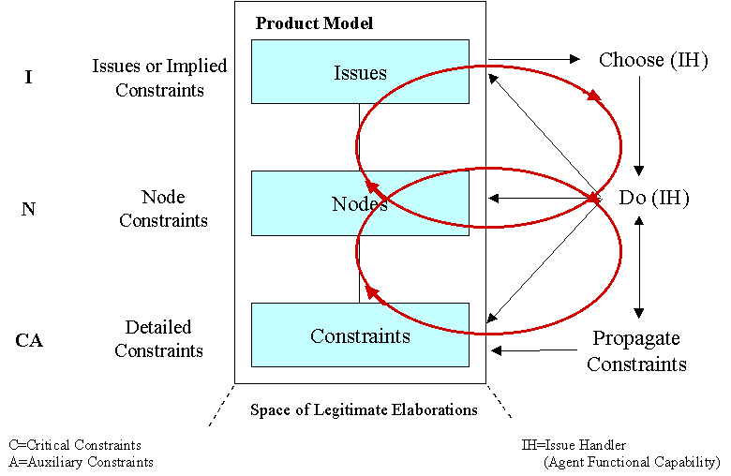

- An I-X system or agent has two cycles:
  - Handle Issues
  - Respect Domain Constraints

- An I-X system or agent carries out a (perhaps dynamically determined) process that leads to the production of (one or more alternative options for) a synthesised artifact.

- An I-X system or agent views the synthesised artifact as being represented by a set of constraints on the space of all possible artifacts in the domain.

I-X also involves a modular systems integration architecture that strongly parallels and supports the abstract view described above.

I-X Process Panels (I-P²)

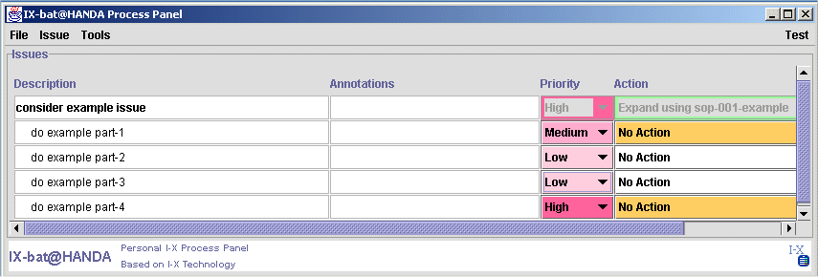

The aim of an I-X Process Panel (I-P²) is to act as a workflow, reporting and messaging “catch all” for its user. It can act in conjunction with other panels for other users if desired.

- Can take ANY requirement to:
  - Handle an issue
  - Perform an activity
  - [later: Add a constraint]

- Deals with these via:
  - Manual (user) activity
  - Internal capabilities
  - External capabilities (invoke or query)
  - Reroute or delegate to other panels or agents (pass)
  - Plan and execute a composite of these capabilities (expand)

- Receives reports and messages and, where possible, interprets them to:
  - Understand current status of issues, activities and constraints
  - Understand current world state, especially status of process products
  - Help control the situation

- Copes with partial knowledge

An I-X Process Panel supports a user or collaborative users in selecting and carrying out "processes" and creating or modifying "process products". Both processes and process products are abstractly considered to be made up on "Nodes" (activities in a process, or parts of a process product) which may have parts called sub-nodes making up a hierarchical description of the process or product. The nodes are related by a set of detailed "Constraints" of various kinds. A set of "Issues" is associated with the processes or process products to represent unsatisfied requirements, problems raised as a result of analysis or critiquing, etc. Processes and process products in I-X are represented in the <I-N-CA> (Issues - Nodes - Critical/Auxiliary) Constraints Model of Synthesised Artifacts.

Three example process panels are shown in the figure below. These panels are from a demonstration of agent systems within a military Coalition context – part of the Coalition Agents eXperiment – CoAX (Allsopp et.al., 2001; Allsopp et.al., 2002).

I-X Process Editor (I-PE)

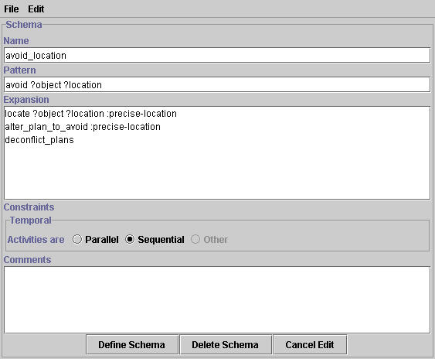The process descriptions used by I-X Process Panels are kept in a domain library. This can be loaded when a panel is started, and can be added to dynamically by a user of a panel.

Simple View - the process panels contain a simple, form-based domain and process editor (right). This simple editor allows simple task breakdown structures to be specified along with a temporal constraint that the sub-steps should all be sequentially ordered or all kept in parallel.

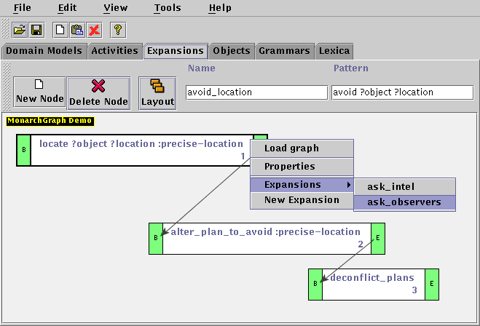
Advanced View - a more powerful domain and process editor allows for multiple perspectives and views to be used to create rich process models beyond those that can be created with the simple view editor. This can be reached by selecting advanced view from the simple domain/process editor. It is also available as a stand-alone application to maintain a set of domain and process libraries.
The advanced editor consists of a form-based structure editor (not shown), which looks similar to the simple editor but allows the user to specify more complex temporal constraints. Other constraints, like spatial ones or constraints on resources, can also be specified using the advanced view.

The graphical editor (right) provides an alternative view to the form-based editor. The graphical editor illustrates precedence relationships between the sub-steps of a process. This editor can also be used to specify task breakdown structures via the expansion of nodes in the graph. Full details of the process and its sub-steps can be accessed via the properties of nodes.

Use of XML and Text Editors - the process and domain models are maintained in XML. You can also modify them using an XML Editing Tool - such as the freely available Microsoft XML Notepad (see http://msdn.microsoft.com/xml/notepad/intro.asp) or a text editor.

I-P² Generic Approach

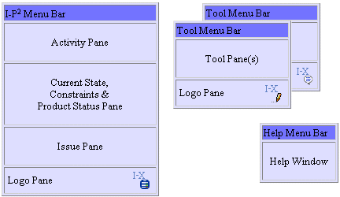

An I-X Process Panel has a menu bar and a number of sub-panels. These can include an activity pane that describes the list of activities to be carried out. Alternative actions to take to perform these activities may be available. A current state pane can be included to describe the current situation, and in particular it may describe the status of the various “process products” being created or modified by the user of the panel. The list of outstanding issues can be included in a pane, and this “to do list” often is at the heart of I-X process panels, and is usually present in all applications. Finally a logo pane can be added to customise the process panel to specific applications.

From the menu bar it is possible to activate a number of “tools” which currently include a free format instant messaging/chat tool, and access to the Process Editor (in Simple or Advanced View varieties). Help is also available from the process panel menu bar.

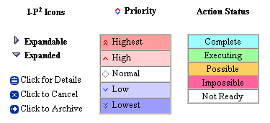

The process panel includes a number of icons and tabular entries to assist its user to maintain awareness of the current status of activities being executed, process product status and issue status. These are shown in the diagram here.

I-LEED and I-DEEL – A Coalition Application of I-X Process Panels

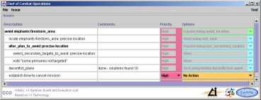
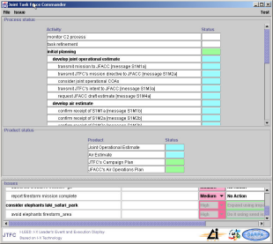
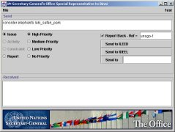

The CoAX demonstration of the I-X concepts is grounded in a system for supporting event management in a highly dynamic military Coalition environment. Two I-X process Panels are involved in the demonstration. One is called the “I-X Leaders Event and Execution List” – I-LEED – and support the Joint Task Force Commander (JTFC) in the Coalition HQ. The other is called the "I-X Dynamic Execution Event List" – I-DEEL – and support the Chief of Combat Operations (CCO). A third system is provided to act as a source for events and messages to initiate the demonstration. Notionally this acts as the UN Secretary general’s Office Special Representative to Binni – the region where the Coalition mission is taking place (Rathmell, 1999).

The process panels support their respective users in mapping events to actions they decide are appropriate to deal with such events. The panels have some (partial) level of process knowledge in a simple process library, and a way to create / expand task lists / processes on the fly which are dependent on the context or situation that is prevailing at the time. The process panels are designed to be able to be used by any decision-maker operating at different time scales and with appropriate abstraction levels of process description to support people involved in military Command and Control in Coalitions and other operations.

The process panels use the issue-addressing core of I-X to handle issues (derived from externally generated events or user initiated ones) relevant to a Coalition C² process within the context of the CoAX Binni scenario. Where these do not match directly to a known capability, the panel seeks (or the user could input) process / task expansions of how to handle these issues and use a very simple expansion engine (a mini-planner termed I-Plan) to match the expanded activities to a range of known capabilities which are performable by the process panel user or by other colleagues or to suitable tasks / solutions which the user could input. Therefore, in a simple way, a process panel can dynamically generate an appropriate response to the issue or event in the current situation - this allows the user to create and interact with a "dynamic event list" to assist with the monitoring of execution outcomes and the resultant actions / changes / new taskings. Links can be created between related tasks (by the user or inferred by the system) and the system can monitor dependencies, etc.

The process panels can identify actions based on known external capabilities to enable the user to "enact" these steps. The process panels can maintain a simple display of the current status of issues and events delegated to the panel and information on how far along in the response process things had proceeded.

Summary

This paper has described the application of I-X Process Panels to military Coalition scenarios. Such process panels can be employed quickly and with partial knowledge to connect together “come-as-you-are” participants and systems together, especially in contexts where physical connectivity of systems is too time consuming, or is not allowed due to security constraints. As process and other knowledge is made available improved interoperability can be supported – allowing for more intelligent task and process management in a loose collaborative setting.

Acknowledgements

The I-X project is partially sponsored by the Defense Advanced Research Projects Agency (DARPA) and Air Force Research Laboratory Command and Control Directorate under grant number F30602-99-1. The US Government and the University of Edinburgh are authorised to reproduce and distribute reprints for their purposes notwithstanding any copyright annotation hereon. The views and conclusions contained herein are those of the authors and should not be interpreted as necessarily representing official policies or endorsements, either express or implied, of DARPA, the Air Force Research Laboratory, the US Government or the University of Edinburgh.

References

Allsopp, D., Beautement, P., Bradshaw, J.M., Carson, J., Kirton, M., Suri, N. and Tate, A. (2001) “Software Agents as Facilitators of Coherent Coalition Operations”, 6th International Command and Control Research and Technology Symposium, US Naval Academy, Annapolis, Maryland, USA, 19-21 June 2001.

Allsopp, D., Beautement, P., Bradshaw, J., Durfee, E., Kirton, M., Knoblock, C., Suri, N., Tate, A. and Thompson, C. (2002) “Coalition Agents eXperiment: Multi-agent Co-operation in an International Coalition Setting”, 2nd International Conference on Knowledge Systems for Coalition Operations, Toulouse, France, 23-24 April 2002.

Fraser, J. and Tate, A. (1995) "The Enterprise Tool Set - An Open Enterprise Architecture", Proceedings of the Workshop on Intelligent Manufacturing Systems, International Joint Conference on Artificial Intelligence (IJCAI-95), Montreal, Canada, August 1995.

Rathmell, R.A. (1999) A Coalition Force Scenario 'Binni - Gateway to the Golden Bowl of Africa', In Proceedings of the International Workshop on Knowledge-Based Planning for Coalition Forces, (ed. Tate, A.) pp. 115-125, Edinburgh, Scotland, 10th-11th May 1999.

Stader J., Moore J., Chung P., McBriar I., Ravinranathan M., Macintosh A.. (2000) "Applying Intelligent Workflow Management in the Chemicals Industries"; in “The Workflow Handbook 2001”, L. Fisher (ed), Published in association with the Workflow Management Coalition (WfMC), pp 161-181, Oct 2000.

Stader J. (1996) “Results of the Enterprise Project”, in Proceedings of Expert Systems '96, the 16th Annual Conference of the British Computer Society Specialist Group on Expert Systems, Cambridge, UK, December 1996.

Tate, A. (1996) "The <I-N-OVA> Constraint Model of Plans", Proceedings of the Third International Conference on Artificial Intelligence Planning Systems (AIPS-96), (ed. Drabble, B.), pp. 221-228, Edinburgh, UK, May 1996, AAAI Press.

Tate, A. (1998) “Roots of SPAR”, in "Special Issue on Ontologies", Knowledge Engineering Review, Vol.13 (1), March 1998, Cambridge University Press.

Tate, A., Dalton, J. and Levine, J. (1998) "Generation of Multiple Qualitatively Different Plan Options", Fourth International Conference on AI Planning Systems (AIPS-98), Pittsburgh, PA, USA, June 1998.

Tate, A., Dalton, J. and Levine, J. (2000) “O-Plan: a Web-based AI Planning Agent”, AAAI-2000 Intelligent Systems Demonstrator, in Proceedings of the National Conference of the American Association of Artificial Intelligence (AAAI-2000), Austin, Texas, USA, August 2000.

Tate, A., Levine, J., Dalton, J. and Nixon, A. (2002) “Task Achieving Agents on the World Wide Web”, in “Creating the Semantic Web”, Fensel, D., Hendler, J., Liebermann, H. and Wahlster, W. (eds.), MIT Press, 2001.

Uschold, M., King, M., Moralee, S. and Zorgios, Y. (1998) "The Enterprise Ontology", in “Special Issue on Ontologies”, Knowledge Engineering Review, Vol.13(1), March, 1998, Cambridge University Press.

